//EB bill

PROGRAM:

package first;
import java.util.*;

public class First {

public static void main(String[] args) {
customerdata ob = new customerdata();
ob.getdata();
ob.calc();
ob.display();
}
}
class customerdata
{
Scanner in= new Scanner(System.in);
Scanner ins= new Scanner(System.in);
String cname,type;
int bn;
double current, previous,tbill,units;
void getdata()
{
System.out.print("\n\tEnter consumer number");
bn=in.nextInt();
System.out.print("\n\tEnter Type of Connection(D for Domestic and C for Commercial)");
type=ins.nextLine();
System.out.print("\n\t Enter consumer name");
cname=ins.nextLine();
System.out.print("\n\tEnter previous month reading");
previous=in.nextDouble();
System.out.print("\n\tEntr current month reading");
current=in.nextDouble();
}
void calc()
{
units=current-previous;
if (type.equals("D"));
{
if(units<=100)
tbill=1*units;
else if (units>100 && units<200)
tbill=2.50*units;
else if (units>200 && units<500)
tbill=4*units;
else
tbill=6*units;
}

else
{
if(units<=100)
tbill=2*units;
else if (units>100 && units<200)
tbill=4.50*units;
else if (units>200 && units<500)
tbill=6*units;
else
tbill=7*units;
}

}
void display()
{
System.out.println("\n\tConsumer number="+bn);
System.out.println("\n\tConsumer name="+cname);
if(type.equals("D"))
System.out.println("\n\tType of connection = DOMESTIC");
else
System.out.println("\n\tType of connection = COMMERCIAL");
System.out.println("\n\tCurrent Month Reading="+current);
System.out.println("\n\tPrevious Month Reading ="+previous);
System.out.println("\n\tTotal units="+units);
System.out.println("\n\tTotal bill=RS"+tbill);
}
}

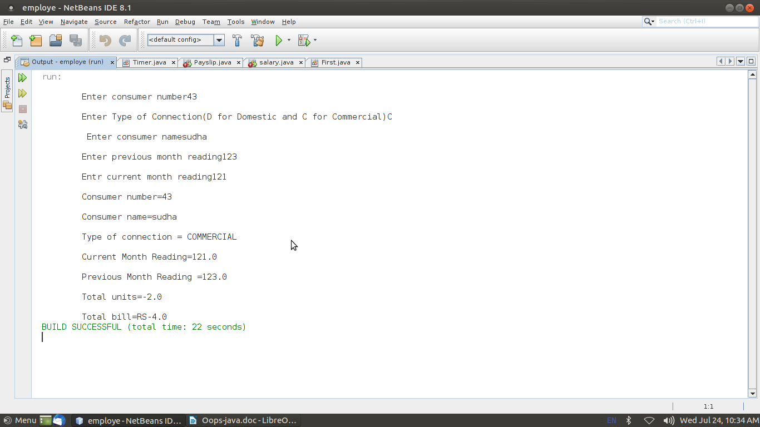
OUTPUT:

PROGRAM

//currencyconversion.java
package currencyconversion;
import java.util.*;
public class currency
{
double inr,usd;
double euro,yen;
Scanner in=new Scanner(System.in);
public void dollartorupee()
{
System.out.println("Enter dollars to convert into Rupees:");
usd=in.nextInt();
inr=usd*67;
System.out.println("Dollar ="+usd+"equal to INR="+inr);
}
public void rupeetodollar()
{
System.out.println("Enter Rupee to convert into Dollars:");
inr=in.nextInt();
usd=inr/67;
System.out.println("Rupee ="+inr+"equal to Dollars="+usd);
}
public void eurotorupee()
{
System.out.println("Enter euro to convert into Rupees:");
euro=in.nextInt();
inr=euro*79.50;
System.out.println("Euro ="+euro +"equal to INR="+inr);
}
public void rupeetoeuro()
{
System.out.println("Enter Rupees to convert into Euro:");
inr=in.nextInt();
euro=(inr/79.50);
System.out.println("Rupee ="+inr +"equal to Euro="+euro);
}
public void yentorupee()
{
System.out.println("Enter yen to convert into Rupees:");
yen=in.nextInt();
inr=yen*0.61;
System.out.println("YEN="+yen +"equal to INR="+inr);
}
public void rupeetoyen()
{
System.out.println("Enter Rupees to convert into Yen:");
inr=in.nextInt();
yen=(inr/0.61);
System.out.println("INR="+inr +"equal to YEN"+yen);
}
}

distance.java
package distanceconversion;
import java.util.*;
public class distance
{
double km,m,miles;
Scanner sc = new Scanner(System.in);
public void kmtom()
{
System.out.print("Enter in km ");
km=sc.nextDouble();
m=(km*1000);
System.out.println(km+"km" +"equal to"+m+"metres");
}
public void mtokm()
{
System.out.print("Enter in meter ");
m=sc.nextDouble();
km=(m/1000);
System.out.println(m+"m" +"equal to"+km+"kilometres");
}
public void milestokm()
{
System.out.print("Enter in miles");
miles=sc.nextDouble();
km=(miles*1.60934);
System.out.println(miles+"miles" +"equal to"+km+"kilometres");
}
public void kmtomiles()
{
System.out.print("Enter in km");
km=sc.nextDouble();
miles=(km*0.621371);
System.out.println(km+"km" +"equal to"+miles+"miles");
}
}

//timer.java
package timeconversion;
import java.util.*;
public class timer
{
int hours,seconds,minutes;
int input;
Scanner sc = new Scanner(System.in);
public void secondstohours()
{
System.out.print("Enter the number of seconds: ");
input = sc.nextInt();
hours = input / 3600;
minutes = (input % 3600) / 60;
seconds = (input % 3600) % 60;
System.out.println("Hours: " + hours);
System.out.println("Minutes: " + minutes);
System.out.println("Seconds: " + seconds);
}
public void minutestohours()
{
System.out.print("Enter the number of minutes: ");
minutes=sc.nextInt();
hours=minutes/60;
minutes=minutes%60;
System.out.println("Hours: " + hours);
System.out.println("Minutes: " + minutes);
}
public void hourstominutes()
{
System.out.println("enter the no of hours");
hours=sc.nextInt();
minutes=(hours*60);
System.out.println("Minutes: " + minutes);
}
public void hourstoseconds()
{
System.out.println("enter the no of hours");
hours=sc.nextInt();
seconds=(hours*3600);
System.out.println("Minutes: " + seconds);
}
}

//converter.java
import java.util.*;
import java.io.*;
import currencyconversion.*;
import distanceconversion.*;
import timeconversion.*;
class converter
{
public static void main(String args[])
{
Scanner s=new Scanner(System.in);
int choice,ch;
currency c=new currency();
distance d=new distance();
timer t=new timer();
do
{
System.out.println("1.dollar to rupee ");
System.out.println("2.rupee to dollar ");
System.out.println("3.Euro to rupee ");
System.out.println("4..rupee to Euro ");
System.out.println("5.Yen to rupee ");
System.out.println("6.Rupee to Yen ");
System.out.println("7.Meter to kilometer ");
System.out.println("8.kilometer to meter ");
System.out.println("9.Miles to kilometer ");
System.out.println("10.kilometer to miles");
System.out.println("11.Hours to Minutes");
System.out.println("12.Hours to Seconds");
System.out.println("13.Seconds to Hours");
System.out.println("14.Minutes to Hours");
System.out.println("Enter ur choice");
choice=s.nextInt();
switch(choice)
{
case 1:
{
c.dollartorupee();
break;
}
case 2:
{
c.rupeetodollar();
break;
}
case 3:
{
c.eurotorupee();
break;
}
case 4:
{
c.rupeetoeuro();
break;
}
case 5:
{c.yentorupee();
break;}
case 6 :
{
c.rupeetoyen();
break;
}
case 7 :
{
d.mtokm();
break;
}
case 8 :
{
d.kmtom();
break;
}
case 9 :
{
d.milestokm();
break;
}
case 10 :
{
d.kmtomiles();
break;
}
case 11 :
{
t.hourstominutes();
break;
}
case 12 :
{
t.hourstoseconds();
break;
}
case 13 :
{
t.secondstohours();
break;
}
case 14 :
{
t.minutestohours();
break;
}
}
System.out.println("Enter 0 to quit and 1 to continue ");
ch=s.nextInt();
}while(ch==1);
}
}

OUTPUT:
1.dollar to rupee
2. rupee to dollar
3.Euro to rupee
4. rupee to Euro
5. Yen to rupee
6. Rupee to Yen
7. Meter to kilometer
8.kilometer to meter
9. Miles to kilometer
10. kilometer to miles
11.Hours to minutes
12. hours to seconds
13. Seconds to hours
14. Minutes to hours
Enter your choice:
1
Enter dollars to convert into Rupees:
2
Dollar=2.0equal to INR=134.0
Enter o to quit and 1 to continue
1
1.dollar to rupee
2. rupee to dollar
3.Euro to rupee
4. rupee to Euro
5. Yen to rupee
6. Rupee to Yen
7. Meter to kilometer
8.kilometer to meter
9. Miles to kilometer
10. kilometer to miles
11.Hours to minutes
12. hours to seconds
13. Seconds to hours
14. Minutes to hours
Enter your choice:
2
Enter Rupees to convert into Dollar:
4
Rupees=4.0equals to dollars+0.05970149253731343
Enter o to quit and 1 to continue
1
1.dollar to rupee
2. rupee to dollar
3.Euro to rupee
4. rupee to Euro
5. Yen to rupee
6. Rupee to Yen
7. Meter to kilometer
8.kilometer to meter
9. Miles to kilometer
10. kilometer to miles
11.Hours to minutes
12. hours to seconds
13. Seconds to hours
14. Minutes to hours
Enter your choice:
3
Enter euro to convert into Rupees:
45
Euro45.0equal to InR=3172.5
Enter o to quit and 1 to continue
1
1.dollar to rupee
2. rupee to dollar
3.Euro to rupee
4. rupee to Euro
5. Yen to rupee
6. Rupee to Yen
7. Meter to kilometer
8.kilometer to meter
9. Miles to kilometer
10. kilometer to miles
11.Hours to minutes
12. hours to seconds
13. Seconds to hours
14. Minutes to hours
Enter your choice:
4
Enter Rupees to convert into Dollar:
23
Rupees=23.0equals to dollars+0.34328358208955223
Enter o to quit and 1 to continue
1
1.dollar to rupee
2. rupee to dollar
3.Euro to rupee
4. rupee to Euro
5. Yen to rupee
6. Rupee to Yen
7. Meter to kilometer
8.kilometer to meter
9. Miles to kilometer
10. kilometer to miles
11.Hours to minutes
12. hours to seconds
13. Seconds to hours
14. Minutes to hours
Enter your choice:
5
Enter yen to convert into Rupees:
22
yen22.0equal to INR=13.42
Enter o to quit and 1 to continue
1
1.dollar to rupee
2. rupee to dollar
3.Euro to rupee
4. rupee to Euro
5. Yen to rupee
6. Rupee to Yen
7. Meter to kilometer
8.kilometer to meter
9. Miles to kilometer
10. kilometer to miles
11.Hours to minutes
12. hours to seconds
13. Seconds to hours
14. Minutes to hours
Enter your choice:
6
Enter rupee to convert into yen:
2
Rupee2.0equal to Yen=22.0
Enter o to quit and 1 to continue
1
1.dollar to rupee
2. rupee to dollar
3.Euro to rupee
4. rupee to Euro
5. Yen to rupee
6. Rupee to Yen
7. Meter to kilometer
8.kilometer to meter
9. Miles to kilometer
10. kilometer to miles
11.Hours to minutes
12. hours to seconds
13. Seconds to hours
14. Minutes to hours
Enter your choice:
7
Enter in meter
25
25.0mequalto0.025km
Enter o to quit and 1 to continue
1
1.dollar to rupee
2. rupee to dollar
3.Euro to rupee
4. rupee to Euro
5. Yen to rupee
6. Rupee to Yen
7. Meter to kilometer
8.kilometer to meter
9. Miles to kilometer
10. kilometer to miles
11.Hours to minutes
12. hours to seconds
13. Seconds to hours
14. Minutes to hours
Enter your choice:
8
Enter in km
87
87.0kmequalto87000.0meters
Enter o to quit and 1 to continue
1
1.dollar to rupee
2. rupee to dollar
3.Euro to rupee
4. rupee to Euro
5. Yen to rupee
6. Rupee to Yen
7. Meter to kilometer
8.kilometer to meter
9. Miles to kilometer
10. kilometer to miles
11.Hours to minutes
12. hours to seconds
13. Seconds to hours
14. Minutes to hours
Enter your choice:
9
Enter in miles
765
765.0milesequalto1231.1451km
Enter o to quit and 1 to continue
1
1.dollar to rupee
2. rupee to dollar
3.Euro to rupee
4. rupee to Euro
5. Yen to rupee
6. Rupee to Yen
7. Meter to kilometer
8.kilometer to meter
9. Miles to kilometer
10. kilometer to miles
11.Hours to minutes
12. hours to seconds
13. Seconds to hours
14. Minutes to hours
Enter your choice:
10
Enter in km
23
23.0kmequalto14.291533miles
Enter o to quit and 1 to continue
1
1.dollar to rupee
2. rupee to dollar
3.Euro to rupee
4. rupee to Euro
5. Yen to rupee
6. Rupee to Yen
7. Meter to kilometer
8.kilometer to meter
9. Miles to kilometer
10. kilometer to miles
11.Hours to minutes
12. hours to seconds
13. Seconds to hours
14. Minutes to hours
Enter your choice:
28
Enter o to quit and 1 to continue
1
1.dollar to rupee
2. rupee to dollar
3.Euro to rupee
4. rupee to Euro
5. Yen to rupee
6. Rupee to Yen
7. Meter to kilometer
8.kilometer to meter
9. Miles to kilometer
10. kilometer to miles
11.Hours to minutes
12. hours to seconds
13. Seconds to hours
14. Minutes to hours
Enter your choice:
11
Enter the number of hours
3
Minutes180
Enter o to quit and 1 to continue
1
1.dollar to rupee
2. rupee to dollar
3.Euro to rupee
4. rupee to Euro
5. Yen to rupee
6. Rupee to Yen
7. Meter to kilometer
8.kilometer to meter
9. Miles to kilometer
10. kilometer to miles
11.Hours to minutes
12. hours to seconds
13. Seconds to hours
14. Minutes to hours
Enter your choice:
12
Enter the number of minutes
45
Seconds:10800
Enter o to quit and 1 to continue
1
1.dollar to rupee
2. rupee to dollar
3.Euro to rupee
4. rupee to Euro
5. Yen to rupee
6. Rupee to Yen
7. Meter to kilometer
8.kilometer to meter
9. Miles to kilometer
10. kilometer to miles
11.Hours to minutes
12. hours to seconds
13. Seconds to hours
14. Minutes to hours
Enter your choice:
13
Enter the number of seconds
280
hours:0Minutes:4Seconds:280
Enter o to quit and 1 to continue
1
1.dollar to rupee
2. rupee to dollar
3.Euro to rupee
4. rupee to Euro
5. Yen to rupee
6. Rupee to Yen
7. Meter to kilometer
8.kilometer to meter
9. Miles to kilometer
10. kilometer to miles
11.Hours to minutes
12. hours to seconds
13. Seconds to hours
14. Minutes to hours
Enter your choice:
14
Enter the number of minutes
277
hours:4Minutes:37
Enter o to quit and 1 to continue

//GENERATE PAYSLIP- INTERFACE
PROGRAM:
import java.util.*;
class employee
{
int empid;
long mobile;
String name, address, mailid;
Scanner get = new Scanner(System.in);
void getdata()
{
System.out.println("Enter Name of the Employee");
name = get.nextLine();
System.out.println("Enter Mail id");
mailid = get.nextLine();
System.out.println("Enter Address of the Employee:");
address = get.nextLine();
System.out.println("Enter employee id ");
empid = get.nextInt();
System.out.println("Enter Mobile Number");
mobile = get.nextLong();
}
void display()
{
System.out.println("Employee Name: "+name);
System.out.println("Employee id : "+empid);
System.out.println("Mail id : "+mailid);
System.out.println("Address: "+address);
System.out.println("Mobile Number: "+mobile);
}
}
class programmer extends employee
{
double salary,bp,da,hra,pf,club,net,gross;
void getprogrammer()
{
System.out.println("Enter basic pay");
bp = get.nextDouble();
}
void calculateprog()
{
da=(0.97*bp);
hra=(0.10*bp);
pf=(0.12*bp);
club=(0.1*bp);
gross=(bp+da+hra);
net=(gross-pf-club);
System.out.println("************************************************");
System.out.println("PAY SLIP FOR PROGRAMMER");
System.out.println("************************************************");
System.out.println("Basic Pay:Rs"+bp);
System.out.println("DA:Rs"+da);
System.out.println("PF:Rs"+pf);
System.out.println("HRA:Rs"+hra);
System.out.println("CLUB:Rs"+club);
System.out.println("GROSS PAY:Rs"+gross);
System.out.println("NET PAY:Rs"+net);
}
}
class asstprofessor extends employee
{
double salary,bp,da,hra,pf,club,net,gross;
void getasst()
{
System.out.println("Enter basic pay");
bp = get.nextDouble();
}
void calculateasst()
{
da=(0.97*bp);
hra=(0.10*bp);
pf=(0.12*bp);
club=(0.1*bp);
gross=(bp+da+hra);
net=(gross-pf-club);
System.out.println("************************************************");
System.out.println("PAY SLIP FOR ASSISTANT PROFESSOR");
System.out.println("************************************************");
System.out.println("Basic Pay:Rs"+bp);
System.out.println("DA:Rs"+da);
System.out.println("HRA:Rs"+hra);
System.out.println("PF:Rs"+pf);
System.out.println("CLUB:Rs"+club);
System.out.println("GROSS PAY:Rs"+gross);
System.out.println("NET PAY:Rs"+net);
}
}
class associateprofessor extends employee
{
double salary,bp,da,hra,pf,club,net,gross;
void getassociate()
{
System.out.println("Enter basic pay");
bp = get.nextDouble();
}
void calculateassociate()
{
da=(0.97*bp);
hra=(0.10*bp);
pf=(0.12*bp);
club=(0.1*bp);
gross=(bp+da+hra);
net=(gross-pf-club);
System.out.println("************************************************");
System.out.println("PAY SLIP FOR ASSOCIATE PROFESSOR");
System.out.println("************************************************");
System.out.println("Basic Pay:Rs"+bp);
System.out.println("DA:Rs"+da);
System.out.println("HRA:Rs"+hra);
System.out.println("PF:Rs"+pf);
System.out.println("CLUB:Rs"+club);
System.out.println("GROSS PAY:Rs"+gross);
System.out.println("NET PAY:Rs"+net);
}
}
class professor extends employee
{
double salary,bp,da,hra,pf,club,net,gross;
void getprofessor()
{
System.out.println("Enter basic pay");
bp = get.nextDouble();
}
void calculateprofessor()
{
da=(0.97*bp);
hra=(0.10*bp);
pf=(0.12*bp);
club=(0.1*bp);
gross=(bp+da+hra);
net=(gross-pf-club);
System.out.println("************************************************");
System.out.println("PAY SLIP FOR PROFESSOR");
System.out.println("************************************************");
System.out.println("Basic Pay:Rs"+bp);
System.out.println("DA:Rs"+da);
System.out.println("HRA:Rs"+hra);
System.out.println("PF:Rs"+pf);
System.out.println("CLUB:Rs"+club);
System.out.println("GROSS PAY:Rs"+gross);
System.out.println("NET PAY:Rs"+net);
}
}
class salary
{
public static void main(String args[])
{
int choice,cont;
do
{
System.out.println("PAYROLL");
System.out.println(" 1.PROGRAMMER \t 2.ASSISTANT PROFESSOR \t 3.ASSOCIATE
PROFESSOR \t 4.PROFESSOR ");
Scanner c = new Scanner(System.in);
choice=c.nextInt();
switch(choice)
{
case 1:
{
programmer p=new programmer();
p.getdata();
p.getprogrammer();
p.display();
p.calculateprog();
break;
}
case 2:
{
asstprofessor asst=new asstprofessor();
asst.getdata();
asst.getasst();
asst.display();
asst.calculateasst();
break;
}
case 3:
{
associateprofessor asso=new associateprofessor();
asso.getdata();
asso.getassociate();
asso.display();
asso.calculateassociate();
break;
}
case 4:
{
professor prof=new professor();
prof.getdata();
prof.getprofessor();
prof.display();
prof.calculateprofessor();
break;
}
}
System.out.println("Do u want to continue 0 to quit and 1 to continue ");
cont=c.nextInt();
}while(cont==1);
}}

OUTPUT:
PAYROLL
1. PROGRAMMER 2.ASSISTANCE PROFESSOR 3. ASSOCIATE PROFESSOR 4.PROFESSOR
1
Enter Employee name
SUDHA
Enter Employee address
VNB
Enter Employee mailid
SD@GMAIL.COM
Enter Employee id
23
Enter mobile number
12345
Enter basic pay
4000
Employee Name:SUDHA
Employee id:23
Mail id:SD@GMAIL.COM
Address:VNB
Mobile number:12345
******************************
PAY SLIP FOR PROGRAMMER
******************************
Basic pay:Rs4000.0
DA:Rs3880.0
PF:Rs480.0
HRA:Rs400.0
CLUB:Rs400.0
Gross PAY:Rs8280.0
NET PAY: Rs7400.0
Do you want to continue 0 to quit and 1 to continue
0

//STACK ADT USING INTERFACE
PROGRAM:
import java.io.*;
interface stackoperation
{
public void push(int i);
public void pop();
}
class Astack implements stackoperation
{
int stack[]=new int[5];
int top=-1;
int i;
public void push(int item)
{
if(top>=4)
{
System.out.println("overflow");
}
else
{
top=top+1;
stack[top]=item;
System.out.println("item pushed"+stack[top]);
}
}
public void pop()
{
if(top<0)
System.out.println("underflow");
else
{
System.out.println("item popped"+stack[top]);
top=top-1;
}
}
public void display()
{
if(top<0)
System.out.println("No Element in stack");
else
{
for(i=0;i<=top;i++)
System.out.println("element:"+stack[i]);
}
}
}
class teststack
{
public static void main(String args[])throws IOException
{
int ch,c;
int i;
Astack s=new Astack();
DataInputStream in=new DataInputStream(System.in);
do
{
try
{
System.out.println("ARRAY STACK");
System.out.println("1.push 2.pop 3.display 4.exit");
System.out.println("enter ur choice:");
ch=Integer.parseInt(in.readLine());
switch(ch)
{
case 1:
System.out.println("enter the value to push:");
i=Integer.parseInt(in.readLine());
s.push(i);
break;
case 2:
s.pop();
break;
case 3:
System.out.println("the elements are:");
s.display();
break;
case 4:
break;
}
}
catch(IOException e)
{
System.out.println("io error");
}
System.out.println("Do u want to continue 0 to quit and 1 to continue ");
c=Integer.parseInt(in.readLine());
}while(c==1);
}
}

OUTPUT:
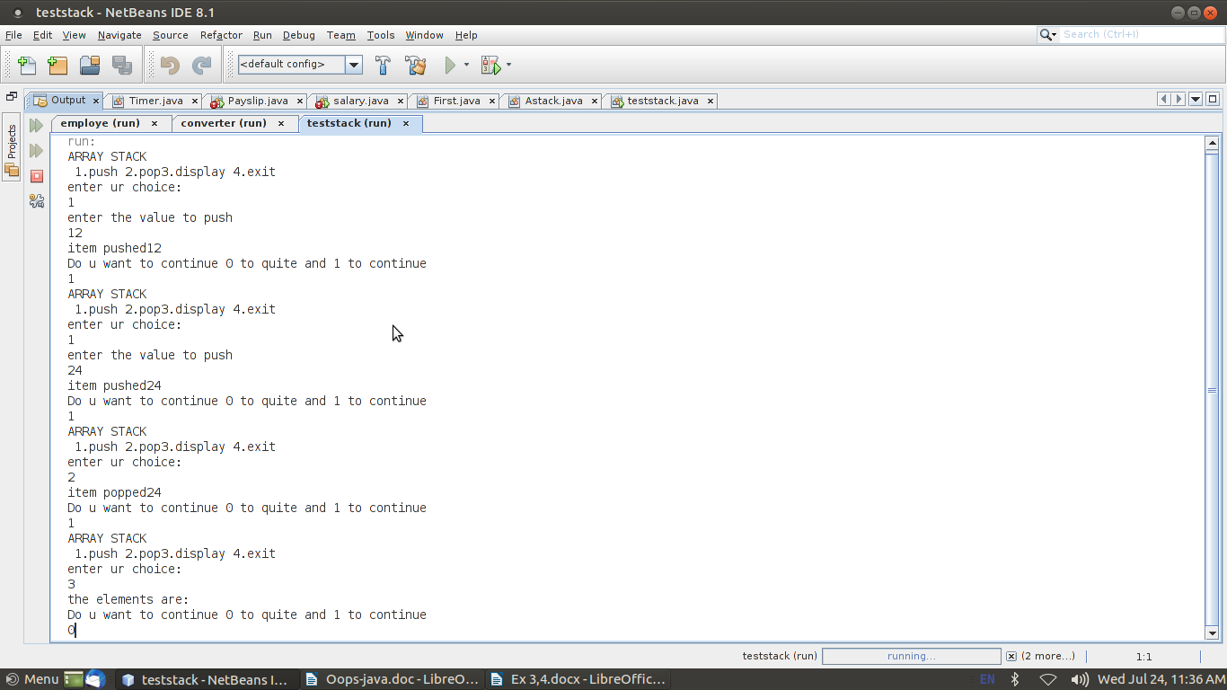

//TO PERFORM STRING OPERATIONS USING ARRAYLIST

PROGRAM:

import java.util.*;
import java.io.*;
public class arraylistexample
{
public static void main(String args[])throws IOException
{
ArrayList<String> obj = new ArrayList<String>();
DataInputStream in=new DataInputStream(System.in);
int c,ch;
int i,j;
String str,str1;
do
{
System.out.println("STRING MANIPULATION");
System.out.println("******************************");
System.out.println(" 1. Append at end \t 2.Insert at particular index \t 3.Search \t");
System.out.println( "4.List string that starting with letter \t");
System.out.println("5.Size \t 6.Remove \t 7.Sort\t 8.Display\t" );
System.out.println("Enter the choice ");
c=Integer.parseInt(in.readLine());
switch(c)
{
case 1:
{
System.out.println("Enter the string ");
str=in.readLine();
obj.add(str);
break;
}
case 2:
{
System.out.println("Enter the string ");
str=in.readLine();
System.out.println("Specify the index/position to insert");
i=Integer.parseInt(in.readLine());
obj.add(i-1,str);
System.out.println("The array list has following elements:"+obj);
break;
}
case 3:
{
System.out.println("Enter the string to search ");
str=in.readLine();
j=obj.indexOf(str);
if(j==-1)
System.out.println("Element not found");
else
System.out.println("Index of:"+str+"is"+j);
break;
}
case 4:
{
System.out.println("Enter the character to List string that starts with specified character");
str=in.readLine();
for(i=0;i<(obj.size()-1);i++)
{
str1=obj.get(i);
if(str1.startsWith(str))
{
System.out.println(str1);
}
}
break;
}
case 5:
{System.out.println("Size of the list "+obj.size());
break;}
case 6:
{
System.out.println("Enter the element to remove");
str=in.readLine();
if(obj.remove(str))
{System.out.println("Element Removed"+str);}
else
{
System.out.println("Element not present");
}
break;
}
case 7:
{
Collections.sort(obj);
System.out.println("The array list has following elements:"+obj);
break;
}
case 8:
{
System.out.println("The array list has following elements:"+obj);
break;
}
}
System.out.println("enter 0 to break and 1 to continue");
ch=Integer.parseInt(in.readLine());
}while(ch==1);
}
}
OUTPUT:
************************

1.Append at end 2.Insert at particular index 3.Search
4.List string that starting with letter 5.Size
6.Remove 7.Sort 8.Display
Enter the choice
1
Enter the string
GOD
enter 0 to break and 1 to continue
1
************************

1.Append at end 2.Insert at particular index 3.Search
4.List string that starting with letter 5.Size
6.Remove 7.Sort 8.Display
Enter the choice
2
Enter the string
RAM
Specify the index/position to insert
2
The array list has following elements:[GOD, RAM]
enter 0 to break and 1 to continue
1
************************

1.Append at end 2.Insert at particular index 3.Search
4.List string that starting with letter 5.Size
6.Remove 7.Sort 8.Display
Enter the choice
3
Enter the string to search
GOD
Index of:GODis0
enter 0 to break and 1 to continue
1
************************

1.Append at end 2.Insert at particular index 3.Search
4.List string that starting with letter 5.Size
6.Remove 7.Sort 8.Display
Enter the choice
4
Enter the character to List string that starts with specified character
R
enter 0 to break and 1 to continue
1
************************

1.Append at end 2.Insert at particular index 3.Search
4.List string that starting with letter 5.Size
6.Remove 7.Sort 8.Display
Enter the choice
5
Size of the list 2
enter 0 to break and 1 to continue
1
************************

1.Append at end 2.Insert at particular index 3.Search
4.List string that starting with letter 5.Size
6.Remove 7.Sort 8.Display
Enter the choice
6
Enter the element to remove
RAM
Element RemovedRAM
enter 0 to break and 1 to continue
1
************************

1.Append at end 2.Insert at particular index 3.Search
4.List string that starting with letter 5.Size
6.Remove 7.Sort 8.Display
Enter the choice
8
The array list has following elements:[GOD]
enter 0 to break and 1 to continue
0

//TO CALCULATE AREA USING ABSTRACT CLASS

PROGRAM:
import java.util.Scanner;
abstract class shape
{
int a,b;
abstract public void printarea();
}
class rectangle extends shape
{
public int area_rect;
public void printarea()
{
Scanner s=new Scanner(System.in);
System.out.println("enter the length and breadth of rectangle");
a=s.nextInt();
b=s.nextInt();
area_rect=a*b;
System.out.println("Length of rectangle "+a +"breadth of rectangle "+b);
System.out.println("The area ofrectangle is:"+area_rect);
}
}
class triangle extends shape
{
double area_tri;
public void printarea()
{
Scanner s=new Scanner(System.in);
System.out.println("enter the base and height of triangle");
a=s.nextInt();
b=s.nextInt();
System.out.println("Base of triangle "+a +"height of triangle "+b);
area_tri=(0.5*a*b);
System.out.println("The area of triangle is:"+area_tri);
}
}
class circle extends shape
{
double area_circle;
public void printarea()
{
Scanner s=new Scanner(System.in);
System.out.println("enter the radius of circle");
a=s.nextInt();
area_circle=(3.14*a*a);
System.out.println("Radius of circle"+a);
System.out.println("The area of circle is:"+area_circle);
}
}
public class Fifth
{
public static void main(String[] args)
{
rectangle r=new rectangle();
r.printarea();
triangle t=new triangle();
t.printarea();
circle r1=new circle();
r1.printarea();
}
}

OUTPUT:
