Jk flip flop 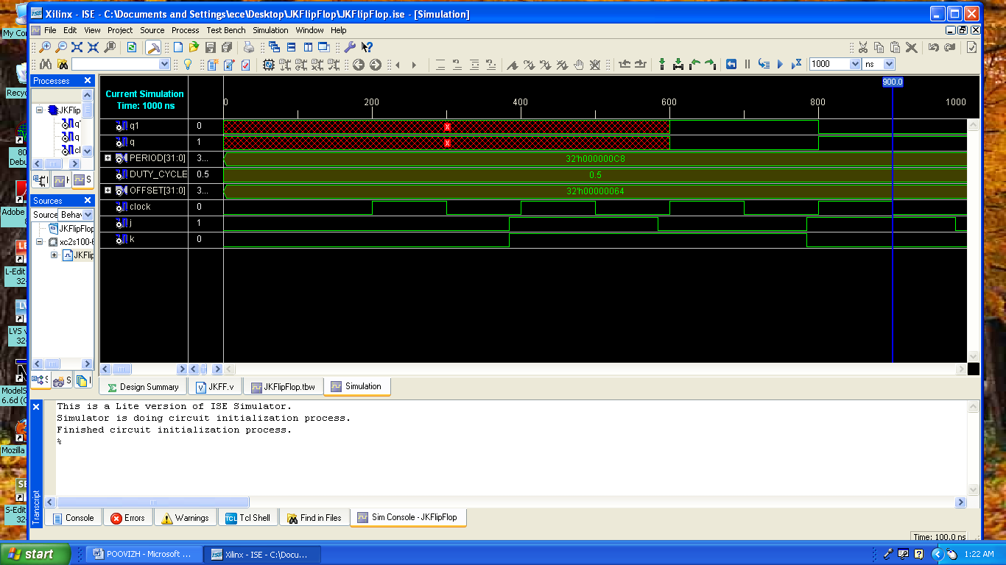
T flip flop

module TFF(t, clk, reset, dout);
input [0:0] t;
input [0:0] clk;
input [0:0] reset;
output [0:0] dout;
reg dout;
wire clk;
wire reset;
initial dout=0;
always@(posedge(clk))
begin
if(reset)
dout<=0;
else
begin
if(t)
dout<=~dout;
end
end

endmodule

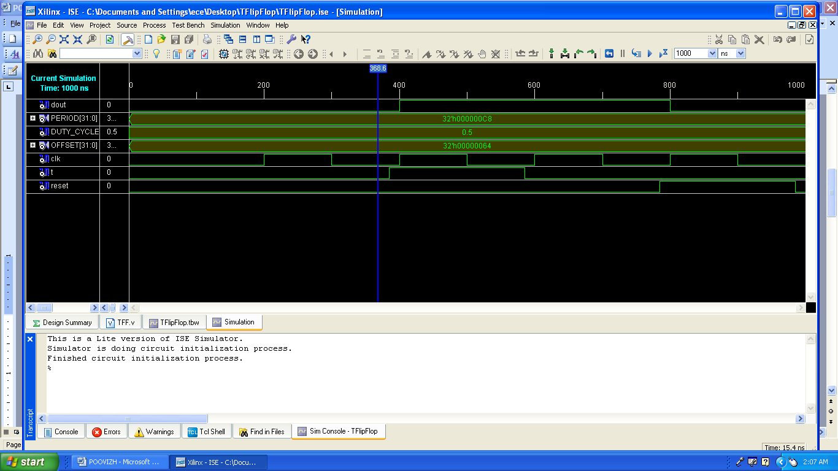
D Flip Flop 