Implementing CRM for Result tracking of a candidate

With internal marks.

1 INTRODUCTION

* 1. OVERVIEW

Administrator should be able to create all base data including Semester, Candidate,

Course and Lecturer ,Lecturer should have the ability to create Internal Results,Dean,

who is one of the Lecturer, should be the only one with ability to update Internal

Results,Re-evaluation Can be initialised by Candidate for all Internal Results.Now

only dean can update the marks after re- evaluation

1.2 Purpose

Are you new to Salesforce? Not sure exactly what it is, or how to use it? Don’t know where

you should start on your learning journey? If you’ve answered yes to any of these questions,

then you’re in the right place. This module is for you.

Welcome to Salesforce! Salesforce is game-changing technology, with a host of

productivity-boosting features, that will help you sell smarter and faster. As you work toward

your badge for this module, we’ll take you through these features and answer the question,

“What is Salesforce, anyway?”

1. Problem Definition & Design Thinking

2.1 Empathy Map:

Empathy maps are an efficient tool used by designers to not only understand user behavior, but also visually communicate those findings to colleagues, uniting the team under one shared understanding of the user. Originally invented by Dave Gray at Xplane, the empathy map was made in an attempt to limit miscommunication and misunderstanding about target audiences, including customers and users.

➢ Based on our understanding about the Empathy map, we created our team Emapthy map and also attached the screenshot.

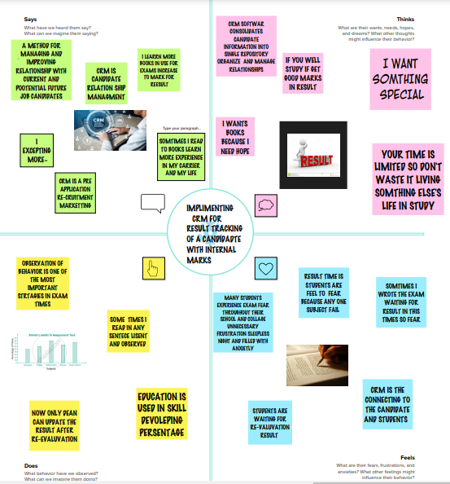

2.2 Ideation & Brainstorming Map

➢ Ideation is a creative process where designers generate ideas in sessions (e.g., brainstorming, worst possible idea). It is the third stage in the Design Thinking process. Participants gather with open minds to produce as many ideas as they can to address a problem statement in a facilitated, judgment-free environment.

➢ Brainstorming is a group problem-solving method that involves the spontaneous contribution of creative ideas and solutions. This technique requires intensive, freewheeling discussion in which every member of the group is encouraged to think aloud and suggest as many ideas as possible based on their diverse knowledge.

­­­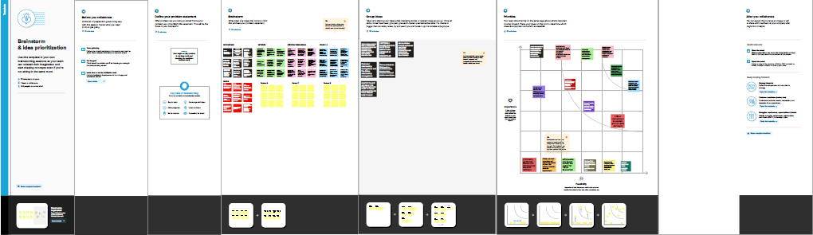

1. RESULT

3.1 Data Model:

|  |  |
| --- | --- |
| OBJECT NAME | FIELDS IN THE OBJECTS |
| 1.SEMESTER NAME | |  |  | | --- | --- | | FIELD LABLE | DATA TYPE | | Semester name | Text | | Course(look up) | Text | |
| 2.CANDIDATE | |  |  | | --- | --- | | FIELD LABLE | DATA TYPE | | Candidate | Text | | Candidate  Name | Text | | [Candidate Id](https://puratchithalaivardrmgrarts9-dev-ed.develop.lightning.force.com/lightning/setup/ObjectManager/01I2w0000036ibz/FieldsAndRelationships/00N2w00000XnP1W/view) | Text | | Semester  Name | Text | | Internal  results(lookup) | Text | |
| 3. Course Details | |  |  | | --- | --- | | FIELD LABLE | DATA TYPE | | Course Details | Text | | Course Name | Text | | Course ID | Text | |
| 4. Lecturer Details | |  |  | | --- | --- | | FIELD LABLE | DATA TYPE | | Lecturer Details | Text | | Lecturer Role | Text | | Lecturer Name | Text | | Course ID | Text | | Course(lookup) | Text | |
| **5.** Internal  results | |  |  | | --- | --- | | **FIELD LABLE** | **DATA TYPE** | | Internal results | Text | | Candidate  ID | Text | | Course ID | Text | | Marks | Text | |

3.2 Activity & Screenshot

Activity 1: Creating Developer Account Creating a developer org in salesforce.

1. Go to developers.salesforce.com/

2. Click on sign up.

3. On the sign up form, enter the following details :

a. First name & Last name a. Email

b. Role : Developer

c. Company : College Name

d. County : India

e. Postal Code : pin code

f. Username : should be a combination of your name and company This need not be an actual email id, you can give anything in the format : [username@organization.com](mailto:username@organization.com)

Click on sign up after filling these.

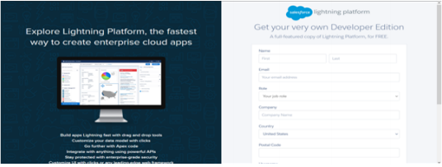

**Account Activation**

Go to the inbox of the email that you used while signing up. Click on the verify account to

activate your account. The email may take 5-10mins, as

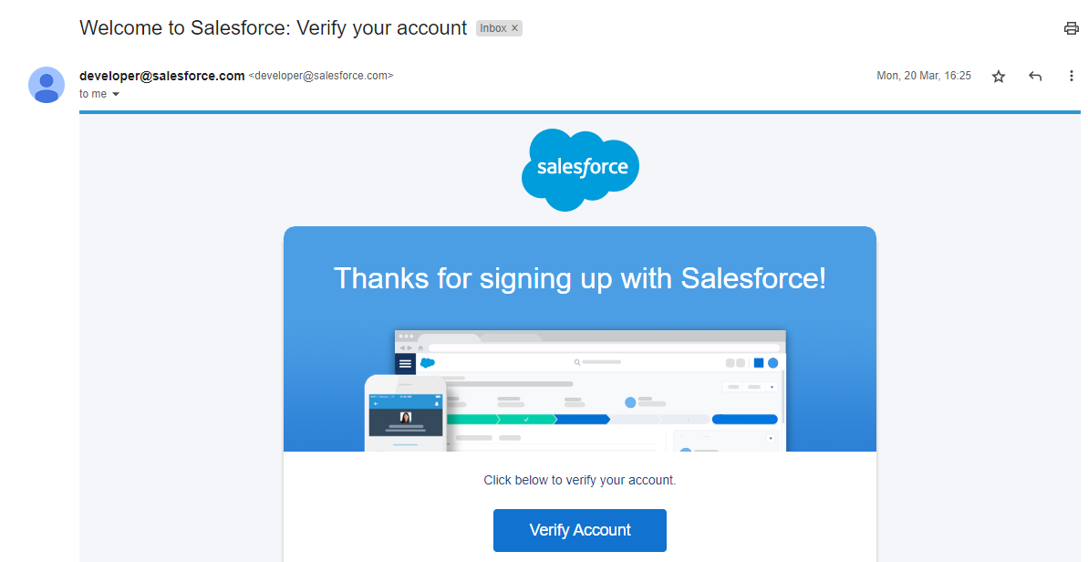

**Login To Your Salesforce Account**

1.Go to salesforce.com and click on login.

2.Enter the username and password that you just created.

3.After login this is the home page which you will see.

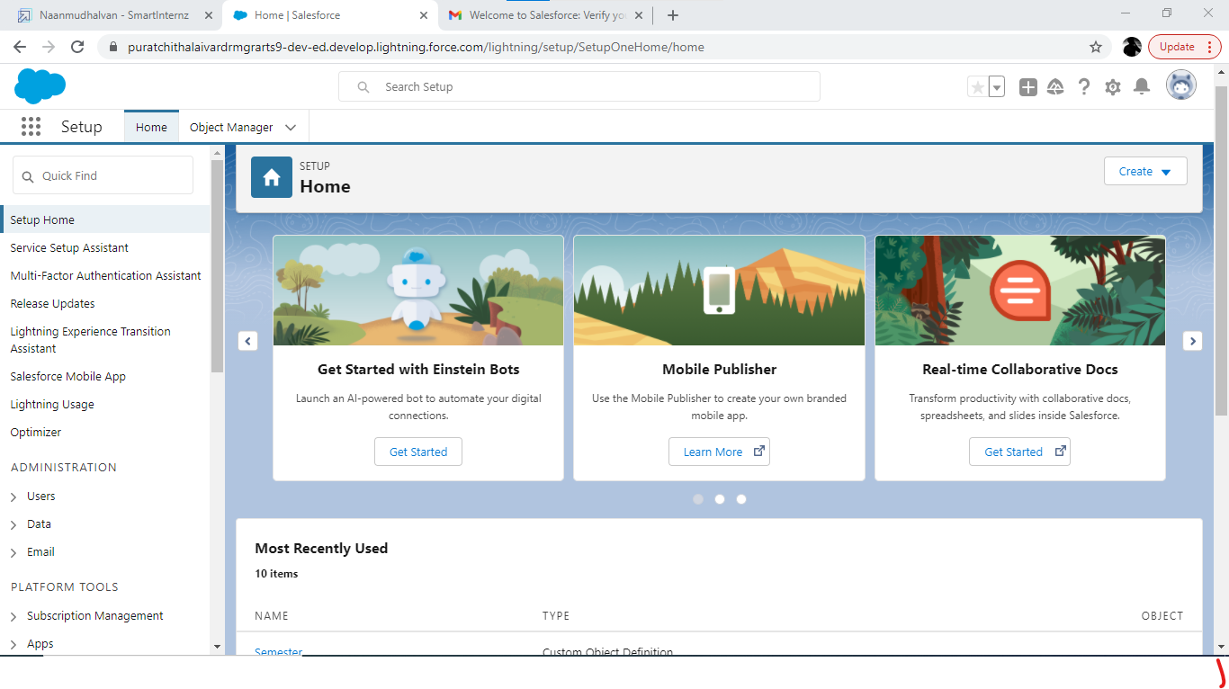

*Salesforce Login*

htttps://login.salesforce.com

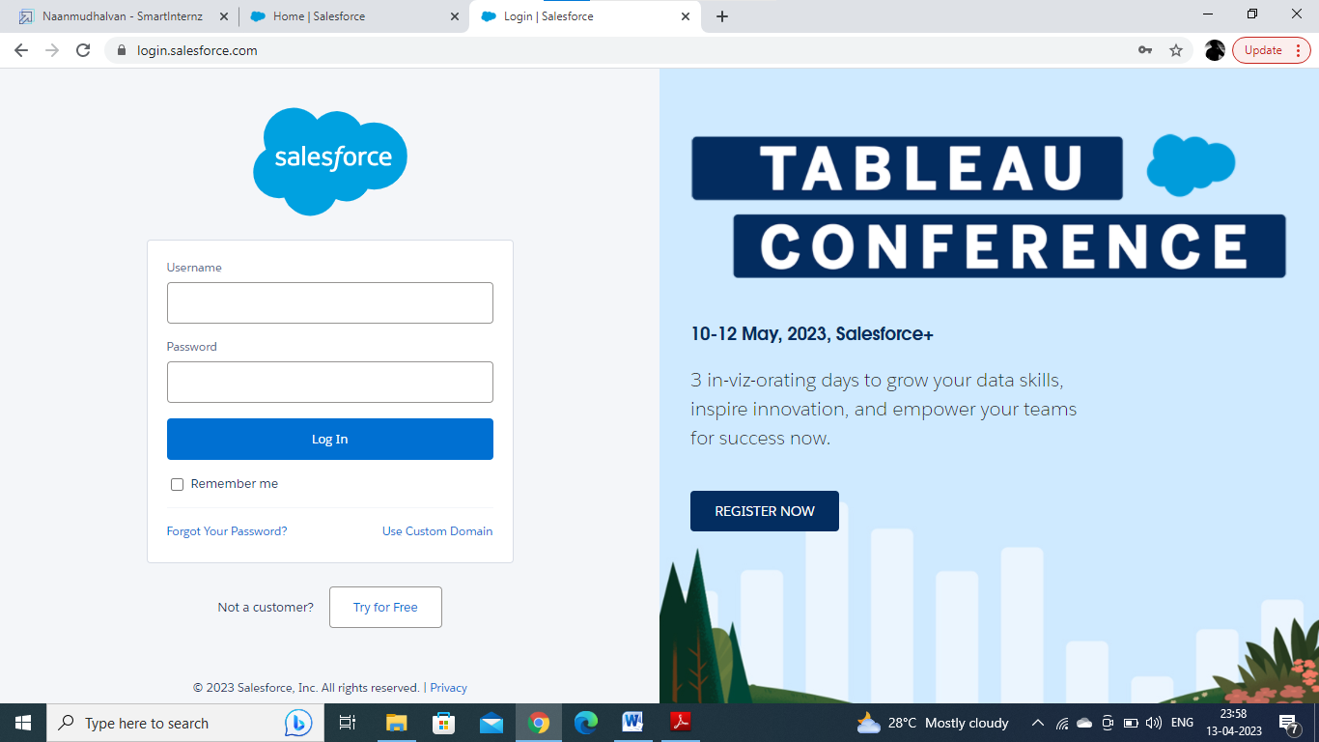

**2:Object**

Salesforce objects are database tables that permit you to store data that is specific to an

organisation. Salesforce objects are of two types: Standard Objects: Standard objects are the

kind of objects that are provided by salesforce.com such as users, contracts, reports,

dashboards, etc.

**Custom objects:**

1.Semester

2.Candidate

3.Course Details

4.Lecturer Details

5.Internal results

**Activity-1:**

**To Create an object**:

Creation of Objects for Candidate Internal Result Card, For this Candidate Internal Result

Card we need to create 5 objects i.e Semester,Candidate,Course Details,Lecturer

Details,Internal Results.

The below steps will assist you in creating those objects.

● Click on the gear icon and then select Setup.

● Click on the object manager tab just beside the home tab.

● After the above steps, have a look on the extreme right you will find a Create

Dropdown click on that and select Custom Object.

On the Custom Object Definition page, create the object as follows:

● Label: Semester

● Plural Label: Semesters

● Record Name: Semester Name

● Check the Allow Reports checkbox

● Check the Allow Search checkbox

● Click Save.

● Now create a custom tab. Click the Home tab, enter Tabs in Quick Find and select

Tabs.

● Under Custom Object Tabs, click New.

● For Object, select Semester.

● For Tab Style, select any icon.

● Leave all defaults as is. Click Next, Next, and Save.

To Navigate to Setup page:

Click on gear icon → click setup.

To

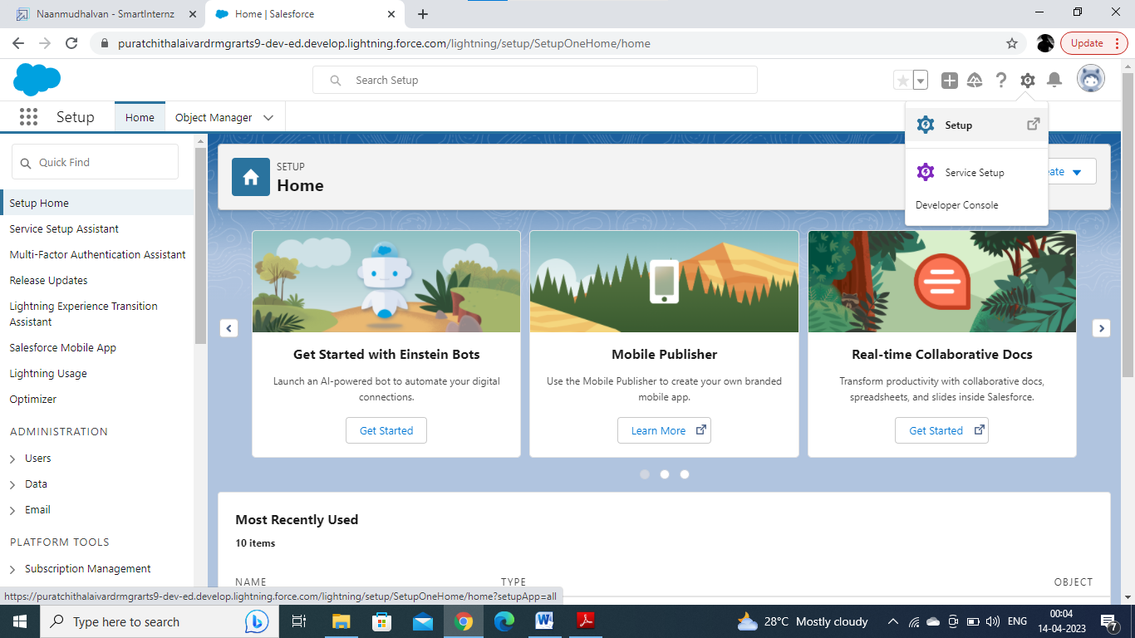

To create an object:

From the setup page → Click on Object Manager → Click on Create → Click on Custom

Object.

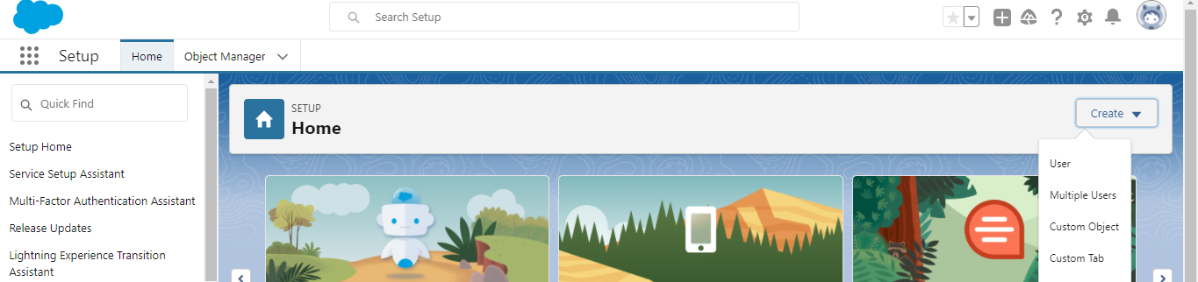

On Custom object defining page:

Enter the label name, plural label name, click on Allow reports, Allow search → Save.

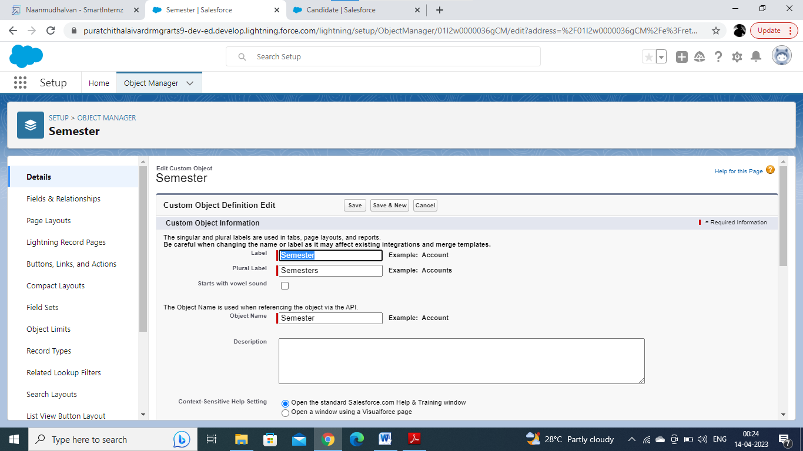

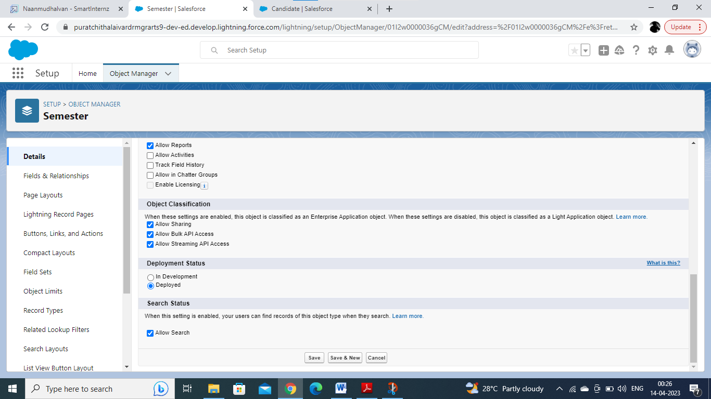

**Activity-2:**

Follow Similar steps to create Candidate,Course Details,Lecturer Details,Internal

results Objects.

**2:Fields and Relationship**

An object relationship in Salesforce is a two-way association between two objects.

Relationships are created by creating custom relationship fields on an object. This is done so

that when users view records, they can also see and access related data.

**Activity-1:**

**Creation of fields:**

**● Click the gear icon and select Setup. This launches Setup in a new tab.**

**● Click the Object Manager tab next to Home.**

**● Select Semester.**

**● Select Fields & Relationships from the left navigation, and click New**

**Now ready to make a custom field. Let's do this!**

**● Select the Text as the Data Type, then click Next.**

**● For Field Label, Enter Semester Name.**

**● Click Next, Next, then Save**

**To create fields in an object:**

**Go to setup → click on Object Manager → type object name in search bar → click on the**

**object.**

**Now click**

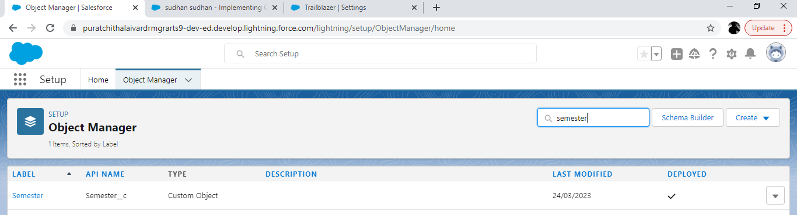

**Now click on “Fields & Relationships” → New**

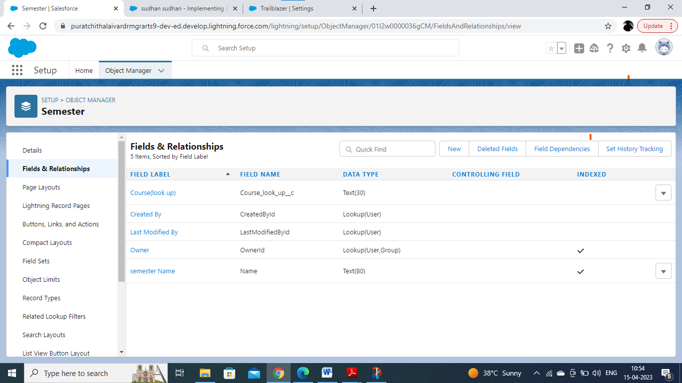

**Fill the field label name → Next → Next → Save.**

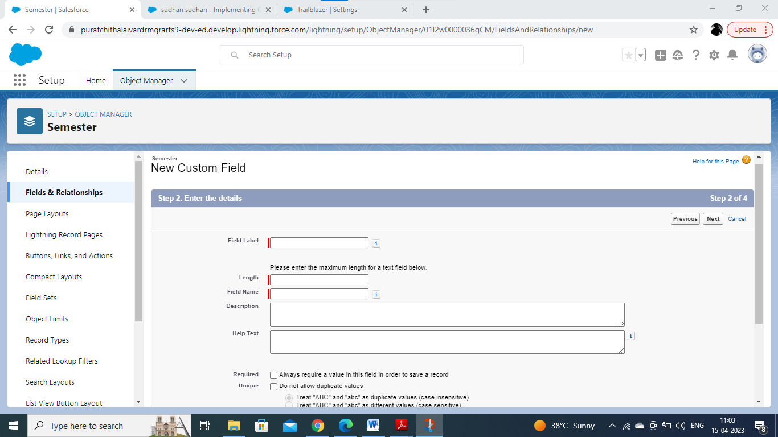

**Activity-2:**Similarly Create Following Fields according to the objects.

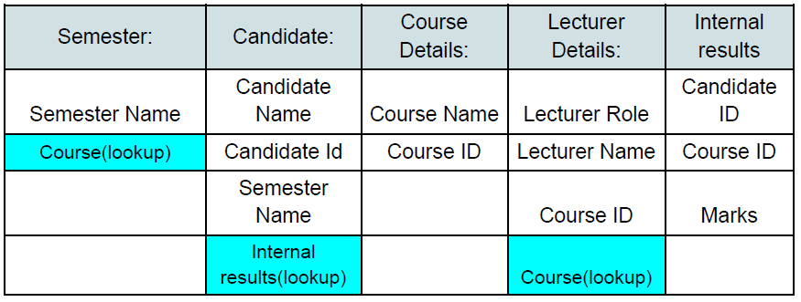

**3:Lightning App**

Apps in Salesforce are a group of tabs that help the application function by working together

as a unit. It has a name, a logo, and a particular set of tabs. The simplest app usually has just

two tabs.

**Activity-1:**

**Create the Candidate Internal Result Card app:**

**● From Setup, enter App Manager in the Quick Find and select App Manager.**

**● Click New Lightning App. Enter Candidate Internal Result Card as the App Name,**

**then click Next**

**● Under App Options, leave the default selections and click Next.**

**● Under Utility Items, leave as is and click Next.**

**● From Available Items, select Semester,Candidate,Course**

**Details,LecturerDetails,InternalResults and move them to Selected Items. Click Next.**

**● From Available Profiles, select System Administrator and move it to Selected**

**Profiles. Click Save & Finish.**

**● To verify your changes, click the App Launcher, type Candidate Internal Result Card**

**and select the Candidate Internal Result Card app.**

**To create a lightning app page:**

**Go to setup page → search “app manager” in quick find → select “app manager” → click on**

**New lightning App.**

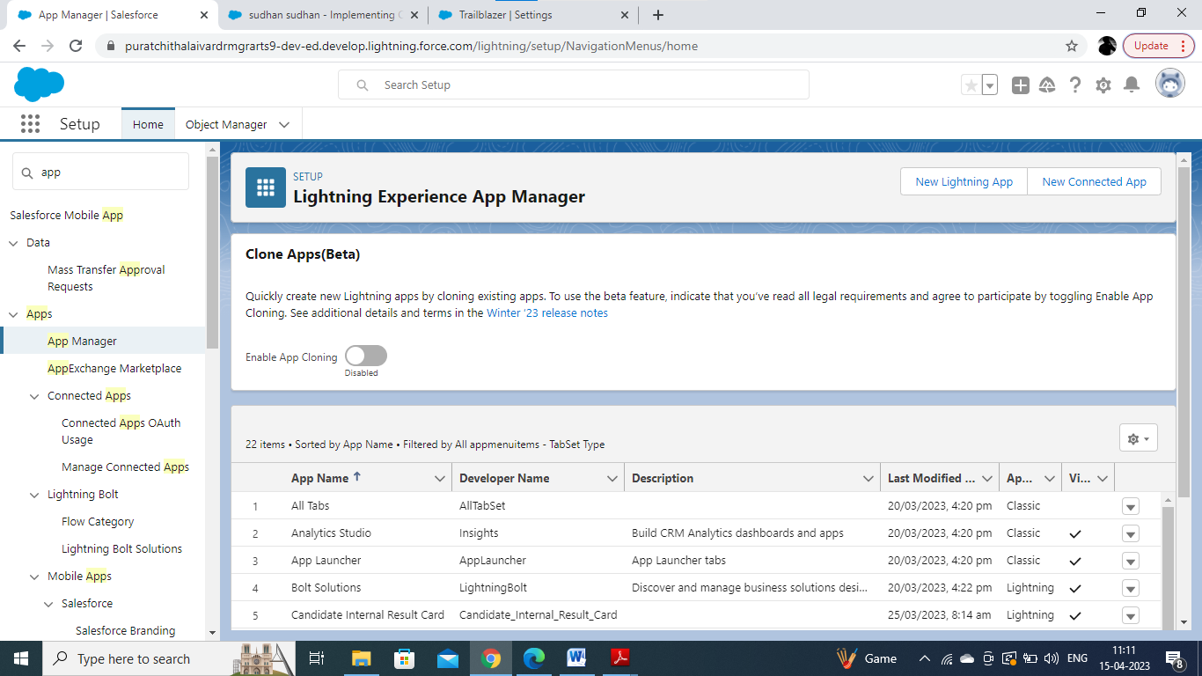

**Fill the app name in app details and branding →Next → (App option page) keep it as default**

**→ Next → (Utility Items) keep it as default → Next → (Add Navigation Items) → Next →**

**(Add User Profile) Add System Administrator → Next.**

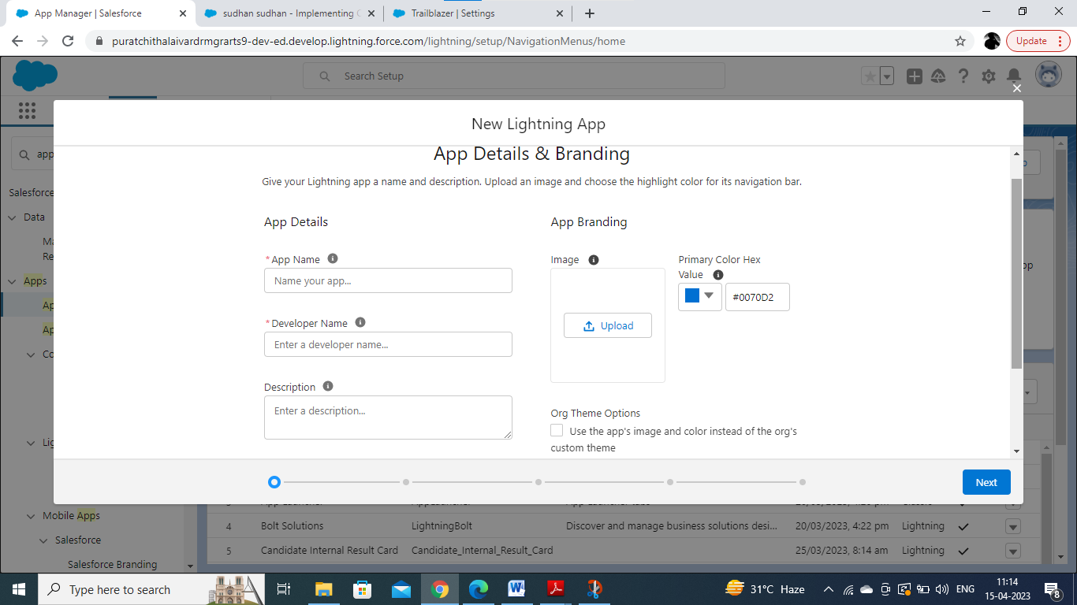

**To Add Navigation Items:**

**Select the items from the search bar and move it using the arrow button → Next.**

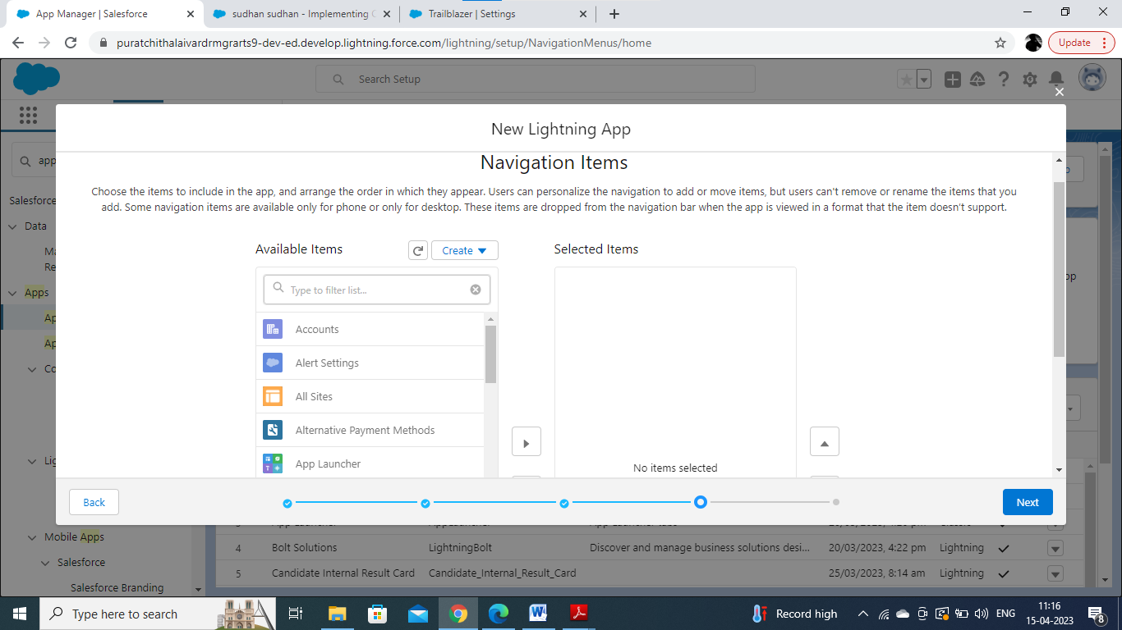

**To Add User Profiles:**

**Search profiles in search bar → click on the arrow button → save & finish.**

**4: Users**

**A user is anyone who logs in to Salesforce. Users are employees at your company,**

**such as sales reps, managers, and IT specialists, who need access to the**

**company's records. Every user in Salesforce has a user account.**

**Activity 1:**

**Creating a Users:**

1. From Setup, in the Quick Find box, enter Users, and then select Users.

2. Click New User.

3. Enter the user’s name John Martin and (Your) email address and a unique

username in the form of an email address. By default, the username is the

same as the email address.

4. Select a **Role**(none)

5. Select a User Licence As salesforce.

6. Select a profile as Salesforce User.

7. Check Generate new password and notify the user immediately to have the

user’s login name and a temporary password emailed to your email.

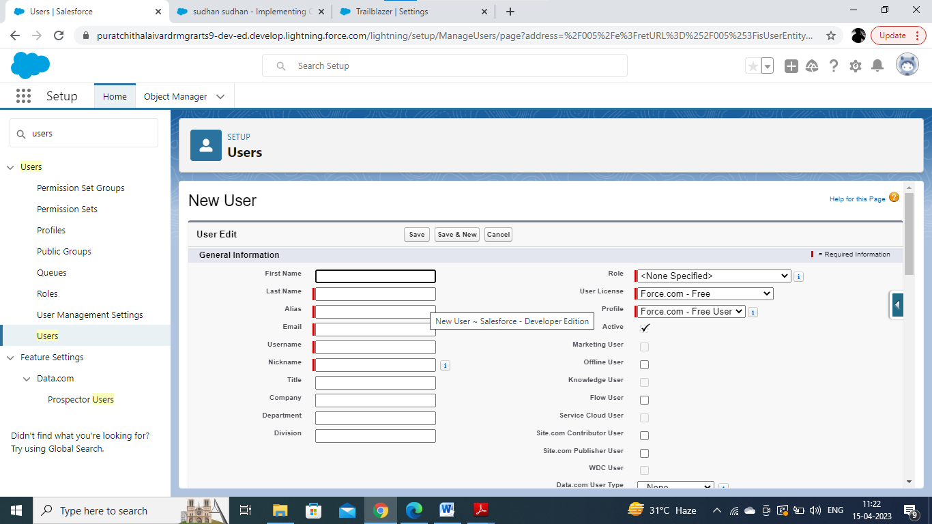

**5:Reports.**

**A report is a list of records that meet the criteria you define. It's displayed in Salesforce in**

**rows and columns, and can be filtered, grouped, or displayed in a graphical chart. Every**

**report is stored in a folder. Folders can be public, hidden, or shared, and can be set to**

**read-only or read/write.**

**Activity 1:**

**Reports and dashboards:**

**1. From the Reports tab, click New Report.**

**2. Select the report type as Candidate with candidate Marks for the report, and click**

**Create.**

**3. Customise your report, then save or run it.**

**To create a report:**

**Go to the app → click on the reports tab**

**Click New**

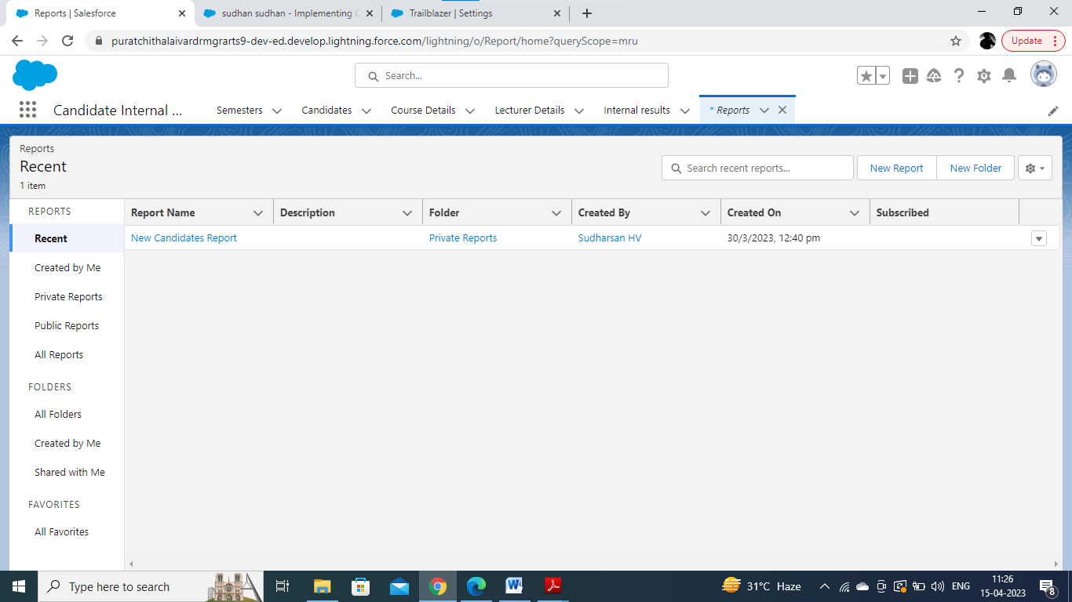

**Click New Report**

**Select report type from category or from report type panel or from search panel → click on**

**start report**

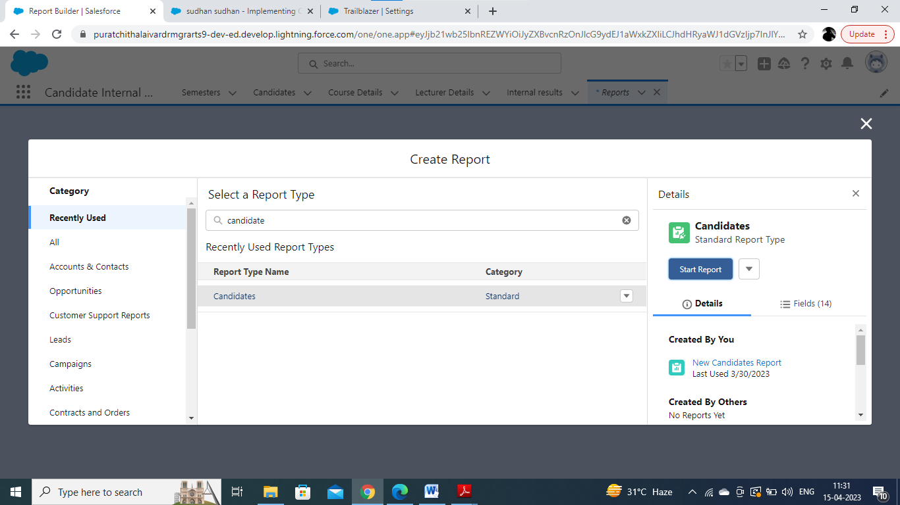

**Customize your report, then save or run it.**

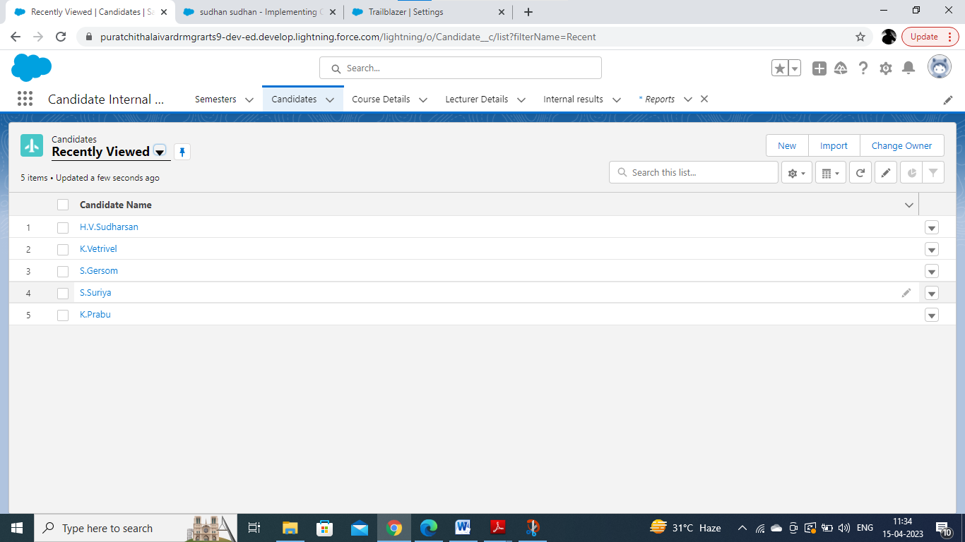

**6:Dashboards:**

**Dashboards let you curate data from reports using charts, tables, and metrics.**

**If your colleagues need more information, then they're able to view your**

**dashboard's data-supplying reports. Dashboard filters make it easy for users**

**to apply different data perspectives to a single dashboard.**

**Activity 1:**

**Create a Dashboard:**

**1. Click the Dashboards tab.**

**2. Click New Dashboard.**

**3. Name your dashboard Candidate Board . Leave all other fields as is and click**

**Create.**

**4. Click + Component.**

**5. For Report, select Candidate Marksby Stage. Click Select. ...**

**6. For Display As, select Vertical Bar Chart and click Add.**

**7. Click Save.**

**8. Click Done**

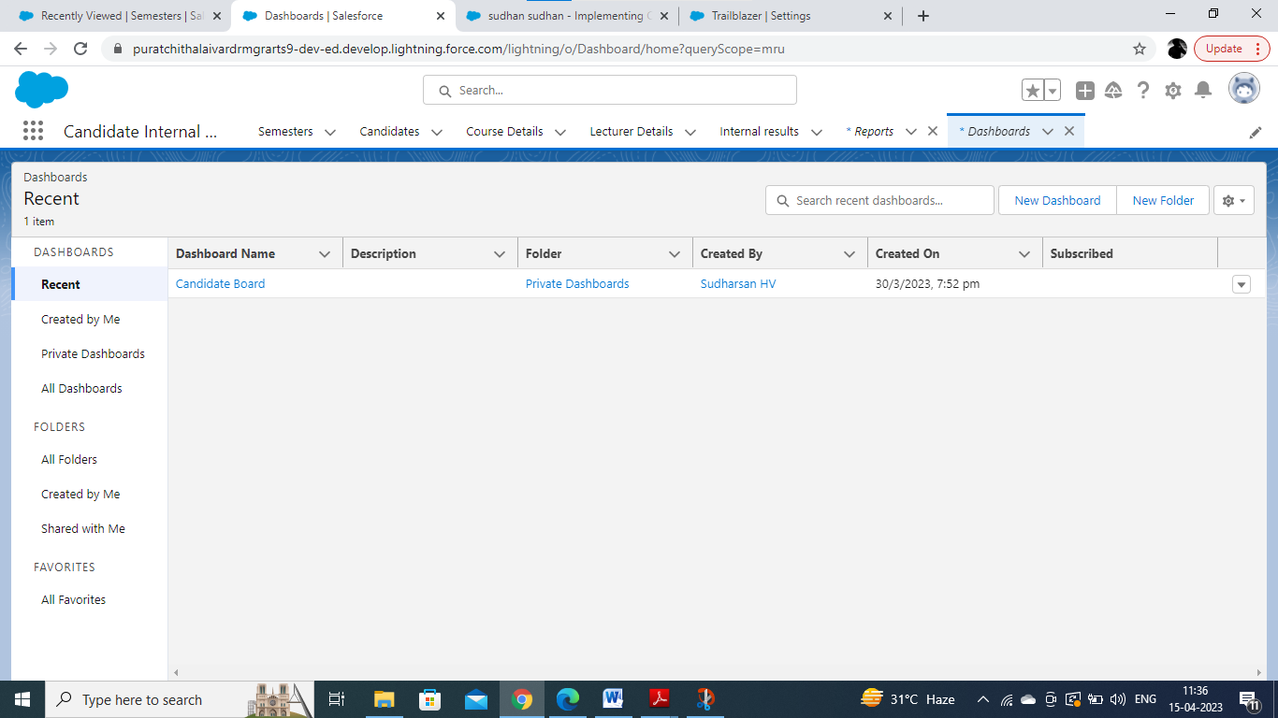

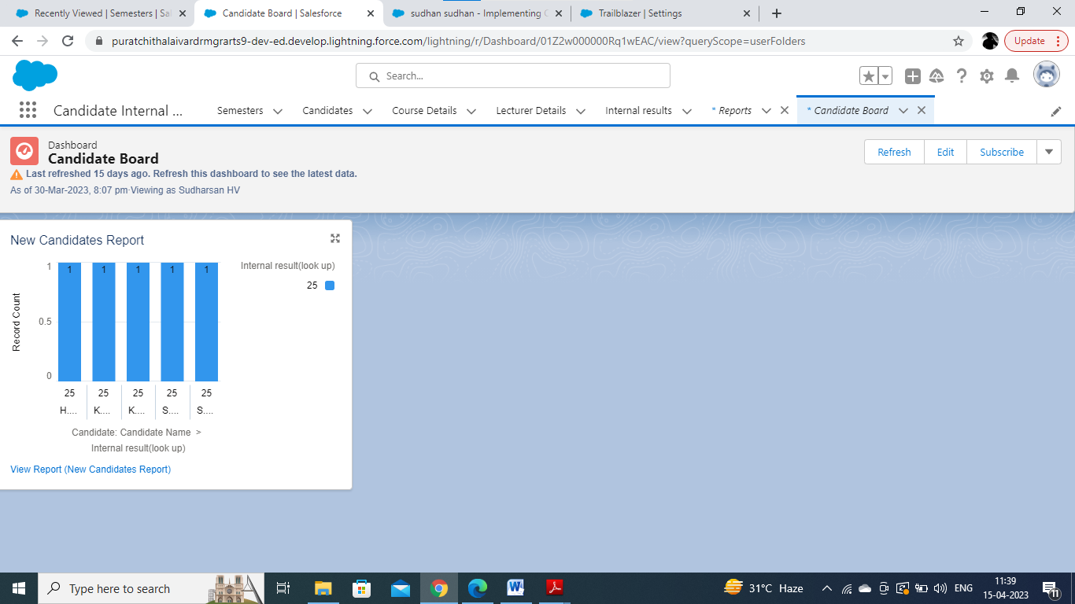

1. **.Trailhead Profile Public URL**

**Team Lead(H.V.Sudharsan)-** [**https://trailblazer.me/id/ssudhan8**](https://trailblazer.me/id/ssudhan8)

**Team Member 1(S.Suriya)-** <https://trailblazer.me/id/pheart2>

**Team Member2(S.Gersom)-**[**https://trailblazer.me/id/ggersom**](https://trailblazer.me/id/ggersom)

**Team Member3(K.Prabu)-** [**https://trailblazer.me/id/p12101**](https://trailblazer.me/id/p12101)

**Team Member4(K.Vetrivel)-** [**https://trailblazer.me/id/vevel9**](https://trailblazer.me/id/vevel9)

Project Report Template

1. **ADVANTAGES & DISADVANTAGE**

**ADVANTAGE**

**Improved Transparency: CRM tracking can provide greater transparency to candidates about their results, as they can log in and view their marks and progress throughout the recruitment process.**

**Enhanced Candidate Experience: By providing candidates with easy access to their marks and progress, CRM tracking can create a positive candidate experience, which can help to attract and retain top talent.**

**Increased Recruitment Efficiency: CRM tracking can automate many of the manual tasks associated with tracking candidate results, freeing up recruiters to focus on higher-value tasks such as screening and interviewing candidates.**

**Better Data Management: CRM tracking can help to keep candidate data organized and accessible, making it easier for recruiters to review and analyze results, identify trends, and make data-driven recruitment decisions.**

**DISADVANTAGE**

**Implementation Costs: Implementing a CRM system can be expensive, especially for small organizations with limited resources. The costs include software licenses, hardware, training, and maintenance.**

**User Adoption: The success of a CRM system depends on user adoption. If recruiters do not see the value of the system or find it difficult to use, they may resist using it, which can reduce the effectiveness of the recruitment process.**

**Data Security: CRM systems store sensitive candidate data, such as marks and results, which can be vulnerable to security breaches if not properly secured. Organizations need to ensure that they have robust security measures in place to protect candidate data.**

**Potential Bias: CRM tracking can create the potential for bias in the recruitment process, as recruiters may be influenced by candidates' marks and results when making recruitment decisions. It's important to ensure that recruitment decisions are made based on a combination of factors, including skills, experience, and fit, to avoid potential bias.**

1. **APPLICATIONS**

**1.Improved Transparency: CRM tracking can provide greater transparency to candidates about their results, as they can log in and view their marks and progress throughout the recruitment process.**

**2.Enhanced Candidate Experience: By providing candidates with easy access to their marks and progress, CRM tracking can create a positive candidate experience, which can help to attract and retain top talent.**

**3.Increased Recruitment Efficiency: CRM tracking can automate many of the manual tasks associated with tracking candidate results, freeing up recruiters to focus on higher-value tasks such as screening and interviewing candidates.**

**4.Better Data Management: CRM tracking can help to keep candidate data organized and accessible, making it easier for recruiters to review and analyze results, identify trends, and make data-driven recruitment decisions.**

**7.CONCLUSION**

**Administrator should be able to create all base data including Semester, Candidate,**

**Course and Lecturer ,Lecturer should have the ability to create Internal Results,Dean,**

**who is one of the Lecturer, should be the only one with ability to update Internal**

**Results,Re-evaluation Can be initialised by Candidate for all Internal Results.Now**

**only dean can update the marks after re- evaluation**

**Are you new to Salesforce? Not sure exactly what it is, or how to use it? Don’t know where**

**you should start on your learning journey? If you’ve answered yes to any of these questions,**

**then you’re in the right place. This module is for you.**

**Welcome to Salesforce! Salesforce is game-changing technology, with a host of**

**productivity-boosting features, that will help you sell smarter and faster. As you work toward**

**your badge for this module, we’ll take you through these features and answer the question,**

**“What is Salesforce, anyway?”**

**8. FUTURE SCOPE**

**The future scope of implementing CRM (Customer Relationship Management) for result tracking of a candidate with internal marks is promising. Here are some potential future developments:**

**Enhanced AI and Predictive Analytics: The use of AI and predictive analytics in CRM systems is likely to become more prevalent in the future. This technology can help recruiters to identify patterns and trends in candidate data, allowing them to make more informed recruitment decisions.**

**Greater Personalization: With the use of CRM, recruiters can personalize the recruitment process for each candidate, providing them with a more tailored experience. In the future, this personalization is expected to become even more sophisticated, with the use of chatbots and virtual assistants to provide real-time support to candidates.**

**Integration with Social Media: Social media is becoming an increasingly important channel for recruitment. In the future, CRM systems are likely to integrate with social media platforms, allowing recruiters to engage with candidates through social media and track their interactions with the organization.**

**Mobile-Friendly Interfaces: With the increasing use of mobile devices, CRM systems are expected to become more mobile-friendly. This will allow recruiters to access candidate data and manage the recruitment process from anywhere, at any time.**

**Improved Data Security: Data security is a growing concern for organizations. In the future, CRM systems are expected to have improved security features, such as two-factor authentication and data encryption, to protect sensitive candidate data.**

**In conclusion, the future scope of implementing CRM for result tracking of a candidate with internal marks is promising. With the advancement of technology, we can expect to see more sophisticated CRM systems that offer enhanced personalization, AI and predictive analytics, integration with social media, mobile-friendly interfaces, and improved data security. These developments are expected to improve the efficiency and effectiveness of the recruitment process, while providing a better candidate experience.**

**THANK YOU**