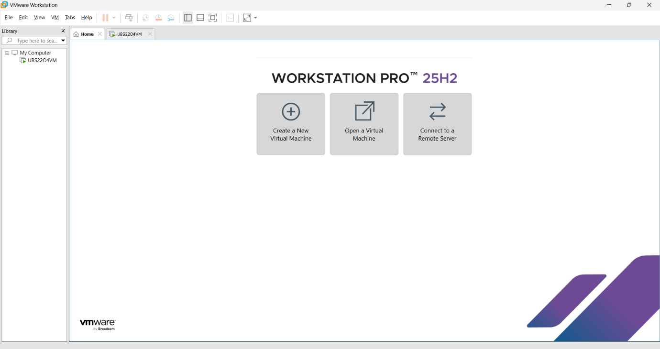
VM ware workstation installed.

Installed ubuntu linux and Using Ubuntu linux inside VM ware

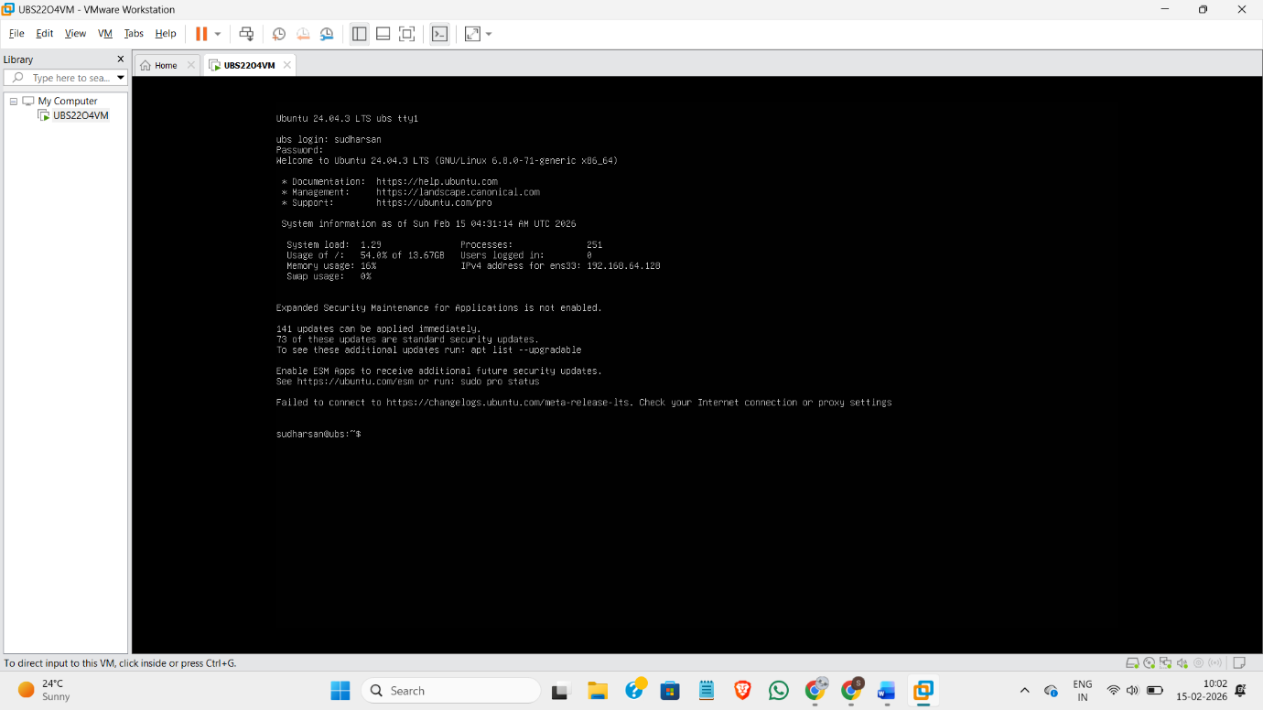

Basic commands practiced and used in the linux terminal.
