**Assignment Questions to be submitted on 27.03.2023**

1. C program to demonstrate example of structure pointer (structure with pointer)

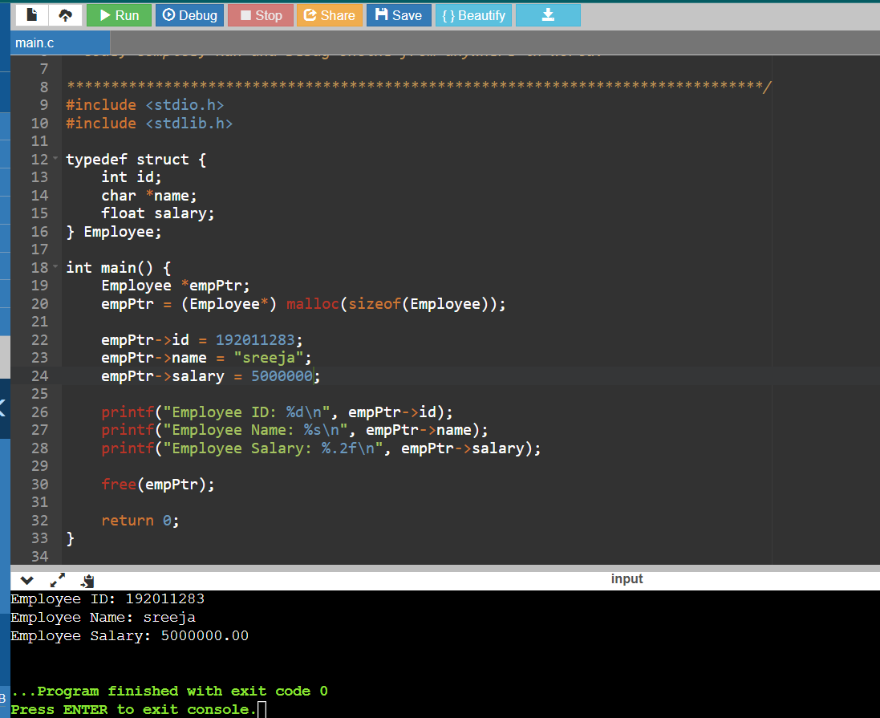

1. What will be the output of the C program?

#include<stdio.h>

int main()

{

struct simp

{

int i = 6;

char city[] = "chennai";

};

struct simp s1;

printf("%d",s1.city);

printf("%d", s1.i);

return 0;

}

The code will not compile due to syntax errors. In C language, we cannot initialize structure members inside the definition of a structure. We have to initialize structure members individually, outside the definition of the structure, after declaring a structure variable.

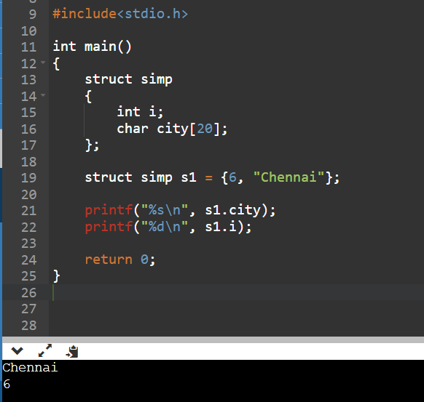

1. What will be the output of the C program?

#include<stdio.h>

int main()

{

struct zoho

{

int employees;

char comp[5];

struct founder

{

char ceo[10];

}p;

};

struct zoho zs = {4000, "zoho", "sridhar"};

printf("%d %s %s", zs.comp, zs.employees, zs.p.ceo);

return 0;

}

The code will not compile due to a syntax error.

The **zs** variable is defined as an instance of the **zoho** structure, which contains three members: an **int** **employees**, a **char** array **comp** of size 5, and another structure **founder** containing a **char** array **ceo** of size 10.

However, in the initialization of **zs**, the **comp** and **p.ceo** members are being initialized with string literals that are longer than the size of the arrays they belong to, which will cause a buffer overflow. Additionally, the order of the members being initialized is incorrect. The correct order should be **employees**, **comp**, and **p.ceo**.

Here's the corrected code

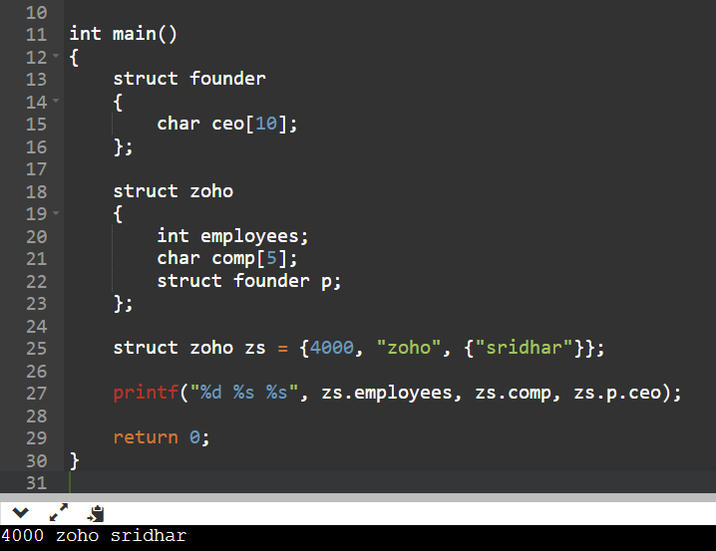

1. What will be the output of the C program?

#include<stdio.h>

int main(){

int a = 130;

char *ptr;

ptr = (char *)&a;

printf("%d ",*ptr);

return 0;

}

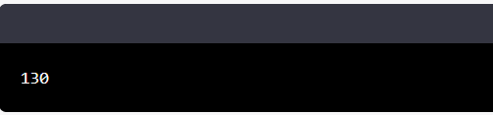

1. What will be the output of the C program?

#include<stdio.h>

#include<string.h>

int main(){

char *ptr = "hello";

char a[22];

strcpy(a, "world");

printf("\n%s %s",ptr, a);

return 0;

}

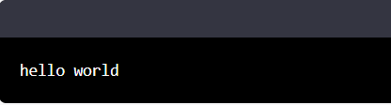

1. Write a C program to accept details of 'n' employee (eno, ename, salary) and display the details of employee having highest salary. Use array of structure.

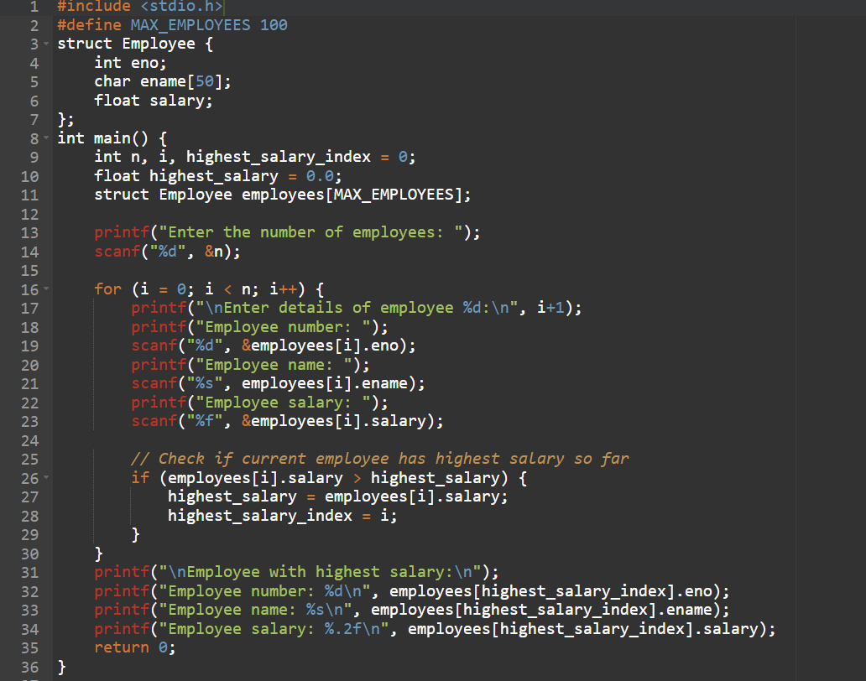

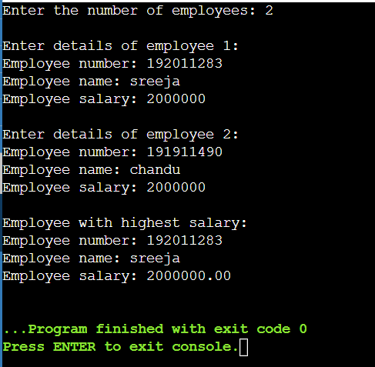

1. Write and execute a program to access the structure members using the pointer and arrow (->) operator in C.

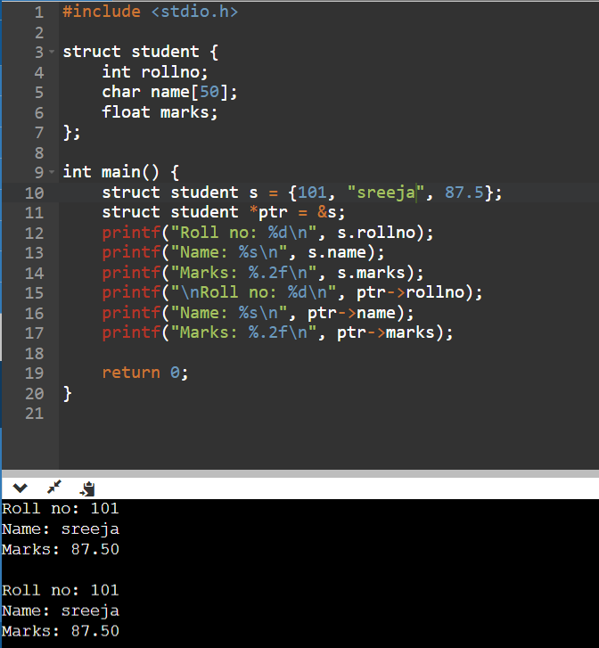

1. Mr. Johnson would like to know how many As, Bs, Cs, Ds, and Fs his students received on a test. He has n students who took the test. He would like to enter the student number and the number grade for the test for each student using structure. Develop the solution to print out each student’s student number, number grade and the total number of As, Bs, Cs, Ds, and Fs. His grading scale is as follows: 90–100 is an A, 78–89 is a B, 65– 77 is a C, 50–64 is a D, and below 50 is an F.

Sample Input :

Enter No.Students: 1

Enter student 1 Number , Grade : 2001, A

Sample Output:

Student 1 details:

Number : 2001

Grade : A

Total no. A: 1, B:0, c=0, D=0, F=0

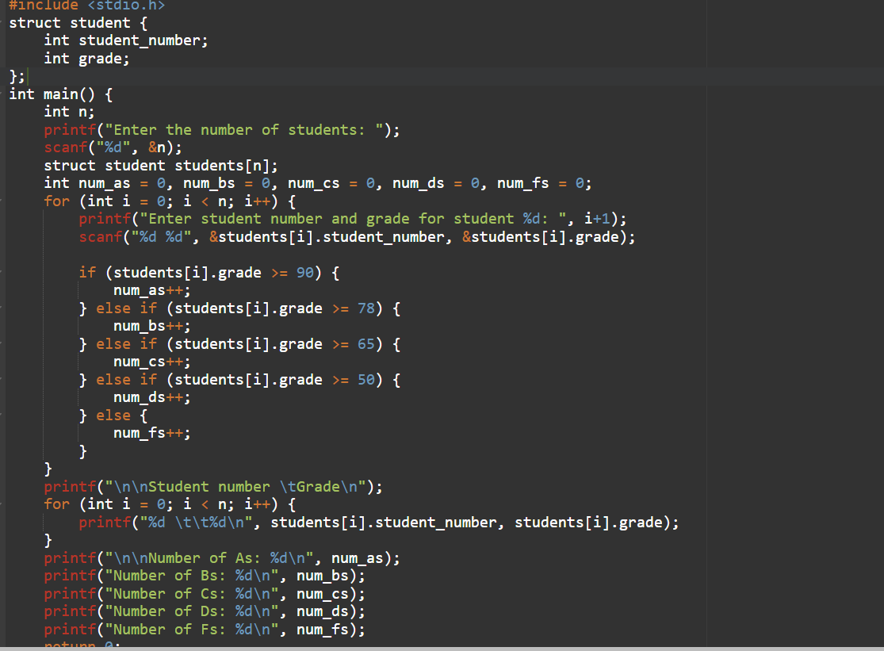

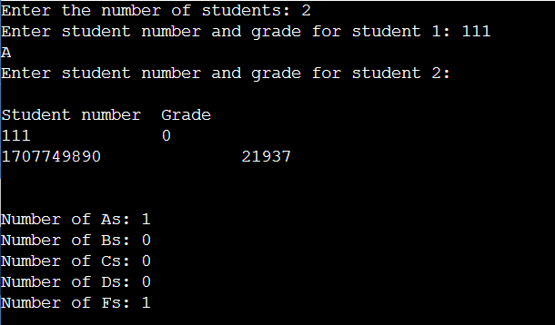

1. Write and execute C program to find out highest common factor ( HCF ) or greatest common factor of two input numbers using functions.

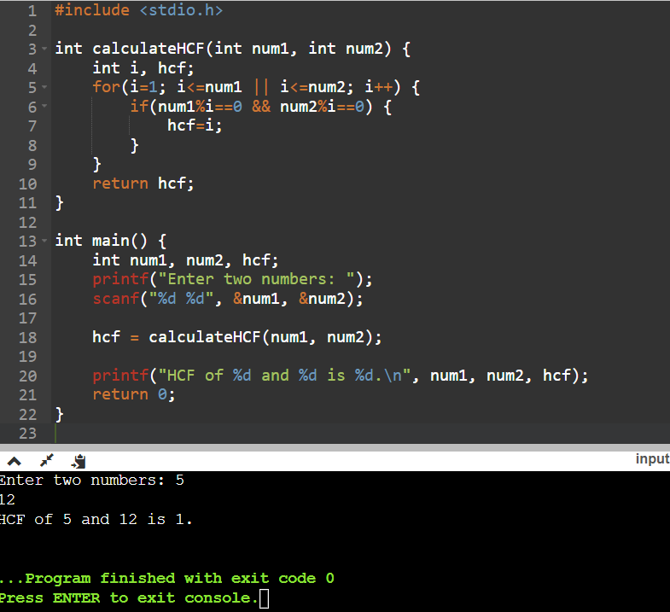

1. Write and execute C program that converts Lower case letter to Upper case letter.

