**VIEW, INDEX, SEQUENCE**

**AIM:**

To create view, index and sequence on the given relation.

1. Create a view with name ‘std_view’ using STUDENT table which holds the value of register number, name and DOB of student.

mysql> create view stu_view as select regno,name and dob from student;

Query OK, 0 rows affected (0.13 sec)

mysql> select* from stu_view;

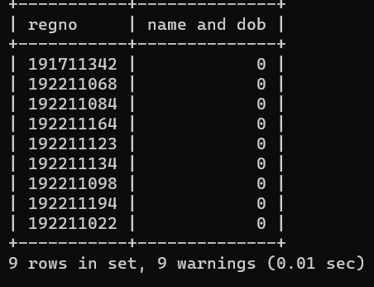

mysql> create index regno on student(regno);

Query OK, 0 rows affected (0.15 sec)