AI-POWERED MULTI-AGENT FRAMEWORK FOR CLAIM VERIFICATION AND AUTOMATED REPORT GENERATION
A PROJECT REPORT
Submitted by
SUDHARSAN. [INITIAL]
KANISHKA. K
MAMTHA. S
VIGNESH. A
in partial fulfillment for the award of the degree
of
BACHELOR OF TECHNOLOGY
IN
INFORMATION TECHNOLOGY
ADHI COLLEGE OF ENGINEERING AND TECHNOLOGY, KANCHEEPURAM
ANNA UNIVERSITY : CHENNAI 600 025
[MONTH YEAR]

AI-POWERED MULTI-AGENT FRAMEWORK FOR CLAIM VERIFICATION AND AUTOMATED REPORT GENERATION
A PROJECT REPORT
Submitted by
SUDHARSAN. [INITIAL]
KANISHKA. K
MAMTHA. S
VIGNESH. A
in partial fulfillment for the award of the degree
of
BACHELOR OF TECHNOLOGY
IN
INFORMATION TECHNOLOGY
ADHI COLLEGE OF ENGINEERING AND TECHNOLOGY, KANCHEEPURAM
ANNA UNIVERSITY : CHENNAI 600 025
[MONTH YEAR]
ANNA UNIVERSITY : CHENNAI 600 025
BONAFIDE CERTIFICATE
Certified that this project report “AI-POWERED MULTI-AGENT FRAMEWORK FOR CLAIM VERIFICATION AND AUTOMATED REPORT GENERATION” is the bonafide work of “SUDHARSAN. [INITIAL], KANISHKA. K, MAMTHA. S and VIGNESH. A” who carried out the project work under my supervision.

SIGNATURE  Mrs. K. BANUPRIYA  HEAD OF THE DEPARTMENT  Department of Information Technology  Adhi College of Engineering and Technology, No. 6, Munu Adhi Nagar, Sankarapuram, Puliambakkam Post, Near Wallajabad, Kancheepuram - 631 605 | SIGNATURE  Mrs. K. BANUPRIYA  SUPERVISOR  [ACADEMIC DESIGNATION]  Department of Information Technology  Adhi College of Engineering and Technology, No. 6, Munu Adhi Nagar, Sankarapuram, Puliambakkam Post, Near Wallajabad, Kancheepuram - 631 605
ABSTRACT
The rapid spread of misinformation online has outpaced manual fact-checking. This project presents the Claim Research and Detection Framework (CRDF), a multi-agent pipeline of 15 specialised AI agents that verifies factual claims and explains its conclusions. Built with the CrewAI orchestration framework, Gemini and Groq language models and web-search evidence, CRDF extends the four-agent design of Trinh et al. (2025). Each agent has a single responsibility and exchanges structured JSON with the others. The pipeline normalises the input, decomposes it into sub-claims, collects evidence, scores source credibility from 0.0 to 1.0 with a 0.40 cap for unfamiliar sources, checks for contradictions, computes a confidence score from 0 to 100, assesses risk and severity, assigns a verdict and writes an evidence-attributed report. Agents were tested individually and then as a pipeline. Testing corrected three prompt-level and five integration-level defects, and a retry layer was added so that the pipeline survives free-tier rate limits. The system is being delivered as a web application. Real multimodal file testing and benchmark evaluation remain future work.
TABLE OF CONTENTS
CHAPTER NO. TITLE PAGE NO.
ABSTRACT iii
LIST OF TABLES vi
LIST OF FIGURES vii
LIST OF SYMBOLS, ABBREVIATIONS AND NOMENCLATURE viii

1. INTRODUCTION 1
1.1 GENERAL 1
1.2 PROBLEM STATEMENT 1
1.3 EXISTING SYSTEMS 2
1.4 PROPOSED SYSTEM 2
1.5 OBJECTIVES 2
1.6 SCOPE OF THE PROJECT 2
1.7 ORGANISATION OF THE REPORT 3
2. LITERATURE REVIEW 4
2.1 GENERAL 4
2.2 MULTI-AGENT SYSTEMS 4
2.2.1 Four-Agent System 4
2.2.2 Confidence-Weighted Voting 4
2.3 RESEARCH GAP 4
3. SYSTEM DESIGN 6
3.1 GENERAL 6
3.2 DESIGN PRINCIPLES 6
3.3 LOGICAL ARCHITECTURE 6
3.4 AGENT DESCRIPTIONS 7
3.4.1 User Interaction Agent 7
3.4.2 Authentication & Session Agent 7
3.4.3 Source Credibility Agent 8
3.4.4 Confidence Scoring Agent 8
3.4.5 Risk and Severity Agent 8
3.4.6 Final Decision Agent 8
3.4.7 Quality Verification Agent 8
3.4.8 Report Writing Agent 8
3.5 DATA CONTRACTS 8
3.6 SCORING PARAMETERS 9
4. IMPLEMENTATION 10
4.1 GENERAL 10
4.2 TECHNOLOGY STACK 10
4.3 PIPELINE EXECUTION 10
4.4 RATE-LIMIT RELIABILITY 10
4.5 CONCURRENT MULTIMODAL CHECKS 11
4.6 REPORT GENERATION 11
4.7 WEB APPLICATION 11
5. TESTING AND RESULTS 12
5.1 GENERAL 12
5.2 TESTING METHODOLOGY 12
5.3 DEFECTS AND CORRECTIONS 12
5.3.1 Prompt-level defects 12
5.3.2 Integration-level defects 12
5.4 USER INTERACTION AGENT TEST 13
5.5 END-TO-END VERIFICATION RUN 13
5.6 LIMITATIONS 13
6. CONCLUSION AND FUTURE WORK 14
6.1 CONCLUSION 14
6.2 RESEARCH CONTRIBUTIONS 14
6.3 FUTURE WORK 14
APPENDIX 1 LAYOUT OF THE CRDF VERIFICATION REPORT 16
APPENDIX 2 OUTPUT CONTRACT OF THE USER INTERACTION AGENT 17
REFERENCES 18
LIST OF TABLES
TABLE NO. TITLE PAGE NO.
3.1 Scoring and classification parameters of CRDF 9
4.1 Rate-limit parameters of the pipeline 11
5.1 Defects identified and corrected during testing 13
LIST OF FIGURES
FIGURE NO. TITLE PAGE NO.
3.1 Logical architecture of the CRDF pipeline 7
4.1 Retry with backoff at the LLM call layer 11
LIST OF SYMBOLS, ABBREVIATIONS AND NOMENCLATURE
AI Artificial Intelligence
API Application Programming Interface
CRDF Claim Research and Detection Framework
JSON JavaScript Object Notation
LLM Large Language Model
OCR Optical Character Recognition
RAG Retrieval-Augmented Generation
Sub-claim An individually verifiable part of a submitted claim
Verdict The classification assigned to a sub-claim after verification
Confidence score A score from 0 to 100 formed by adding three components
Credibility score A score from 0.0 to 1.0 given to an evidence source

CHAPTER 1

INTRODUCTION

1.1 GENERAL
The rapid circulation of information through social media, messaging platforms and news websites makes it easy for false or misleading claims to reach large audiences within a short time. Manual fact-checking by trained journalists and researchers is credible, but it cannot keep pace with the volume and speed at which claims appear online. Advances in Large Language Models (LLMs) have made it possible to automate parts of the verification process, such as breaking a statement into checkable parts, searching for supporting or opposing evidence, and writing an explanation of the conclusion.
A single LLM prompt that simply asks whether a claim is true tends to give answers that cannot be audited. Multi-agent systems address this by dividing the task among specialised agents, each with a narrow responsibility and a defined input and output. This project presents the Claim Research and Detection Framework (CRDF), a pipeline of 15 cooperating AI agents that accepts a claim, gathers and evaluates evidence, assigns a verdict with a confidence score and produces a structured verification report. CRDF was developed by Team Vault X as a capstone project in the Department of Information Technology, Adhi College of Engineering and Technology.

1.2 PROBLEM STATEMENT
Automated fact-checking requires more than a true or false label. A usable system must separate claims that can be verified from questions, opinions and ambiguous statements; handle inputs made of several parts that may differ in truth; weigh evidence by the credibility of its source; detect contradictions between sources; state how confident it is and why; avoid inventing facts, scores or sources; and remain usable within the request limits of freely available LLM services. The problem addressed in this project is the design, implementation and testing of a multi-agent pipeline that meets these requirements and presents its result as a clear report to an end user.

1.3 EXISTING SYSTEMS
Traditional fact-checking is performed by human experts. It is credible, but it struggles with the volume and velocity of online content. Automated systems powered by LLMs have been introduced to address this, but existing automated approaches face limitations in handling complex claims, ensuring source credibility and maintaining transparency (Trinh, Nguyen and Hy, 2025). A single prompt to an LLM does not separate these concerns and gives conclusions that are difficult to audit.

1.4 PROPOSED SYSTEM
The proposed system, CRDF, divides verification among 15 specialised agents that exchange structured JSON. It separates claim handling, evidence collection, source credibility scoring, contradiction checking, confidence scoring, risk assessment, final decision, quality verification and report writing into distinct agents, so that each step can be tested and inspected. Its output is a structured, evidence-attributed verification report.

1.5 OBJECTIVES
The objectives of the project are:
(a) to design a 15-agent pipeline in which each agent has a single responsibility and communicates through structured JSON;
(b) to score every evidence source for credibility and to combine credibility, absence of contradiction and cross-verification into one confidence score;
(c) to classify each sub-claim into a verdict category and to attach a risk and severity assessment;
(d) to produce a structured verification report in which every statement is attributed to evidence;
(e) to keep the pipeline reliable under free-tier API request limits; and
(f) to deliver the system as a web application for end users and not only as a command-line tool.

1.6 SCOPE OF THE PROJECT
Text claims are verified by the full text pipeline. Image, video and document inputs are accepted and examined by separate multimodal checks. In the present version, the findings of the multimodal checks are not passed into the text pipeline (Section 5.6). Evidence is gathered from web search results available at the time of a run, and the language models used are Gemini and Groq. CRDF is a decision-support tool: its reports show the evidence and reasoning behind each verdict so that a reader can judge them, and they are not an authority in themselves.

1.7 ORGANISATION OF THE REPORT
Chapter 2 reviews the related work on multi-agent fact-checking. Chapter 3 describes the design of the CRDF pipeline and its agents. Chapter 4 explains the implementation, including the handling of API rate limits. Chapter 5 reports the testing carried out, the defects corrected and the limitations that remain. Chapter 6 concludes the report and lists future work. The appendices give the layout of the verification report and the output contract of the User Interaction Agent.
CHAPTER 2

LITERATURE REVIEW

2.1 GENERAL
Research on automated fact-checking spans supervised truthfulness classification, evidence retrieval, natural language inference, explainable AI and, more recently, LLM-based reasoning systems. This chapter reviews the work that most directly shaped the design of CRDF.

2.2 MULTI-AGENT SYSTEMS

2.2.1 Four-Agent System
Trinh, Nguyen and Hy (2025) propose a multi-agent system for automated fact-checking that comprises four specialised agents: an Input Ingestion Agent for claim decomposition, a Query Generation Agent for formulating targeted sub-queries, an Evidence Retrieval Agent for sourcing credible evidence, and a Verdict Prediction Agent that synthesises veracity judgments with human-interpretable explanations. The system was evaluated on the FEVEROUS, HOVER and SciFact benchmark datasets, where the authors report a 12.3% improvement in Macro F1-score over baseline methods. This paper is the grounding base paper of the present project.

2.2.2 Confidence-Weighted Voting
Araya and Liao (2025) present FinVet, a multi-agent framework for financial misinformation detection. FinVet integrates two Retrieval-Augmented Generation (RAG) pipelines with external fact-checking through a confidence-weighted voting mechanism, and uses an LLM-based fallback when direct evidence is unavailable. The work shows that confidence-based aggregation of several verification components is an established design choice in multi-agent verification.

2.3 RESEARCH GAP
The four-agent design of Trinh et al. (2025) covers claim decomposition, query generation, evidence retrieval and verdict prediction. CRDF keeps this overall flow and extends it from four agents to fifteen. The additional agents handle input normalisation and non-claim detection, session validation, source credibility scoring with an explicit cap for unfamiliar sources, contradiction and cross-verification checks, confidence scoring, risk and severity assessment, quality verification of the outputs and structured report writing. These additions are intended to make every verdict auditable.
No benchmark evaluation was performed in this project. The contribution of CRDF is therefore architectural, and no claim is made that it is more accurate than the systems reviewed above.
CHAPTER 3

SYSTEM DESIGN

3.1 GENERAL
This chapter describes the design principles of CRDF, its logical architecture, the agents whose behaviour was specified and tested individually, the structure of the data they exchange, and the scoring parameters of the pipeline.

3.2 DESIGN PRINCIPLES
The pipeline follows four design principles. First, each agent has a single responsibility, which keeps its prompt short and makes it testable in isolation. Second, agents communicate through structured JSON contracts, so that the output of one agent can be checked before the next agent uses it. Third, a value computed by an upstream agent is passed through unchanged by downstream agents; for example, the Final Decision Agent must pass through the confidence score and must not compute a second one. Fourth, when information is missing, the pipeline states this plainly and does not invent a figure, a source or a date.

3.3 LOGICAL ARCHITECTURE
Figure 3.1 shows the logical architecture of CRDF. The agents are grouped by function into six stages. The stages are logical groups and are not a one-to-one description of the order in which individual tasks execute. The multimodal checks for image, video and document inputs form a separate track that runs concurrently with the text pipeline.
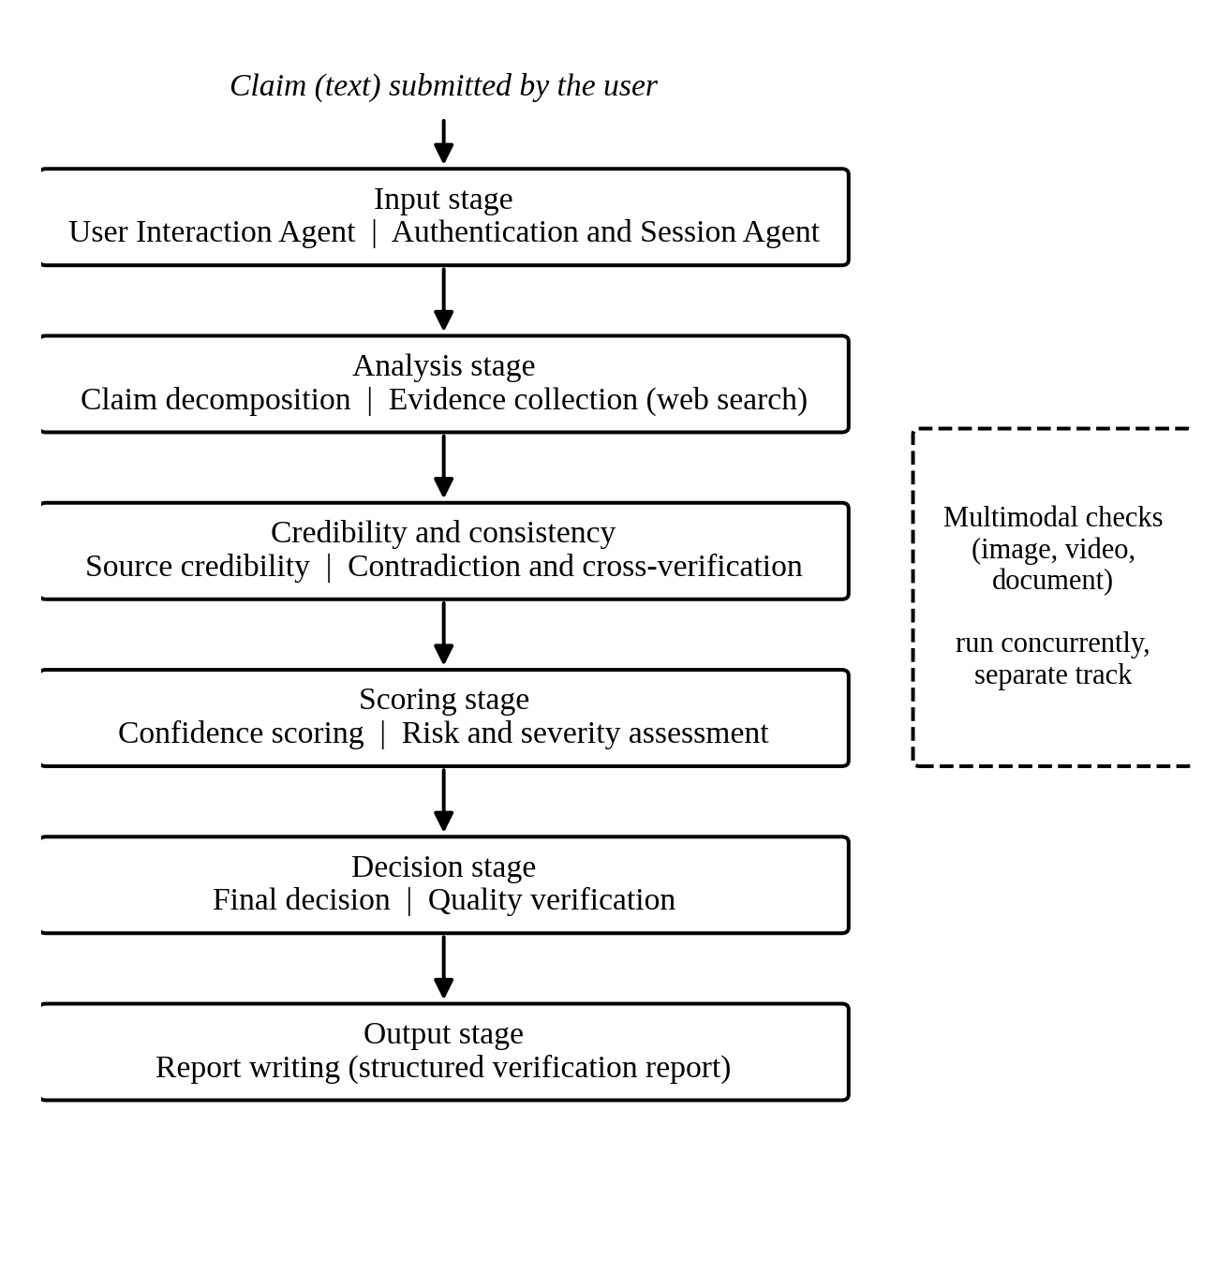
Figure 3.1 Logical architecture of the CRDF pipeline

3.4 AGENT DESCRIPTIONS
The pipeline consists of 15 agents in total. The agents below are those whose specifications were tested individually; the remaining agents follow the same contract-driven design.

3.4.1 User Interaction Agent
This agent is the entry point. It cleans and standardises the raw input, detects inputs that are not verifiable factual claims (such as questions and opinions), flags inputs that lack sufficient context, and detects inputs that contain several unrelated claims. It returns a strict JSON object with three fields, described in Appendix 2.

3.4.2 Authentication & Session Agent
This agent validates the session under which a request is made, keeps an audit trail and flags abusive use.

3.4.3 Source Credibility Agent
This agent scores each evidence source from 0.0 to 1.0. A source that the agent does not recognise is subject to a hard cap of 0.40, and corroboration by other sources cannot lift an unfamiliar source above this cap.

3.4.4 Confidence Scoring Agent
This agent aggregates three factors with weights: source credibility, absence of contradiction and cross-verification. The sum of the three components gives the confidence score of a sub-claim on a scale of 0 to 100.

3.4.5 Risk and Severity Agent
This agent classifies the potential harm of a claim into three severity tiers and returns its result as JSON.

3.4.6 Final Decision Agent
This agent assigns the final classification of each sub-claim by applying priority-ordered rules. It passes the upstream confidence score through without change.

3.4.7 Quality Verification Agent
This agent reviews the outputs of other agents in iterative JSON-based review cycles. It flags statistics that are not supported by evidence, and it accepts the legitimate verdict labels produced upstream so that revision cycles terminate.

3.4.8 Report Writing Agent
This agent writes the structured verification report with strict attribution of each statement to evidence. The layout of the report is given in Appendix 1.

3.5 DATA CONTRACTS
Besides the text of the report, the pipeline produces structured task outputs: the sub-claims, the evidence collected for each, the credibility score of each source, the contradictions found, the verdicts, the confidence scores and the final verdicts. These structured outputs are kept so that any chart or table can be built from the numbers the pipeline actually produced and not from a parsed description. Every sub-claim receives one of four verdict categories: True, False, Misleading or Partially True, and Unverifiable or Requires More Evidence. If the sub-claims of one input have different verdicts, each is reported separately and no single combined verdict is forced.

3.6 SCORING PARAMETERS
Table 3.1 lists the numerical parameters of the scoring and classification scheme.
Table 3.1 Scoring and classification parameters of CRDF
Parameter | Value
Number of agents in the pipeline | 15
Source credibility score range | 0.0 to 1.0
Credibility cap for an unfamiliar source | 0.40
Confidence score range | 0 to 100
Components of the confidence score | 3
Verdict categories | 4
Severity tiers | 3

CHAPTER 4

IMPLEMENTATION

4.1 GENERAL
This chapter describes the technology used to implement CRDF, how a run is started, how the pipeline was made reliable under API rate limits, and how the final deliverable is presented to users.

4.2 TECHNOLOGY STACK
The agents are orchestrated with CrewAI. Each agent task is defined in a crew configuration file, and a run is started from a Python script. Gemini and Groq serve as the LLM backends, and the Serper API provides the web search used for evidence collection. The end-user interface is a web frontend through which a claim and optional image, video and document inputs can be submitted.

4.3 PIPELINE EXECUTION
A run is started from the command line with the claim text, optional image, video and document inputs, and a session identifier. When no multimodal input is supplied, the corresponding option is set to none and only the text pipeline runs.

4.4 RATE-LIMIT RELIABILITY
The free tier of the Gemini API allows 15 requests per minute in total, and a complete CRDF run issues about 16 LLM calls. A run can therefore exceed the quota even when concurrency is reduced. When this happens the service returns a 429 RESOURCE_EXHAUSTED error, and a run was observed to fail at the report-writing task as a result.
To make the pipeline recover instead of failing, retry with backoff was added at the LLM call layer. When a call fails with a rate-limit or transient error, the layer waits for the retry delay and tries again, up to three times (Figure 4.1). The relevant limits are listed in Table 4.1. Verification of this fix by repeated runs of the same claim is part of the end-to-end test described in Section 5.5.
Table 4.1 Rate-limit parameters of the pipeline
Parameter | Value
Free-tier quota (requests per minute) | 15
Approximate LLM calls in one complete run | 16
Maximum retries after a rate-limit error | 3

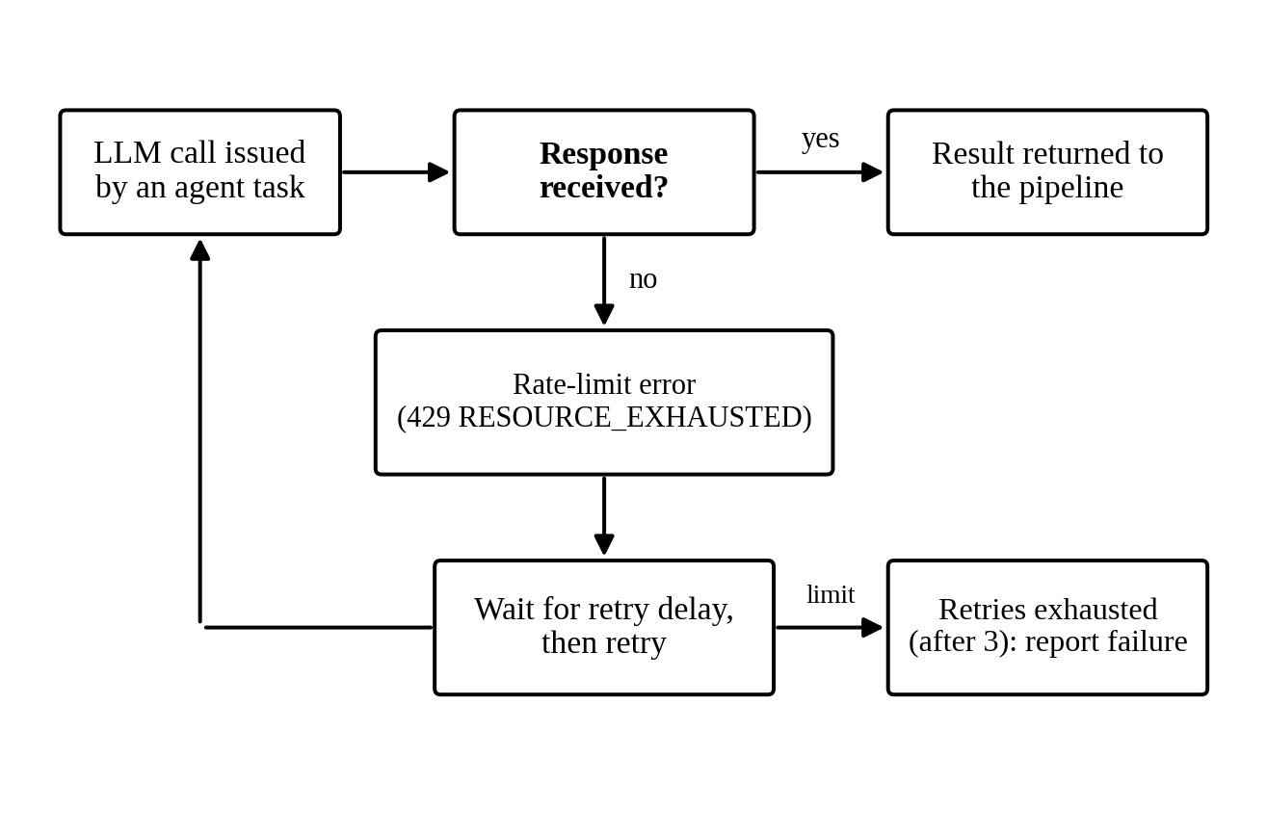
Figure 4.1 Retry with backoff at the LLM call layer

4.5 CONCURRENT MULTIMODAL CHECKS
The image, video and document checks do not depend on any other task in the pipeline. They originally ran last and one after another. They now run concurrently in a thread pool, which reduces the total running time of a run that includes multimodal inputs.

4.6 REPORT GENERATION
The Report Writing Agent produces the verification report, whose layout is given in Appendix 1. For presentation, the verdict of each sub-claim is shown in a colour-coded banner: green for True, red for False, amber for Misleading or Partially True, and grey for Unverifiable or Requires More Evidence. The figures in this report are drawn in black and white to suit the format of the university.

4.7 WEB APPLICATION
The final deliverable of the project is a web application for end users. The frontend offers a claim input and drop zones for image, video and document files. An earlier frontend that handled only OCR through a Node proxy was merged into this single frontend.
CHAPTER 5

TESTING AND RESULTS

5.1 GENERAL
This chapter describes how CRDF was tested, the defects that testing revealed and the changes made to correct them, and the limitations that remain.

5.2 TESTING METHODOLOGY
Testing was carried out in three phases. In the first phase, in late July 2026, individual agents were tested in isolation to validate their prompt logic and the data contracts between them. The agents tested were the Quality Verification Agent, the Final Decision Agent, the Source Credibility Agent, the Authentication and Session Agent, the Report Writing Agent, the Confidence Scoring Agent and the Risk and Severity Agent.
In the second phase, in August 2026, the agent prompts were tested on three platforms: Claude, ChatGPT and Google AI Studio. In the third phase the assembled pipeline was run end to end. A standard test claim was used for the reliability runs: “The iPhone was the first touchscreen smartphone, launched by Steve Jobs in 2005.”

5.3 DEFECTS AND CORRECTIONS

5.3.1 Prompt-level defects
Three prompt-level defects were found and corrected. The Source Credibility Agent allowed corroboration to lift an unfamiliar source above the 0.40 cap; the cap now holds. The Final Decision Agent invented a second confidence score; it now passes through the upstream value. The Quality Verification Agent rejected legitimate upstream verdict labels, which would have caused endless revision cycles; it now accepts them.

5.3.2 Integration-level defects
Five defects were found and corrected when the agents were assembled into a pipeline: the gating logic of Agent 2, the confidence arithmetic of Agent 8, the report format of Agent 10, a Report ID in which the date was generated by the model instead of taken from the system, and a parsing problem in the environment configuration file. In addition, the rate-limit failure described in Section 4.4 was addressed by the retry layer. Table 5.1 summarises the corrections.
Table 5.1 Defects identified and corrected during testing
Category | Number corrected
Prompt-level defects | 3
Integration-level defects | 5
Rate-limit failure (retry layer added) | 1

5.4 USER INTERACTION AGENT TEST
A Tamil-language input was submitted to the User Interaction Agent. The agent classified it as a question and not as a verifiable claim and returned ready_for_processing as false, which is the intended behaviour. This test shows that input in languages other than English must be considered by the pipeline; testing with more languages, edge cases and ambiguous claims is still to be done.

5.5 END-TO-END VERIFICATION RUN
The standard test claim of Section 5.2 is used for the end-to-end run. The values to be reported from the run output are the number of sub-claims, the verdict and confidence score of each, and whether three consecutive runs completed without a rate-limit failure.
[INSERT FROM THE PROJECT OUTPUT FOLDER (combined_result.json): number of sub-claims, verdict and confidence score of each sub-claim, and the result of the three consecutive runs. Do not estimate these values.]

5.6 LIMITATIONS
The following limitations apply to the present version of CRDF:
(a) the findings of the multimodal checks do not reach the text pipeline;
(b) real multimodal file testing through a separate test script was set up but had not been executed at the time of the last record;
(c) throughput is bounded by free-tier API quotas;
(d) no benchmark evaluation was carried out, so the accuracy of CRDF is not quantified; and
(e) evidence is limited to the web search results available when a run is made.
CHAPTER 6

CONCLUSION AND FUTURE WORK

6.1 CONCLUSION
This project designed and implemented CRDF, a pipeline of 15 cooperating agents that verifies factual claims, scores the credibility of sources, computes a confidence score from three components, assesses risk and severity, and writes an evidence-attributed report. Agents were tested individually and as a pipeline, and the defects found were corrected. A retry layer allows the pipeline to recover from rate-limit errors on free-tier API quotas. The design principles of single responsibility, structured JSON contracts, pass-through of upstream values and explicit statement of missing information are intended to make each verdict auditable.
The limitations in Section 5.6 show what remains to be done before the system can be relied on for all input types.

6.2 RESEARCH CONTRIBUTIONS
(a) A 15-agent architecture that extends the four-agent design of Trinh et al. (2025) with credibility scoring, contradiction checking, confidence scoring, risk assessment, quality verification and report writing.
(b) A scoring scheme in which a capped source credibility score and a three-component confidence score are passed through the pipeline without being recomputed downstream.
(c) A retry layer that lets the pipeline recover from rate-limit errors on free-tier API quotas.
(d) A structured report layout (Appendix 1) in which each statement is attributed to evidence.

6.3 FUTURE WORK
(a) Pass the findings of the multimodal checks into the text pipeline.
(b) Complete real multimodal file testing.
(c) Evaluate CRDF on benchmark datasets such as FEVEROUS, HOVER and SciFact so that its accuracy can be quantified.
(d) Test the User Interaction Agent on more languages, edge cases and ambiguous claims.
(e) Reduce running time and API usage, for example by limiting the context given to each task and by avoiding repeated evidence collection for sub-claims that share sources.
APPENDIX 1

LAYOUT OF THE CRDF VERIFICATION REPORT
The verification report for a claim contains the following parts, in this order:
1. Title and report information (report identifier, generation time, claim category, number of evidence items submitted)
2. Verdict and confidence banner for each sub-claim
3. Executive summary
4. Claim decomposition
5. Evidence summary for each sub-claim (stance, evidence, source)
6. Source credibility
7. Contradiction and consistency
8. Evidence timeline
9. Chain-of-evidence validation
10. Risk and severity assessment
11. Legal and policy considerations
12. Confidence score breakdown
13. Final verdict
14. References
APPENDIX 2

OUTPUT CONTRACT OF THE USER INTERACTION AGENT
The User Interaction Agent returns one strict JSON object with exactly three fields:
(a) normalized_claim: the cleaned and standardised form of the submitted claim;
(b) missing_context: the context that is missing and prevents verification, if any; and
(c) ready_for_processing: true if the input is a verifiable factual claim that can move to the next stage, and false otherwise (for example for a question, an opinion or an ambiguous statement).
REFERENCES

1. Araya, D.B. and Liao, D. (2025) ‘FinVet: A Collaborative Framework of RAG and External Fact-Checking Agents for Financial Misinformation Detection’, arXiv:2510.11654.
2. Trinh, T., Nguyen, M. and Hy, T.-S. (2025) ‘Towards Robust Fact-Checking: A Multi-Agent System with Advanced Evidence Retrieval’, arXiv:2506.17878.

