MONGO-DB-TASK-2

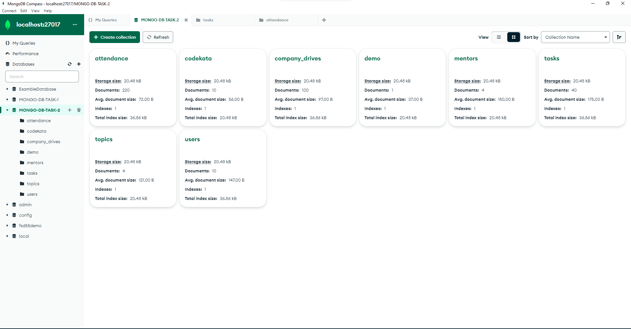**1.Find all the topics and tasks which are thought in the month of October:**

**QUERY**:

db.topics.aggregate([

{

$match: {

'topic_held_on': { $gte: new Date('2020-10-01') }

}

},

{

$lookup: {

from: 'tasks',

localField: 'topic_id',

foreignField: 'topic_id',

as: 'taskInfo'

}

},

{ $unwind: '$taskInfo' },

{

$match: {

$and: [

{ 'taskInfo.task_assigned_on': { $gte: new Date('2020-10-01') } },

{ 'taskInfo.task_assigned_on': { $lte: new Date('2020-10-31') } }

]

}

},

{

$group: {

_id: '$taskInfo.task',

topic_id: { $first: '$topic_id' },

topic_covered_by: { $first: '$topics_covered_by' },

topic_held_on:{$first:'$topic_held_on'},

assigned_tasks: { $first: '$taskInfo.task' }

}

},

{

$project: {

_id: 0,

topic_id: 1,

topic_covered_by: 1,

topic_held_on:1,

assigned_tasks: 1

}

},

{

$sort:{'topic_id':1}

}

]);

**ANSWER**:

{

topic_id: 2,

topic_covered_by: 'pugazh',

topic_held_on: 2020-10-01T00:00:00.000Z,

assigned_tasks: 'javascript-task'

}

{

topic_id: 3,

topic_covered_by: 'sureshbabu',

topic_held_on: 2020-10-16T00:00:00.000Z,

assigned_tasks: 'react-task'

}

{

topic_id: 4,

topic_covered_by: 'akbar',

topic_held_on: 2020-10-20T00:00:00.000Z,

assigned_tasks: 'mongo-db-task'

}

**2.Find all the company drives which appeared between 15 oct-2020 and 31-oct-2020**

**QUERY:**

db.company_drives.aggregate([

{

$match: {

$and: [

{ 'date': { $gt: new Date('2020-oct-15') } },

{ 'date': { $lt: new Date('2020-oct-31') } }

]

}

},

{

$group: {

_id: '$company_name',

dates: { $addToSet: '$date' }, // Accumulate an array of unique dates for each company

count: { $sum: 1 }

}

},

{$unwind:'$dates'},

{

$project: {

_id: 0,

company_name: '$_id',

drive_date: '$dates',

}

},

{$sort:{drive_date:1}}

]);

For 1st Question: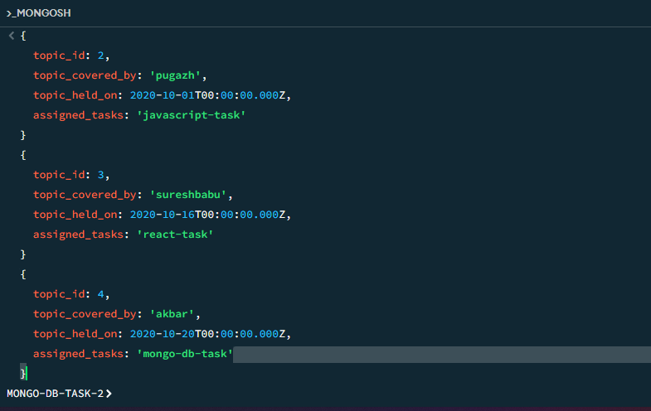

**ANSWER:**

{

company_name: 'swiggy',

drive_date: 2020-10-16T00:00:00.000Z

}

company_name: 'tcs',

drive_date: 2020-10-19T00:00:00.000Z

}

{

company_name: 'wipro',

drive_date: 2020-10-23T00:00:00.000Z

}

{

company_name: 'zoho',

drive_date: 2020-10-26T00:00:00.000Z

}

For 2nd Question: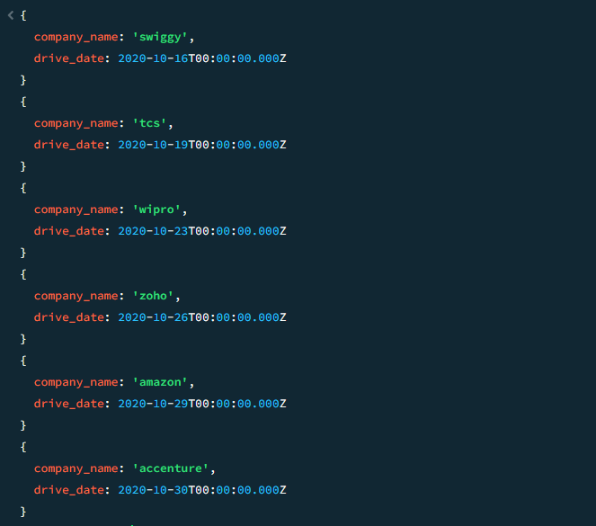

**3.Find all the company drives and students who are appeared for the placement.**

**QUERY:**

db.company_drives.aggregate([

{

$match: {

attended: 'yes' // Filter documents where attended is 'yes'

}

},

{

$lookup: {

from: 'users',

localField: 'user_id',

foreignField: 'user_id',

as: 'user_info'

}

},

{

$unwind: '$user_info'

},

{

$group: {

_id: {

company_name: '$company_name',

username: '$user_info.user_name'

},

attended: { $first: '$attended' } // Keep attended field

}

},

{

$group: {

_id: '$_id.company_name',

users: { $addToSet: { username: '$_id.username', attended: '$attended' } }

}

},

{

$project: {

_id: 0,

companyname: '$_id',

users: 1

}

},

{

$project: {

companyname: 1,

appeared_users: '$users'

}

},

{

$sort:{

'companyname':1,

}

}

]);

**ANSWER**:

{

companyname: 'accenture',

appeared_users: [

{

username: 'manu',

attended: 'yes'

},

{

username: 'parthiban',

attended: 'yes'

},

{

username: 'yusrin',

attended: 'yes'

},

{

username: 'harsha',

attended: 'yes'

}

]

}

{

companyname: 'amazon',

appeared_users: [

{

username: 'manu',

attended: 'yes'

},

{

username: 'parthiban',

attended: 'yes'

},

{

username: 'yusrin',

attended: 'yes'

},

{

username: 'harsha',

attended: 'yes'

}

]

For 3rd Question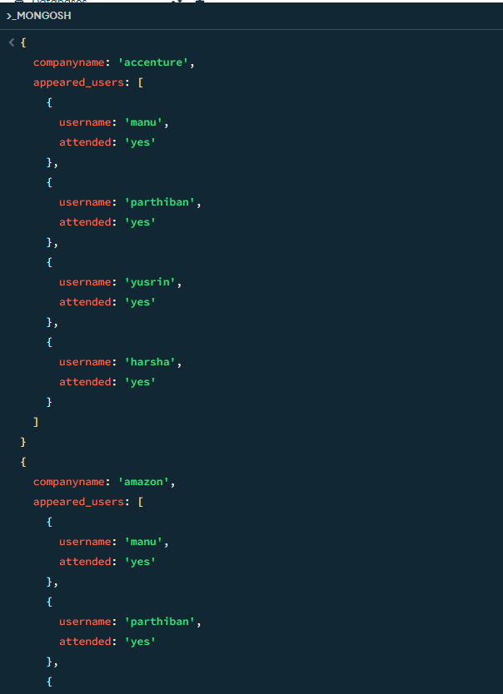

**4.Find the number of problems solved by the user in codekata**

**QUERY:**

db.codekata.aggregate([

{

$lookup: {

from: 'users',

localField: 'user_id',

foreignField: 'user_id',

as: 'userInfo'

}

},

{$unwind:'$userInfo'},

{

$project: {

_id:0,

user_id:1,

user_name:'userInfo.user_name',

user_email:'userInfo.user_email',

problems_solved:'$problems_solved'

}

},

{$sort:{'user_id':1}}

]);

**ANSWER:**

{

user_id: 1,

user_name: 'userInfo.user_name',

user_email: 'userInfo.user_email',

problems_solved: 85

}

{

user_id: 2,

user_name: 'userInfo.user_name',

user_email: 'userInfo.user_email',

problems_solved: 65

}

{

user_id: 3,

user_name: 'userInfo.user_name',

user_email: 'userInfo.user_email',

problems_solved: 70

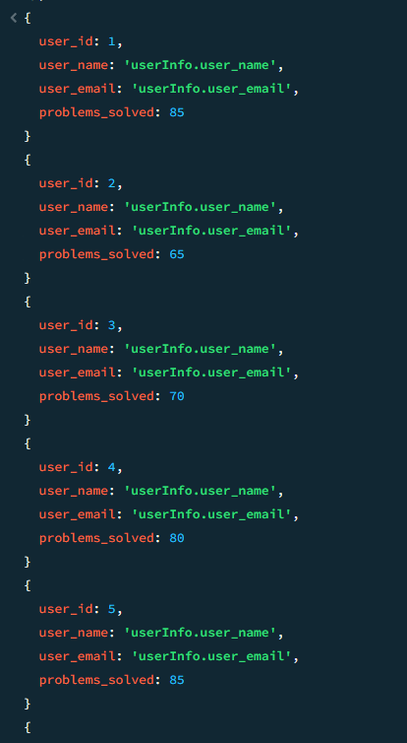

**5.Find all the mentors with who has the mentee's count more than 15**

**QUERY:**

db.mentors.aggregate([

{$match:{'mentee-count':{$gt:15}}}

]);

**Answer:**

{

_id: ObjectId('65e31fa19af95aef33742948'),

mentor_id: 1,

mentor_name: 'ruban',

mentor_email: 'ruban090@gmail.com',

topic: 'html&css',

topic_id: 1,

'mentee-count': 25

}

{

_id: ObjectId('65e31fa19af95aef33742949'),

mentor_id: 2,

mentor_name: 'pugazh',

mentor_email: 'pugazh56@gmail.com',

topic: 'javascript',

topic_id: 2,

'mentee-count': 30

}

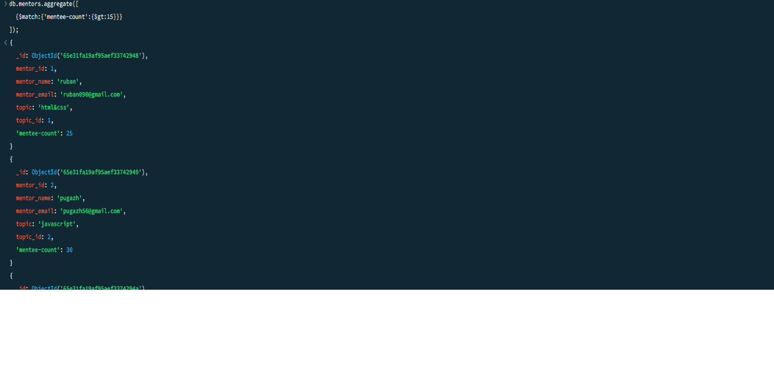

**6.Find the number of users who are absent and task is not submitted between 15 oct-2020 and 31-oct-2020**

**QUERY:**

db.attendance.aggregate([

{

$match: {

attendance: 'absent',

date: {

$gte: new Date("2020-10-15"),

$lte: new Date("2020-10-31")

}

}

},

{

$lookup: {

from: 'tasks',

localField: 'user_id',

foreignField: 'user_id',

as: 'taskInfo'

}

},

{

$lookup: {

from: 'users',

localField: 'user_id',

foreignField: 'user_id',

as: 'userInfo'

}

},

{

$match: {

$and: [

{ 'taskInfo.submitted': false },

{ 'taskInfo.task_completed_on': { $gte: new Date("2020-10-15"), $lte: new Date("2020-10-31") } }

]

}

},

{

$project: {

_id: 0,

user_name: { $arrayElemAt: ['$userInfo.user_name', 0] },

user_email: { $arrayElemAt: ['$userInfo.user_email', 0] },

attendance: 1,

user_id: 1,

'taskInfo.submitted': 1

}

},

{

$project: {

user_id: 0,

user_email: 0

}

}

]);

**ANSWER:**

{

user_id: 10,

attendance: 'absent',

taskInfo: [

{

task: 'html&css-task',

submitted: false

},

{

task: 'javascript-task',

submitted: false

},

{

task: 'react-task',

submitted: false

},

{

task: 'mongo-db-task',

submitted: false

}

],

user_name: 'nazeem',

user_email: 'nazeem65@gmail.com'

}

