CodTech Virtual Internship Project

An Internship Report submitted to
Mohan Babu University, Tirupati
In partial fulfilment of the requirements for the award of the degree of
BACHELOR OF TECHNOLOGY
IN
COMPUTER SCIENCE AND ENGINEERING

Submitted by
Kayam Sudharshan Reddy
24302A040005
B.Tech. CSE 7th Semester

Under the Esteemed Supervision of
Ms. I. Sravani
Assistant professor M.Tech.,(Ph.D)
Department of CSE



Department of Computer Science and Engineering
School of Computing
Mohan Babu University
Sree Sainath Nagar, Tirupati – 517 102
2026 – 2027

DEPARTMENT OF COMPUTER SCIENCE AND ENGINEERING

Certificate

This is to certify that the internship report titled “CodTech Virtual Internship Project” is the bonafide work done by Kayam Sudharshan Reddy (Reg. No: 24302A040005) in the Department of Computer Science and Engineering, and submitted to Mohan Babu University, Tirupati in partial fulfillment of the requirements for the award of the degree of Bachelor of Technology in Computer Science and Engineering during the academic year 2026-2027.

Supervisor: | Head:
MS. I Sravani  Assistant professor M.Tech.,(Ph.D)  Dept. of CSE | Dr. G. Sunitha  Professor & Head  Dept. of CSE

INTERNAL EXAMINER EXTERNAL EXAMINER

INTERNSHIP COMPLETION CERTIFICATE FROM COMPANY
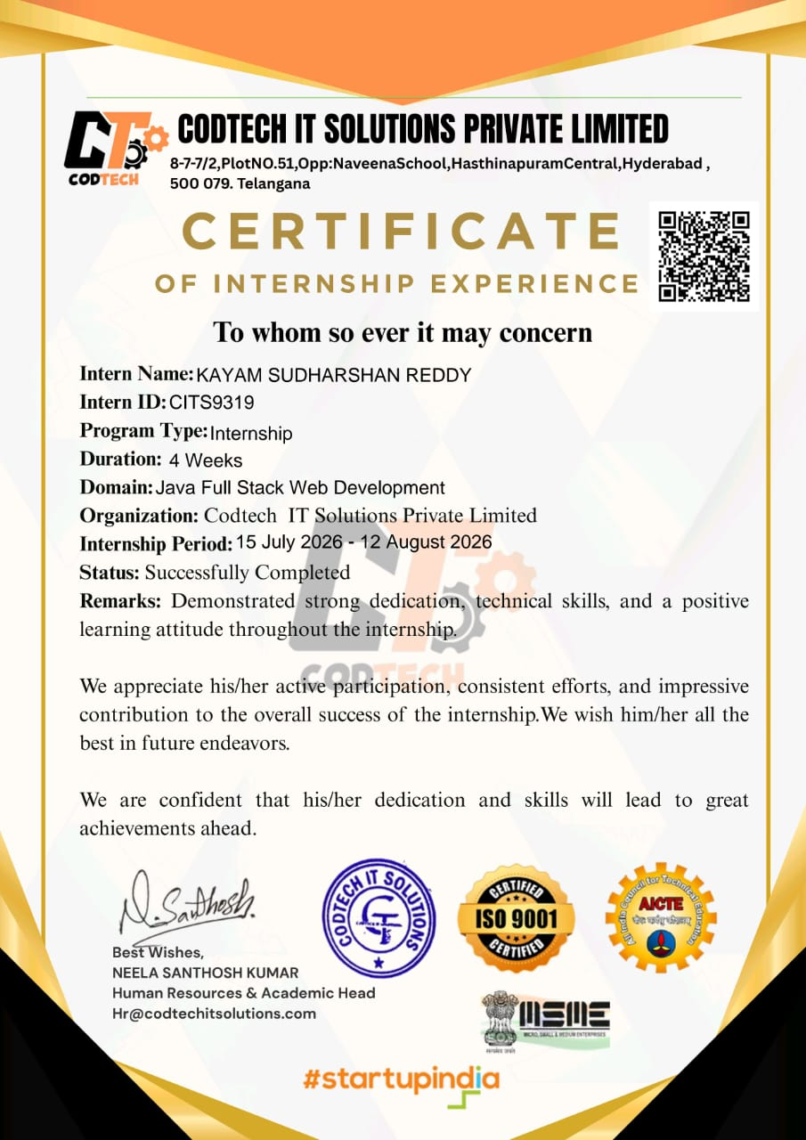
ACKNOWLEDGEMENT

I am extremely thankful to our beloved Chancellor, Dr. M. Mohan Babu garu, for his inspiration and unwavering commitment to academic growth and student development.
I express my sincere gratitude to our Pro-Chancellor, Sri Vishnu Manchu garu, his constant encouragement and visionary leadership in fostering a culture of learning and excellence.
I express my sincere gratitude to our Honorable Vice-Chancellor, Prof. P. Venkatramana garu, for his valuable guidance, encouragement, and continuous support in all academic endeavours.
I am deeply obliged to Dr. G. Sunitha, Professor & Head, Department of CSE, for her motivation, insightful guidance, and persistent encouragement.
I would like to extend my heartfelt thanks to my supervisor, MS. I. Sravani, Assistant professor M.Tech.,(Ph.D), Department of CSE, for the consistent support, insightful guidance, and constructive feedback provided during my internship.
I would also like to express my special thanks to CodTech for providing me with the opportunity to pursue this internship. The experience has been immensely valuable, enabling me to enhance my technical knowledge, conduct research, and gain practical exposure to new concepts and technologies.

Kayam Sudharshan Reddy
24302A040005
B.Tech. CSE 7th Semester


MOHAN BABU UNIVERSITY
Vision
To be a globally respected institution with an innovative and entrepreneurial culture that offers transformative education to advance sustainability and societal good.
Mission
- Develop industry-focused professionals with a global perspective.
- Offer academic programs that provide transformative learning experience founded on the spirit of curiosity, innovation, and integrity.
- Create confluence of research, innovation, and ideation to bring about sustainable and socially relevant enterprises.
- Uphold high standards of professional ethics leading to harmonious relationship with environment and society.

SCHOOL OF COMPUTING
Vision
To lead the advancement of computer science research and education that has real-world impact and to push the frontiers of innovation in the field.
Mission
- Instil within our students fundamental computing knowledge, a broad set of skills, and an inquisitive attitude to create innovative solutions to serve industry and community.
- Provide an experience par excellence with our state-of-the-art research, innovation, and incubation ecosystem to realise our learners’ fullest potential.
- Impart continued education and research support to working professionals in the computing domain to enhance their expertise in the cutting-edge technologies.
- Inculcate among the computing engineers of tomorrow with a spirit to solve societal challenges.

DEPARTMENT OF COMPUTER SCIENCE AND ENGINEERING
Vision
To become a Centre of Excellence in Computer Science and its emerging areas by imparting high quality education through teaching, training and research.

Mission
- Imparting quality education in Computer Science and Engineering and emerging areas of IT industry by disseminating knowledge through contemporary curriculum, competent faculty and effective teaching-learning methodologies.
- Nurture research, innovation and entrepreneurial skills among faculty and students to contribute to the needs of industry and society.
- Inculcate professional attitude, ethical and social responsibilities for prospective and promising engineering profession.
- Encourage students to engage in life-long learning by creating awareness of the contemporary developments in Computer Science and Engineering and its emerging areas.

B.Tech. Computer Science and Engineering
PROGRAM EDUCATIONAL OBJECTIVES
After few years of graduation, the graduates of B.Tech. CSE will be:
- Pursuing higher studies in core, specialized or allied areas of Computer Science, or Management.
- Employed in reputed Computer and I.T organizations or Government to have a globally competent professional career in Computer Science and Engineering domain or be successful Entrepreneurs.
- Able to demonstrate effective communication, engage in teamwork, exhibit leadership skills and ethical attitude, and achieve professional advancement through continuing education.

PROGRAM OUTCOMES
On successful completion of the Program, the graduates of B.Tech. CSE Program will be able to:
- Engineering Knowledge: Apply the knowledge of mathematics, science, engineering fundamentals, and an engineering specialization to the solution of complex engineering problems.
- Problem Analysis: Identify, formulate, review research literature, and analyze complex engineering problems reaching substantiated conclusions using first principles of mathematics, natural sciences, and engineering sciences.
- Design/Development of Solutions: Design solutions for complex engineering problems and design system components or processes that meet the specified needs with appropriate consideration for the public health and safety, and the cultural, societal, and environmental considerations.
- Conduct Investigations of Complex Problems: Use research-based knowledge and research methods including design of experiments, analysis and interpretation of data, and synthesis of the information to provide valid conclusions.
- Modern Tool Usage: Create, select, and apply appropriate techniques, resources, and modern engineering and IT tools including prediction and modeling to complex engineering activities with an understanding of the limitations.
- The Engineer and Society: Apply reasoning informed by the contextual knowledge to assess societal, health, safety, legal and cultural issues and the consequent responsibilities relevant to the professional engineering practice.
- Environment and Sustainability: Understand the impact of the professional engineering solutions in societal and environmental contexts, and demonstrate the knowledge of, and need for sustainable development.
- Ethics: Apply ethical principles and commit to professional ethics and responsibilities and norms of the engineering practice.
- Individual and Team Work: Function effectively as an individual, and as a member or leader in diverse teams, and in multidisciplinary settings.
- Communication: Communicate effectively on complex engineering activities with the engineering community and with society at large, such as, being able to comprehend and write effective reports and design documentation, make effective presentations, and give and receive clear instructions.
- Project Management and Finance: Demonstrate knowledge and understanding of the engineering and management principles and apply these to one’s own work, as a member and leader in a team, to manage projects and in multidisciplinary environments.
- Life-long Learning: Recognize the need for, and have the preparation and ability to engage in independent and life-long learning in the broadest context of technological change.

PROGRAM SPECIFIC OUTCOMES
On successful completion of the Program, the graduates of B. Tech. (CSE) program will be able to:
PSO1. Apply knowledge of computer science engineering, Use modern tools, techniques and technologies for efficient design and development of computer-based systems for complex engineering problems.
PSO2. Design and deploy networked systems using standards and principles, evaluate security measures for complex networks, apply procedures and tools to solve networking issues.
PSO3. Develop intelligent systems by applying adaptive algorithms and methodologies for solving problems from inter-disciplinary domains.
PSO4. Apply suitable models, tools and techniques to perform data analytics for effective decision making.

Course Code | Course Title | L | T | P | S | C
22CS111001 | Internship | - | - | - | - | 2

COURSE OUTCOMES: After successful completion of this course, the students will be able to:
CO1. Analyse latest equipment, materials and technologies that are used in industry to solve complex engineering problems following relevant standards, codes, policies and regulations.
CO2. Analyse safety, health, societal, environmental, sustainability, economical and managerial factors considered in industry in solving complex engineering problems.
CO3. Perform individually or in a team besides communicating effectively in written, oral and graphical forms on practicing engineering.

CO-PO-PSO Mapping Table:
Course Outcome | Program Outcomes |  |  |  |  |  |  |  |  |  |  |  | Program Specific Outcomes
Course Outcome | PO1 | PO2 | PO3 | PO4 | PO5 | PO6 | PO7 | PO8 | PO9 | PO10 | PO11 | PO12 | PSO1 | PSO2 | PSO3 | PSO4
CO1 | 3 | 3 |  | 3 | 3 |  |  | 3 |  |  |  | 3
CO2 |  | 3 |  |  |  | 3 | 3 |  |  |  | 3
CO3 |  |  |  |  |  |  |  |  | 3 | 3
Correlation Level: 3-High; 2-Medium; 1-Low
TABLE OF CONTENTS
Chapter | Page no
Abstract | 1
List of Acronyms | 2
List of Figures | 3
List of Tables | 4
Chapter 1 Introduction  1.1 Description of the Company  1.2 Overview of the Project  1.3 Technology Stack | 5
Chapter 2 Summary of Experience | 12
Chapter 3 Reflection on Learning | 16
Conclusion | 20

ABSTRACT
The internship in Java Full Stack Web Development at CodTech IT Solutions Private Limited was conducted for a duration of four weeks, from 15 July 2026 to 12 August 2026. The primary objective of this internship was to gain practical knowledge of web application development and understand the technologies involved in designing, developing, and maintaining modern web applications. The internship provided an opportunity to strengthen programming fundamentals, improve technical skills, and gain exposure to the software development process.
Java Full Stack Web Development involves working with both front-end and back-end technologies to develop complete web applications. The front end focuses on creating user-friendly interfaces through which users interact with the application, while the back end manages business logic, data processing, and communication between the application and the database. Java plays an important role in back-end development because of its object-oriented programming features, platform independence, security, and reliability. Understanding these components helps developers create efficient, scalable, and maintainable web applications.
During the internship, the learning process focused on understanding the fundamentals of Java programming, object-oriented programming concepts, web development principles, and the structure of full-stack applications. It also provided an opportunity to understand how different components of a web application interact with one another. The internship emphasized the importance of writing structured code, identifying and resolving errors, testing application functionality, and following a systematic approach to software development. These concepts helped build a strong foundation for working on real-world programming tasks and projects.
The internship also contributed to the development of analytical thinking, logical reasoning, problem-solving abilities, and independent learning skills. It highlighted the importance of time management, consistency, adaptability, and continuous improvement in the software development field. Furthermore, the experience provided an understanding of how theoretical knowledge can be applied to practical situations and how different technologies can be integrated to achieve the desired functionality of an application.
The knowledge and skills gained during this internship will serve as a foundation for future projects, further technical learning, and professional growth in the field of software development.

List of Acronyms

Acronym | Definition
Java | Java Programming Language
OOP | Object-Oriented Programming
JDK | Java Development Kit
JRE | Java Runtime Environment
JVM | Java Virtual Machine
HTML | HyperText Markup Language
CSS | Cascading Style Sheets
SQL | Structured Query Language
API | Application Programming Interface
UI | User Interface
DBMS | Database Management System
IDE | Integrated Development Environment
HTTP | HyperText Transfer Protocol
CRUD | Create, Read, Update, Delete
JDBC | Java Database Connectivity
XML | Extensible Markup Language
JSON | JavaScript Object Notation
JSP | JavaServer Pages
JDBC | Java Database Connectivity
MVC | Model-View-Controller
REST | Representational State Transfer
AJAX | Asynchronous JavaScript and XML
Maven | Apache Maven Build Tool

List of Figures
Figure No. | Description | Page No.
1.1 | Multi-Tier Architecture Diagram of the Java Full Stack Application | 7
1.2 | End-to-End Request-Response Flow Diagram | 7
1.3 | Model-View-Controller (MVC) Pattern Flow | 7
1.4 | Entity-Relationship (ER) Schema Diagram | 8
2.1 | Four-Week Technical Milestone Progression Roadmap | 13
2.2 | Agile Sprint and Development Iteration Lifecycle | 14
3.1 | Comprehensive Learning Outcomes and Competency Framework | 19
List of Tables

Table No. | Description | Page No.
1.1 | Technology Stack Summary | 10
2.3 | Weekly Summary of Internship Experience and Technical Deliverables | 15

CHAPTER 1
INTRODUCTION

Software engineering has fundamentally shifted toward distributed, scalable, and responsive application designs. The rapid evolution of internet technologies has made traditional, monolithic web systems less suitable for modern enterprise demands. Today’s software landscape requires agile systems that can seamlessly deliver dynamic user experiences while maintaining high-performance data processing and transaction management on the server side.

Full-stack development bridges these critical domains. It encompasses client-side presentation engineering as well as server-side business logic, database design, and network communication.

Combining Java’s backend capabilities with modern, responsive front-end libraries allows organizations to create applications that are modular, secure, and maintainable over long lifecycles.

Internships represent an essential milestone in software engineering education by bridging theoretical academic principles with industrial standards. While classroom training emphasizes foundational algorithmic problem-solving and database theory, practical industry work demands
The program was structured to provide direct immersion into full-stack application development, covering system architecture, interface styling, service layer implementation, relational data mapping, and API testing. This chapter establishes the structural foundation of the report by introducing the organizational profile of the host company, providing an overview of the development project undertaken, and summarizing the complete technology stack utilized throughout the internship lifecycle.

1.1 Description of the Company

Codtech IT Solutions Private Limited is an innovative information technology services, software consulting, and workforce development enterprise based in Telangana, India. The organization maintains its operational headquarters at 8-7-7/2, Plot No. 51, Opposite Naveena School, Hasthinapuram Central, Hyderabad, Telangana – 500 079. Established to provide reliable digital transformations and industry-grade engineering solutions, Codtech IT Solutions operates across two primary domains: commercial software product engineering and technical workforce enablement. In an era of rapid technological progress, organizations require resilient cloud infrastructures, scalable web architectures, and high-performance backend systems. Codtech IT Solutions addresses these market needs by conceptualizing, developing, and deploying modern IT systems for business clients while simultaneously conducting specialized incubation programs designed to bridge the gap between academic curricula and industry demands.

The company adheres strictly to operational quality standards, regulatory compliances, and government-recognized frameworks. It is officially recognized under the Startup India initiative by the Government of India, supporting innovation, digital entrepreneurship, and technical growth. Demonstrating its commitment to process consistency and organizational excellence, Codtech IT Solutions holds an active ISO 9001 quality management certification, confirming adherence to international benchmarks for management, reliability, and structured training operations. In addition, the firm is registered under the Ministry of Micro, Small, and Medium Enterprises (MSME) and aligns its technical curriculum and internship structures with the guidelines established by the All India Council for Technical Education (AICTE). This ensures that its technical deliverables, training frameworks, and practical modules yield tangible, industry-recognized academic and professional value.

1.2 Overview of the Project

The primary objective of the professional internship project completed at Codtech IT Solutions Private Limited between 15 July 2026 and 12 August 2026 was the Design and Implementation of an Enterprise Java Full Stack Web Application. The initiative focused on constructing an end-to-end, production-grade web solution adhering strictly to enterprise architectural standards, modular software decomposition, and responsive client-side design.

The application was designed using a decoupled multi-tier architectural framework that partitions presentation logic, core business services, and database persistence into distinct, manageable layers. On the client side, the presentation tier offers an interactive, cross-device interface that captures user inputs and renders dynamic interface views. It communicates asynchronously with the backend application server through stateless RESTful web services utilizing JSON payloads over secure HTTP protocols.

The server-side system, constructed using the Java enterprise ecosystem and the Spring Boot framework, coordinates request routing, payload validation, business policy execution, and access control. To maintain transactional integrity and avoid boilerplate data operations, the application leverages Spring Data JPA alongside Hibernate Object-Relational Mapping (ORM) to interface directly with a relational database management system.

Development workflows incorporated established software engineering best practices, including Git-based source code version control, comprehensive endpoint validation using Postman, and automated project packaging via Apache Maven. The final deliverable represents an enterprise-ready system demonstrating robust data persistence, secure service communication, and dynamic client-side rendering.

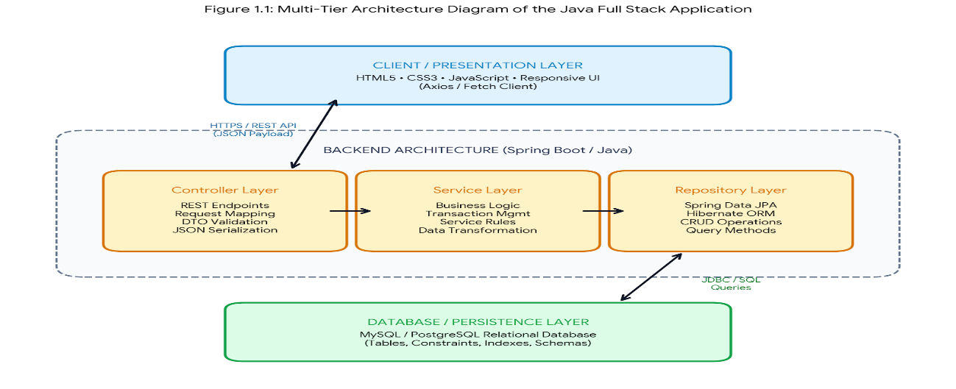
Figure 1.1: Multi-Tier Architecture Diagram of the Java Full Stack Application
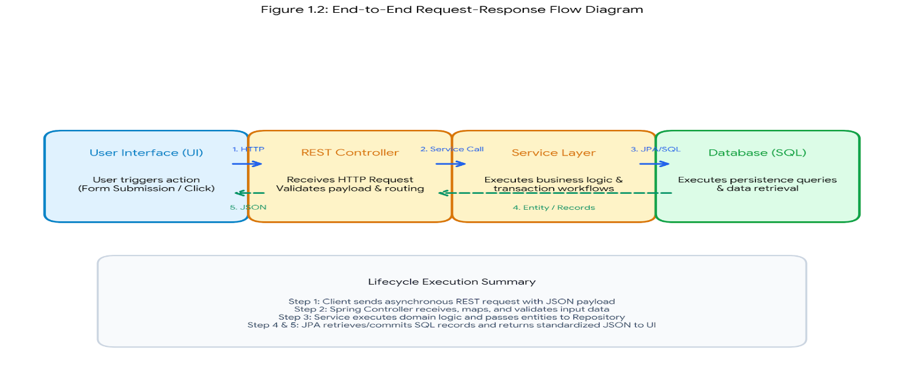
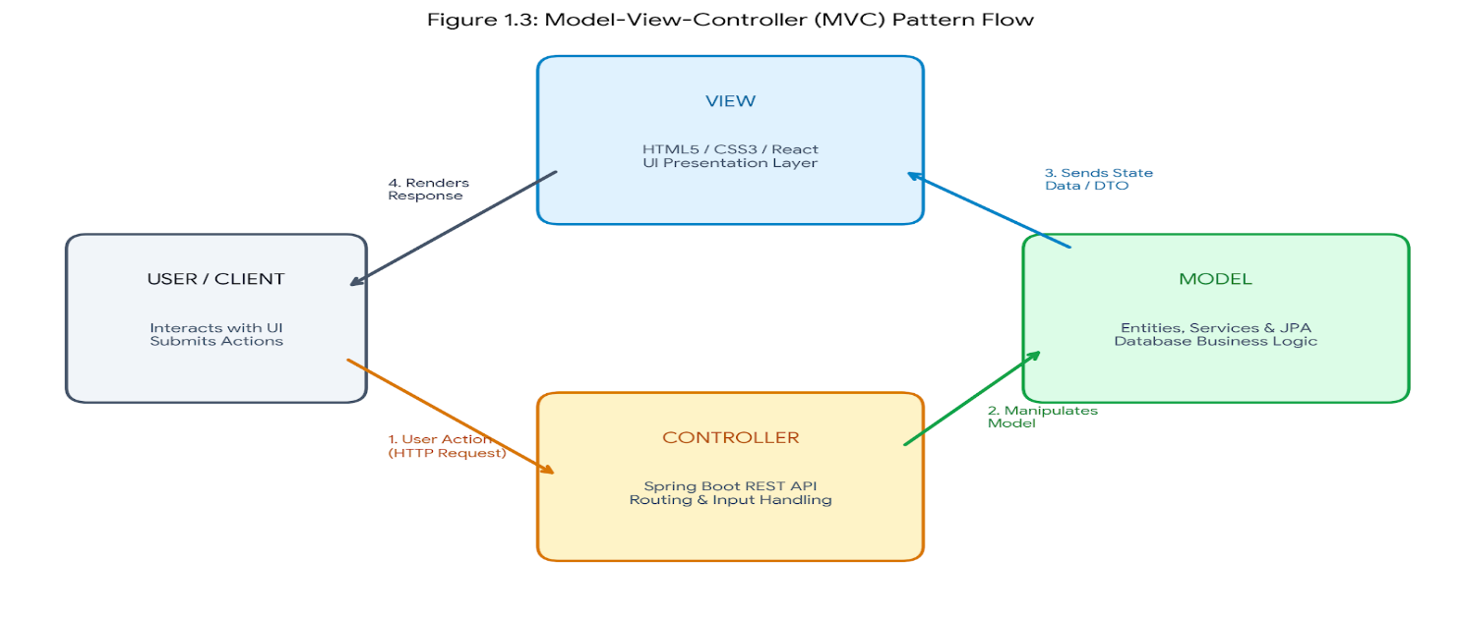
Figure 1.2: End-to-End Request-Response Flow Diagram
Figure 1.3: Model-View-Controller (MVC) Pattern Flow
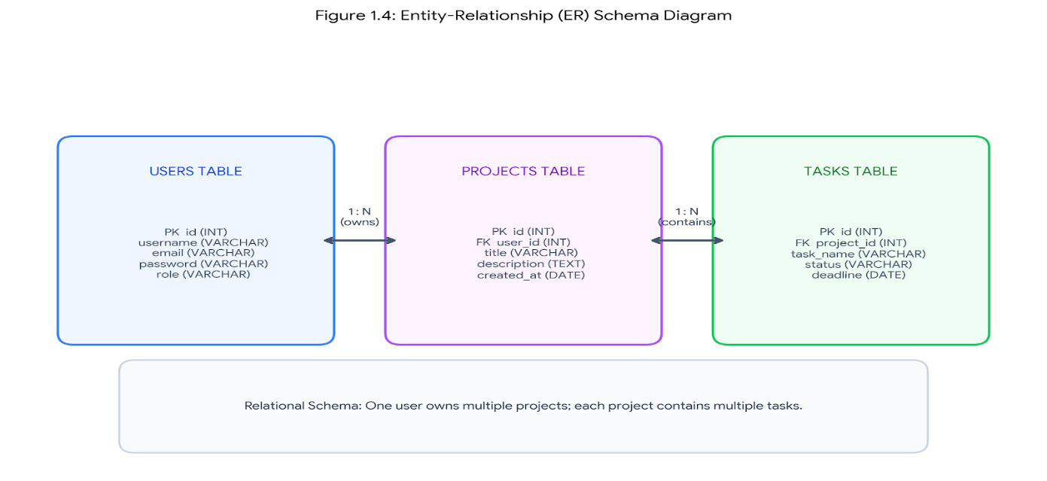
Figure 1.4: Entity-Relationship (ER) Schema Diagram

1.3 Technology Stack

The implementation of the enterprise application leverages a robust, industry-standard technology stack spanning backend service orchestration, data persistence, client-side interface rendering, and software build automation.

Backend Architecture & Server Technologies
- Java (JDK 17/21): Serves as the core object-oriented programming language, providing strong type safety, multi-threading capabilities, and high-performance execution.

- Spring Boot: Employs an opinionated configuration approach to bootstrap stand-alone, production-grade Spring applications with embedded servlet containers (Tomcat).

- Spring Data JPA & Hibernate: Implements Object-Relational Mapping (ORM) to abstract database interactions, handle entity state transitions, and execute CRUD operations without raw SQL boilerplate.

- Spring Security: Provides declarative authorization, authentication filters, and secure password-encoding mechanisms.

- RESTful Web Services: Facilitates stateless, JSON-based client-server communication using standard HTTP methods (GET, POST, PUT, DELETE).

Database & Persistence Layer
- MySQL / PostgreSQL: Operates as the underlying Relational Database Management System (RDBMS) ensuring ACID compliance, relational integrity, table constraints, and indexed data lookup.

Frontend Presentation Layer
- HTML5 & CSS3: Structures semantic DOM elements and implements responsive styling across diverse viewport dimensions.

- JavaScript (ES6+) / React: Handles asynchronous HTTP requests (Fetch API / Axios), state management, reactive component lifecycle updates, and dynamic DOM manipulation.

- Bootstrap / Modern UI Frameworks: Accelerates interface styling using pre-configured responsive grid layouts and UI components.

Build Automation, Version Control & Development Tools
- Apache Maven: Manages automated dependency resolution, build lifecycle phases, and packaging into executable .jar artifacts.

- Git & GitHub: Enforces distributed version control, feature branching, code tracking, and repository management.

- Postman: Used for manual and automated API endpoint testing, HTTP payload inspection, and response status verification.

- Integrated Development Environment (IDE): IntelliJ IDEA / Eclipse IDE for source code editing, refactoring, and local debugging.
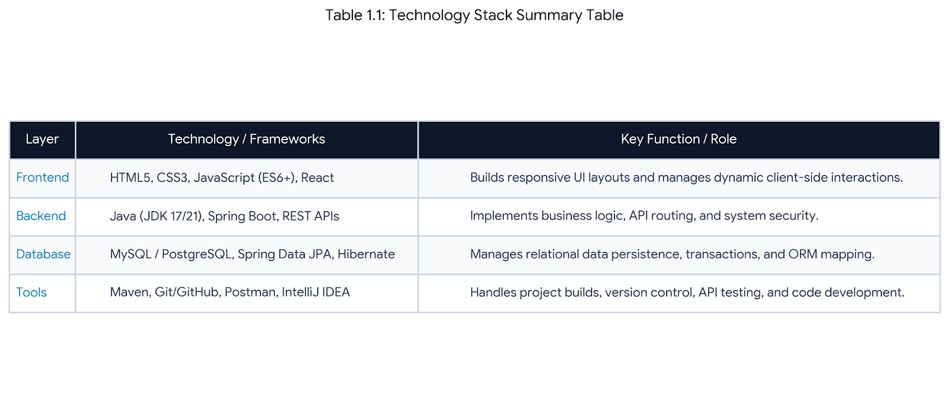

CHAPTER 2
SUMMARY OF EXPERIENCE

The four-week professional internship completed at Codtech IT Solutions Private Limited between 15 July 2026 and 12 August 2026 provided structured immersion into enterprise software engineering. The training focused on architecting and delivering an end-to-end web application within the Java Full Stack domain. The internship offered direct exposure to modern software engineering workflows, agile task cycles, clean code practices, and collaborative version control under technical supervision.

2.2 Weekly Technical Progression and Milestones
- Week 1: Environment Setup, Core Java & Git Workflows

  - Initialized local development environments with JDK 17/21 runtimes, IDE configurations, and Apache Maven build profiles.

  - Configured Git and GitHub repositories adhering to isolated feature branching and structured commit messages.

  - Implemented core object-oriented principles, collection structures, and robust exception-handling hierarchies in Java.

- Week 2: Backend Architecture & RESTful API Construction

  - Bootstrapped modular backend services using the Spring Boot framework.

  - Developed RESTful controller endpoints using standard HTTP request verbs (@GetMapping, @PostMapping, @PutMapping, @DeleteMapping).

  - Structured Data Transfer Objects (DTOs) for strict input validation, response serialization, and clean separation between network payloads and domain entities.

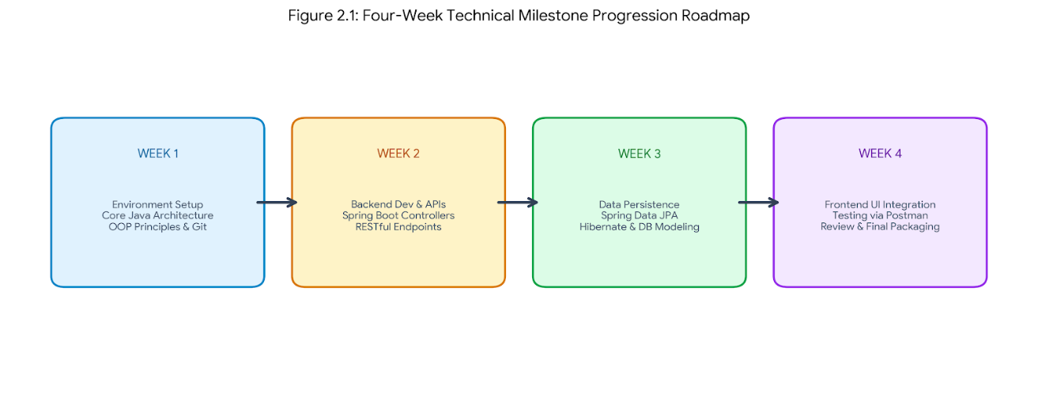

Figure 2.1: Four-Week Technical Milestone Progression Roadmap

- Week 3: Data Persistence, ORM & Database Design

  - Designed normalized relational database schemas with table relationships and constraints in MySQL.

  - Configured Spring Data JPA and Hibernate Object-Relational Mapping (ORM) to handle persistence logic.

  - Implemented repository interfaces to perform transactional CRUD operations and query indexing without writing raw SQL boilerplate.

- Week 4: Frontend Integration, Testing & Packaging

  - Engineered dynamic user interfaces using HTML5, CSS3, and JavaScript/React to consume backend REST endpoints.

  - Validated system behavior and API contracts using Postman across varying HTTP response codes and test payloads.

  - Bundled the finalized codebase into executable .jar artifacts using Maven, followed by technical evaluations and project review.
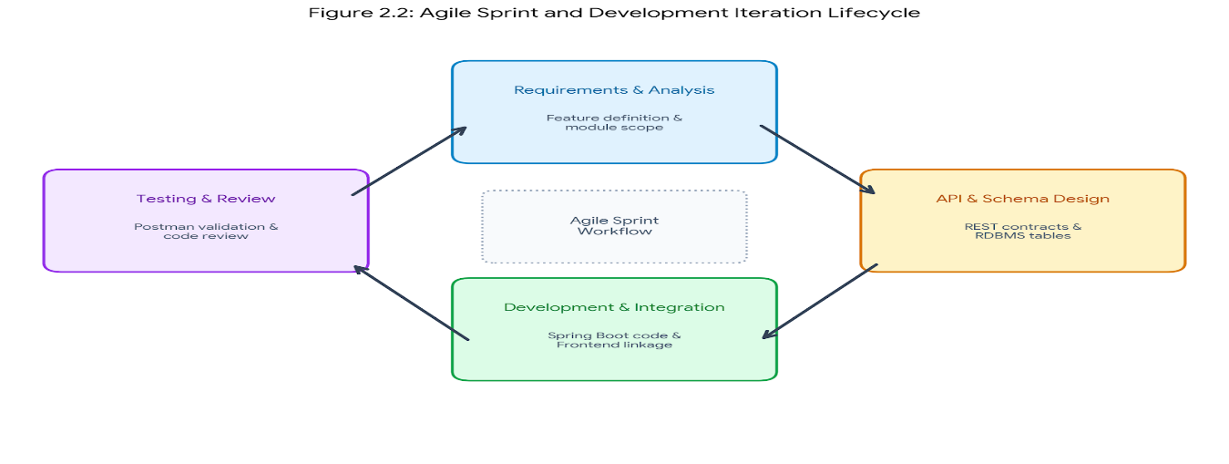

Figure 2.2: Agile Sprint and Development Iteration Lifecycle

2.3 Key Technical Competencies Acquired
- Full Stack Architecture: Gained direct experience decoupling frontend components from backend microservices via stateless JSON communications.

- Enterprise Persistence: Acquired practical competence in mapping domain models to relational tables using Hibernate and Spring Data JPA.

- API Validation: Mastered functional debugging, payload inspection, and status code verification using Postman.

- Engineering Standards: Adopted industry-standard Git version control workflows, automated Maven builds, and structured project documentation.
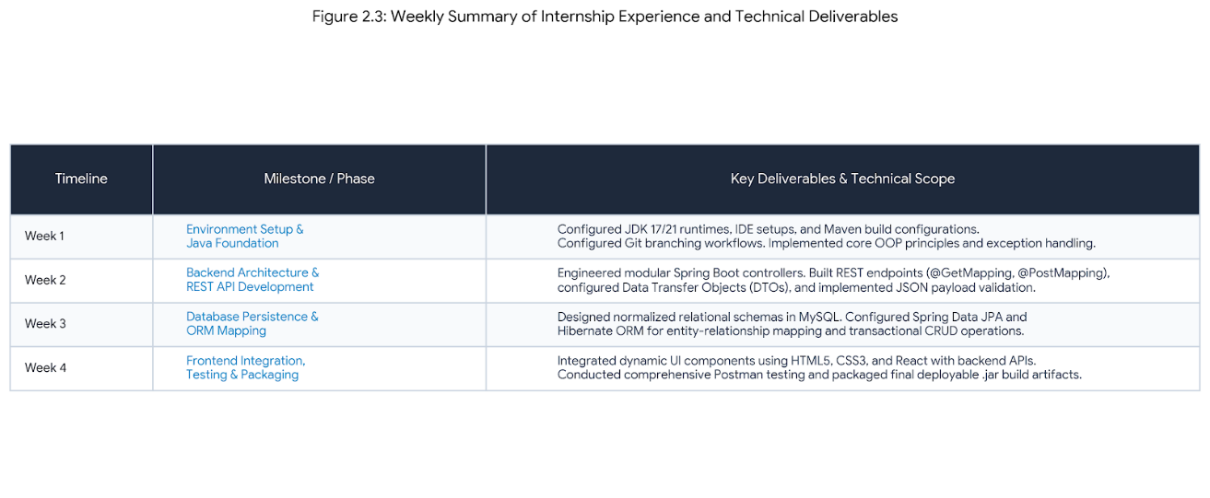

CHAPTER 3
REFLECTION ON LEARNING
3.1 Overview of Learning Experience
The four-week internship in Java Full Stack Web Development at Codtech IT Solutions Private Limited served as a crucial transition from academic study to professional software engineering. Working directly with enterprise frameworks provided deep insight into the full software development lifecycle (SDLC), including requirements analysis, REST API contract design, relational database modeling, and frontend integration. Beyond syntax and programming libraries, the experience highlighted the importance of code modularity, maintainability, system security, and performance optimization.

3.2 Technical Growth and Practical Insights
- Enterprise Backend Engineering:

  - Developed a strong understanding of the Spring Boot framework, particularly Dependency Injection (Inversion of Control) and modular component configuration.

  - Implemented stateless RESTful APIs adhering to standard HTTP request methods (GET, POST, PUT, DELETE) with unified JSON payloads.

  - Configured Data Transfer Objects (DTOs) and global exception handlers (@ControllerAdvice) to separate API models from database entities and ensure predictable error responses.

- Database Persistence and ORM Efficiency:

  - Gained hands-on experience mapping relational schemas using Hibernate and Spring Data JPA.

  - Learned to manage entity relationships (@OneToMany, @ManyToOne), cascade operations, and foreign key constraints effectively.

  - Addressed common ORM challenges, including lazy-loading exceptions and transaction boundary management using @Transactional.

- Frontend Integration and Client-Server Flow:

  - Connected responsive web user interfaces with backend endpoints using asynchronous HTTP requests (Axios/Fetch API).

  - Managed client-side states, dynamic DOM rendering, and user input validation to ensure a seamless end-to-end user experience.

3.3 Challenges Encountered and Problem-Solving Strategies
- Cross-Origin Resource Sharing (CORS) Issues:

  - Challenge: Early API calls from the frontend application were blocked by the browser due to CORS security policies.

  - Resolution: Implemented dedicated Spring Boot CORS configuration filters (@CrossOrigin and WebMvcConfigurer) to securely authorize client origins and HTTP headers.

- Entity Serialization Loops:

  - Challenge: Bidirectional relationships between parent and child database entities caused infinite JSON recursion during serialization.

  - Resolution: Applied @JsonManagedReference and @JsonBackReference annotations alongside tailored DTO projections to prevent cyclic dependency loops.

- API Validation and Debugging:

  - Challenge: Tracking mismatches between frontend request payloads and backend model definitions.

  - Resolution: Used Postman for systematic request testing, verifying HTTP response status codes (200 OK, 201 Created, 400 Bad Request, 500 Internal Error), and inspecting response payloads before connecting UI components.
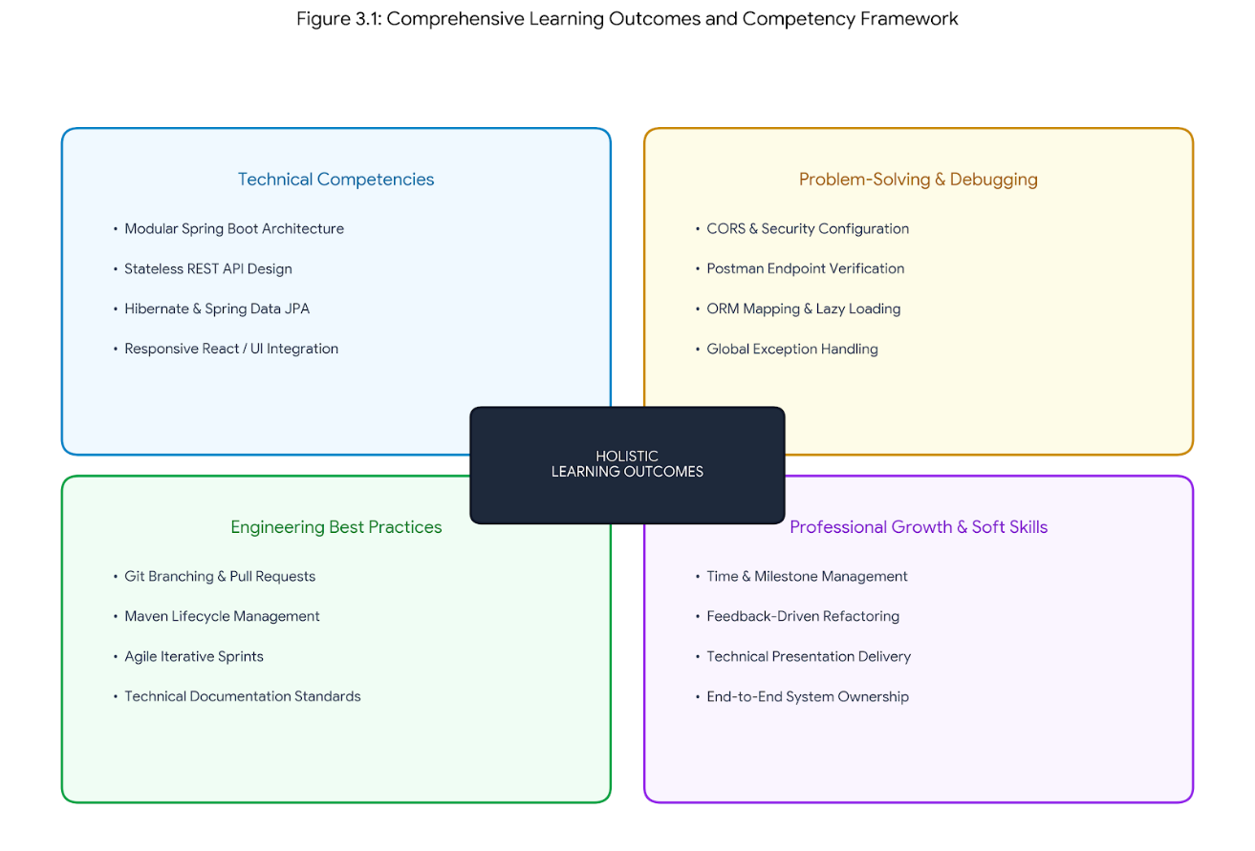
Figure 3.1: Comprehensive Learning Outcomes and Competency Framework

3.4 Professional and Industry Practices Learned
- Version Control and Collaboration: Practiced standard Git workflows, including branch isolation for new features, frequent meaningful commit messages, and conflict resolution before merging.

- Build Automation: Utilized Apache Maven for dependency management, build packaging into standalone .jar artifacts, and maintaining project configurations via pom.xml.

- Agile Sprint Execution: Followed iterative development sprints with weekly milestones, participating in code reviews, technical mentoring, and requirement adjustments under company supervision.

CONCLUSION

The four-week professional internship in Java Full Stack Web Development at Codtech IT Solutions Private Limited has been a transformative milestone in translating academic theoretical concepts into industry-standard software engineering practices. Over the course of the internship, the complete development lifecycle was navigated—from requirement gathering and API contract definition to relational database modeling, business logic implementation, and client-side user interface integration.

Through the practical execution of the Design and Implementation of an Enterprise Java Full Stack Web Application, strong technical competence was achieved across the modern Java enterprise stack. Key takeaways include architecting decoupled, maintainable multi-tier applications using the Spring Boot framework, managing transactional data persistence via Hibernate and Spring Data JPA, designing secure RESTful API endpoints, and connecting responsive client-side views

Beyond core technical skills, the internship cultivated crucial professional attributes such as analytical problem-solving, structured debugging, agile sprint discipline, and adherence to clean coding principles. Overcoming real-world integration hurdles, such as CORS configuration policies and ORM entity relationship handling, provided valuable insights into building resilient enterprise software.

The practical knowledge, architectural perspectives, and industry workflows acquired during this internship establish a solid, dependable foundation for future software development endeavors and career progression in full-stack engineering.

