**Table creation:**

CREATE TABLE Customers (

CustomerID NUMBER PRIMARY KEY,

Name VARCHAR2(100),

DOB DATE,

Balance NUMBER,

LastModified DATE

);

CREATE TABLE Accounts (

AccountID NUMBER PRIMARY KEY,

CustomerID NUMBER,

AccountType VARCHAR2(20),

Balance NUMBER,

LastModified DATE,

FOREIGN KEY (CustomerID) REFERENCES Customers(CustomerID)

);

CREATE TABLE Transactions (

TransactionID NUMBER PRIMARY KEY,

AccountID NUMBER,

TransactionDate DATE,

Amount NUMBER,

TransactionType VARCHAR2(10),

FOREIGN KEY (AccountID) REFERENCES Accounts(AccountID)

);

CREATE TABLE Loans (

LoanID NUMBER PRIMARY KEY,

CustomerID NUMBER,

LoanAmount NUMBER,

InterestRate NUMBER,

StartDate DATE,

EndDate DATE,

FOREIGN KEY (CustomerID) REFERENCES Customers(CustomerID)

);

CREATE TABLE Employees (

EmployeeID NUMBER PRIMARY KEY,

Name VARCHAR2(100),

Position VARCHAR2(50),

Salary NUMBER,

Department VARCHAR2(50),

HireDate DATE

);

**Data Insertion:**

INSERT INTO Customers (CustomerID, Name, DOB, Balance, LastModified)

VALUES (1, 'John Doe', TO_DATE('1985-05-15', 'YYYY-MM-DD'), 1000, SYSDATE);

INSERT INTO Customers (CustomerID, Name, DOB, Balance, LastModified)

VALUES (2, 'Jane Smith', TO_DATE('1990-07-20', 'YYYY-MM-DD'), 1500, SYSDATE);

INSERT INTO Accounts (AccountID, CustomerID, AccountType, Balance, LastModified)

VALUES (1, 1, 'Savings', 1000, SYSDATE);

INSERT INTO Accounts (AccountID, CustomerID, AccountType, Balance, LastModified)

VALUES (2, 2, 'Checking', 1500, SYSDATE);

INSERT INTO Transactions (TransactionID, AccountID, TransactionDate, Amount, TransactionType)

VALUES (1, 1, SYSDATE, 200, 'Deposit');

INSERT INTO Transactions (TransactionID, AccountID, TransactionDate, Amount, TransactionType)

VALUES (2, 2, SYSDATE, 300, 'Withdrawal');

INSERT INTO Loans (LoanID, CustomerID, LoanAmount, InterestRate, StartDate, EndDate)

VALUES (1, 1, 5000, 5, SYSDATE, ADD_MONTHS(SYSDATE, 60));

INSERT INTO Employees (EmployeeID, Name, Position, Salary, Department, HireDate)

VALUES (1, 'Alice Johnson', 'Manager', 70000, 'HR', TO_DATE('2015-06-15', 'YYYY-MM-DD'));

INSERT INTO Employees (EmployeeID, Name, Position, Salary, Department, HireDate)

VALUES (2, 'Bob Brown', 'Developer', 60000, 'IT', TO_DATE('2017-03-20', 'YYYY-MM-DD'));

Select * from Customers;

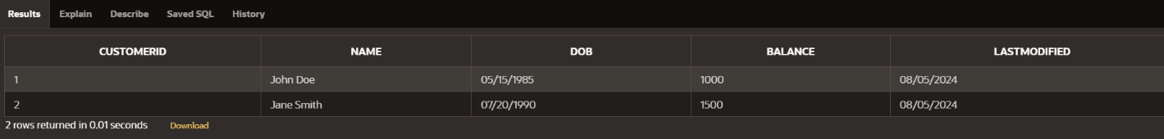

Select * from Accounts;

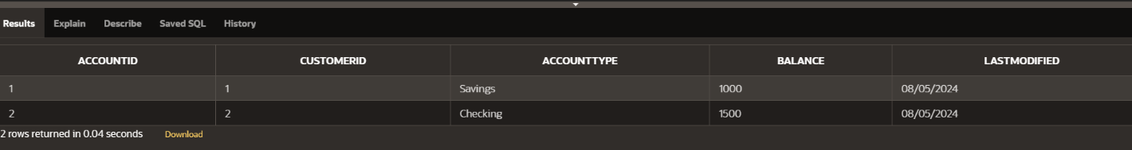

Select * from Transactions;

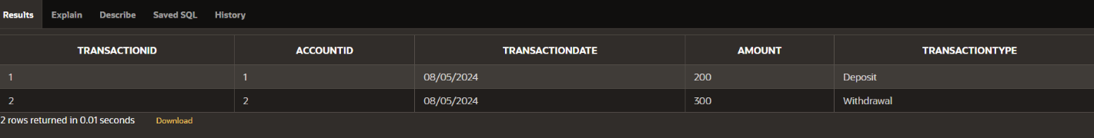

Select * from Loans;

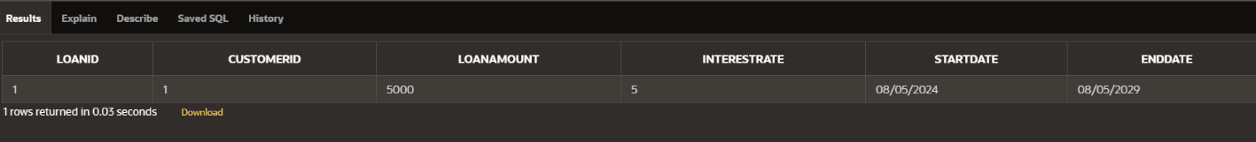

Select * from Employees;

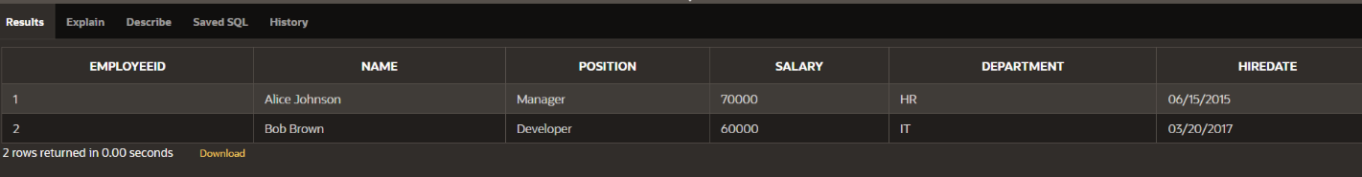

**Exercise 1: Control Structures**

**Scenario 1:** The bank wants to apply a discount to loan interest rates for customers above 60 years old.

* + **Question:** Write a PL/SQL block that loops through all customers, checks their age, and if they are above 60, apply a 1% discount to their current loan interest rates.

**Scenario 2:** A customer can be promoted to VIP status based on their balance.

* + **Question:** Write a PL/SQL block that iterates through all customers and sets a flag IsVIP to TRUE for those with a balance over $10,000.

**Scenario 3:** The bank wants to send reminders to customers whose loans are due within the next 30 days.

* + **Question:** Write a PL/SQL block that fetches all loans due in the next 30 days and prints a reminder message for each customer.

**SCENARIO 1:**

DECLARE

v_current_date DATE := SYSDATE;

v_age NUMBER;

BEGIN

FOR rec IN (SELECT CustomerID, DOB FROM Customers) LOOP

-- Calculate age

v_age := TRUNC(MONTHS_BETWEEN(v_current_date, rec.DOB) / 12);

IF v_age > 60 THEN

-- Apply 1% discount to loan interest rates

UPDATE Loans

SET InterestRate = InterestRate - 1

WHERE CustomerID = rec.CustomerID;

END IF;

END LOOP;

COMMIT;

END;

/

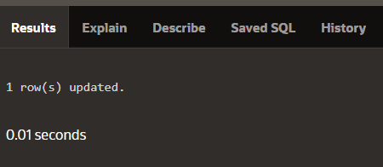

**SCENARIO 2:**

ALTER TABLE Customers ADD (IsVIP CHAR(1));

DECLARE

BEGIN

FOR rec IN (SELECT CustomerID, Balance FROM Customers) LOOP

IF rec.Balance > 10000 THEN

-- Set VIP flag to TRUE

UPDATE Customers

SET IsVIP = 'Y'

WHERE CustomerID = rec.CustomerID;

ELSE

-- Set VIP flag to FALSE

UPDATE Customers

SET IsVIP = 'N'

WHERE CustomerID = rec.CustomerID;

END IF;

END LOOP;

COMMIT;

END;

/



**SCENARIO 3:**

DECLARE

v_due_date DATE;

BEGIN

FOR rec IN (SELECT CustomerID, EndDate FROM Loans WHERE EndDate BETWEEN SYSDATE AND SYSDATE + 30) LOOP

v_due_date := rec.EndDate;

-- Print reminder message

DBMS_OUTPUT.PUT_LINE('Reminder: Loan for Customer ID ' || rec.CustomerID || ' is due on ' || v_due_date);

END LOOP;

END;

/

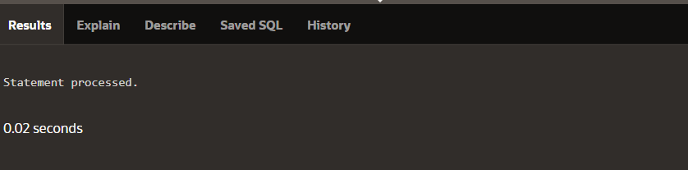

**Exercise 2: Error Handling**

**Scenario 1:** Handle exceptions during fund transfers between accounts.

* + **Question:** Write a stored procedure **SafeTransferFunds** that transfers funds between two accounts. Ensure that if any error occurs (e.g., insufficient funds), an appropriate error message is logged and the transaction is rolled back.

**Scenario 2:** Manage errors when updating employee salaries.

* + **Question:** Write a stored procedure **UpdateSalary** that increases the salary of an employee by a given percentage. If the employee ID does not exist, handle the exception and log an error message.

**Scenario 3:** Ensure data integrity when adding a new customer.

* + **Question:** Write a stored procedure **AddNewCustomer** that inserts a new customer into the Customers table. If a customer with the same ID already exists, handle the exception by logging an error and preventing the insertion.

**SCENARIO 1:**

CREATE OR REPLACE PROCEDURE SafeTransferFunds (

p_from_account_id IN NUMBER,

p_to_account_id IN NUMBER,

p_amount IN NUMBER

) AS

v_from_balance NUMBER;

v_to_balance NUMBER;

BEGIN

-- Start transaction

BEGIN

-- Check balances

SELECT Balance INTO v_from_balance

FROM Accounts

WHERE AccountID = p_from_account_id FOR UPDATE;

SELECT Balance INTO v_to_balance

FROM Accounts

WHERE AccountID = p_to_account_id FOR UPDATE;

-- Ensure sufficient funds

IF v_from_balance < p_amount THEN

RAISE_APPLICATION_ERROR(-20001, 'Insufficient funds.');

END IF;

-- Perform transfer

UPDATE Accounts

SET Balance = Balance - p_amount

WHERE AccountID = p_from_account_id;

UPDATE Accounts

SET Balance = Balance + p_amount

WHERE AccountID = p_to_account_id;

-- Commit transaction

COMMIT;

EXCEPTION

WHEN OTHERS THEN

-- Rollback on error

ROLLBACK;

DBMS_OUTPUT.PUT_LINE('Error occurred: ' || SQLERRM);

END;

END;

/

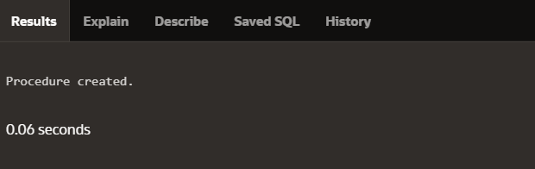

**SCENARIO 2:**

CREATE OR REPLACE PROCEDURE UpdateSalary (

p_employee_id IN NUMBER,

p_percentage IN NUMBER

) AS

BEGIN

-- Start transaction

BEGIN

-- Update salary

UPDATE Employees

SET Salary = Salary * (1 + p_percentage / 100)

WHERE EmployeeID = p_employee_id;

IF SQL%ROWCOUNT = 0 THEN

RAISE_APPLICATION_ERROR(-20002, 'Employee ID does not exist.');

END IF;

-- Commit transaction

COMMIT;

EXCEPTION

WHEN OTHERS THEN

-- Rollback on error

ROLLBACK;

DBMS_OUTPUT.PUT_LINE('Error occurred: ' || SQLERRM);

END;

END;

/

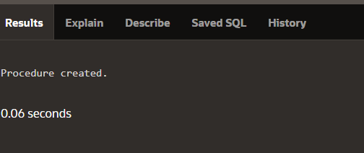

**SCENARIO 3:**

CREATE OR REPLACE PROCEDURE AddNewCustomer (

p_customer_id IN NUMBER,

p_name IN VARCHAR2,

p_dob IN DATE,

p_balance IN NUMBER,

p_last_modified IN DATE

) AS

BEGIN

-- Start transaction

BEGIN

-- Insert new customer

INSERT INTO Customers (CustomerID, Name, DOB, Balance, LastModified)

VALUES (p_customer_id, p_name, p_dob, p_balance, p_last_modified);

-- Commit transaction

COMMIT;

EXCEPTION

WHEN DUP_VAL_ON_INDEX THEN

-- Handle duplicate customer ID error

ROLLBACK;

DBMS_OUTPUT.PUT_LINE('Error: Customer with ID ' || p_customer_id || ' already exists.');

WHEN OTHERS THEN

-- Rollback on any other error

ROLLBACK;

DBMS_OUTPUT.PUT_LINE('Error occurred: ' || SQLERRM);

END;

END;

/

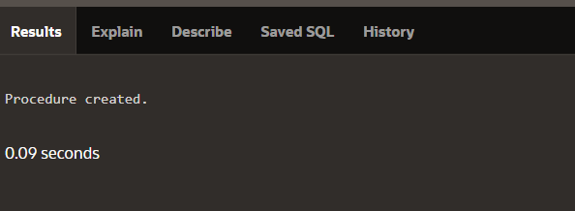

**Exercise 3: Stored Procedures**

**Scenario 1:** The bank needs to process monthly interest for all savings accounts.

* + **Question:** Write a stored procedure **ProcessMonthlyInterest** that calculates and updates the balance of all savings accounts by applying an interest rate of 1% to the current balance.

**Scenario 2:** The bank wants to implement a bonus scheme for employees based on their performance.

* + **Question:** Write a stored procedure **UpdateEmployeeBonus** that updates the salary of employees in a given department by adding a bonus percentage passed as a parameter.

**Scenario 3:** Customers should be able to transfer funds between their accounts.

* + **Question:** Write a stored procedure **TransferFunds** that transfers a specified amount from one account to another, checking that the source account has sufficient balance before making the transfer.

**SCENARIO 1:**

CREATE OR REPLACE PROCEDURE ProcessMonthlyInterest AS

v_interest_rate NUMBER := 0.01; -- 1% interest rate

BEGIN

-- Update the balance of all savings accounts

UPDATE Accounts

SET Balance = Balance * (1 + v_interest_rate)

WHERE AccountType = 'Savings';

-- Commit the transaction

COMMIT;

DBMS_OUTPUT.PUT_LINE('Monthly interest processed for all savings accounts.');

END;

/

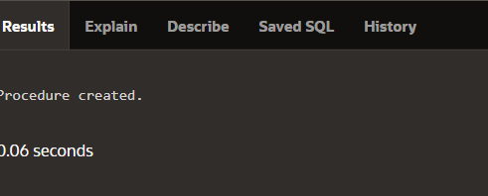

**SCENARIO 2:**

CREATE OR REPLACE PROCEDURE UpdateEmployeeBonus (

p_department IN VARCHAR2,

p_bonus_percentage IN NUMBER

) AS

BEGIN

-- Start transaction

BEGIN

-- Update employee salaries with bonus

UPDATE Employees

SET Salary = Salary * (1 + p_bonus_percentage / 100)

WHERE Department = p_department;

-- Commit the transaction

COMMIT;

DBMS_OUTPUT.PUT_LINE('Employee bonuses updated for department ' || p_department || '.');

EXCEPTION

WHEN OTHERS THEN

-- Rollback on error

ROLLBACK;

DBMS_OUTPUT.PUT_LINE('Error occurred: ' || SQLERRM);

END;

END;

/



**SCENARIO 3:**

CREATE OR REPLACE PROCEDURE TransferFunds (

p_from_account_id IN NUMBER,

p_to_account_id IN NUMBER,

p_amount IN NUMBER

) AS

v_from_balance NUMBER;

v_to_balance NUMBER;

BEGIN

-- Start transaction

BEGIN

-- Lock the accounts for update

SELECT Balance INTO v_from_balance

FROM Accounts

WHERE AccountID = p_from_account_id FOR UPDATE;

SELECT Balance INTO v_to_balance

FROM Accounts

WHERE AccountID = p_to_account_id FOR UPDATE;

-- Ensure sufficient funds

IF v_from_balance < p_amount THEN

RAISE_APPLICATION_ERROR(-20001, 'Insufficient funds in the source account.');

END IF;

-- Perform the transfer

UPDATE Accounts

SET Balance = Balance - p_amount

WHERE AccountID = p_from_account_id;

UPDATE Accounts

SET Balance = Balance + p_amount

WHERE AccountID = p_to_account_id;

-- Commit transaction

COMMIT;

DBMS_OUTPUT.PUT_LINE('Transfer successful from account ' || p_from_account_id || ' to account ' || p_to_account_id || '.');

EXCEPTION

WHEN OTHERS THEN

-- Rollback on error

ROLLBACK;

DBMS_OUTPUT.PUT_LINE('Error occurred: ' || SQLERRM);

END;

END;

/



**Exercise 4: Functions**

**Scenario 1:** Calculate the age of customers for eligibility checks.

* + **Question:** Write a function CalculateAge that takes a customer's date of birth as input and returns their age in years.

**Scenario 2:** The bank needs to compute the monthly installment for a loan.

* + **Question:** Write a function **CalculateMonthlyInstallment** that takes the loan amount, interest rate, and loan duration in years as input and returns the monthly installment amount.

**Scenario 3:** Check if a customer has sufficient balance before making a transaction.

* + **Question:** Write a function **HasSufficientBalance** that takes an account ID and an amount as input and returns a boolean indicating whether the account has at least the specified amount.

**SCENARIO 1:**

CREATE OR REPLACE FUNCTION CalculateAge (

p_dob DATE

) RETURN NUMBER AS

v_age NUMBER;

BEGIN

-- Calculate age in years

v_age := TRUNC(MONTHS_BETWEEN(SYSDATE, p_dob) / 12);

RETURN v_age;

END;

/

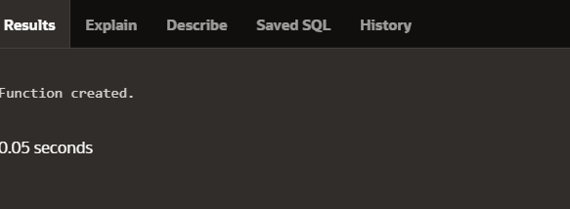

**SCENARIO 2:**

CREATE OR REPLACE FUNCTION CalculateMonthlyInstallment (

p_loan_amount NUMBER,

p_annual_interest_rate NUMBER,

p_loan_duration_years NUMBER

) RETURN NUMBER AS

v_monthly_installment NUMBER;

v_monthly_interest_rate NUMBER;

v_total_months NUMBER;

BEGIN

-- Convert annual interest rate to monthly and calculate total months

v_monthly_interest_rate := p_annual_interest_rate / 12 / 100;

v_total_months := p_loan_duration_years * 12;

-- Calculate the monthly installment using the formula

v_monthly_installment := (p_loan_amount * v_monthly_interest_rate) /

(1 - POWER(1 + v_monthly_interest_rate, -v_total_months));

RETURN v_monthly_installment;

END;

/



**SCENARIO 3:**

CREATE OR REPLACE FUNCTION HasSufficientBalance (

p_account_id NUMBER,

p_amount NUMBER

) RETURN BOOLEAN AS

v_balance NUMBER;

BEGIN

-- Get the current balance of the account

SELECT Balance INTO v_balance

FROM Accounts

WHERE AccountID = p_account_id;

-- Check if the balance is sufficient

IF v_balance >= p_amount THEN

RETURN TRUE;

ELSE

RETURN FALSE;

END IF;

EXCEPTION

WHEN NO_DATA_FOUND THEN

-- Account not found

RETURN FALSE;

WHEN OTHERS THEN

-- Handle any other unexpected errors

DBMS_OUTPUT.PUT_LINE('Error occurred: ' || SQLERRM);

RETURN FALSE;

END;

/

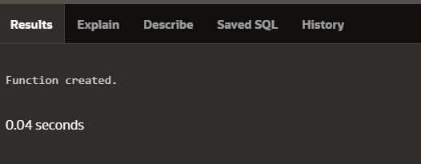

**Exercise 5: Triggers**

**Scenario 1:** Automatically update the last modified date when a customer's record is updated.

* + **Question:** Write a trigger **UpdateCustomerLastModified** that updates the LastModified column of the Customers table to the current date whenever a customer's record is updated.

**Scenario 2:** Maintain an audit log for all transactions.

* + **Question:** Write a trigger **LogTransaction** that inserts a record into an AuditLog table whenever a transaction is inserted into the Transactions table.

**Scenario 3:** Enforce business rules on deposits and withdrawals.

* + **Question:** Write a trigger **CheckTransactionRules** that ensures withdrawals do not exceed the balance and deposits are positive before inserting a record into the Transactions table.

**SCENARIO 1:**

BEGIN

EXECUTE IMMEDIATE '

CREATE OR REPLACE TRIGGER UpdateCustomerLastModified

BEFORE UPDATE ON Customers

FOR EACH ROW

BEGIN

:NEW.LastModified := SYSDATE;

END;

';

END;

/

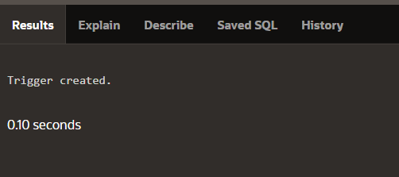

**SCENARIO 2:**

CREATE TABLE AuditLog (

AuditID NUMBER GENERATED BY DEFAULT AS IDENTITY PRIMARY KEY,

TransactionID NUMBER,

ActionDate DATE,

ActionType VARCHAR2(20),

OldBalance NUMBER,

NewBalance NUMBER

);

CREATE OR REPLACE TRIGGER TestTrigger

AFTER INSERT ON Transactions

FOR EACH ROW

BEGIN

NULL; -- Placeholder action for testing

END;

/

BEGIN

EXECUTE IMMEDIATE '

CREATE OR REPLACE TRIGGER TestTrigger

AFTER INSERT ON Transactions

FOR EACH ROW

BEGIN

NULL; -- Placeholder action for testing

END;

';

END;

/

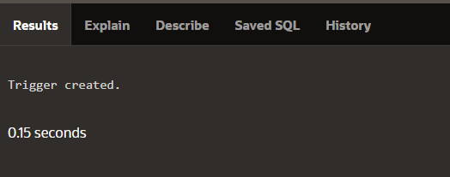

**SCENARIO 3:**

BEGIN

EXECUTE IMMEDIATE '

CREATE OR REPLACE TRIGGER CheckTransactionRules

BEFORE INSERT ON Transactions

FOR EACH ROW

DECLARE

v_balance NUMBER;

BEGIN

-- Get the current balance from the Accounts table

SELECT Balance INTO v_balance

FROM Accounts

WHERE AccountID = :NEW.AccountID;

-- Check if the transaction rules are followed

IF :NEW.TransactionType = ''Withdrawal'' THEN

IF v_balance < :NEW.Amount THEN

RAISE_APPLICATION_ERROR(-20002, ''Withdrawal amount exceeds account balance.'');

END IF;

ELSIF :NEW.TransactionType = ''Deposit'' THEN

IF :NEW.Amount <= 0 THEN

RAISE_APPLICATION_ERROR(-20003, ''Deposit amount must be positive.'');

END IF;

END IF;

END;

';

END;

/



**Exercise 6: Cursors**

**Scenario 1:** Generate monthly statements for all customers.

* + **Question:** Write a PL/SQL block using an explicit cursor **GenerateMonthlyStatements** that retrieves all transactions for the current month and prints a statement for each customer.

**Scenario 2:** Apply annual fee to all accounts.

* + **Question:** Write a PL/SQL block using an explicit cursor **ApplyAnnualFee** that deducts an annual maintenance fee from the balance of all accounts.

**Scenario 3:** Update the interest rate for all loans based on a new policy.

* + **Question:** Write a PL/SQL block using an explicit cursor **UpdateLoanInterestRates** that fetches all loans and updates their interest rates based on the new policy.

**SCENARIO 1:**

DECLARE

CURSOR c_transactions IS

SELECT t.TransactionID, t.AccountID, t.TransactionDate, t.Amount, t.TransactionType, a.CustomerID

FROM Transactions t

JOIN Accounts a ON t.AccountID = a.AccountID

WHERE EXTRACT(MONTH FROM t.TransactionDate) = EXTRACT(MONTH FROM SYSDATE)

AND EXTRACT(YEAR FROM t.TransactionDate) = EXTRACT(YEAR FROM SYSDATE);

v_customer_id Customers.CustomerID%TYPE;

v_transaction_id Transactions.TransactionID%TYPE;

v_account_id Transactions.AccountID%TYPE;

v_transaction_date Transactions.TransactionDate%TYPE;

v_amount Transactions.Amount%TYPE;

v_transaction_type Transactions.TransactionType%TYPE;

BEGIN

FOR rec IN c_transactions LOOP

v_customer_id := rec.CustomerID;

v_transaction_id := rec.TransactionID;

v_account_id := rec.AccountID;

v_transaction_date := rec.TransactionDate;

v_amount := rec.Amount;

v_transaction_type := rec.TransactionType;

-- Print statement (this can be replaced with actual logic to generate statements)

DBMS_OUTPUT.PUT_LINE('Customer ID: ' || v_customer_id ||

', Transaction ID: ' || v_transaction_id ||

', Account ID: ' || v_account_id ||

', Date: ' || v_transaction_date ||

', Amount: ' || v_amount ||

', Type: ' || v_transaction_type);

END LOOP;

END;

/

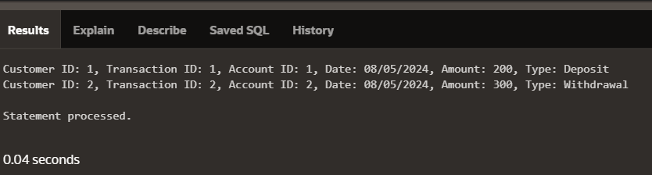

**SCENARIO 2:**

DECLARE

CURSOR c_accounts IS

SELECT AccountID, Balance

FROM Accounts;

v_account_id Accounts.AccountID%TYPE;

v_balance Accounts.Balance%TYPE;

v_annual_fee NUMBER := 50; -- Example annual fee

BEGIN

FOR rec IN c_accounts LOOP

v_account_id := rec.AccountID;

v_balance := rec.Balance;

-- Deduct the annual maintenance fee

UPDATE Accounts

SET Balance = v_balance - v_annual_fee

WHERE AccountID = v_account_id;

DBMS_OUTPUT.PUT_LINE('Account ID: ' || v_account_id || ' - Annual fee applied. New Balance: ' || (v_balance - v_annual_fee));

END LOOP;

COMMIT; -- Commit the changes

END;

/

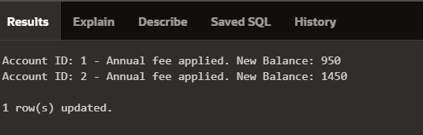

**SCENARIO 3:**

DECLARE

CURSOR c_loans IS

SELECT LoanID, InterestRate

FROM Loans;

v_loan_id Loans.LoanID%TYPE;

v_interest_rate Loans.InterestRate%TYPE;

v_new_interest_rate NUMBER; -- New interest rate based on policy

BEGIN

FOR rec IN c_loans LOOP

v_loan_id := rec.LoanID;

v_interest_rate := rec.InterestRate;

-- Set the new interest rate (example new policy rate)

v_new_interest_rate := v_interest_rate + 1; -- Example: increase by 1%

-- Update the interest rate

UPDATE Loans

SET InterestRate = v_new_interest_rate

WHERE LoanID = v_loan_id;

DBMS_OUTPUT.PUT_LINE('Loan ID: ' || v_loan_id || ' - Interest rate updated from ' || v_interest_rate || ' to ' || v_new_interest_rate);

END LOOP;

COMMIT; -- Commit the changes

END;

/

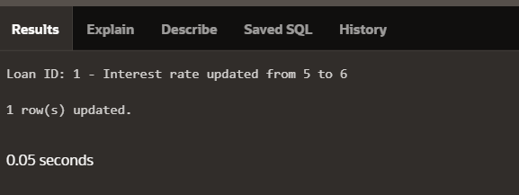

**Exercise 7: Packages**

**Scenario 1:** Group all customer-related procedures and functions into a package.

* + **Question:** Create a package **CustomerManagement** with procedures for adding a new customer, updating customer details, and a function to get customer balance.

**Scenario 2:** Create a package to manage employee data.

* + **Question:** Write a package **EmployeeManagement** with procedures to hire new employees, update employee details, and a function to calculate annual salary.

**Scenario 3:** Group all account-related operations into a package.

* + **Question:** Create a package **AccountOperations** with procedures for opening a new account, closing an account, and a function to get the total balance of a customer across all accounts.

**SCENARIO 1:**

**Package Specification (customer_management_spec.pks):**

CREATE OR REPLACE PACKAGE CustomerManagement AS

PROCEDURE AddCustomer(p_CustomerID IN NUMBER, p_Name IN VARCHAR2, p_DOB IN DATE, p_Balance IN NUMBER);

PROCEDURE UpdateCustomer(p_CustomerID IN NUMBER, p_Name IN VARCHAR2, p_DOB IN DATE, p_Balance IN NUMBER);

FUNCTION GetCustomerBalance(p_CustomerID IN NUMBER) RETURN NUMBER;

END CustomerManagement;

/

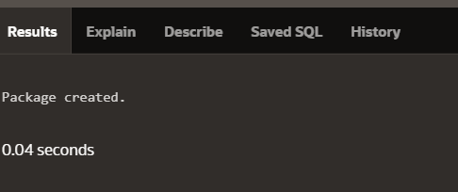

**Package Body** **(customer_management_body.pkb):**

CREATE OR REPLACE PACKAGE BODY CustomerManagement AS

PROCEDURE AddCustomer(p_CustomerID IN NUMBER, p_Name IN VARCHAR2, p_DOB IN DATE, p_Balance IN NUMBER) IS

BEGIN

INSERT INTO Customers (CustomerID, Name, DOB, Balance, LastModified)

VALUES (p_CustomerID, p_Name, p_DOB, p_Balance, SYSDATE);

EXCEPTION

WHEN DUP_VAL_ON_INDEX THEN

DBMS_OUTPUT.PUT_LINE('CustomerID already exists.');

END AddCustomer;

PROCEDURE UpdateCustomer(p_CustomerID IN NUMBER, p_Name IN VARCHAR2, p_DOB IN DATE, p_Balance IN NUMBER) IS

BEGIN

UPDATE Customers

SET Name = p_Name, DOB = p_DOB, Balance = p_Balance, LastModified = SYSDATE

WHERE CustomerID = p_CustomerID;

EXCEPTION

WHEN NO_DATA_FOUND THEN

DBMS_OUTPUT.PUT_LINE('CustomerID not found.');

END UpdateCustomer;

FUNCTION GetCustomerBalance(p_CustomerID IN NUMBER) RETURN NUMBER IS

v_Balance NUMBER;

BEGIN

SELECT Balance INTO v_Balance

FROM Customers

WHERE CustomerID = p_CustomerID;

RETURN v_Balance;

EXCEPTION

WHEN NO_DATA_FOUND THEN

RETURN NULL;

END GetCustomerBalance;

END CustomerManagement;

/

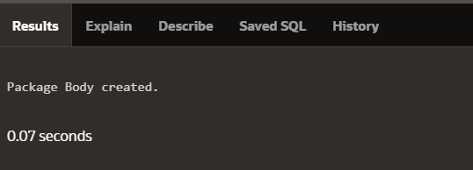

**SCENARIO 2:**

**Package Specification (employee_management_spec.pks):**

CREATE OR REPLACE PACKAGE EmployeeManagement AS

PROCEDURE HireEmployee(p_EmployeeID IN NUMBER, p_Name IN VARCHAR2, p_Position IN VARCHAR2, p_Salary IN NUMBER, p_Department IN VARCHAR2);

PROCEDURE UpdateEmployee(p_EmployeeID IN NUMBER, p_Name IN VARCHAR2, p_Position IN VARCHAR2, p_Salary IN NUMBER, p_Department IN VARCHAR2);

FUNCTION CalculateAnnualSalary(p_EmployeeID IN NUMBER) RETURN NUMBER;

END EmployeeManagement;

/



**Package Body (employee_management_body.pkb):**

CREATE OR REPLACE PACKAGE BODY EmployeeManagement AS

PROCEDURE HireEmployee(p_EmployeeID IN NUMBER, p_Name IN VARCHAR2, p_Position IN VARCHAR2, p_Salary IN NUMBER, p_Department IN VARCHAR2) IS

BEGIN

INSERT INTO Employees (EmployeeID, Name, Position, Salary, Department, HireDate)

VALUES (p_EmployeeID, p_Name, p_Position, p_Salary, p_Department, SYSDATE);

EXCEPTION

WHEN DUP_VAL_ON_INDEX THEN

DBMS_OUTPUT.PUT_LINE('EmployeeID already exists.');

END HireEmployee;

PROCEDURE UpdateEmployee(p_EmployeeID IN NUMBER, p_Name IN VARCHAR2, p_Position IN VARCHAR2, p_Salary IN NUMBER, p_Department IN VARCHAR2) IS

BEGIN

UPDATE Employees

SET Name = p_Name, Position = p_Position, Salary = p_Salary, Department = p_Department

WHERE EmployeeID = p_EmployeeID;

EXCEPTION

WHEN NO_DATA_FOUND THEN

DBMS_OUTPUT.PUT_LINE('EmployeeID not found.');

END UpdateEmployee;

FUNCTION CalculateAnnualSalary(p_EmployeeID IN NUMBER) RETURN NUMBER IS

v_Salary NUMBER;

BEGIN

SELECT Salary INTO v_Salary

FROM Employees

WHERE EmployeeID = p_EmployeeID;

RETURN v_Salary * 12;

EXCEPTION

WHEN NO_DATA_FOUND THEN

RETURN NULL;

END CalculateAnnualSalary;

END EmployeeManagement;

/



**SCENARIO 3:**

**Package Specification (account_operations_spec.pks):**

CREATE OR REPLACE PACKAGE AccountOperations AS

PROCEDURE OpenAccount(p_AccountID IN NUMBER, p_CustomerID IN NUMBER, p_AccountType IN VARCHAR2, p_Balance IN NUMBER);

PROCEDURE CloseAccount(p_AccountID IN NUMBER);

FUNCTION GetTotalBalance(p_CustomerID IN NUMBER) RETURN NUMBER;

END AccountOperations;

/



**Package Body (account_operations_body.pkb):**

CREATE OR REPLACE PACKAGE BODY AccountOperations AS

PROCEDURE OpenAccount(p_AccountID IN NUMBER, p_CustomerID IN NUMBER, p_AccountType IN VARCHAR2, p_Balance IN NUMBER) IS

BEGIN

INSERT INTO Accounts (AccountID, CustomerID, AccountType, Balance, LastModified)

VALUES (p_AccountID, p_CustomerID, p_AccountType, p_Balance, SYSDATE);

EXCEPTION

WHEN DUP_VAL_ON_INDEX THEN

DBMS_OUTPUT.PUT_LINE('AccountID already exists.');

END OpenAccount;

PROCEDURE CloseAccount(p_AccountID IN NUMBER) IS

BEGIN

DELETE FROM Accounts

WHERE AccountID = p_AccountID;

EXCEPTION

WHEN NO_DATA_FOUND THEN

DBMS_OUTPUT.PUT_LINE('AccountID not found.');

END CloseAccount;

FUNCTION GetTotalBalance(p_CustomerID IN NUMBER) RETURN NUMBER IS

v_TotalBalance NUMBER;

BEGIN

SELECT SUM(Balance) INTO v_TotalBalance

FROM Accounts

WHERE CustomerID = p_CustomerID;

RETURN NVL(v_TotalBalance, 0); -- Return 0 if no accounts are found

EXCEPTION

WHEN NO_DATA_FOUND THEN

RETURN 0;

END GetTotalBalance;

END AccountOperations;

/

