Task-1

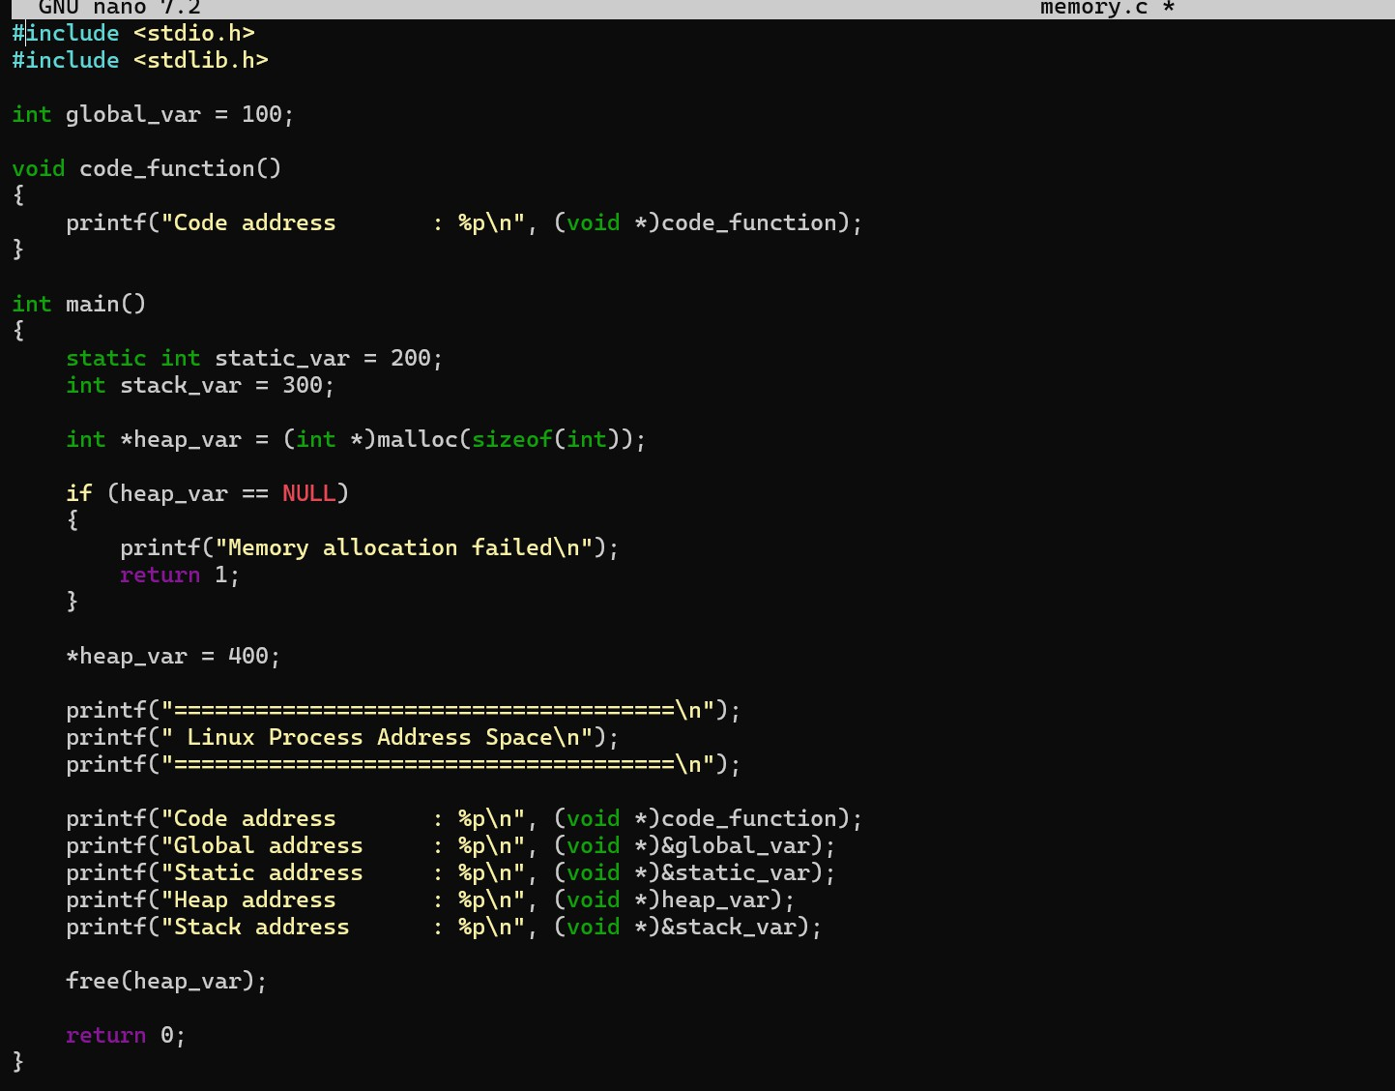
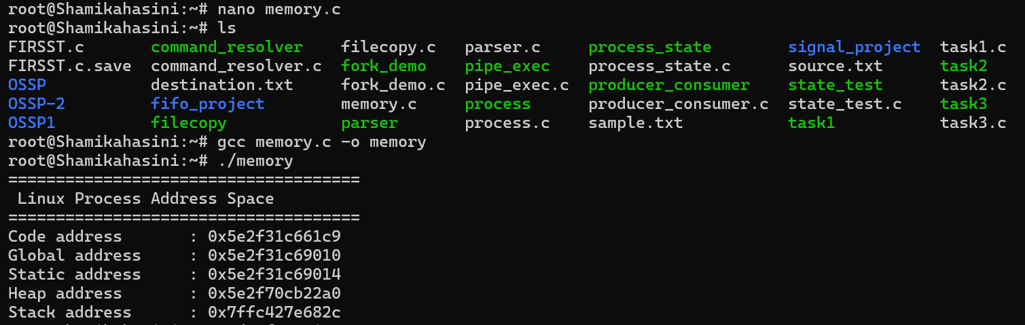
Write a program that prints the addresses Of code, global, static, heap, and stack variables. Analyze the Linux process address space layout and explain each memory segment.

Observation:
The program demonstrates the addresses of code, global, static, heap, and stack variables and analyzes the Linux process address space, which consists mainly of text/code, data, BSS, heap, and stack regions.

TASK-2
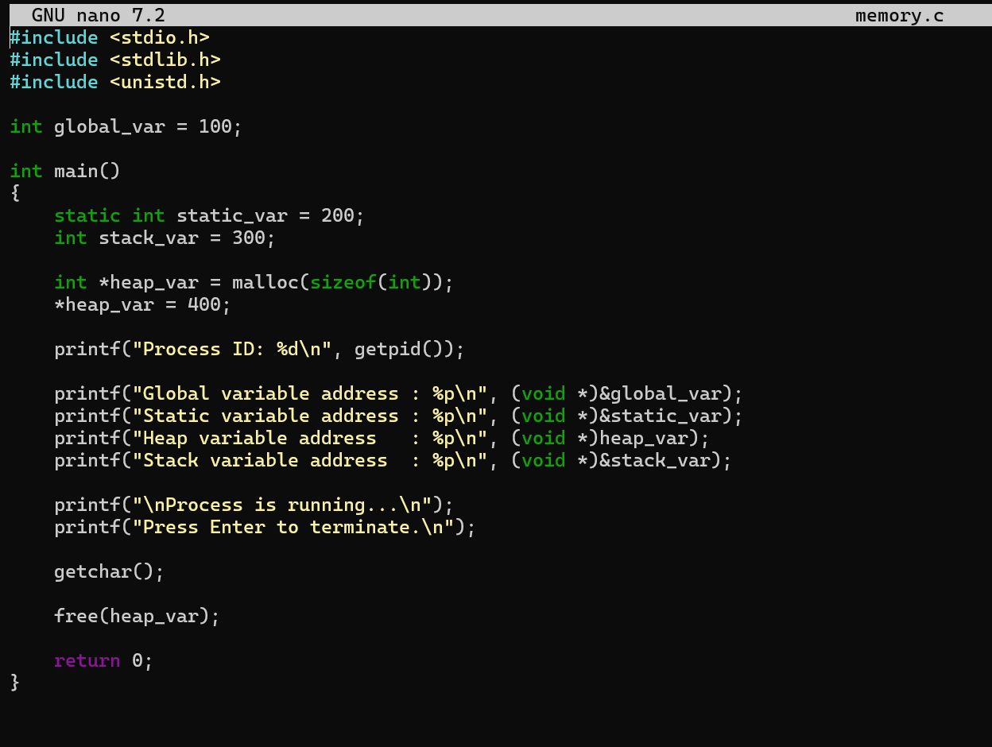
Make use of the /proc//maps file and memory analysis tools to study the memory organization of a running process. Prepare a report explaining virtual memory mappings.

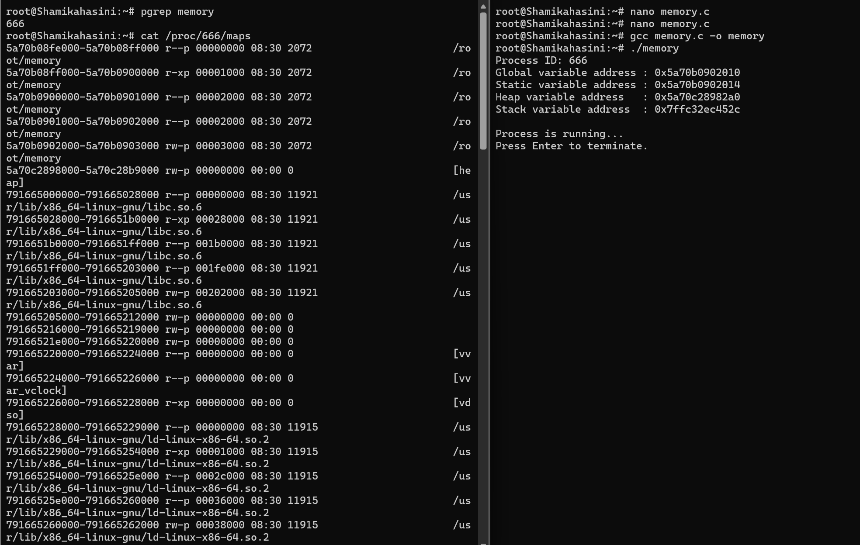
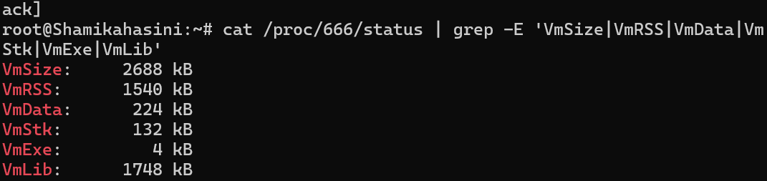

Observation

The /proc/666/maps file was used to observe the process's virtual memory layout. The code, data, heap, stack, and shared library regions were identified with their virtual addresses and permissions.

