

**Streamlining Ticket Assignment for Efficient Support Operations**

**Project Overview:**

At **ABC Corporation**, the increasing volume of support requests has highlighted the need for a more efficient and automated ticket management process. Currently, manual assignment of tickets often leads to delays, misrouting, and uneven workload distribution across support teams.

This project introduces an **automated ticket assignment system** designed to streamline support operations. Leveraging predefined rules, intelligent routing mechanisms, and workflow automation, the system ensures that each ticket is directed to the most suitable team or individual.

By implementing this solution, ABC Corporation aims to:

* **Reduce resolution delays** by eliminating manual routing errors.
* **Enhance customer satisfaction** through faster and more accurate issue handling.
* **Optimize resource utilization** by balancing workloads across support teams.
* **Improve operational transparency** with clear assignment logic and reporting.

Ultimately, this initiative supports the organization’s goal of delivering **high-quality, responsive, and efficient IT support services** while empowering teams to focus on problem resolution rather than administrative overhead.

## Table of Contents

1. Introduction
2. ProjectObjectives
3. Key Features
4. ServiceNow Developer Setup
5. Project Implementation in ServiceNow
6. Screenshots of Output
7. Conclusion

## **1. Introduction**

In today’s fast-paced business environment, timely and accurate handling of IT support requests is essential for maintaining productivity and customer satisfaction. At **ABC Corporation**, the growing number of support tickets has made manual assignment inefficient, often resulting in delays, misrouted issues, and increased workload on support staff.

To overcome these challenges, this project focuses on implementing an **automated ticket assignment system**. By leveraging workflow automation and intelligent routing, the system will ensure that tickets are assigned to the right teams or individuals without manual intervention. This not only improves response and resolution times but also enhances overall efficiency, resource utilization, and service quality within the support department.

## **2. Project Objective**

The primary objective of this project is to **implement an automated ticket assignment system** at **ABC Corporation** that enhances the efficiency of IT support operations. The solution is designed to:

* **Automate ticket routing** to ensure accurate and timely assignment to the appropriate support teams or individuals.
* **Reduce delays in issue resolution** by minimizing manual intervention and routing errors.
* **Improve customer satisfaction** through faster response times and consistent service delivery.
* **Optimize resource utilization** by balancing workloads across support teams.
* **Enhance operational transparency** with clear assignment logic, reporting, and monitoring capabilities.

By achieving these objectives, the project aims to transform the support process into a more **streamlined, reliable, and customer-centric system**.

## **3. Key Features**

* **Automated Routing** – Tickets assigned to the right team/person.
* **Dynamic Rules** – Configurable logic based on category, priority, etc.
* **Load Balancing** – Distributes workload evenly across teams.
* **Escalation Support** – Auto-escalates tickets nearing SLA breach.
* **Notifications** – Real-time alerts for quicker response.
* **Analytics** – Reports on ticket flow and team performance.

## **4. ServiceNow Developer Setup:**

**Create a Developer Account**

1. Go to ServiceNow Developer Portal(<https://developer.servicenow.com/dev.do>).

* Sign up for a free developer account and fill the following details.

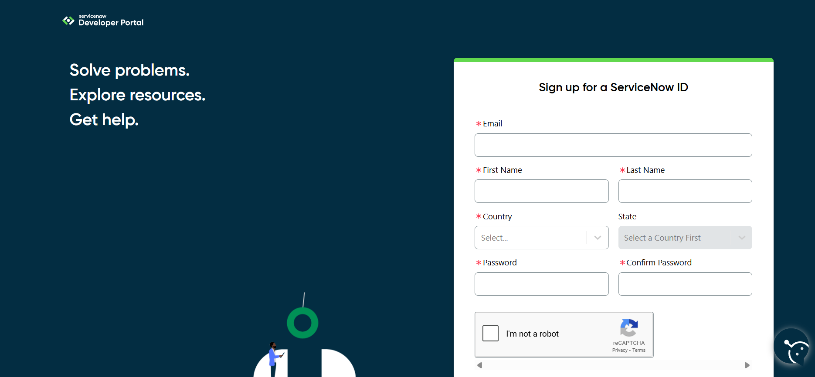

After signing up you will get an verification mail to you provided email id. After the verification your ServiceNow Developer Portal Home Page will appear

Now click on start building it will take you to the section where you can **request a Personal Developer Instance (PDI)** or start using **App Engine Studio** and other tools.

**Profile Icon (Top Right Corner)** → Manage your account, request instances, and check your developer profile.

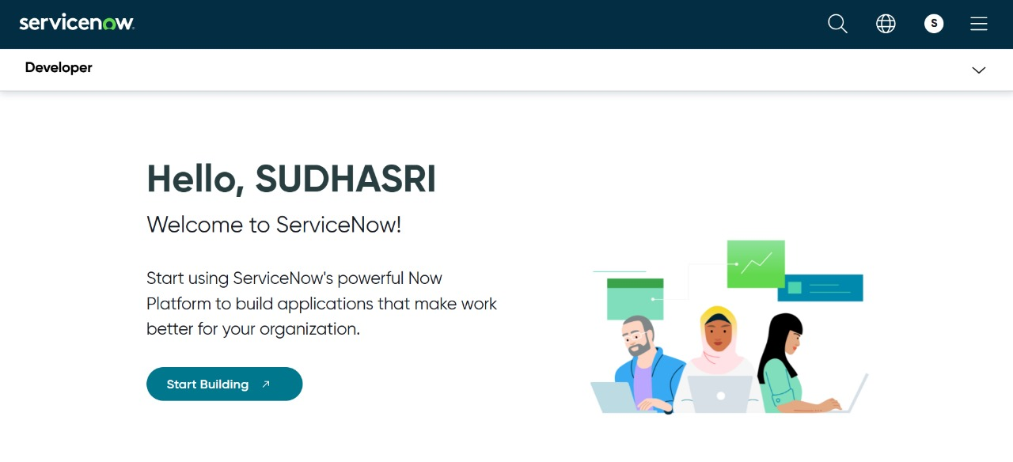

## **5. Project Implementation in ServiceNow:**

After the instance building is completed the page will be directed to your creator studio.

Creator Studio in ServiceNow provides a **guided, no-code environment** to build applications quickly. It is especially useful for creating **request-based applications** by defining forms, setting up tables, and automating workflows.

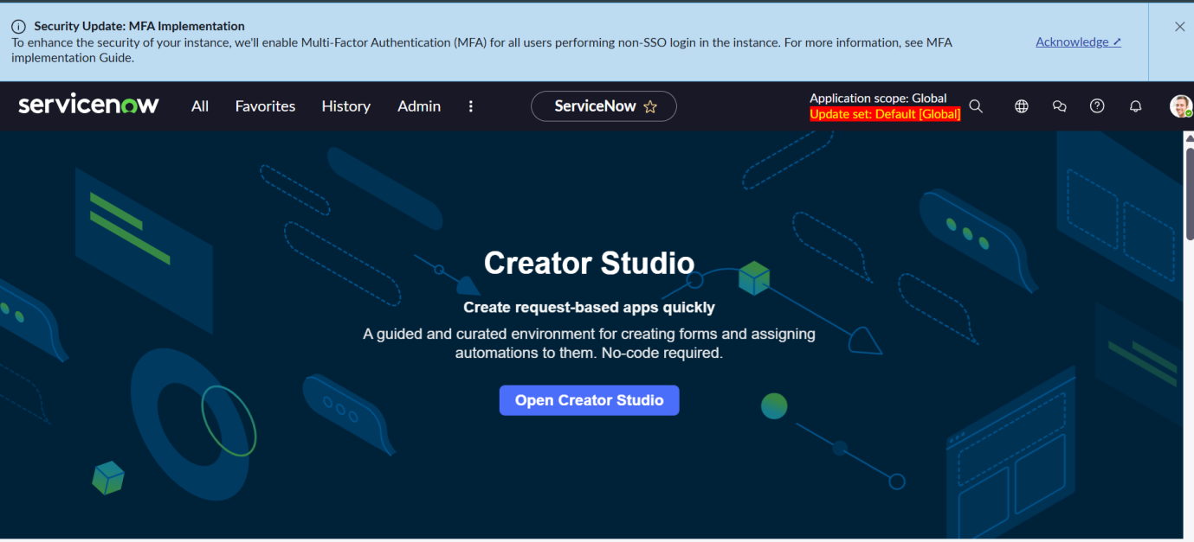

a. Creating Users:

1. In the left-hand navigation panel, click on **All** and search for **Users**.

1. Under **System Security**, select **Users**.

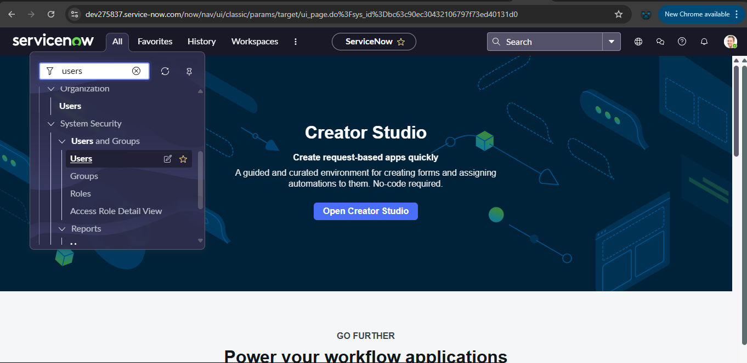

1. Click on **New** to create a new user record.
2. Fill in the required details (such as *First Name, Last Name, User ID, Email, Password, Roles*).
3. Click **Submit** to save the user.

Create the user by filling the following details:

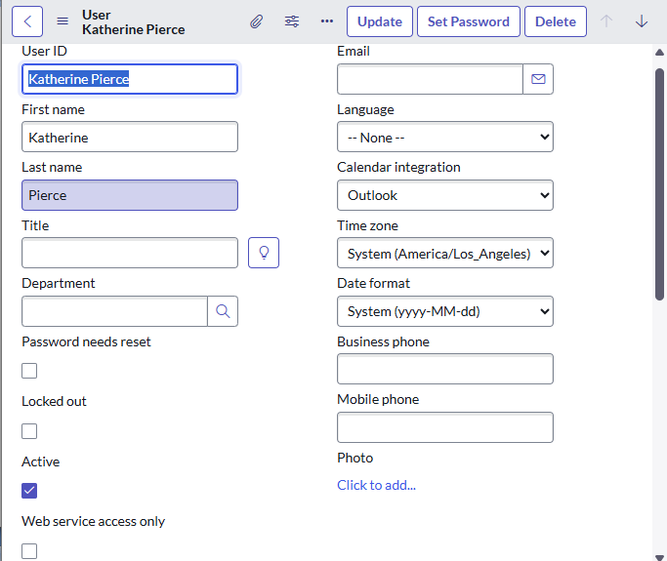

**Create another user:**

* Repeat the same steps to add a second user with different details.
* Click **Submit** again to save the second user.

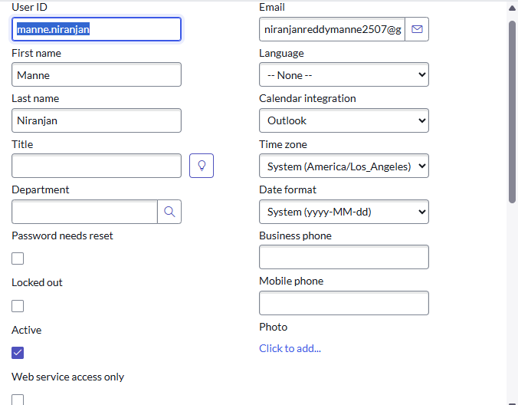

### b. Create Groups:

1. In the left-hand navigation panel, click on **All** and search for **Groups**.
2. Under **System Security**, select **Groups**.
3. Click on **New** to create a new group record.
4. Fill in the required details such as:

* **Name** – Group name.
* **Description** – Short description of the group
* **Manager** – Assign a manager if required.

1. Click **Submit** to save the group

Create the group by filling the following details:

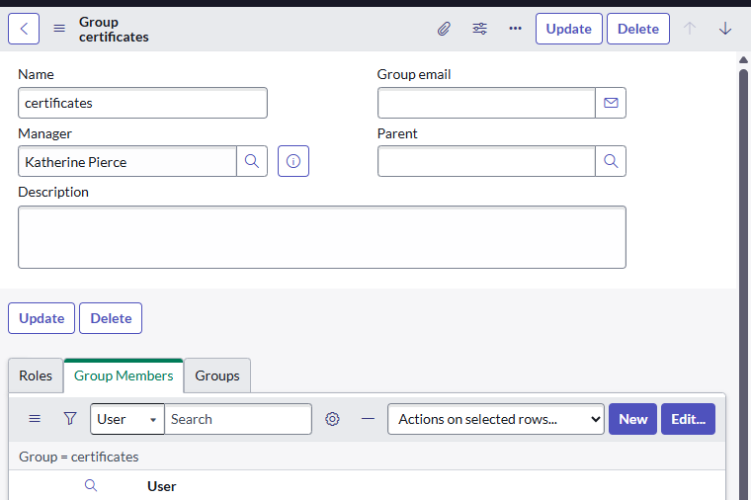

**Create another group:**

* Repeat the same steps to create a second group with different details.
* Click **Submit** again to save the second group.

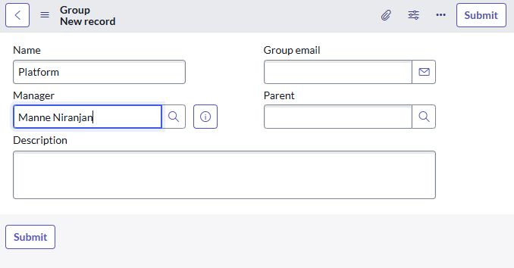

### c. Create Roles:

1. In the left navigation panel, select **All** → search for **Roles**.
2. Under **System Security**, click **Roles**.
3. Choose **New** to add a role.
4. Enter the required information, for example:
   * **Name** – A unique role identifier (e.g., *Certificate_role*).
   * **Description** – Brief details of what this role is meant for (e.g., Can deal with certification issues).
5. Click **Submit** to save.

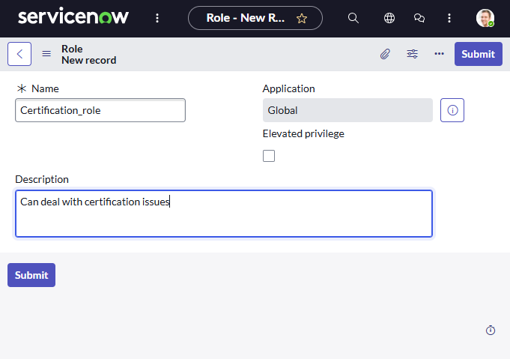

**Add another role:**

* Follow the same steps to define a second role.
* Role name as Platform_role and with suitable description.

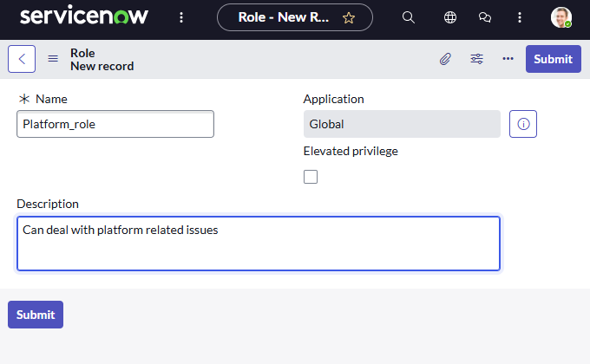

### d. Create Table:

1. In the left-hand navigation panel, click on **All** → search for **Tables**.

2. Under **System Definition**, select **Tables**.

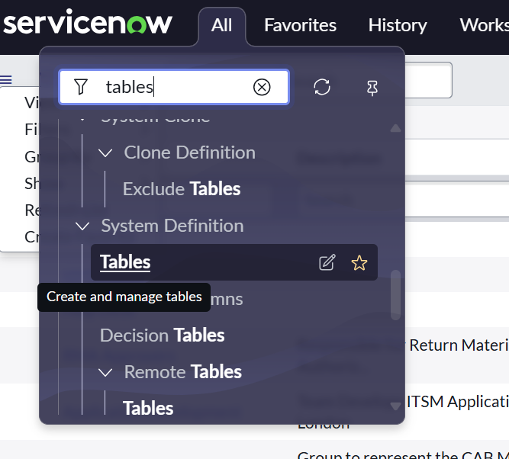

3. Click on **New** to create a new table.

4. Fill in the required details:

* **Label**: *Operations related*
* Check the boxes **Create module** and **Create mobile module**.
* **New menu name**: *Operations related*

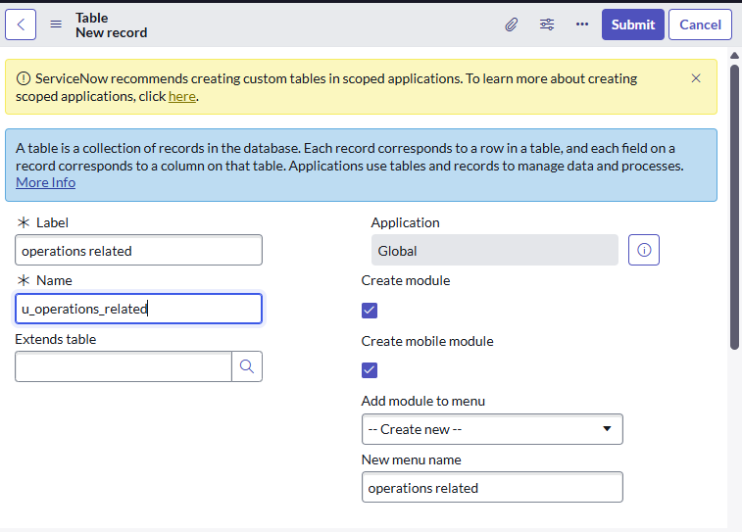

5. Define the **table columns** as per the project requirements (e.g., Issue, Description, Assigned To, Status).

1. Click **Submit** to save the table.

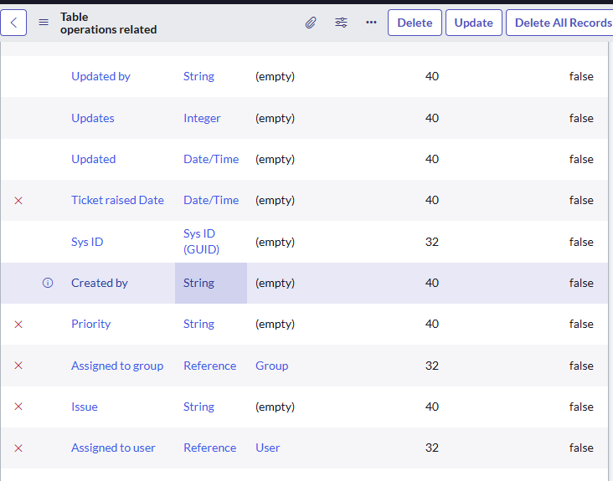

This custom table will act as the data storage for support tickets in our project. It allows us to capture details about issues raised by users and makes it possible to route them automatically to the right team. Without this table, we wouldn’t have a centralized place to manage project-specific records.

**Adding Choices for the *Issue* Field**

1. Navigate to the created table and open **Form Design**.
2. Select the **Issue** field.
3. Add the following choices:
   * *Unable to login to platform*
   * *404 error*
   * *Regarding certificates*
   * *Regarding user expired*

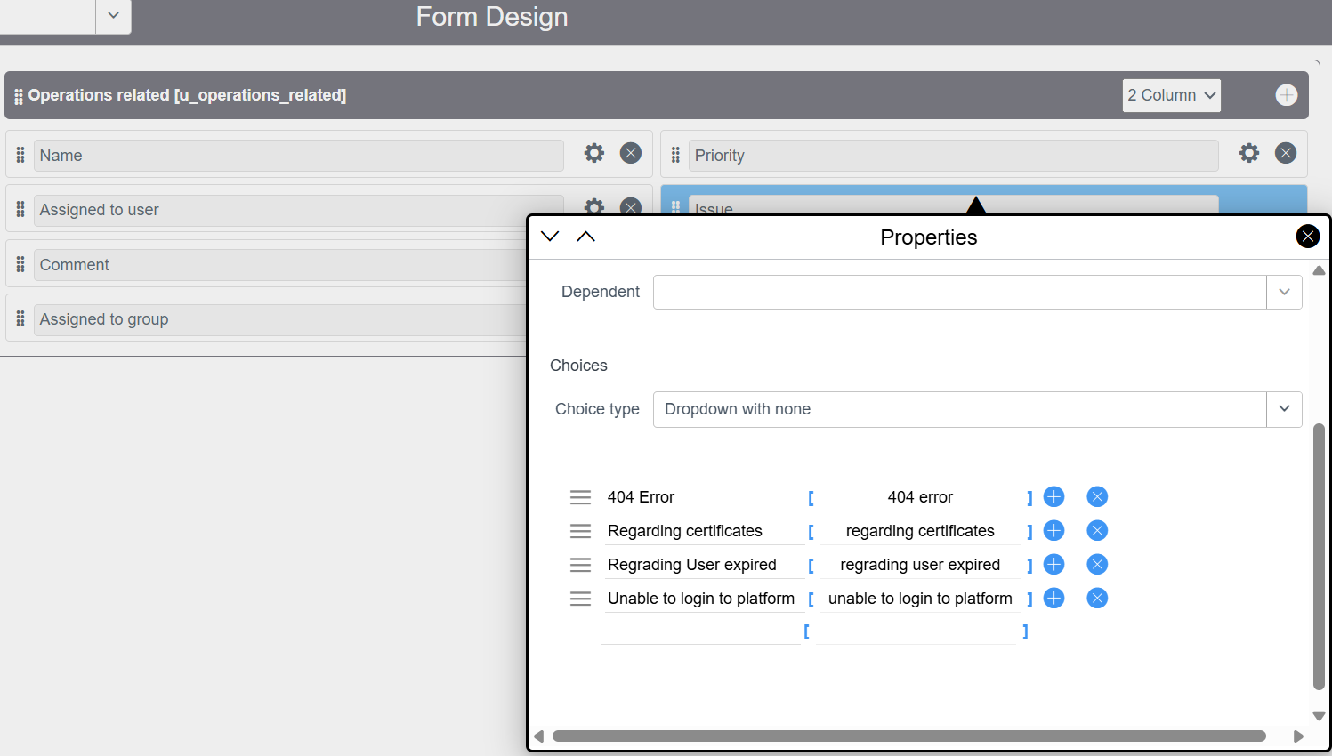

1. Save the form design.

The *Issue* field with predefined choices ensures **standardization** when users log problems. This avoids ambiguity (e.g., someone typing “login issue” vs. “can’t login”) and makes it easier to set up **automation rules** for ticket assignment later.

### e. Assign roles & users to groups:

### i. Assign roles & users to certificate group:

1. In the left-hand navigation panel, click on **All** → search for **Groups**.

2.Under **System Security**, select **Groups**.

3.Open the **Certificates Group** that was created earlier.

4.In the **Group Members** tab:

* Click **Edit**.
* Select *Katherine Pierce* as a member.
* Save the changes.

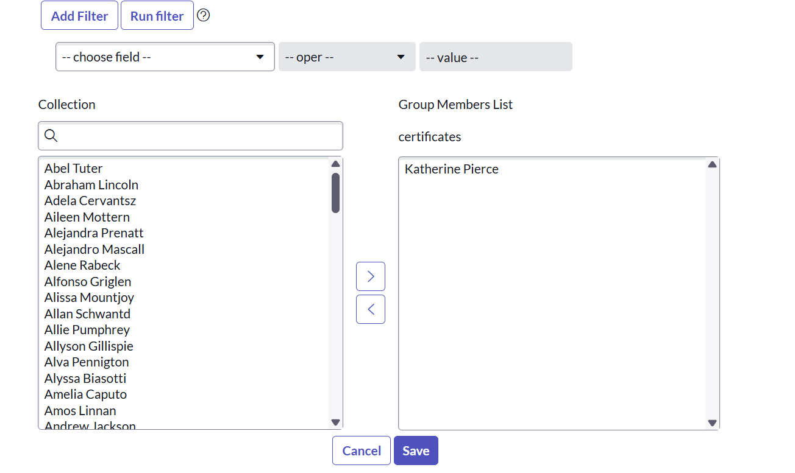

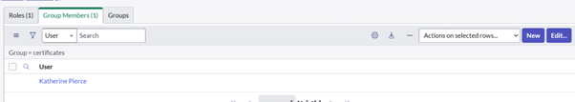

1. In the **Roles** tab:

* Click **Edit**.
* Select *Certification_role*.
* Save the changes.

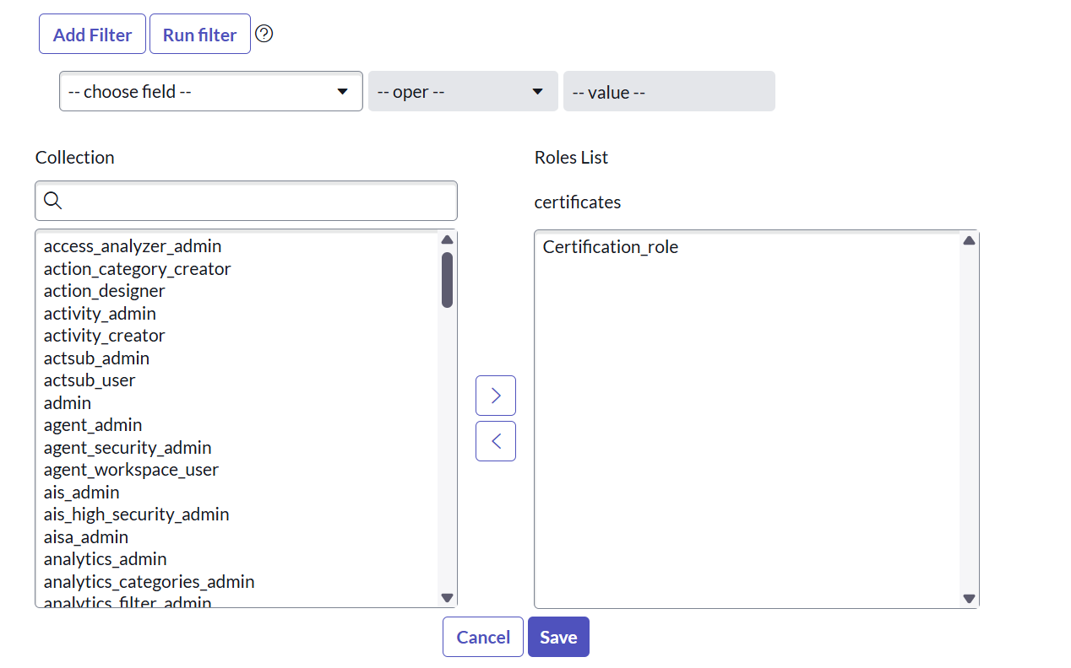

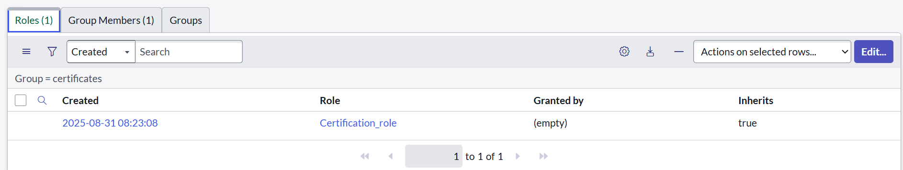

Assigning users and roles to the **Certificates Group** ensures that only authorized members can handle **certificate-related support tickets**. This allows proper **access control**, ensures **responsibility assignment**, and enables the ticket assignment automation to work correctly.

### ii. Assign roles & users to platform group:

1. In the left-hand navigation panel, click on **All** → search for **Groups**.

2. Under **System Security**, select **Groups**.

3. From the list of groups, open the **platform group**.

4. In the **Group Members** tab:

* Click **Edit**.
* Select *Manne Niranjan*from the available users.
* Save the changes.

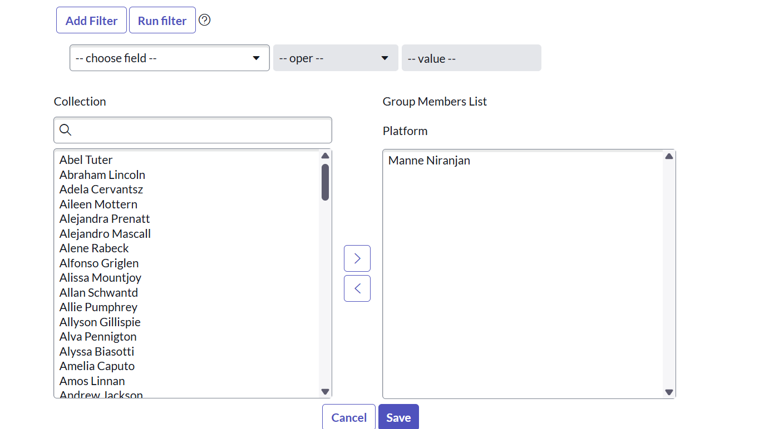

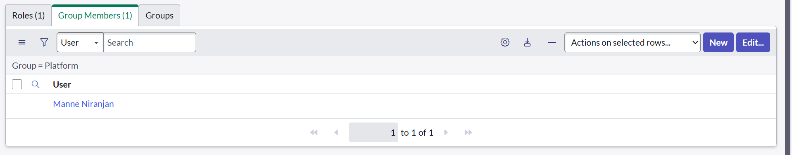

5. In the **Roles** tab:

* Click **Edit**.
* Select *platform group*from the available roles.
* Save the changes.

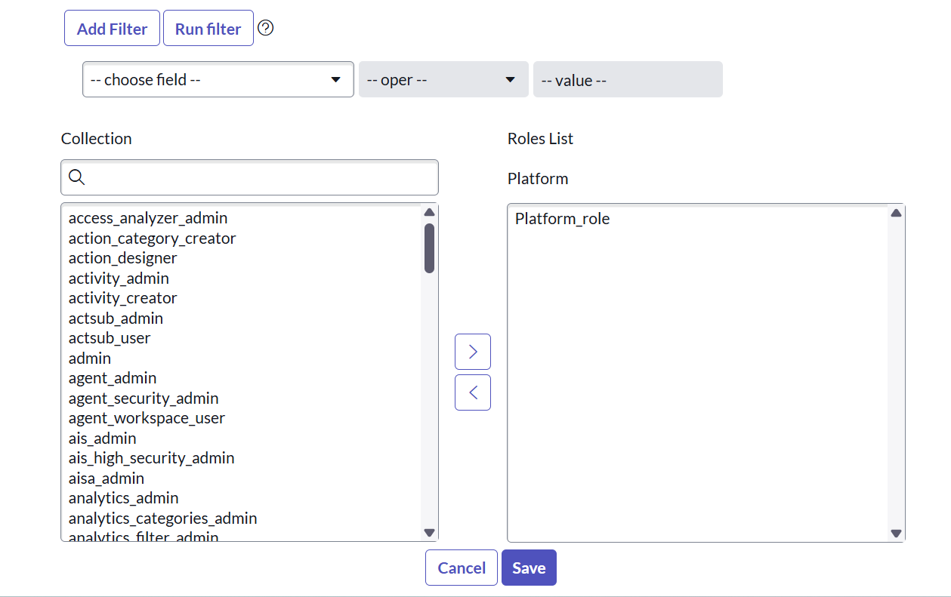

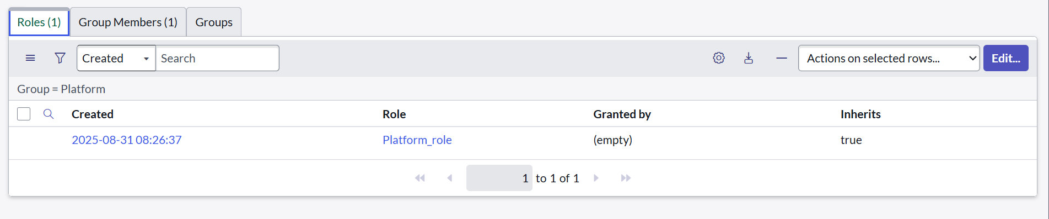

### f. Assign role to table:

1. In the left-hand navigation panel, click on **All** → search for **Tables**.
2. From the list, select the **Operations related** table.
3. Go to the **Application Access** tab.
4. Click on your profile (top-right corner).

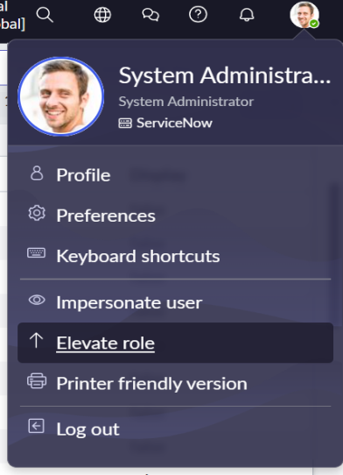

1. Select **Elevate Role** → choose **security_admin** → click **Update**.

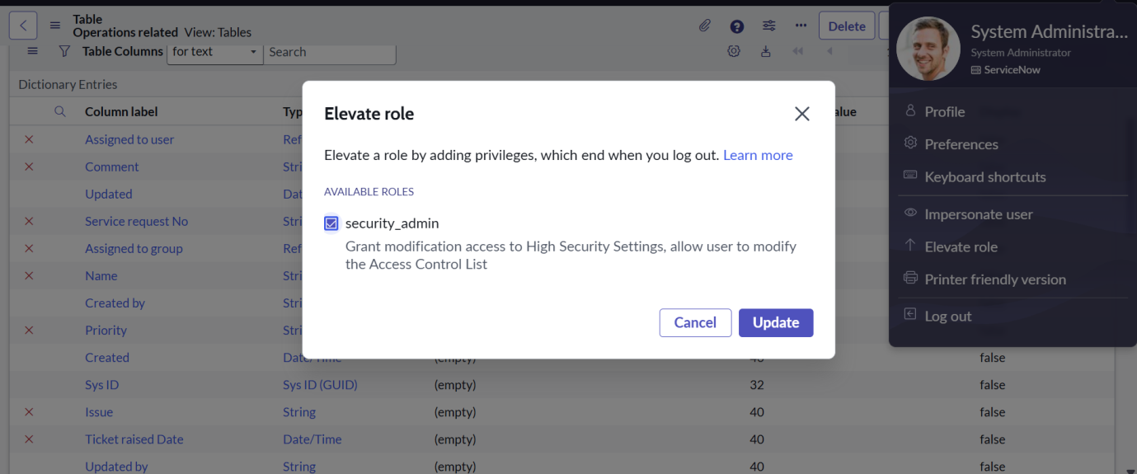

1. Under **u_operations_related [Read] operation**:

* In **Requires Role**, double-click to insert a new row.
* Add **platform_role** and **certificate_role**.
* Click **Update**.

1. Under **u_operations_related [Write] operation**:

* In **Requires Role**, double-click to insert a new row.
* Add **platform_role** and **certificate_role**.
* Click **Update**

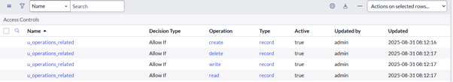

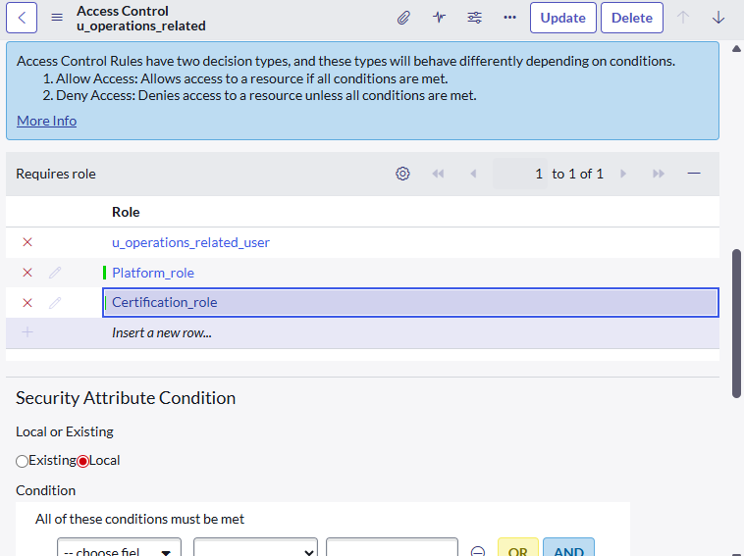

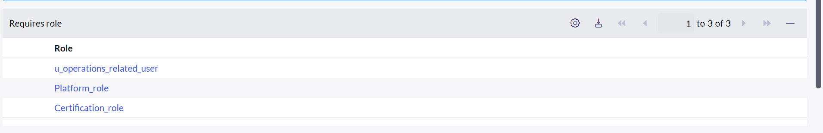

Assigning roles to the **Operations related** table ensures that only authorized users (those with **Platform Role** or **Certificate Role**) can **read** and **write** records. This provides **data security**, **controlled access**, and ensures tickets are handled only by the correct teams.

### g. Creating Access Control Rules (ACL):

1.**Open ServiceNow** and log in to your Personal Developer Instance (PDI).

2. In the left-hand navigation panel, click on **All** → search for **ACL**.

3. Under **System Security**, select **Access Control (ACL)**.

4. Click on **New** to create a new ACL.

5. Fill in the required details for the ACL rule (such as *Table, Operation, Field*).

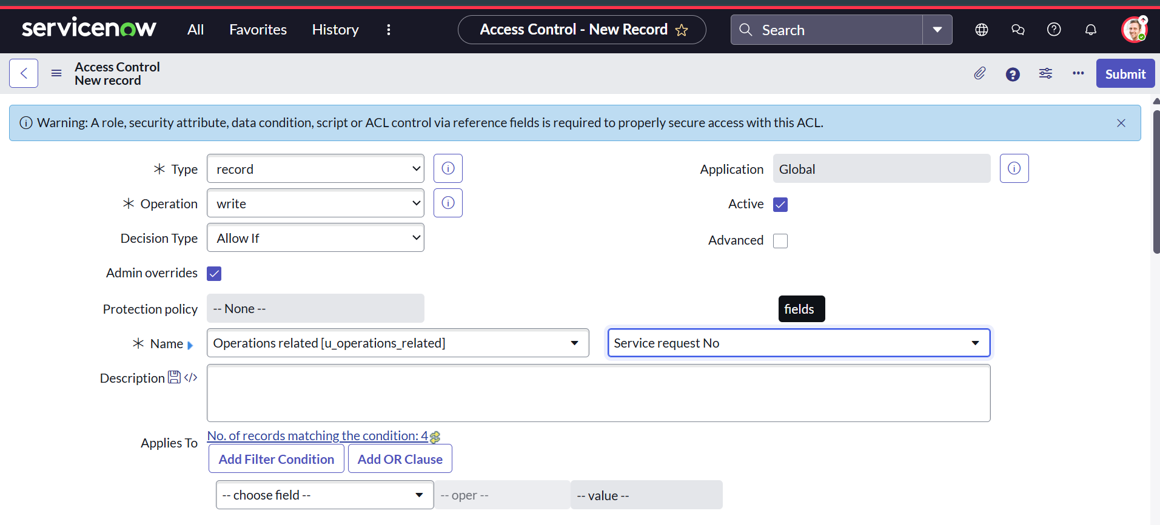

6. Scroll down to the **Requires Role** section.

* Double-click on **Insert a new row**.
* Add the **admin** role.

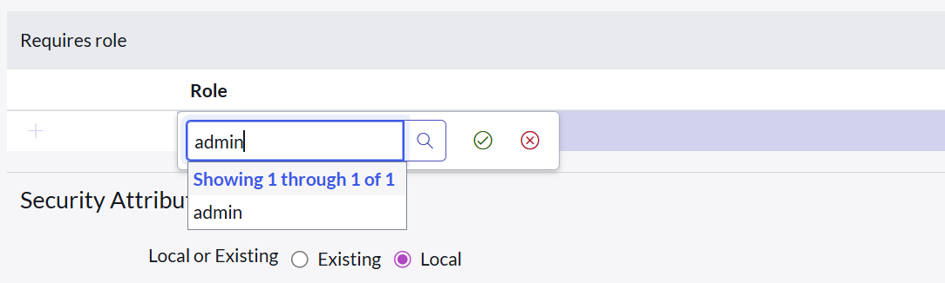



7. Click **Submit** to save the ACL.

**Similarly, create four ACLs** for the following fields:

* Field 1: Issue
* Field 2: Priority
* Field 3: Ticket raised Date

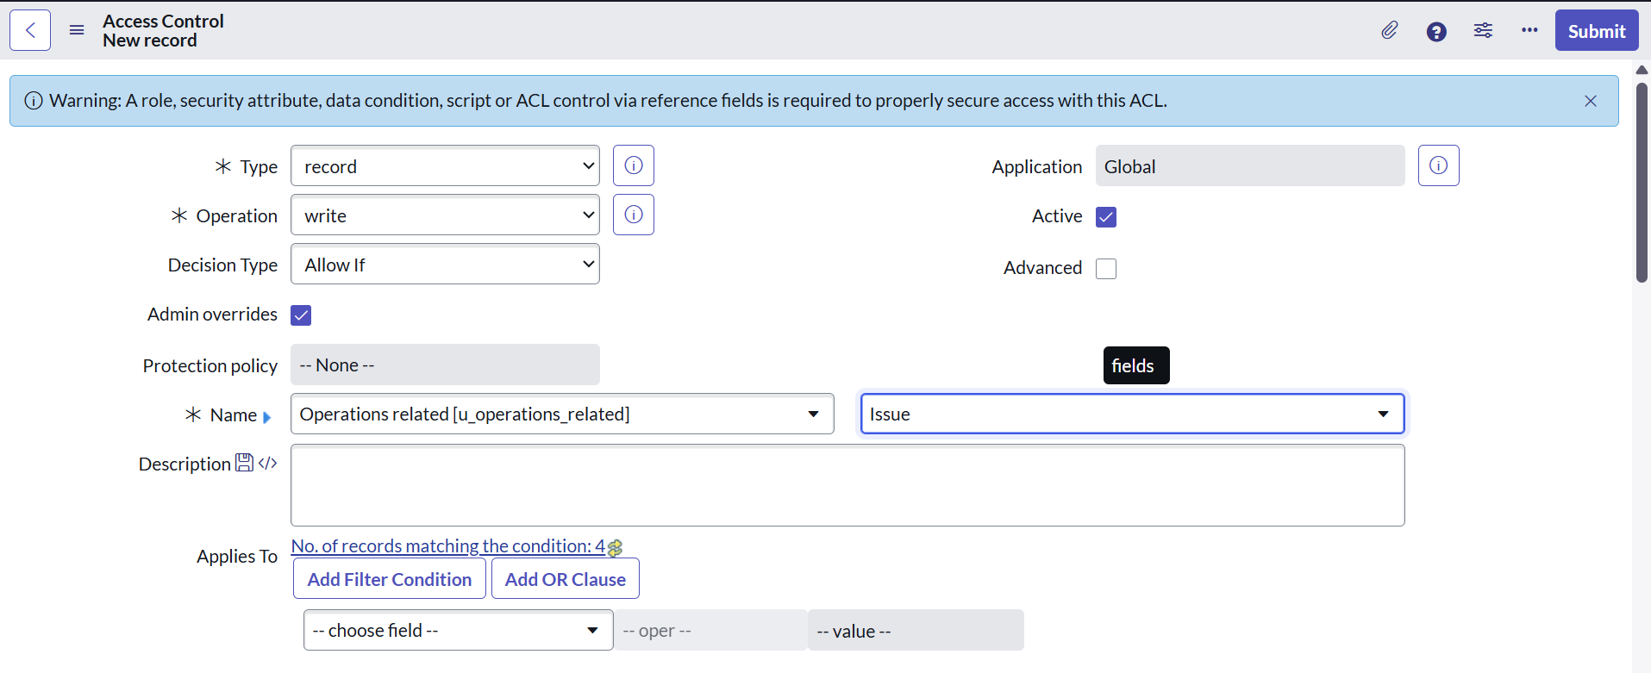

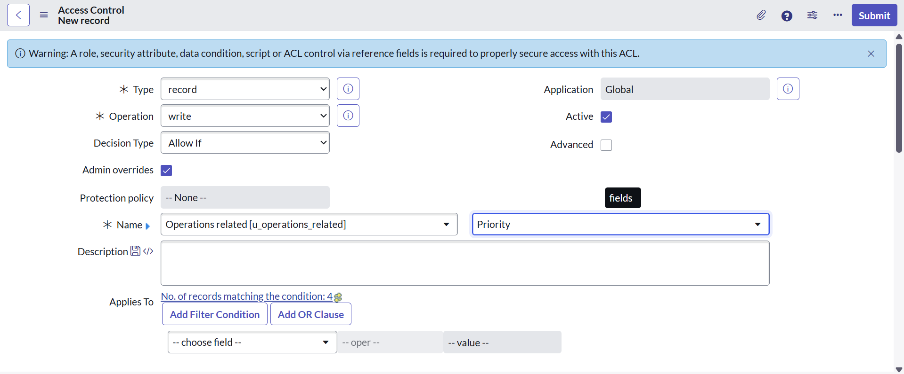

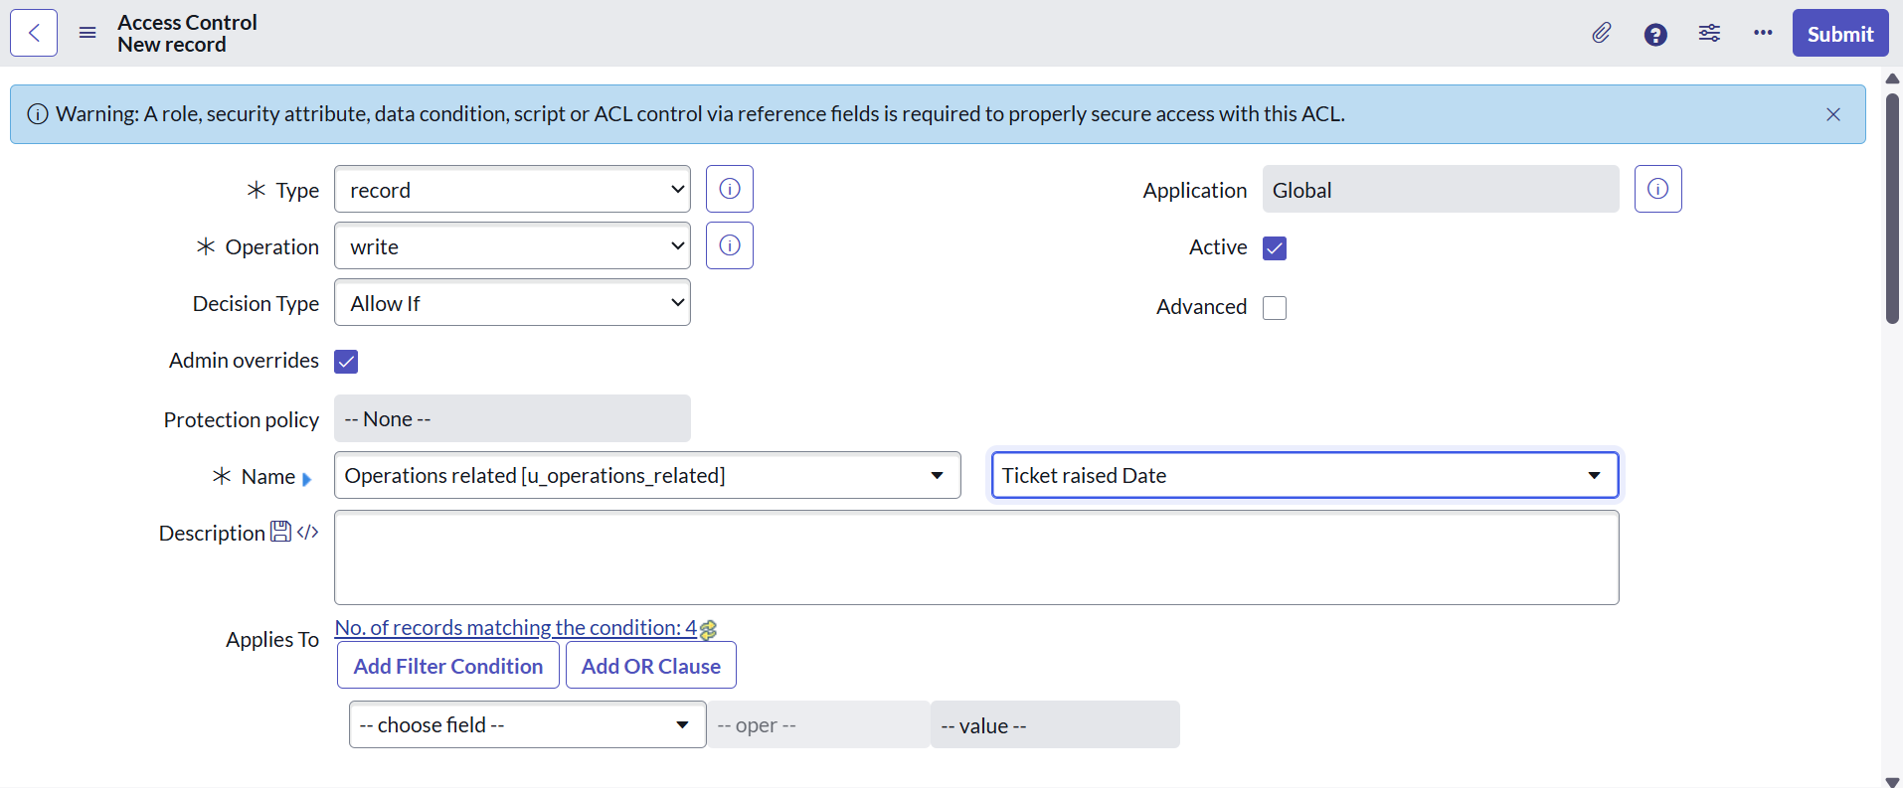

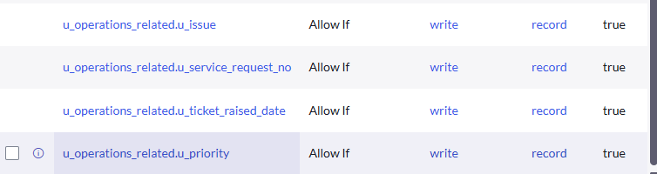

ACLs (Access Control Rules) provide **granular security** at the **table and field level**. By creating these ACLs, we ensure that only users with the **admin role** (or other required roles) can access or modify sensitive fields. This prevents unauthorized actions and protects critical data in the **Operations related** table.

### h. Flow:

### i. Create a Flow to Assign operations ticket to group:

1. **Open ServiceNow** and log in to your instance.
2. In the left navigation panel, click on **All** → search for **Flow Designer**.
3. Select **Flow Designer** under *Process Automation*.

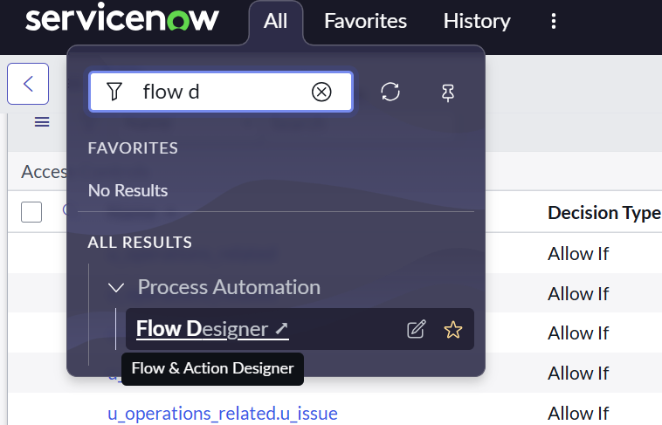

1. Once Flow Designer opens, click on **New** → select **Flow**.

**Configure Flow Properties:**

* **Flow Name:***Regarding Certificate*
* **Application:***Global*
* **Run As User:***System User*
* Click **Submit**.

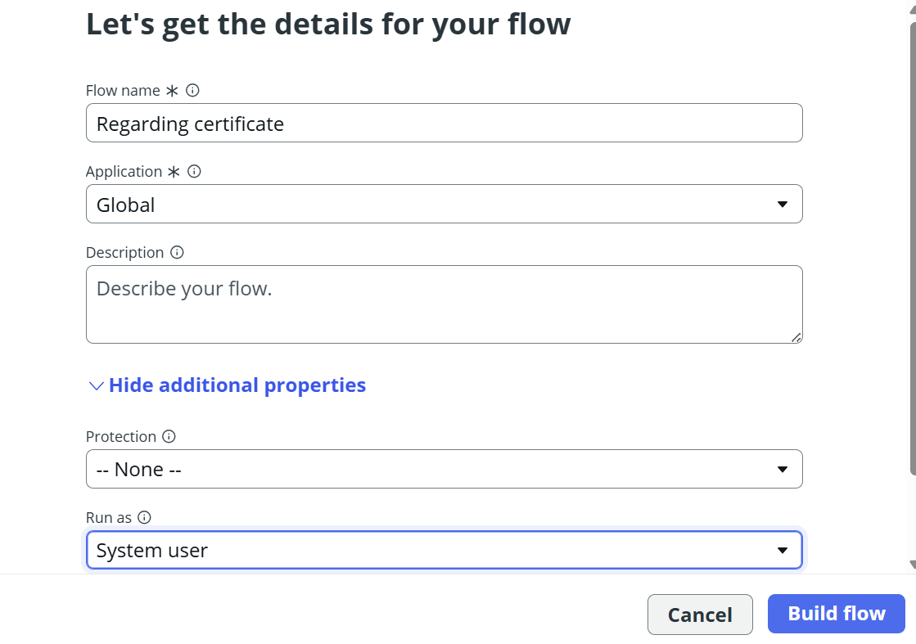

**Add a Trigger:**

1. Click **Add a trigger**.
2. Search and select **Create or update a record**.
3. In the configuration:
   * **Table:***Operations related*
   * **Condition:**
     + *Field:* Issue
     + *Operator:* is
     + *Value:* Regarding Certificates
4. Click **Done**.

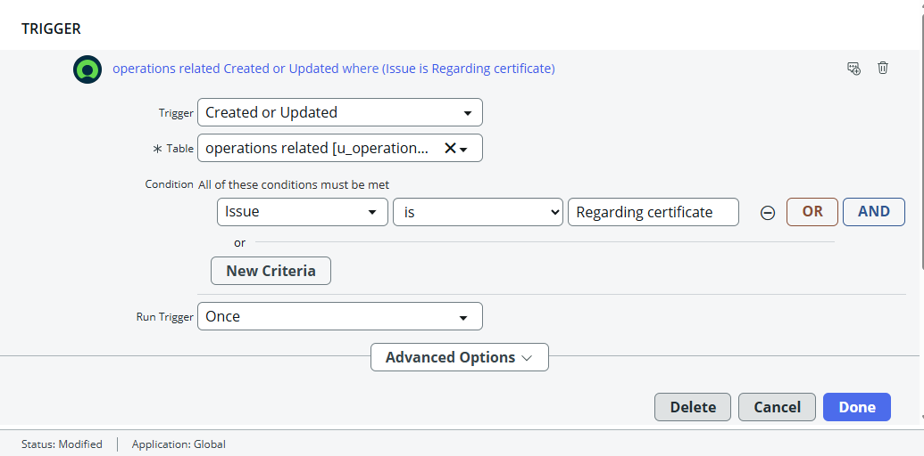

**Add an Action:**

1. Click **Add an action**.
2. Search for **Update Record** and select it.
3. In the **Record field**, drag the required fields from the **Data Panel** on the left.
4. Configure the update:
   * **Table:***Auto-assigned from trigger*
   * **Field:** Assigned to Group
   * **Value:** Certificates
5. Click **Done**.

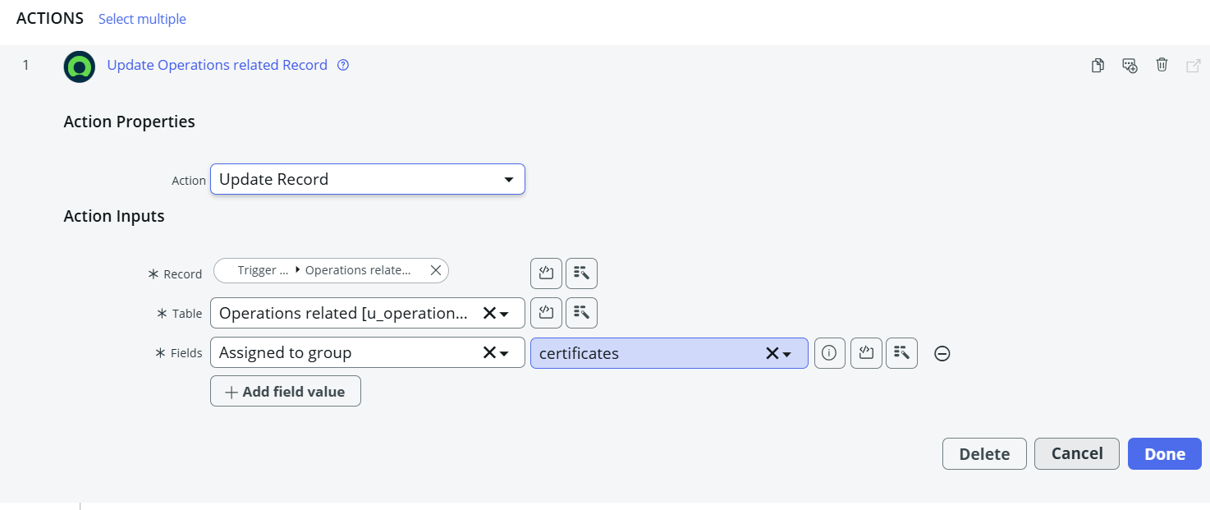

**Final Steps:**

* Click **Save** to save the Flow.
* Click **Activate** to enable it.

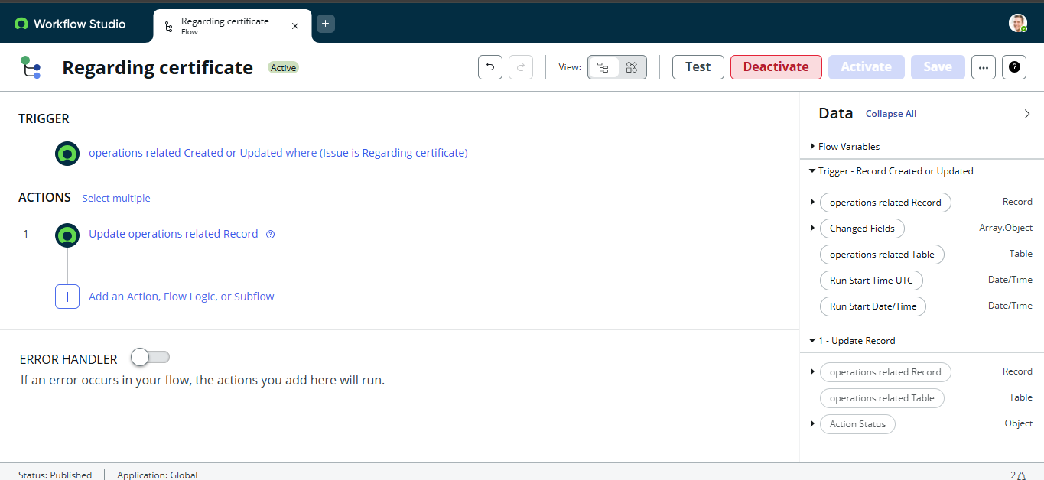

This Flow ensures that whenever a new **Operations related** ticket is created with the issue *"Regarding Certificates"*, it will be **automatically routed** to the **Certificates group**. This eliminates manual assignment, speeds up issue resolution, and improves efficiency in ticket handling.

### ii. Create a Flow to Assign operations ticket to Platform group:

1. **Open ServiceNow** and log in to your instance.
2. In the left navigation panel, click on **All** → search for **Flow Designer**.
3. Select **Flow Designer** under *Process Automation*.
4. Once Flow Designer opens, click on **New** → select **Flow**.

**Configure Flow Properties:**

* **Flow Name:***Regarding Platform*
* **Application:***Global*
* **Run As User:***System User*
* Click **Submit**.

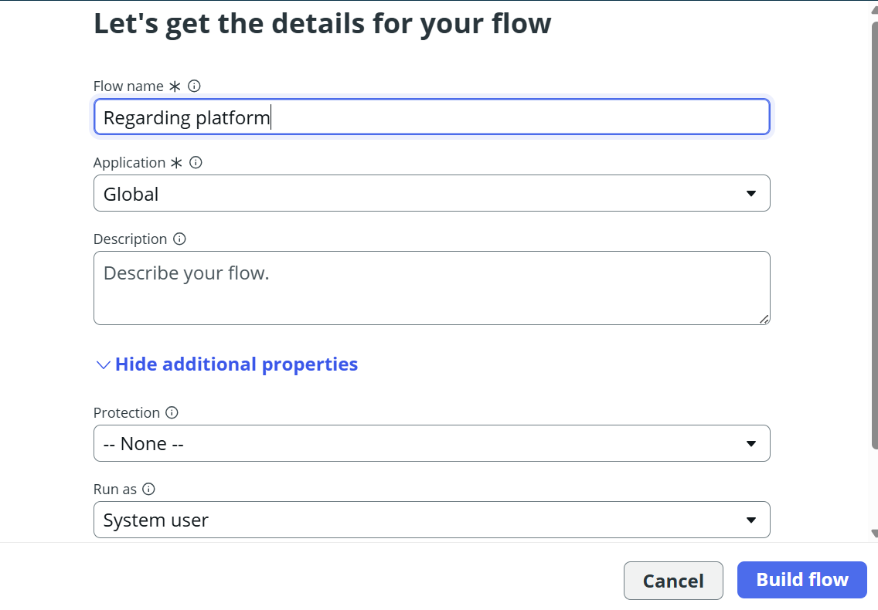

**Add a Trigger:**

1. Click **Add a trigger**.
2. Search and select **Create or update a record**.
3. Configure the trigger:
   * **Table:***Operations related*
   * **Conditions:**
     + *Field:* Issue → *is* → *Unable to login to platform*
     + Click **New Criteria** → *Issue → is → 404 Error*
     + Click **New Criteria** → *Issue → is → Regarding User expired*
4. Click **Done**.

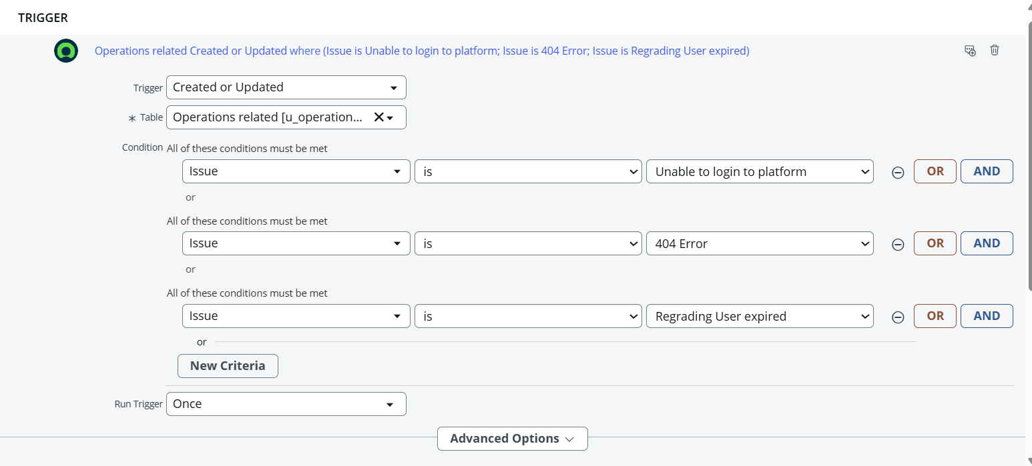

**Add an Action:**

1. Click **Add an action**.
2. Search for **Update Record** and select it.
3. In the **Record field**, drag the fields from the **Data Panel** on the left.
4. Configure the update:
   * **Table:***Auto-assigned from trigger*
   * **Field:** Assigned to Group
   * **Value:** Platform
5. Click **Done**.

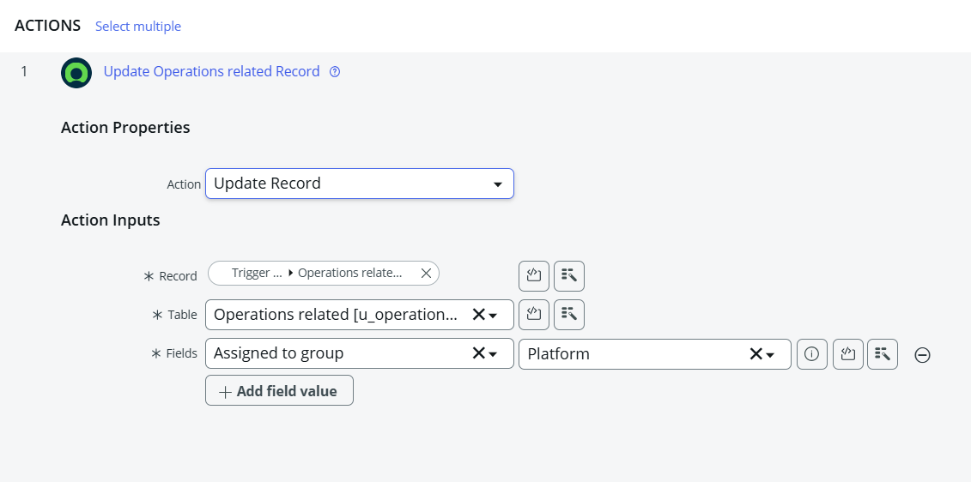

**Final Steps:**

* Click **Save** to save the Flow.
* Click **Activate** to enable it.

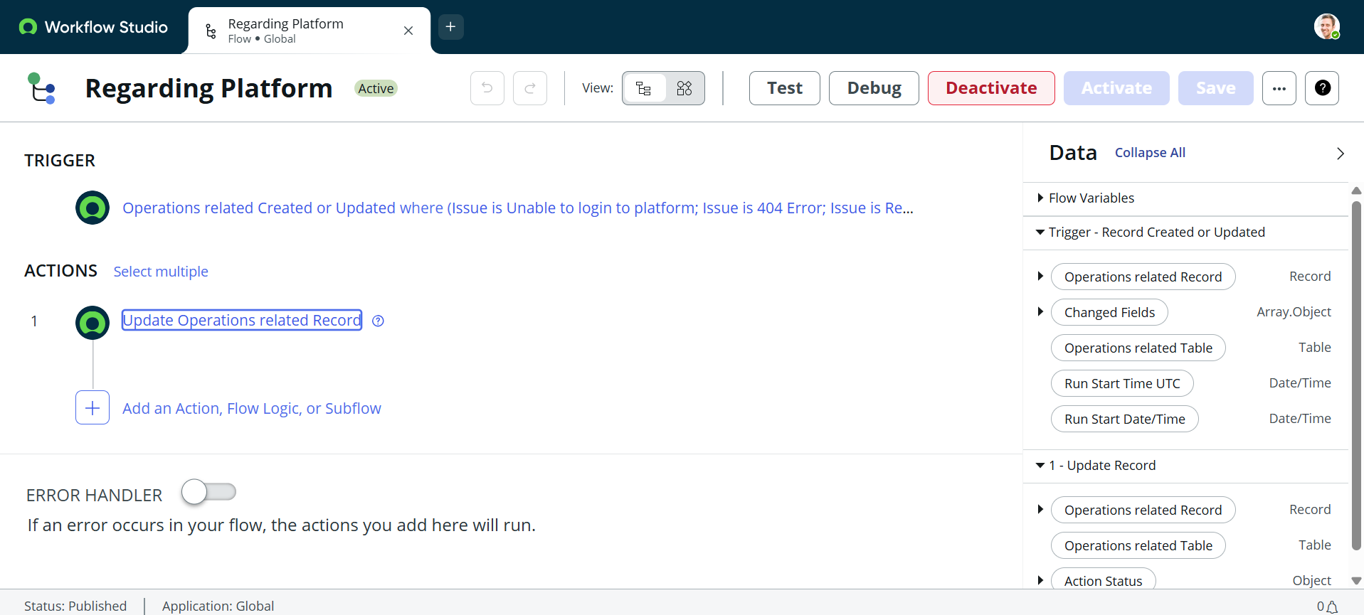

This Flow ensures that all tickets in the **Operations related** table with issues like *“Unable to login to platform”*, *“404 Error”*, or *“Regarding User expired”* are **automatically assigned** to the **Platform group**. This reduces manual intervention, speeds up resolution times, and ensures tickets reach the correct support team without delays.

## **6. Screenshots of Output:**

After implementing the Flows in ServiceNow, the ticket assignment works as follows:

* When a ticket is created in the **Operations related** table with the issue **“Regarding Certificates”**, it is **automatically assigned** to the **Certificates group**.
* When a ticket is created with issues like **“Unable to login to platform”**, **“404 Error”**, or **“Regarding User expired”**, it is **automatically assigned** to the **Platform group**

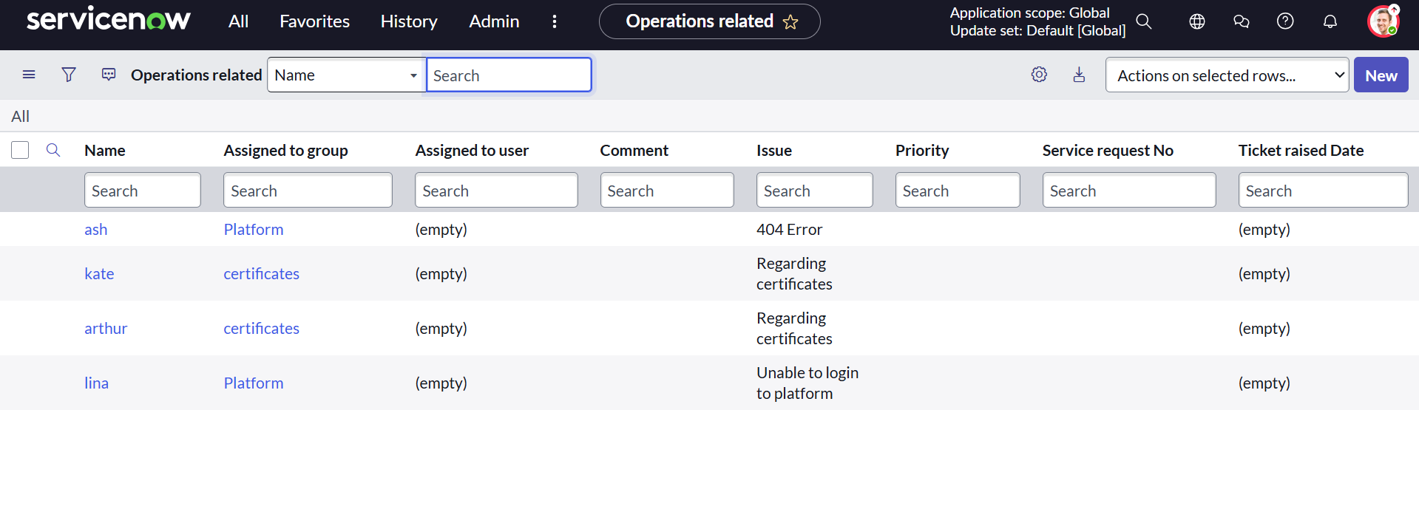

## **7. Conclusion:**

The implementation of automated ticket assignment in ServiceNow has streamlined the support operations at **ABC Corporation**. By leveraging **Flow Designer**, tickets are now intelligently routed to the correct support groups based on the issue type. This eliminates manual intervention, reduces delays, and ensures efficient handling of incidents.

With the setup of **users, groups, roles, tables, ACLs, and automated flows**, the support process is now:

* **Faster** – Tickets reach the right team instantly.
* **Accurate** – Reduced chances of misrouting.
* **Efficient** – Optimized resource utilization across support groups.
* **Customer-focused** – Improved resolution times lead to higher customer satisfaction.

In summary, this project demonstrates how ServiceNow can be used to **enhance IT service management (ITSM)** by automating repetitive tasks and empowering support teams to focus on resolving issues rather than managing ticket assignments.

**GitHub link:** https://github.com/sudhasri7/Streamlining-Ticket-Assignment-for-Efficient-Support-Operations