Simplilearn FullStack Java Developer Phase 2

Project 1

GitHub: https://github.com/sudhee46/SshRemoteRepo/tree/master/Project_Phase1

IDE: Eclipse IDE for Enterprise Java and Web Developers (includes Incubating components)

Version: 2022-03 (4.23.0)

Core Libraries:

MySQL

Hibernate

JSP/Servlet/HTML

Description:

Learner’s Academy is a school that has an online management system. The system keeps track of its classes, subjects, students, and teachers. It has a back-office application with a single administrator login.

Sprint 1:

Setup Database and provide master List in Java EE for all entities

- Classes

- Subjects

- Teacher

- Student

Sprint 2:

Implement the Assignments:

- Student to class

- Subject to Teacher

- Subject to Class

Sprint 3:

Class Report

Improvements in Navigation

Clean Up

Screenshots:

Welcome Page: Navigation to all Sites is possible

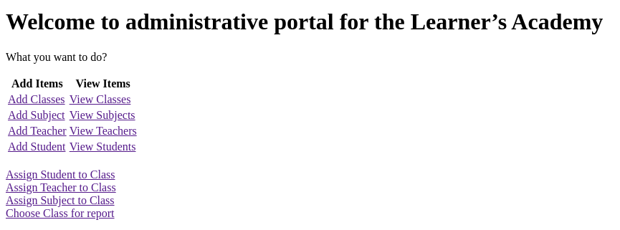

Create the Masterlists:



