Project Outputs.

1) Home Page.
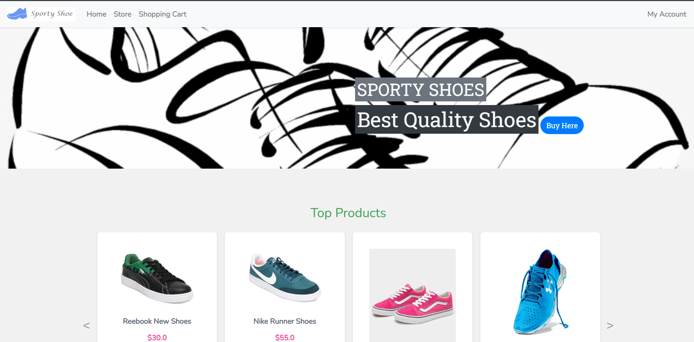
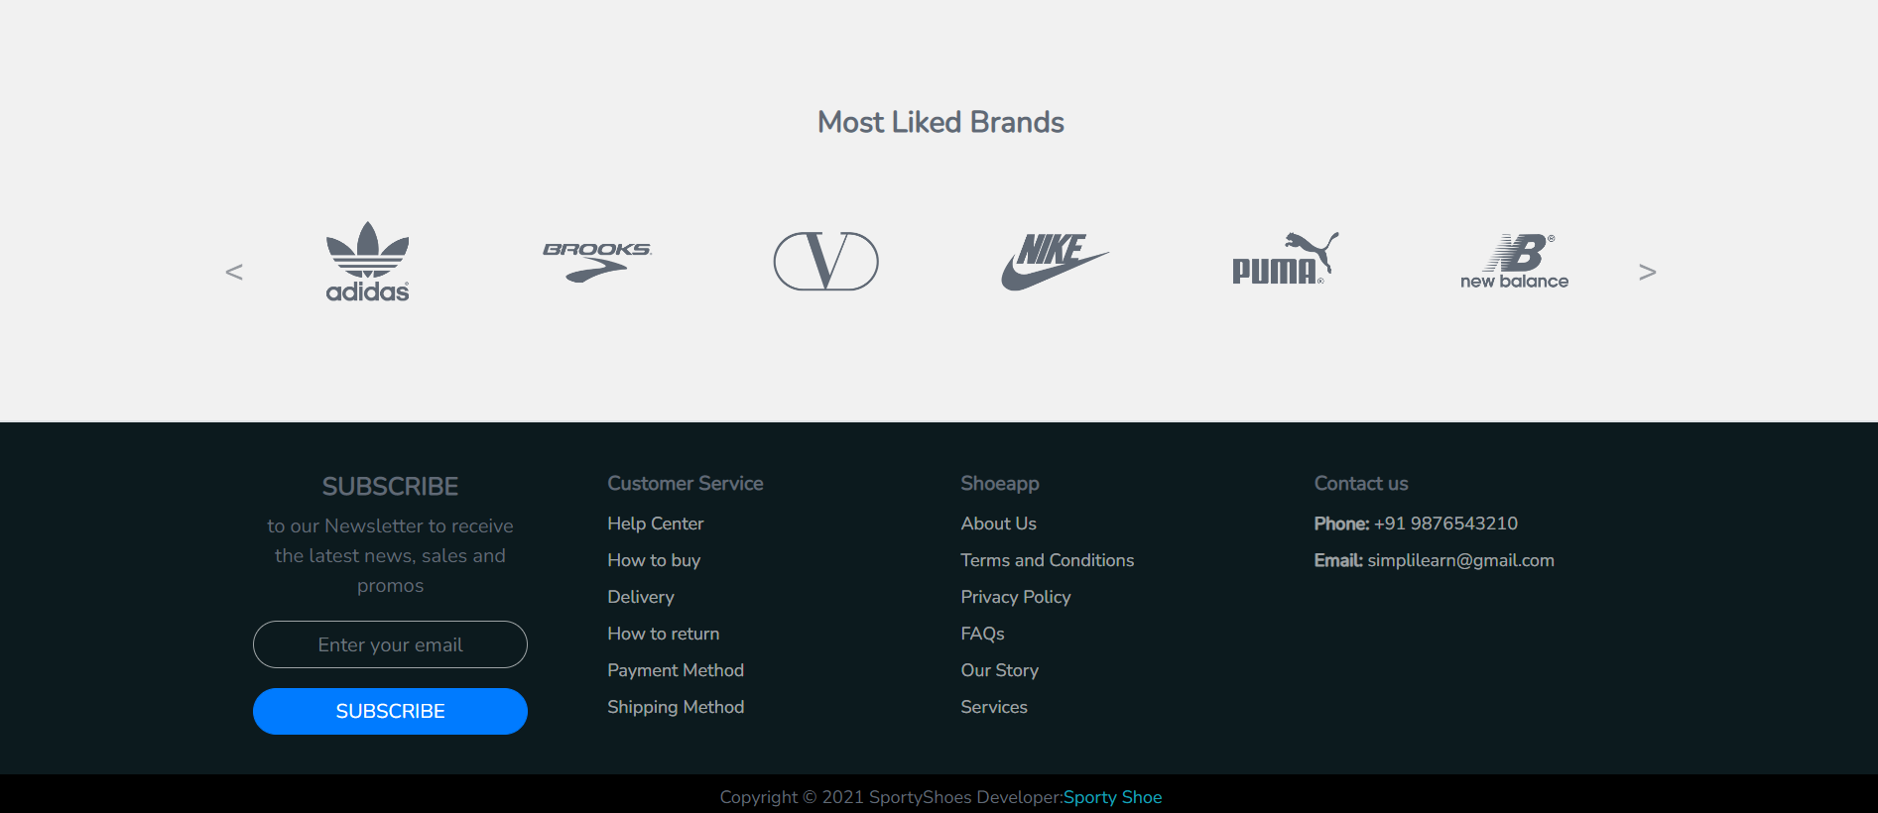

2) Login and Registration Page
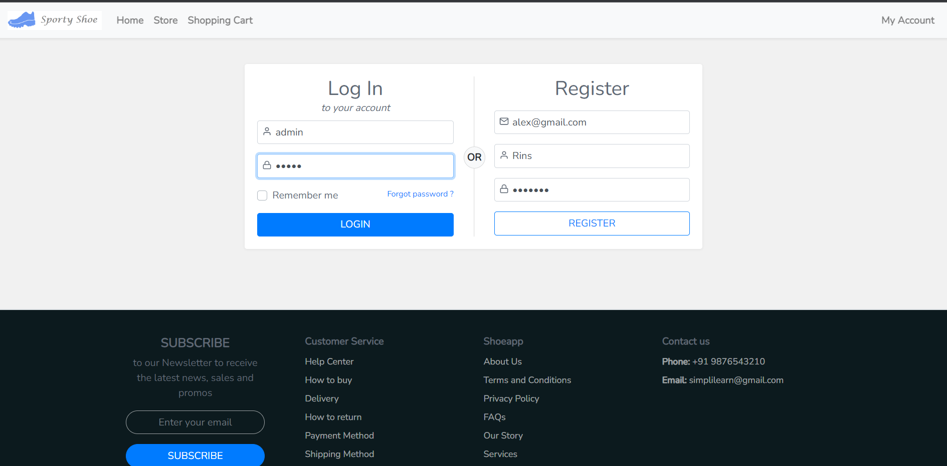3) Home Page After Login.

4) Admin Login
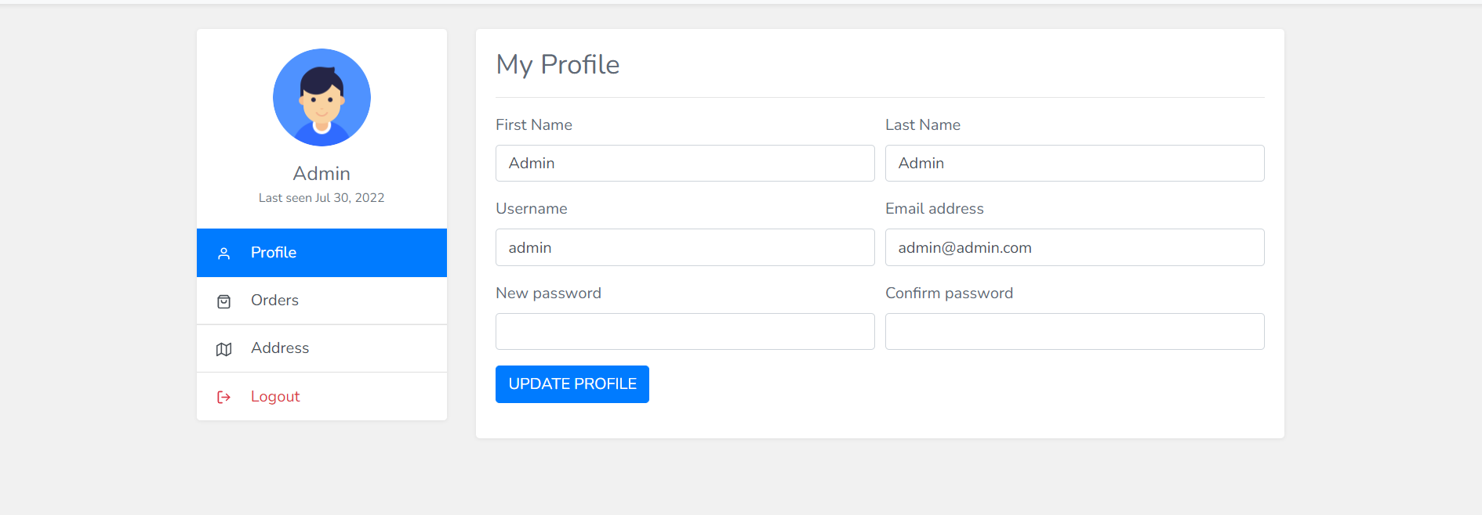

a. Active Orders/My Orders.
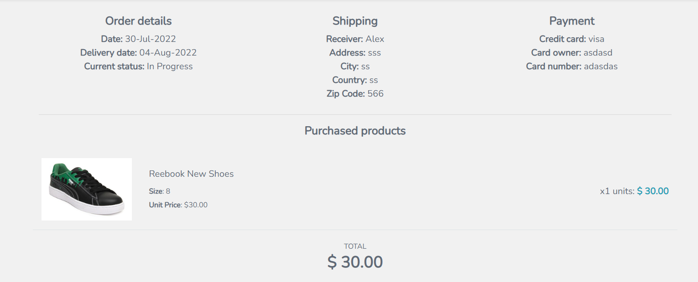

5) Shopping Cart.

6)Admin Portal.

a. Product Menu - (Product List)

- (Add New Product)

8) User List.

9) Password.

Password Update Successfully……………

10) Shopping Cart.

