**2x4-BINARY DE­­CODER**

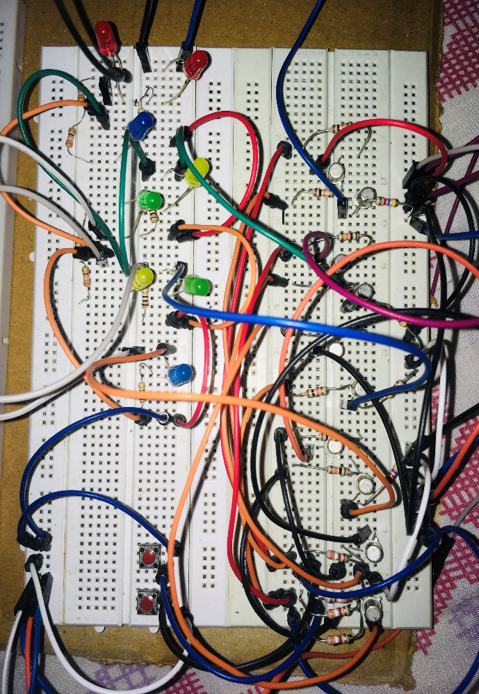

**NAME: S.V.S.SUDHEEP RAO**

**ROLL No. 184159**

**BRANCH: E.C.E**

**SECTION : A**

**Background ­­­:**

The 2-to-4 line binary decoder depicted above consists of an array of four AND gates. The 2 binary inputs labelled A and B are decoded into one of 4 outputs, hence the description of 2-to-4 binary decoder. Each output represents one of the minterms of the 2 input variables, (each output = a minterm).

The binary inputs A and B determine which output line from Q0 to Q3 is “HIGH” at logic level “1” while the remaining outputs are held “LOW” at logic “0” so only one output can be active (HIGH) at any one time. Therefore, whichever output line is “HIGH” identifies the binary code present at the input, in other words it “decodes” the binary input.

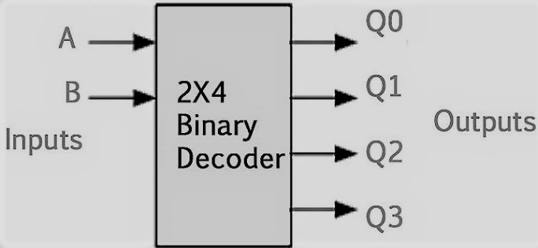

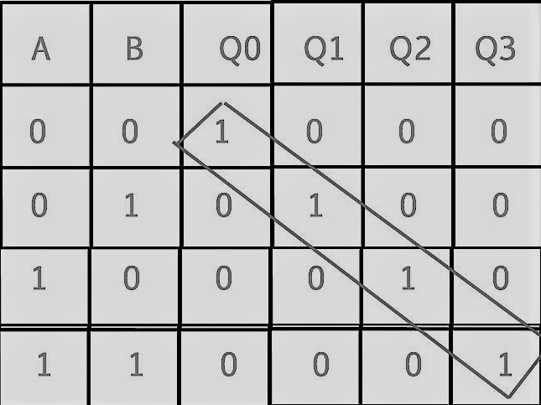

The above shown is the truth table of the 2-to4- decoder circuit

**ELEMENTS USED:**

01.TRANSISTORS(BC107B) -10.

02.RESISTORS(10K,4.7K,3.9K,100) -8,4,4,4.

03.L.E.D’S(RED,BLUE,YELLOW,GREEN)-4.

04.MALE &FEMALE JUMPER WIRES

05.BATTERY (9V) -1.

06.BUTTONS -2.

**CIRCUIT DIAGRAM:**

(using gates)

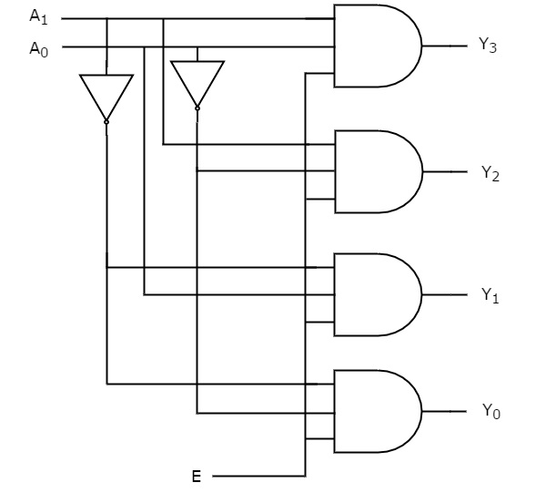

This is the basic format in which connections are made is shown .Each AND gate is made of 2 transistors and 3 resistors. Each inverter is made of one transistor and 2 resistors

Inverter circuit with transistor:

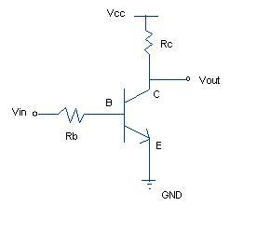

AND gate using transistor:

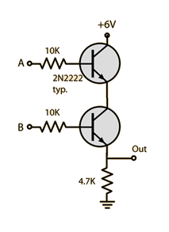

Complete circuit :

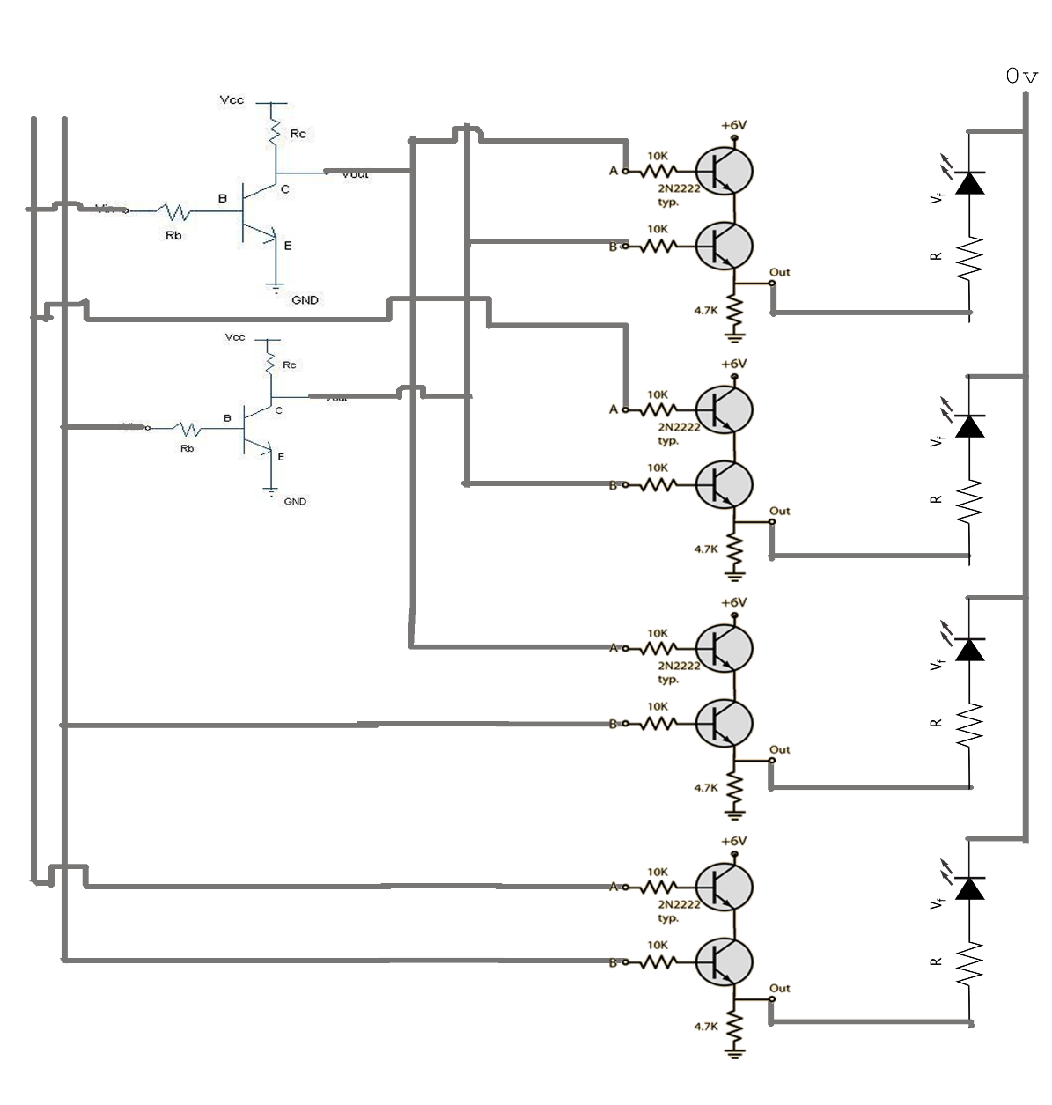

**WORKING:**

Solving the truth table we can say that

Q3 = A0.A1;

Q2= A0.A1’;

Q1=A0’.A1;

Q0=A0’.A1’;

Therefore from the above solutions we used AND gates with respective inputs.

In this circuit transistors are mainly used as switches in all the cases.

**Transistor as switch:**

A transistor conducts current across the collector-emitter path only when a voltage is applied to the base. When no base voltage is present, the switch is off. When base voltage is present, the switch is on.

Transistor will be in OFF ( cutoff ) when the input Vin equal to zero. During this state transistor acts as an open circuit and thus the entire voltage Vcc will be available at collector.

Transistor will become ON ( saturation ) when a sufficient voltage V is given to input. During this condition the Collector Emitter voltage Vce will be approximately equal to zero, ie the transistor acts as a short circut.Thus collector current **Ic = Vcc/Rc**will flows.

Basically we are using the transition from cut off to saturation region principle.

All the Inverters and AND gates used are adjusted with suitable resistance to get desired output and decrease power consumption.

**ADVANTAGES & DISADVANTAGES:**

In digital electronics, a binary decoder is a combinational logic circuit that converts binary information from the n coded inputs to a maximum of 2n unique outputs. They are used in a wide variety of applications, including data multiplexing and data demultiplexing, seven segment displays, and memory address decoding.

There are several types of binary decoders, but in all cases a decoder is an electronic circuit with multiple input and multiple output signals, which converts every unique combination of input states to a specific combination of output states. In addition to integer data inputs, some decoders also have one or more "enable" inputs. When the enable input is negated (disabled), all decoder outputs are forced to their inactive states.

Depending on its function, a binary decoder will convert binary information from n input signals to as many as 2n unique output signals. Some decoders have less than 2n output lines; in such cases, at least one output pattern may be repeated for different input values.

A binary decoder is usually implemented as either a stand-alone integrated circuit (IC) or as part of a more complex IC. In the latter case the decoder may be synthesized by means of a hardware description language such as VHDL or Verilog. Widely used decoders are often available in the form of standardized ICs.

The decoder made using these elements is not that effective but when we use MOSFET,and other transistors like 2N3094,…

we get to see faster results with better accuracy