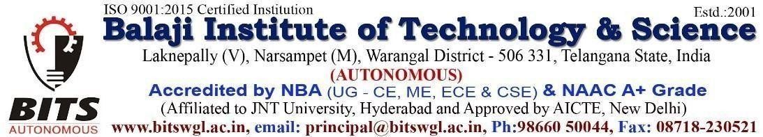

**DEPARTMENT OF CSE(AI&ML)**

**TITLE: STUDENT INFORMATION MANAGEMENT SYSTEM**

**ABSTRACT**:

The Student Information Management System (SIMS) is a web-based application designed to streamline the management of student academic records within educational institutions. This system provides a secure and user-friendly interface for faculty members to enter, update, and monitor students' marks across various assessments, including mid-term exams, unit tests, and final evaluations. Key features include role-based access control to ensure data security, department-wise organization of student records, automated calculations of overall performance, and real-time validation to minimize errors. The platform leverages modern web technologies, including React.js for the front end, Node.js with Express.js for the back end, and MongoDB/MySQL/Firebase for database management. Additionally, the system offers data export capabilities, detailed performance analytics, and a responsive design, ensuring accessibility across multiple devices. By reducing manual effort, improving data accuracy, and enhancing accessibility, SIMS facilitates efficient academic record management for faculty, students, and administrative staff.

**Project Team:**

1. A. Sudheer Kumar - 22C31A6601

2. A. Sahodar Reddy - 22C31A6606

3. K. Srinitha - 22C35A6603

4. N. Naveen - 22C31A6648

**Project Guide:** Dr. J. Vijay Kumar

**Sign of Guide Sign of Project Coordinator Sign of HOD**