1)Output when the API is requested in browser.

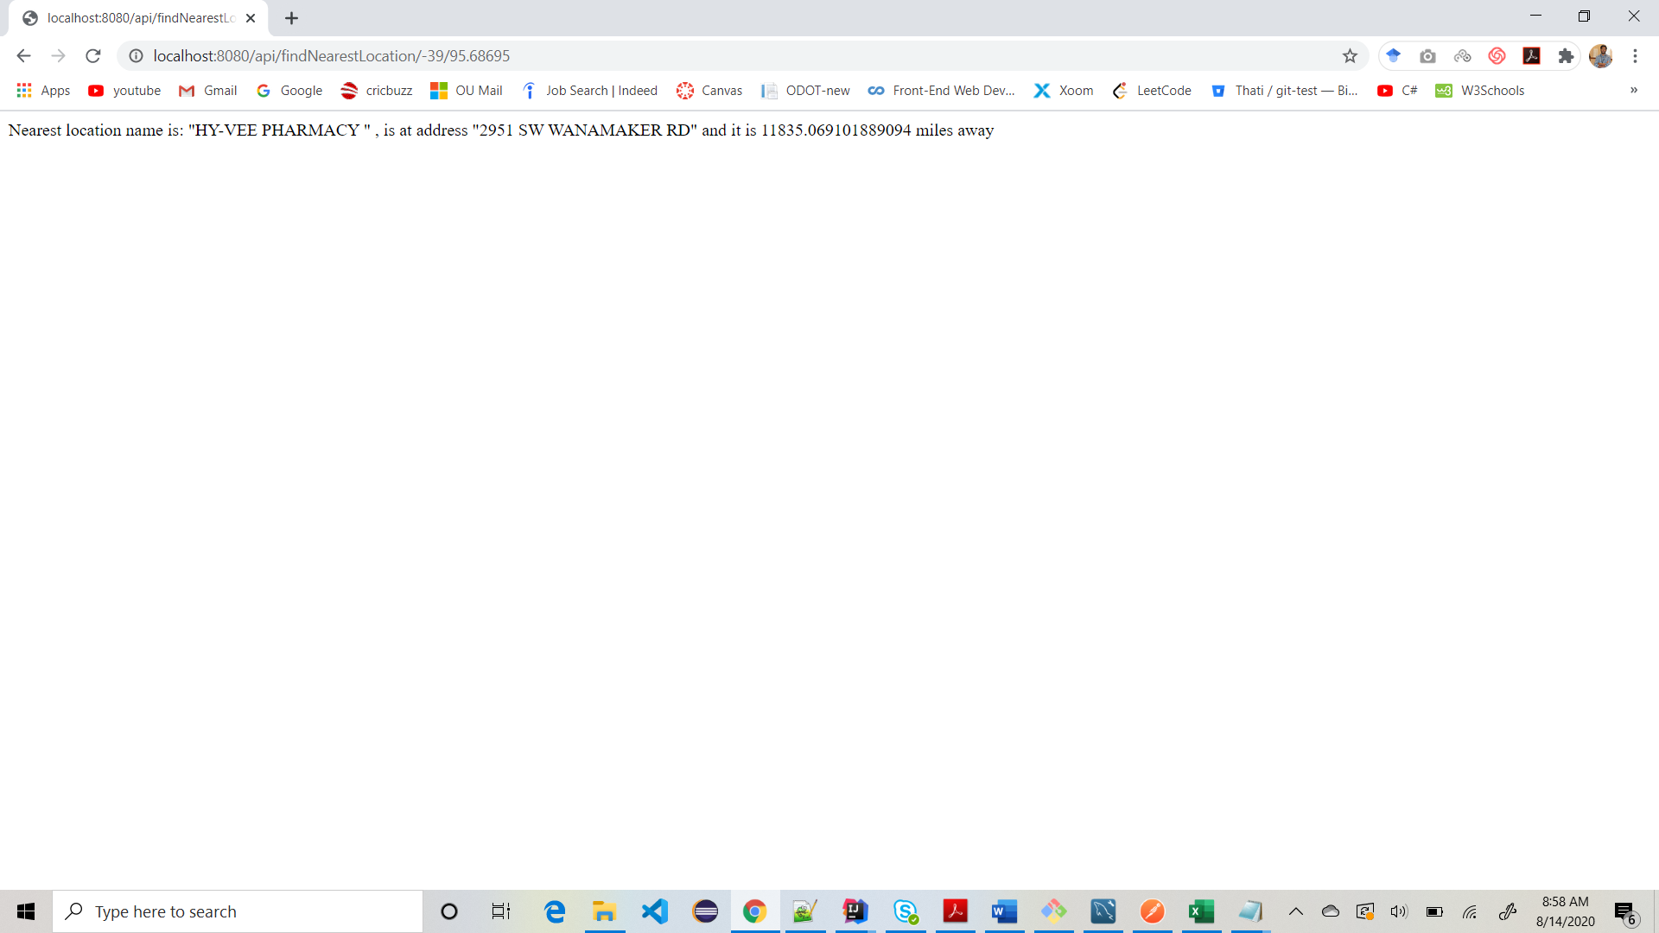

2)Output when tested the API in postman tool.

