## Steps:

Ref: <https://www.youtube.com/watch?v=ePTNs3pqVvg&list=PLVz2XdJiJQxxurKT1Dqz6rmiMuZNdClqv&index=8>

**Interview point:**

* As part of RDS db configuration we used AWS secret manager for securing our datasource url, username, password.
* Advantage:
  + Suppose if we have multiple microservice than we don’t need to configure credential in each application instead we can define in **central repo so it gives** **eassy to control access and keep it safe.**
  + And It gives **secret rotation** so that we don’t need to change the credentials manualy in propery file, AWS secret manager will take care.

**Steps:**

### Creaste a database

### Note down db details: endpoint and port username and password

Note: If you have already rds created you can use same

### Go to "AWS secret manager" and create secret

you need to provide **secret name, username, password and select the databas**e so that it generates a code for you.

### Use generated code snippet in your source code

Use generated code snippet in your code by creating a config class and customize it as per your need

### create secret-key and secret-access-key

create secret-key and secret-access-key and use that in application.yaml file.

### create model class for db properties

remove **datasource, username, password, port** from property file and keep remaining properties as it is. and create one model class with those properties like datasource, username, password, port etc

(off course add required dependency)

### generate jar and deploy in s3 and run the application.

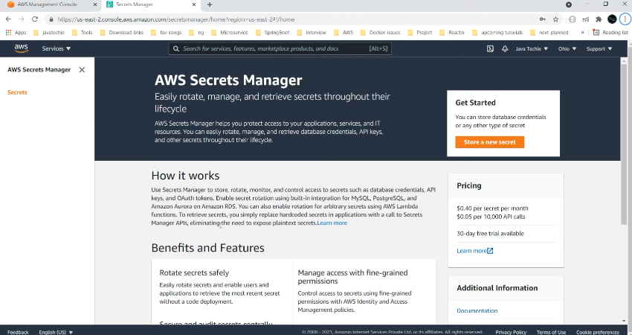

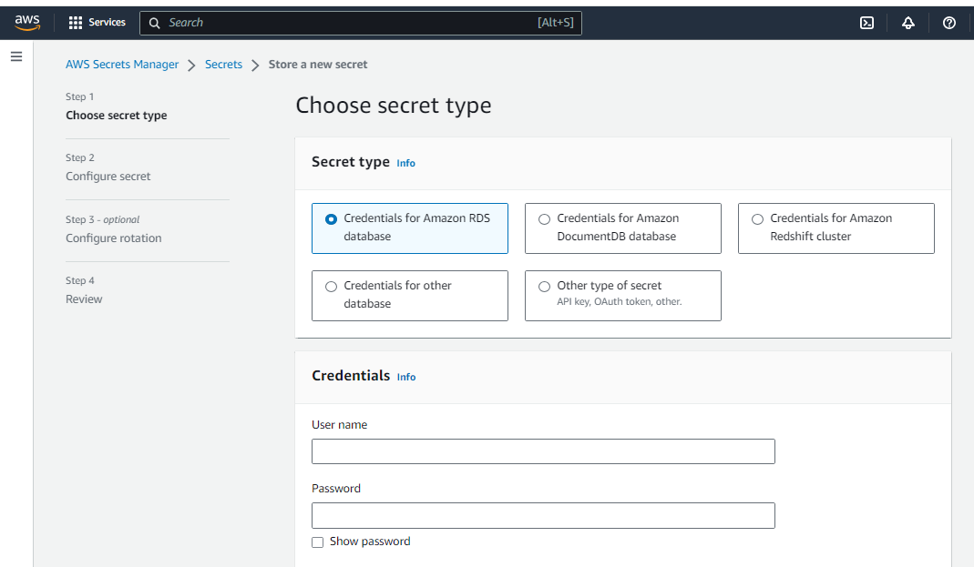

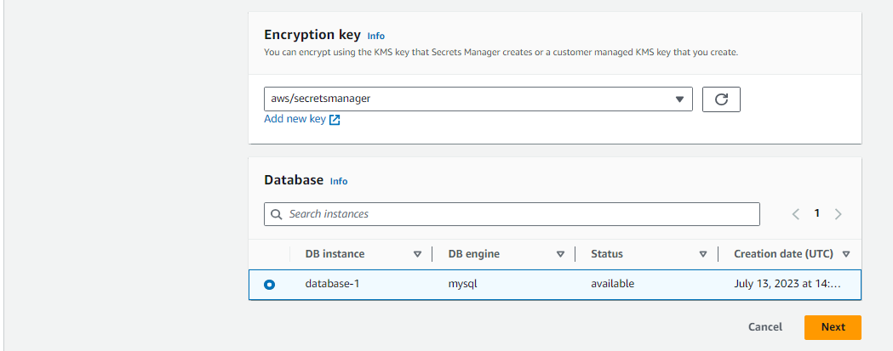

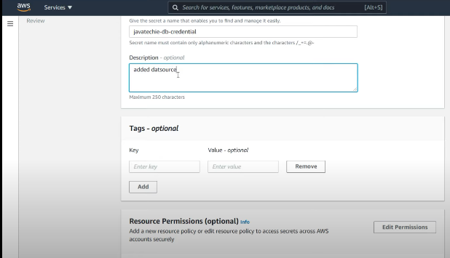

Given secret name as: **javatechie-db-credentials**

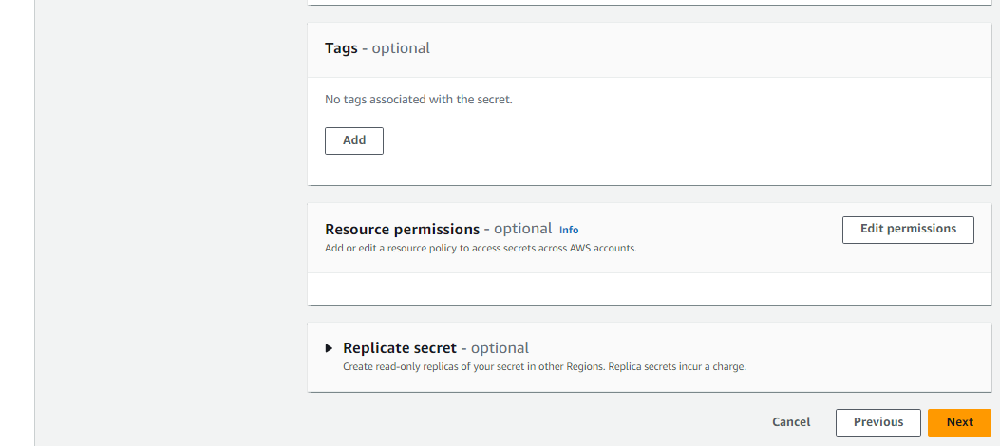

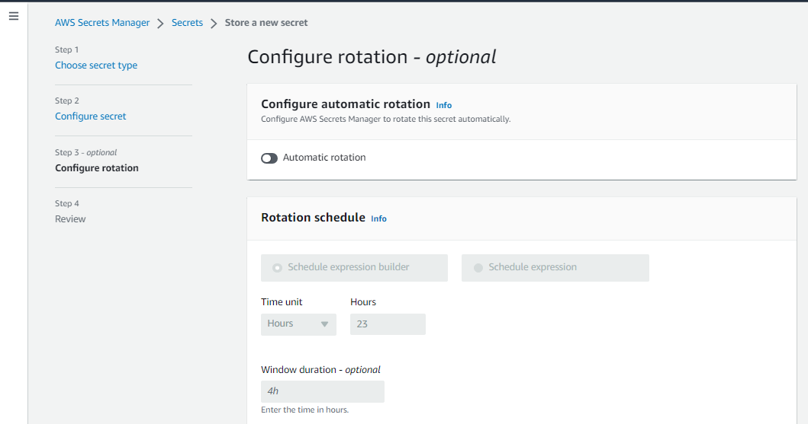

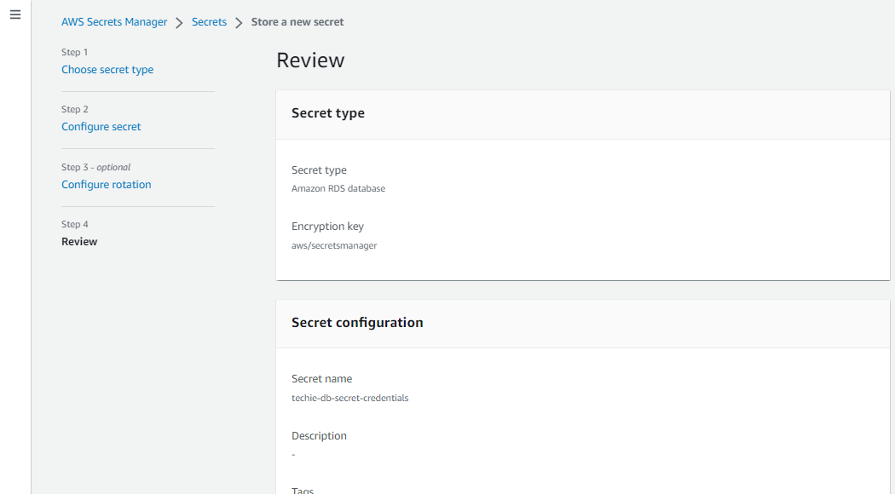

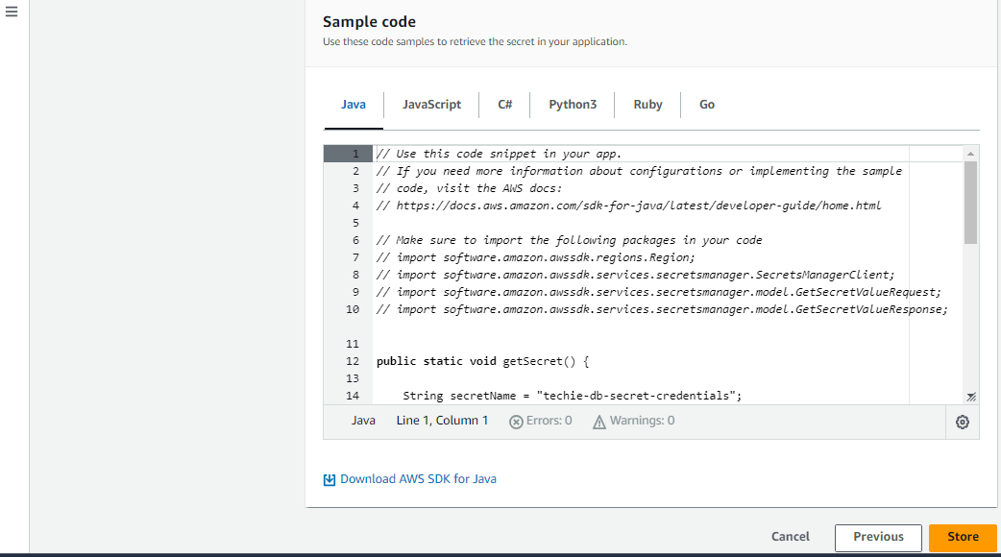

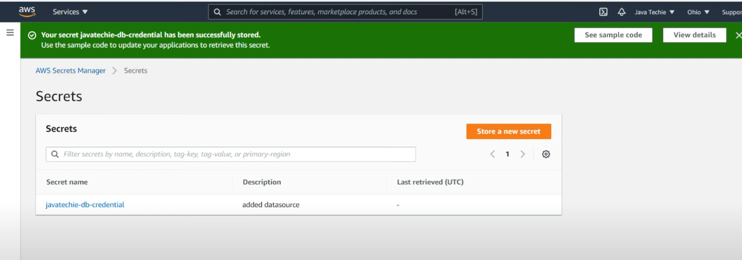

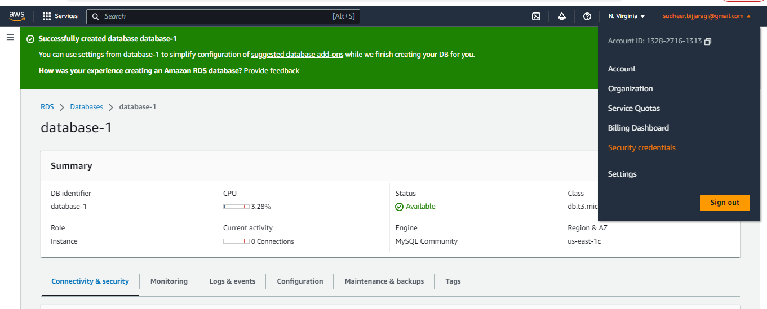

Create a access-key and secret access-key

Right click on profile - select “security credentials” – click “creatre access-key”

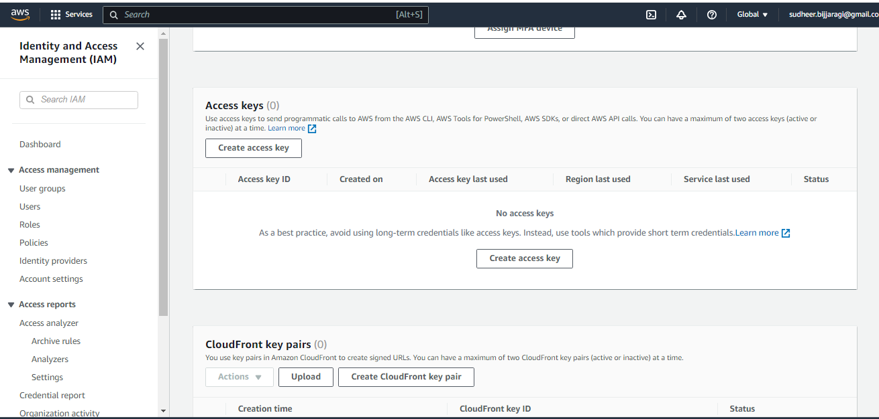

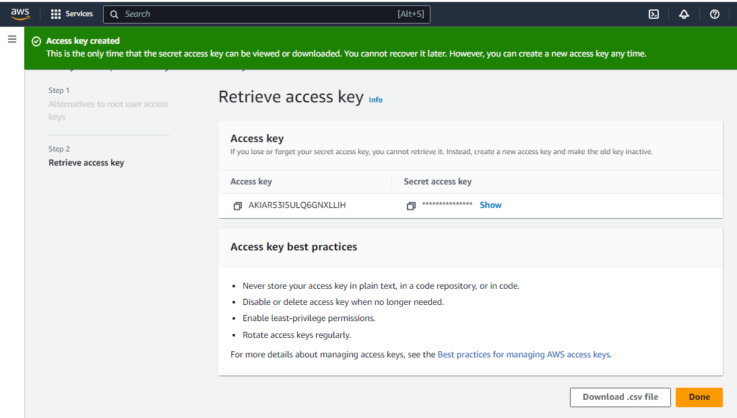

Add these above **access key and secret key** in **application.yml** file.

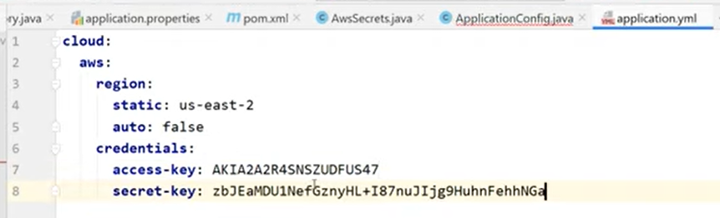

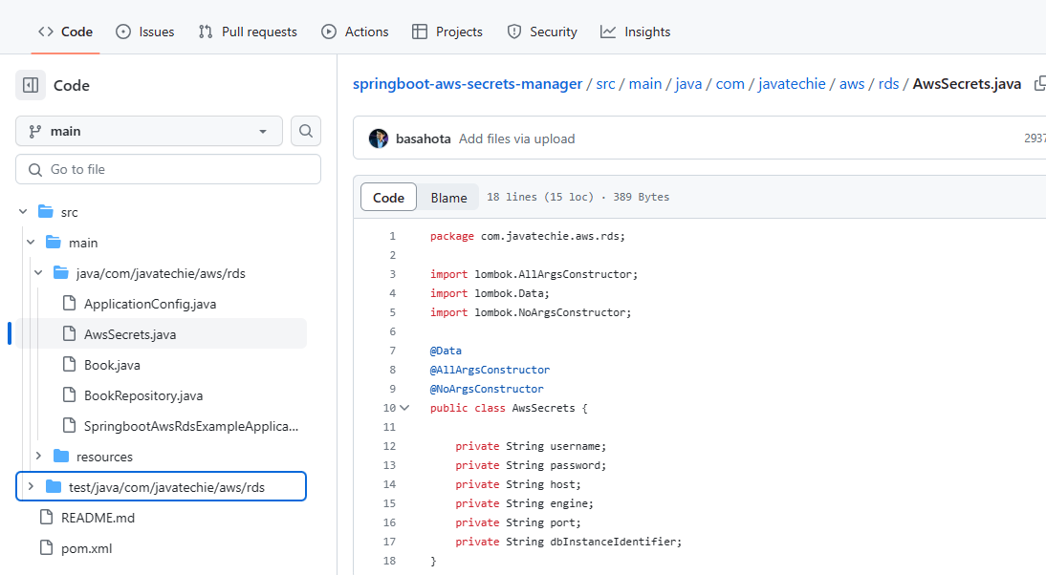

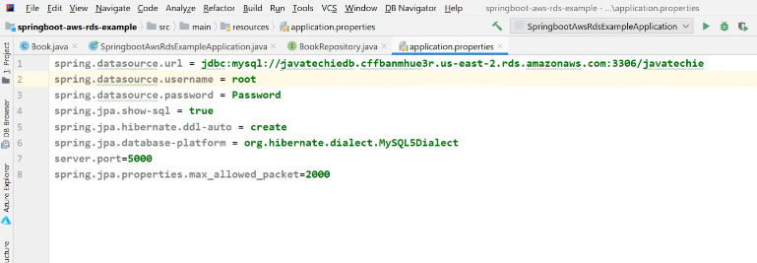

Above creating model class (AWSSecreats.java) and removing datasource, username, password from property file

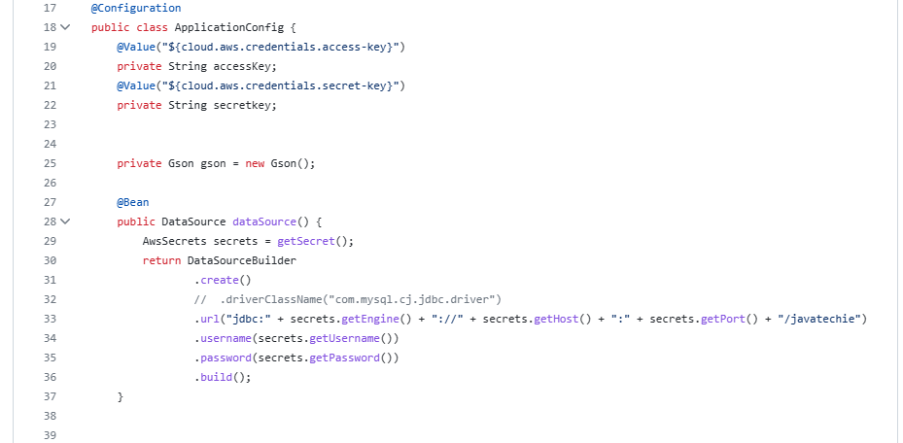

// for .url appending at last is schemaname (dbname).

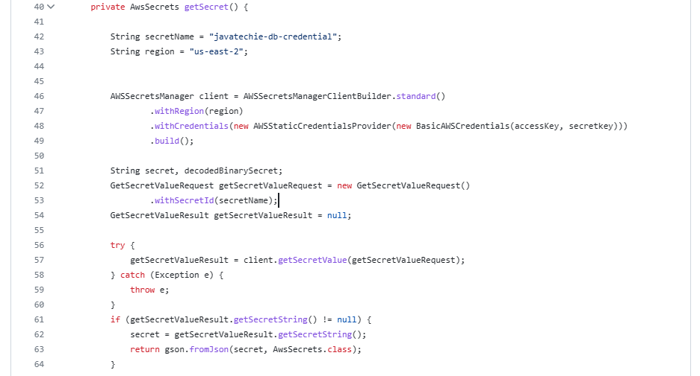



Above created config class(ApplicationConfig.java) and paste auto generated code snippet and modify as shown above.

(offcourse add the required dependency )