# Steps:

### Create a database say mysql

* AWS: go to RDS and choose one relational db any one like mysql,oracle,mariadb, sql server : give **username**, **password** finaly click on create.
* While creating RDS db make sure to enable for **public access**
* Add **mysql** for inbound and outbound rules in security group for db connect:

### Note down db details: endpoint and port username and password

Once db created, note down: db endpoint / port number / username /password

endpoint:

database-1.cuwxyjmyqlu2.us-east-1.rds.amazonaws.com

3306

username: admin

password: password

### Install mysql and connect db

Once you connect to ec2 instance, execute below commands :

*sudo dnf install mariadb105*

**And below commands are just optional(you can skip if you want)**

*mysql -h <db-endpoint> -P 3306 -u admin -p*

*example:*

*mysql -h database-1.cuwxyjmyqlu2.us-east-1.rds.amazonaws.com -P 3306 -u admin -p*

*MySQL [(none)]> CREATE DATABASE testDB;*

*MySQL [(none)]> show databases;*

*MySQL [(none)]> use testDB;*

*MySQL [testDB]> CREATE TABLE Persons (PersonID int, FirstName varchar(255) );*

*MySQL [testDB]> show tables;*

***Note: Expected error/exceptions:***

* *If you try to create/alter existing database/table you might be land up with access denied error.*
* ***Important:***  *create your own database. so that its required to mention in property file (for datasource.url)*

*Else it will throw: Caused by: java.sql.SQLSyntaxErrorException: Unknown database 'testDB'*

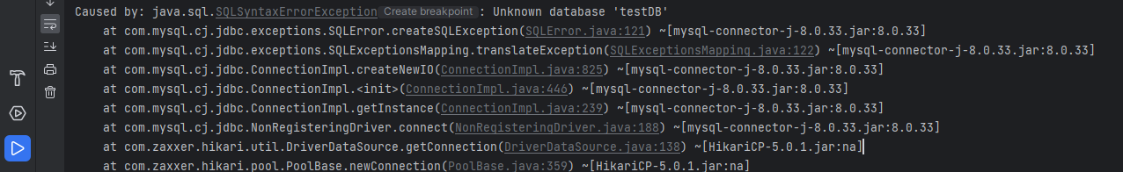

### Modify your property file and generate a jar:

Git hub: <https://github.com/sudheer436/springboot-rds>

download and import

* Make remote db configuration :
  + datasource.url , username and password
* No need to define driver class in this case (required in case of local db connection)

syntax:

spring.datasource.url = jdbc:mysql://<endpoint>:3306/<database-name>

eg: spring.datasource.url = jdbc:mysql://database-1.cuwxyjmyqlu2.us-east-1.rds.amazonaws.com:3306/testDB

### Create EC2 instance and deploy springboot jar and run

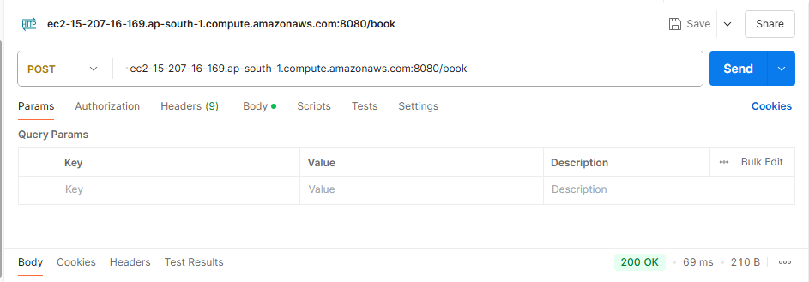

Add book:

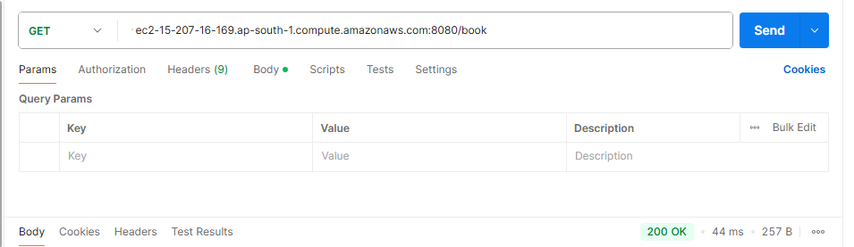

Get book: