1. In this example created the simple spring boot with h2 CRUD operation.
2. Than just consuming the above CRUD rest api’s in html+ javascript.

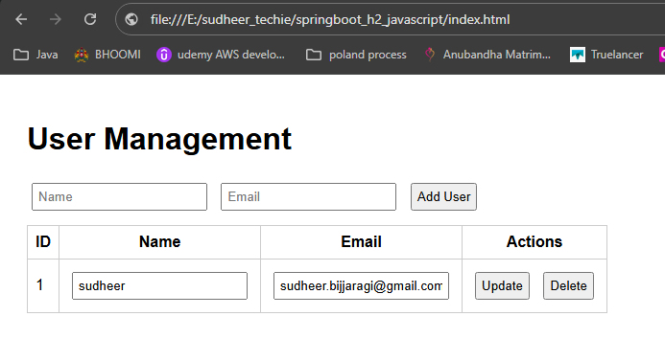

Make the springboot application up and than just hit index.html and play with API’s which is already ingrated in html+javascript.

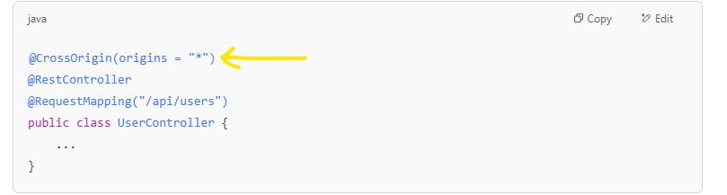

And added above highlighted line controller to avoid CORS issue in browser.

**Trick:** to generate html and javascript to consume our API’s

1. in postman tested all CRUD api’s and exported a JSON file.
2. Open chatgpt, and uploaded the JSON file and asked to generate frondend app using html and javascript. It generates automatically for us.