Team members:

Bhanu Teja P (201501212)
Sudheer A (20161076)
Pavan Kumar (201530101)

Fast Panorama Stitching

Abstract:

A fast stitching approach is proposed for combining a set of
source images into a panoramic image using little memory, and
implemented on mobile phones. In this approach, color correction reduces color differences of source images and balances colors and luminance in the whole image sequence, dynamic programming finds optimal seams in overlapping areas between adjacent images and merges them together, and image blending further smoothens color transitions and hides visible seams and stitching artifacts.

Introduction:

The task of image stitching is to find optimal seams in
overlapping areas of source images, merge them along the
seams, and minimize merging artifacts. By stitching together a sequence of overlapping normal images, we can create a panoramic image. Image stitching is a very important step in creating panoramas. A simple pasting of overlapping images into the final panorama produces visible seams due to changes of scene illumination and camera responses, or spatial alignment errors.

Related Work:

There are two main categories of current image stitching approaches: transition smoothing and optimal seam finding. Transition smoothing approaches reduce color differences between source images to make seams invisible and remove stitching artifacts. Recently, gradient domain image blending approaches have been applied to image stitching. These algorithms can reduce color differences and smooth color transitions using gradient domain operations, producing high-quality composite images. Optimal seam finding approaches search for seams in overlapping areas along paths where differences between source images are minimal. The combination of optimal seam finding and transition smoothing for image stitching has also been used in panorama applications. Source images are combined by compositing along optimal seams. If the seams and stitching artifacts are visible, transition smoothing is applied to reduce color differences to hide the artifacts. Current panorama stitching approaches running on camera phones use graph cut algorithms.

Method:
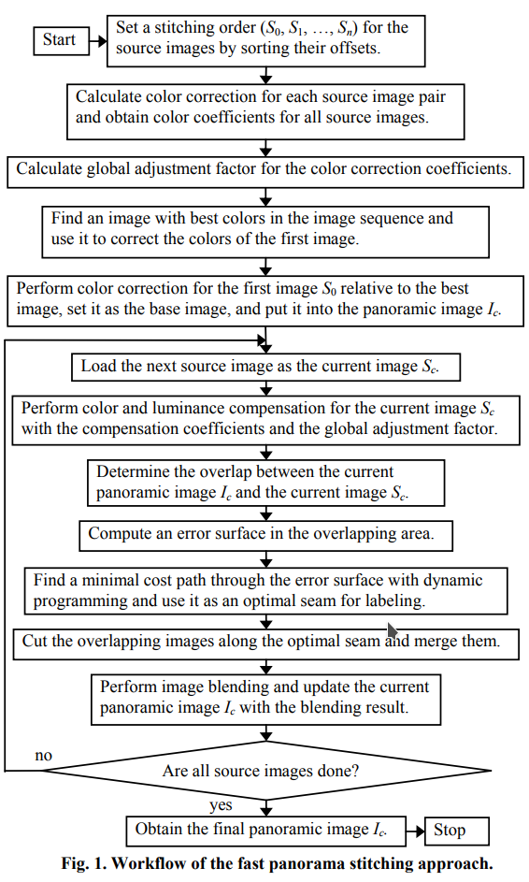

Results:
Linearly Blended Over Seam
Overlap: 75% of image size Shift: 25% of image size

Overlap: 75% of image size Shift: 25% of image size

Overlap: 75% of image size Shift: 25% of image size

Overlap: 75% of image size Shift: 25% of image size

Overlap: 75% of image size Shift: 25% of image size

Overlap: 80% of image size Shift: 20% of image size

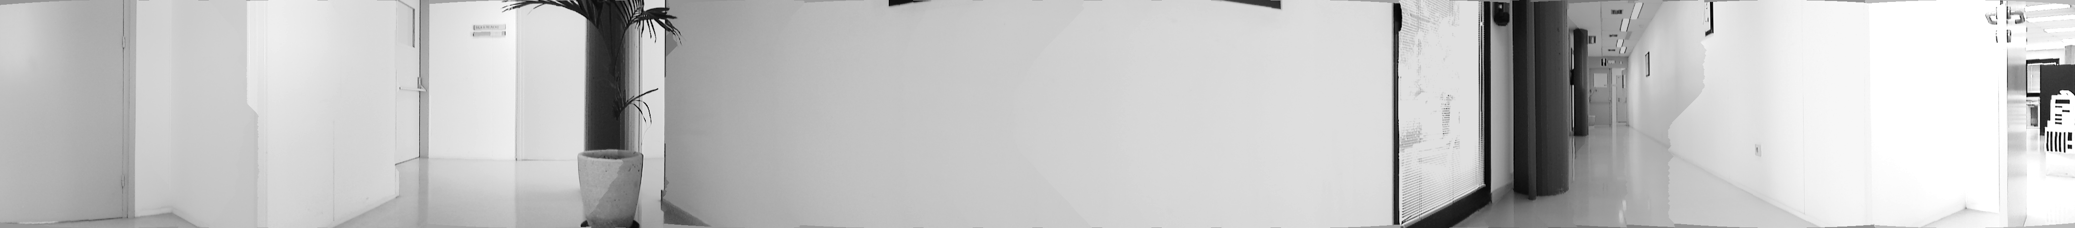
Overlap: 80% of image size Shift: 20% of image size

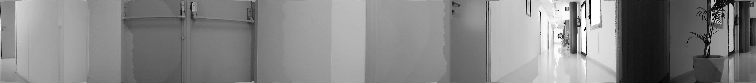
Overlap: 80% of image size Shift: 20% of image size

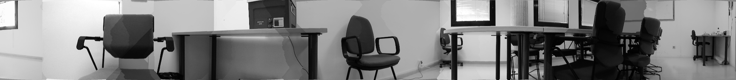
Overlap: 80% of image size Shift: 20% of image size

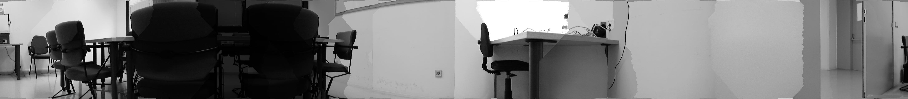
Overlap: 75% of image size Shift: 25% of image size

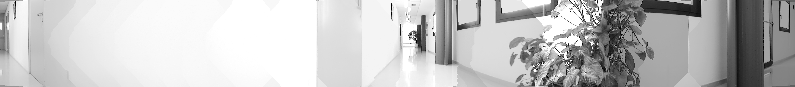
Overlap: 60% of image size Shift: 40% of image size

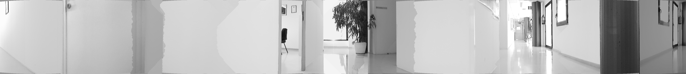

Overlap: 75% of image size Shift: 25% of image size

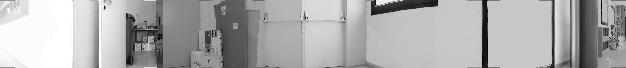
Overlap: 85% of image size Shift: 15% of image size

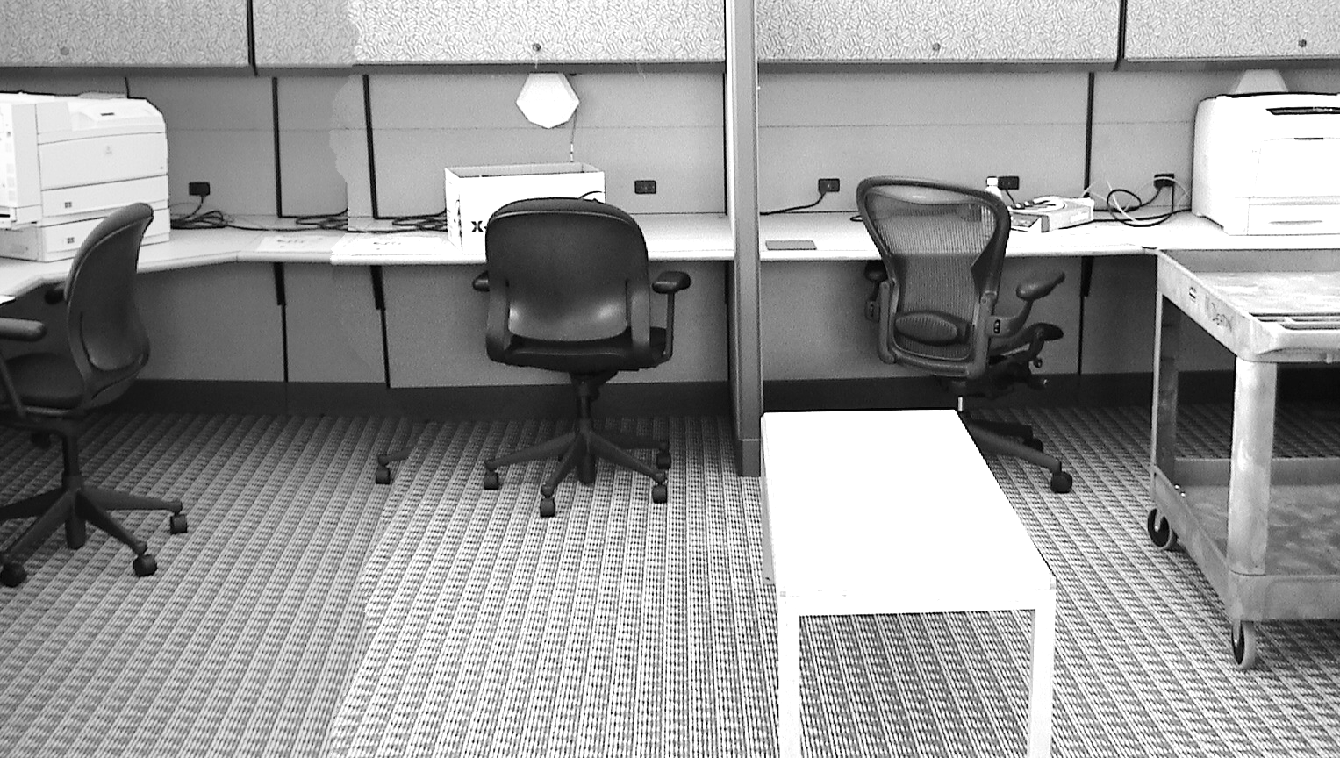

Overlap: 60% of image size Shift: 40% of image size

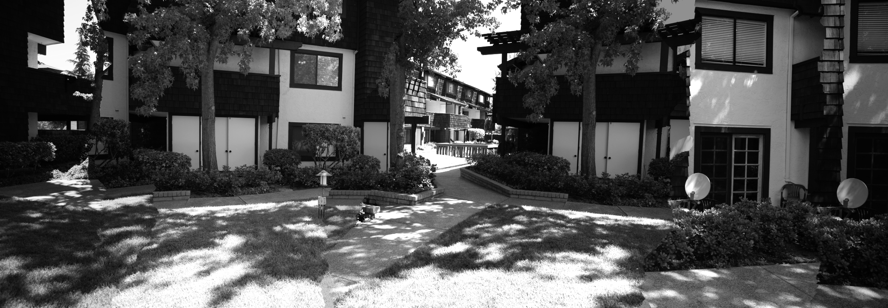
Overlap: 70% of image size Shift: 30% of image size

Overlap: 70% of image size Shift: 30% of image size

Overlap: 70% of image size Shift: 30% of image size

Overlap: 75% of image size Shift: 25% of image size
Overlap: 75% of image size Shift: 25% of image size

Limitations:

- Pre Assumption or estimation of approximate overlap is required.

- Constant amount of shift or motion captured pictures gives better results rather than irregular shifted images.

- Only complete horizontal or vertical shifted images can be sticthed because we dont align images based on feature (SIFT) matching.

