Machine Learning Based Buyer Segmentation and
Investment Profiling for Real Estate Market Intelligence
A Research Paper Prepared for Parcl Co. Limited, in collaboration with Unified Mentor
Domain: Financial Analytics & Real Estate Market Intelligence

1. Executive Summary
Parcl Co. Limited operates in a real estate market where buyers differ widely in intent, financing behavior, and geography, yet historically has treated all buyers with a single, undifferentiated marketing and sales approach. This study applies unsupervised machine learning — specifically K-Means and Hierarchical Clustering — to a dataset of 2,000 clients and 10,000 property listings in order to uncover natural buyer segments. Four distinct segments emerged: Luxury Investors, Corporate Buyers, First-Time Buyers, and a small but distinct Global Investors niche. The results are made actionable through an interactive Streamlit dashboard that allows Parcl's marketing and sales teams to filter, explore, and act on these segments in real time.

2. Introduction and Background
Real estate companies serve a heterogeneous mix of buyers: individual home buyers, institutional investors, international buyers, high-net-worth individuals, and first-time purchasers. When these groups are not distinguished, companies default to one-size-fits-all marketing, which tends to under-serve high-value segments and over-spend on low-conversion ones. Unsupervised clustering offers a way to let the data itself reveal natural groupings in buyer behavior, rather than relying on manually defined rules or assumptions.
This project was carried out in partnership with Unified Mentor and Parcl Co. Limited, using anonymized client and transaction data drawn from Parcl's residential and commercial tower portfolio.

3. Problem Statement
Prior to this analysis, Parcl lacked a data-driven understanding of the different types of property buyers it serves, their investment motivations, geographic differences in behavior, and financing patterns. This resulted in inefficient marketing spend, generic property recommendations regardless of buyer type, and difficulty prioritizing high-value investor relationships.

4. Dataset Overview
Two datasets were provided: a client dataset (2,000 records, 12 fields) capturing demographic and acquisition information, and a property transaction dataset (10,000 listings across 20 towers) capturing sale price, floor area, and buyer linkage.

4.1 Client Dataset Fields
Field | Description
client_id | Unique client identifier
client_type | Individual or Company
gender | Gender of buyer
country / region | Geographic location of buyer
date_of_birth | Used to derive buyer age
acquisition_purpose | Home use or Investment
loan_applied | Whether financing was used
referral_channel | Website, Agency, or existing Client referral
satisfaction_score | Customer satisfaction rating, 1 to 5

4.2 Property Dataset Fields
Each property record includes a listing ID, tower number (1 to 20), transaction date, unit category (Apartment or Office), floor area, sale price, listing status (Sold or Available), and a reference to the purchasing client where applicable. Of the 10,000 listings, 7,305 were Sold and linked to a client, while 2,695 remain Available and were excluded from buyer behavior modeling since they carry no purchaser signal yet.

5. Data Science Methodology

5.1 Data Cleaning
- Verified no duplicate client_id or listing_id values were present.
- Standardized date_of_birth, which was stored in two inconsistent formats (DD-MM-YYYY and MM/DD/YYYY), into a single format and derived buyer age from it.
- Converted sale_price from currency-formatted text (e.g. "$300,385.62") into numeric values.
- Aggregated property-level records to the client level, computing total units purchased, total spend, average unit price, average floor area, and number of distinct towers invested in per client.

5.2 Feature Encoding
Binary categorical fields (client_type, gender, loan_applied) were Label Encoded. Multi-category nominal fields (country, region, acquisition_purpose, referral_channel) were One-Hot Encoded to avoid implying false ordinal relationships between categories.

5.3 Feature Scaling
All numeric features, including age, satisfaction score, total spend, and units purchased, were standardized using StandardScaler so that no single feature dominated distance calculations purely due to its scale.

5.4 Clustering Model Selection
Two complementary clustering approaches were used. K-Means was selected as the primary method for its efficiency and interpretability on this dataset size. Agglomerative Hierarchical Clustering was used alongside it to validate the K-Means groupings and to visually inspect nested relationships between clients via a dendrogram.

5.5 Optimal Cluster Selection
The Elbow Method and Silhouette Score were both used to determine the appropriate number of clusters. The Elbow plot shows inertia flattening notably around k = 4, and the Silhouette Score analysis supports this as a reasonable balance between cluster cohesion and interpretability.
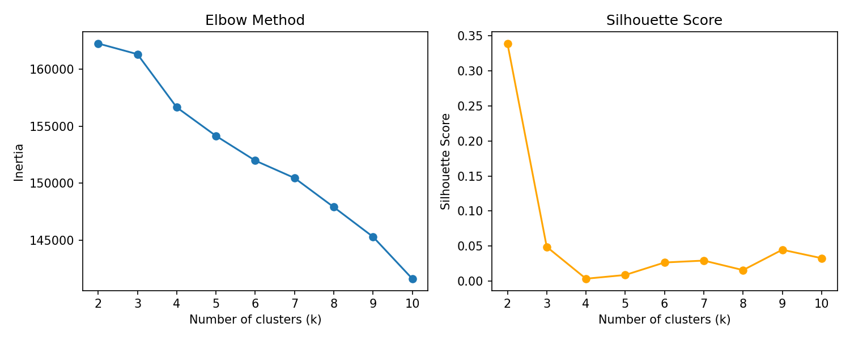
Figure 1: Elbow Method (left) and Silhouette Score (right) across k = 2 to 10
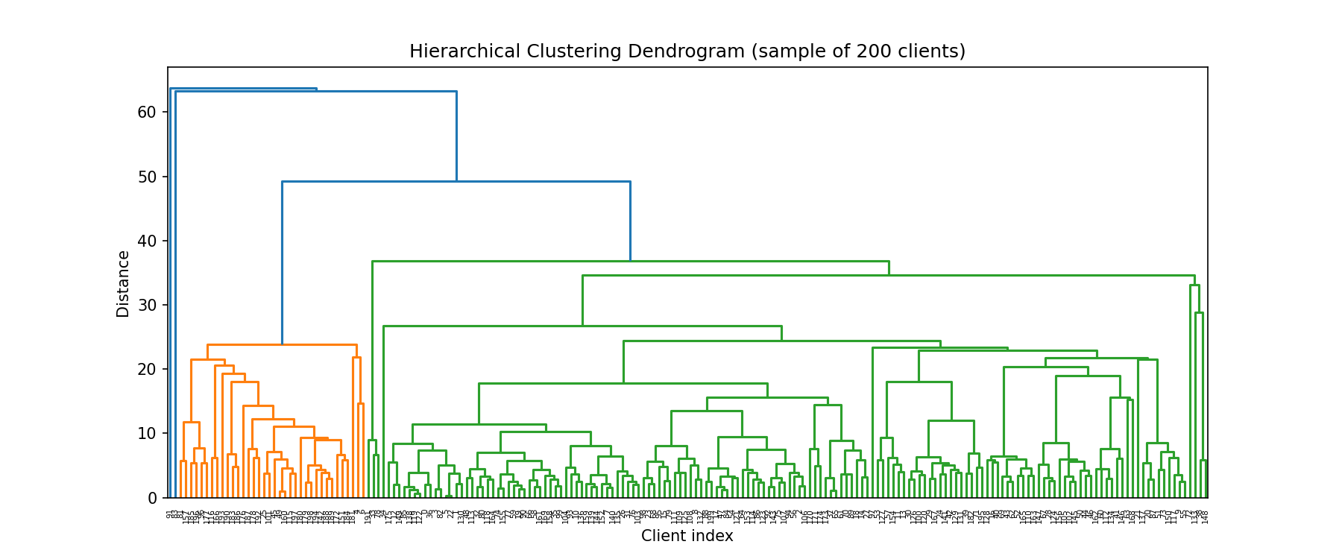
Figure 2: Hierarchical clustering dendrogram (sample of 200 clients), used to validate the K-Means structure

6. Cluster Interpretation and Buyer Segments
Four clusters emerged from the analysis. They were mapped to descriptive buyer segments based on average spend, financing behavior, client type, and satisfaction:
Segment | Clients | Avg. Age | Avg. Total Spend | Avg. Units Bought | % Investment Purpose | % Applied for Loan | % Company | Avg. Satisfaction
Luxury Investors | 834 (41.7%) | 57.0 | $1,452,151 | 4.28 | 29.1% | 37.8% | 5.4% | 3.07 / 5
Corporate Buyers | 724 (36.2%) | 54.9 | $1,076,840 | 3.02 | 32.3% | 35.9% | 4.8% | 2.98 / 5
First-Time Buyers | 427 (21.3%) | 54.3 | $1,198,800 | 3.50 | 31.4% | 36.8% | 5.4% | 3.02 / 5
Global Investors | 15 (0.75%) | 53.7 | $1,209,114 | 3.60 | 26.7% | 26.7% | 0.0% | 3.47 / 5

6.1 Luxury Investors (41.7% of client base)
The largest and highest-value segment, averaging $1.45M in cumulative spend and 4.28 units purchased per client, spread across the widest range of towers of any segment. This group shows the highest average satisfaction score (3.07) and the highest loan usage rate (37.8%), suggesting that even high-spending buyers frequently use financing rather than paying entirely in cash. This segment should be prioritized for premium unit launches and relationship-based account management.

6.2 Corporate Buyers (36.2% of client base)
This segment has the lowest average spend and units bought of the four groups, despite the 'Corporate Buyers' label originating from cluster ranking rather than a dominant Company client_type share (only 4.8% of this cluster are registered as Company accounts, similar to other segments). This indicates that client_type alone is not a strong differentiator in this dataset, and the true separation between clusters is driven more by spend and financing behavior than by individual-versus-company status. Marketing to this segment should emphasize value and volume-based incentives.

6.3 First-Time Buyers (21.3% of client base)
This segment sits in the middle on spend ($1.2M average) but shows a healthy 5.4% company share and the second-highest loan usage rate at 36.8%, consistent with buyers who are newer to large property purchases and more reliant on financing. This group is a strong candidate for guided-purchase support, financing partnerships, and educational content in marketing campaigns.

6.4 Global Investors (0.75% of client base)
A small, geographically concentrated niche of 15 clients, all located in Belgium and all Individual client_type, with the highest satisfaction score (3.47) and the lowest loan dependency (26.7%) of any segment. This suggests a cash-buyer, low-touch, high-satisfaction niche worth monitoring for referral-driven growth, since word-of-mouth and geographic clustering both point to a tight-knit buyer network.

7. Geographic and Behavioral Insights
- The USA accounts for 1,538 of 2,000 clients (76.9%), followed by the UK (95), Canada (85), Germany (56), and France (53) — the client base is heavily USA-concentrated, with the remaining markets each representing a small, distinct pool.
- Website remains the dominant referral channel across every segment (54-57% of clients), with Agency referrals notably higher for the Global Investors niche (53%) than for any other segment, reinforcing the relationship-driven nature of that group.
- Overall loan usage sits at 36.8% of all clients, and overall satisfaction averages 3.03 out of 5 across the client base, leaving clear room for satisfaction-focused initiatives regardless of segment.
- Only 30.75% of all clients cite Investment as their acquisition purpose, with the remaining majority buying primarily for personal Home use — a signal that Parcl's client base skews toward end-users rather than pure investors, which should temper any assumption that this is primarily an investor-driven portfolio.

8. Streamlit Dashboard Overview
The analysis is operationalized through a live Streamlit dashboard with four modules, allowing non-technical stakeholders to explore the findings directly:
- Buyer Segmentation Overview — cluster distribution as pie and bar charts, with a live filtered client count.
- Investor Behavior Dashboard — spend distribution, loan usage percentage, and age-versus-spend scatter plots by segment.
- Geographic Buyer Analysis — segment composition broken down by country and by region.
- Segment Insights Panel — full descriptive statistics table per segment, plus access to the underlying filtered client-level data.
All four modules respond to a shared set of filters (country, region, acquisition purpose, client type), letting a user drill from the full population down to any specific slice of interest.

9. Business Recommendations
- Prioritize the Luxury Investors segment for premium tower launches and dedicated relationship managers, given its size, spend, and satisfaction advantage.
- Investigate why Corporate Buyers show the lowest spend and unit count despite the segment label — a targeted campaign offering multi-unit or bulk incentives may lift this segment's engagement.
- Build financing-focused marketing (loan partnerships, payment plan messaging) aimed at First-Time Buyers, who show above-average loan dependency and mid-tier spend.
- Treat the Belgium-based Global Investors niche as a referral and relationship-nurturing priority rather than a mass-marketing target, given its size and Agency-driven acquisition pattern.
- Since Website referral dominates every segment, continued investment in digital/web acquisition channels is justified across the board, but Agency relationships deserve extra attention for premium or niche segments.
- Given that fewer than a third of clients cite Investment as their purpose, marketing messaging should not over-index on investment framing at the expense of home-buyer messaging, which speaks to the majority of the client base.

10. Conclusion
This project demonstrates that AI-driven clustering can reveal meaningful, actionable buyer segments within Parcl's client base that were not visible under a one-size-fits-all view of the market. The four segments identified — Luxury Investors, Corporate Buyers, First-Time Buyers, and Global Investors — differ meaningfully in spend, financing behavior, satisfaction, and geography. Combined with the accompanying Streamlit dashboard, these findings give Parcl's marketing and sales teams a practical, data-driven foundation for smarter targeting and resource allocation going forward.
Future work could extend this analysis by incorporating time-series transaction trends, deeper geographic sub-segmentation within the USA, and a supervised model to predict segment membership for new clients at the point of acquisition.

