|  |
| --- |
|  |
| 7PAM2000 Applied Data Science 1  Assignment 1: Visualisation |
| |  |  |  | | --- | --- | --- | | Student Name: |  | Student ID | |

Contents

Dataset used: 2

Graph 1: Line plot graph 2

Graph 2: Stacked Bar Chart 4

Graph 3: Scatter Plot Graph 4

# Dataset used:

<https://www.data.gov.uk/dataset/090b5b23-5020-4480-96a0-8b294ca82653/local-authority-food-law-enforcement-returns/datafile/e06a6024-c761-4880-8a36-650b99a32c4b/preview>

# Graph 1: Line plot graph

This function will generate a graph that depicts the trends in the overall number of establishments, establishments subject to official enforcement proceedings, and the proportion of interventions accomplished by premises classified A-C, A, B, and C from 2003 to 2017 for all local authorities that are included in the dataset. The graph will be generated for all local authorities that are included in the dataset. Using this graph, these patterns will be applied to each local government that is included in the dataset.

On the basis of this graph, we are able to see that both the overall number of enterprises and the number of establishments that are subject to official enforcement proceedings have consistently dropped over the course of the last few years. Despite this, the percentage of interventions carried out by facilities with ratings of A through C has grown, while the percentages achieved by facilities with ratings of A, B, and C have declined. This recurring trend has been seen over the course of many years. This would imply that food regulations have been enforced more effectively throughout the course of time, resulting in an increase in the number of firms that satisfy the highest standards of food safety.

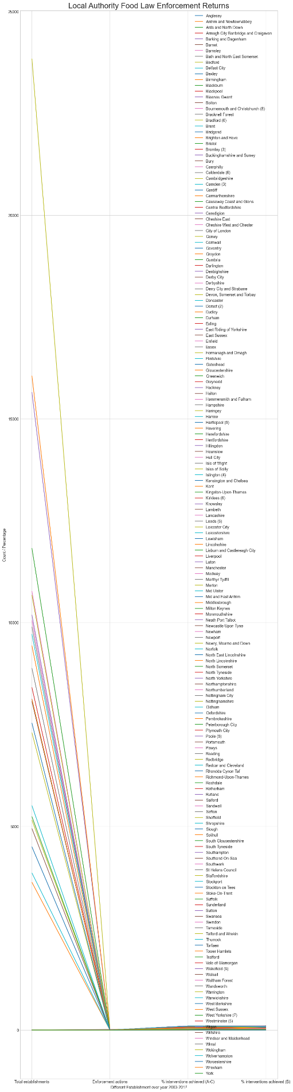

Figure 1 Line Plot Graph

# Graph 2: Stacked Bar Chart

The second graph that was generated is a stacked bar chart that illustrates the distribution of formal enforcement actions that were carried out by local authorities in the United Kingdom. The selected graph illustrates, with respect to each kind of formal enforcement action carried out by local authorities, the relative frequency of such actions. In addition, the stacked bars make it straightforward to contrast the total number of companies that are subject to each kind of regulatory action. The x-axis displays the multiple municipal authorities, and the caption gives a simple manner for recognising the various sorts of enforcement actions. We are able to derive conclusions regarding the frequency of formal enforcement actions conducted by local authorities in the United Kingdom as well as the various sorts of these actions based on the data that is shown in this graph. These findings can be seen below.

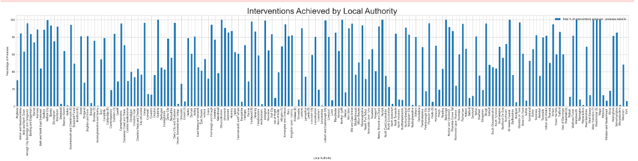

Figure 2 Stacked Bar Graph

# Graph 3: Scatter Plot Graph

The goal of this graph is to study if there is a link between the number of businesses that breach food safety standards and the number of corrective measures done by enforcement employees. Specifically, the graph will look at whether or not there is a correlation between the two. If there is a significant positive connection between the two variables, it is possible that local authorities are taking enforcement measures against enterprises that break food safety standards. This will be the case if there is a high positive correlation between the two variables. This would imply that local authorities are working hard to make changes to the food safety system. On the other side, the existence of a weak or negative association might suggest that the local authorities are not making enough steps to ensure that laws are followed.

The scatter plot demonstrates that there is a correlation, both positive and negative, between the number of businesses that are subject to formal enforcement action and the number of actions that are actually taken. The number of businesses that are targeted by law enforcement is directly related to the number of law enforcement operations that are carried out by the local government. This would imply that local authorities are taking legal action against businesses that breach standards pertaining to food safety.

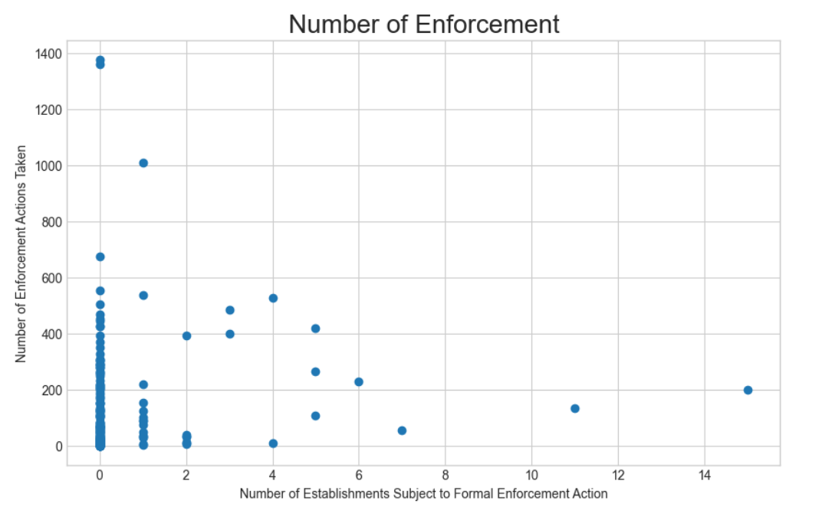

Figure 3 Scatter Plot