
Orbit Backup and Restore Guide
Document Type: Backup and Restore Guide
Product Name: Orbit Analytics
Doc Id: Backup & restore V1.1
Last updated: Oct 20, 2020
Table of Contents

1. General 4
1.1. Purpose 4
1.2. Scope 4
1.3. Audience 4
2. Getting Started 5
3. Orbit Backup 6
3.1. Orbit Metadata Backup (Oracle) 6
3.2. Orbit Metadata Backup (MySQL) 6
3.3. Orbit Metadata Backup (SQL Server) 7
3.4. Orbit Application Backup (Tomcat) 8
3.5. Orbit Application Backup (WebLogic) 8
3.5.1. Prerequisites 8
3.5.2. Reporting Engine Backup 8
4. Orbit Restore 11
4.1. Orbit Metadata Restore (Oracle) 11
4.2. Orbit Metadata Restore (MySQL) 11
4.3. Orbit Metadata Restore (SQL Server) 12
4.4. Orbit Application Restoring (Tomcat) 14
4.5. Orbit Application Restoring (WebLogic) 14
4.5.1. Cleansing Process 14
4.5.2. Restoring Reporting Engine 15
5. Appendix 16
6. Appendix A: Stopping WebLogic Server 17
LINUX Command 17
Windows Command 17
7. Appendix B: Starting WebLogic Server 18
Linux Command 18
Windows Command 18
8. Appendix C: Starting Tomcat Server 19
Linux Command 19
Windows Command 19
9. Appendix D: Stopping Tomcat Server 20
LINUX Command 20
Windows Command 20

General

Purpose
The purpose of this document is to provide a set of instructions that explains the backup and restore process of the Orbit Analytics application.

Scope
Scope of this document is to provide instructions to backup and restore the Orbit Analytics application.

Audience
This document is for the administrators and implementation personnel responsible for backup and restoring the Orbit Analytics application.
It is assumed that the audience is familiar with:
- Application server deployment on which Orbit Analytics application is running such as Apache Tomcat or Oracle WebLogic.
- Export and import operations on database management systems configured for Orbit Analytics application such as Oracle, MySQL, MSSQL, or PostgreSQL.
- Maintenance of Orbit Analytics application.

Getting Started
This document explains about the following topics:
- Orbit Backup
- Orbit Restore

Orbit Backup
Orbit Backup is divided into the following topics:
- Orbit Metadata Backup
- Orbit Application Backup

Orbit Metadata Backup (Oracle)
Orbit metadata schema and Staging schema are required to run the Orbit application.
For instance, consider orbit metadata schema as XXORB and staging schema as XXSTG and perform the following steps.
- Log in to the server and create a directory in the server.
mkdir -p /u01/app/oracle/datapump
- Connect to SQL*Plus and create directory object for the directory created in the previous step.
SQL>CREATE DIRECTORY datapump AS ‘/u01/app/oracle/datapump’;
- Give read and write privileges to the directory created in the previous step.
SQL>GRANT read, write ON DIRECTORY datapump TO system;
- Export the Orbit metadata schemas with the below command and save the dump file.
expdp system/manager schemas=XXORB,XXSTG directory=DATAPUMP dumpfile=Orbit_metadata.dmp logfile=Orbit_metadata_exp.log
Note: Here, the metadata backup dump file is named as <Orbit_metadata.dmp>.

Orbit Metadata Backup (MySQL)
For instance, consider orbit metadata database as XXORB and staging database as XXSTG and perform the following steps:
Log in to the server where the MySQL is running and issue the following command.
mysqldump -u root -p --databases XXORB XXSTG > Orbit_backup.sql

Orbit Metadata Backup (SQL Server)
To take a backup of the database, do the following:
- Launch the SQL Server Management Studio (SSMS) and connect to your SQL Server instance.
- Expand the Databases node in the Object Explorer.
- Right-click the database, hover over Tasks, and select Back up.
- Under Destination, confirm the path for backup. If you need to change this, select Remove to remove the existing path, and then Add to type in a new path. Use the ellipses to navigate to a specific file.
- Select OK to take a backup of the database.
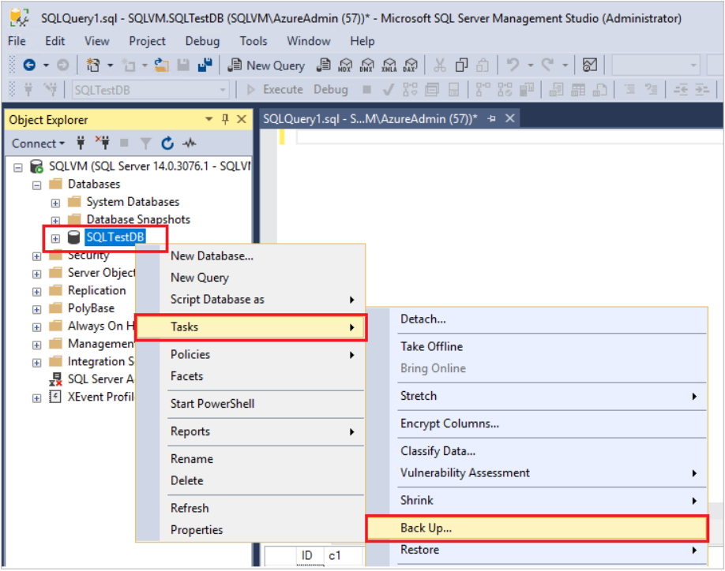

Orbit Application Backup (Tomcat)
- Shut down the running Orbit application going into the tomcat home bin directory.
cd $TOMCAT_HOME/bin
./shutdown.sh
- Go to the Tomcat home webapps folder and tar the reporting folder.
tar -czvf reporting.tar.gz reporting
- Copy the reporting.tar.gz and reporting.war to desired location.
cp reporting.tar.gz reporting.war /u01/backups

Orbit Application Backup (WebLogic)
This section explains about Orbit backup on WebLogic 12.1.3 using Windows OS.

Prerequisites
- Windows OS
- Any Browser
- WINSCP

Reporting Engine Backup
- Log in to the WebLogic console using proper credentials.
- Identify the domain where the Orbit is installed.
  - On the home page, Domain Structure appears.
  - Under the Domain Structure section, base_domain appears.
- In this case, Orbit is installed in the base_domain; the domain name may differ, here, it is taken as base_domain.
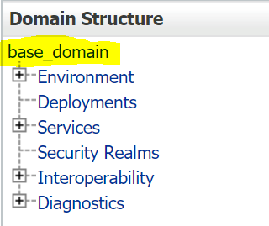
Note: It is recommended to stop the WebLogic server before taking any backup.
- Stop the WebLogic Server. Refer to Stopping WebLogic Server for more information.
- After successfully stopping the WebLogic server, open WinSCP, identify and navigate to <ORACLE_HOME> directory.
- Under Oracle_Home directory navigate to user_projects/domains, where all domains are available.
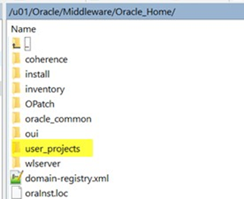
- Select the required domain where Orbit war files are installed.
- For example, here Orbit war files are installed in the base_domain.
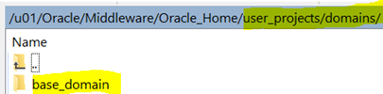
- Navigate to base_domain/servers/AdminServer/upload.
- Under the upload folder, the war files appear.
- Note: The files which must be downloaded onto our local machine exist in the upload folder.
- Back up OrbitJars.war and reporting.war.
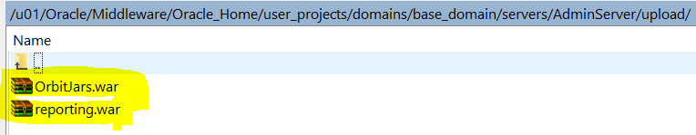
- To save the backup file in local machine, select the war files, and then click Download.
- Download dialog box appears.
- To download the war files, click OK.
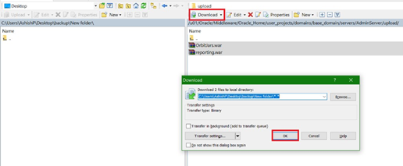
- To restore Orbit, the following backup files are required:
Backup Filename | Description
Orbit_metadata.dmp | This is the dump file that becomes available as a result of Orbit Metadata Backup
OrbitJars.war  Reporting.war | These files become available as a result of Reporting Engine Backup

Orbit Restore
The process of Orbit Restore comprises of the following:
- Orbit Metadata Restore
- Orbit Application Restore

Orbit Metadata Restore (Oracle)
This section explains the Orbit metadata restore process on WebLogic 12.1.3. This includes dropping an existing schema, recreating the same schema, and restoring the data.
To Restore Orbit Metadata
- Drop the existing Orbit metadata schemas.
SQL>drop user XXORB cascade;
SQL>drop user XXSTG cascade;
- Create the Orbit metadata schemas with the same username and passwords.
SQL>create user XXORB identified by <password>;
SQL>create user XXSTG identified by <password>;
- Grant the necessary roles to the created orbit metadata schemas.
SQL>grant connect,resource,unlimited tablespace to XXORB;
SQL>grant connect,resource,unlimited tablespace to XXSTG;
- To restore the orbit metadata schema, use the dump file that is backed up previously with the following command:
impdp system/manager directory=DATAPUMP dumpfile=Orbit_metadata.dmp logfile= Orbit_metadata_imp.log
Note: <Orbit_metadata.dmp> file becomes available as a result of Orbit Metadata Backup.

Orbit Metadata Restore (MySQL)
- Create a database to import the data. If the database already exists (In case of a refresh or restoring in the same server), first drop the existing database.
  - Dropping the database if already exists.
mysql> drop database XXORB;
mysql> drop database XXSTG;
  - Creating new databases for restoring the orbit metadata.
mysql> create database XXORB;
mysql> create database XXSTG;
- Restore the databases separately using the follow command.
mysql> mysql -u root -p --one-database XXORB < Orbit_backup.sql
mysql> mysql -u root -p --one-database XXSTG < Orbit_backup.sql

Orbit Metadata Restore (SQL Server)
To restore the database, do the following:
- Launch the SQL Server Management Studio (SSMS) and connect to your SQL Server instance.
- Right-click the Databases node in the Object Explorer and select Restore Database.
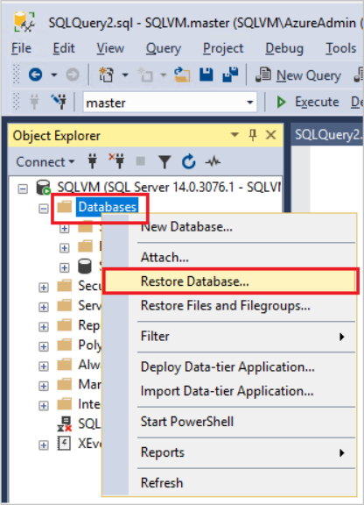
- Select Device, and then select the ellipses (...) to locate backup file.
- Select Add and navigate to where .bak file is located. Select the .bak file and then select OK.
- Select OK to close the Select backup devices dialog box.
- Select OK to restore the backup of the database.
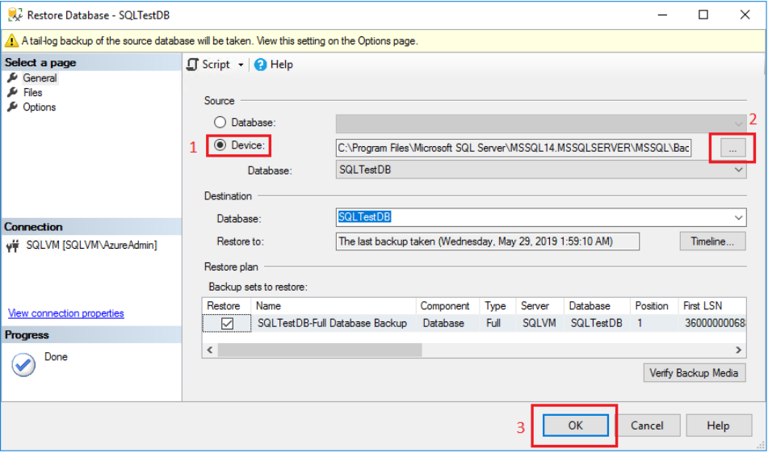

Orbit Application Restoring (Tomcat)
This section explains the restoration process of the Orbit reporting engine by restoring the war files reporting.tar.gz and reporting.war, which has been backed up earlier in the Reporting Engine Backup process.
To restore the process, extract the reporting.tar.gz file in the $TOMCAT_HOME/webapps folder.
The installation process is the same as described in the Orbit Installation Guide. Refer to the Orbit installation guide for the remaining process of restoration of the reporting engine.

Orbit Application Restoring (WebLogic)
This section explains the restoring process of the Orbit application. The restoration phase comprises of: Restoring Reporting Engine
Start the WebLogic server. Refer to Starting WebLogic Server for more information.
Note: Before continuing with restoring the Orbit reporting engine, it is recommended to perform the Cleansing Process to remove any unwanted or corrupt file.

Cleansing Process
This process is to remove any existing unwanted files.
- Log in to the WebLogic console.
- Under the Deployments section, select OrbitJars and reporting checkboxes.
- Click Stop and select Force Stop Now from the dropdown list.
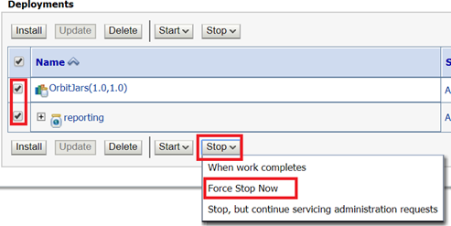
- The following message appears:
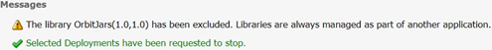
- Select OrbitJars and reporting checkboxes, and then click Delete.
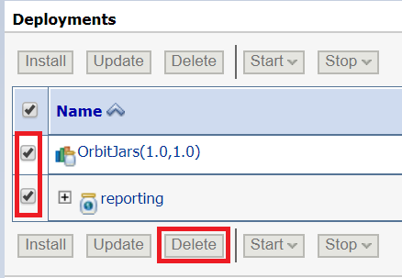
- The following message appears with a green tick mark if the action is successful.

- All the deployments are deleted as shown below:
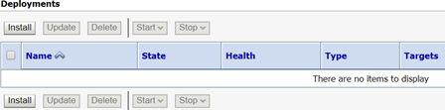

Restoring Reporting Engine
This section explains the restoration process of the Orbit reporting engine by restoring the war files OrbitJars.war and reporting.war, which have been backed up earlier in the Reporting Engine Backup process.
To restore the process, install the backup copies of OrbitJars and reporting.war.
The installation process is the same as described in the Orbit Installation Guide. Refer to the Orbit Installation guide for the remaining process of restoration of the reporting engine.

Appendix

Appendix A: Stopping WebLogic Server
Note: Assuming <ORACLE_HOME> as /u01/Oracle/Middleware/Oracle_Home

LINUX Command
- Navigate to <ORACLE_HOME>/user_projects/domains/base_domain/bin using cd command.
cd
/u01/Oracle/Middleware/Oracle_Home/user_projects/domains/base_domain/bin
- Under bin folder, run the below command to stop WebLogic server:
$ ./stopWebLogic.sh

Windows Command
- Navigate to %ORACLE_HOME%\user_projects\domains\base_domain\bin using cd command in command prompt.
cd C:\Oracle\Middleware\Oracle_Home\user_projects\domains\base_domain\bin
- Under bin folder, run the below command to stop WebLogic server:
>stopWebLogic.cmd

Appendix B: Starting WebLogic Server

Linux Command
- To start WebLogic on Linux Machine, navigate to <ORACLE_HOME>/ user_projects/domains/base_domain/bin using cd command and run <startup.sh> file.
$ cd
/u01/Oracle/Middleware/Oracle_Home/user_projects/domains/base_domain/bin
$ nohup sh startWebLogic.sh &

Windows Command
- Navigate to %ORACLE_HOME%\user_projects\domains\base_domain\bin using cd command in command prompt.
cd C:\Oracle\Middleware\Oracle_Home\user_projects\domains\base_domain\bin
- Under bin folder, run the below command to stop WebLogic server:
> startWebLogic.cmd

Appendix C: Starting Tomcat Server

Linux Command
- To start tomcat on Linux machine, navigate to $TOMCAT_HOME/bin using cd command.
$cd /u01/orbweb/apache/apache-tomcat-8.5.47/bin
- Under bin folder run the below command to start tomcat.
$ ./startup.sh

Windows Command
- To start tomcat on Windows machine, navigate to %TOMCAT_HOME%\bin using cd command.
cd c:\orbweb\apache-tomcat-8.5.47\bin
- Under bin folder run the below command to start tomcat.
> startup.cmd

Appendix D: Stopping Tomcat Server

LINUX Command
- To stop tomcat on Linux machine, navigate to <TOMCAT_HOME>/bin using cd command.
$cd /u01/orbweb/apache-tomcat-8.5.47/bin
- Under bin folder run the below command to stop tomcat.
$ ./shutdown.sh

Windows Command
- To stop tomcat on Windows machine, navigate to %TOMCAT_HOME%\bin using cd command.
cd c:\orbweb\apache-tomcat-8.5.47\bin
- Under bin folder run the below command to stop tomcat.
> shutdown.cmd

