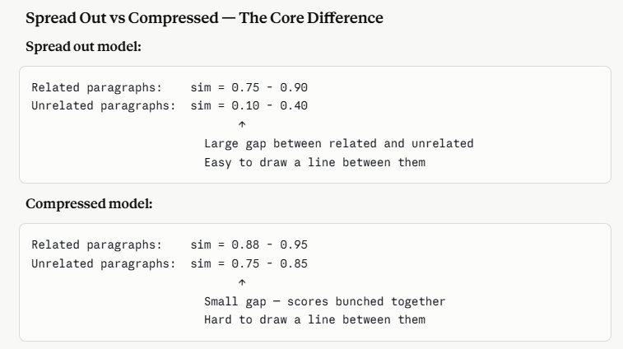

Why Some Models Produce Compressed Scores
It comes down to how the model was trained.
Some models are trained to maximize the difference between related and unrelated content — they push related vectors very close together and unrelated vectors very far apart. Wide spread.
Other models are trained on next-token prediction — they learn general language patterns but not specifically to distinguish related from unrelated text. Everything ends up relatively similar to everything else in a narrow band.

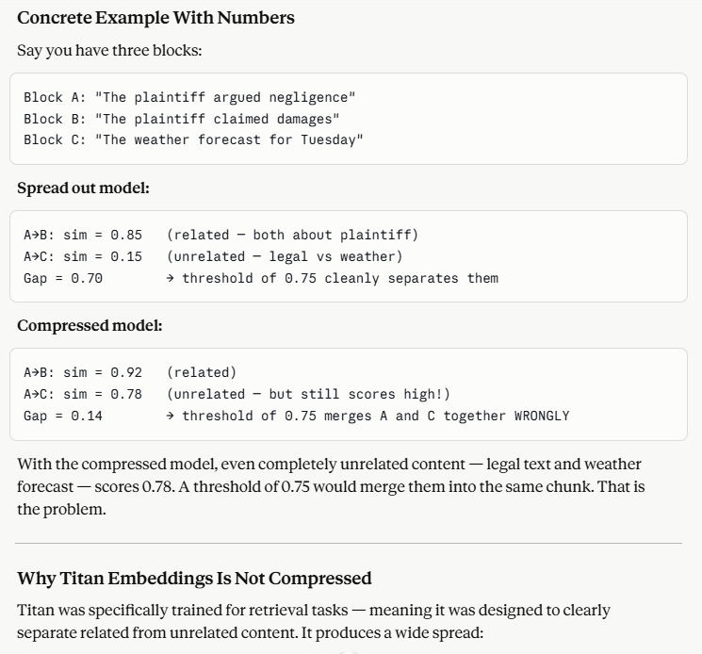

This data came from below URL
https://claude.ai/chat/6eede107-c964-41a0-be34-c87134177bc8

"Titan is specifically optimized for retrieval tasks — it produces a wide spread between related and unrelated content similarity scores. This makes our fixed 0.75 threshold reliable for semantic chunking. Models like OpenAI ada-002 produce compressed scores where even unrelated content scores above 0.75, making fixed thresholds unreliable without adaptive approaches."

