**Data Types:**

* Primitive data types
* Reference data types

**Primitive Data type:**

The variable is used to store a value, and that is placed on the stack. This means that when you create a variable you reserve some space in memory. Based on the data type of a variable, the operating system allocates memory and decides what can be stored in the reserved memory.

The value which is stored on the memory (stack) will occupy some space; this space size is specified by Data Types.

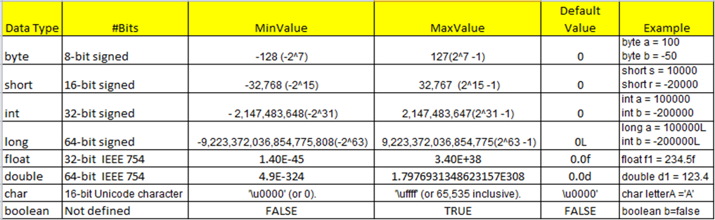

**Reference Data type:**

Reference variables are used to access the object.

Dog dog123 = new Dog(); // dog reference variable is used to locate the object present in heap.

1. Class objects and various types of array variables come under reference data type.
2. Default value of any reference variable is null.

Note:

For storing simple value creating the object is not efficient, because objects are placed on the heap,

That’s the reason Primitive data types brought to java from c & c++;