**Exception**

**Exception Hierarchy:**

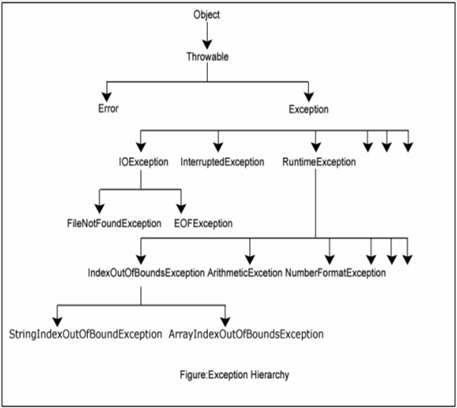

Exceptions are problems that occur at runtime; Exceptions are caused by the program, and are recoverable.

Checked Exceptions: Checked exceptions are checked at compile time to ensure smooth execution of program at runtime.

Unchecked Exception: Unchecked exceptions are checked at Runtime, and they occur at Runtime.

Runtime Exception, its subclasses and Error, Its subclasses are unchecked exceptions.

Errors are caused due to lack of system resources, and are not recoverable.

**The throws/throw Keywords:**

If a method does not handle a checked exception, the method must declare it using the **throws** keyword followed with an Exception. The throws keyword appears at the end of a method's signature.

You can declare multiple exceptions using throws keyword.

A method can declare that it throws more than one exception, in which case the exceptions are declared in a list separated by commas.

Public void readFile() throws FileNotFoundException

Public void readFile() throws FileNotFoundException,FileNameIncorrectException

You can throw an exception, either a newly instantiated one or an exception that you just caught, by using the **throw** keyword.

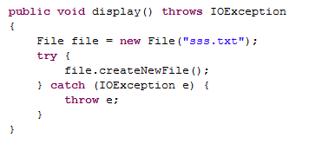

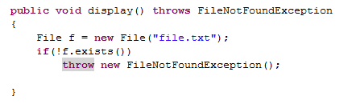

**Finally:**

The finally keyword is used to create a block of code that follows a try block. A finally block of code always executes, whether or not an exception has occurred.

Using a finally block allows you to run any clean-up-type statements that you want to execute, no matter what happens in the protected code.

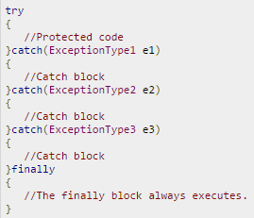 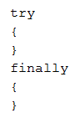

**UserDefinedException:**

You can create your own exceptions in Java. Keep the following points in mind when writing your own exception classes:

* All exceptions must be a child of Throwable.
* If you want to write a checked exception that is automatically enforced by the Handle or Declare Rule, you need to extend the Exception class.
* If you want to write a runtime exception, you need to extend the RuntimeException class.

