CleanBot — The Smart Anti-Littering Android

Product Specification & Business Model Plan

1. Executive Summary
Urban areas worldwide face persistent littering issues, degrading the environment, public health, and aesthetics of cities. CleanBot is an android-based, humanoid robot system designed to detect and discourage littering behavior in public spaces. Using a combination of camera streaming, OpenCV-based image processing, and real-time alerts, CleanBot identifies offenders, records evidence, and helps authorities take timely action. It also acts as a deterrent through its audible warning system, educating the public about responsible waste disposal.

2. Technical Specification
- Hardware Components:
- High-definition camera module for live visual feed and image capture
- Embedded processor (e.g., NVIDIA Jetson Nano or Raspberry Pi 5) for real-time image analysis
- Loudspeaker system for audio warnings or public messages
- Android interface module for communication with central app
- Connectivity: Wi‑Fi/4G for cloud synchronization and reporting
- Battery & power system: Solar-assisted rechargeable battery for outdoor operation
- Robotic mobility (optional): Semi-humanoid design with limited mobility to reposition or face offenders
- Casing: Weatherproof, vandal-resistant shell suitable for urban deployment
- Software Architecture:
- Operating System: Android (integrated with embedded Linux controller)
- Detection Engine: OpenCV-based litter detection trained with image datasets (plastic, paper, bottles, etc.)
- Alert Module: Triggers alarm and captures photo evidence when littering is detected
- Reporting System: Sends event data (image, timestamp, GPS) to municipal authorities or user dashboard
- Machine Learning Integration: Continuous model improvement via cloud retraining
- App Interface: Admins can configure zones, monitor logs, and control alert intensity

3. Functional Flow
1. Camera continuously scans the area.
2. OpenCV processes frames to detect motion and identify littering gestures or discarded waste.
3. If littering is detected:
- The robot plays an audio alert (e.g., “Please do not litter!”).
- Captures an image or short video of the event.
- Uploads evidence to the cloud and notifies authorities or community admin.
4. Admins can review the incidents and take appropriate action.
5. Data analytics dashboard displays hotspot patterns and behavioral improvements over time.

4. Business Model
- Model A: Direct Purchase
- Target Customers: Municipal bodies, private facilities (malls, campuses, parks), event organizers.
- Revenue: One-time sale per device.
- After-sales: Annual maintenance contract (AMC) for software updates, repairs, and analytics.
- Model B: Rental / Subscription
- Target Customers: Welfare associations, gated communities, city wards.
- Revenue: Monthly/quarterly rental based on deployment duration and features enabled.
- Mobility Advantage: Device can be relocated to new hotspots as littering declines in deployed area.

5. Market Potential
- Urban local bodies under Smart City initiatives and national cleanliness missions.
- Corporate campuses, shopping centers, and educational institutions aiming for green certifications.
- Event organizers for temporary deployment to manage public cleanliness.

6. Competitive Edge
CleanBot combines AI-based detection, public deterrence, and evidence reporting in one system. It offers adaptable deployment models (fixed or mobile), enhances civic image and compliance for cities, and reduces manpower dependency for monitoring.

7. Future Enhancements
- Integration with facial recognition (where legally permissible) for repeat offender identification.
- Voice interaction module for educational messages and citizen engagement.
- Environmental sensors to track air quality and waste levels.
- Integration with municipal ERP systems for automated fine issuance.

8. Financial Overview (Indicative)
Item | Cost (INR) | Notes
Prototype Development | ₹2,00,000 | Includes hardware and software
Production Unit Cost | ₹80,000 | At small scale
Suggested Selling Price | ₹1,50,000–₹2,00,000 | 40–60% margin
Rental Price | ₹10,000–₹15,000 per month | Includes maintenance
Expected ROI | 12–15 months | Depending on scale

9. Social and Environmental Impact
CleanBot encourages civic responsibility through behavioral reinforcement, supports city-wide waste reduction and sustainability goals, and acts as a visible technological commitment toward cleaner communities.

10. Visual Concept & Block Diagram
Concept: A 3 ft tall humanoid robot with a solar panel on top, a camera in the head, and a speaker in the torso for alarms. Designed for visibility, durability, and ease of relocation. Ideal colors: white and blue with reflective markings for night visibility.
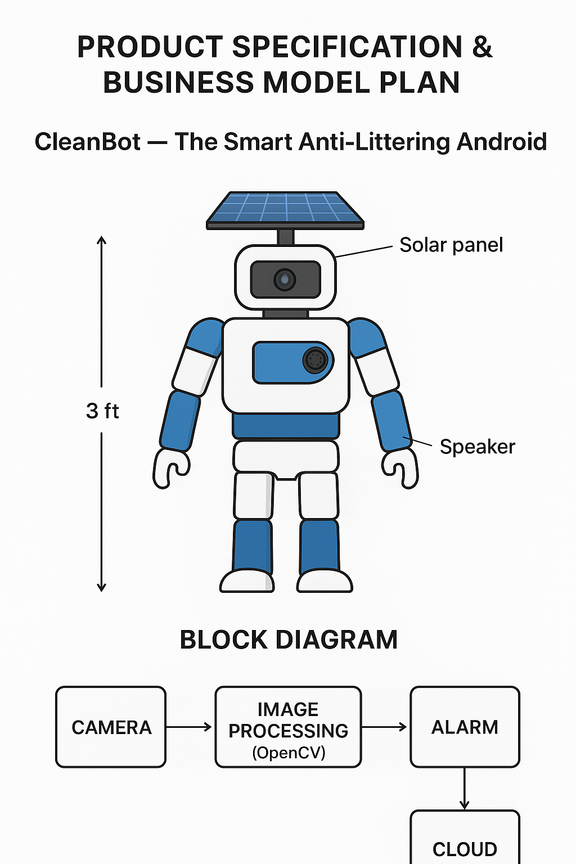
Figure: CleanBot design (3 ft humanoid) with labeled solar panel, camera, speaker and the system block diagram below.

11. Deployment & Operations
Deployment steps:
1. Site survey to identify hotspots and optimal mounting positions.
2. Configure detection sensitivity and geofencing in the admin app.
3. Install device with solar panel exposure; ensure stable network connectivity.
4. Monitor incidents via dashboard and relocate device when littering declines.
Operations:
- Routine maintenance: battery check, camera cleaning, firmware updates.
- Data privacy: store minimal required metadata; comply with local privacy laws.
- Community engagement: publicize deployment to inform citizens and reduce false positives.

12. Legal & Ethical Considerations
Ensure compliance with local surveillance and data protection laws. Avoid storage of personally identifiable information unless legally permitted. Implement audit logs, data retention policies, and consent/notice where required.

13. Contact & Next Steps
Next steps:
- Approve prototype design and budget.
- Develop MVP and run pilot deployments in 2–3 hotspots.
- Iterate based on field feedback and scale production.
For partnership, pilot requests, or investor information, contact: [Your Name / Company]

