**Kubernetes (K8S) - 3 Tier Architecture Implementation**

In this project, created 3 tier architecture using Kubernetes. I uploaded all the files (including screenshots file Kubernetes_project.docx) to the github (**https://github.com/sudheerkumar19/Kubernetes-Project.git**). I cloned that file, and I opened that folder and executed all the commands.

1. **I logged in GCP through acloud guru playground.**

1. **Choose Services -🡪 Kubernetes Engine --🡪 Clusters**

1. **Click on CREATE, GCP creates a controller and 3 nodes.**

1. **Click on GKE Standard🡪 COFIGURE**

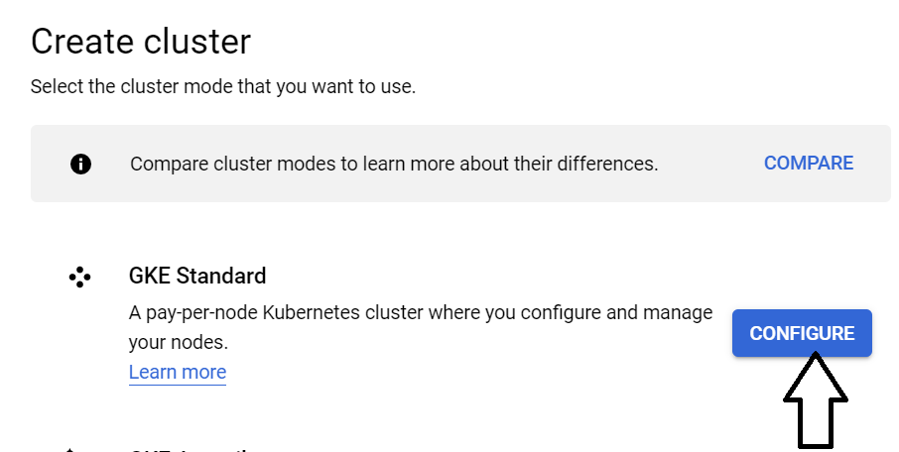

1. **Specify cluster name and click on CREATE.**

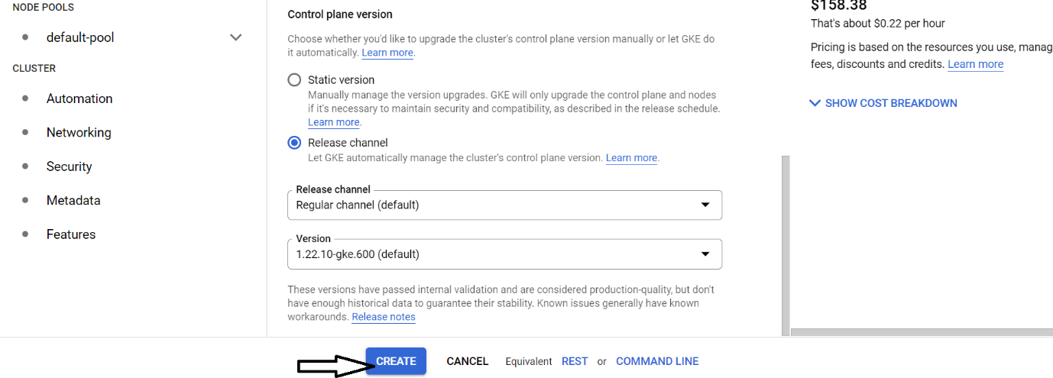

1. **Processing to create Cluster.**

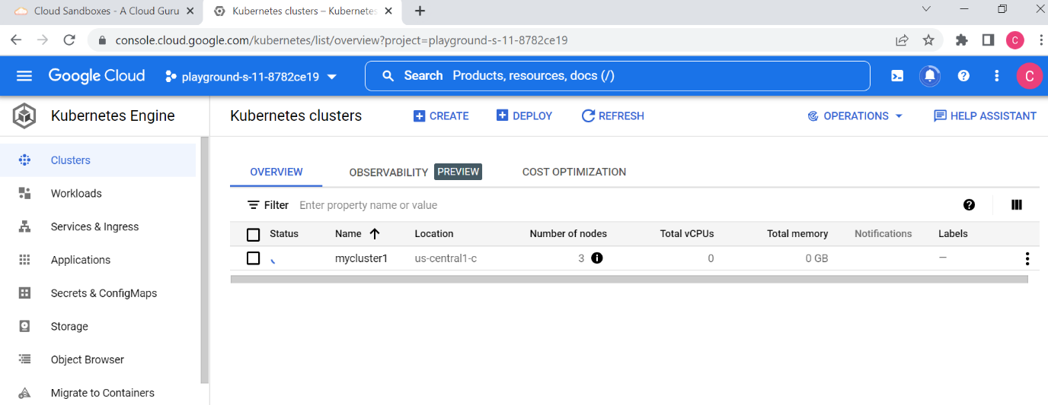

1. **Cluster has created.**

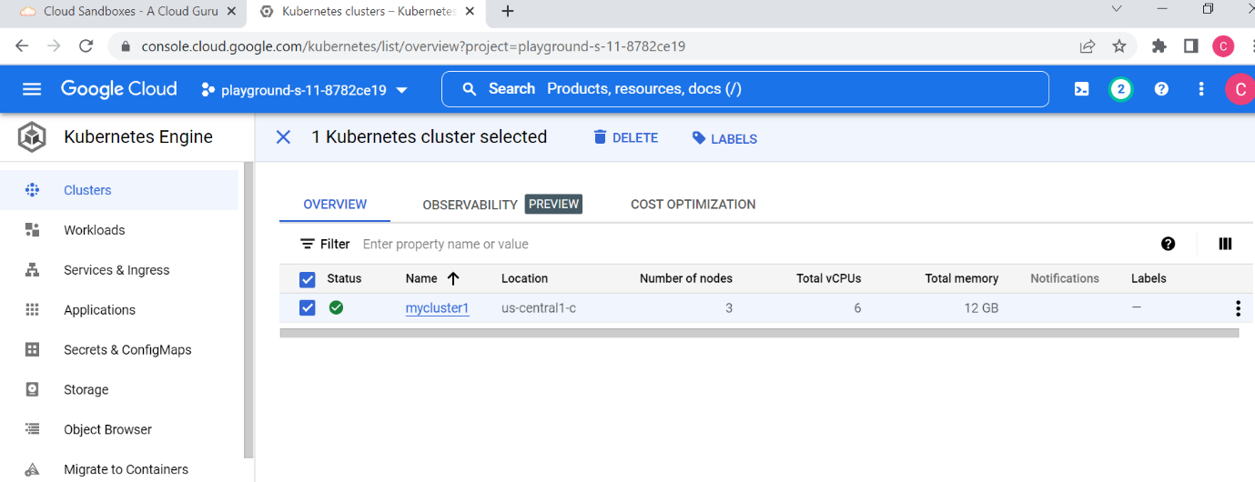

1. **Connecting through cloudshell and cloning the github project files into our cluster.**

1. **Go to the specific project folder.**



1. **Executing all .yml files. These files are related to**



















1. **To know all the information related to cluster, we use the following command.**

1. **By using external IP, we can execute in the browser. Then it displays the output on the screen.**

1. **After choosing our option, it looks like below screenshot.**

