**CS551 Advanced Software Engineering**

**Midterm: Hackathon (Take-home exam)**

**Report Guideline:**

In this project I have implemented a website, where it provides the services :

i) Creating the Events

ii) Event Date

iii) Event Location

iv) Product List

v) Product Name

vi) Product Price

vii)Inviting friends through mails

1. **Design**
   1. **Architecture Diagram**



* 1. **Class Diagram**



1. **Features Implemented**
   1. **Web Services**
      1. **Your own services**

Tried to implement the Barcode reading API service.

* + 1. **Existing services/APIs**

There are some existing services and API's.

<https://hacks.mozilla.org/2012/04/taking-pictures-with-the-camera-api-part-of-webapi/>

<http://stackoverflow.com/questions/10456140/how-take-a-photo-using-jquery-and-show-in-canvas>

* 1. **Database**
     1. **Your own data model/data sources**

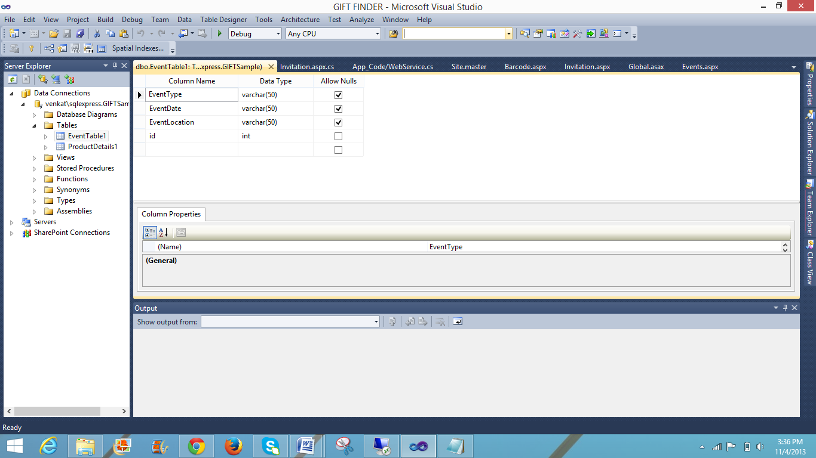

ProductTable1:

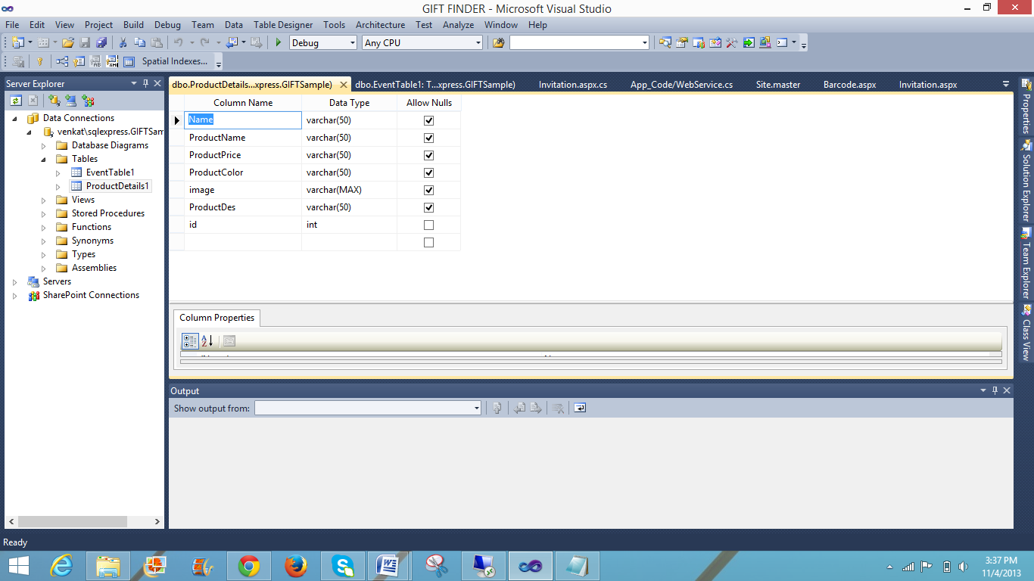

* 1. **Mobile User Interface**
     1. **own design**

In the user interface I have created a design for Creating Events, Displaying product details, Inviting friends and family members.

1. **Screenshots of the Features**

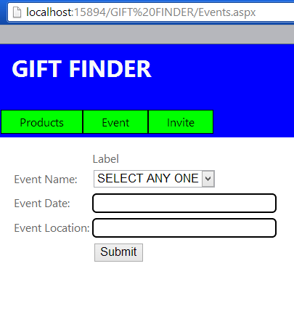

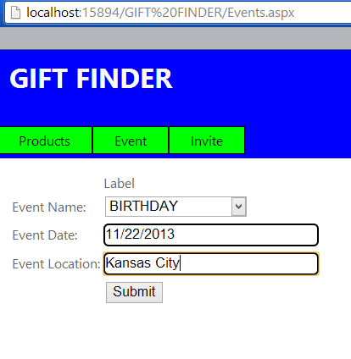

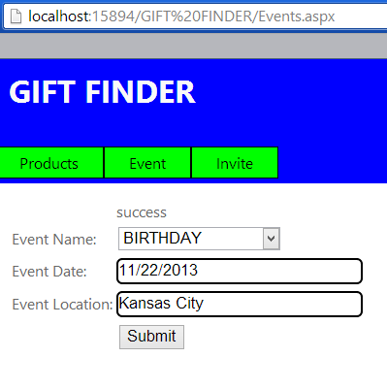

**Values into the database:**

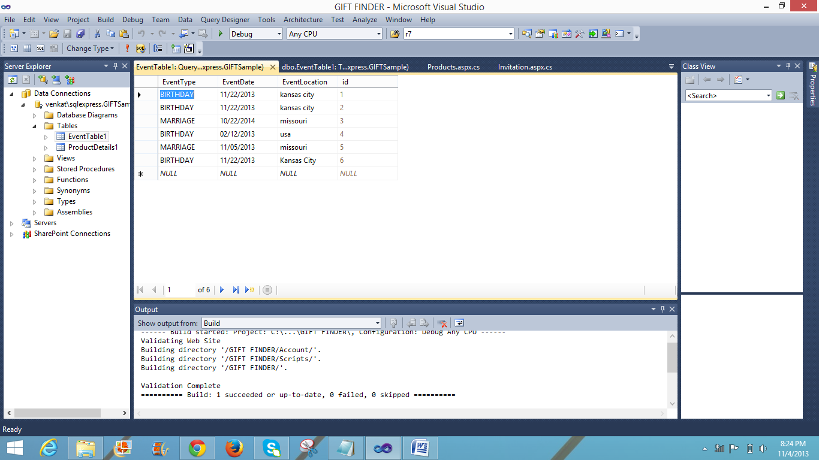

**Displaying the Product Details:**

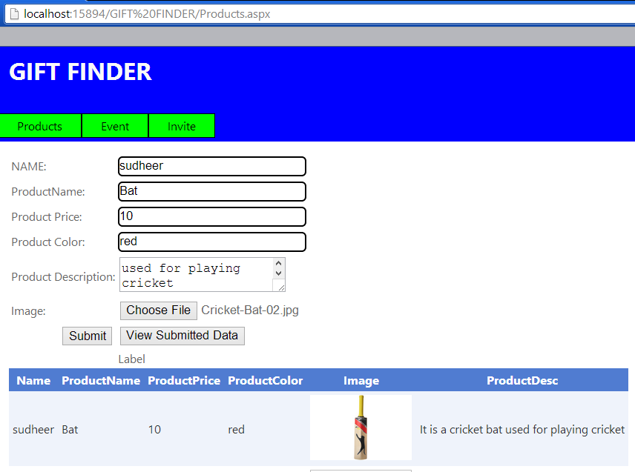

**Displaying list of Products:**

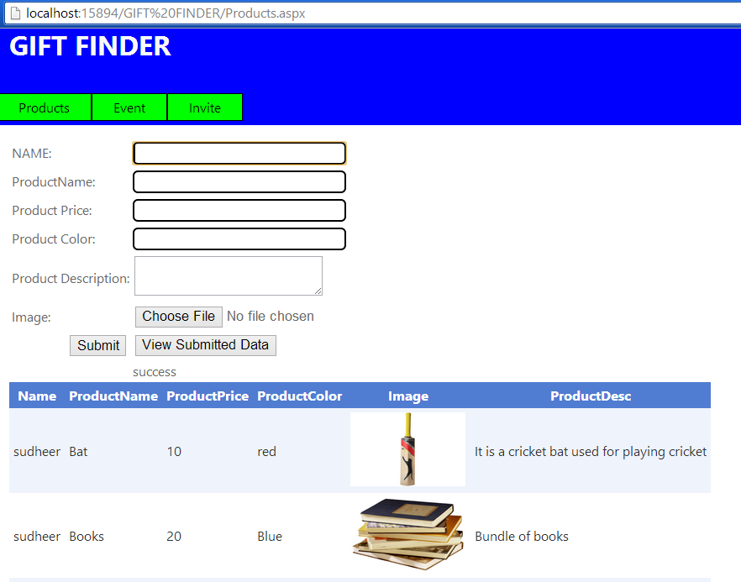

**Values in to the database:**

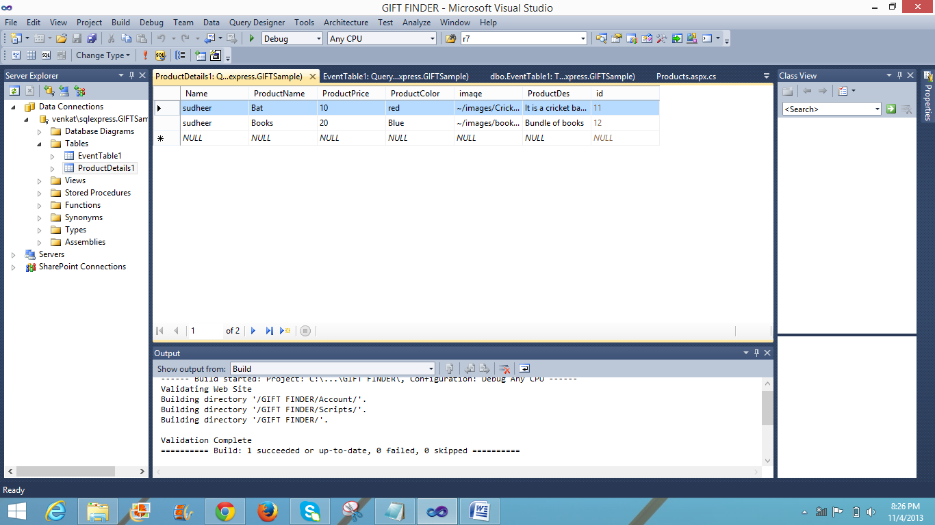

**Sending Email to friends:**

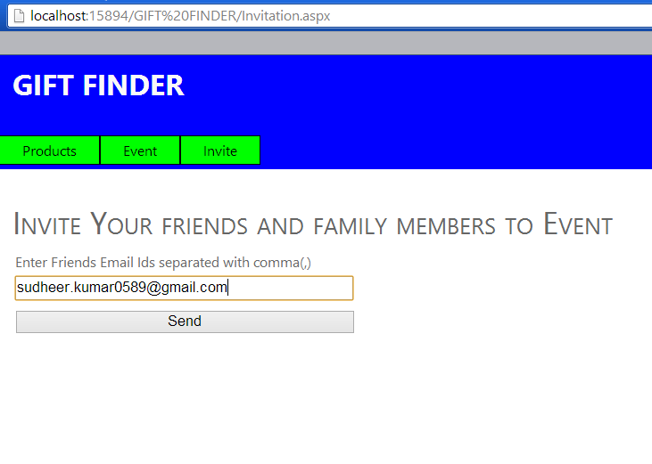

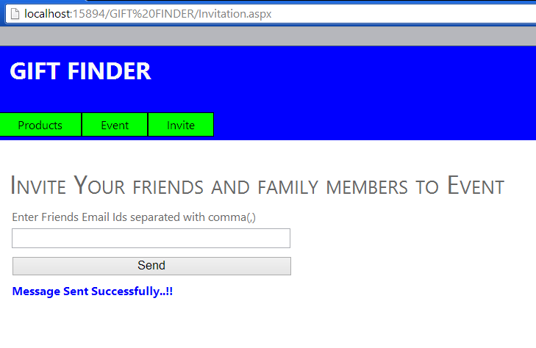

Gmail:



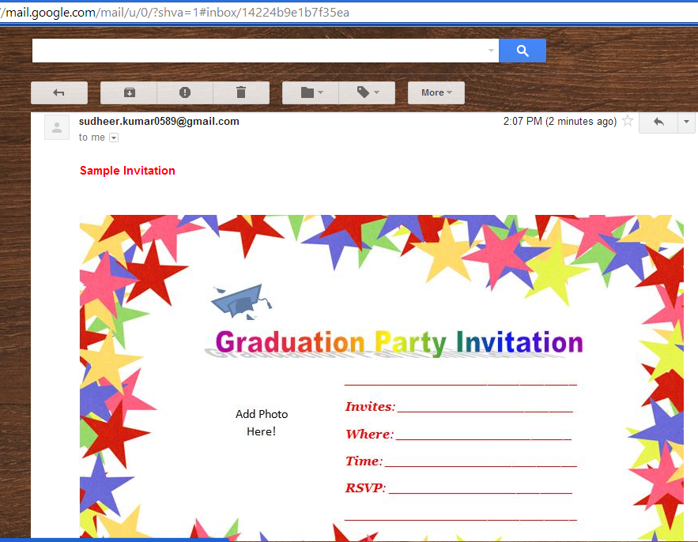

1. **Include all the Web Service and Web Site URLs**

<http://localhost:15894/GIFT%20FINDER/Events.aspx>

<http://localhost:15894/GIFT%20FINDER/Products.aspx>

<http://localhost:15894/GIFT%20FINDER/Invitation.aspx>

1. **Limitations**

The project is limited to some of the services which displays the list of products that are needed by the host and the host sends the Invitation to the list of friends(guests).I have implemented the project requirements in the web site but was not able to do it as a mobile application using jquery mobile, I was encountering compatibility issues.

1. **References**

For sending the mails to the mail addresses of the guests I have used the code from the following reference link:

http://www.csharptutorial.in/2013/03/Csharp.Net-How-To-Send-email-from-gmail-using-c-sharp.html#.UneCLlLa-Ij