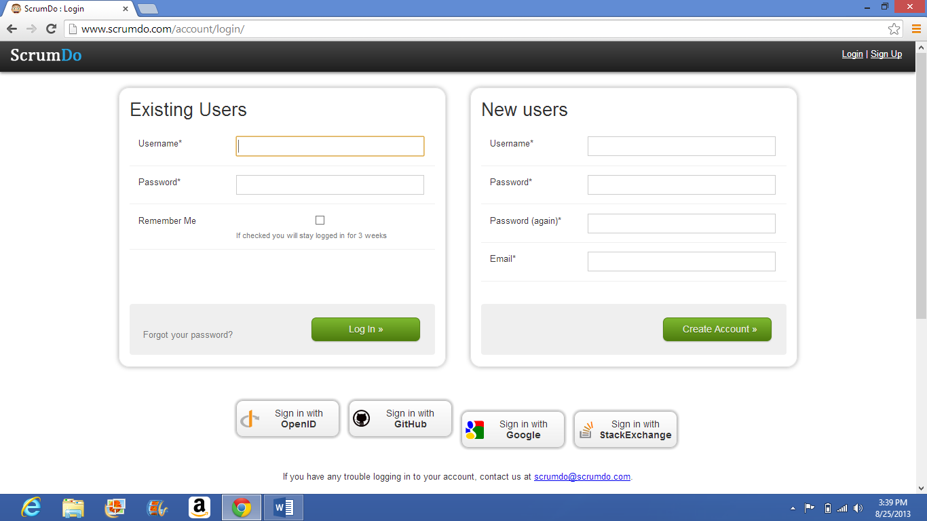

@SCRUMDO SIGNUP

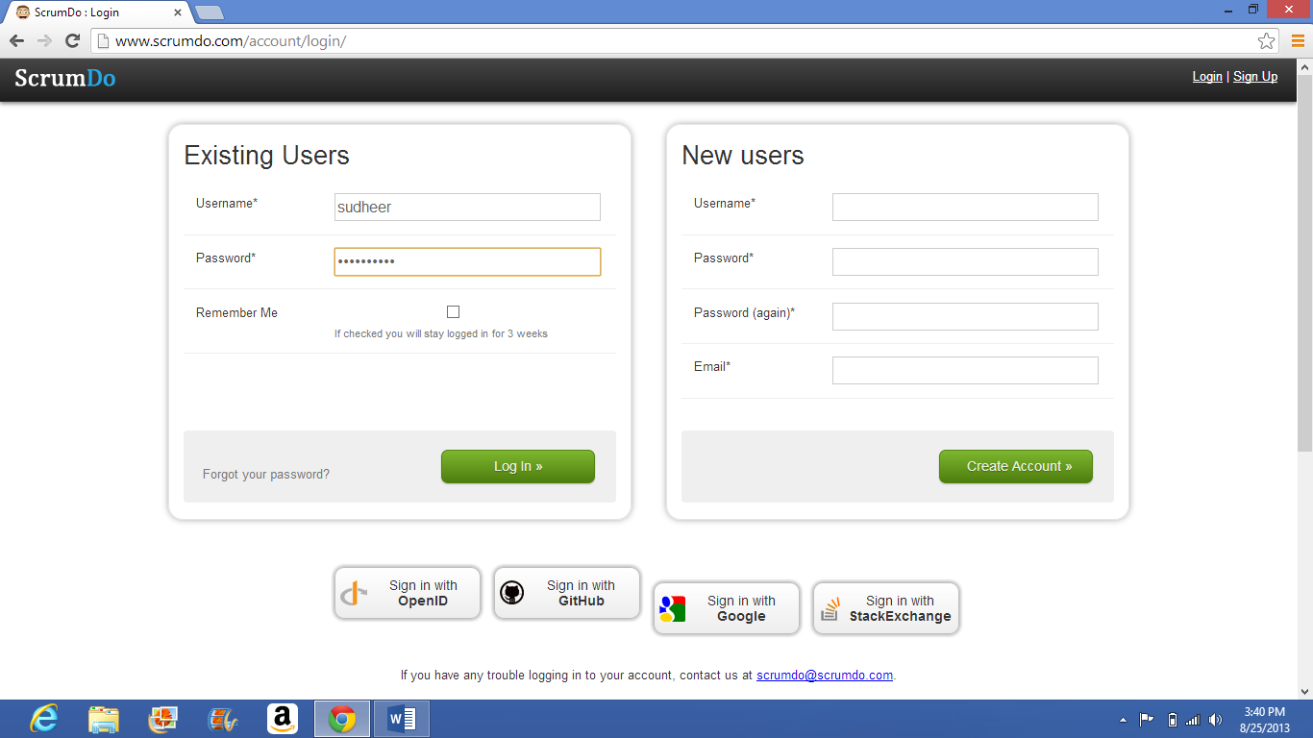

@LOGGING INTO SCRUMDO

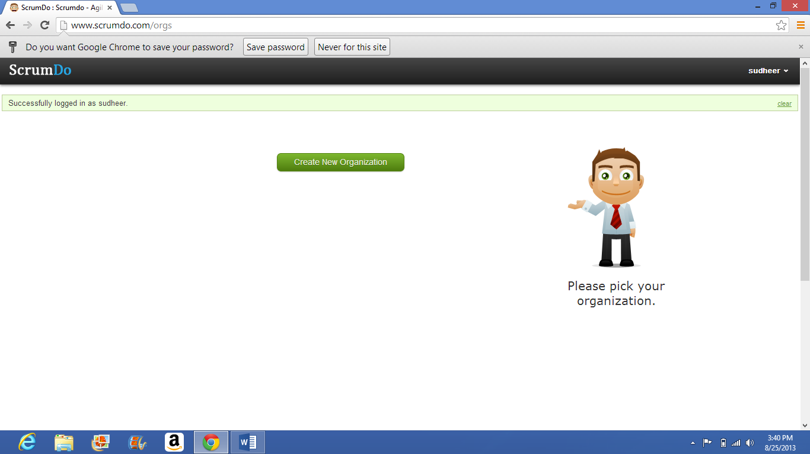

@SUCCESSFULLY LOGGED IN

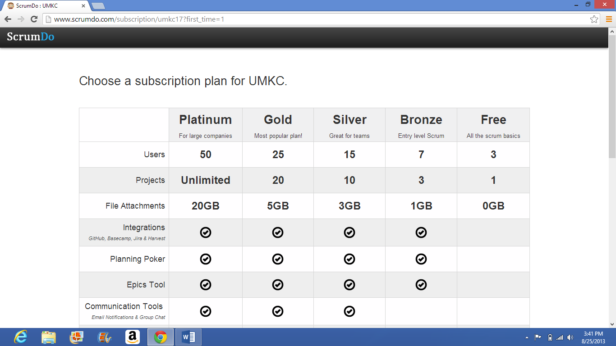

CHOOSING THE PLAN (DEFAULT IS FREE)

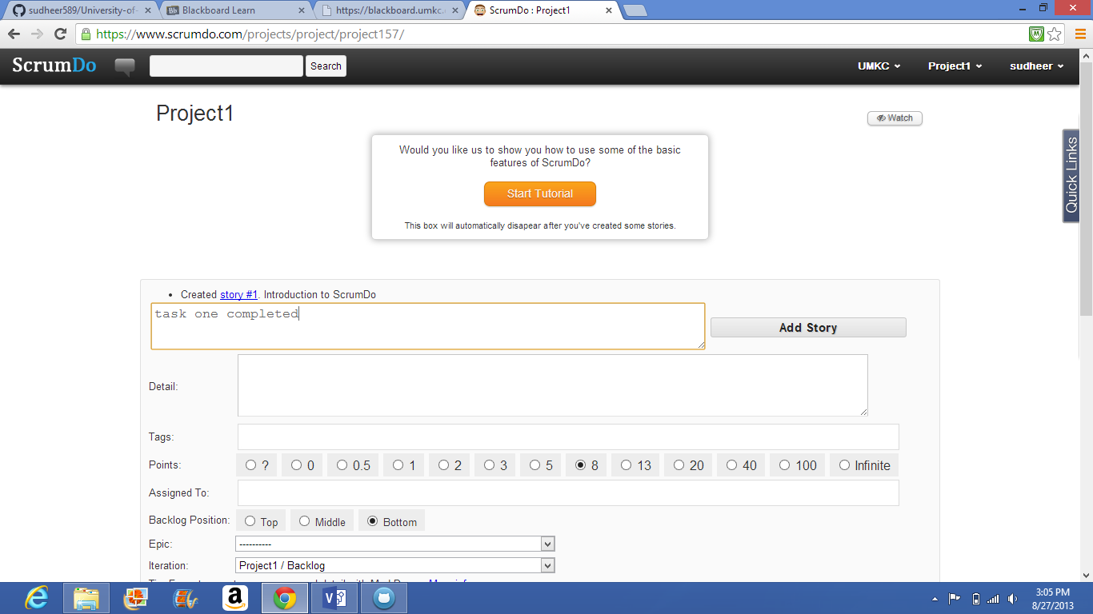

@CREATING FIRST STORY

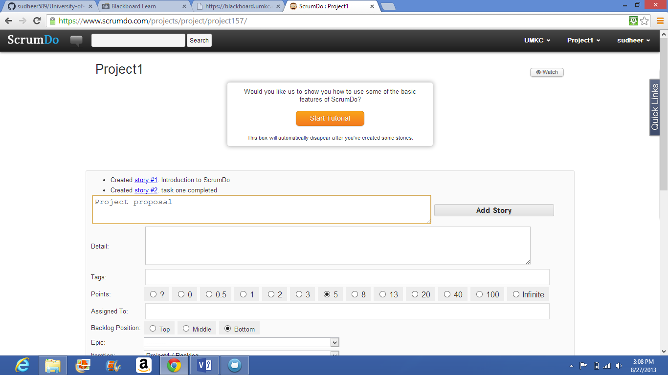

@CREATING SECOND STORY

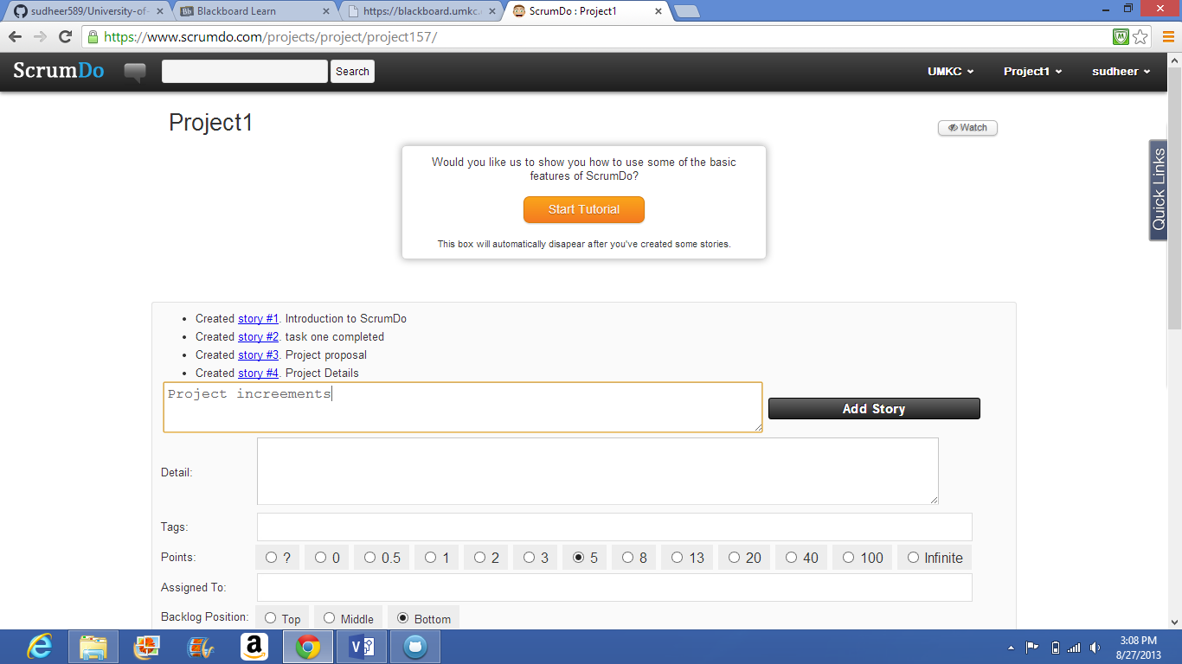

@CREATING MULTIPLE STORIES

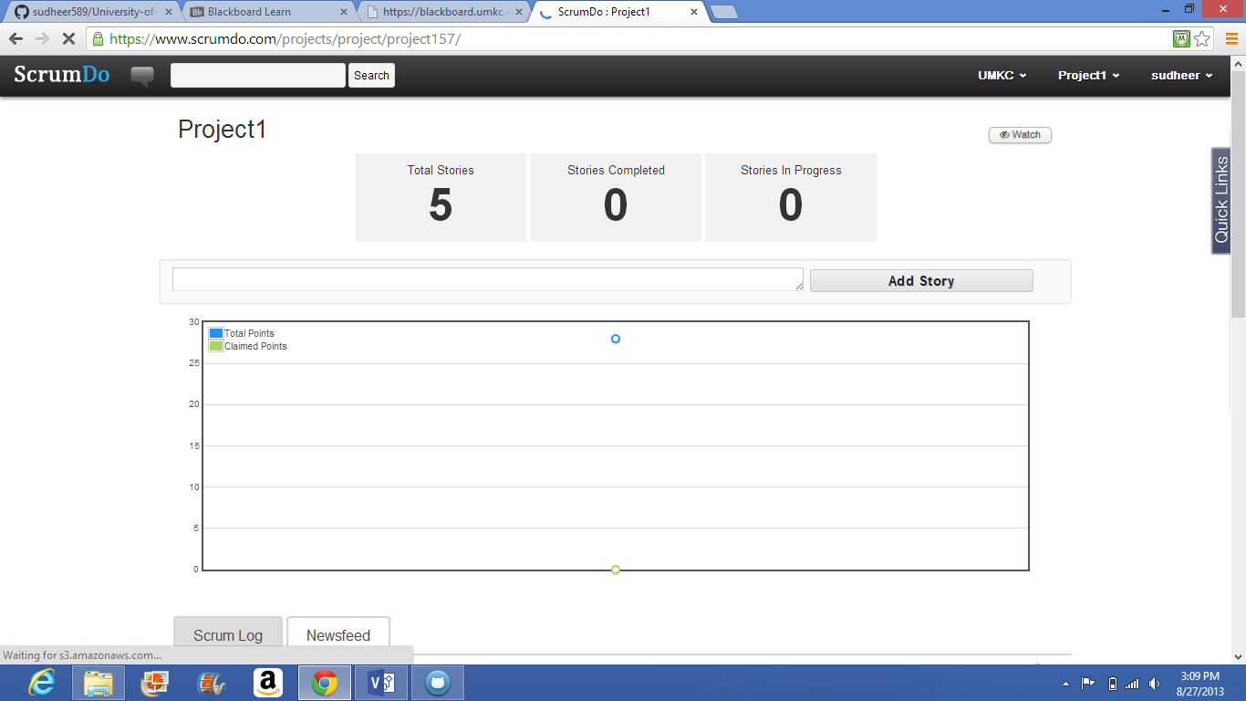

@OPENING SCRUMLOG

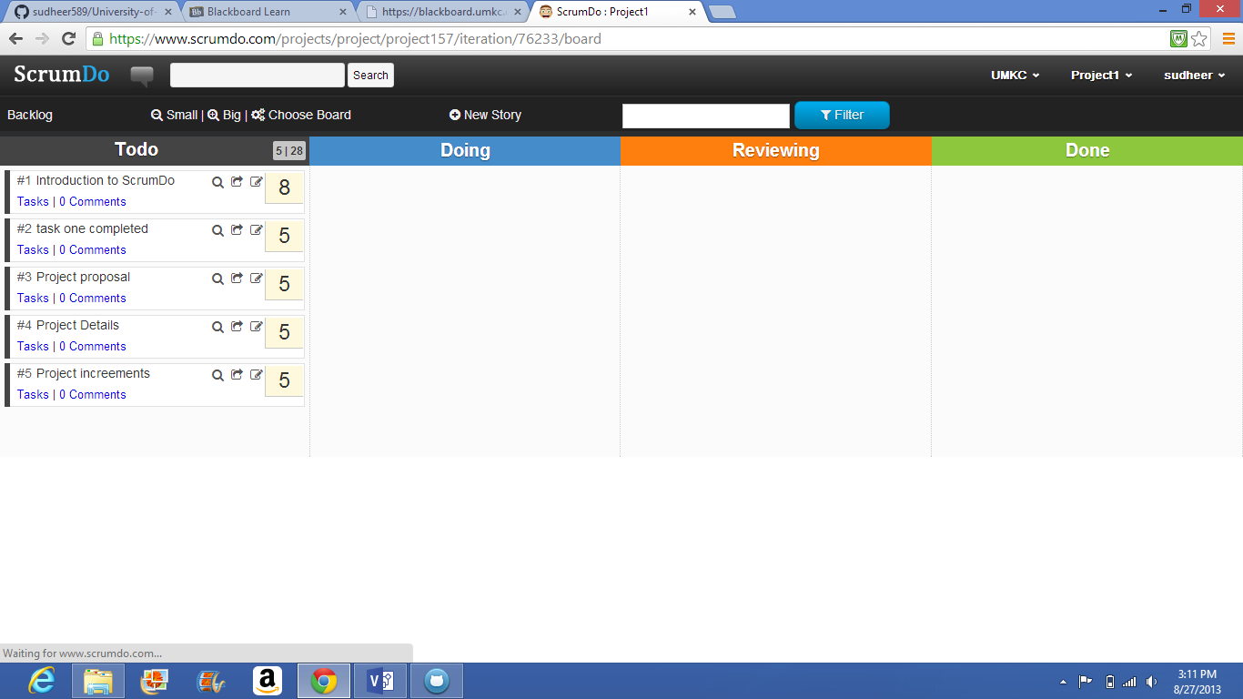

@OPENING BACKLOG

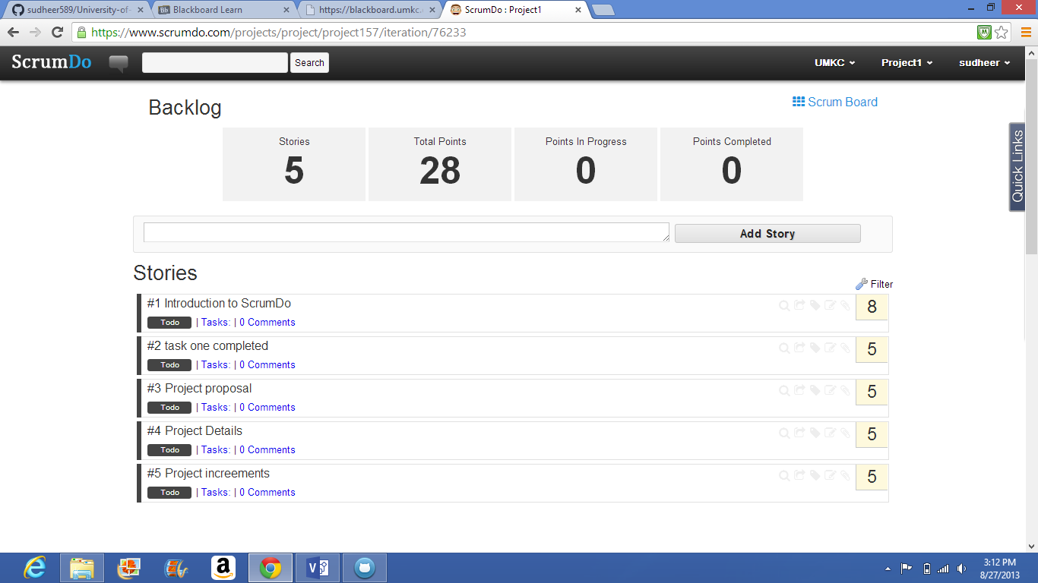

@CHECKING BLACKLOG INFORMATION

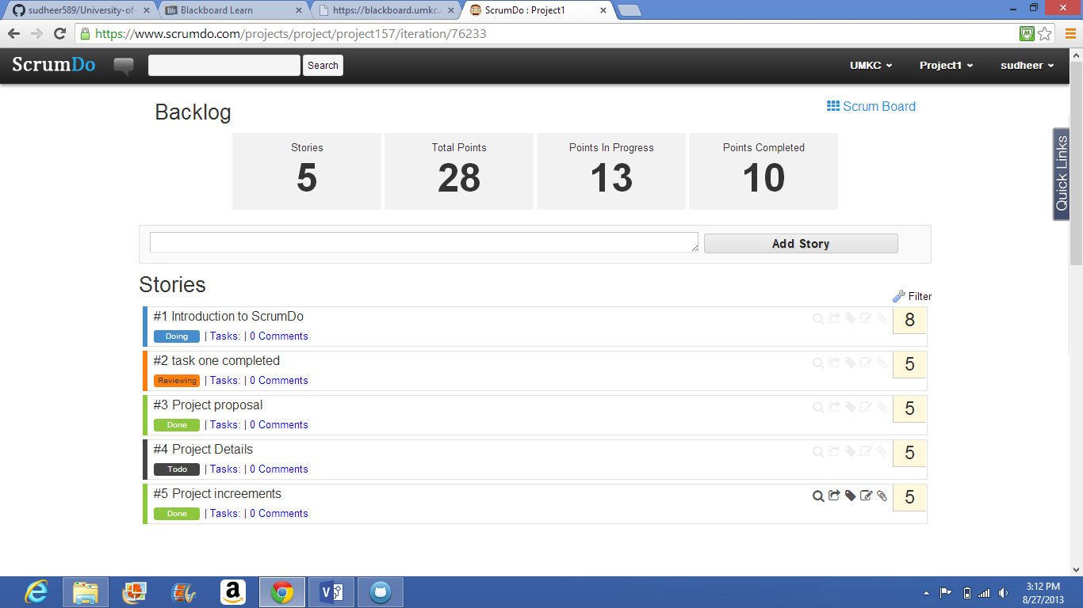

@BACKLOG DETAILS

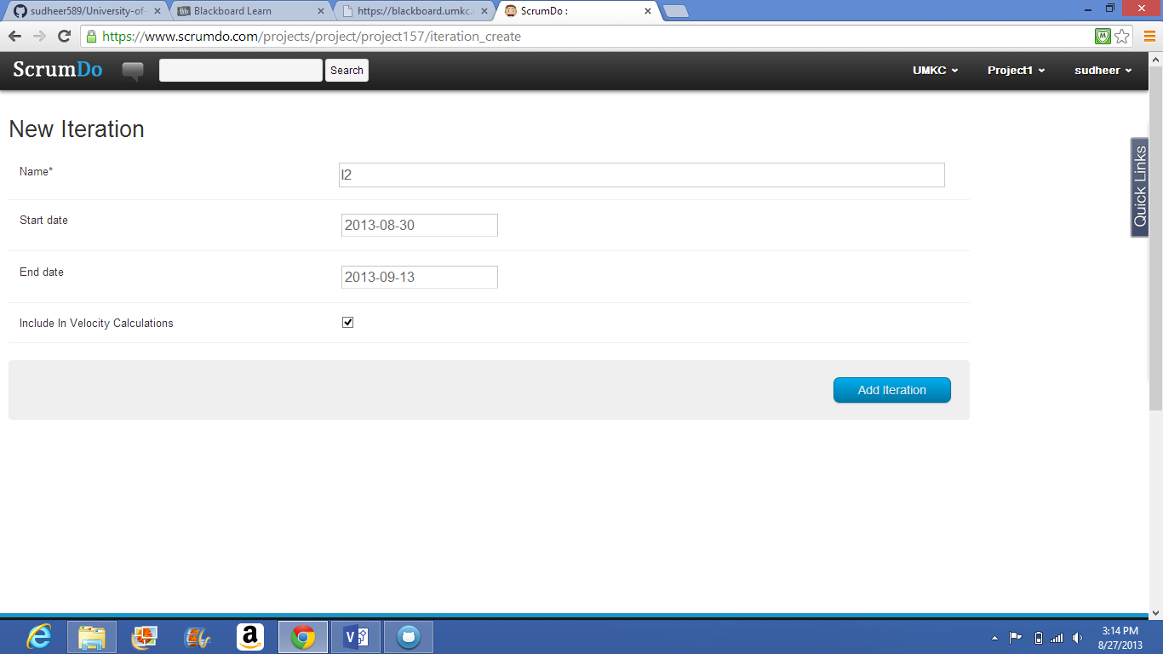

@CREATING ITERATIONS

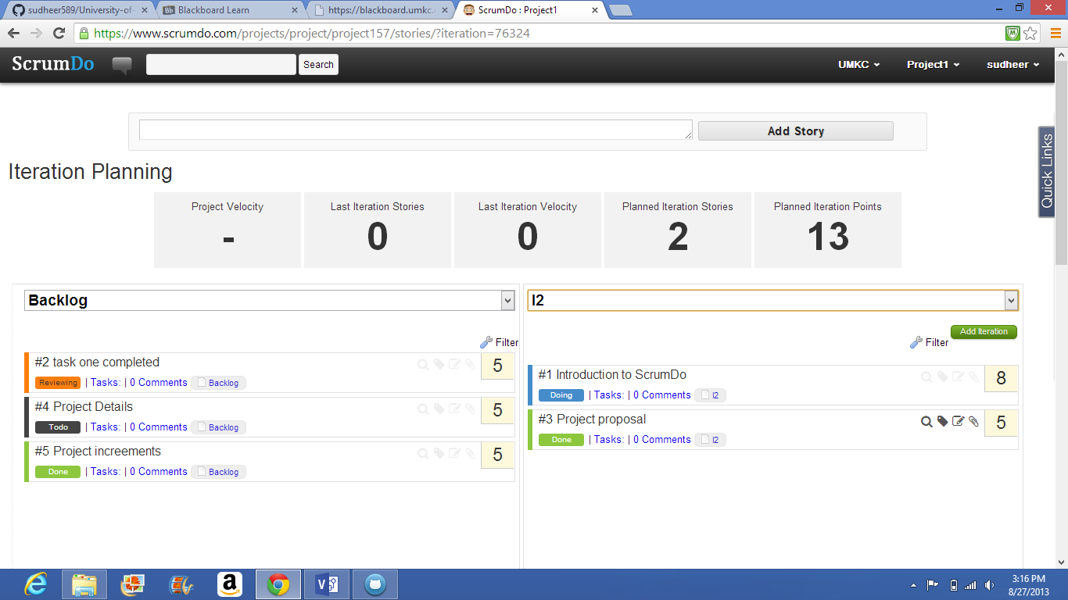

@ITERATION PLANNING

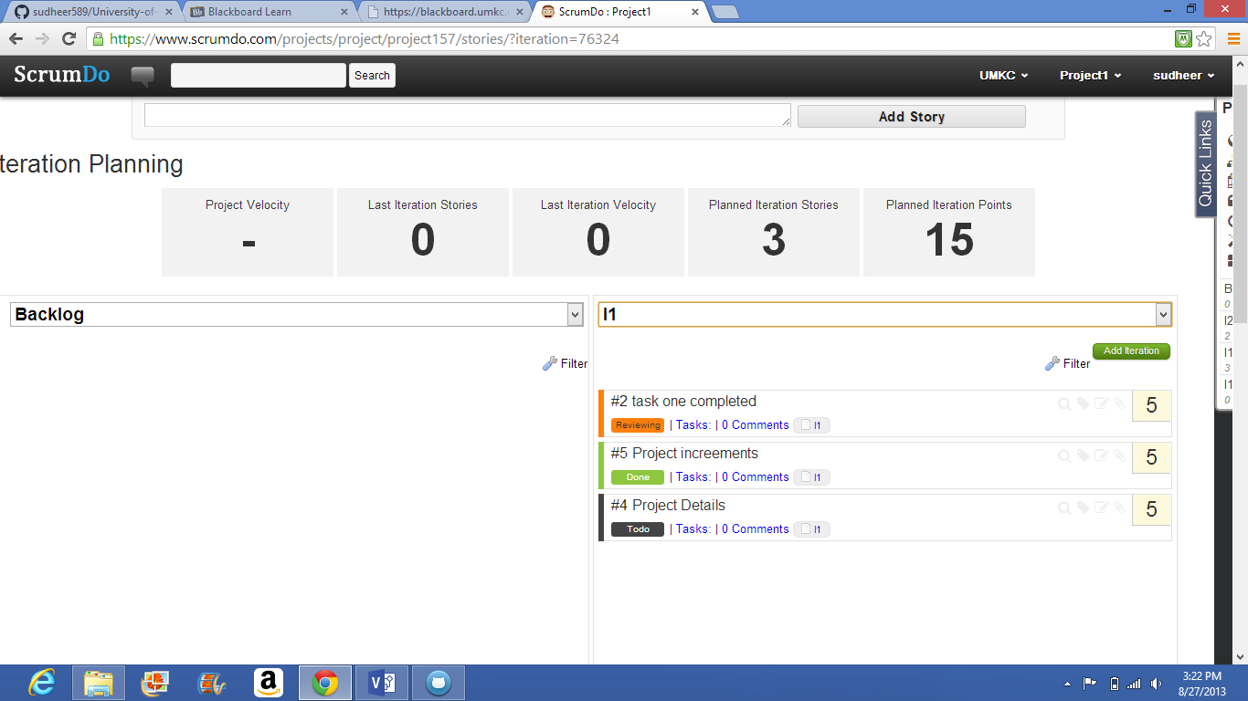

@BLACKLOG ITERATION PLANNING

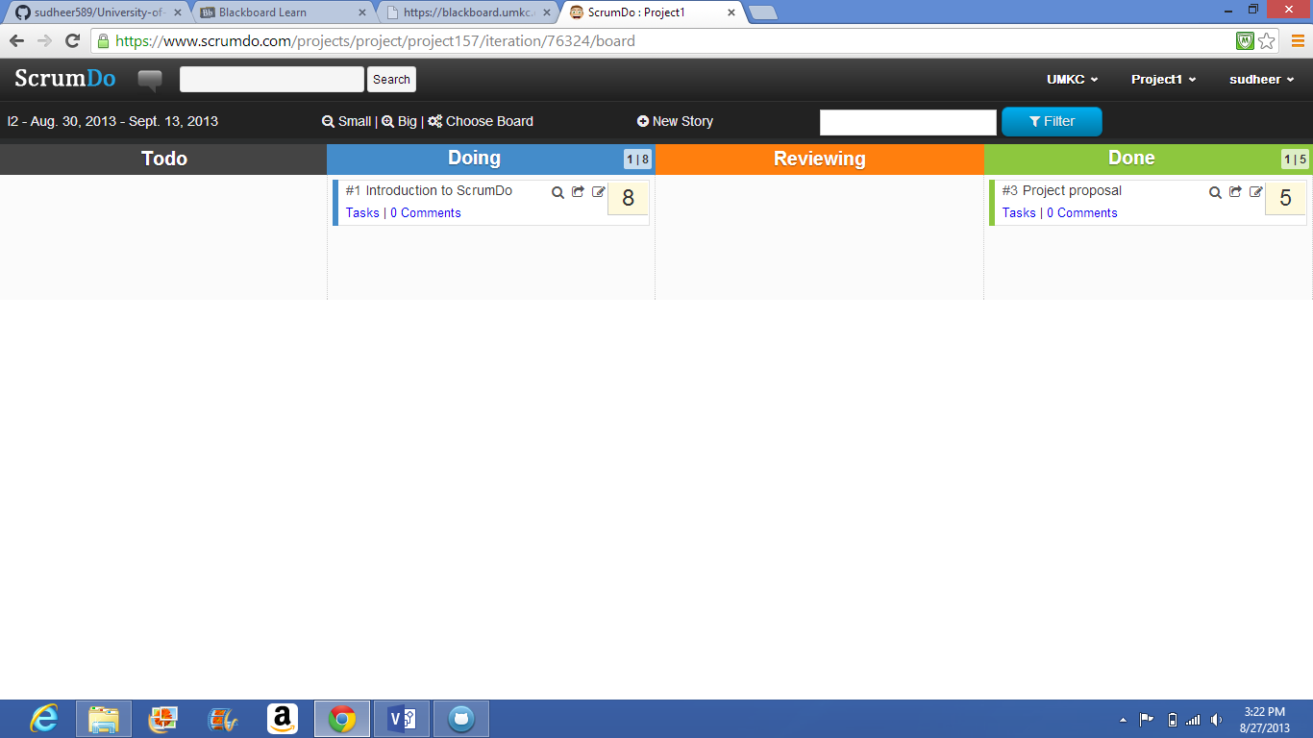

@TODO LIST

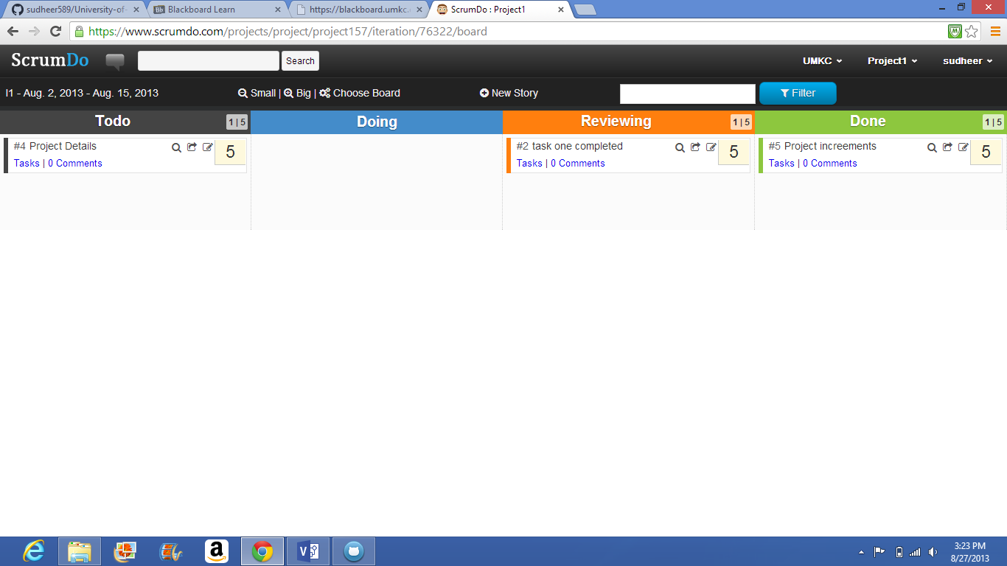

@CHOOSE BOARD

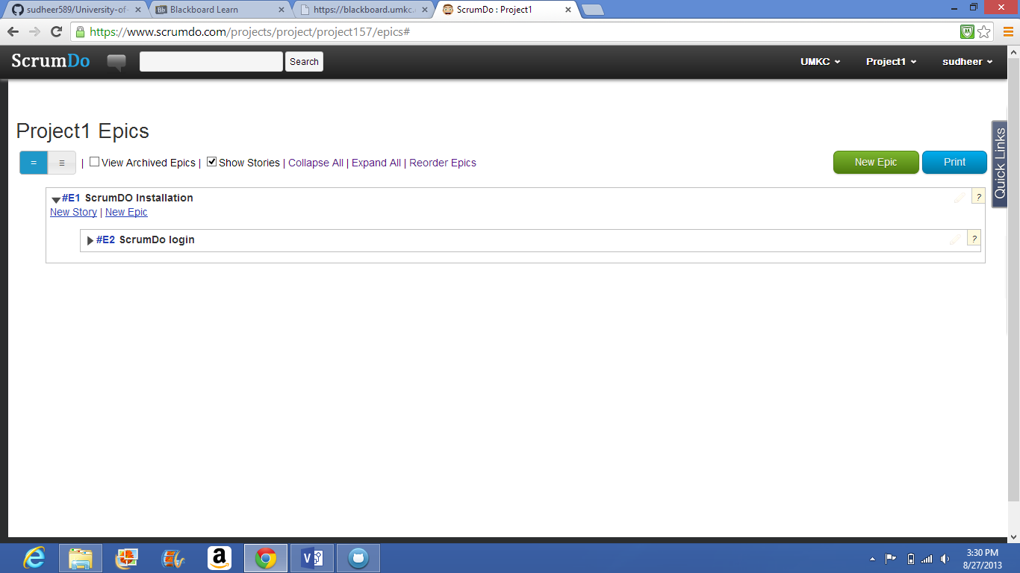

@CREATING EPICS

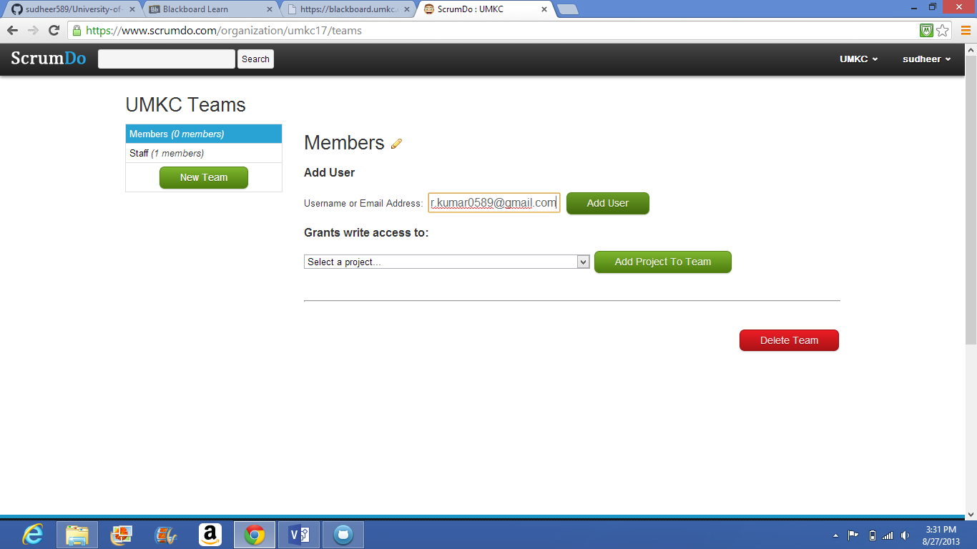

@CREATING TEAMS

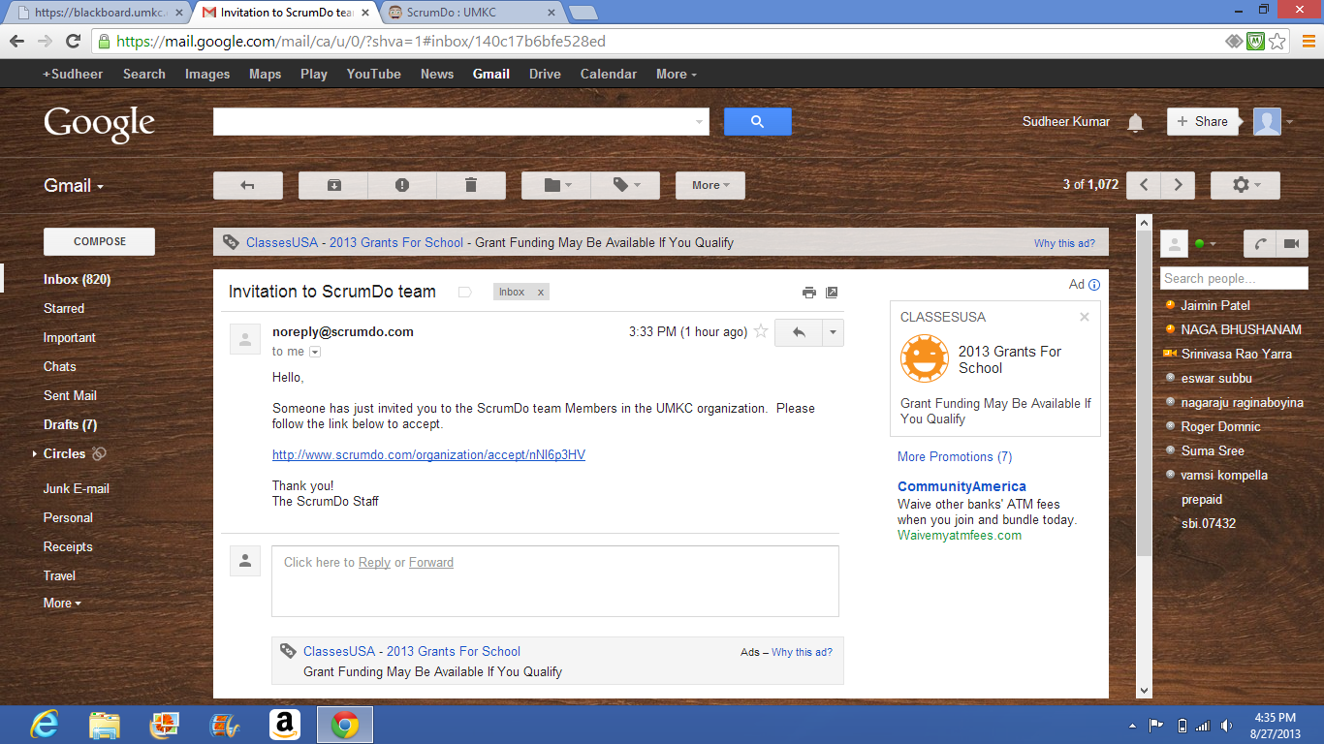

@INVITATION TO OTHER TEAM MEMBER

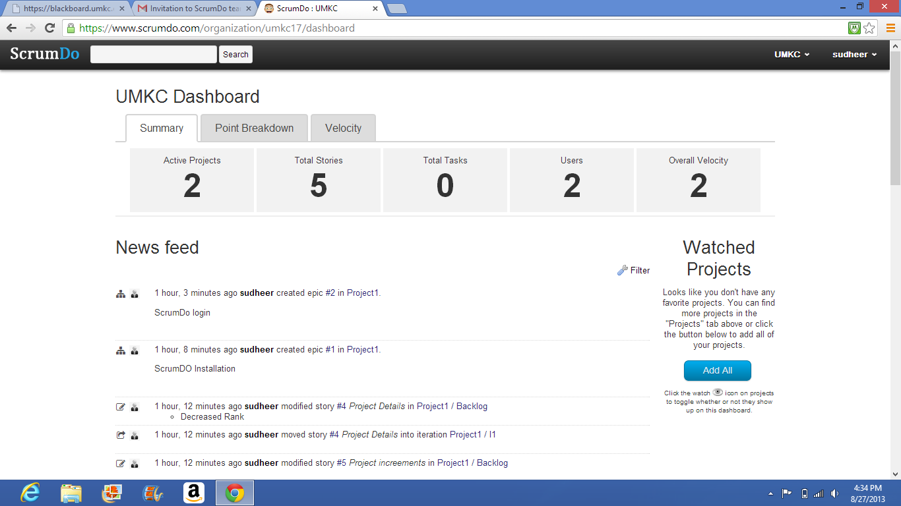

@SCRUMDO DASHBOARD