***EXERCISE – 1 CONTROL STRUCTURES***   
  
**SCENARIO 1**

CREATE TABLE Customers (

CustomerID SERIAL PRIMARY KEY,

Name VARCHAR(100),

Age INT,

LoanInterestRate DECIMAL(5,2)

);

INSERT INTO Customers (Name, Age, LoanInterestRate) VALUES

('Alice', 65, 6.5),

('Bob', 45, 7.2),

('Charlie', 70, 6.8),

('David', 55, 7.0),

('Eve', 61, 6.9);

DO $$

DECLARE

customer_rec RECORD;

BEGIN

FOR customer_rec IN (SELECT CustomerID, Age, LoanInterestRate FROM Customers) LOOP

IF customer_rec.Age > 60 THEN

UPDATE Customers

SET LoanInterestRate = LoanInterestRate - 1

WHERE CustomerID = customer_rec.CustomerID;

END IF;

END LOOP;END $$;  
SELECT * FROM Customers;

Output

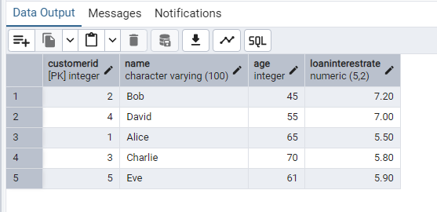

**SCENARIO 2**

CREATE TABLE Customers (

CustomerID SERIAL PRIMARY KEY,

Name VARCHAR(100),

Age INT,

Balance DECIMAL(10,2),

IsVIP BOOLEAN DEFAULT FALSE

);

INSERT INTO Customers (Name, Age, Balance) VALUES

('Alice', 65, 15000.00),

('Bob', 45, 9000.00),

('Charlie', 70, 11000.00),

('David', 55, 7500.00),

('Eve', 35, 12000.00);

DO $$

DECLARE

customer_rec RECORD;

BEGIN

FOR customer_rec IN (SELECT CustomerID, Balance FROM Customers) LOOP

IF customer_rec.Balance > 10000 THEN

UPDATE Customers

SET IsVIP = TRUE

WHERE CustomerID = customer_rec.CustomerID;

END IF;

END LOOP;

END $$;

SELECT * FROM Customers;

Output   
  
  
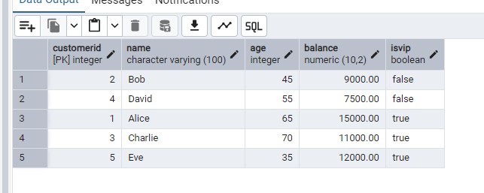

**SCENARIO 3**

CREATE TABLE Loans (

LoanID SERIAL PRIMARY KEY,

CustomerName VARCHAR(100),

DueDate DATE

);

INSERT INTO Loans (CustomerName, DueDate) VALUES

('Alice', CURRENT_DATE + INTERVAL '10 days'),

('Bob', CURRENT_DATE + INTERVAL '35 days'),

('Charlie', CURRENT_DATE + INTERVAL '5 days'),

('David', CURRENT_DATE - INTERVAL '2 days'),

('Eve', CURRENT_DATE + INTERVAL '25 days');

DO $$

DECLARE

loan_rec RECORD;

BEGIN

FOR loan_rec IN (

SELECT CustomerName, DueDate

FROM Loans

WHERE DueDate BETWEEN CURRENT_DATE AND CURRENT_DATE + INTERVAL '30 days'

) LOOP

RAISE NOTICE 'Reminder: % has a loan due on %', loan_rec.CustomerName, loan_rec.DueDate;

END LOOP;

END $$;

SELECT * FROM Loans

WHERE DueDate BETWEEN CURRENT_DATE AND CURRENT_DATE + INTERVAL '30 days';

Ouput   
  
