**Cloud Application Development**

**Disaster Recovery with IBM Cloud Virtual Servers**

**Phase 3**

* Start building the disaster recovery plan using IBM Cloud Virtual Servers.
* Define the disaster recovery strategy, including RTO, RPO, and priority of virtual machines.
* Set up regular backups of the on-premises virtual machine using backup tools or scripts.

**Define the disaster recovery strategy, including RTO, RPO, and priority of virtual machines.**

Disaster Recovery:

Disaster recovery (DR) is a comprehensive strategy and set of procedures designed to help an organization resume normal operations following a disruptive event. Disruptive events, often referred to as disasters, can include natural disasters (such as hurricanes, earthquakes, floods), technological disasters (such as data breaches, system failures, or cyberattacks), and human-made disasters (such as terrorism or human error).

The primary goal of disaster recovery is to minimize downtime, data loss, and operational disruption by ensuring that critical systems, data, and processes can be restored and made functional as quickly as possible

Recovery Time Objective (RTO):

RTO is the maximum acceptable downtime for a system or service following a disaster or incident. It represents the time frame within which a system or application must be restored to normal operation to avoid significant business impact.

RTO is typically expressed in hours, minutes, or even seconds, depending on the criticality of the system or application.

The choice of RTO depends on factors such as the importance of the system, its role in supporting critical business functions, and the cost associated with achieving faster recovery times.

High-priority systems may have very low RTOs, while less critical systems may have longer RTOs.

Recovery Point Objective (RPO):

RPO is the maximum allowable data loss that an organization can tolerate in the event of a disaster or incident. It defines the point in time to which data must be recovered to resume normal operations.

RPO is typically measured in terms of time, such as hours or minutes. For example, an RPO of 1 hour means that data must be recoverable up to 1 hour before the disaster occurred.

The choice of RPO depends on the nature of the data and its criticality to business operations. Critical data may have a very low RPO, while less critical data may have a longer RPO.

Priority of virtual machines:

The priority of virtual machines (VMs) in a disaster recovery (DR) scenario within IBM Cloud, or any cloud platform for that matter, should be based on the criticality and importance of the applications and services that the VMs support. In a disaster recovery plan, you typically categorize VMs into different tiers based on their criticality, and then assign recovery priorities accordingly. These tiers and priorities could look something like this:

Tier 1 - Mission-Critical VMs:

These VMs host applications or services that are absolutely essential for business operations.

Recovery Priority: Highest

Recovery Time Objective (RTO): Minimal - should be recovered as quickly as possible.

Tier 2 - Important VMs:

VMs in this category support critical functions but are not as essential as Tier 1 applications.

Recovery Priority: High

RTO: Relatively short - recovered soon after Tier 1 VMs.

Tier 3 - Less Critical VMs:

VMs that are important but can tolerate longer downtimes.

Recovery Priority: Medium

RTO: Longer than Tier 1 and Tier 2, but still reasonable.

Tier 4 - Non-Essential VMs:

VMs hosting non-critical applications or services that can be offline for an extended period.

Recovery Priority: Low

RTO: Flexible - can be recovered after more critical VMs are restored.

**Set up regular backups of the on-premises virtual machine using backup tools or scripts:**

IBM Cloud Account:

After creating the IBM Cloud Account, login with the IBMid.

Enter your IBMid then click continue.

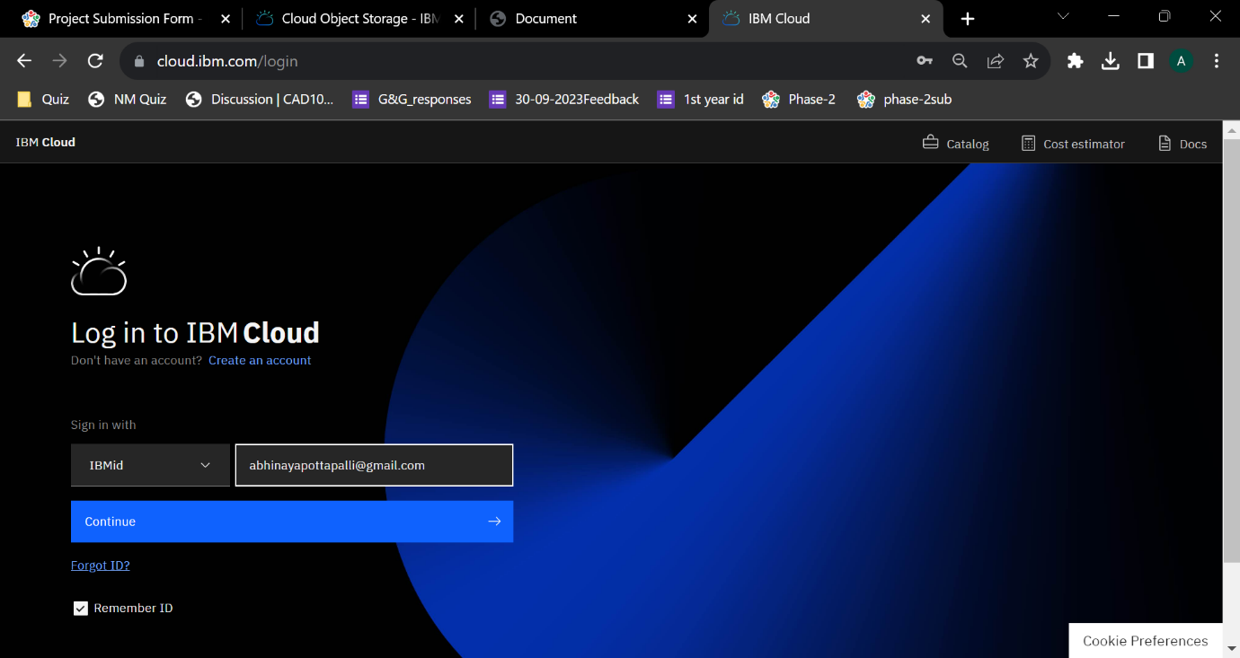

Enter your password, then click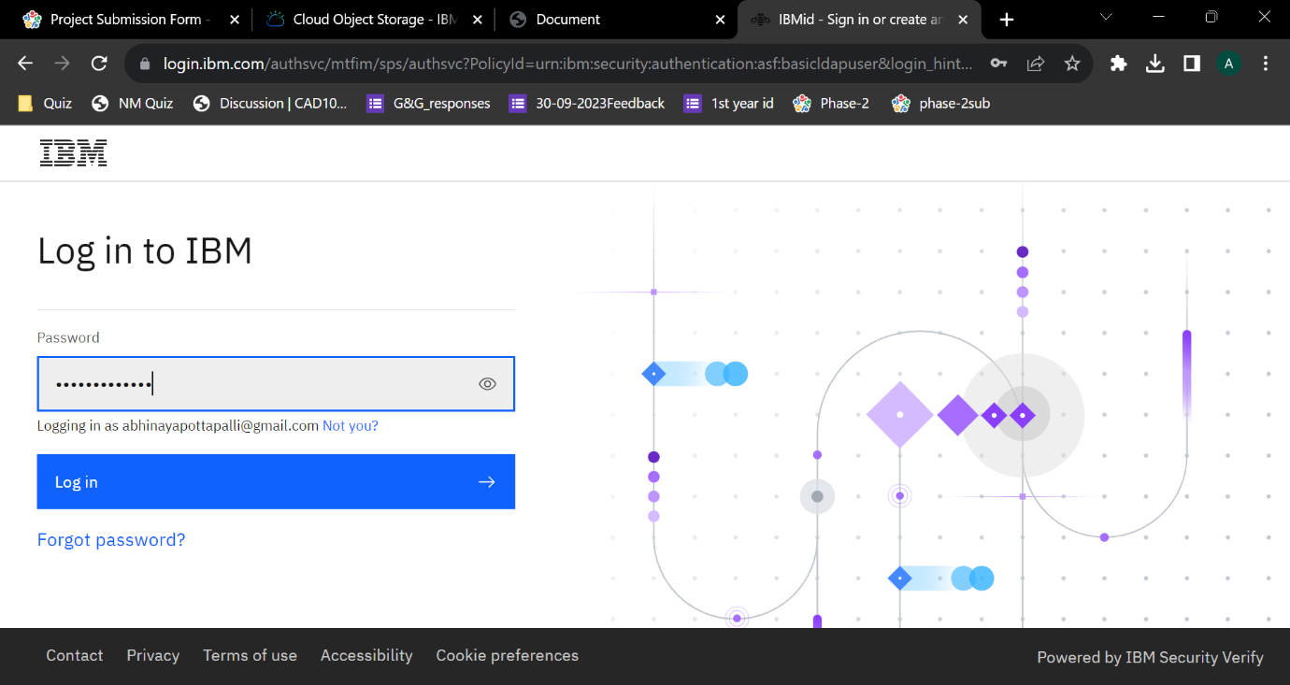

login.

The homepage of the IBM account as follows:

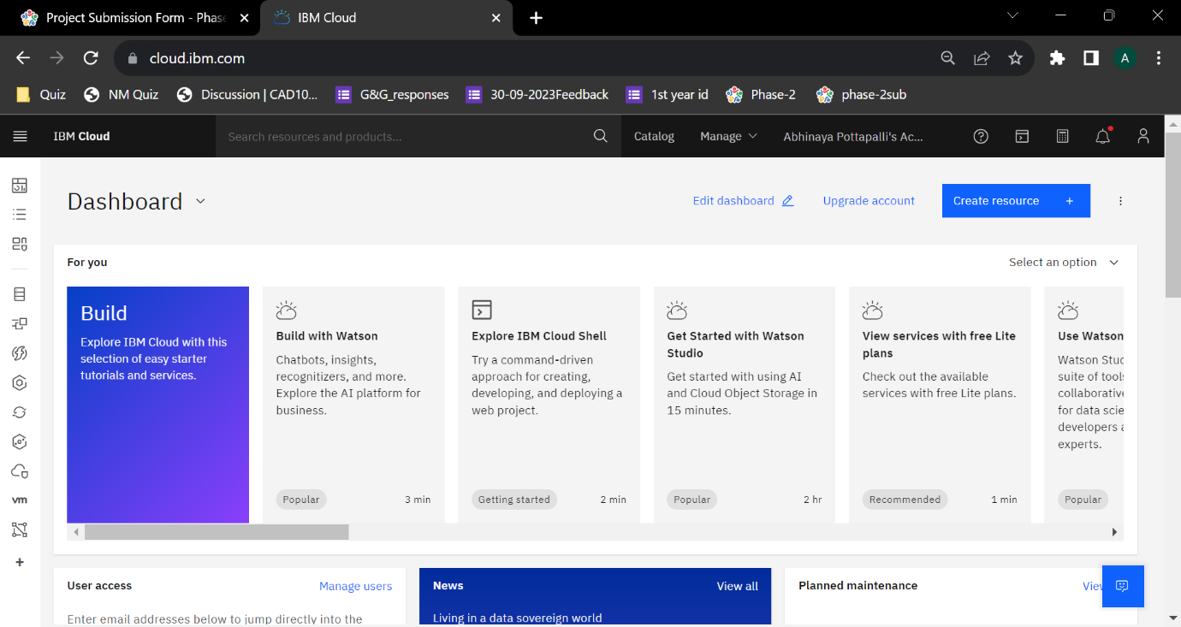

**Set up Disaster Recovery Service:**

Open the homepage of your IBM account.

Click on the manage.

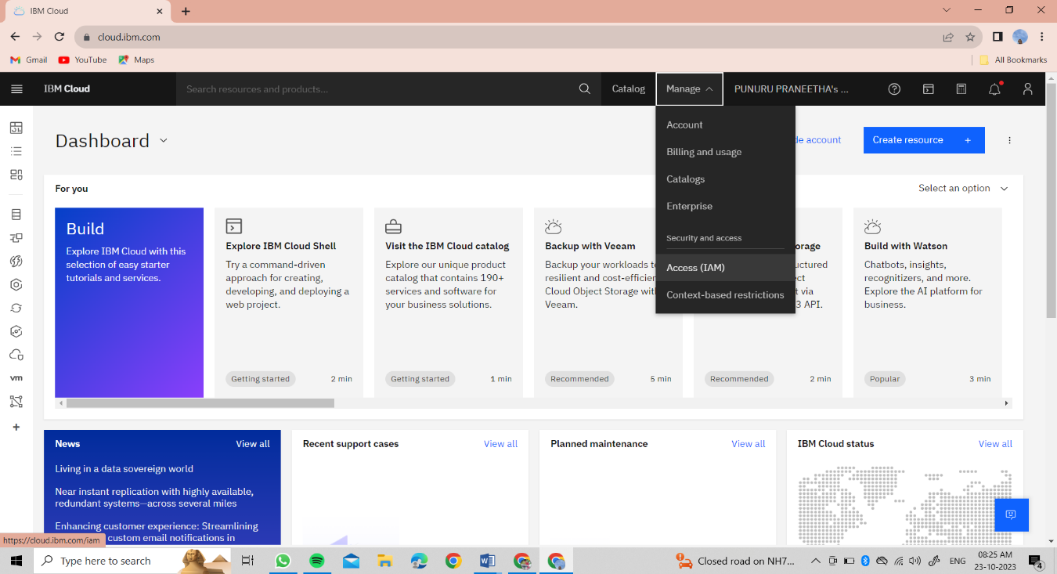

Click on the Access(IAM).

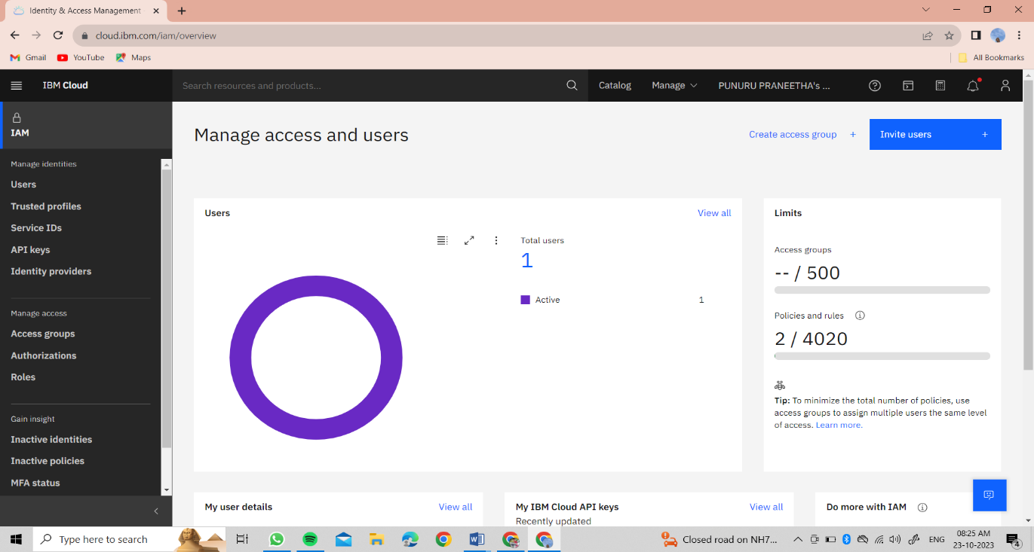

Then click on the Service IDs.

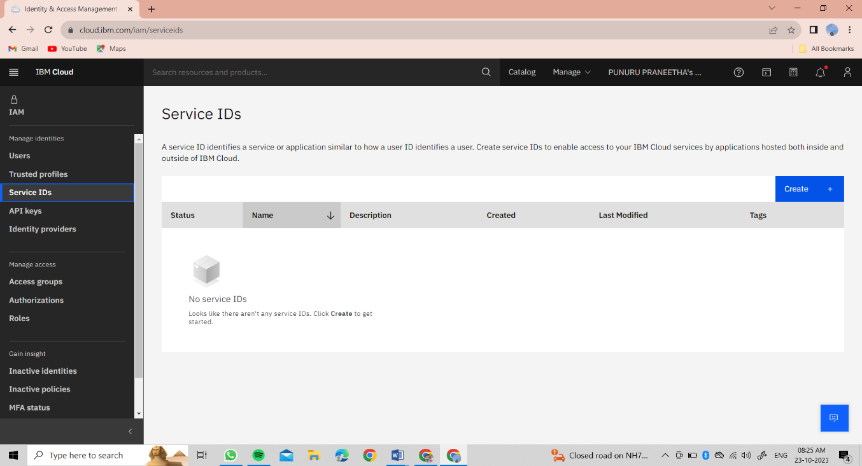

Click on Create button, to create the service.

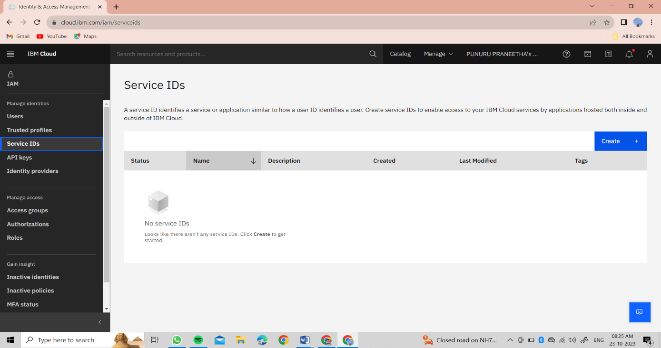

Enter the name and the description for the service, then click on Create button to create the service.

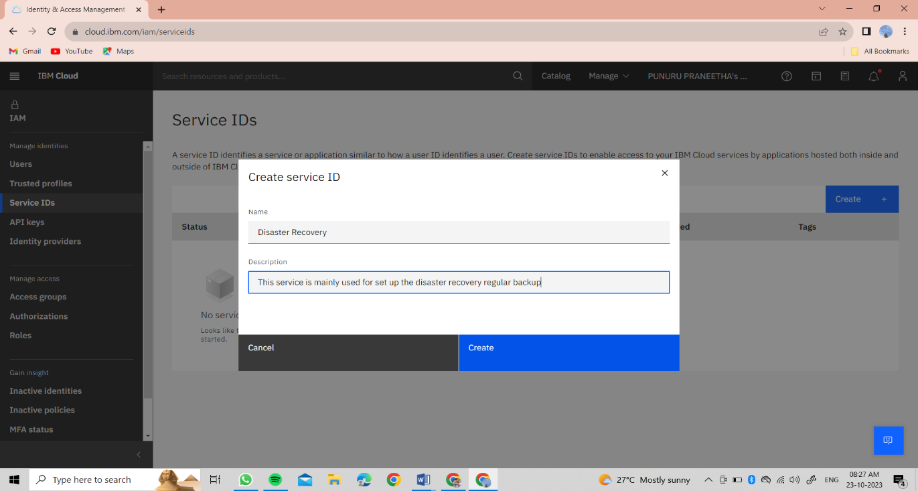

Disaster Recovery service has been created.

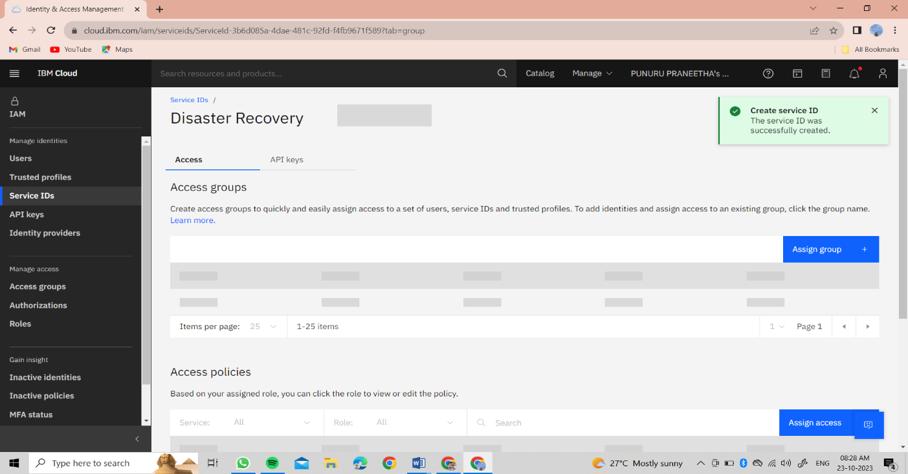

This is the Service created

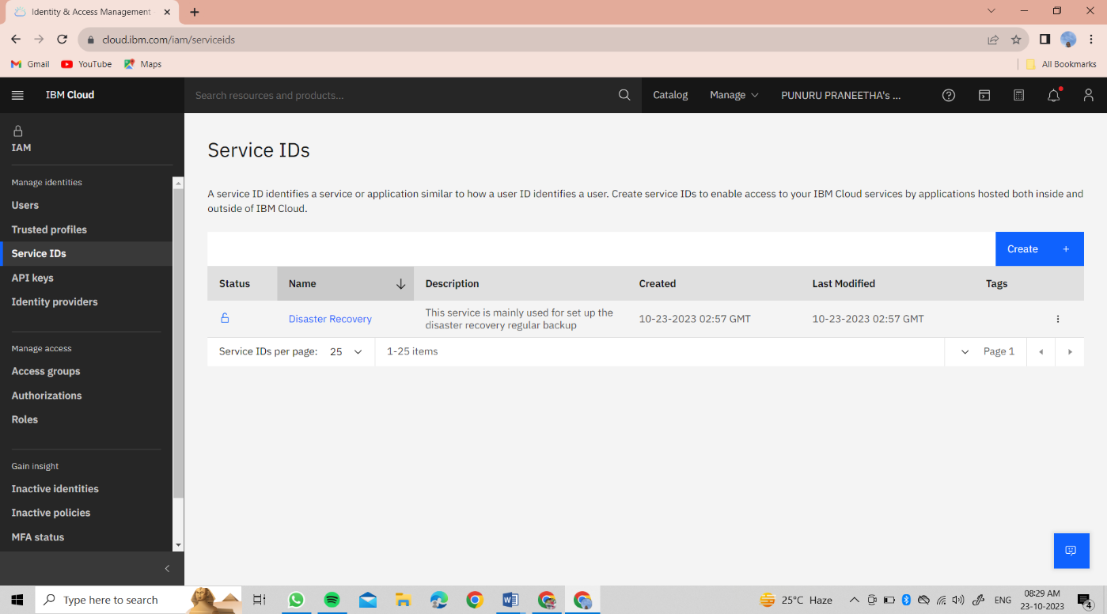

After that back to IBM home page and search disaster recovery,then click on

Customs migration and disaster recovery as a service

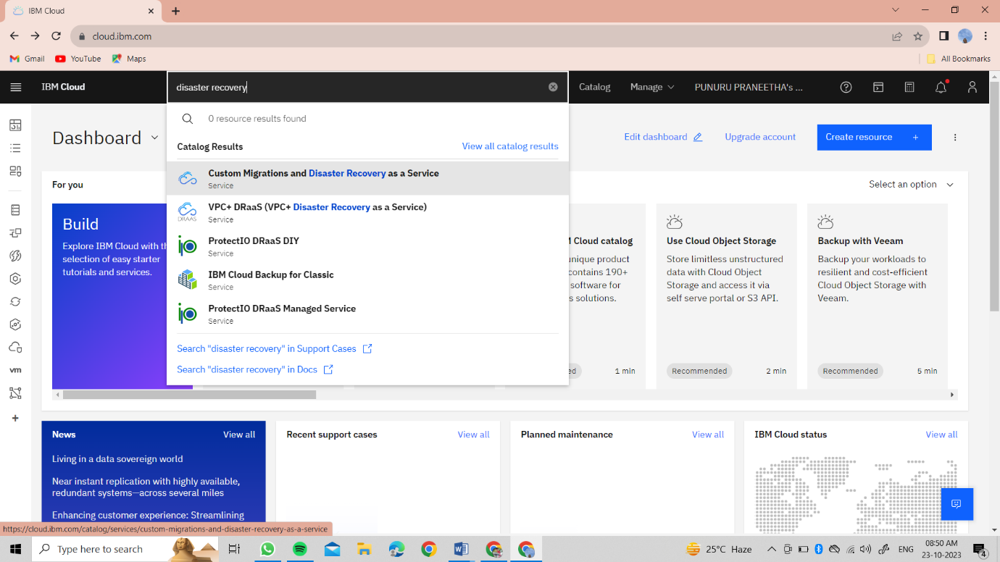

Then we get this page

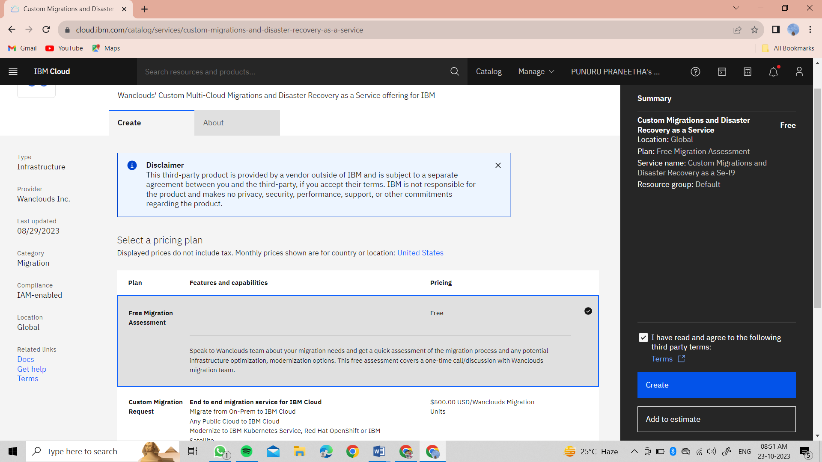

Here we create the resource page for regular backup

After click on create the resource is created

Then back to home page

And go to help, then click on docs

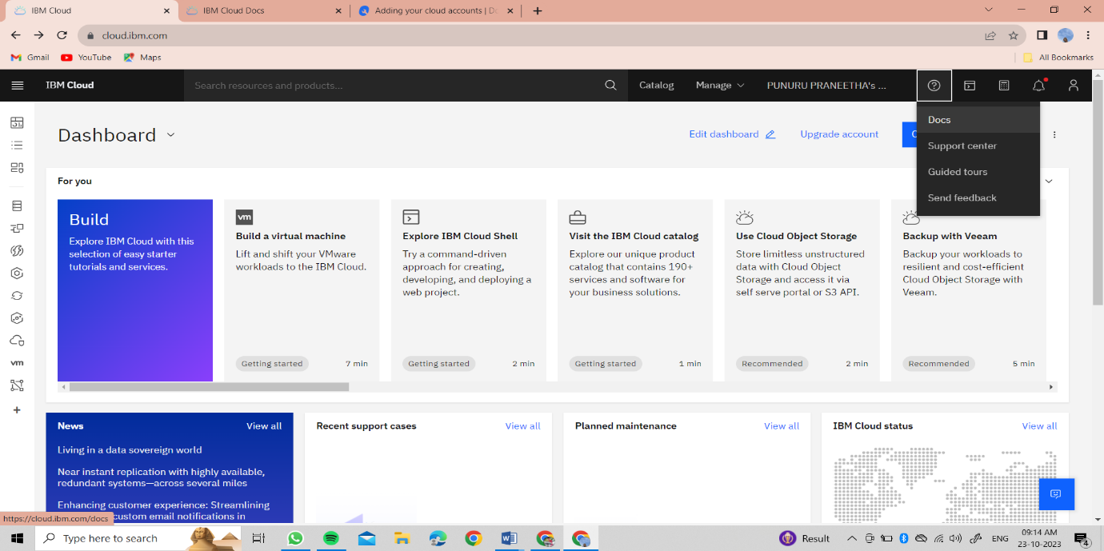

Then search for disaster recovery

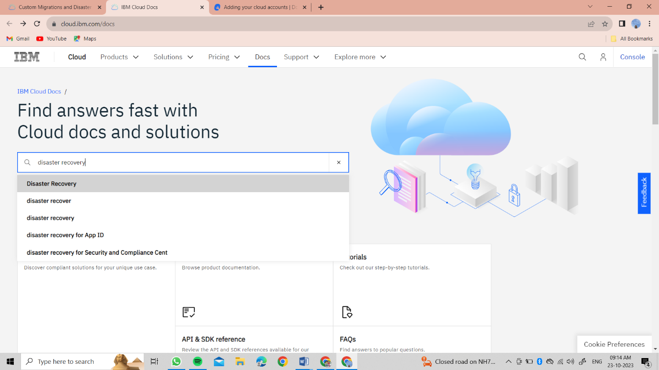

After that we get the overview steps for disaster recovery backup and recovery

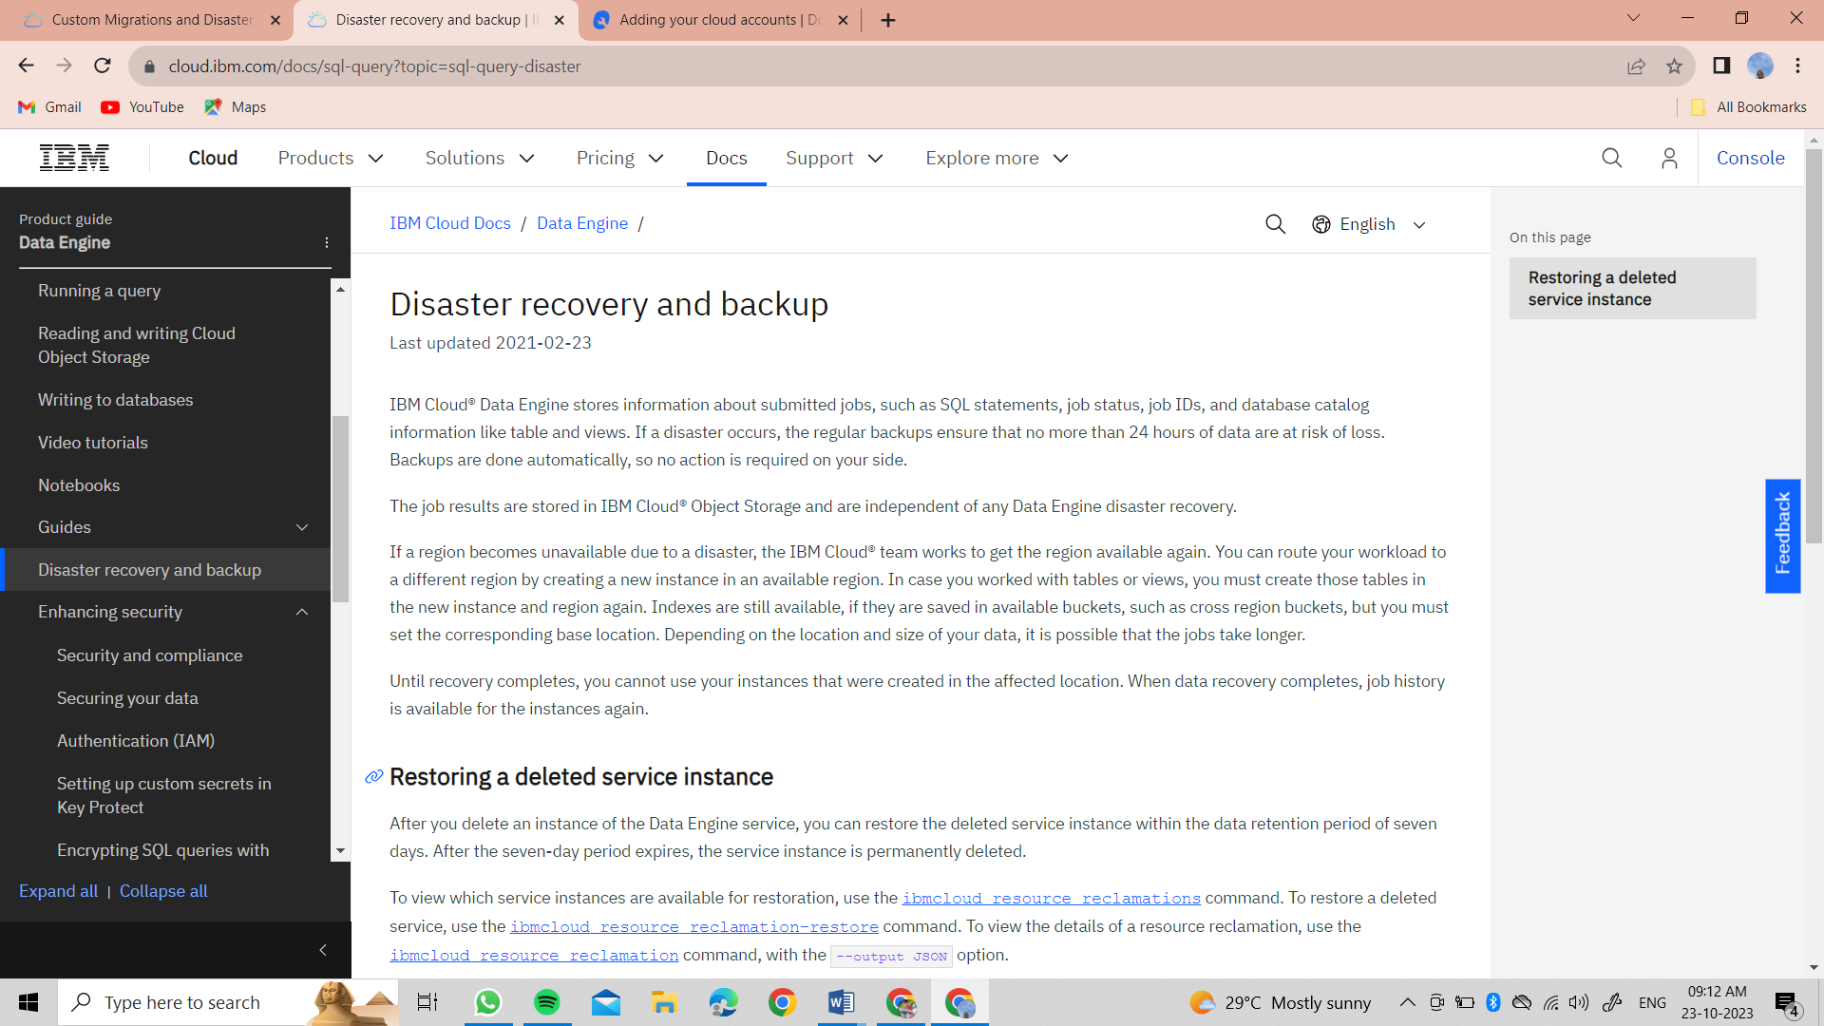

By using this steps we can move the next steps to complete the project.