DigiCart - E-Commerce Microservices Platform
Complete Technical Documentation
Document Version: 1.0 | Last Updated: May 8, 2026 | Created By: Sudheer Parkibanda
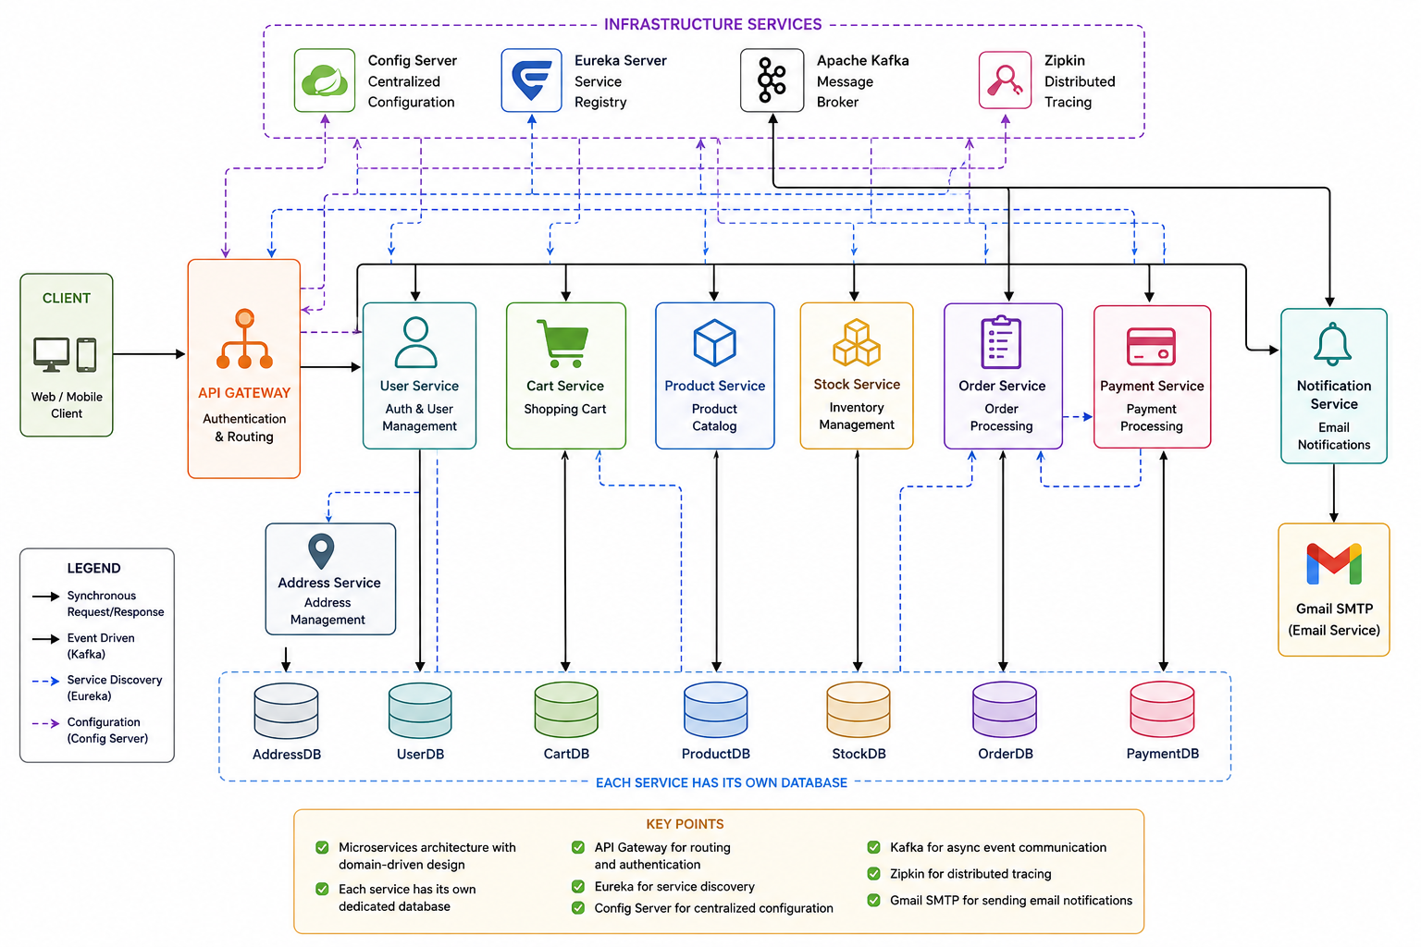

Document Control
Attribute | Value
Document Name | DigiCart - E-Commerce Microservices Platform Technical Documentation
Version | 1.0
Last Updated | May 8, 2026
Audience | Developers, architects, DevOps engineers, QA engineers, and technical reviewers
Scope | Architecture, services, data stores, integrations, use cases, deployment, security, and operations

Executive Summary
DigiCart is a cloud-native e-commerce platform structured around independently deployable Spring Boot microservices. The architecture separates business capabilities into focused services, keeps databases isolated per service, centralizes configuration, and uses Eureka for runtime service discovery. Kafka supports asynchronous workflows such as order and payment notifications, while Zipkin provides distributed tracing across request paths.
The platform is designed for maintainability, operational visibility, and incremental scaling. Customer-facing workflows pass through the API Gateway, while core services collaborate through REST APIs and event streams. External integrations are isolated behind service boundaries, reducing coupling between business workflows and third-party systems.

Architecture Highlights
- Database-per-service pattern improves data ownership and service independence.
- API Gateway provides a single entry point for authentication, routing, and policy enforcement.
- Config Server and Eureka reduce configuration drift and simplify service discovery.
- Kafka decouples order, payment, and notification workflows for better resilience.
- Zipkin tracing improves debugging and performance analysis across distributed calls.

Table of Contents
1. Document Control
2. Executive Summary
3. Project Overview
4. System Architecture
5. Microservices
6. Databases
7. External Integrations
8. Use Cases
9. Data Flow
10. Technology Stack
11. API Endpoints
12. Deployment & Configuration
13. Non-Functional Requirements
14. Security Considerations
15. Error Handling & Resilience
16. Monitoring & Logging
17. Testing
18. Operational Runbook
19. Risks & Mitigations
20. Future Enhancements
21. Contact & Support

Project Overview
DigiCart is a modern, scalable e-commerce microservices platform built with Spring Boot and cloud-native technologies. The system supports high-volume transactions using independent services that communicate through REST APIs and asynchronous Kafka messaging.

Key Features
- User authentication and role-based access control (RBAC)
- Product catalog with stock management
- Shopping cart with real-time updates
- Order processing with payment integration
- Email notifications for user events
- Distributed tracing for system monitoring
- Centralized configuration management
- Service discovery and load balancing

System Architecture

Architecture Diagram
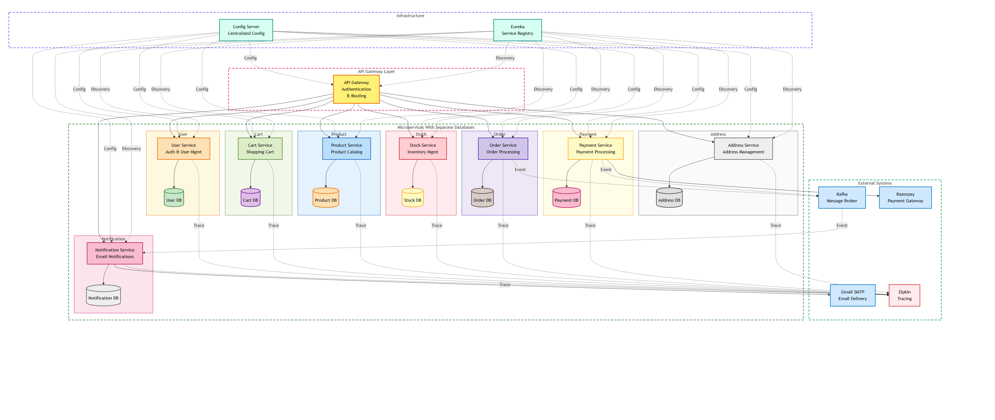

Layered Architecture
- Client Layer: Web and mobile applications use a single entry point.
- API Gateway: Handles authentication, authorization, routing, JWT security, and request/response transformation.
- Infrastructure Services: Config Server manages centralized configuration; Eureka provides service discovery and load balancing.
- Microservices Layer: Eight independent services own specific business responsibilities and communicate through REST and Kafka.
- Data Layer: Each service owns a separate MySQL database for isolation and independent scaling.
- External Integrations: Gmail SMTP, Razorpay, Kafka, and Zipkin provide email, payment, messaging, and tracing capabilities.

Microservices

Service Responsibility Matrix
Service | Primary Responsibility | Database | Main Integrations
API Gateway | Authentication, authorization, request routing, and policy enforcement | None | User Service, all downstream microservices, Eureka
User Service | Identity, login, account verification, roles, and user profile ownership | user_service_db | Notification Service, Address Service
Product Service | Product catalog, product metadata, and customer-facing catalog queries | product_service_db | Stock Service, Price Service
Stock Service | Inventory availability, reservation, deduction, and stock integrity | stock_service_db | Product Service, Order/Payment workflows
Cart Service | Cart lifecycle, cart items, quantity updates, checkout preparation | cart_service_db | Product Service, Stock Service, Address Service, Order Service
Address Service | Shipping and billing address records for users | address_service_db | User Service, Cart Service, Order Service
Order Service | Order creation, status lifecycle, order history, and notification events | order_service_db | Cart Service, Stock Service, Payment Service, Kafka
Payment Service | Payment link generation, payment verification, webhooks, and payment records | payment_service_db | Razorpay, Order Service, Kafka
Notification Service | Transactional email delivery and async notification processing | notification_service_db | Gmail SMTP, Kafka

Communication Patterns
- Synchronous REST calls are used when the caller needs an immediate response, such as product lookup, stock validation, and payment link creation.
- Asynchronous Kafka events are used for notification workflows and cross-service side effects that should not block the primary user request.
- Service discovery through Eureka avoids hard-coded service locations and supports runtime scaling.
- Centralized configuration through Config Server keeps service configuration consistent across environments.

User Service (Port 8080)
Responsibility: Authentication, user management, and account verification
Database: user_service_db
Key Endpoints: POST /auth/register; POST /auth/login; POST /auth/verify-account; GET /internal/users/{id}; POST /internal/users/{id}/addresses/{addressId}
Key Features / Dependencies: Registration, JWT, BCrypt, profiles, roles, address mapping, verification emails

Product Service (Port 8081)
Responsibility: Product catalog management and product information
Database: product_service_db
Key Endpoints: GET /products; GET /products/{code}; POST /products; PUT /products/{code}; GET /products/{code}/stock
Key Features / Dependencies: Product search, details, pricing, categorization, Stock Service and Price Service integration

Stock Service (Port 8082)
Responsibility: Inventory management and stock tracking
Database: stock_service_db
Key Endpoints: GET /stocks/{productId}; POST /stocks; PUT /stocks/{productId}; PATCH /stocks/{productId}/reserve; PATCH /stocks/{productId}/deduct
Key Features / Dependencies: Real-time availability, reservations, deduction after payment, low-stock alerts

Cart Service (Port 8083)
Responsibility: Shopping cart management and cart operations
Database: cart_service_db
Key Endpoints: POST /carts; GET /carts/{cartId}; POST /carts/{cartId}/items; DELETE /carts/{cartId}/items/{itemId}; PUT /carts/{cartId}/items/{itemId}
Key Features / Dependencies: Cart persistence, add/remove/update items, totals, stock validation, address selection, checkout

Address Service (Port 8084)
Responsibility: User address management
Database: address_service_db
Key Endpoints: POST /addresses; GET /addresses/{addressId}; PUT /addresses/{addressId}; DELETE /addresses/{addressId}; GET /addresses/user/{userId}
Key Features / Dependencies: Multiple addresses, default address, validation, billing and shipping support

Order Service (Port 8085)
Responsibility: Order processing and lifecycle management
Database: order_service_db
Key Endpoints: POST /orders; GET /orders/{orderId}; GET /orders; PATCH /orders/{orderId}/order-placed-email-sent; PATCH /orders/{orderId}/payment-success-email-sent
Key Features / Dependencies: Order creation, status tracking, payment link generation, notification events, order history

Payment Service (Port 8086)
Responsibility: Payment processing and Razorpay integration
Database: payment_service_db
Key Endpoints: POST /payments/create-link; GET /payments/{paymentId}; POST /payments/webhook; PATCH /payments/{paymentId}/verify
Key Features / Dependencies: Razorpay payment links, verification, webhooks, payment history, Order Service integration

Notification Service (Port 8089)
Responsibility: Email notifications and user communication
Database: notification_service_db
Key Endpoints: POST /internal/notifications/verification-email; POST /test/send-order-notification
Key Features / Dependencies: Gmail SMTP, Thymeleaf templates, Kafka listeners, verification, order, and payment emails

Important Service Configuration
spring.datasource.url=jdbc:mysql://mysql:3306/<service_database>
spring.jpa.hibernate.ddl-auto=update
app.kafka.topics.notification-order-placed=notification.order-placed
app.kafka.topics.notification-payment-success=notification.payment-success
razorpay.api.url=https://api.razorpay.com/v1
spring.mail.host=smtp.gmail.com
spring.mail.port=587

Databases
Service | Database | Port | Purpose
User Service | user_service_db | 3306 | User accounts, roles, verification codes
Product Service | product_service_db | 3306 | Product catalog, descriptions, categories
Stock Service | stock_service_db | 3306 | Inventory levels and stock tracking
Cart Service | cart_service_db | 3306 | Shopping carts and cart items
Address Service | address_service_db | 3306 | User billing and shipping addresses
Order Service | order_service_db | 3306 | Orders, order items, status tracking
Payment Service | payment_service_db | 3306 | Payment records and transaction history
Notification Service | notification_service_db | 3306 | Email logs and notification history

Key Tables
- User Service: users, user_address_ids; columns include u_id, name, password, active, verification_code, role, creation_time.
- Order Service: orders; columns include order_id, user_id, total_amount, status, order_placed_email_sent, payment_success_email_sent, created_at.
- Payment Service: payments; columns include payment_id, order_id, razorpay_link_id, amount, status, created_at.

External Integrations

Gmail SMTP
Used by Notification Service to send verification, order confirmation, and payment success emails. It uses JavaMailSender, MimeMessage, Thymeleaf templates, and environment variables MAIL_USERNAME, MAIL_PASSWORD, and MAIL_FROM_ADDRESS.
spring.mail.host=smtp.gmail.com
spring.mail.port=587
spring.mail.username=${MAIL_USERNAME}
spring.mail.password=${MAIL_PASSWORD}
mail.smtp.auth=true
mail.smtp.starttls.enable=true

Razorpay Payment Gateway
Used by Payment Service to create payment links, verify payment status, and receive webhook callbacks.
POST https://api.razorpay.com/v1/payment_links
GET https://api.razorpay.com/v1/payment_links/{id}
RAZORPAY_KEY_ID=your_key_id
RAZORPAY_KEY_SECRET=your_key_secret

Apache Kafka
Topic | Producer | Consumer | Purpose
notification.order-placed | Order Service | Notification Service | Order placed events
notification.payment-success | Payment Service | Notification Service | Payment confirmation events
payment-link-request | Cart Service | Payment Service | Payment link requests
payment-link-response | Payment Service | Cart Service | Payment link responses

Zipkin
Zipkin runs at zipkin:9411 and receives traces at http://zipkin:9411/api/v2/spans. It supports end-to-end tracing, latency analysis, dependency visualization, and cross-service error tracking.

Use Cases

UC1: User Registration & Verification
Customer registers; User Service validates input, encrypts password with BCrypt, creates inactive user and verification code, calls Notification Service, sends email via Gmail SMTP, validates code, activates account, and clears the verification code.

UC2: Browse Products & Manage Cart
Customer logs in, browses catalog, Product Service returns details and stock status, Cart Service validates availability, updates items, calculates totals, and supports shipping address selection.

UC3: Place Order & Generate Payment Link
Customer checks out; Order Service creates PENDING order, reserves stock, calculates amount, calls Payment Service, creates Razorpay payment link, and publishes notification.order-placed.

UC4: Process Payment & Send Confirmation
Razorpay webhook reaches Payment Service; signature is validated, payment becomes COMPLETED, order moves to PAID/PROCESSING, stock is deducted, Kafka event is published, and Notification Service sends email.

UC5: Order Tracking & Notifications
Customer views order history; Order Service returns status and details; status transitions through PROCESSING, SHIPPED, and DELIVERED; each change can trigger notification email.

Data Flow

Registration Flow
Client -> API Gateway -> User Service -> User DB
User Service -> Notification Service -> Gmail SMTP
Email Sent

Cart & Checkout Flow
Client -> API Gateway -> Cart Service -> Cart DB
Cart Service -> Product Service <-> Stock Service
Cart Service -> Address Service
Order Service -> Order DB
Payment Service -> Payment DB -> Razorpay API

Order Processing Flow
Razorpay Webhook -> Payment Service -> Payment DB
Payment Service -> Order Service -> Order DB
Payment Service -> Stock Service (deduct)
Payment Service -> Kafka -> Notification Service -> Gmail SMTP

Technology Stack
Area | Technologies
Core Frameworks | Spring Boot 3.5.13, Spring Cloud 2025.0.2, Java 17
Spring Dependencies | Spring Web, Spring Data JPA, Spring Security, Config, Eureka, Kafka, Mail
Security | JWT io.jsonwebtoken, BCrypt
Database | MySQL Connector, Liquibase/Flyway
Messaging | Apache Kafka, Jackson
Monitoring & Tracing | Micrometer, Zipkin
Email | JavaMail, Thymeleaf
Build & Deployment | Maven, Docker, Docker Compose

API Endpoints
Service | Endpoints
User Service | POST /auth/register; POST /auth/login; POST /auth/verify-account; GET /internal/users/{id}; POST /internal/users/{id}/addresses/{addressId}
Product Service | GET /products; GET /products/{code}; POST /products; PUT /products/{code}; GET /products/{code}/stock
Cart Service | POST /carts; GET /carts/{cartId}; POST /carts/{cartId}/items; DELETE /carts/{cartId}/items/{itemId}; PUT /carts/{cartId}/items/{itemId}
Order Service | POST /orders; GET /orders/{orderId}; GET /orders; PATCH /orders/{orderId}/order-placed-email-sent; PATCH /orders/{orderId}/payment-success-email-sent
Payment Service | POST /payments/create-link; GET /payments/{paymentId}; POST /payments/webhook; PATCH /payments/{paymentId}/verify
Notification Service | POST /internal/notifications/verification-email; POST /test/send-order-notification

Deployment & Configuration

Docker Compose Services
- mysql: Database server (3306)
- kafka: Message broker (9092)
- zipkin: Distributed tracing (9411)
- config-server: Configuration server (8888)
- service-registry: Eureka registry (8761)
- api-gateway: API Gateway (8080)
- user-service: 5000
- product-service: 5001
- stock-service: 5002
- cart-service: 5003
- order-service: 5004
- payment-service: 5005
- notification-service: 5014
- address-service

Environment Variables Required
MAIL_USERNAME=your-email@gmail.com
MAIL_PASSWORD=your-app-specific-password
MAIL_FROM_ADDRESS=noreply@digicart.com
RAZORPAY_KEY_ID=your_razorpay_key_id
RAZORPAY_KEY_SECRET=your_razorpay_key_secret
DB_HOST=mysql
DB_PORT=3306
DB_USER=root
DB_PASSWORD=root
KAFKA_BROKER=kafka:9092
ZIPKIN_HOST=zipkin
ZIPKIN_PORT=9411

Build & Run Commands
./mvnw clean package
docker-compose up -d
docker-compose logs -f <service-name>
docker-compose down

Non-Functional Requirements
Category | Requirement | Implementation Notes
Scalability | Services should scale independently based on traffic and workload. | Stateless Spring Boot services can be scaled horizontally behind the gateway and service registry.
Availability | Core customer flows should remain resilient to partial failures. | Use retry, timeout, fallback, and asynchronous event handling where possible.
Security | Sensitive workflows require authentication and role-based authorization. | JWT validation at API Gateway; BCrypt password hashing; secrets supplied via environment variables.
Observability | Every distributed request should be traceable. | Micrometer tracing with Zipkin; trace IDs included in logs.
Data Ownership | Each microservice owns its own database and schema. | Avoid direct cross-service database access; use REST APIs or events.
Maintainability | Services should be loosely coupled and independently deployable. | Separate service boundaries, configuration, and databases.
Performance | User-facing flows should avoid unnecessary synchronous calls. | Use Kafka for background notifications and side-effect processing.

Security Considerations
- JWT tokens include user ID, username, role, and expiration time.
- API Gateway validates tokens and enforces RBAC.
- Admin has full access; Customer can access only own data.
- Passwords are encrypted using BCrypt.
- Verification code is generated at registration and cleared after activation.

Error Handling & Resilience
- RestTemplate calls use timeouts, fallbacks, and error handling.
- Kafka messages are retried on failure.
- Database transactions roll back on error.
- Standard error responses include error message, timestamp, and path.
{
"error": "Error message",
"timestamp": "2026-05-08T10:30:00Z",
"path": "/api/endpoint"
}

Failure Handling Guidelines
- Payment webhook processing should be idempotent so duplicate Razorpay callbacks do not double-update orders.
- Order status transitions should be validated to prevent invalid jumps in the lifecycle.
- Kafka consumers should log failed payloads with correlation IDs and retry metadata.
- External service calls should use explicit timeouts and meaningful fallback responses.
- Inventory reservation and deduction should be transactionally safe to prevent overselling.

Monitoring & Logging
- Spring Boot logger provides centralized service logging.
- Trace ID and span ID are included in logs.
- Metrics include latency, request count, and error rate.
- Zipkin visualizes request traces and service dependencies.

Operational Dashboards
Dashboard Area | Recommended Signals
Gateway | Request rate, latency, 4xx/5xx errors, authentication failures
Orders | Order creation rate, failed orders, status transition delays
Payments | Payment link creation failures, webhook failures, pending payments
Kafka | Consumer lag, failed messages, retry counts, topic throughput
Email | Email send failures, template errors, SMTP latency
Database | Connection pool usage, slow queries, lock waits, failed transactions

Operational Runbook
Scenario | Checks | Recommended Action
Service not registering in Eureka | Service logs, Eureka URL, network connectivity, application name | Restart service after validating config server and Eureka endpoint.
Payment links not generated | Razorpay credentials, API errors, Payment Service logs | Validate credentials, inspect Razorpay response, retry link creation if safe.
Emails not delivered | SMTP credentials, Gmail app password, Notification Service logs | Verify MAIL_USERNAME/MAIL_PASSWORD and check SMTP authentication errors.
Kafka notifications delayed | Consumer lag, topic availability, Notification Service listener logs | Scale consumer, restart listener, inspect failed payloads.
Orders stuck in PENDING | Payment record, webhook logs, Order Service status updates | Verify webhook delivery and manually reconcile payment/order if needed.
Trace missing in Zipkin | Tracing config, Zipkin endpoint, service dependency | Check management.tracing and Zipkin exporter configuration.

Risks & Mitigations
Risk | Impact | Mitigation
Direct synchronous dependency chains become too long | Higher latency and cascading failures | Use Kafka for non-critical side effects and add circuit breakers/timeouts.
Payment webhook duplication | Incorrect payment/order status updates | Make webhook handling idempotent using payment IDs and current status checks.
Shared MySQL instance becomes bottleneck | All services impacted by database load | Use separate schemas initially; migrate high-load services to separate database instances.
Secrets leaked in config files | Account compromise and payment/email abuse | Use environment variables or a secrets manager; rotate exposed credentials immediately.
Notification failure blocks checkout | Poor user experience if checkout waits for email | Publish notification events asynchronously and retry email delivery independently.
Missing observability during incidents | Slow debugging and longer outage recovery | Standardize trace IDs, structured logs, health checks, and dashboards.

Document Version: 1.0
Last Updated: May 8, 2026
Maintained By: Sudheer Parkibanda

