1. **Market analysis:**

The predictive maintenance market in India is expected to reach $4 billion by 2026, growing at a compound annual growth rate (CAGR) of 25.2%. In 2021, the market generated nearly $900 million in revenue. The growth is due to increasing demand for reducing productivity loss and maintenance costs.

Predictive maintenance uses artificial intelligence (AI) to improve productivity and efficiency. AI can predict when a machine will break down, which allows for planning maintenance efforts where they are needed. This can reduce long-term repair costs.

The predictive maintenance market is expected to expand at a 24.2% CAGR from 2023 to 2033. The energy and utilities segment is expected to grow at a CAGR of around 32% over the forecast period. The large enterprises segment is projected to lead the market at a CAGR of 21.4% during the timeframe of 2022-2032.

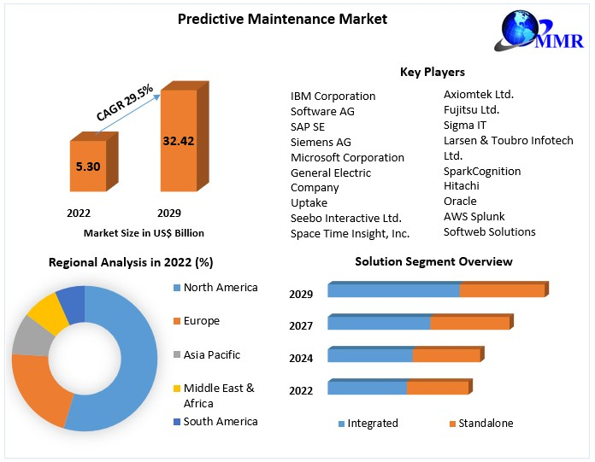The recorded data allows an engineer to estimate the eventual failure point of the observed asset, enabling it to be repaired or replaced shortly before it fails. Predictive maintenance reduces the occurrence of repair while still eliminating unexpected reactive maintenance and reducing equipment downtime and expenses associated with preventative maintenance. Predictive maintenance increases the lifespan of the equipment being observed. The report explores the Predictive Maintenance market's segments (Solution, Service, Deployment, Enterprise Size, End-Use, and Region). Data has been provided by market participants, and regions (North America, Asia Pacific, Europe, Middle East & Africa, and South America). It provides a thorough analysis of the rapid advances that are currently taking place across all industry sectors. Facts and figures, illustrations, and presentations are used to provide key data analysis for the historical period from 2018 to 2022. The report investigates the Predictive Maintenance market's drivers, limitations, prospects, and barriers. This MMR report includes investor recommendations based on a thorough examination of the Predictive Maintenance market's contemporary competitive scenario.

**Predictive Maintenance Market** size was valued at US$ 5.30 Bn.in 2022 and the total Predictive Maintenance revenue is expected to grow at 29.5% from 2023 to 2029, reaching nearly US$ 32.42 Bn.

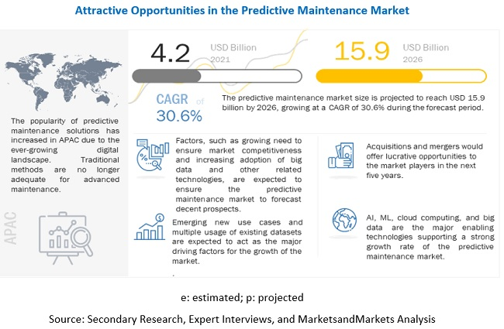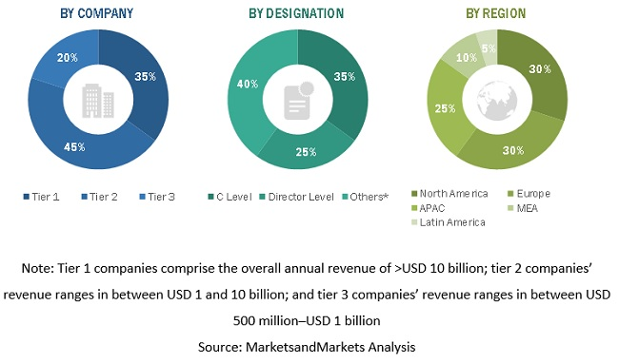

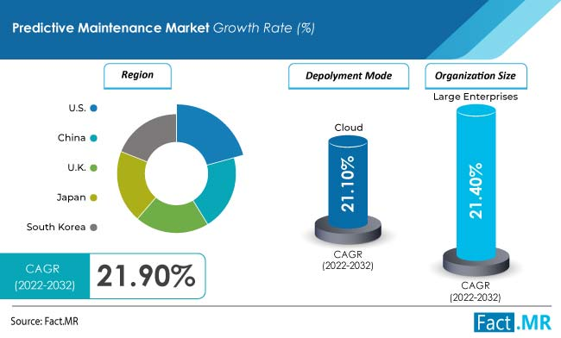

By deployment, the cloud-based segment is expected to dominate the market exhibiting a CAGR of 21.1% during the forecast period. Expansion of the segment can be attributed to benefits offered such as cost-efficiency, increased asset utilization, and better safety and compliance, among others.

Based on organization size, the large enterprises segment is projected to lead the market at a CAGR of 21.4% during the timeframe of 2022-2032. Predictive maintenance allows easy access to specific details on product and application habits. It also eases expenses and offers cost-cutting solutions that inhibit the expenses.

According to the analysis, the market in the US is expected to lead the global market. The country is estimated to secure a market value worth US$ 15.8 Million by 2032. The growth of the market can be attributed to the presence of established players in the region.

**Source:** [**https://www.marketsandmarkets.com/Market-Reports/operational-predictive-maintenance-market-8656856.html#:~:text=%5B294%20Pages%20Report%5D%20The%20Predictive,at%20a%20CAGR%20of%2030.6%25.**](https://www.marketsandmarkets.com/Market-Reports/operational-predictive-maintenance-market-8656856.html#:~:text=%5B294%20Pages%20Report%5D%20The%20Predictive,at%20a%20CAGR%20of%2030.6%25.)

1. Business Model**:**
   1. **.** Offering of Subscription Based Services:

Business model are back bones of any business model, spending time on defining a business model is good strategy rather than direct door sales. Subscription based business model can be effective in our scenario. There are many businesses use such strategy of some fixed cost and other requirement-based cost services.

|  |  |  |  |
| --- | --- | --- | --- |
|  | **Subscription plan 1** | **Subscription plan 2** | **Subscription plan 3** |
| Personalised web-based monitoring system | Checkmark | Checkmark | Checkmark |
| Personalised predictive system | Checkmark | Checkmark | Checkmark |
| Validity | **6 months** | **1 year** | **3 years** |
| IOT based services*(optional) | Checkmark | Checkmark | Checkmark |
| Services Charges**(fixed charges) | **20000** | **35000** | **80000** |

*\*\*modification charges & IOT based service didn’t included*

* 1. **. Product & service description:**

**2.2.1.** Real time Web Based monitoring and predictive maintenances **app:**

***Include image here***

*prototype of real time web based predictive maintenance services*

2.2.2. **How it works?**

Data collection through IOT based sensor

Step 1

Step 2

Step 3

Step 4

Step 5

Cloud storage

Data processing, Data checkup

Analytics, Prediction

Web based application

sample text. Enter your text here

. Enter your text here

* 1. Go-to-market Strategy:

*\*\* done by third-party*

* + 1. Step 1: Approaching Clients:Approaching potential clients as a predictive maintenance service provider can be a strategic process that involves utilizing various marketing channels and direct sales through affiliations. Here's a step-by-step approach to effectively approach clients in this industry:
       1. **Market Research and Segmentation**:

Begin by conducting thorough market research to understand target audience. Identify industries and businesses that can benefit from predictive maintenance services, such as manufacturing, energy, healthcare, and transportation.

|  |  |  |  |
| --- | --- | --- | --- |
| Industry | Feasibility | Viability | Monetization |
| Manufacturing | 9 | 8 | 7 |
| Oil and gas | 8 | 7 | 6 |
| Transportation | 8 | 7 | 6 |
| Energy | 7 | 6 | 5 |
| Healthcare | 7 | 6 | 5 |

Out of these industries Manufacturing, Industry seems to be targeting segment with good feasibility, viability, monetization

* + - 1. **Compelling Value Proposition**:

We have developed compelling value proposition of subscription service to attract customer from different segment, market size, that outlines the benefits of PDM service. Our solution can help clients reduce downtime, lower maintenance costs, and improve overall equipment efficiency.

* + - 1. Marketing:
* Developing Websitepredictive maintenance services, case studies, client testimonials, and industry expertise.
* Implement search engine optimization (SEO) strategies and social media marketing to ensure website ranks well on search engines for relevant keywords.
* Creating informative and educational content related to predictive maintenance, such as blog posts, whitepapers, infographics, and videos. Share industry insights, news, and success stories to engage your audience and build relationships.
* Building an email list of potential clients who have expressed interest in your services. Send personalized and informative emails that address their pain points and offer solutions.
  + - 1. Future development:

Showcase success stories and case studies on your website to demonstrate the real-world benefits your predictive maintenance services have delivered to clients.

Regularly assess the effectiveness of your marketing and sales strategies and make adjustments as needed. Stay up-to-date with industry trends and technologies to ensure your services remain competitive.

* + 1. **Step 2:Identifying needs**:
* By active communication understands need and wants of client.
* Observe and Analyse their operations, processes, and any existing systems or equipment.
* Engage the client in collaborative problem-solving discussions and offer expertise and insights and do comprehensive documentation
  + 1. **Step 3:Physical Installation**:
* Physical installation will be done by third party IOT service-based company with data security and integration
  + 1. Step 4:Offering Solutions:
* Prioritize Needs and offer customize solutions to meet the specific needs and goals of the client.
* Offer customer support and data security

1. Financial equation:

One of best way to calculate way of profit would be by using following linear equation where each term has its sperate significance:

$$y=m*x\left(l\right)+c$$

$y=$ total profit

$m=$ cost of subscription services or (expected total sales/No. of customer)

$x(l)=$ market

$c=$ constant depends on other cost including primary and secondary cost

Therefore, this formula can also be written as

* 1. **Justifying Value of each variable**:
     1. Value of C:

C is fixed cost associated with primary and supportive structure of business. It includes **supportive structure** human resource cost, technology cost, firm infrastructure, procurement and **primary structure** cost like cloud infrastructure, product development, distribution and reliability channel, marketing sales and services.

|  |  |  |
| --- | --- | --- |
| Supportive Activities | Cost | Justification |
| Human Resource | ₹ 12,00,000.00 | 4 employees |
| Technology development | ₹ 1,00,000.00 | software development/ security |
| Firm infrastructure | ₹ 3,00,000.00 | office furniture, rent, electricity |
| Procurement | ₹ 5,00,000.00 | 5000 per sensor |
| Primary Activities | **Cost** | **Justification** |
| Cloud Infrastructure | ₹ 1,00,000.00 | GCP, AWS storage bucket, compute engine |
| Product development | ₹ 50,000.00 | resources, data |
| Distribution and reliability | ₹ 2,00,000.00 | distribution channels, |
| Marketing and Sales | ₹ 1,00,000.00 | affiliate based, |
| Services | ₹ 1,00,000.00 | physical deployment of sensor, & maintenances, data quality checkup, personalised web-based app |
| Total Cost | ₹26,50,000.00 |  |

Since we are in ideation stage, let us consider cost of supportive structure would be zero, but still primary structure of business will cost around 5 to 6 lakh rupees.

Therefore, **let us consider value of C = 6 lakh.**

Value of C is doesn’t directly depend upon market.

3.1.2 **Value of x(l):**

This suggests that x(l) is a function that describes how market performance (x) is influenced by some variable or parameter (l).

The condition on which x(l) depends will vary depending on the factors that affect market performance in your predictive maintenance startup. These factors could include:

**Customer Demand:** If customer demand plays a significant role in profitability, l could represent variables related to customer behaviour, such as the number of customers, market segments, or demographics.

**Industry-Specific Metrics**: Industry growth and external factors, geopolitical scenario.

Since there is no direct formula for x(l), Let us consider following two scenarios for determining value of x

Current market size for predictive maintenance services in India 1.5 billion $ (by McKinsey), with currently 22% adoption rate for PDM in overall manufacturing units in India with 26.7 % CAGR growth rate.

**3.1.3 Value of m:**

Value of m can be determined by comprehensive market segmentation techniques on manufacturing client, by size of client company, no. of employees, no. of machines, no. of new machines, old machines, current status (closed or in operations) etc.

For time being we will take it as **35000**

Therefore equation will be,

$$y=35000*x\left(l\right)+600000$$

**3.2** **Financial equation for determine benefits of PdM:**

The following financial equation can be used to estimate the benefits of predictive maintenance for the manufacturing industry:

$$Benefits of predictive maintenance = (Cost of downtime * Downtime reduction) + (Cost of repairs * Repair reduction) + (Cost of asset replacement * Asset life extension)$$

Where:

**Cost of downtime**: The cost of downtime is the cost of lost production, revenue, and customer satisfaction due to machine and equipment failures.

**Downtime reduction:** The downtime reduction is the percentage reduction in downtime achieved through predictive maintenance.

**Cost of repairs:** The cost of repairs is the cost of repairing and replacing failed machines and equipment.

**Repair reduction:** The repair reduction is the percentage reduction in repairs achieved through predictive maintenance.

**Cost of asset replacement**: The cost of asset replacement is the cost of replacing machines and equipment that have reached the end of their useful life.

**Asset life extension:** The asset life extension is the percentage increase in asset life achieved through predictive maintenance.

For example, suppose that a manufacturing company has an annual cost of downtime of $1 million. If the company implements predictive maintenance and achieves a 20% reduction in downtime, the annual savings from reduced downtime would be $200,000.

This can also be fine tune by adding

Following formula for overall maintenances

Total Maintenance Cost (TMC) equation in the form of a linear equation as follows:

TMC = PMC + CMC + PrMC

$$TMC = (m_{p} * x) + (m_{c} * x) + (m_{pr} * x) + c$$

Where:

TMC represents the Total Maintenance Cost.

PMC, CMC, and PrMC represent the Predictive Maintenance Cost, Corrective Maintenance Cost, and Preventive Maintenance Cost, respectively.

$m_{p}, m_{c}, and m_{pr}$ are the coefficients representing the slopes of the respective costs in relation to some independent variable x (e.g., time or production volume).

c is the constant term, representing fixed or baseline maintenance costs.