**11. Web Application**

**11.1. Intro**

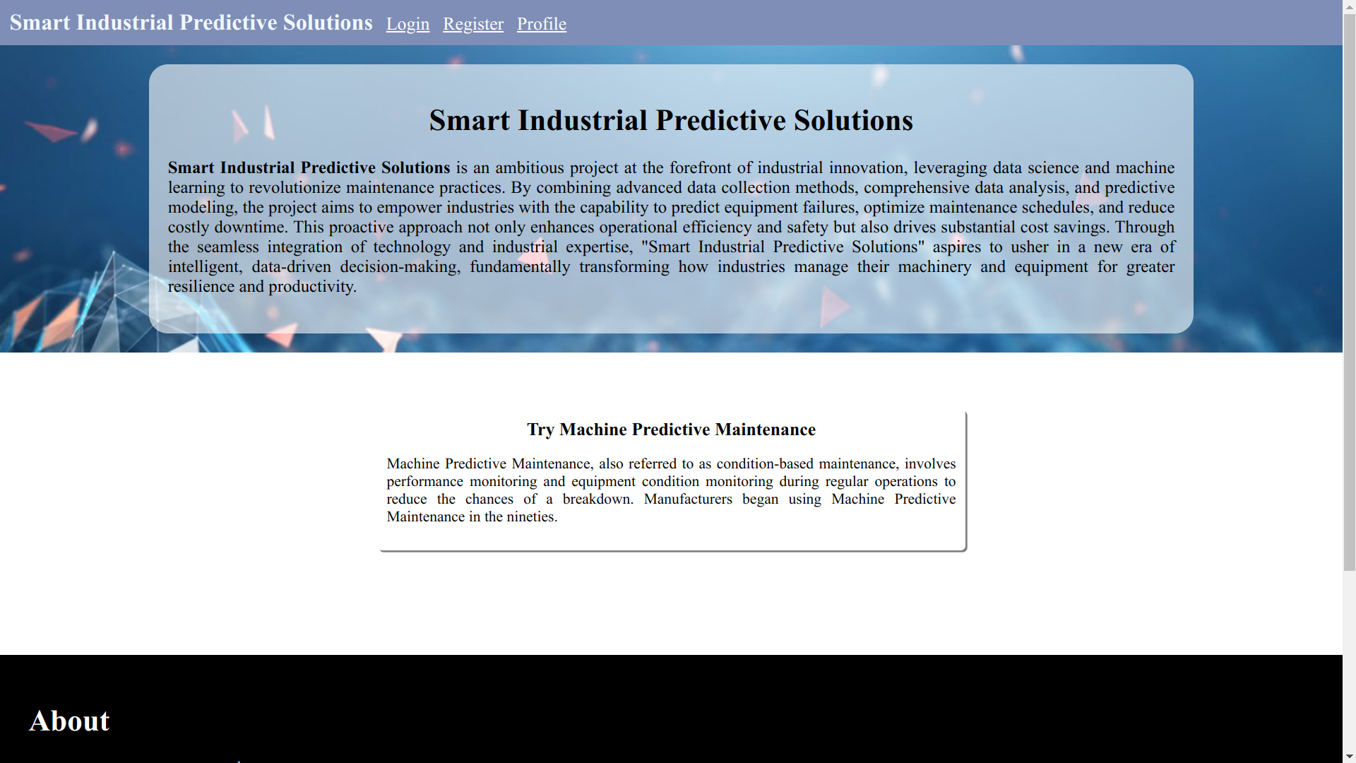

Our web app is a subscription-based predictive maintenance application tailored for industrial settings. Leveraging cutting-edge machine learning algorithms, it offers real-time insights into machinery health, allowing proactive maintenance to prevent costly breakdowns. Key features include a user-friendly interface, limited trial version and full analysis reports. Subscribers gain access to comprehensive reports, empowering them to optimize maintenance practices, reduce downtime, and enhance operational efficiency.

The trial version offers users a valuable sneak peek into the world of predictive maintenance. It provides a limited yet insightful experience, allowing users to explore the app's capabilities and witness its potential benefits. During the trial, users can access a subset of predictive maintenance insights, enabling them to understand how the app can enhance machinery health monitoring and maintenance planning. This trial version is an excellent opportunity for users to gauge the app's value before committing to a subscription, ensuring informed decision-making and a seamless transition to the full-featured app for comprehensive predictive maintenance analysis.

**11.2. Trial version**

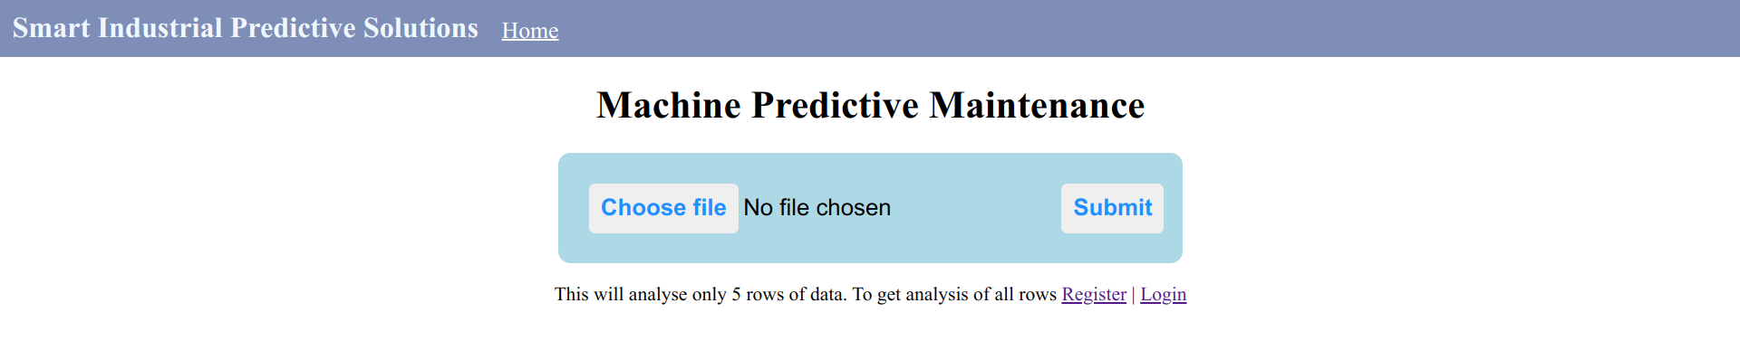

In the trial version, all you need to do is upload a CSV file with your machine's data and once you hit "submit," you'll instantly receive a failure report that provides valuable insights into your machinery's health and potential maintenance needs. It's a quick and easy way to experience how our app can help you prevent breakdowns and save on maintenance costs.

**11.3. Registering**

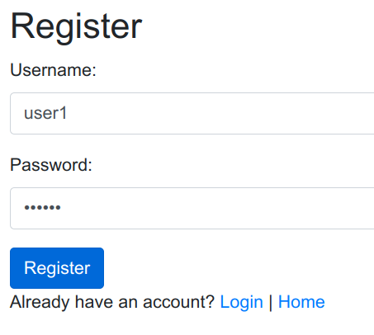

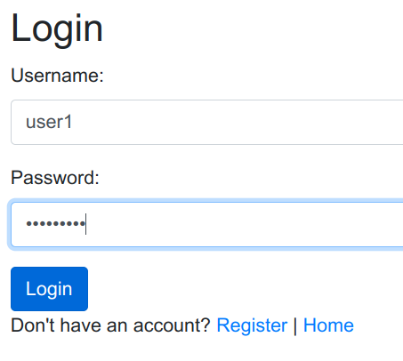 By registering, you unlock the full potential of our app, granting you access to comprehensive analysis reports that delve deep into your machinery's health and maintenance needs.

Once you log in, you'll gain immediate access to full analysis reports powered by our machine learning model. It's as straightforward as uploading a CSV file, and just like that, the detailed failure report will be available for instant download.

**11.4. Business mode in web app**

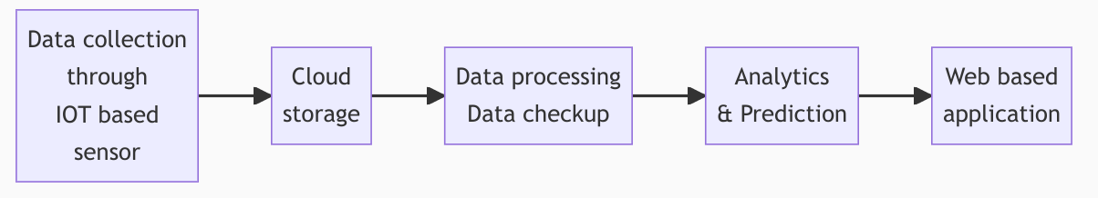

Our business model simplifies predictive maintenance by following a streamlined process. It begins with IoT-based sensors that collect real-time data from your machinery, which is securely stored in the cloud. Before analysis, the data undergoes thorough processing and checks to ensure accuracy. Using advanced analytics and machine learning, we predict maintenance needs and potential issues. Finally, users can conveniently access these insights through our user-friendly web-based application. This end-to-end approach ensures efficient and effective predictive maintenance for industrial operations.

**11.5. Data Analysis & Machine Learning Model in web app**

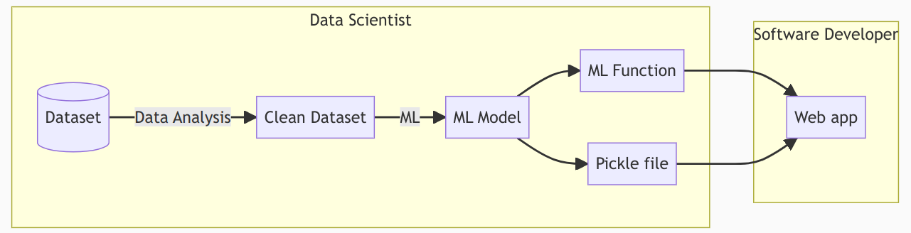

In our workflow, the machine learning (ML) model is at the core of our predictive maintenance system, serving as the brain behind the operation. Data scientists first analyze and clean the dataset to prepare it for training. They then employ the dataset to train the ML model, which includes creating a machine learning function. Once the model is trained, it's saved as a pickle file. The software developers take over from there, integrating the ML function into our web application. This collaborative effort between data scientists and software developers ensures that our web app delivers accurate and valuable predictive maintenance insights to our users.

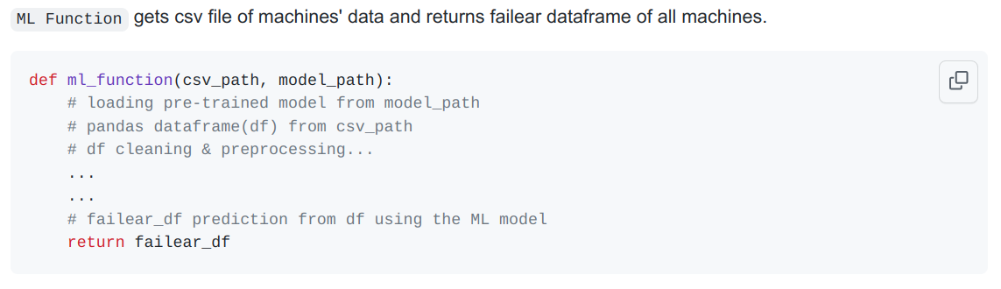

The "ML Function" is a pivotal component of our predictive maintenance system. It accepts a CSV file path containing machinery data and a pre-trained model path as inputs. Within this function, the pre-trained model is loaded, and the provided CSV data is processed and cleaned to ensure its suitability for analysis. Following data preparation, the function applies the ML model to make predictions related to machinery failure, resulting in a failure dataframe. This dataframe contains crucial insights about the potential failures of all the machines under analysis. The "ML Function" plays a critical role in our system's ability to proactively identify maintenance needs and enhance operational efficiency.

**11.6. Web app architecture**

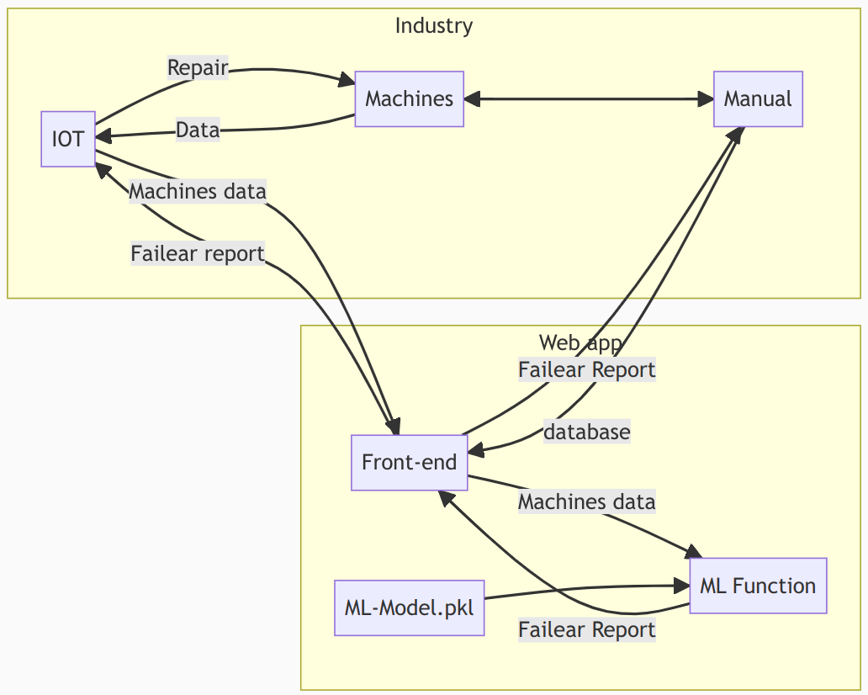

In our system architecture, the web application serves as the central hub connecting various components for streamlined predictive maintenance. The journey begins with data collection, where machinery data is sourced from IoT devices (represented by "IOT") and manual input (represented by "Manual"). This data flows into the web application's front-end (represented by "Front-end"), where users can interact with the system. Within the application, the data is further processed and analyzed using the "ML Function" and a pre-trained ML model ("ML-Model.pkl"). The result of this analysis is the generation of comprehensive failure reports, which are then made available to users through the front-end. Users can access these reports, gaining insights into machinery health and maintenance needs. Additionally, the web application facilitates bidirectional communication with the industry, allowing data exchange for analysis and providing repair instructions when necessary.

The industry side of the architecture involves data provision to the IoT devices and the web application. Machinery data is sent to the web application for analysis, while repair instructions are communicated back to the industry for action. This two-way flow of data ensures a closed feedback loop, enabling proactive maintenance and optimizing industrial operations. Moreover, the web application maintains a database of machinery data, ensuring a historical record of maintenance-related information and facilitating further analysis. This comprehensive architecture streamlines predictive maintenance, minimizing downtime and enhancing machinery reliability in industrial settings.

**11.7. Upload CSV format**

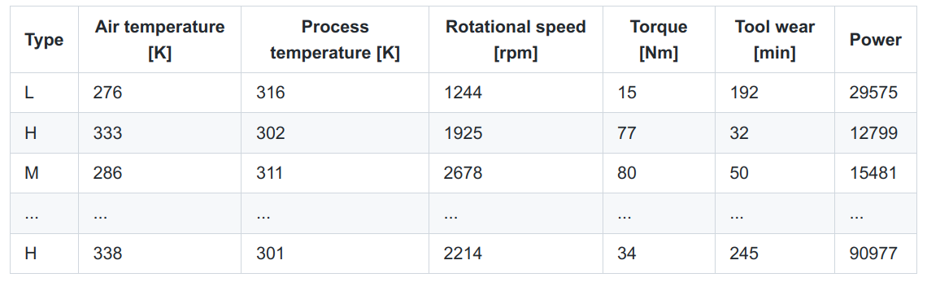

Our CSV upload format adheres to a structured table with specific columns essential for predictive maintenance analysis. These columns include "Type," "Air temperature [K]," "Process temperature [K]," "Rotational speed [rpm]," "Torque [Nm]," "Tool wear [min]," and "Power." While users have the option to include additional columns for machine names or identification numbers, the core columns mentioned above must be present in the uploaded CSV file. The resulting report CSV file exclusively contains data related to machines experiencing failures. To facilitate easy identification of the failing machines, an additional column labeled "Index" is incorporated into the report CSV, ensuring clarity and precision in pinpointing the machines in need of attention within the predictive maintenance process.

**12. Future Development:**

As part of our commitment to continuous improvement and staying at the forefront of technological advancements, we have identified key areas for future development that will further enhance the capabilities of "Smart Industrial Predictive Solutions." One pivotal area is the implementation of a robust CI/CD (Continuous Integration/Continuous Deployment) pipeline. This pipeline will streamline the development, testing, and deployment processes, ensuring seamless updates and enhancements to our application. By adopting best practices in CI/CD, we aim to deliver new features, improvements, and bug fixes efficiently and without disruption to our users.

This initiative aligns with industry trends and emerging technologies, such as cloud-based services like Google Cloud Platform (GCP) and Kubernetes. In the future, our CI/CD pipeline will seamlessly integrate with cloud services, facilitating automatic scaling, efficient resource management, and rapid deployment of updates. This not only enhances the reliability and performance of our application but also equips our team with valuable skills and experience in managing cloud-based solutions, including GCP's BigQuery and Kubernetes. By embracing this forward-looking approach, we ensure that "Smart Industrial Predictive Solutions" remains adaptable, agile, and ready to meet the evolving needs of our users and the industry as a whole.

**13. Conclusion:**

In conclusion, "Smart Industrial Predictive Solutions" represents a transformative leap forward in the realm of industrial maintenance. This innovative project combines cutting-edge technology, data-driven insights, and user-friendly accessibility to empower industries with proactive maintenance capabilities. By harnessing the power of machine learning and IoT data, this solution equips businesses with the foresight to prevent costly machinery breakdowns and optimize operational efficiency. The comprehensive web application, coupled with a seamlessly integrated data flow from sensors to analytics, offers a holistic approach to predictive maintenance. It is poised to revolutionize the way industries operate by minimizing downtime, reducing maintenance costs, and ensuring a competitive edge in an increasingly dynamic industrial landscape.

As industries continue to evolve, the need for data-driven decision-making and efficient maintenance practices becomes paramount. "Smart Industrial Predictive Solutions" rises to this challenge by providing a robust framework for informed decision-making, enhanced safety, and cost-effective maintenance. By offering trial versions, customizable options, and real-time insights, it ensures a user-centric experience that caters to businesses of all sizes. In essence, this project not only represents a technological milestone but also a strategic imperative for industries seeking to thrive in the 21st century. "Smart Industrial Predictive Solutions" is not just a tool; it's a game-changer that empowers industries to stay ahead of the curve, ensuring resilience and success in a rapidly evolving industrial landscape.