######################IT-Performance 2017-18############################

1> Fog Imaging solution

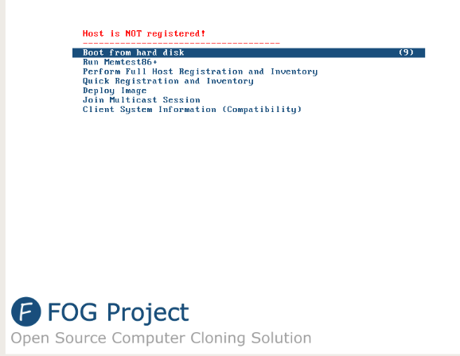

Inventory options to track system details

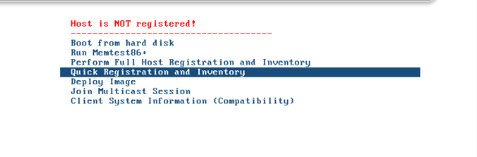

Multiple Imaging and multicasting Solutions: available os

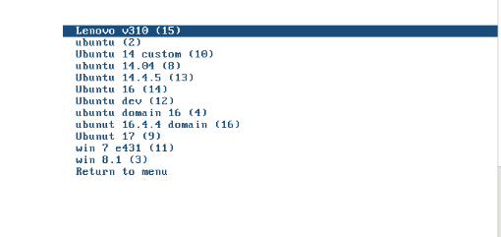

Imaging Time

5-8mins

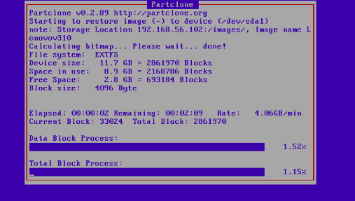

After Imaging

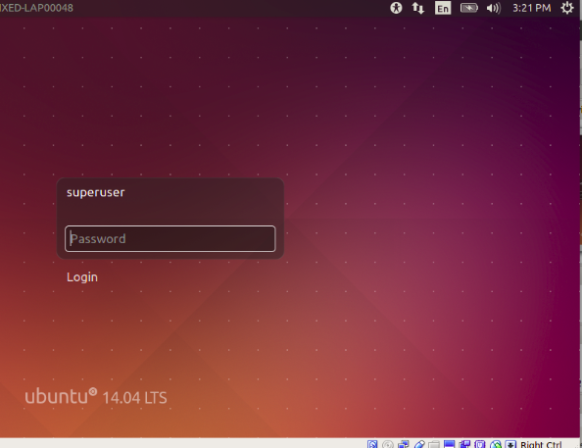

Fog Imaging Enables options to clone applications along with os so as to avoid post os software

installation

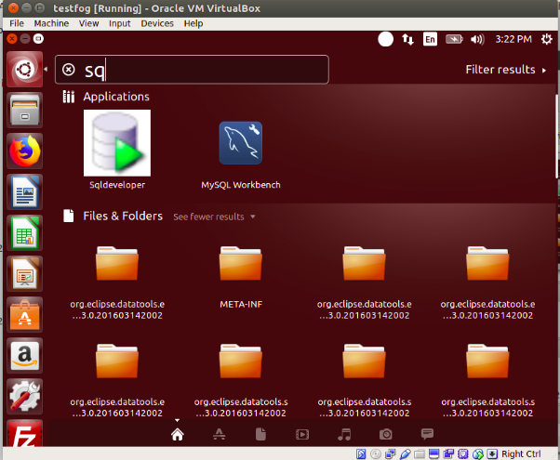

List of available softwares after cloning

Apache tomcat,Eclipse, ant,maven,Java 151, mysql, Sqldeveloper ,rabbit svn, forticlient etc

Other option available withFog

Hardware inventory,Snapin option : remote install of windows softwares by installing fog agent

Multiple os

######Time taken to install software and softwares

Before

Installating os : 15-20mins

Configuring domain : 15-20 mins

update and upgrade : 10-15 mins + 500mb internet

Installing softwares like eclipse, rabbit svn, mysql ect : 20-30 mins + 500mb + internet

After Implementation

5-10mins with latest update and softwares preinstalled,

Multicasting enabled to image multiple images at a time

No of laptops imaged from Fog imaging solution

92-100 laptops till now

2> Cups

Configured Cups in ubuntu as the centralise network printer for both mac and ubuntu laptops

users can directly see printers listed in printer setting who is using ubuntu 14.4.5 and

mac users can also use the printer by selecting add printer option

No need of installing drivers manually

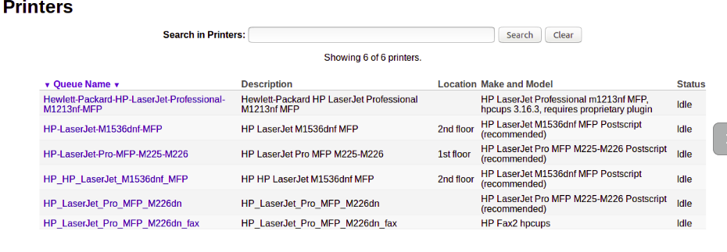

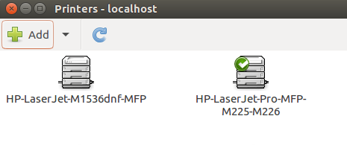

3>Re -using old laptops

Identified faulty hardware like wifi card, mother board, display , keyboard in old spare and changed the parts with new parts accordingly to keep the laptop in working condition and assigned the same

to the new employees

Model:E520,E420,E430

4> Ticketing

Resolving users laptop Hardware and software issues, asset management by providing new laptop to users and maintaining asset sheet, Requesting new assets to the vendor

5> software repo

Mainting the software/application offline packages and its dependencies for the future installation to avoid internet usage

Helpful mainly in ubuntu systems when installing software with has dependencies

6> Software deploy

Implemented jenkins in local system so as to copy windows softwares and ubuntu scripts

remotely with single click so as to reduce software installation and scripts running time in laptops

7> update repo

Maintaining latest OS updates offline so as avoid the internet usage on updates

windows update 1803 :3.6GB

Windows update 1809: 3.6GB

Mac os High seirra update: 5 GB

Mac OS Majove upadte: 5Gb

8> Wallpaper & limiting sudo access, Knowledge base update in ticketing system

Wallaper: shell scripts to apply desktop wallapaper and block usb in ubuntu systems

Knowledge base: Provides info about Ticketing policy and software repo path and vpn configuration details to the user

http://192.168.1.1/support/kb/index.php

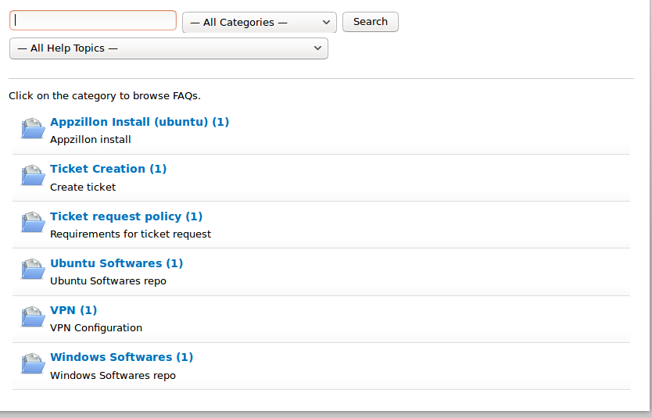

Sudo access

limiting sudo user access to /opt/user_data

so that user can copy packages to the /opt/user_data path and

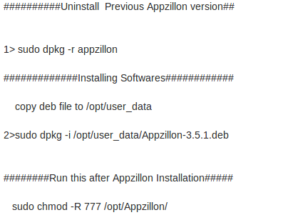run the following cmds for installing

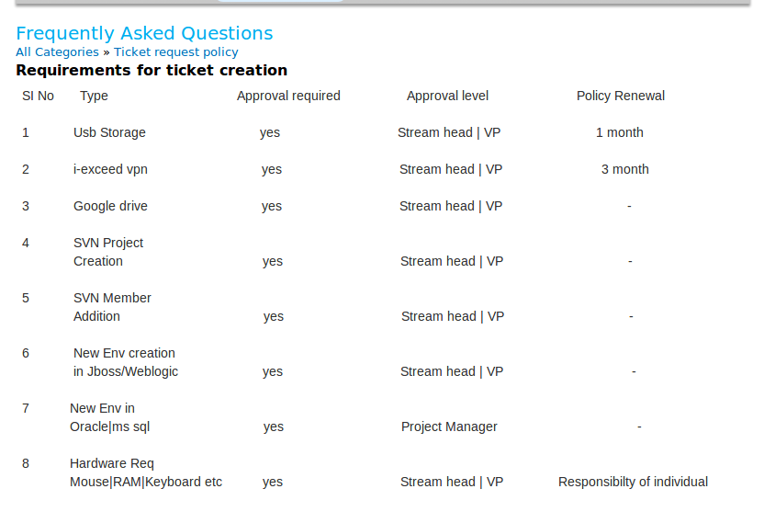

9>Ubuntu Migration

Migration succesfully tested from ubuntu 14-18 over internet

waiting for performance update for ubuntu 18 from users

user1:Dinesh Muneeshwaran

user2:ripu pandey

After successfull migration over internet trying to implement the same with

offline packages as the update is of 4.2 gb on single system

Offline repo

It would save 140 ubuntu * 4 gb= aroung 500+gb of internet

10> Wifi Restriction

As per you guidance wifi block tested on multiple systems facing some challenges as the connetionname is being different in several systems unable to implement properly

ubuntu 14 has update service

ubuntu 16 and 18 has systemd service

As the both the verisons has different system service cmds might take some more time

to find proper solution

On Windows Systems

Tried bat files in win 7 found it working

will be tesing the same in win 8 an win 10

and update the progress accordingly

There are few more which are not listed in this document