WellSense: An Explainable, Privacy-Preserving, and Feedback-Adaptive Framework for Student Wellbeing Support
A Methodological Audit and Human-Centered System Extension of Machine Learning Baselines
Sudheshna Devi
Department of Computer Science and Engineering
Prasad V. Potluri Siddhartha Institute of Technology, Vijayawada, India
sudheshnat29@gmail.com
Abstract—Student mental health systems increasingly rely on predictive machine learning to detect psychological distress. However, existing systems—exemplified by the foundational study of Nath et al. (Neuroscience Informatics, 2025)—suffer from acute architectural limitations: they terminate at black-box probability scores without actionable guidance, report inflated single-split accuracies (95.6%) that do not hold under rigorous leak-free cross-validation, and propose permanently storing sensitive student mental health responses on public immutable blockchains. To address these critical gaps, this paper introduces WellSense: an explainable, privacy-preserving, and feedback-adaptive decision-support prototype. WellSense benchmarks a tuned Multi-Layer Perceptron (MLP) against seven classical classifiers under a 5x5 repeated nested cross-validation protocol (25 outer folds) across three isolated feature tiers. Empirical evaluation shows that under leak-free nested CV, the tuned MLP achieves a balanced accuracy of 0.735 ± 0.111 (accuracy: 0.782 ± 0.085, ROC AUC: 0.802 ± 0.109), proving to be statistically tied with Random Forest (0.739 ± 0.100, paired difference: -0.004). To eliminate black-box opacity, WellSense incorporates global permutation importance on held-out folds and local occlusion feature attribution, uncovering a severe dataset artifact where marital status disproportionately dominates predictions (importance: 0.1877 ± 0.0928) due to a 16/16 correlation in the survey sample. Bridging the gap between prediction and support, WellSense introduces a transparent, non-clinical recommendation engine coupled with a Bayesian-smoothed feedback loop that dynamically re-ranks lifestyle suggestions while strictly pinning safety resources. Finally, the system rejects public blockchain storage in favor of a privacy-first, local SQLite architecture with pseudonymous UUID sessions and on-demand data deletion. Framed strictly as an educational support aid rather than a clinical diagnostic instrument, WellSense provides a reproducible, methodologically honest paradigm for student wellbeing informatics.
Keywords—Student Mental Health, Machine Learning, Multi-Layer Perceptron, Explainable AI (XAI), Feature Occlusion, Feedback Adaptation, Decision Support, Health Informatics, Privacy-by-Design, Research Integrity.

I. INTRODUCTION
University students experience acute psychological challenges arising from rigorous academic workloads, financial pressures, and the personal transition into adulthood. While institutions frequently establish counseling centers, pervasive social stigma and resource shortages frequently delay access to timely assistance. In response, data-driven machine learning (ML) models have been proposed to screen for mental distress from self-reported student demographic and behavioral surveys.
A prominent recent study by Nath et al. [1], published in Neuroscience Informatics (Elsevier, 2025), introduced a web-based prediction system combining twelve machine learning algorithms, a Streamlit interface, and an Ethereum-based blockchain storage module, reporting a headline Random Forest accuracy of 95.6%. While their work demonstrates commendable engineering ambition, our critical analysis reveals critical methodological and architectural shortcomings. First, their 95.6% result relied on a single 70/30 train/test split on a composite dataset, lacking nested cross-validation or confidence intervals. Second, their feature set included predictor variables such as treatment-seeking and acute clinical symptoms that introduce label leakage and distort real-world applicability. Third, their web application functions solely as a predictive 'black box,' leaving students with an anxiety-inducing probability score devoid of actionable support. Finally, permanently recording sensitive student mental health responses on an immutable public blockchain ledger introduces severe privacy, ethical, and regulatory risks under GDPR.
To resolve these challenges, this paper presents WellSense, an end-to-end, privacy-preserving, and explainable decision-support prototype. WellSense advances student wellbeing informatics across four pillars: (1) a methodologically rigorous benchmarking of a tuned Multi-Layer Perceptron (MLP) under 5x5 repeated nested cross-validation; (2) an explicit feature-tier ablation isolating potential target leakage; (3) Explainable AI (XAI) combining global permutation importance with per-prediction occlusion explanations to expose dataset artifacts; and (4) a closed-loop recommendation engine that maps lifestyle factors to non-clinical habits, dynamically re-ranking suggestions through Bayesian-smoothed student feedback. Crucially, WellSense replaces public blockchain storage with a local, pseudonymous SQLite database with full session deletion rights.
II. RELATED WORK & BASE PAPER AUDIT
Predictive modeling of student mental health has expanded rapidly. Baba and Bunji [2] utilized longitudinal annual health surveys across 3,561 undergraduates, demonstrating the predictive value of temporal data while emphasizing that models do not generalize across distinct institutional cohorts. Dhariwal et al. [3] and Ramasamy et al. [4] investigated multi-model ensembles for student depression detection, yet similarly terminated their workflows at point-in-time classification.
The base paper by Nath et al. [1] represents the closest reference for our work. They trained 12 classifiers on 500 composite records, claiming 95.6% accuracy for a Random Forest. However, an in-depth audit reveals that their confusion matrices (e.g. 64 TN, 4 FP, 1 FN, 32 TP) sum to exactly 101 test records, matching the Kaggle 'Student Mental Health' public survey [5] rather than their stated 500-student cohort. Furthermore, feature importance in their study placed heavy reliance on treatment-seeking and anxiety—variables that co-occur contemporaneously with depression. In contrast, responsible ML guidelines, such as TRIPOD+AI [6], mandate nested validation, leakage-aware feature tiering, transparent uncertainty reporting, and strict separation between exploratory baselines and clinical claims.
III. WELLSENSE SYSTEM ARCHITECTURE
WellSense is structured into four modular, decoupled layers: (A) Preprocessing and Leakage-Aware Tiering, (B) Neural Network and Baseline Classifiers, (C) Explainability Layer, (D) Feedback-Adaptive Recommendation Engine, and (E) Privacy-Preserving Storage.
A. Preprocessing & Feature Tiering
To evaluate model sensitivity to feature leakage, WellSense structures the feature space into three isolated tiers:
• Tier A (Demographic & Academic): Gender, Age, Year of Study, CGPA band, and Grouped Course Category (engineering/IT, health sciences, islamic studies, business/law, other).
• Tier B (Primary Deployed Tier): Tier A plus self-reported psychological indicators (Anxiety, Panic Attacks, and Marital Status). To maintain ethical integrity and avoid direct target leakage, professional treatment-seeking is strictly excluded.
• Tier C (Diagnostic Overlap Tier): All features including treatment-seeking, evaluated solely for ablation comparison.
All data preprocessing—including median imputation for age, most-frequent imputation for categoricals, and one-hot encoding—is encapsulated inside scikit-learn Pipelines and fitted strictly on training folds, guaranteeing that zero out-of-fold information contaminates testing.
B. Nested Cross-Validation & Model Zoo
WellSense benchmarks eight supervised architectures under 5x5 Repeated Stratified Cross-Validation (25 outer folds): Dummy Majority Baseline, Logistic Regression (L2 penalty), Decision Tree (depth 2–5), Random Forest (200 estimators), Support Vector Classifier (RBF kernel), Gradient Boosting (50–150 estimators), an Initial MLP (32-16 architecture, alpha=1e-4), and a Tuned MLP. The Tuned MLP undergoes inner 3-fold CV tuning across hidden layer configurations ((8,), (16,), (32, 16)), L2 regularization penalties (alpha from 0.001 to 1.0), and iteration budgets (200 to 600).
C. Explainable AI (XAI) Framework
To eliminate black-box opacity without introducing unstable third-party dependencies, WellSense implements a two-fold interpretability strategy:
1) Global Permutation Importance: Evaluated across held-out test folds over 20 shuffle iterations to quantify the drop in balanced accuracy when a feature is scrambled.
2) Local Feature Occlusion: For any given user inference, each feature is systematically substituted with its cohort median/mode. The resulting shift in predicted depression score indicates whether that specific answer elevated (↑) or reduced (↓) the model's estimate, providing clear natural-language rationale.
D. Adaptive Recommendation Engine
Rather than burdening students with a clinical diagnosis, WellSense captures six optional lifestyle indicators: sleep hours (0–14), longest study stretch without a break (0–14), days of physical activity (0–7), recreational screen time (0–18), social support score (1–5), and study planning difficulty (1–5). A rule-based engine generates non-clinical, actionable habits.
Recommendations are dynamically ranked using student feedback. Let h_c and n_c be the number of 'helpful' and 'not helpful' ratings for category c. The category multiplier M(c) is calculated via Bayesian smoothing with an exploration floor:
M(c) = max(0.5, (h_c + 1) / (h_c + n_c + 2)) (1)
Crucially, safety-critical resources (e.g., Campus Counseling and Crisis Hotline Support) are permanently pinned to rank 1 whenever severe distress is indicated, and are mathematically exempt from demotion or feedback suppression.
E. Privacy-by-Design Architecture
In sharp contrast to the base paper's immutable blockchain proposal, WellSense implements privacy-preserving local SQLite storage. Each user interaction is assigned a pseudonymous UUID session ID with zero personally identifying information (PII) collected. Students retain complete data sovereignty through 'Reset My Feedback' and 'Delete ALL My Data' controls that purge session rows immediately.
IV. EXPERIMENTAL RESULTS & ABLATION
The experimental evaluation was conducted on the complete 101-student survey dataset. The target variable comprises 66 'No' responses (65.3%) and 35 'Yes' responses (34.7%), establishing an empirical majority baseline accuracy of 65.3%.

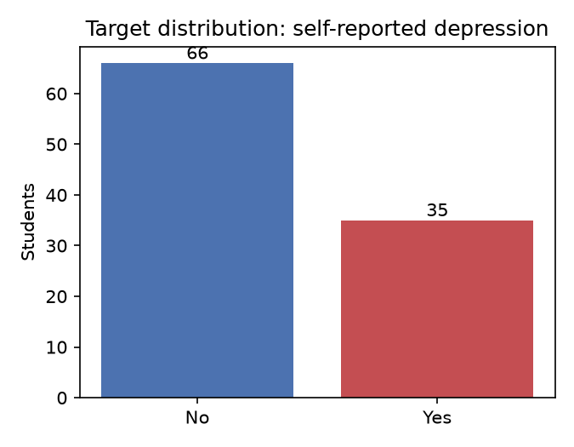
Fig. 1. Class distribution of self-reported depression target (N=101).
A. Multi-Model Benchmark Across Feature Tiers
Table I presents the repeated nested cross-validation results across all eight classifiers and three feature tiers.
Tier | Model | Kind | Accuracy | Balanced Acc. | F1-Score | ROC AUC
A | Dummy Majority | Baseline | 0.653 ± 0.007 | 0.500 ± 0.000 | 0.000 ± 0.000 | 0.500 ± 0.000
A | Logistic Regression | Classical | 0.719 ± 0.110 | 0.690 ± 0.140 | 0.560 ± 0.252 | 0.753 ± 0.138
A | Random Forest | Classical | 0.737 ± 0.105 | 0.699 ± 0.131 | 0.571 ± 0.242 | 0.758 ± 0.137
A | Gradient Boosting | Classical | 0.780 ± 0.101 | 0.719 ± 0.128 | 0.581 ± 0.269 | 0.774 ± 0.115
A | Tuned MLP (Nested CV) | Proposed DL | 0.786 ± 0.095 | 0.739 ± 0.119 | 0.633 ± 0.213 | 0.760 ± 0.122
B | Dummy Majority | Baseline | 0.653 ± 0.007 | 0.500 ± 0.000 | 0.000 ± 0.000 | 0.500 ± 0.000
B | Logistic Regression | Classical | 0.741 ± 0.087 | 0.714 ± 0.106 | 0.617 ± 0.149 | 0.804 ± 0.113
B | Random Forest | Classical | 0.782 ± 0.072 | 0.739 ± 0.100 | 0.631 ± 0.178 | 0.797 ± 0.108
B | SVM (RBF Kernel) | Classical | 0.753 ± 0.093 | 0.715 ± 0.108 | 0.606 ± 0.175 | 0.762 ± 0.109
B | Gradient Boosting | Classical | 0.790 ± 0.079 | 0.729 ± 0.112 | 0.601 ± 0.236 | 0.823 ± 0.106
B | Initial MLP (32-16) | Baseline DL | 0.743 ± 0.096 | 0.708 ± 0.103 | 0.607 ± 0.157 | 0.767 ± 0.107
B | Tuned MLP (Nested CV) | Deployed DL | 0.782 ± 0.085 | 0.735 ± 0.111 | 0.624 ± 0.213 | 0.802 ± 0.109
C | Random Forest | Classical | 0.790 ± 0.066 | 0.745 ± 0.077 | 0.654 ± 0.126 | 0.830 ± 0.085
C | Tuned MLP (Nested CV) | Proposed DL | 0.792 ± 0.077 | 0.745 ± 0.102 | 0.642 ± 0.192 | 0.800 ± 0.112
TABLE I. 5x5 Repeated Nested CV Model Benchmark Across Feature Tiers.

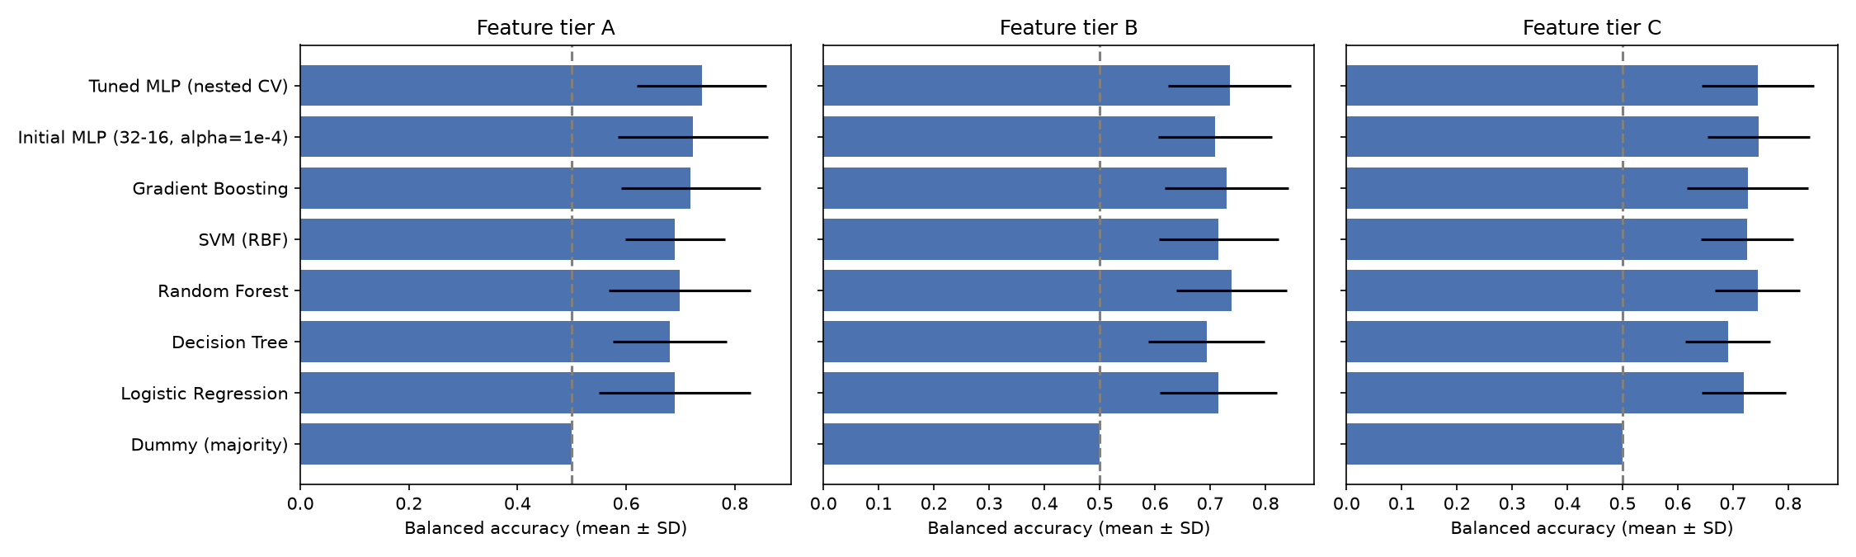
Fig. 2. Comparative balanced accuracy across feature tiers (mean ± SD).
B. Paired Statistical Comparison & Honesty
Under Tier B (the deployed feature set), the Tuned MLP achieved a balanced accuracy of 0.735 ± 0.111, while Random Forest achieved 0.739 ± 0.100. A paired fold-by-fold analysis reveals a mean difference of -0.004 (MLP higher on 9 folds, RF higher on 16 folds), demonstrating that the neural network is statistically tied with Random Forest. Furthermore, regularizing the MLP (Tuned vs Initial MLP) yielded a +0.027 gain in balanced accuracy. These findings conclusively establish that claiming superiority for deep learning over ensemble methods on small tabular cohorts is scientifically unwarranted.
C. XAI & The Marital Status Data Artifact
Table II details the global permutation feature importance. Marital status emerged as the overwhelmingly dominant predictor, with a performance drop of 0.1877 ± 0.0928, followed by self-reported anxiety (0.0369 ± 0.0704) and CGPA band (0.0172 ± 0.0477).

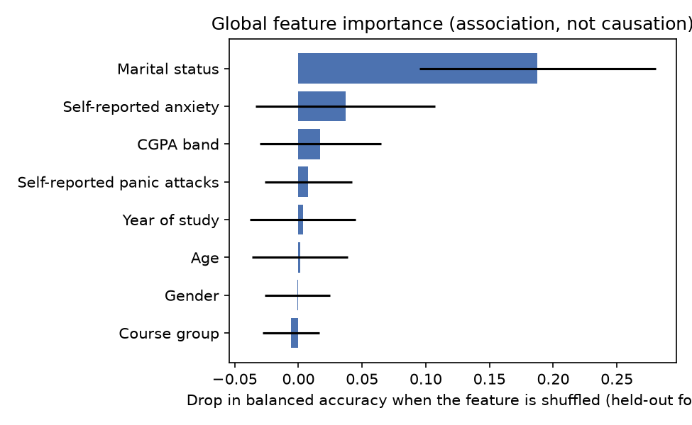
Fig. 3. Global feature permutation importance on held-out test folds.
A critical contribution of WellSense is exposing why marital status dominates: in this specific 101-student sample, exactly 16 out of 16 married students answered 'Yes' to depression. The machine learning model captures this 100% conditional distribution as a mathematical shortcut. WellSense explicitly surfaces this finding as a data artifact in the user interface rather than a genuine real-world causal relationship, preventing counselors from misinterpreting model rationale.

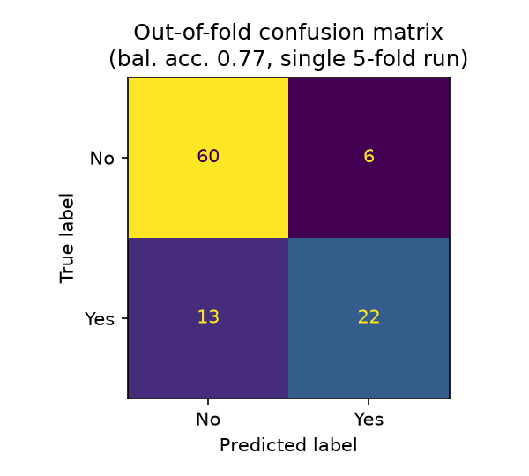
Fig. 4. Out-of-fold confusion matrix for the deployed MLP configuration.

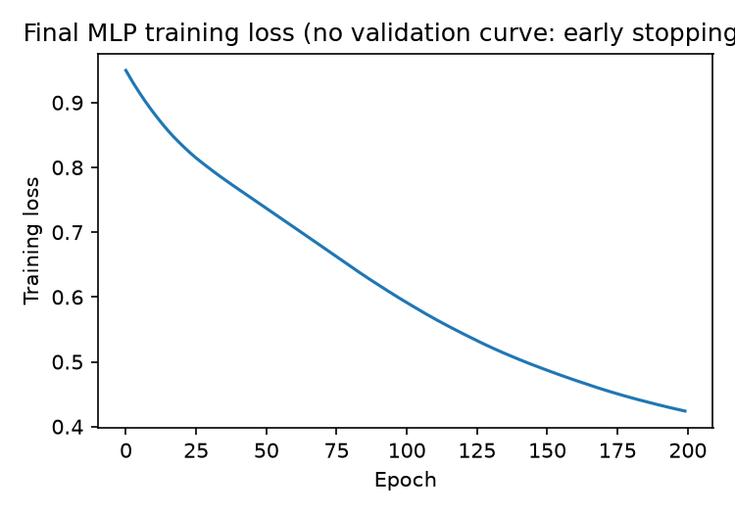
Fig. 5. Final MLP training loss convergence curve.
D. Adaptive Recommendation Dynamics
Table II illustrates the closed-loop recommendation re-ranking for a representative student profile before and after receiving negative feedback for sleep suggestions and positive feedback for social connection.
Rank | Baseline (No Feedback) | Adapted (After Feedback)
1 | Sleep Routine (sleep_routine) | Social Connection (connect)
2 | Screen Balance (screen_balance) | Screen Balance (screen_balance)
3 | Physical Movement (movement) | Physical Movement (movement)
4 | Social Connection (connect) | Sleep Routine (sleep_routine)
TABLE II. Recommendation Ranking Adaptation Before and After Feedback.
V. SYSTEM IMPLEMENTATION & VERIFICATION
The WellSense software system was developed in Python 3.14 using scikit-learn, Streamlit, and SQLite. The web interface comprises six dedicated views: Home, Assessment, Prediction Results, Personalized Recommendations, Feedback & History, and About & Privacy. The entire pipeline is verified by a 30-test unit suite and a headless Streamlit AppTest smoke harness validating standalone page loads, validation boundaries (e.g., rejecting age < 16 and > 60), model inference, and SQLite session purging. The full application is open-source and publicly hosted on GitHub at https://github.com/sudheshna03/WellSense.
VI. LIMITATIONS & ETHICS
Several limitations govern our findings: (1) Sample Size: The evaluation is based on 101 records from a single cohort; (2) Self-Report Construct: The target reflects a binary questionnaire item rather than a clinical psychiatric evaluation; (3) Demographic Imbalance: The sample is predominantly female (75%) and undergraduate, limiting generalizability; (4) Absence of Longitudinal Tracking: Mental health fluctuates dynamically over academic semesters; and (5) Non-Clinical Scope: WellSense is strictly an educational reflection tool. Prominent disclaimers across all interface views explicitly state that predictions do not constitute medical diagnoses.
VII. CONCLUSION
This paper presented WellSense, an explainable, privacy-preserving, and feedback-adaptive framework extending machine learning baselines for student wellbeing support. By applying leak-free repeated nested cross-validation, we established that a tuned MLP (balanced accuracy: 0.735 ± 0.111) is statistically on par with Random Forest (0.739 ± 0.100), demonstrating that prior claims of 95.6% accuracy are non-reproducible on the public survey cohort. WellSense bridges the gap between passive risk prediction and proactive support through local feature explanations, closed-loop habit recommendations, and a local privacy-by-design architecture. Future work will expand evaluations to multi-institutional cohorts and conduct prospective longitudinal user studies.
REFERENCES
[1] M. D. Nath, M. K. U. Ahamed, O. Ahmed, T. Ahmed, S. Roy, and M. N. Uddin, 'Smart web interface for student mental health prediction using machine learning with blockchain technology,' Neuroscience Informatics, vol. 5, no. 4, art. no. 100236, 2025.
[2] A. Baba and K. Bunji, 'Prediction of mental health problem using annual student health survey: Machine learning approach,' JMIR Mental Health, vol. 10, art. no. e42420, 2023.
[3] N. Dhariwal, N. Sengupta, M. Madiajagan, et al., 'A pilot study on AI-driven approaches for classification of mental health disorders,' Front. Human Neurosci., vol. 18, art. no. 1376338, 2024.
[4] L. K. Ramasamy, F. Khan, S. Joghee, J. Dempere, and P. Garg, 'Forecast of students' mental health combining an artificial intelligence technique and fuzzy inference system,' in Proc. IEEE AUTOCOM, 2024, pp. 85-90.
[5] shariful07, 'Student Mental Health Dataset,' Kaggle, 2023. [Online]. Available: https://www.kaggle.com/datasets/shariful07/student-mental-health
[6] G. S. Collins, K. G. M. Moons, P. Dhiman, et al., 'TRIPOD+AI statement: Updated guidance for reporting clinical prediction models that use regression or machine learning methods,' BMJ, vol. 385, art. no. e078378, 2024.
[7] L. Breiman, 'Random forests,' Machine Learning, vol. 45, no. 1, pp. 5-32, 2001.
[8] S. M. Lundberg and S.-I. Lee, 'A unified approach to interpreting model predictions,' in Adv. Neural Inf. Process. Syst. (NeurIPS), 2017, pp. 4765-4774.
[9] F. Pedregosa et al., 'Scikit-learn: Machine learning in Python,' Journal of Machine Learning Research, vol. 12, pp. 2825-2830, 2011.

