**CS553 Project**

**Understanding the Cost of Cloud Computing**

Cloud computing, one of the scalable infrastructure for computing available today is catered by means of service. Amazon being one of the companies who provide these services tend to follow a on demand pricing business model. This project aims at comparing amazon on demand cloud service against the cost to set up a private infrastructure.

The report is formed in such a way that comparison between the two infrastructure options are evident. For the cloud computing setup, we have considered three configurations described in the following format.

Configuration details

Amazon public cloud setup cost estimation

Private cloud setup cost estimation

Finally, at the end we will compare all three configurations to showcase which is better and why

**Configuration 1**

|  |  |
| --- | --- |
|  | Description |
| Compute Servers | 32 k cores |
| Memory | 256 TB |
| Disk | 50 PB HDD |
| Network | 10 Gb/sec |
| Distributed storage (100GB/sec throughput) | 100 PB |

*Table 1: configuration 1 specification*

**Amazon public on demand cloud computing cost**

Instance chosen: d2.8xlarge

Each instance configuration:

|  |  |  |  |  |
| --- | --- | --- | --- | --- |
| **Name** | **vCPU** | **Mem(GiB)** | **HDD(GB)** | **cost** |
| **D2.xlarge** | **36** | **244** | **24*2000** | **$5.52/Hour** |

Cost breakdown for config 1

|  |  |  |  |  |
| --- | --- | --- | --- | --- |
|  | Description | Price | Quantity | Total Price for 5 years |
| Compute Servers | D2.8xlarge | $ 5.52/hr | 1,093 | $264,261,168 |
| Distributed Storage | S3 | $ 0.021/GB |  | $132,120,576 |
| Total | N/A | N/A | N/A | $ 396,381,744 |

**1.Instance Calculation**

For the configuration mentioned in the above table. The required instances are computing below

CPU

32K cores required

1 d2 instance CPU’s = 36 vCPU

vCPU to cores = vCPU

= 36 cores

Instances required for 32 K core = 32000/36

= 889 d2.8xlarge instances --------> a

Memory

256TB in GB = 262,144 GB

1 d2 instance Disk capacity = 244 GiB

244 GiB in GB = 244* 1.074 = 262.06 GB

Instances required for 256TB = 262,144 /262.06

= 1,001 d2.8xlarge instances --------> b

Disk

50PB in GB = 52,428,800 GB

1 d2 instance Disk capacity = 48,000 GB

Instances required for 50PB = 52,428,800/48000

= 1,093 d2.8xlarge instances --------> c

Total number of d2.8xlarge instances required = max ( a, b, c)

= 1,093 instances

**2.Distributed Storage**

S3 standard storage pricing per month = $0.021 per GB

100 PB in GB = 104,857,600 GB

Storage cost for 5 years = 0.021 * 104,857,600 * 12 * 5

= $ 132,120,576

**3.Total Cost calculation**

1 D2.8xlarge instance cost

36 cores, 244 GiB of Memory and 24* 2000 HDD at the cost of $5.52 per hour

1,093 instances cost per hour = 5.52 * 1,093

= $ 6033.36

1,093 instances cost for 5 years = $9,814.56 * 24 * 365 * 5

= $ 264,261,168

Total cost = distributed storage cost + d2.8xlarge instance cost

= $ 132,120,576 + $ 264,261,168

**= $ 396,381,744**

**Private Cloud setup cost estimation**

Each rack used: Iris 2482

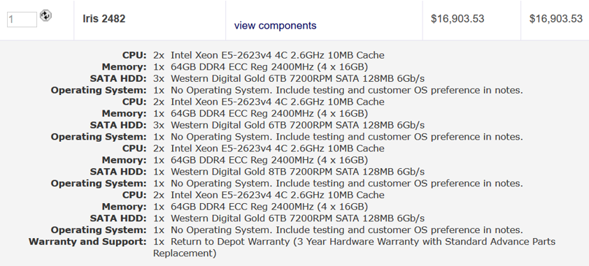

Cost breakdown

|  |  |  |  |  |
| --- | --- | --- | --- | --- |
|  | Description | Price per Item | Quantity | Total Price |
| Compute Servers | Iris 2482 | $ 16,903.53 | 1,000 | $ 16,903,530 |
| Network Switches | Dell Z9000 switches | $ 862.62 | 71 | $ 61,246.02 |
| Network Cables | Dell Networking Cable,40GbE (QSFP+) to 4 x 10GbE SFP+ | $ 720 | 256 | $ 184,320 |
| Network Cables | Dell Networking, Cable, QSFP+ to QSFP+, 40GbE | $ 590 | 992 | $ 585,280 |
| Storage Servers | STX-CL XE72-2460 | $ 43,934 | 237 | $ 10,412,358 |
| Electric Power | 1200W (compute nodes)+ 1200W(cooling) over 5 years | N/A | N/A | $ 12,614,400 |
| Cooling | Cooler master v1200 | $ 303 | 1,000 | $ 303,000 |
| Administration | 1 per 1000 nodes over 5 years | $ 500,000 | 1 | $ 500,000 |
| TOTAL | N/A | N/A | N/A | $ 41,564,134.02 |

**1.Instance Calculation**

The rack has core - 2*4, 2*4, 2*4, 2*4 – 32 cores

Memory - 1*64, 1*64, 1*64, 1*64 – 256 GB

Disk - 3*6, 3*6, 1*6, 1*8 – 50 TB

1,000 of such instance

**2. Fat tree network with spine and leaf configuration**

Network cost with Dell z9000 switches in Fat tree configuration with 10GbE

16 leaf switches =16 * $**862**.62 = 13,801.92

8 spine switches = 8 * $**862**.62 = 6,900.96

leaf to spine cable = 16 * 16 * 590 = 151,040

( # leaf switches * # spine switches * # of connection per switch * cost of cable

leaf to node cable = 16*4 splitter( 16 ports split to 4 each) = 16 *16 * 720 = 184,320

( # leaf switch port * cost of splitter cable)

**3. Distributed Storage estimation**

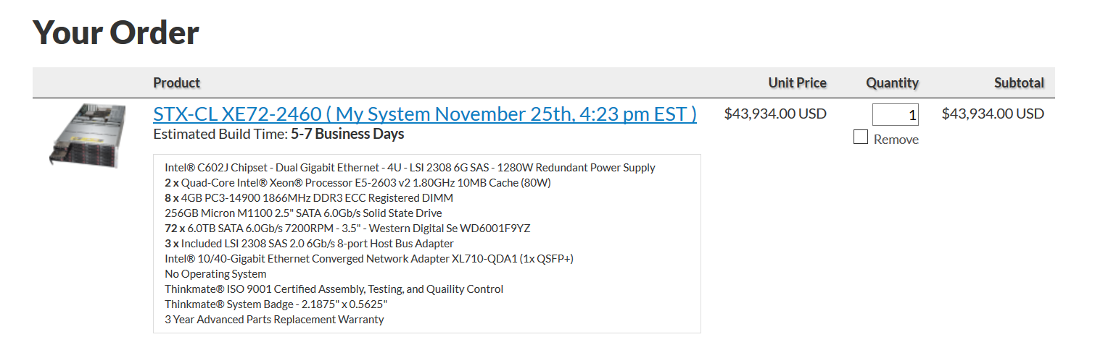

Each node = 72 * 6 TB HDD SATA= 432 TB/node

Instances required for 100PB = 100 * 1024 /432 = 237 instances

Total cost = instances * cost per instance = 237 * 43,934 = 10,412,358

**4. Storage network cost estimation**

31 leaf switches =31 * $**862**.62 = 26,741.22

16 spine switches = 16 * $**862**.62 = 13,801.92

leaf to spine cable = 31 * 16 * 590 = 292,640

( # leaf switches * # spine switches * # of connection per switch * cost of cable

leaf to node cable = 15 cables = 15 * 16 * 590 = 141,600

( # leaf switch port * cost of splitter cable)

**5. Admin cost estimation**

Admin cost = $100,000 * 5 = 500,000

**6. Cooling cost estimation**

Cooler master v1200

1 rack = 303

1000 instances

$303,000

Power 1200W For 1000 instances 6,307,200

**7. Power cost estimation**

1 rack = 1200W

Per year 1261.44 cost of a rack

For 5 years = 6307.2

For 1000 instances 6,307,200

Total cost of configuration = $41,564,134.02

**Configuration 2**

|  |  |
| --- | --- |
|  | Description |
| Compute Servers | 1 Million * 2 cores |
| Memory | 1 Million * 15 GB RAM |
| Disk | 1 Million * 32 GB SSD |
| Network | 1 Million * 1GB/sec |
| Distributed storage (10GB/sec throughput) | 10 PB |

*Table 2: configuration 2 specification*

**Amazon public on demand cloud computing cost**

Instance chosen: r3.large

Each instance configuration:

|  |  |  |  |  |
| --- | --- | --- | --- | --- |
| **Name** | **vCPU** | **Mem(GiB)** | **HDD/SSD(GB)** | **cost** |
| **R3.large** | **2** | **15** | **1*32SSD** | **$0.166/Hour** |

For the configuration mentioned in table 2. The required instances are computed below

|  |  |  |  |  |
| --- | --- | --- | --- | --- |
|  | Description | Price | Quantity | Total Price for 5 years |
| Compute Servers | R3.large | $ 0.166/hr | 1,000,000 | $7,270,800,000 |
| Distributed Storage | S3 | $ 0.021/GB |  | $13,212,057.6 |
| Total | N/A | N/A | N/A | $7,284,012,057.6 |

**1.Instances Required**

For the configuration mentioned in first table

CPU

Required 2 million cores

1 r3.large instance CPU’s = 2 vCPU

vCPU to cores = vCPU

= 1 core

Instances required for 2Million core = 2,000,000/2

= 1,000,000 r3.large instances --------> a

Memory

15 Million GB

1 r3.large instance Disk capacity = 15 GiB

15 GiB in GB = 15 * 1.074 = 16.11 GB

Instances required for 15 Million GB = 15000000/16.11

= 931,099 r3.large instances --------> b

Disk

32 Million GB

1 r3.large instance Disk capacity = 32 GB

Instances required for 32 Million GB = 32000000/32

= 1,000,000 r3.large instances --------> c

Total number of r3.large instances required = max ( a, b, c)

= 1,000,000 instances

**2.Distributed Storage**

S3 standard storage pricing per month = $0.021 per GB

10 PB in GB = 10485760 GB

Storage cost for 5 years = 0.021 * 10485760 * 12 * 5

= $ 13,212,057.6

**3.Cost calculation**

1 r3.large instance cost is 0.166/hr

1,000,000 instances cost per hour = 0.166 * 1,000,000

= $166,000

1,000,000 instances cost for 5 years = $166,000* 24 * 365 * 5

= $7,270,800,000

Total cost = distributed storage cost + r3.large instance cost

= $13,212,057.6 + $7,270,800,000

= $ 7,284,012,057.6

**Private Cloud setup cost estimation**

Each rack used: Iris 2482

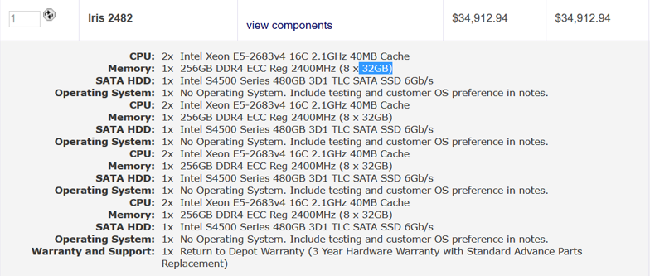

Cost Breakdown

|  |  |  |  |  |
| --- | --- | --- | --- | --- |
|  | Description | Price per Item | Quantity | Total Price |
| Compute Servers | Iris 2482 | $ 34,912.94 | 16,667 | $ 581,893,970.98 |
| Network Switches | Dell Z9000 switches | $ 862.62 | 1,565 | $ 1,350,000.3 |
| Network Cables | Dell Networking Cable,40GbE (QSFP+) to 4 x 10GbE SFP+ | $ 720 | 16,688 | $ 12,015,360 |
| Network Cables | Dell Networking, Cable, QSFP+ to QSFP+, 40GbE | $ 590 | 16,688 | $ 9,845,920 |
| Storage Servers | STX-CL XE72-2460 | $ 43,934 | 24 | $ 1,054,416 |
| Electric Power | 1200W (compute nodes)+ 1200W(cooling) over 5 years | N/A | N/A | $ 210,244,204.8 |
| Cooling | Cooler master v1200 | $ 303 | 16,667 | $ 5,050,101 |
| Administration | 1 per 1000 nodes over 5 years | $ 500,000 | 17 | $ 8,500,000 |
| TOTAL | N/A | N/A | N/A | $ 829,953,973.08 |

**1.Instance Calculation**

1 rack = $34,912.94

1 million vm = 16,667 instances * 34,912.94 = $ 581,893,970.98

the rack has core - 2*16, 2*16, 2*16, 2*16 – 128 cores

memory - 1*256, 1*256, 1*256, 1*256– 1024 GB

Disk - 1*480, 1*480, 1*480, 1*480 – 1920 GB

60 * 1VM

16,667 of instances

**2. Fat tree network with spine and leaf configuration**

Network cost with Dell z9000 switches in Fat tree configuration with 10GbE

1042 leaf switches =1042 * $**862**.62 = 898,850.04

521 spine switches = 521 * $**862**.62 = 449,425.02

leaf to spine cable = 1042 * 16 * 590 = 9,836,480

( # leaf switches * # spine switches * # of connection per switch * cost of cable

leaf to node cable = 1042*4 splitter( 1042 ports splitted to 4 each) = 1042 *16 * 720 = 12,003,840

( # leaf switch port * cost of splitter cable)

**3. Distributed Storage estimation**



Each node = 72 * 6 TB HDD SATA= 432 TB/node

Instances required for 10PB = 10 * 1024 /432 = 23.7 instances

Total cost = instances * cost per instance = 24 * 43,934 = 1,054,416

**4. Total network cost estimation**

Network cost with Dell z9000 switches in Fat tree configuration with 10GbE

1043 leaf switches =1043 * $**862**.62 = 899712.66

522 spine switches = 522 * $**862**.62 = 450287.64

leaf to spine cable = 1043 * 16 * 590 = 9845920

( # leaf switches * # spine switches * # of connection per switch * cost of cable

leaf to node cable = 1043*4 splitter( 1043 ports splitted to 4 each) = 1043 *16 * 720 = 12015360

( # leaf switch port * cost of splitter cable)

Total Network cost = 23,211,280.3

**5. Admin cost estimation**

1 Admin cost = $100,000 * 5 = 500,000

For 16,667 instances admin cost = = $100,000 * 5 * 17= 8,500,000

**6. Cooling cost estimation**

Cooler master v1200

16,667 instances

1 rack = $303

16,667 instances

$5,050,101

Power 1200W For 16,667 instances 105,122,102.4

**7. Power cost estimation**

16,667 instances

1 rack = 1200W

Per year 1261.44

5 years = 6307.2

For 16,667 instances 105,122,102.4

210,244,204.8

Total cost = $829,953,973.08

**Configuration 3**

|  |  |
| --- | --- |
|  | Description |
| Compute Servers | 1 exaflop mixed precision |
| (NVIDIA V100 GPUs) | 8 GPU/node(64cores/node) |
| Memory | 8GB/core(512GB/node) |
| Disk |  |
| Network | 10Gb/s per GPU(100Gb/s should work) |
| Distributed storage | 1 PB |

*Table 3: configuration 3 specification*

|  |  |  |  |  |  |  |
| --- | --- | --- | --- | --- | --- | --- |
| **Name** | **GPU’s per node** | **(vCPU)** | **Mem(GB)** | **HDD/SSD(GB)** | **Precision(mixed) / GPU** | **cost** |
| Each p3.16xlarge | 8 | 64 | 488 | N/A | 125 TF | 24.48/hr |

*Table 4: Each p3.16xlarge instance*

1.Distributed Storage

S3 standard storage pricing per month = $0.021 per GB

1 PB in GB = 1,048,576 GB

Storage cost for 5 years = 0.021 * 1048576 * 12 * 5

= **$ 1,321,205.76**

2.Instances Required

1 exaflop = 1,000,000 TF

Each instance performance = GPU’s per node * mixed precision/GPU

= 8 * 125 TF

= 1000TF

Instances required = 1,000,000 TF/1,000 TF

= 1,000 instances

Cost of total nodes = 1,000 * 24.48 * 24 * 365 * 5 = $1,072,224,000

512GB /node = 488 GB/node * 1.05

Inclusive of instance count from previous calculation = 1.05 * 1,000 =1050

Cost of total nodes = 1,050 * 24.48 * 24 * 365 * 5

=$ 1,125,835,200

3.Total Cost

Total cost = distributed storage cost + compute cost

= $ 1,321,205.76 + $1,125,835,200

Total cost = $1,127,156,405.76

**Private Cloud setup cost estimation**

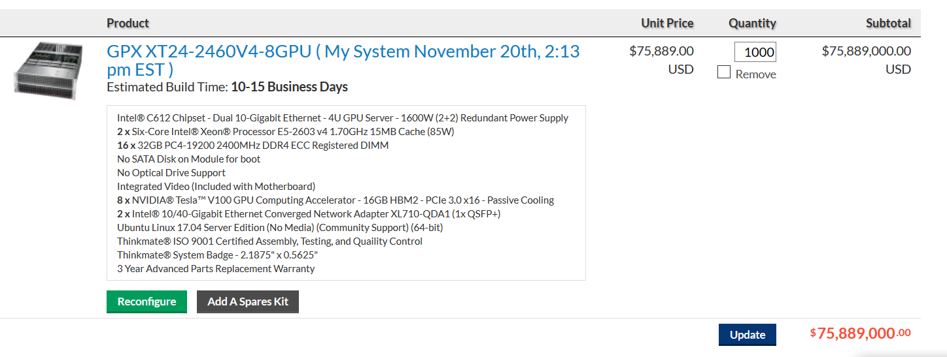

**1.Instance Calculation**

1 exaflop = 1,000,000 TF

Each instance perf = 8 * 125 TF = 1000TF

Instances required = 1,000,000 TF/1,000 TF = 1,000 instances

Cost of total nodes = 1,000 instances* $75889

= $75,889,000

1,000 instances

**2. Fat tree network with spine and leaf configuration**

Network cost with Dell z9000 switches in Fat tree configuration with 10GbE

# leaf = # instances / 16 port connection(each leaf) = 1000/16 = 63

# spine = # uplinks from each leaf /32 = 16 * 63/32 = 32

Cost of 63 leaf switches =63 * $**862**.62 = $54,345.06

32 spine switches = 32 * $**862**.62 = $27,603.84

leaf to spine cable = 63 * 16 * 590 = 594,720

( # leaf switches * # spine switches * # of connection per switch * cost of cable

leaf to node cable = 1 cable per port = 63 * 16 * 590 = $594,720

Total Network cost = $ 1,271,388.9

Total Network cost = $ 61,246.02+$ $1,189,440

= $1,250,686.02

**3. Distributed Storage estimation**



Each node = 72 * 6 TB HDD SATA= 432 TB/node

Instances required for 1PB = 1 * 1024 /432 = 3 instances

Total cost = instances * cost per instance = 3 * 43,934 = 131,802

**5. Admin cost estimation**

1 Admin cost = $100,000 * 5 = 500,000

For 1000 instances admin cost = = $100,000 * 5 * 1= 500,000

**6. Cooling cost estimation**

Cooler master v1200

1000 instances

1 rack = $303

1000 instances

$303,000

Power 3000W For 1000 instances 15,768,000

**7. Power cost estimation**

1000 instances

1 rack = 3000W

Per year $3153.6

5 years = 15,768

For 1000 instances 15,768,000

Total cost = $109,610,488.02

|  |  |  |  |  |
| --- | --- | --- | --- | --- |
|  | Description | Price per Item | Quantity | Total Price |
| GPU Servers | GPX XT24-2460V4-8GPU | $75889 | 1,000 | $75,889,000 |
| Network Switches | Dell Z9000 switches | $ 862.62 | 95 | $ 61,246.02 |
| Network Cables | Dell Networking, Cable, QSFP+ to QSFP+, 40GbE | $ 590 | 2016 | $ 1,189,440 |
| Storage Servers | STX-CL XE72-2460 | $ 43,934 | 3 | $131,802 |
| Electric Power | 3000W (compute nodes)+ 3000W(cooling) over 5 years | N/A | N/A | $ 31,536,000 |
| Cooling | Cooler master v1200 | $ 303 | 1000 | $ 303,000 |
| Administration | 1 per 1000 nodes over 5 years | $ 500,000 | 1 | $ 500,000 |
| TOTAL | N/A | N/A | N/A | $ 109,610,488.02 |

**Summary Table:**

|  |  |  |  |
| --- | --- | --- | --- |
|  | **Configuration 1** | **Configuration 2** | **Configuration 3** |
| Public Cloud (including EC2 and S3) Cost over 5 years, 24/7 operation, with 100% usage | $396,381,744 | $7,284,012,057.6 | $1,127,156,405.76 |
| Private Cloud cost over 5 years, 24/7 operation, with 100% usage | $ 41,564,134.02 | $829,953,973.08 | $109,610,488.02 |
| What utilization must be achieved with the private cloud to make the private cloud option more attractive than the public cloud? | 10.5% utilization will give breakeven cost of private cloud. Anything above this percent is a profit over public cloud usage | 11.4 % utilization will give breakeven cost of private cloud. Anything above this percent is a profit over public cloud usage | 10 % utilization will give breakeven cost of private cloud. Anything above this percent is a profit over public cloud usage |

**Hardware Used**

**Config 1**

**Server rack**



**Storage server**



**Config 2**

**Server rack**



**Storage server**



**Config 3**

**Server rack**



**Storage server**



**Hardware common to all configuration**

**Cooler**

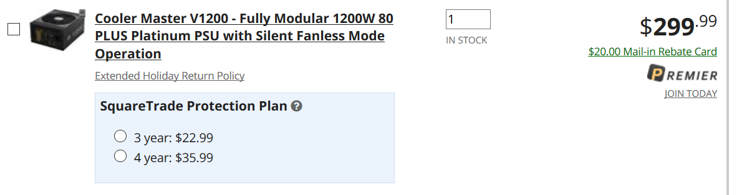

**Network switch**

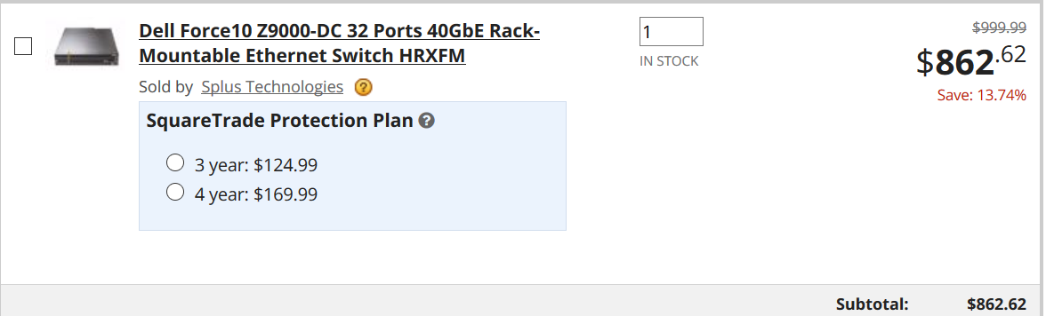

**Network cables**

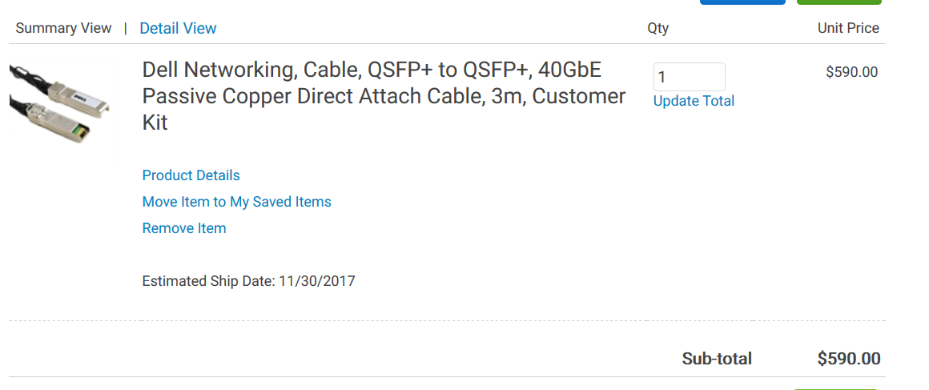

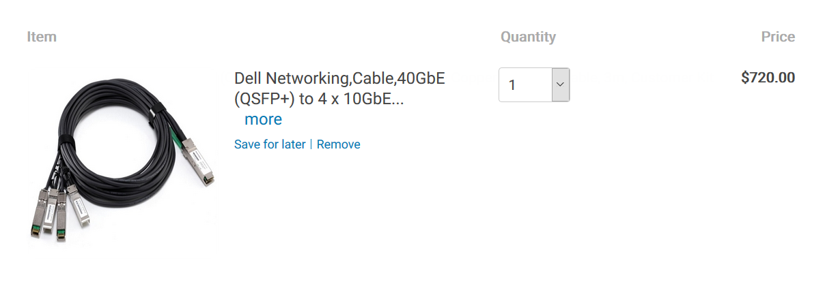

**References**

<https://www.newegg.com/Product/Product.aspx?Item=9SIA9AX6JG4291&cm_re=dell_z9000-_-9SIA9AX6JG4291-_-Product>

<http://accessories.us.dell.com/sna/productdetail.aspx?c=us&l=en&orig_s=gen&sku=470-AAWN&s=biz>

<http://www.dell.com/en-us/shop/dell-networkingcable40gbe-qsfp-to-4-x-10gbe-sfp-passive-copper-breakout-cable-3m-customer-kit/apd/470-aaxg/networking>

<https://www.manualslib.com/manual/546580/Dell-Force10-Z9000.html?page=38#manual>

**Info different types of servers**

<http://www.dummies.com/programming/networking/network-basics-server-form-factors/>

<https://www.lynda.com/Windows-Server-tutorials/Server-form-factors/503999/539121-4.html>

**Socket description**

<http://www.makeuseof.com/tag/cpu-socket-types-explained-from-socket-5-to-bga-makeuseof-explains/>

**Vcpus vs cpu**

<https://blog.pythian.com/virtual-cpus-with-amazon-web-services/>

**ethernet fat tree**

<http://en.community.dell.com/techcenter/high-performance-computing/b/general_hpc/archive/2012/07/02/designing-scalable-10gb-ethernet-networks-part-1>

<http://clusterdesign.org/fat-trees-with-ethernet-switches/>

<http://clusterdesign.org/fat-trees/#network-design-tool>

<http://www.dell.com/en-us/work/shop/cty/pdp/spd/force10-z-series>

**Server configuration**

<https://www.thinkmate.com/order>

<https://www.newegg.com/>

<http://www.pogolinux.com/>

<https://ark.intel.com/products/83354/Intel-Xeon-Processor-E5-2623-v3-10M-Cache-3_00-GHz>

<http://www.rapidtables.com/calc/electric/energy-cost-calculator.htm>

**Power and cooling calculation**

<https://www.easycalculation.com/analytical/two-point.php>

<http://www.rapidtables.com/calc/electric/energy-cost-calculator.htm>

<http://www.coolermaster.com/power-supply-calculator/>