**CS553 Project**

**Understanding the Cost of Cloud Computing**

Cloud computing, one of the scalable infrastructure for computing available today is catered by means of service. Amazon being one of the companies who provide these services tend to follow a on demand pricing business model. This project aims at comparing amazon on demand cloud service against the cost to set up a private infrastructure.

The report is formed in such a way that comparison between the two infrastructure options are evident. For the cloud computing setup, we have considered three configurations described in the following format.

Configuration Details

Amazon Public cloud setup cost estimation

Private cloud setup cost estimation

And finally, at the end we will compare all three configurations to showcase which is better and why

**Setup 1**

Configuration

|  |  |
| --- | --- |
| Config 1 | Description |
| Compute Servers | 32 k cores |
| Memory | 256 TB |
| Disk | 50 PB HDD |
| Network | 10 Gb/sec |
| Distributed storage (100GB/sec throughput) | 100 PB |

*Table 1: configuration 1 specification*

Amazon public on demand cloud computing cost

Instance chosen: d2.8xlarge

Each instance configuration:

36 cores, 244 GiB of Memory and 24* 2000 HDD at the cost of $5.52 per hour

For the configuration mentioned in the above table. The required instances are computing below

CPU

32K cores

1 d2 instance CPU’s = 36 vCPU

vCPU to cores = vCPU

= 36 cores

Instances required for 32 K core = 32000/36

= 889 d2.8xlarge instances --------> a

Memory

256TB in GB = 262,144 GB

1 d2 instance Disk capacity = 244 GiB

244 GiB in GB = 244* 1.074 = 262.06 GB

Instances required for 256TB = 262,144 /262.06

= 1,001 d2.8xlarge instances --------> b

Disk

50PB in GB = 52,428,800 GB

1 d2 instance Disk capacity = 48,000 GB

Instances required for 50PB = 52,428,800/48000

= 1,093 d2.8xlarge instances --------> c

Total number of d2.8xlarge instances required = max ( a, b, c)

= 1,093 instances

Distributed Storage

S3 standard storage pricing per month = $0.021 per GB

100 PB in GB = 104,857,600 GB

Storage cost for 5 years = 0.021 * 104,857,600 * 12 * 5

= $ 132,120,576

Total Cost calculation

1 D2.8xlarge instance cost

36 cores, 244 GiB of Memory and 24* 2000 HDD at the cost of $5.52 per hour

1,093 instances cost per hour = 5.52 * 1,093

= $ 6033.36

1,093 instances cost for 5 years = $9,814.56 * 24 * 365 * 5

= $ 264,261,168

Total cost = distributed storage cost + d2.8xlarge instance cost

= $ 132,120,576 + $ 264,261,168

= $ 396,381,744

Private Cloud setup cost estimation

Each rack used: Iris 2482

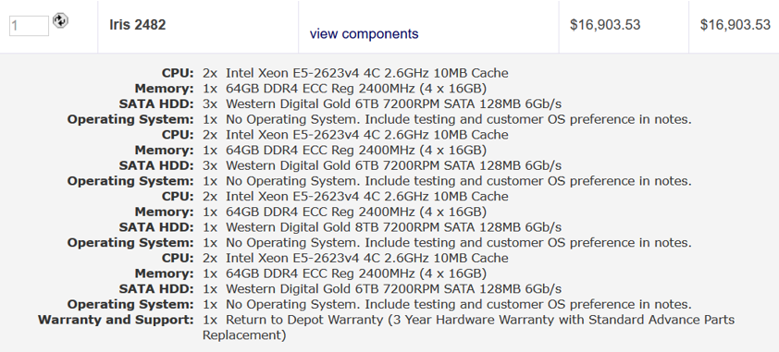

|  |  |  |  |  |
| --- | --- | --- | --- | --- |
|  | Description | Price per Item | Quantity | Total Price |
| Compute Servers | Iris 2482 | $ 16,903.53 | 1,000 | $ 16,903,530 |
| Network Switches | Dell Z9000 switches | $ 862.62 | 71 | $ 61,246.02 |
| Network Cables | Dell Networking Cable,40GbE (QSFP+) to 4 x 10GbE SFP+ | $ 720 | 256 | $ 184,320 |
| Network Cables | Dell Networking, Cable, QSFP+ to QSFP+, 40GbE | $ 590 | 992 | $ 585,280 |
| Storage Servers | STX-CL XE72-2460 | $ 43,934 | 237 | $ 10,412,358 |
| Electric Power | 1200W (compute nodes)+ 1200W(cooling) over 5 years | N/A | N/A | $ 12,614,400 |
| Cooling | Cooler master v1200 | $ 303 | 1,000 | $ 303,000 |
| Administration | 1 per 1000 nodes over 5 years | $ 500,000 | 1 | $ 500,000 |
| TOTAL | N/A | N/A | N/A | $ 41,564,134.02 |