You are hired by a start-up company who is considering using cloud computing instead of building its own infrastructure

(Isn’t a private cloud same as building own infrastructure

What is the meaning when you say cloud computing vs own infrastructure?

What other infrastructure is being referred to here?)

Cloud computing software stack at the Iaas layer will be used

But not sure whether the computing resources need to be rented from a public cloud on-demand or a private cloud should be purchased

You are tasked to find the cost breakdown of a private cloud, and compare that to what Amazon would charge

Amazon instance types and prices

<http://aws.amazon.com/ec2/instance-types/>

<http://aws.amazon.com/ec2/pricing/>

stick to Linux on-demand pricing

Since there is a need to estimate the cost of the hardware when building a private cloud

Can find prices of hardware in the following link

Dell - <http://www.dell.com/p/enterprise-products.aspx?c=ae&l=en&s=bsd&~ck=mn>

AcmeMicro - <http://www.acmemicro.com>

PogoLinux - <http://www.pogolinux.com>

(good sources for server h/w)

You must include a printout of your shoping cart in your final writeup report for this assignment; include this as an appendix at the end of your report.

You are to estimate the cost of different configurations for 3 different set of requirements: conf1 conf2 and conf3

you may assume a 5-year amortization cost

you will have to factor in things other than hardware, such as cooling, power, administration costs, network infrastructure (e.g. switches); you can assume 1 system administrator is needed for every 1000 servers

Strategy

1) Can first list down the h/w cost for each component needed

2) find out the performance achieved by combining the hardware in different ways

a) consider the performance of each component

b) how it works when combined

3) must compare both Amazon on-demand service and private cloud

**Cloud computing course**

**Establishing the cloud computing environment**

**1st project to know how each individual item perform so that you can get to know how to combine them to a bigger cluster depending on the requirement**

**2nd project is to introduce how data analytics on cloud is being performed**

**3rd ?**

**Project**

**Uses 1st knowledge and knowledge about cloud computing environment to build a cloud infrastructure cost**

**And provides a comparison how our cost with amazon cost**

**How does amazon achieve that can also be seen by the project**

1) Can first list down the h/w cost for each component needed

Private cloud

PowerEdge Tower server

PowerEdge Rack server

Modular infrastructure

Amazon

ECU unit of compute performance

|  |  |  |  |  |  |  |
| --- | --- | --- | --- | --- | --- | --- |
| **Name** | **Core** | **Mem** | **Hdd/ssd** | **n/w** | **Dist storage** | **Total cost** |
| **D2.8x large** | **36** | **244** | **48000 HDD** |  | **132,120,576$** | **1,208,880$** |
|  |  |  |  |  |  |  |
|  |  |  |  |  |  |  |
|  |  |  |  |  |  |  |

**Mem - In gb 262,144 -> 1075 instances**

**Disk - In gb 52,428,800 -> 1093 instances**

**Total time in hrs (5years) -> 2,19,000**

**1000 instances 1 admin -> 6 admins ->25,50,000**

**Each admin 85k per year (6 admins)(24/7)**

**Over 500TB/month standard storage S3 -> 0.021 /gb**

**Forming a cluster under public cloud Amazon EC2 instance with S3 distributed storage**

**1) can we use multiples of d2.8xlarge instance**

**2) can we use some other instance and make up a d2.8x large instance**

**3) how to calculate 100gb/s throughput**

**They can focus on the data storage space and costs, and they can ignore the bandwidth costs of accessing data on S3. (But for their private cloud, they need to make sure they will have enough storage and network bandwidth to deliver 1000PB of storage and 100GB/sec of I/O performance.)**

**4) should the calculation be based on the number of instances got by calculating using individual components like (HDD/MEM)**

**5) how to be sure of the fat n/w 10gb/sec ethernet being used in our cluster**

**6) calculation of 100PB distributed storage using S3 strategy valid?**

**7) how to calculate admin cost**

**9) what do you mean by each VM**

**10)suppose we use different instance cluster .. will we be able to segregate a vm to form d2 configuration**

**Number of d2.8x large instances required to full fill below requirement**

|  |  |
| --- | --- |
| Config 1 | Description |
| Compute Servers | 32 k cores |
| Memory | 256 TB |
| Disk | 50 PB HDD |
| Network | 10 Gb/sec |
| Distributed storage | 100 PB |

**Calculations**

**Instances Required**

**Each d2 instance**

**36 cores, 244 GB of Memory and 24* 2000 HDD at the cost of $5.52 per hour**

**For the configuration mentioned in the above table. We require a minimum of 1**

**CPU**

**32K cores**

**1 d2 instance Cpu’s = 36 Vcpu**

**Instances required for 32 K core = 32000/36**

**= 889 d2.8xlarge instances --------> a**

**Memory**

**256TB in GB = 262,144 GB**

**1 d2 instance Disk capacity = 244 GB**

**Instances required for 256TB = 262,144 /244**

**= 1,075 d2.8xlarge instances --------> b**

**Disk**

**50PB in GB = 52,428,800 GB**

**1 d2 instance Disk capacity = 48,000 GB**

**Instances required for 50PB = 52,428,800/48000**

**= 1,093 d2.8xlarge instances --------> c**

**Total number of d2.8xlarge instances required = max ( a, b, c)**

**= 1,093 instances**

**Distributed Storage**

**S3 standard storage pricing per month = $0.021 per GB**

**100 PB in GB = 104,857,600 GB**

**Storage cost for 5 years = 0.021 * 104,857,600 * 12 * 5**

**= $ 132,120,576**

**Cost calculation**

**1 D2.8xlarge instance cost**

**36 cores, 244 GB of Memory and 24* 2000 HDD at the cost of $5.52 per hour**

**1,093 instances cost per hour = 5.52 * 1093**

**= $6,033.36**

**1,093 instances cost for 5 years = $6,033.36 * 24 * 365 * 5**

**= $264,261,168**

**Total cost = distributed storage cost + d2.8xlarge instance cost**

**= $ 132,120,576 + $ 264,261,168**

**= $ 396,381,744**

**632 wattages 1021 watts**

**$ 48,113**

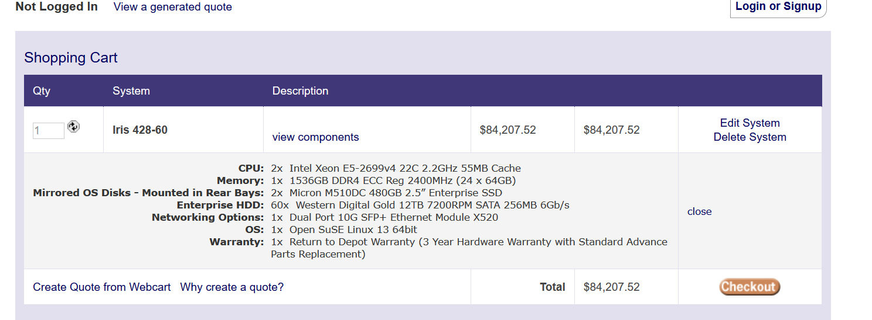

**44 cores**

**1536 GB**

**720 TB – 7,37,280 GB**

**728 machines to reach the required cores**

**170 machines to reach the required memory**

**71 machines to reach the required disk storage**

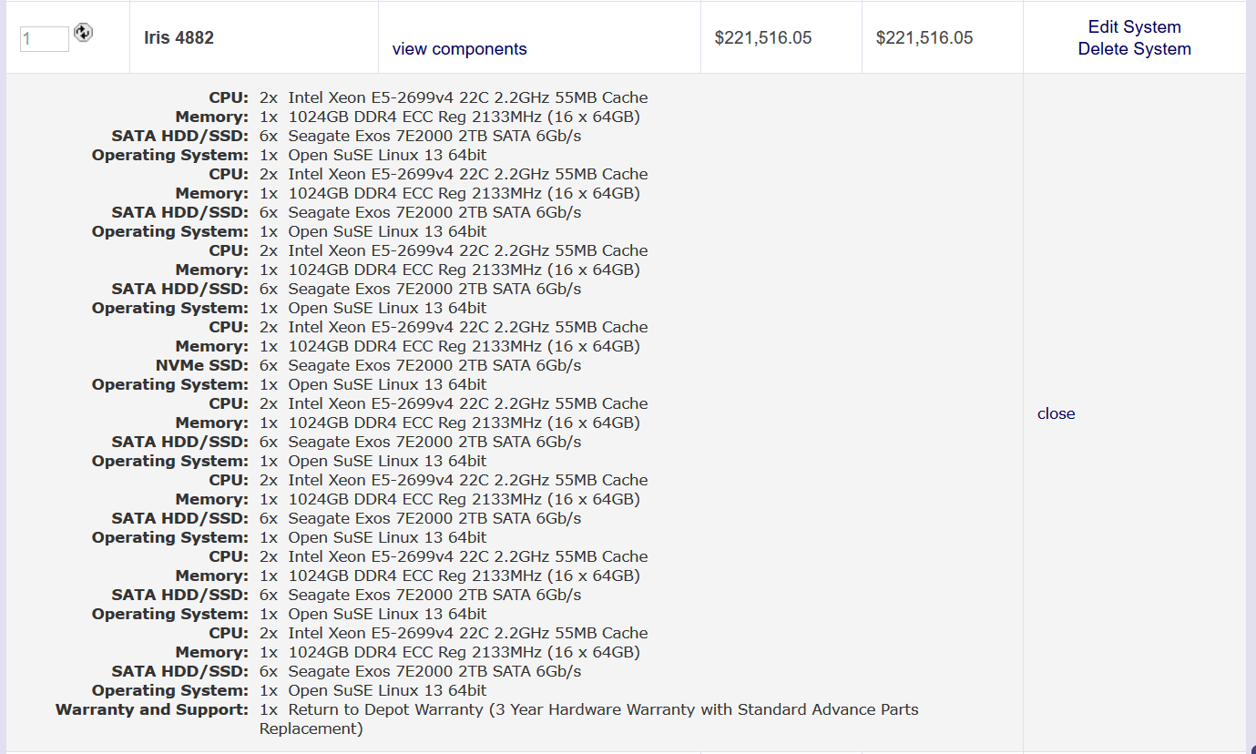

**Core 16 * 22 = 352 ->91 machines**

**8 * 1024 = 8192 -> 32 machines**

**8 * 6 * 2 * 1024 = 98,304 -> 533.33**

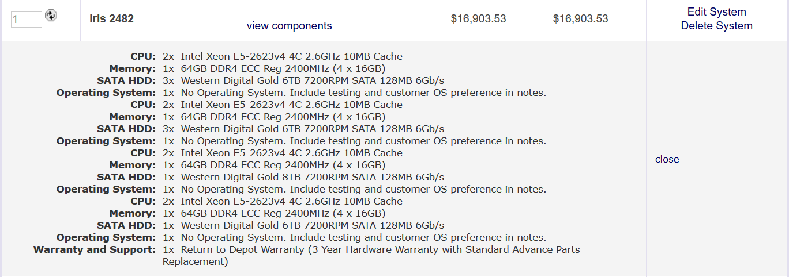

**d2.8xlarge 1 instance – $16,903.53**

**instances * 1000 – 16,903,530**

**the rack has core - 2*4, 2*4, 2*4, 2*4 – 32 cores**

**memory - 1*64, 1*64, 1*64, 1*64 – 256 GB**

**Disk - 3*6, 3*6, 1*6, 1*8 – 50 TB**

Network cost with Dell z9000 switches in Fat tree configuration with 10GbE

16 leaf switches =16 * $**862**.62 = 13,801.92

8 spine switches = 8 * $**862**.62 = 6,900.96

leaf to spine cable = 16 * 16 * 590 = 151,040

( # leaf switches * # spine switches * # of connection per switch * cost of cable

leaf to node cable = 16*4 splitter( 16 ports splitted to 4 each) = 16 *16 * 720 = 184,320

( # leaf switch port * cost of splitter cable)

**Total Network cost = 356,062.88**

**Total cost = $17,093,693**

**TODO:**

**calculate private cloud cost for 5 years 24/7**

**include system admin cost**

**add distributed storage cost**

**cooling cost**

**power cost**

**utilization for 5 years**

**Private cloud**

|  |  |  |
| --- | --- | --- |
| **Equipment** | **Device details** | **Cost** |
| **CPU/Processor** | **Intel Xeon E5-2676 v3 LGA 2011-03 Server Processor** | **$671** |
| **Motherboard** | **ASRock Mini ITX Server Motherboard socket LGA 2011 R3 Intel** | **$270** |
| **Memory** | **Black Diamond Memory 128 GB(2*64GB) +128GB(2*64GB) DDR3 SDRAM 1866** | **$3600** |
| **Disk** | **Seagate Archive HDD v2 ST8000AS0002, Internal hard Drive** | **$219** |
| **Chassis** | **Super Chassis cse 833T 6538 650 W Rackmount server chassis** | **$565** |
| **Network switch and Network card** | **Intel X540T2 Ethernet Network adapter+ Netgear ProSafe Managed Switch** | **$7558** |
| **Rack** | **Odyssey Innovative Design CRP Carpeted Rack case** | **$270** |
| **Cooling Power** | **763W** | **$5012.9** |
| **System Power** | **763W** | **$5012.9** |
| **Administration** |  | **$400000** |
| **Total Cost** |  | **$4,23,178** |

The [Dell Force10 Z9000 TM](http://www.dell.com/us/business/p/force10-z9000/pd?refid=force10-z9000&baynote_bnrank=0&baynote_irrank=0&%7Eck=baynoteSearch&isredir=true)  is a line-speed, 32-port 40GbE, two rack unit, top of rack (TOR) switch.  Each 40Gb QSFP port can be split into 4 10Gb SFP+ ports using a simple splitter cable.

A two tier fat tree network uses what are commonly called “leaf” and “spine” switches.  Leaf switches are switches at the edge of the network that connect to the compute or storage node elements in the cluster.  Spine switches make up the second tier of switches that connect the leaf switches together.

A non-blocking leaf switch configuration using the Z9000 is made by splitting half of the Z9000’s 32 40Gb ports into 10Gb ports enabling the connection of up to 64 compute nodes (each 40Gb port is split into 4 10Gb ports).  The remaining 16 40Gb ports will be used as uplink ports to connect into spine switches.  There is an equal number of 40Gb ports used for connection to compute nodes and spine switches so this is a non-blocking configuration.

[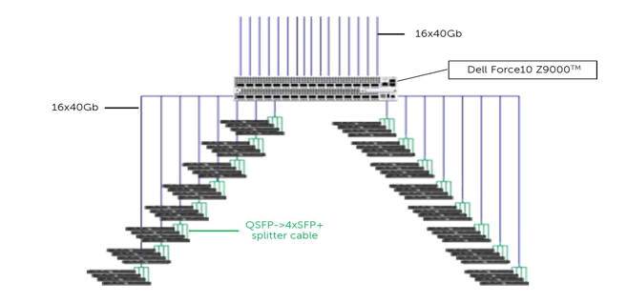](http://en.community.dell.com/cfs-file.ashx/__key/communityserver-blogs-components-weblogfiles/00-00-00-45-39/2047.Screen-shot-2012_2D00_07_2D00_02-at-11.46.56-AM.png)

To complete the fat tree network, leaf switches are connected to spine switches.  The number of spine switches needed is determined by counting the number of 40Gb uplinks from all leaf switches and dividing by 32 (since there are 32 40Gb ports in the Z9000).  To connect the network leaf switch uplinks are evenly divided between the spine switches.

The maximum number of non-blocking 10Gb connected systems that can be configured into a single network fabric using the leaf switch configuration described here is 2048.  2048 comes from multiplying the number of ports in the spine switch times the number of nodes that can be connected to each leaf switch.  If we change from using 40Gb connections to 10Gb connections in the spine and leaf switches, by splitting each QSFP port into 4 SFP+ ports, the Z9000 becomes a 128 port 10Gb switch and the maximum number of non-blocking 10Gb ports in a single network fabric grows to 8192 (128 spine switch ports * 64 leaf switch node connections).

Dell z9000

<https://www.newegg.com/Product/Product.aspx?Item=9SIA9AX6JG4291&cm_re=dell_z9000-_-9SIA9AX6JG4291-_-Product>

<http://accessories.us.dell.com/sna/productdetail.aspx?c=us&l=en&orig_s=gen&sku=470-AAWN&s=biz>

<http://www.dell.com/en-us/shop/dell-networkingcable40gbe-qsfp-to-4-x-10gbe-sfp-passive-copper-breakout-cable-3m-customer-kit/apd/470-aaxg/networking>

<https://www.manualslib.com/manual/546580/Dell-Force10-Z9000.html?page=38#manual>

**Info different types of servers**

<http://www.dummies.com/programming/networking/network-basics-server-form-factors/>

<https://www.lynda.com/Windows-Server-tutorials/Server-form-factors/503999/539121-4.html>

**Socket description**

<http://www.makeuseof.com/tag/cpu-socket-types-explained-from-socket-5-to-bga-makeuseof-explains/>

**vcpus vs cpu**

<https://blog.pythian.com/virtual-cpus-with-amazon-web-services/>

**ethernet fat tree**

<http://en.community.dell.com/techcenter/high-performance-computing/b/general_hpc/archive/2012/07/02/designing-scalable-10gb-ethernet-networks-part-1>

<http://clusterdesign.org/fat-trees-with-ethernet-switches/>

<http://clusterdesign.org/fat-trees/#network-design-tool>

<http://www.dell.com/en-us/work/shop/cty/pdp/spd/force10-z-series>

**GPU server configuration**

<https://www.thinkmate.com/order>