Topic-1: Overview of UNIX/Linux Operating System

Basic Computer Architecture

As DevOps and Cloud Engineers, we often create and manage infrastructure in environments like:
- AWS
- Google Cloud (GCP)
- Microsoft Azure
- Oracle Cloud
When creating Virtual Machines (VMs) or containers, we select resources such as:
- CPU
- Memory (RAM)
- Disk Storage
To properly configure these resources, it is important to understand basic computer architecture and how different components work together.

Main Components of Computer Architecture
A computer system mainly consists of the following components:
Component | Purpose
CPU | Executes instructions
Memory (RAM) | Temporarily stores data and programs
Disk Storage | Permanently stores OS, applications, and data
Cache | Speeds up data access
Input Devices | Send data to computer
Output Devices | Display results
Buses | Transfer data between components

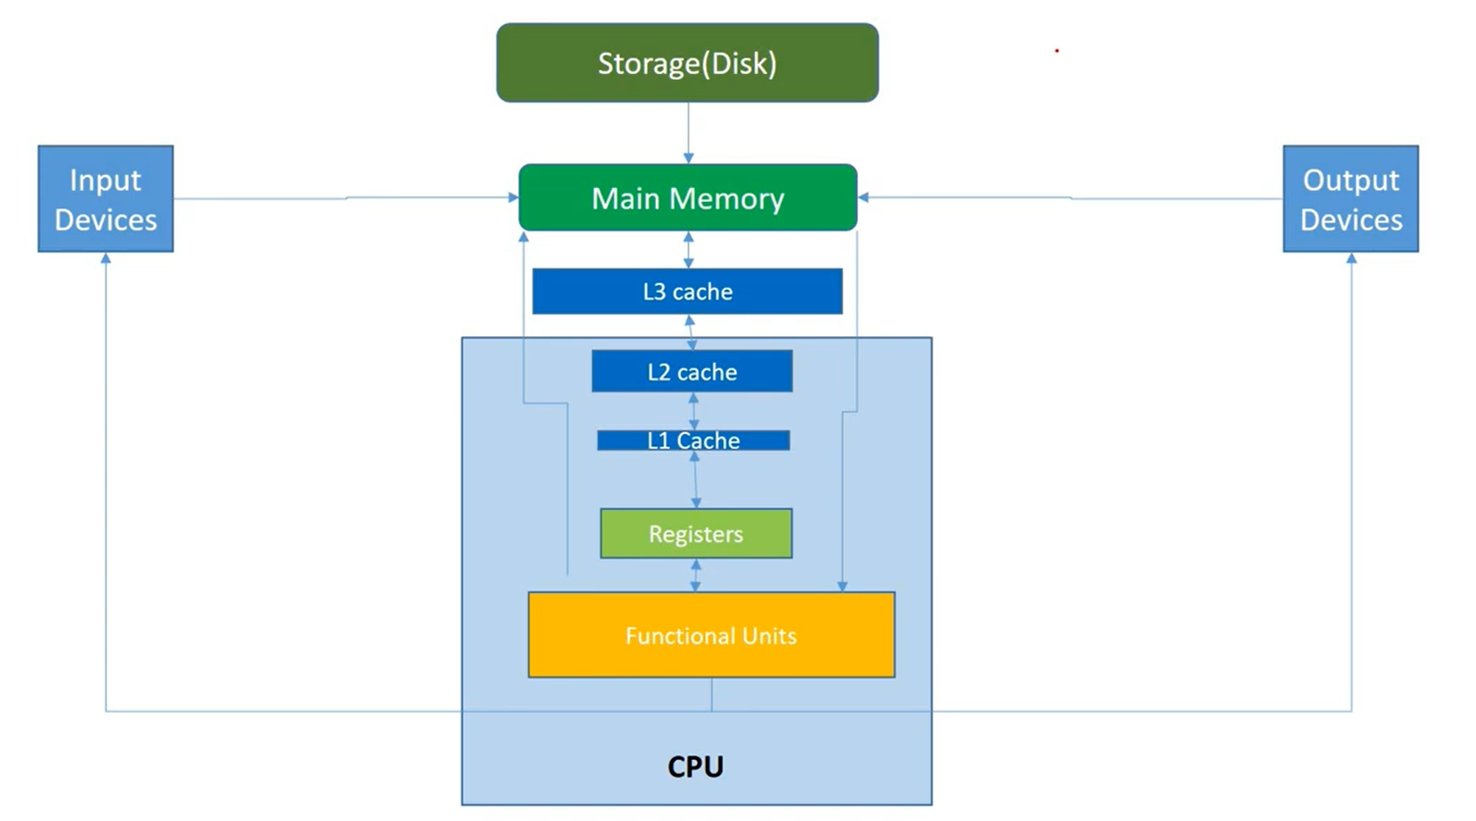

CPU (Central Processing Unit)
The CPU is the brain of the computer.
It executes instructions from applications and the operating system.
Main Parts of CPU
Component | Function
Control Unit (CU) | Controls the execution of instructions
ALU (Arithmetic Logic Unit) | Performs arithmetic and logical operations
FPU (Floating Point Unit) | Handles floating-point calculations
Registers | Small storage inside CPU for temporary data

How CPU Works
- CPU reads instructions from RAM.
- Instructions are stored temporarily in registers.
- ALU or FPU performs the required calculations.
- Results are sent back to memory.

Types of Buses
Buses are groups of wires used to transfer data between components.
Bus Type | Function
Data Bus | Transfers data between CPU and memory
Address Bus | Identifies the memory location
I/O Bus | Transfers data between I/O devices and memory

Input and Output Devices
Computers communicate with external devices through I/O devices.
Input Devices | Output Devices
Keyboard | Monitor
Mouse | Printer
Scanner | Speakers
The CPU communicates with these devices using I/O controllers.

Cache Memory
Cache memory is a small and fast memory placed between CPU and RAM.
It stores recently used data and instructions so the CPU can access them quickly.
Types of Cache
Cache Type | Description
L1 Cache | Located inside CPU, fastest
L2 Cache | Slightly slower than L1
L3 Cache | Shared between CPU cores

Why Cache is Used
If CPU finds data in cache, it does not need to access RAM, which improves performance.

CPU vs GPU
Both CPU and GPU execute instructions but they are designed for different tasks.
Feature | CPU | GPU
Purpose | General processing | Graphics and parallel processing
Number of cores | Few powerful cores | Many smaller cores
Processing type | Sequential processing | Parallel processing
Usage | OS tasks, databases, web apps | Machine learning, graphics

Example
- CPU executes instructions one by one.
- GPU processes many data points at the same time.
GPU is widely used in:
- Artificial Intelligence
- Machine Learning
- Image Processing

RAM (Random Access Memory)
RAM is the main memory used by the CPU to execute programs.
Features of RAM
Feature | Description
Volatile memory | Data is lost when power is off
Read and Write | Data can be read and written
Temporary storage | Stores running programs

Example
When you open Google Chrome, the program is loaded into RAM.
When you close Chrome, it is removed from RAM.

ROM (Read Only Memory)
ROM stores permanent instructions needed to start the computer.
Features of ROM
Feature | Description
Non-volatile | Data is not lost when power is off
Read-only | Data cannot easily be modified
Stores firmware | Contains BIOS

BIOS Function
BIOS performs:
- Hardware initialization
- Loading the operating system into RAM

Disk Storage
Disk storage stores operating systems, applications, and files permanently.
Storage Characteristics
Feature | Description
Non-volatile | Data remains even after shutdown
Permanent storage | Stores files and applications
Slower than RAM | Access time is higher

Types of Disk Storage
Storage Type | Description | Speed
HDD (Hard Disk Drive) | Uses spinning magnetic disks | Slow
SSD (Solid State Drive) | Uses electronic memory chips | Faster
NVMe SSD | Advanced SSD with parallel access | Very Fast
In Cloud Platforms
When creating VMs in cloud platforms like AWS or Azure, we select storage based on:
- Performance (IOPS)
- Cost
- Application requirement

Registers
Registers are very small and fastest memory units inside the CPU.
Types of Registers
Register | Function
Program Counter | Stores address of next instruction
Instruction Register | Stores current instruction
Memory Address Register | Stores memory address
Memory Data Register | Stores data from memory
Registers allow CPU to access data very quickly.

Difference Between RAM and Disk Storage
Feature | RAM | Disk Storage
Speed | Very fast | Slower
Data storage | Temporary | Permanent
Volatility | Data lost after shutdown | Data remains
Usage | Running programs | Storing files and OS
Example
- A Python program file is stored on disk.
- When executed, it is loaded into RAM.
- CPU reads instructions from RAM and executes them.
After the program finishes:
- It is removed from RAM
- But still exists on disk storage

Summary of Computer Architecture
Component | Role
CPU | Executes instructions
RAM | Temporary storage for running programs
ROM | Stores boot instructions
Disk Storage | Permanent storage
Cache | Improves CPU performance
GPU | Parallel processing
Registers | Fast temporary storage inside CPU

What is an Operating System?
An Operating System (OS) is a software that acts as a bridge between the user and the computer hardware.
- Computers understand only binary language (0s and 1s).
- Humans cannot easily communicate using binary language.
- So, the Operating System converts human commands into machine language and vice-versa.
This helps the user to interact with the computer easily.

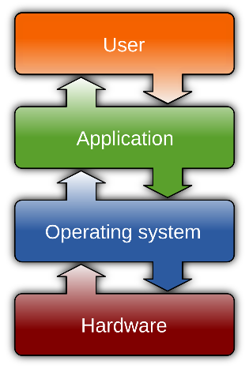

Types of Operating Systems
Type | Description | Example
Single User – Single Tasking OS | Only one user can log in and perform one task at a time | MS-DOS
Single User – Multitasking OS | One user can log in but can run multiple tasks simultaneously | Windows 98, XP, 7, 8, 10
Multi User – Multitasking OS | Multiple users can log in and perform multiple tasks at the same time | UNIX, Linux

Example
Situation | Type of OS
One user typing commands in MS-DOS | Single user – Single task
Listening to music while browsing internet in Windows | Single user – Multitasking
Multiple users using same server | Multi user – Multitasking

What is UNIX?

UNIX is an operating system that allows users and applications to communicate with computer hardware.
- It was developed in the 1960s.
- Later, many organizations created their own versions (flavors) of UNIX.

Features of UNIX
Feature | Description
Open Source | Source code available
Multi User | Multiple users can work at the same time
Multi Tasking | Multiple tasks can run simultaneously
CUI & GUI | Supports both Command Line and Graphical Interface
Secure | More secure compared to many operating systems

History of UNIX
UNIX was developed before Linux and played a major role in the evolution of modern operating systems.
- Created in the 1960s at Bell Labs.
- Developed by Ken Thompson and Dennis Ritchie.
- Initially designed for large mainframe computers.
- Later modified to run on smaller computer systems.
Over time, UNIX evolved into several commercial versions maintained by different vendors.

Popular UNIX Variants
Variant | Developed By
AIX | IBM
HP-UX | Hewlett Packard
Solaris | Sun Microsystems / Oracle

Where UNIX is Commonly Used
UNIX systems are often used in:
- Banking infrastructure
- Telecom networks
- Government data centers
- Large enterprise servers
Since UNIX systems are usually proprietary, organizations must:
- Purchase licenses
- Depend on vendor support for updates and maintenance

What is Linux?

Linux is a free and open-source operating system based on UNIX concepts.
- Developed by Linus Torvalds in 1991.
- Released under the GNU General Public License (GPL).
This means:
- Anyone can use it
- Anyone can modify it
- Anyone can redistribute it
Unlike UNIX, Linux is not owned by a single company.
It is developed by a global community of developers.

Why Linux Became Popular
Linux quickly gained popularity because it is:
- Free and open-source
- Highly customizable
- Supported by a large developer community
- Compatible with many hardware platforms

Where Linux is Used Today
Today Linux powers many modern technologies, including:
- Most web servers
- Cloud platforms like AWS, Azure, and GCP
- Android smartphones
- Supercomputers
- DevOps pipelines
- Container platforms such as Docker and Kubernetes

Features of Linux
Feature | Description
Portable | Works on different hardware platforms
Open Source | Source code available freely
Multi User | Many users can use system simultaneously
Multiprogramming | Multiple applications run at the same time
Hierarchical File System | Organized file structure
Shell | Command interpreter to run commands
Security | Password protection, file permissions, encryption

Linux Distributions (Distros)
Linux itself is only the kernel.
When the kernel is combined with utilities, package managers, and software, it becomes a Linux distribution (distro).

1. RHEL-Based Distributions
Distribution | Package Manager
Red Hat Enterprise Linux | yum / dnf
CentOS | yum / dnf
Fedora | dnf
Amazon Linux | yum

2. Debian-Based Distributions
Distribution | Package Manager
Debian | apt
Ubuntu | apt

3. Other Popular Distributions
Distribution | Usage
Arch Linux | Advanced users
Manjaro | Beginner-friendly Arch
openSUSE | Enterprise environments
Kali Linux | Cybersecurity and penetration testing
Alpine Linux | Lightweight, commonly used in Docker containers

UNIX vs Linux

Detailed Comparison
Aspect | UNIX | Linux
Origin | Developed in the 1970s at Bell Labs | Developed in 1991 by Linus Torvalds
License | Mostly proprietary | Open-source (GPL license)
Cost | Requires paid licenses | Mostly free
Customization | Limited customization | Highly customizable
Hardware Support | Vendor-specific hardware | Supports a wide range of hardware
Usage | Large enterprise systems | Servers, cloud, DevOps, and modern infrastructure
In simple terms:
- UNIX is mostly commercial and vendor-controlled.
- Linux is open-source, flexible, and widely used today.

Key Differences Between UNIX and Linux
1. Licensing Model
UNIX | Linux
Proprietary system | Open-source system
Requires paid licenses | Free to use
This made Linux very popular among developers, startups, and cloud providers.

2. Development Model
UNIX | Linux
Developed by specific companies | Developed by global community
Updates controlled by vendors | Frequent updates from contributors worldwide
Major technology companies also contribute to Linux development.

3. Hardware Compatibility
UNIX | Linux
Often runs on specific hardware | Runs on almost any hardware
Linux can run on:
- Personal computers
- Servers
- Embedded systems
- Raspberry Pi
- Cloud virtual machines

4. Cost and Accessibility
UNIX | Linux
Expensive due to licensing | Free to download
Requires vendor support | Large community support
Because of this, Linux became widely adopted in modern computing.

5. Usage in Modern Technology (2026)
Today:
- Linux dominates cloud computing
- Linux powers AI workloads
- Linux is essential for DevOps
- Linux is widely used in microservices architecture
UNIX is still used, but mainly in legacy enterprise environments.

Similarities Between UNIX and Linux
Even though they are different, UNIX and Linux share many common features.
Similar Feature
Multi-user environment
Multitasking support
Command Line Interface (CLI)
Shell scripting
File permission system
Process management
Linux is often called “Unix-like” because it follows the design principles and philosophy of UNIX.

Environment Setup for Practice
To practice Linux commands:
Step 1
Create an AWS Free Tier Account
Step 2
Create a Linux Virtual Machine using EC2
Step 3
Connect to the VM using tools like:
- MobaXterm
- PuTTY

Architecture of Linux System

The Linux system architecture is divided into different layers.
Each layer performs a specific function and works together to run applications.
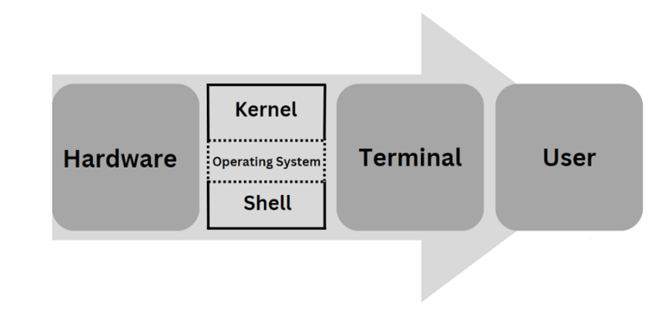
The main components of Linux architecture are:
- Applications
- Shell
- Kernel
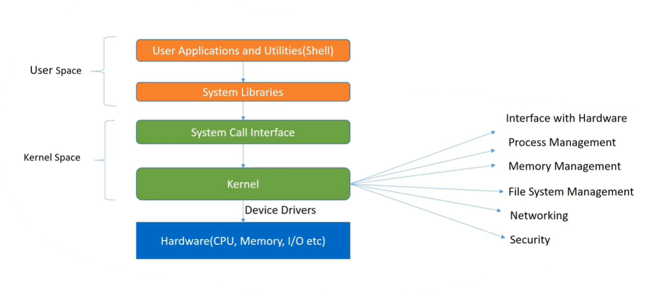
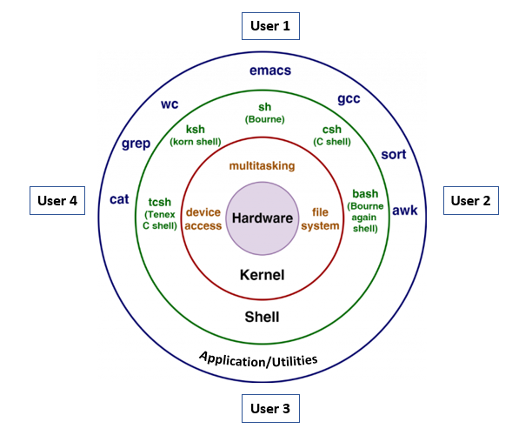

1. Applications
Applications are software programs that run on top of the Linux operating system.
They use the services provided by the Shell and Kernel to perform tasks.
Linux supports many types of applications used in daily computing.
Examples of Linux Applications
Application Type | Examples
Web Browsers | Firefox, Chrome
Office Tools | LibreOffice
Media Players | VLC
Text Editors | Vim, Nano
These applications allow users to perform tasks such as browsing the internet, editing documents, playing media, and writing code.

2. Shell
The Shell is the outer layer of the Linux/UNIX operating system.
It acts as an interface between the user and the kernel.
Functions of Shell
- Reads the command entered by the user
- Checks whether the command syntax is correct
- Verifies if the required command or program exists
- Converts the user command into a format understood by the kernel
- Sends the command to the kernel for execution

Types of Shells in Linux
Linux provides different types of shells.
Shell Name | Command
Bourne Shell | sh
C Shell | csh
TC Shell | tcsh
Korn Shell | ksh
Bourne Again Shell | bash
The Bash shell is the most commonly used shell in Linux.

Command to Check Current Shell

echo $0 # Displays which shell you are currently using

3. Kernel
The Kernel is the core part of the Linux operating system.
It directly communicates with the hardware and manages system resources.
Functions of Kernel
Function | Description
Command Execution | Executes commands received from the shell
Hardware Interaction | Communicates with CPU, memory, and devices
Memory Management | Allocates and manages system memory
Process Management | Manages running programs
CPU Allocation | Assigns processor time to programs

The kernel ensures that the system runs smoothly by managing hardware and software communication.

Commands to Check Kernel Version
To check the kernel version in Linux, use the following commands:

uname -a # Display Detailed Kernel Information
uname -r # Display Kernel Version Only

Summary of Linux Architecture
Layer | Role
Applications | Software programs used by users
Shell | Interface between user and kernel
Kernel | Core of OS that manages hardware and system resources

Command Execution Flow
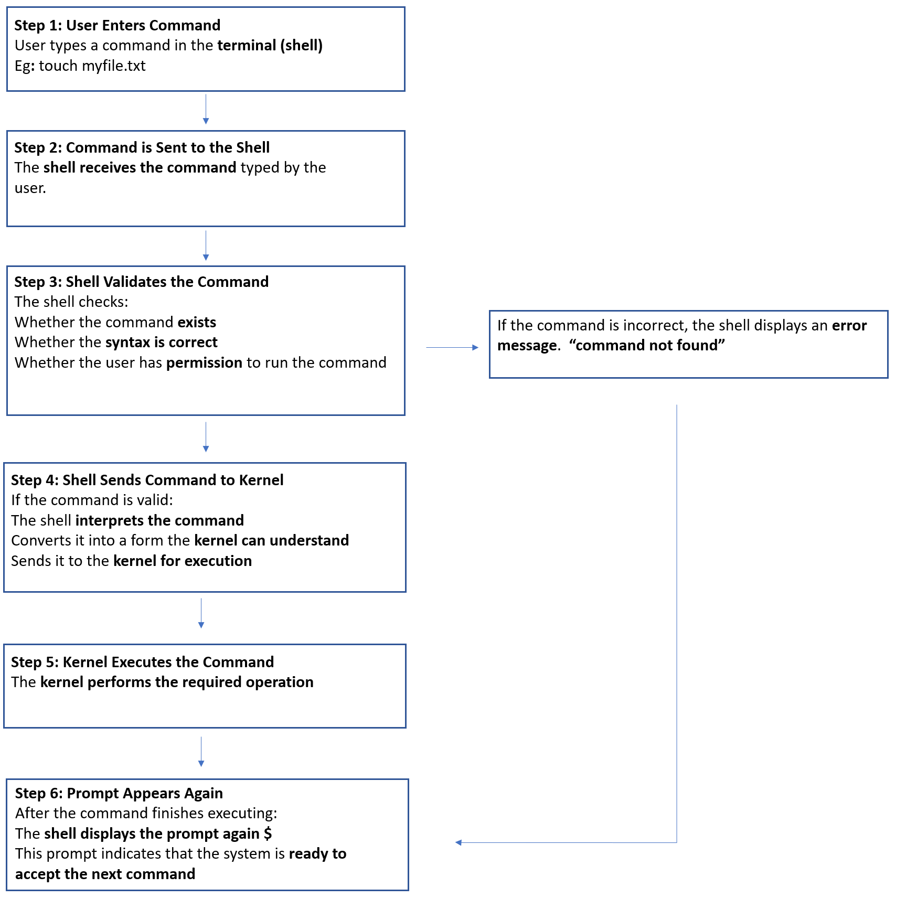
Most Commonly Used Basic Linux Commands
pwd # Print the current working directory
ls # List all files and directories in the current directory
mkdir # Create a new directory
cd # Change from one directory to another
touch # Create a new empty file
rmdir # Remove an empty directory
rm # Remove (delete) files
cal # Display the monthly calendar
date # Display the current date and time
help # Show list of available commands
hostname # Display system/host name information
clear # Clear the terminal screen
exit # Logout or close the terminal session

Type of Files in Linux

In Linux, everything is treated as a file.
All files in Linux are mainly divided into three types.
1. Normal (Ordinary/Regular) Files
2. Directory Files
3. Device Files

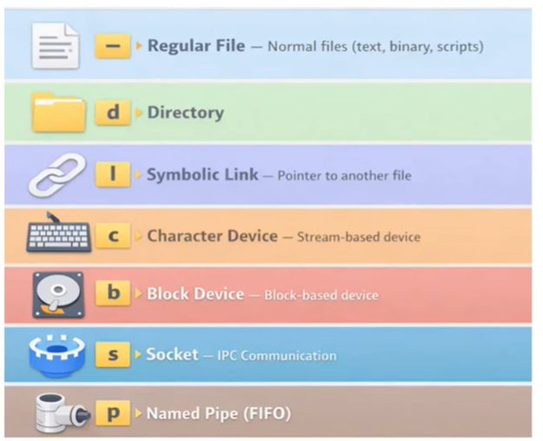

1. Normal (Ordinary/Regular) Files
Normal files are used to store data.
They can be:
- Text files – such as abc.txt, which contain readable text.
- Binary files – such as images, videos, and compiled programs.
These are the most common files used by users.

Examples:
- Text files (.txt)
- Script files (.sh)
- Program files (.jar, .war)
- Package files (.rpm, .deb)
- Images and videos
These files are stored on the disk.
Example
touch test.txt
ls -l test.txt
Output:
-rw-r--r-- 1 user user 0 Nov 17 21:24 test.txt

The first character - indicates that it is a regular file.

2. Directory Files
Directory files are used to store other files and directories.
- In Windows, we call them folders.
- In Linux, they are called directories.
A directory can contain:
- Files
- Sub-directories (directories inside directories)
Example:
Documents/
file1.txt
file2.txt
images/

Example:
mkdir example
ls -l
Output will show:
drwxr-xr-x example
The letter d indicates a directory.

3. Device Files
In Linux, hardware devices are also represented as files.
Examples of devices:
- Keyboard
- Mouse
- Hard disk
- Printer
Using these device files, the operating system can communicate with the hardware devices.
Example
cd /dev
ls
Output will show many device files like:
sda
tty
null
random

Other Important Files Types
4. Symbolic Links (Soft Links)
A symbolic link is a file that points to another file or directory.
It works like a shortcut.
Example:
/bin/ls → /usr/bin/ls
If you run /bin/ls, the system actually runs /usr/bin/ls.
Example
touch original.txt
ln -s original.txt link.txt
ls -l
Output will show:
lrwxrwxrwx link.txt -> original.txt
Here:
- l → Symbolic link
- -> → Shows the file it points to
Important:
If original.txt is deleted, link.txt becomes invalid (broken link).

Hard Link vs Soft Link
Feature | Hard Link | Soft Link
Points to | Same inode | File path
Works across file systems | No | Yes
Works for directories | No | Yes
If original file deleted | Data still exists | Link becomes broken

5. Character Device Files
Character devices transfer data one character at a time.
Examples:
- Keyboard
- Mouse
- Terminal
Symbol in ls -l output:
c
Example
ls -l /dev | grep ^c
Output will show:
crw-rw-rw- 1 root root 1, 3 null
crw-rw-rw- 1 root root 1, 8 random
Here:
- c → Character device file

6. Block Device Files
Block devices transfer data in blocks.
Examples:
- Hard disk
- SSD
- Storage partitions
Symbol in ls -l output:
b
Example
ls -l /dev | grep ^b
Output will show:
brw-rw---- 1 root disk 8, 0 sda
brw-rw---- 1 root disk 8, 1 sda1
Here:
- b → Block device

Example
Another useful command:
lsblk
Output will show:
NAME SIZE TYPE
sda 100G disk
sda1 50G part
sda2 50G part

7. Socket Files
Sockets are used for communication between processes.
This is called Inter-Process Communication (IPC).
Types:
- Unix domain sockets → Communication within the same machine
- Network sockets → Communication between different machines
Symbol in ls -l:
s
Example
ls -l /run
Output may show:
srwxrwxrwx docker.sock
Here:
- s → Socket file

8. Pipe Files
Pipes allow communication between processes.
They pass output of one command as input to another command.
Example
ls -l | wc -l
Explanation:
- ls -l → Lists files
- wc -l → Counts lines
- | → Pipe operator

Types of Pipes
1. Anonymous Pipe
Temporary pipe created in RAM.
Example
ls -l | grep test
Output will show:
-rw-r--r-- test.txt
Explanation:
- ls -l output is sent to grep
- grep filters files containing test
Anonymous pipes exist only while the command runs.

2. Named Pipe (FIFO)
A named pipe is a special file created in the file system.
Example
mkfifo mypipe
ls -l
Output will show:
prw-r--r-- mypipe
Here:
- p → Named pipe
- FIFO means First In First Out

Terminal Shortcut Keys
Shortcut | Description
Ctrl + Alt + T | Open the terminal
Ctrl + D | Close the terminal

How to Check File Type in Linux
In some Linux systems like Ubuntu:
- Blue color → Directory
- Other colors → Normal files
However, color is not a reliable method, because it can change depending on the Linux distribution.
The correct way to check file type is using:
ls -l
Example output:
drwxr-xr-x 102 durgasoft durgasoft 4096 Nov 17 21:19 magic
-rw-r--r-- 1 durgasoft durgasoft 0 Nov 17 21:24 sunny.txt
First Character Indicates File Type
Symbol | File Type
d | Directory
- | Normal file
l | Link file
c | Character special file
b | Block special file
s | Socket file

Note:
c, b, and s are system files and are usually used by the superuser (root/admin).

File System Navigation Commands
Linux provides several commands to navigate between directories.
Special Directories
Every directory automatically contains two special entries:
Symbol | Meaning
. | Current directory
.. | Parent directory

Common Navigation Commands
1. Move to Current Directory
cd .
This command refers to the current directory, so it is usually not useful.

2. Move to Parent Directory
cd ..
Moves one level up to the parent directory.

3. Move to Home Directory
cd
If no argument is given, the command takes you to the user’s home directory.

4. Move to Home Directory Using Symbol
cd ~
~ represents the user’s home directory.

5. Move to Previous Directory
cd -
- represents the previous working directory.

Example Navigation
pwd # Shows the current directory path
/home/durgasoft/Downloads/coreutils-8.31/src
cd ~ # Moves to the home directory
pwd
/home/durgasoft
cd - # Moves back to the previous directory
pwd
/home/durgasoft/Downloads/coreutils-8.31/src
cd ../../.. # Moves three levels up in the directory structure
pwd
/home/durgasoft

Explanation:
- pwd → Shows the current directory path.
- cd ~ → Moves to the home directory.
- cd - → Moves back to the previous directory.
- cd ../../.. → Moves three levels up in the directory structure.

Types of Users in Linux
Linux is a multi-user operating system, which means many users can use the same system at the same time.
Each user type has different permissions and responsibilities.

The common types of users in Linux.
1. Root User (Superuser / Admin User)
2. Regular User (Normal User)
3. sudo User
4. System / Service Account
5. Guest User

1. Root User (Superuser / Admin User)
The root user is the administrator of the Linux system.
- Has full control over the system
- Can install or remove software
- Can change system configuration
- Can access and delete any file
- UID: 0
⚠️ Because it has full power, using root carelessly can damage the system.

Username: root
Prompt Symbol: #
(e.g., root@server:~#)

Example
Login as root:
sudo -i

Create a user:
useradd john

Delete a file anywhere in the system:
rm /etc/testfile

2. Regular User (Normal User)
- A regular user is a normal user account created for daily work.
- Created by the root user.
- Can create files
- Can run applications
- Cannot change system-level settings
- Cannot install software without permission
This improves system security.

Prompt Symbol: $
(e.g., sana@linux:~$)

Example
touch myfile.txt
mkdir projects
These commands work, but system changes will not.

Example (permission denied):
apt install nginx

3. sudo User
A sudo user is a regular user with temporary administrator privileges.
They can perform admin tasks using the sudo command.
This is commonly used in modern Linux systems instead of logging in as root.
Example
Install software:
sudo apt install nginx

Update system:
sudo apt update
Here the user temporarily gets root privileges.

4. System / Service Account
These accounts are not used by humans.
They are created by system services and applications.
Used to run background processes.
Hidden from normal user lists.

Examples:
- mysql
- nginx
- apache
- sshd
These users run services in the background with limited permissions.
Example
Check system users:
cat /etc/passwd

Example output:
mysql:x:27:27:MySQL Server:/var/lib/mysql:/bin/false
nginx:x:101:101:Nginx server:/var/www:/sbin/nologin

5. Guest User
A guest user is a temporary user account.
- Has very limited permissions
- Used for temporary access
- Changes are usually not saved after logout
This is useful when someone needs to use the system for a short time.
Example
A guest user may:
browse the internet
open applications
But cannot install software or change system settings.

Summary
User Type | Access Level | Purpose
Root User | Full control | System administration
Regular User | Limited | Daily work
Sudo User | Temporary admin rights | Secure system management
System/Service Account | Limited | Run system services
Guest User | Very limited | Temporary usage

✅ Simple way to remember

User Type | Easy Meaning
Root User / Super User / Admin User | Full power over the entire system
Sudo User | Temporary admin power for Regular/Normal users
Regular User | Normal user for daily tasks
System User / Service Account | Accounts used by services and applications
Guest User | Temporary user with very limited access

Linux File System Hierarchy
The Linux file system follows a tree structure.
- It starts from the root directory /.
- All files and directories come under this root.
Important Point
- In Linux → single hierarchy starting from /
- In Windows → multiple drives like C:, D:, E:

Main Directories in Linux
/ → Root directory (top-level of the filesystem).
├── /bin → User Binaries
├── /boot → Boot Loader Files
├── /dev → Device Files
├── /etc → Configuration Files
├── /home → Home Directories
├── /lib → System Libraries
├── /lib64 → System Libraries
├── /media → Mount Point for Removable Media
├── /mnt → Mount Point for Temporary Filesystems
├── /opt → Optional Add-on Applications
├── /proc → Process Information
├── /root → Root User Directory
├── /sbin → System Binaries
├── /srv → Service Data
├── /sys → Virtual Filesystem
├── /tmp → Temporary Files
├── /usr → User Programs
├── /var → Variable Files
└── /lost+found → Misplaced Data (Used for Recovery)

1. / (Root Directory)
The (/) directory is the top-level directory of the Linux file system.
All other directories are located inside this directory.
📌 Windows Comparison
Similar to the C:\ drive root in Windows.
Example
ls /
Output
bin boot dev etc home lib root usr var

2. /root (Root User Directory)
The /root directory is the home directory of the root user (administrator) in Linux.
- It is located inside the root filesystem /.
- Only the root user (superuser) normally has access to it.
- Not accessible to normal users.
📌 Windows Comparison
C:\Users\Administrator
Example
cd /root
ls
Example output
backup.sh
scripts
notes.txt

Difference Between / and /root
Directory | Meaning
/ | Top level directory of Linux
/root | Home directory of the root (admin) user

Example
/home/john # normal user home
/root # root user home

3. /home (Home Directories)
This directory stores home folders for normal users.
Since Linux is a multi-user operating system,
- Stores personal files and settings for users.
- Each user gets a separate directory.
📌 Windows Comparison
Similar to:
C:\Users\Ram
C:\Users\Adan

Example
ls /home
Output
demo john adam
Example user folder
/home/john # /home directory for user john
Inside it you may see:
Desktop
Documents
Downloads
Pictures
Videos

4. /boot (Boot Loader Files)
- Contains boot-related files.
- Stores the Linux kernel and bootloader (e.g., GRUB).
Examples include:
- Kernel files
- Bootloader files (GRUB)
📌 Windows Comparison
Similar to Windows System Boot files in System32 / Boot Manager.
Example
ls /boot
Output
grub vmlinuz initrd.img

5. /etc (Configuration Files)
- Stores system-wide configuration files.
- Used for application and system settings.
📌 Windows Comparison
Similar to:
- Windows Registry
- Environment Variables
Important files
File | Purpose
/etc/passwd | User information
/etc/group | Group information
/etc/hosts | Hostname and IP mapping
/etc/ssh/sshd_config | SSH configuration

Example
cat /etc/passwd

When Installing a Service
If we install a service like:
- Web server
- FTP
- SFTP
Linux usually creates:
- A user account
- A home directory
- A configuration file inside /etc

6. /bin (User Binaries)
bin means binary.
- Contains essential command-line utilities.
- Available for all users.
📌 Windows Comparison
Similar to system command executables in Windows System folders.

Examples
ls (List directory)
cp (Copy files)
rm (Remove files)
cat (Display file content)

7. /sbin (System Binaries)
- Contains system administration commands.
- Only root users/admin user/super user typically run these commands.
📌 Windows Comparison
Similar to admin system utilities.

Examples
fdisk # (Partition management)
fsck # (Filesystem check)
iptables # (Firewall configuration)
reboot # (Restart the system)

Difference Between /bin and /sbin
Feature | /bin | /sbin
Used by | All users | Admin (root)
Commands | Basic commands | System management

8. /usr (User Programs)
usr means Unix Shared Resources.
- Stores installed user applications and libraries.
📌 Windows Comparison
Similar to:
C:\Program Files

Example
ls /usr/bin
Contains many application commands.
Example software:
OpenJDK
Python
Editors (vim, nano)

9. /opt (Optional Add-on Applications)
opt means optional add on software.
- Used to install Stores third-party software and add-on’s manually.
📌 Windows Comparison
Similar to:
Program Files
Example
/opt/google/chrome/ # (Google Chrome installation)

Examples
- Google Chrome
- Custom software

Difference Between /usr and /opt
Feature | /usr | /opt
Purpose | System installed software | Third-party software
Installed by | Package manager | Manual installation

10. /dev (Device Files)
dev means device files.
In Linux, hardware devices are represented as files.
- Contains files representing hardware devices.
📌 Windows Comparison
Similar to Device Manager.

Examples
Device | File
Keyboard | stdin
Monitor | stdout
Hard disk | hd / sd
Terminal | tty
Example
ls /dev
Output
tty sda sdb null random

Example
/dev/sda # (Hard disk)
/dev/usb # (USB device)
/dev/null # (Null device)

11. /proc (Process Information)
proc means process information.
- Contains information about running processes
- Each process has a Process ID (PID).
📌 Windows Comparison
Similar to Task Manager process information.

Example
ps -ef
Output
UID PID CMD
root 1 /sbin/init
root 2 kthreadd

Example process directory
/proc/1234
Useful commands
cat /proc/cpuinfo # CPU details
cat /proc/meminfo # Memory information

12. /srv (Service Data)
- Stores service-related data like web servers or FTP servers.
- Example:
/srv/www # (Web server files)
/srv/ftp # (FTP server files)

13. /mnt (Mount Point for Temporary Filesystems)
mnt means mounting.
- . Used for manually mounting filesystems.
- Used to manually mount external devices

Example
mount /dev/sdb1 /mnt
📌 Windows Comparison
Similar to attaching external drive manually.

14. /media (Mount Point for Removable Media)
- Used for automatic mounting of removable devices.
- Used for mounting external drives like USB and CD-ROMs.

Examples
/media/usb #(USB device)
/media/cdrom #(CD/DVD drive)

Difference Between /mnt and /media
Feature | /mnt | /media
Mounting | Manual | Automatic
Used by | Admin | System

15. /lib (System Libraries)
lib means libraries.
- Contains shared libraries needed by binaries in /bin and /sbin.
📌 Windows Comparison
Similar to DLL files in Windows.
Example
/lib/libc.so

16. /var (Variable Files)
var means variable data.
This directory stores data that changes frequently.
- Stores log files, temporary files, and caches.

Examples
/var/log # (System logs)
/var/cache #(Cached data)
📌 Windows Comparison
Similar to log files and temporary system data.

17. /tmp (Temporary Files)
tmp means temporary files.
- Contains temporary files for current session
Important points
- Files are temporary
- deleted during reboot
Example
cd /tmp
touch testfile
📌 Windows Comparison
Similar to:
C:\Windows\Temp

18. /lost+found (Misplaced Data)
- Used by the fsck tool to store recovered corrupted files.
- Found in ext3 and ext4 formatted partitions

Important Notes
1. Linux file system helps the OS to find files quickly.
2. Different Linux file systems exist:
ext2
ext3
ext4
XFS
3. Windows file systems include:
NTFS
FAT
FAT32

Linux Installation Guide

1. Install Oracle VirtualBox
Oracle VirtualBox is a software that allows you to run another operating system inside your computer without affecting your main operating system.
In simple words, it creates a virtual computer inside your computer. Using this, you can run multiple operating systems like Linux, Windows, etc., at the same time.

Steps:
- Open the website virtualbox.org
- Click Downloads
- Select Windows Hosts
- Download the file and install it on your system.

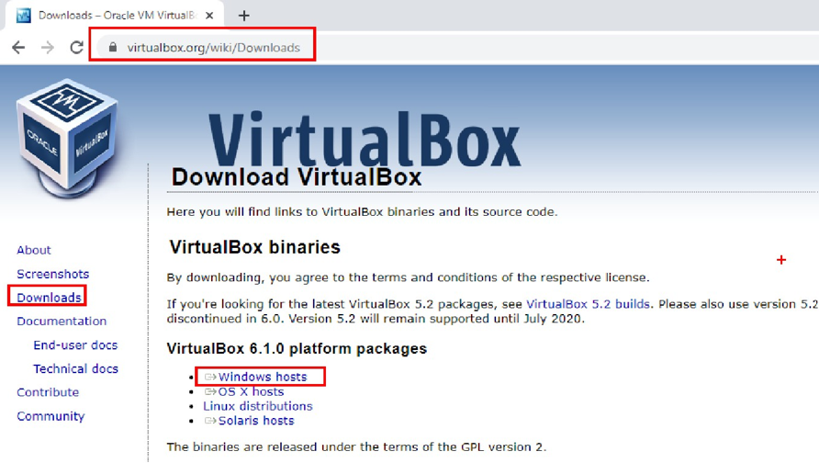

Example:
If your computer has Windows, you can install Ubuntu Linux inside VirtualBox and use both operating systems on the same computer.

2. Create a Virtual Machine with Ubuntu
After installing VirtualBox, we need to install a Linux operating system inside it. Here we will use Ubuntu.
Steps to download Ubuntu:
- Open ubuntu.com
- Click Download
- Select Ubuntu Desktop
- Download Ubuntu 18.04 LTS ISO file
This ISO file is used to install Ubuntu inside the virtual machine.
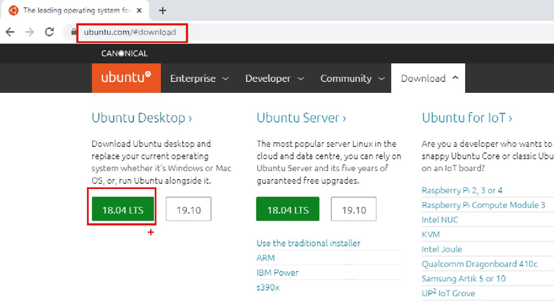
Example:
You create a virtual machine in VirtualBox and load the Ubuntu ISO file to install Ubuntu just like installing an operating system on a real computer.

Note
You can also download the required software from:
bit.ly/36evx8y

Useful Shortcuts and Utilities in Ubuntu
Function | Shortcut / Method
Make Virtual Machine Full Screen | Devices → Insert Guest Additions CD Image
Open Terminal | Ctrl + Alt + T
Close Terminal | Ctrl + D
Increase Terminal Font | Ctrl + Shift + +
Decrease Terminal Font | Ctrl + -
Copy & Paste between Windows and Ubuntu | Devices → Shared Clipboard → Bidirectional
Drag & Drop files between Windows and Ubuntu | Devices → Drag and Drop → Bidirectional

Example
- If you copy text from Windows, you can paste it in Ubuntu Terminal using Shared Clipboard.
- If you want to move a file from Windows Desktop to Ubuntu, you can drag and drop the file when Drag & Drop is set to Bidirectional.

Topic: File System Navigation in Linux
Linux provides several commands to move between directories in the file system. These commands help users navigate from one folder to another easily.

1. Special Directories in Linux
Every directory automatically contains two special entries.
Symbol | Meaning
. | Represents the current directory
.. | Represents the parent directory (one level above)
Example:
cd .
This command moves to the current directory, so it does nothing useful.

2. Move to Parent Directory
To move one level up in the directory structure, use:
cd ..
Example:
Current location:
/home/user/Documents/projects
Command:
cd ..
New location:
/home/user/Documents

3. Change to Home Directory
If you run cd without any argument, Linux automatically moves to the user's home directory.
cd
Example:
Current location:
/home/user/Downloads
After running:
cd
New location:
/home/user

4. Using ~ (Home Directory)
The symbol ~ represents the user’s home directory.
cd ~
or
cd~ # ~ without a space, the shell still understands it and goes to the home directory.
Example:
Current location:
/home/user/Documents
Command:
cd ~
New location:
/home/user

5. Go to Previous Directory
The symbol - represents the previous working directory.
cd -
Example:
Current location:
/home/user/Downloads/coreutils/src
Move to home directory:
cd ~
Now run:
cd -
You will return to the previous location:
/home/user/Downloads/coreutils/src

6. Moving Multiple Levels Up
You can move multiple levels up using ../
Example:
Current location:
/home/user/Downloads/coreutils/src
Command:
cd ../../..
or
cd ../../../
New location:
/home/user
Each ../ moves one directory up.

7. Go to /root Directory
The / represents the Root Directory (top of the Linux file system).
Command:
cd /
This is the starting point of the entire Linux file system.
Example structure:
/
├── home
├── bin
├── etc
├── var
└── usr

Difference Between cd and cd /
Command | Meaning | Example Result
cd or cd~ or cd ~ | Goes to user home directory | /home/sudhin
cd / | Goes to root directory | /

✅ Quick Summary
Command | Purpose
cd . | Stay in current directory
cd .. or cd ../ | Move to parent directory
cd | Go to home directory
cd / | Go to root directory
cd ~ | Go to home directory
cd - | Go to previous directory

Topic: ls Command in Linux
1. ls Command
The ls command is used to list all files and directories in a given directory.
Example
ls
Output Example
Documents Downloads Music Pictures script.sh
Description
This command shows all files and folders in alphabetical order.

Manual Help for ls
You can see the complete documentation of the ls command using the man (manual) command.
Example
man ls
Description
This command opens the manual page which explains all options available for ls.

Various Options of ls Command
1. ls
Displays all files and directories in alphabetical order.
ls
Description
Shows normal listing of files.

2. ls -r
Displays files in reverse alphabetical order.
ls -r
Description
-r means reverse order.
Example output:
script.sh Pictures Music Downloads Documents

3. ls -l
Displays long listing format of files.
ls -l
Example Output
-rw-r--r-- 1 jbossuser jbossgroup 200 Mar 10 10:20 script.sh
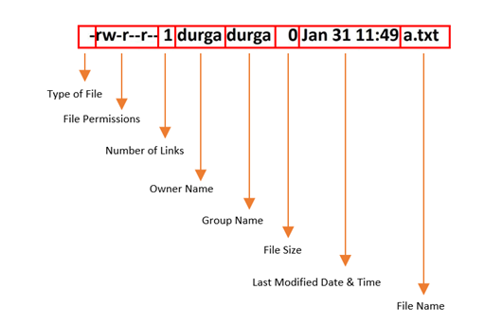
Description
Shows detailed information like:
- Type of File
- File Permissions
- Number of Links
- Owner Name
- Group Name
- File Size
- Last Modified Date & Time
- File Name

Each part of this output has a specific meaning

Field | Example | Description
Type of File | - | Shows the file type. - means regular file, d means directory, l means link file.
File Permissions | rw-r--r-- | Permissions for owner, group, and others (read, write, execute).
Number of Links | 1 | Number of hard links pointing to this file.
Owner Name | jbossuser | Name of the user who owns the file.
Group Name | jbossgroup | Group associated with the file.
File Size | 200 | Size of the file in bytes.
Last Modified Date & Time | Mar 10 10:20 | The last time the file was modified.
File Name | script.sh | Name of the file.

File Type Symbols
Symbol | File Type
- | Regular File
d | Directory
l | Link File

4. ls -t
Displays files based on last modified time.
ls -t
Description
- Newest files appear at the top
- Oldest files appear at the bottom

5. ls -rt
Displays files based on reverse modification time.
ls -rt
Description
- Old files appear at the top
- Recent files appear at the bottom

6. ls -a
a means all files.
ls -a
Description
Displays all files including hidden files.
Hidden files start with .
Example:
. .. .bashrc .profile Music Documents
. → Current directory
.. → Parent directory

7. ls -A
A means almost all files (except . and ..)
ls -A
Description
Displays hidden files except:
. → Current directory
.. → Parent directory
Example:
.bashrc .profile Music Documents

8. ls -F
Displays file type symbols.
ls -F
Description
Symbol meanings:
Symbol | Meaning
/ | Directory
* | Executable file
@ | Link file
Example:
Documents/ script.sh* initctl@

9. ls -f
Disables colored output.
ls -f
Description
Shows files without colors.

10. ls -i
Displays inode numbers.
ls -i
Description
Inode is the internal address where file information is stored.
File attributes stored in inode include:
- File size
- Number of links
- Owner
- Group
- Creation time
- Last modified time
- Last accessed time
Example:
131279 script.sh
131277 notes.txt

11. ls -R
R means Recursive.
ls -R
Description
Lists files in current directory and all subdirectories.
Example:
Documents:
file1.txt
Documents/Reports:
report1.txt

12. ls -s
Displays number of blocks used by a file.
ls -s
Description
- 1 Block = 1 KB in Ubuntu
Example:
4 script.sh
8 notes.txt

13. ls -h
Displays file sizes in human readable format.
ls -lh
Description
Shows sizes like:
2K 10M 1G
instead of large numbers.

Viewing Large Output Using less or more
If there are many files, we can view them page by page.
Example
ls /dev | less
ls /dev | more
Description
- less → Scroll up and down
- more → Scroll only forward

Display Limited Lines Using head and tail
Show first few files
ls /dev | head -5
Description
Displays top 5 lines.

Show last few files
ls /dev | tail -5
Description
Displays bottom 5 lines.

Using Multiple Options Together
You can combine multiple options in any order.
Examples
ls -l -t -r
ls -t -r -l
ls -l -r -t
ls -ltr
ls -trl
Description
All the above commands produce the same result.

Most Commonly Used ls Command
ls -lrt
Description
Shows files:
- in long format
- sorted by oldest first

Example with search
ls -lrt | grep examresult.txt
Description
Displays details only for the file examresult.txt.

Interview Questions
Q1
Display all files including hidden files in modification time order (oldest first) with:
- inode number
- block size
- long listing format
Command
ls -atrisl

Q2
Which command lists all files including hidden files with inode numbers?
ls -ai

Q3
Which command lists all files including hidden files in long format sorted by modification date (oldest first)?
ls -lrta

Q4
Does -r list files sorted by modification date (oldest first)?
Answer: False
ls -r
Description
It lists files in reverse alphabetical order, not by modification date.
Correct command for oldest first:
ls -rt

Q5
ls -la and ls -al produce different results.
Answer: False
ls -la
ls -al
Description
Both commands produce the same output.

Topic: date Command in Linux
The date command is used to display the current system date and time.
Example
date
Output Example
Sat Mar 14 13:07:36 IST 2026
This shows:
- Day
- Month
- Date
- Time
- Time zone
- Year

Various Options of date Command
1. Display Date Only
date +%D
Output Format
mm/dd/yy
Example
03/14/26

2. Display Time Only
date +%T
Output Format
hh:mm:ss
Example
13:07:36

3. Display Day Only
date +%d
Example
14

4. Display Month Only
date +%m
Example
03

5. Display Year in Short Format
date +%y
Example
26
Shows the year in two digits.

6. Display Year in Full Format
date +%Y
Example
2026
Shows the year in four digits.

7. Display Hours
date +%H
Example
13
Comment
Shows hours in 24-hour format.

8. Display Minutes
date +%M
Example
07

9. Display Seconds
date +%S
Example
36

Practical Examples
Example 1: Display Date in dd-mm-yyyy Format
Default format is mm/dd/yy, but we can change it.
date +%d-%m-%Y
Example Output
14-03-2026

Example 2: Create a File with Current Date in the File Name
touch "durgajobs$(date +%d%m%Y).log"
Example Files Created
durgajobs31102026.log
Here the current date is automatically added to the file name.

Example 3: Create a File with Date and Time in the File Name
touch "durgajobs$(date +%d%m%Y%H%M%S).log"
Example Output
durgajobs31102026205834.log

Note
If a file name contains the date and time, it is called a timestamped file.
A timestamped file helps us:
- Track when the file was created
- Maintain logs with unique names
- Avoid overwriting existing files

Topic: cal Command in Linux
The cal command is used to display a calendar in the terminal.
It can show the current month, a specific month, or the calendar of a whole year.

1. Display Current Month Calendar
cal
Example Output
March 2026
Su Mo Tu We Th Fr Sa
1 2 3 4 5 6 7
8 9 10 11 12 13 14
15 16 17 18 19 20 21
22 23 24 25 26 27 28
29 30 31
This command shows the calendar of the current month.

2. Display Calendar for a Specific Year
cal 2020
This command displays the calendar for the entire year 2020.
Example
January 2020 February 2020 March 2020 ...

3. Display Calendar for Year 1
cal 1
This command shows the calendar for the year 1.

4. Display Calendar for Year 9999
cal 9999
This command shows the calendar for the year 9999.

5. Invalid Year Example
cal 10000
Output
cal: year '10000' not in range 1..9999
This means the cal command cannot display calendars for years greater than 9999.

6. Display Calendar for a Specific Month and Year
cal 08 2019
This command displays the calendar for August 2019.
Example Output
August 2019
Su Mo Tu We Th Fr Sa
1 2 3
4 5 6 7 8 9 10
11 12 13 14 15 16 17
18 19 20 21 22 23 24
25 26 27 28 29 30 31

Note
The cal command supports years only from 1 to 9999.
If you enter a year outside this range, it will show an error message.

Topic: Working with Directories in Linux
1. Creating Directories (mkdir)
The mkdir command is used to create directories (folders) in Linux.

1. Create a Single Directory
mkdir dir1
Example
dir1
This command creates a directory named dir1.

2. Create Multiple Directories
mkdir dir1 dir2 dir3
Example
dir1 dir2 dir3
This command creates three directories at the same time.

3. Create Nested Directory
mkdir dir1/dir2/dir3
This creates dir3 inside dir2, and dir2 inside dir1.
⚠️ Important:
dir1 and dir2 must already exist. Otherwise, the command will fail.

4. Create Nested Directories with -p
mkdir -p dir1/dir2/dir3
Explanation
- -p means create the complete path
- If directories do not exist, they will be created automatically.
Example Structure
dir1
└── dir2
└── dir3

Case Study 1: Film Heroine Manager Example
Suppose a manager manages three heroines:
- sunny
- katrina
- kareena
Each heroine has monthly folders and inside those folders schedule files for each days.

Step 1: Create Main Directory
mkdir heroines
cd heroines

Step 2: Create Directories for Heroines
mkdir sunny katrina kareena

Step 3: Create Month and Year Directories
mkdir {sunny,katrina,kareena}/{jan,feb,mar,apr,may,jun,jul,aug,sep,oct,nov,dec}_{2020,2021,2022}
Example:
sunny/jan_2020
sunny/feb_2020
...
katrina/jan_2020
...

Step 4: Create Schedule Files
touch {sunny,katrina,kareena}/{jan,feb,mar,apr,may,jun,jul,aug,sep,oct,nov,dec}_{2020,2021,2022}/schedule_{1..31}.txt
Example files:
schedule_1.txt
schedule_2.txt
...
schedule_31.txt

Case Study 2
Create directories dir6 to dir10, and inside each directory create files a.txt, b.txt, c.txt, d.txt
Step 1: Create Directories
mkdir dir{6..10}
Directories created:
dir6 dir7 dir8 dir9 dir10

Step 2: Create Files Inside Each Directory
touch dir{6..10}/{a..d}.txt
Example:
dir6/a.txt
dir6/b.txt
dir6/c.txt
dir6/d.txt
:::

Note
Symbols like
*
[]
{}
are called wildcard characters and can be used in many Linux commands.

Difference Between Two Commands
Command 1
mkdir dir1/dir2/dir3
- Only dir3 is created
- dir1 and dir2 must already exist

Command 2
mkdir -p dir1/dir2/dir3
- -p creates complete path
- dir1, dir2, and dir3 will all be created

2. Removing Directories (rmdir or rm)
Directories can be removed using rmdir or rm.

Remove Empty Directory
rmdir dir1
This removes dir1 only if it is empty.

Remove Multiple Empty Directories
rmdir dir1 dir2 dir3

⚠️ Important
rmdir works only for empty directories.
Example error:
rmdir: failed to remove 'heroines': Directory not empty

Remove Non-Empty Directory
Use the rm command.
rm -r heroines
or
rm -R heroines
-r means recursive removal (remove directory and all its contents).

⚠️ Warning
Linux does not have an undo option.
Once a file or directory is deleted, it cannot be recovered easily.
Dangerous command:
rm -r /
This can delete the entire file system.

Options with rm Command
1. Interactive Mode (-i)
rm -ri dir7
This will ask confirmation before deleting each file.
Example:
remove file 'a.txt'? y
remove directory 'dir7'? y

2. Force Removal (-f)
rm -rf dir99
This command:
- removes files without confirmation
- no error message if file does not exist

3. Verbose Mode (-v)
rm -rv dir8
Displays each file being deleted.
Example:
removed 'dir8/a.txt'
removed 'dir8/b.txt'
removed directory 'dir8'

Advantage of rm over rmdir
Command | Works For
rmdir | Empty directories only
rm | Files and directories (empty or non-empty)

3. Absolute Path vs Relative Path
Absolute Path
Complete path from root directory /
Example:
cd /home/sudhin/y/y2

Relative Path
Path from current directory
Example:
cd ../../y/y2

4. Copy Command (cp)
The cp command is used to copy files or directories.

Copy File to Another File
cp file1 file2
Content of file1 will be copied into file2.

Copy Files to Directory
cp file1 file2 output
Both files will be copied into output directory.

Copy All Files from One Directory to Another
cp dir1/* dir2
All files from dir1 will be copied to dir2.

Copy Entire Directory to Another Directory
cp -r dir1 dir2
-r means recursive copy.
Suppose you have this structure:
dir1
├── file1.txt
├── file2.txt
└── subfolder
└── file3.txt

After running the command:
The result will be:
dir2
└── dir1
├── file1.txt
├── file2.txt
└── subfolder
└── file3.txt

So dir1 and all its contents are copied inside dir2.

Case 1: dir3 does NOT exist
Command:
cp -r dir1 dir3
Result
Linux will create a new directory named dir3 and copy all the contents of dir1 into it.
Example before command:
dir1
After command:
dir1
dir3
dir3 is the new copied directory (same contents as dir1).

Case 2: dir3 already exists
Command:
cp -r dir1 dir3
Result
Example before command:
dir1
dir3
After command:
dir1
dir3
└── dir1
Here dir1 will be copied inside dir3.

Simple Rule to Remember
Situation | Result
Destination does not exist | Source directory is copied and a new destination directory is created with the same contents.
Destination already exists | Source directory is copied and placed inside the destination directory.

5. Moving and Renaming (mv)
The mv command is used to move files or rename files/directories.

Rename File
mv file1.txt file2.txt
File name will change from file1.txt to file2.txt.

Rename Directory
mv dir1 dir2
Directory name becomes dir2.
- If dir2 exists → dir1 moves into dir2
- If dir2 does not exist → dir1 renamed to dir2

Move a File to Directory
mv a.txt output
a.txt file will move into output directory.

Move Multiple Files to Directory
mv a.txt b.txt c.txt output
All files will move into output directory.

Move All Files from One Directory to Another
mv dir1/* dir2
All files from dir1 move to dir2.

Move Entire Directory
mv dir1 dir2
- If dir2 exists → dir1 moves into dir2
- If dir2 does not exist → dir1 renamed to dir2

Summary of Important Commands
Create Directories
mkdir dir1
mkdir dir1 dir2 dir3
mkdir dir{1..6}
mkdir -p dir1/dir2/dir3

Remove Directories
rmdir dir1
rm -r dir1
rm -rf dir1
rm -rv dir1

Copy
cp file1 file2
cp file1 file2 dir
cp -r dir1 dir2

Move / Rename
mv file1 file2
mv dir1 dir2
mv dir1/* dir2

Topic:Working with Files in Linux
In Linux, we can perform many operations on files such as creating, viewing, copying, renaming, deleting, and comparing files.
Common File Operations
- Creation of Files
- Viewing File Content
- Copying Files
- Renaming Files
- Deleting Files
- Comparing Files

1. Creating Files
In Linux, files can be created in several ways.
1. Using touch Command
The touch command is used to create an empty file.
Example:
touch file1.txt
If the file does not exist, it will be created.
If the file already exists, the content will not change, but the timestamp (last modified time) will be updated.
Example:
ls -l file1.txt
touch file1.txt
ls -l file1.txt
You will see the modified time updated.

2. Using cat Command
The cat command can create a file and add content to it.
Example:
cat > file1.txt
Hello Friends
Linux Learning
Ctrl + D
This will create file1.txt with the entered content.
If the file already exists, the old content will be overwritten.

Append Data Instead of Overwriting
To add new content without deleting old content, use >>
Example:
cat >> file1.txt
Extra content
Ctrl + D

Difference Between touch and cat
Command | Purpose
touch | Creates an empty file
cat | Creates a file with content

Use of touch
The touch command is used for two purposes:
- Create an empty file
- Update the timestamp of an existing file

2. Viewing File Content
Linux provides several commands to read file content.
1. cat Command
Displays the entire content of a file.
Example:
cat file1.txt
Show line numbers:
cat -n file1.txt
View multiple files:
cat file1.txt file2.txt
The word cat comes from concatenation.

2. tac Command
tac is the reverse of cat.
It displays file content from bottom to top.
Example:
tac file1.txt

3. rev Command
rev reverses the characters in each line.
Example:
rev file1.txt

4. head Command
Displays the first few lines of a file.
Example:
head file1.txt
By default it shows first 10 lines.
Show first 30 lines:
head -30 file1.txt

5. tail Command
Displays the last few lines of a file.
Example:
tail file1.txt
Show last 30 lines:
tail -30 file1.txt

Example: Display Lines 3 to 7
head -7 demo.txt | tail -5
This will display line 3 to line 7.

6. more Command
Displays file content page by page.
Example:
more file1.txt
Controls:
- Enter → Next line
- Space → Next page
- q → Quit

7. less Command
less is similar to more but allows forward and backward navigation.
Example:
less file1.txt
Controls:
- d → Next page
- b → Previous page

3. Copying Files
The cp command is used to copy files.
Example:
cp file1.txt file2.txt
- If file2.txt does not exist, it will be created.
- If it already exists, its content will be overwritten.

Confirmation Before Overwriting
cp -i file1.txt file2.txt
-i means interactive.

Show Copy Process
cp -v file1.txt file2.txt
-v means verbose output.

4. Renaming and Moving Files
The mv command is used for both renaming and moving files.
Rename File
mv file1.txt file2.txt
file1.txt will be renamed to file2.txt.
Case 1:
If file2.txt already exists, then:
- The existing file2.txt will be overwritten by file1.txt.
Example:
Before:
file1.txt
file2.txt
After running:
mv file1.txt file2.txt
Result:
file2.txt
- Old file2.txt content will be lost
- file1.txt content becomes new file2.txt

Prevent Overwriting (Recommended)
Use -i option to ask confirmation before overwriting.
mv -i file1.txt file2.txt
Example output:
mv: overwrite 'file2.txt'?
You can type y or n.

Rename Directory
mv dir1 dir2
Directory name becomes dir2.
- If dir2 exists → dir1 moves into dir2
- If dir2 does not exist → dir1 renamed to dir2

Move a File to Directory
mv a.txt output
a.txt file will move into output directory.
Case 1:
If output directory does not exist, Linux will rename the file to output.
Before:
a.txt
Command:
mv a.txt output
After Output
Here a.txt becomes file named "output".

Move Multiple Files to Directory
mv a.txt b.txt c.txt output
All files will move into output directory.
Case 1:
If output directory does not exist, Linux will show an error:
mv: target 'output' is not a directory
Because when moving multiple files, the destination must be a directory.

Move All Files from One Directory to Another
mv dir1/* dir2
All files from dir1 move to dir2.
Case 1
If dir2 does not exist, Linux will show an error:
mv: cannot move 'dir1/*' to 'dir2': No such file or directory

Move Entire Directory
mv dir1 dir2
- If dir2 exists → dir1 moves into dir2
- If dir2 does not exist → dir1 renamed to dir2

5. Comparing Files
1. diff Command
To check differences between files, we use diff command.
Example:
diff file1.txt file2.txt
If files are identical → no output
If different → it shows differences.

Useful Options
Show if files are different:
diff -q a.txt b.txt
Show if files are identical:
diff -s a.txt b.txt
Side-by-side comparison:
diff -y a.txt b.txt

2. vimdiff Command
vimdiff compares files using the Vim editor and highlights differences.
First install vim:
sudo apt install vim
Example:
vimdiff a.txt b.txt
Useful keys:
- Ctrl + w + w → Switch window
- :q → Quit current window
- :qa → Quit all windows
- :qa! → Force quit

Topic: Hidden Files and Directories in Linux
In Linux, files/directory that start with a dot (.) are called hidden files/directory.
These files are not displayed in normal ls command output.
Hidden files are usually used to store system settings or configuration data.
Many system files required by the Linux kernel or applications are hidden files.
Example:
.securefile.txt
.bashrc
.profile

Creating Hidden Files
Hidden files can be created just like normal files.
The only difference is that the file name must start with a dot (.).
Example 1: Using touch
Create an empty hidden file.
touch .securefile1.txt

Example 2: Using cat
Create a hidden file with content.
cat > .securefile1.txt
This is hidden data
Ctrl + D

Example 3: Using Editors
You can also create hidden files using editors such as:
- vi
- nano
- gedit

Creating Hidden Directories
Hidden directories can also be created the same way as normal directories.
Example:
mkdir .db_info
Here .db_info is a hidden directory.

Important Note
Hidden files do not provide full security.
They only hide the file from normal listing.
To provide real security, we must use file permissions with the chmod command.
Example:
chmod 600 .securefile1.txt
This restricts access to the file.

Interconversion of Normal Files/Directories and Hidden Files/ Directories
Converting Normal Files to Hidden Files
We can convert a normal file into a hidden file by renaming it with a dot (.) at the beginning.
Example:
mv a.txt .a.txt
Here:
- a.txt → normal file
- .a.txt → hidden file

Converting Hidden Files to Normal Files
Remove the dot (.) from the beginning of the file name.
Example:
mv .a.txt a.txt
Now the file becomes visible again.

Converting Directories
The same method works for directories.
Normal Directory → Hidden Directory
mv dir1 .dir1
Hidden Directory → Normal Directory
mv .dir1 dir1

Topic: Creation of Link Files in Linux
In Linux, a link file is a file that points to another file.
Links are mainly used to access the same file from multiple locations.
There are two types of links in Linux:
- Hard Link
- Soft Link (Symbolic Link)
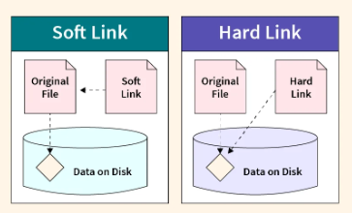

Links for Files
1. Hard Link
A hard link is another name for the same original file.
Both the original file and the hard link point to the same data on the disk.
Command to Create Hard Link
We use the ln command.
ln originalfile hardlinkfile
Example
ln file1.txt file2.txt
Here:
- file1.txt → Original file
- file2.txt → Hard link of file1.txt
Both files refer to the same content.

Important Points About Hard Links
- Both files have the same inode number.
- They have the same file size and timestamp.
- If we delete the original file, the hard link still works because the data still exists.

2. Soft Link (Symbolic Link)
A soft link is a pointer to another file.
It works like a shortcut in Windows.
Soft links are also called symbolic links.
Command to Create Soft Link
ln -s originalfile softlinkfile
Example
ln -s file1.txt file2.txt
Here:
- file1.txt → Original file
- file2.txt → Soft link pointing to file1.txt

Important Points About Soft Links
- Original file and soft link have different inode numbers.
- Their file sizes and timestamps are different.
- Soft link file size is usually smaller than the original file.
- If the original file is deleted, the soft link becomes broken or useless.

How to Identify Hard Link, Soft Link, or Normal File
Example:
touch file1.txt
ln file1.txt hardlink.txt
ln -s file1.txt softlink.txt
ls -li

We can use ls -li command.
ls -li
Example Output
12345 -rw-r--r-- 2 user user 100 Jun 10 file1.txt
12345 -rw-r--r-- 2 user user 100 Jun 10 hardlink.txt
56789 lrwxrwxrwx 1 user user 9 Jun 10 softlink.txt-> file1.txt
Explanation
File | Meaning
file1.txt & file2.txt | Same inode → Hard link
linkfile | l at beginning → Soft link

Hard Link
file1.txt ─────┐
├── Same inode (same data)
hardlink.txt ───┘
Soft Link
softlink.txt ───► file1.txt

Hard Link vs Soft Link
Feature | Hard Link | Soft Link
Original file and link file Inode number | Same | Different
Works after deleting original file | Yes | No
Directory support | Not allowed | Allowed
File size and timestamps | Same | Usually smaller

Links for Directories
1. Hard Links for Directories
Hard links cannot be created for directories because they can break the Linux file system structure.
Example:
ln dir1 dir2
Output:
hard link not allowed for directory

2. Soft Links for Directories
Soft links can be created for directories.
Example:
ln -s dir1 dir2
Here dir2 is a soft link pointing to dir1.

Important Rule
File Type | Hard Link | Soft Link
Files | Allowed | Allowed
Directories | Not Allowed | Allowed

Important Note
If we modify the content of the original file, the changes will also appear in the link file.
Similarly, if we modify the link file, the changes will also reflect in the original file.
This behavior applies to both hard links and soft links.

Deleting Soft Link Files/Directories
a) Deleting Soft Link Files
To delete a soft link, use rm command.
rm linkfile
Example:
rm linkfile.txt
This removes only the link, not the original file.

b) Using unlink
Another command used to remove links is unlink.
Example:
unlink softlink.txt
This deletes the soft link file only.

Deleting Soft Link Directory
rm linkdir
Example:
rm mylinkdir
Only the link is deleted, the original directory remains safe.

Deleting Hard Link
Hard links are deleted using rm command like normal files.
rm file2.txt
Example:
Before:
file1.txt
file2.txt (hard link)
Command:
rm file1.txt
Result:
file2.txt
The file still exists because file2.txt is another hard link to the same data.
The data is deleted only when all hard links are removed.

Important Rule
Action | Result
Delete soft link | Only link removed
Delete original file (soft link exists) | Soft link becomes broken
Delete one hard link | Data still exists
Delete all hard links | File data removed

Topic: Word Count Command in Linux (wc)
The wc (word count) command is used to count the number of lines, words, and characters in a file.
Syntax
wc filename
Output Format
number_of_lines number_of_words number_of_characters filename

Example
wc a.txt
Sample Output
4 26 166 a.txt
Explanation
Value | Meaning
4 | Number of lines
26 | Number of words
166 | Number of characters (file size in bytes)

Useful Options with wc
The wc command provides several options to display specific counts.
Option | Purpose
-l | Count only number of lines
-w | Count only number of words
-c | Count only number of characters
-L | Length of the longest line
-lw | Count lines and words
-lc | Count lines and characters
-wc | Count words and characters

Examples
Count Only Lines
wc -l a.txt
Output:
4 a.txt

Count Only Words
wc -w a.txt
Output:
26 a.txt

Count Only Characters
wc -c a.txt
Output:
166 a.txt

Count Lines and Words
wc -lw a.txt
Output:
4 26 a.txt

Count Lines and Characters
wc -lc a.txt
Output:
4 166 a.txt

Count Words and Characters
wc -wc a.txt
Output:
26 166 a.txt

Find Length of the Longest Line
wc -L a.txt
Output:
57 a.txt
This means the longest line in the file has 57 characters.

Using wc with Multiple Files
The wc command can also count multiple files at the same time.
Example
wc a.txt b.txt c.txt
Sample Output
4 26 166 a.txt
3 4 27 b.txt
4 4 112 c.txt
11 34 305 total
Explanation
File | Lines | Words | Characters
a.txt | 4 | 26 | 166
b.txt | 3 | 4 | 27
c.txt | 4 | 4 | 112
total | 11 | 34 | 305

The last line shows the total count for all files.

Topic: Piping in Linux
The output of one command as the input to another command.This concept is called Piping.
With piping, multiple commands can work together to achieve a specific task.
Piping is implemented using the vertical bar (|) symbol.
Syntax
command1 | command2
Here, the output of command1 becomes the input of command2.
command1 | command2 | command3
Here, the output of command1 becomes the input of command2
and the output of command2 becomes the input of command3.
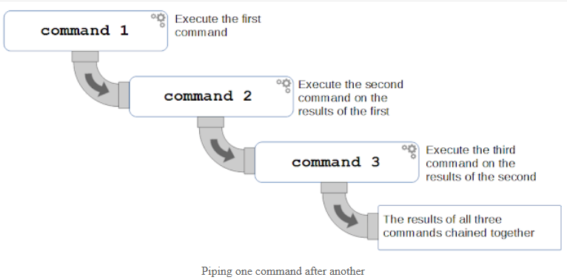

The command as it would be run from the command line would be as follows;
ls -lt /var/log | head | grep root
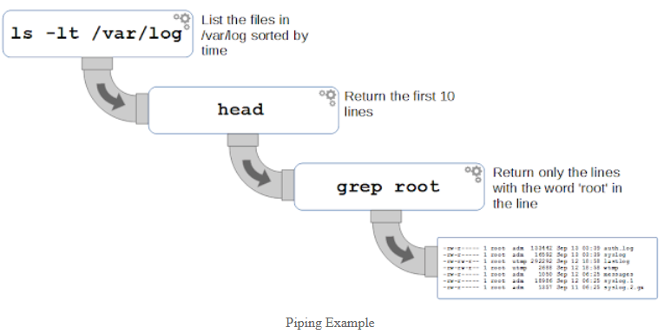
Example 1
$ ls -l /etc | wc
Output
215 1940 11872
Explanation:
- ls -l /etc lists files in the /etc directory.
- The output is sent to the wc command.
- wc counts lines, words, and characters.

Example 2
Display the directory listing page by page.
$ ls -l /etc | more
Explanation:
- ls -l /etc lists files.
- more shows the output one screen at a time.

Example 3
$ ls -l /etc | wc | wc -l
Output
1
Explanation:
- First wc gives line, word, and character count.
- The second wc -l counts the number of lines in that output, which is 1.

Example 4
Display the first 5 lines of output.
$ ls -l /etc | head -5

💡 Note:
Instead of ls -l, many Linux distributions support the shortcut command:
ll

Topic: tee Command
Requirement
Save the output of a command to a file and also send it as input to another command.
If we try:
$ ls -l > output.txt | wc
This will not work properly because redirection breaks the pipe.
To solve this problem, we use the tee command.

What is tee?
The tee command works like a T-junction pipe.
It:
- Takes one input
- Produces two outputs
- Writes output to a file
- Sends the same output to the next command
Syntax:
[command] | tee [options] [filename]

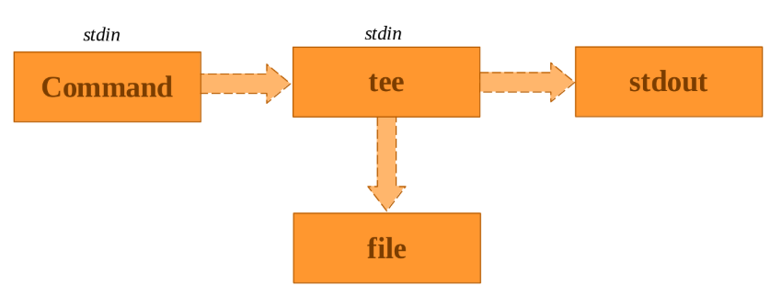

Example 1
Save the output of ls to a file and also display it on the terminal.
$ ls -l | tee abc.txt
Explanation:
- Output is displayed on the terminal
- Output is also saved in abc.txt

Example 2
Save output and also pass it to another command.
$ ls | tee abc.txt | wc
Explanation:
- ls -l output is saved in output.txt
- The same output is sent to wc -l to count lines.
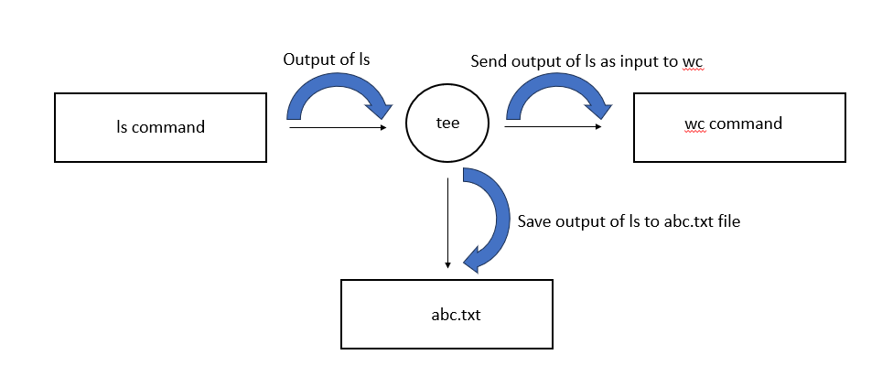

Example 3
Save output and also pass it to another command.
$ ls -l | tee output.txt | wc -l
Explanation:
- ls -l output is saved in output.txt
- The same output is sent to wc -l to count lines.

Topic: xargs Command
Problem
Some commands do not accept input from pipes. They only accept command line arguments.
Example:
$ date | echo
This will not work because:
- date produces output stream
- echo accepts command line arguments, not stream input.

Solution: xargs
xargs converts the output stream into command line arguments.
The xargs command takes the output of one command and converts it into arguments for another command.

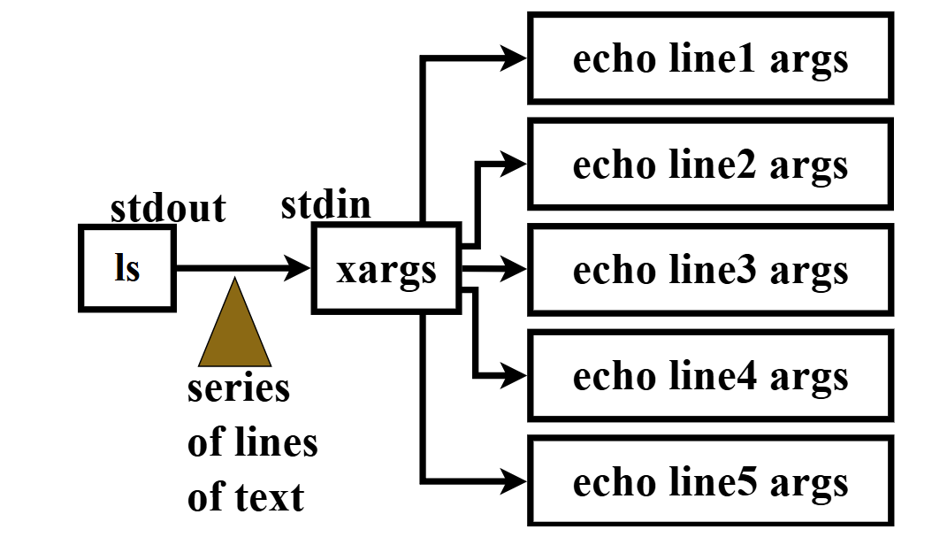

Example
$ date | xargs echo
Explanation:
- date produces output
- xargs converts it to arguments
- echo prints the result

Example 1
Assume input.txt contains file names.
Goal:
- Read file names from input.txt
- Display their contents
- Save them to output.txt
- Count total lines
$ cat input.txt | xargs cat | tee output.txt | wc -l
Explanation:
- cat input.txt reads file names
- xargs cat displays contents of those files
- tee output.txt saves the data
- wc -l counts total lines

Example 2
Remove all files listed in input.txt.
$ cat input.txt | xargs rm
Explanation:
- File names from input.txt are passed as arguments to rm.

Common Use Cases of xargs
Here are some practical examples of how the xargs command is used in Linux systems.

1. Automatically Delete Old Files
find /var/log -type f -mtime +30 | xargs rm
Explanation:
- find /var/log searches for files in the /var/log directory.
- -type f selects only files.
- -mtime +30 finds files older than 30 days.
- xargs rm passes those file names to the rm command to delete them.
✅ This helps remove old log files automatically and keep the system clean.

2. Compress Files in Batches
find . -name "*.txt" | xargs -n 10 tar -czf archive.tar.gz
Explanation:
- find . -name "*.txt" finds all .txt files in the current directory.
- xargs -n 10 passes 10 files at a time to the next command.
- tar -czf archive.tar.gz compresses those files into an archive.
✅ Useful when working with many files, because it processes them in groups.

3. Run Commands in Parallel (Faster Execution)
find . -name "*.log" | xargs -P 4 gzip
Explanation:
- find locates all .log files.
- xargs -P 4 runs 4 processes at the same time.
- gzip compresses the log files.
✅ This speeds up processing by running multiple tasks in parallel.

Questions
Q1
List contents of /dev and save to file1.txt.
$ ls /dev > file1.txt
Q2
List contents of /bin and save to file2.txt.
$ ls /bin > file2.txt
Q3
Pipeline Requirement:
- Read file1.txt and file2.txt
- Save combined output to file3.txt
- Sort in reverse order
- Save result to sorted.txt
$ cat file1.txt file2.txt | tee file3.txt | sort -r > sorted.txt

Q4
How to save the output of command B while piping A, B and C?
A | B | tee results.txt | C

Q5)
If command B does not accept standard input but only arguments?
Use xargs.
A | xargs B

Topic: How to Use Multiple Commands in a Single Line
Sometimes we may need to run several commands in one line instead of executing them one by one.
In Linux, we can do this in two ways.
1. Using Semicolon (;)
2. Using && (AND Operator)

1. Using Semicolon (;)
A semicolon (;) allows us to execute multiple commands one after another in a single line.
Syntax
cmd1 ; cmd2 ; cmd3 ; ... ; cmdn
How it Works
- First cmd1 runs.
- Then cmd2 runs.
- Then cmd3, and so on.
Even if one command fails, the remaining commands will still execute.

Example
Requirement:
- Create a directory dir1
- Create files a.txt, b.txt, and c.txt
- Write the current date and time to a.txt
- Write the current month calendar to b.txt
mkdir dir1 ; touch dir1/{a,b,c}.txt ; date > dir1/a.txt ; cal > dir1/b.txt

Example When a Command Fails
mkdir dir1 ; touch dir1/{a,b,c}.txt ; Date > dir1/a.txt ; cal > dir1/b.txt
Explanation:
- Date is incorrect (Linux command is date).
- The 3rd command fails.
- But the 4th command (cal) still runs.

2. Using && (AND Operator)
The && operator executes the next command only if the previous command is successful.
Syntax
cmd1 && cmd2 && cmd3 && ... && cmdn
How it Works
- cmd1 runs first.
- If cmd1 is successful → cmd2 runs.

If any command fails, the remaining commands will not execute.

Example
mkdir dir1 && touch dir1/{a,b,c}.txt && date > dir1/a.txt && cal > dir1/b.txt
Explanation:
- If directory creation is successful → files are created.
- If file creation is successful → date is written to a.txt.
- Finally, calendar is written to b.txt.

Example When a Command Fails
mkdir dir1 && touch dir1/{a,b,c}.txt && Date > dir1/a.txt && cal > dir1/b.txt
Explanation:
- Date is an incorrect command.
- The 3rd command fails.
- Therefore, the 4th command (cal) will NOT execute.

Simple Summary
Operator | Behavior
; | Executes all commands even if one fails
&& | Executes next command only if previous command is successful

Topic: Regular Expressions and Wildcard Characters in Linux
Sometimes we need to work with multiple files that follow a specific pattern. To represent such patterns, we use Regular Expressions.
In Linux, wildcard characters help us create these patterns easily.
A wildcard character acts as a substitute for one or more characters in file names.

1. Basic Wildcard Characters
Wildcard | Meaning | Example | Example Description
* | Represents zero or more characters | ls *.txt | Lists all files with .txt extension
? | Represents exactly one character | ls a? | Lists files with two characters where the first letter is a (example: ab, ac)
[abc] | Matches a or b or c | ls [abc]* | Lists files starting with a, b, or c
[!abc] | Matches any character except a, b, or c | ls [!abc]* | Lists files that do not start with a, b, or c

2. Character Ranges
Pattern | Meaning | Example | Example Description
[a-z] | Any lowercase letter | ls [a-z]* | Lists files starting with a lowercase letter (a to z)
[A-Z] | Any uppercase letter | ls [A-Z]* | Lists files starting with an uppercase letter (A to Z)
[0-9] | Any digit | ls [0-9]* | Lists files starting with a digit (0 to 9)
[a-zA-Z] | Any alphabet | ls [a-zA-Z]* | Lists files starting with any alphabet (uppercase or lowercase)
[a-zA-Z0-9] | Any alphanumeric character | ls [a-zA-Z0-9]* | Lists files starting with a letter or digit

3. POSIX Character Classes
Pattern | Meaning | Example | Example Description
[[:lower:]] | Lowercase letters | ls [[:lower:]]* | Lists files starting with a lowercase letter
[[:upper:]] | Uppercase letters | ls [[:upper:]]* | Lists files starting with an uppercase letter
[[:alpha:]] | Alphabet characters | ls [[:alpha:]]* | Lists files starting with any alphabet letter
[[:digit:]] | Digits | ls [[:digit:]]* | Lists files starting with a digit
[[:alnum:]] | Alphanumeric characters | ls [[:alnum:]]* | Lists files starting with a letter or digit

Curly Braces {}
Pattern | Meaning | Example | Example Description
{pattern1,pattern2} | Used to match multiple patterns at the same time | ls {*.java,*.py} | Lists all .java files and .py files in the current directory

Quick Memory Trick
Symbol | Remember
* | Any number of characters (many characters)
? | One character (one character)
[ ] | Range or group (range or selection)
{ } | Multiple patterns (multiple patterns)

5. Common ls Command Examples
Command | Meaning | Example Description
ls * | List all files | Displays all files in the current directory
ls *.txt | List .txt files | Displays all files with .txt extension
ls a* | Files starting with a | Lists files whose names start with a
ls a*t | Files starting with a and ending with t | Lists files that begin with a and end with t
ls ??? | Files with exactly 3 characters | Lists files whose names contain exactly three characters
ls ???* | Files with at least 3 characters | Lists files whose names contain three or more characters

6. Using Wildcards with Other Commands
Wildcard characters can also be used with commands like cp (copy), mv (move), and rm (remove).
Command | Purpose | Example Description
cp [0-9]* dir1 | Copy files | Copies all files starting with a digit into dir1 directory
mv [[:alpha:]]*.txt dir2 | Move files | Moves all .txt files starting with alphabets to dir2
rm [abc]*[et] | Remove files | Deletes files starting with a, b, or c and ending with e or t

Examples with ls Command
No | Command | Description
1 | ls * | Lists all files in the current directory
2 | ls *.* | Lists all files with extensions
3 | ls a* | Lists files starting with a
4 | ls a*t | Lists files starting with a and ending with t
5 | ls *.java | Lists all .java files
6 | ls a? | Lists files with two characters where the first letter is a
7 | ls ??? | Lists files with exactly three characters
8 | ls ???* | Lists files with at least three characters
9 | ls [abc]* | Lists files starting with a, b, or c
10 | ls [!abc]* | Lists files not starting with a, b, or c
11 | ls [a-z]* or ls [[:lower:]]* | Lists files starting with lowercase letters
12 | ls [A-Z]* or ls [[:upper:]]* | Lists files starting with uppercase letters
13 | ls [0-9]* or ls [[:digit:]]* | Lists files starting with digits
14 | ls [[:upper:]][[:digit:]][[:lower:]] | Lists files where first letter is uppercase, second is digit, third is lowercase
15 | ls [![:alnum:]]* | Lists files starting with special characters

Wildcards with File Operations
No | Command | Description
16 | cp [0-9]* dir1 | Copies all files starting with digits to dir1
17 | cp [[:digit:]]* dir1 | Copies files starting with digits to dir1
18 | mv [[:alpha:]]*.txt dir2 | Moves .txt files starting with alphabets to dir2
19 | rm [abc]*[et] | Removes files starting with a, b, or c and ending with e or t

Topic: Locate Command in Linux
The locate command is used to find files and directories in the system.
Instead of searching the entire filesystem, the locate command searches a pre-built database that contains information about files and directories.
Because it searches in a database, the locate command is very fast compared to other search commands.
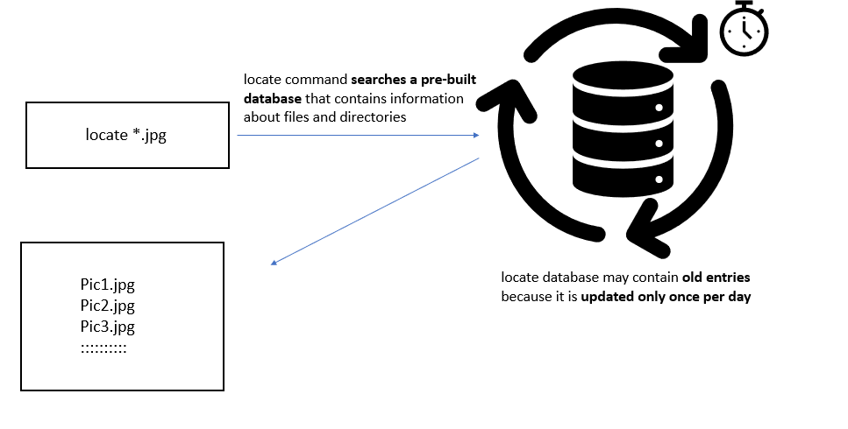

Important locate Command Options
Option | Meaning | Example | Description
-i | Ignore case while searching | locate -i *.jpg | Finds files regardless of case (e.g., .jpg, .JPG, .Jpg)
--limit | Limit the number of results | locate --limit 5 *.conf | Displays only the first 5 matching results
-L | Follow symbolic links | locate -L *.txt | Shows results by following symbolic links and ignores broken links
-e | Show only existing files | locate -e *.jpg | Displays only files that currently exist in the system
--existing | Same as -e (check file existence) | locate --existing *.conf | Ensures the file exists before displaying it
--follow | Follow symbolic links | locate --follow *.txt | Prevents broken symbolic links from appearing in the output

Note:
To avoid showing broken symbolic links, we can use -L or --follow.

Basic Example
1. Find all .jpg files
locate *.jpg
Explanation:
This command lists all files with the .jpg extension in the system.

2. Ignore Case While Searching
By default, the locate command is case-sensitive.
To ignore case differences, we use the -i option.
Example
locate -i *.jpg
Explanation:
This command finds .jpg, .JPG, .Jpg, etc.
⚠ Note:
In some Ubuntu systems, the -i option may not work properly.

3. Limit the Number of Results
We can limit the number of results displayed using the --limit option.
Example
locate --limit 5 *.conf
Example Output:
/etc/adduser.conf
/etc/apg.conf
/etc/appstream.conf
/etc/brltty.conf
/etc/ca-certificates.conf
Explanation:
Only the first 5 matching results will be displayed.

4. Check if Files Exist
The locate database may contain old entries because it is updated only once per day.
To display only existing files, we use the -e or --existing option.
Example
locate --existing *.jpg
Explanation:
Displays only .jpg files that actually exist in the system.

5. Ignore Broken Symbolic Links
To avoid showing broken symbolic links, we use the -L or --follow option.
Example
locate --follow *.txt
Explanation:
Shows .txt files but skips broken symbolic links.

6. Using Multiple Options Together
We can combine several options in one command.
Example
locate --existing --follow -i --limit 5 *.conf | wc -l
Explanation:
This command:
- Ignores case (-i)
- Shows only existing files (--existing)
- Skips broken symbolic links (--follow)
- Limits results to 5
- Counts the number of results using wc -l

7. Comparing Results
You can compare results using different options.
locate *.conf | wc -l
locate -i *.conf | wc -l
locate --existing -i *.conf | wc -l
locate --existing --follow -i *.conf | wc -l
locate --existing --follow -i --limit 10 *.conf | wc -l
Each command may produce different result counts depending on the options used.

8. Viewing Locate Database Information
To view information about the locate database, use the -S option.
Example
locate -S
Example Output:
Database /var/lib/mlocate/mlocate.db:
39,527 directories
369,078 files
242,42,520 bytes in file names
93,40,974 bytes used to store database
Explanation:
This shows:
- Number of directories
- Number of files
- Database size

Updating the Locate Database
The locate database is updated automatically once per day.
If new files are created or deleted, the database may not reflect the changes immediately.
To update it manually, use the updatedb command.
Example
sudo updatedb
Note:
Administrator (sudo) permission is required.

Multiple Choice Questions
Q1) Which of the following are valid options for the locate command?
Option
-i
--limit
-L
-e
--existing
--follow
✅ Answer: G) All of these

Q2) Locate command internally uses a database to find results.( True / False)
Answer: True

Q3) A file named demo.txt was created 2 hours ago, but the locate database has not been updated yet. Will locate find it? (Yes or No)
Answer: No

Q4) How can we update the database used by the locate command?
Option | Command
A | update locatedb
B | updatedb
C | sudo updatedb
✅ Answer: C) sudo updatedb

Topic: find Command in Linux
The find command is used to search for files and directories in the Linux file system.
Unlike the locate command, the find command searches the filesystem in real time, so it always shows current results.
The find command provides many powerful search options such as:
• Search only files
• Search only directories
• Search by name
• Search by file size
• Restrict search depth
• Use the search results for other commands (cp, mv, rm, etc.)

Basic Usage of find Command
1. Find Files and Directories in Current Directory
find
Explanation
This command finds all files and directories in the current directory and its subdirectories.
This is the default behaviour of the find command.

2. Find Files in a Specific Directory
We can also search inside a specific directory.
Example
find /dev
find /etc
Explanation
These commands search for all files and directories inside /dev or /etc and their subdirectories.

Restrict search depth (-maxdepth)
By default, find searches all directory levels.
We can limit the search depth using the -maxdepth option.
Example Directory Structure
Desktop
│
├── file1.txt
├── level_1_dir
│ ├── file2.txt
│ ├── level_2_dir
│ ├── file3.txt
│ ├── level_3_dir
│ ├── file4.txt
│ ├── level_4_dir
│ └── file5.txt
Create This Structure
mkdir -p level_1_dir/level_2_dir/level_3_dir/level_4_dir
touch file1.txt
touch level_1_dir/file2.txt
touch level_1_dir/level_2_dir/file3.txt
touch level_1_dir/level_2_dir/level_3_dir/file4.txt
touch level_1_dir/level_2_dir/level_3_dir/level_4_dir/file5.txt
Explanation
Command | Description
find . -maxdepth 1 | Searches only the current directory
find . -maxdepth 2 | Searches current directory and one level below
find . -maxdepth 3 | Searches up to three levels deep
find . -maxdepth 100 | Searches almost the entire directory tree

Important Note
1. Use single hyphen (-) with maxdepth.
-maxdepth ✅ Valid
--maxdepth ❌ Invalid
2. The find command also searches hidden files and directories.

Find by Type (-type)
We can search only files or only directories using the -type option.
Option | Meaning
-type f | Search only files
-type d | Search only directories
Example
find -type f
Output Example
./file1.txt
./level_1_dir/file2.txt
./level_1_dir/level_2_dir/file3.txt
Example
find -type d
Output Example
.
./level_1_dir
./level_1_dir/level_2_dir
./level_1_dir/level_2_dir/level_3_dir

Important Note
When using multiple options, -maxdepth should come first.
❌ Incorrect
find -type f -maxdepth 2
⚠ May generate warning.
✅ Correct
find -maxdepth 2 -type f

Find by Name (-name)
We can search files and directories using the -name option.
Create Sample Files
touch {A..D}.txt
touch {A,B}{A,B}.txt
Examples
find . -name 'A.txt'
find . -name '?.txt'
find . -name '??.txt'
find . -name '*.txt'
find . -maxdepth 2 -name '*.txt'
Explanation
Pattern | Meaning
A.txt | Finds file named A.txt
?.txt | Finds files with single character name
??.txt | Finds files with two character names
*.txt | Finds all .txt files

Ignore Case While Searching
To ignore case differences, use -iname.
find -iname 'a.txt'
Explanation
This finds:
a.txt
A.txt
A.TXT

Find Files by Size (-size)
We use the -size option to search by file size.
Symbol | Meaning
+n | Greater than n
-n | Less than n
n | Exactly n

Example 1
Find files larger than 200 KB
find / -type f -size +200k
This command may require root privileges.
sudo find / -type f -size +200k | wc -l
Counts the number of such files.

Example 2
Find files greater than 200 KB but less than 4 MB
find / -type f -size +200k -size -4M | wc -l

Example 3
Find files less than 200 KB OR greater than 4 MB
find / -type f -size -200k -o -size +4M | wc -l
-o means OR.

Question
find / -type f -size -200k -size +4M | wc -l
Answer
0
Because a file cannot be both less than 200 KB AND greater than 4 MB at the same time.

Find Empty Files (-empty)
To find empty files or directories, use:
find . -empty
Explanation
This finds:
• Empty files
• Empty directories

Using Search Results with Other Commands
We can perform operations on the results of the find command using -exec.
-exec means execute a command on the search results.

Example
Copy files smaller than 2 KB from /etc to dir1.
find /etc -type f -size -2k -exec cp {} dir1 \;
Explanation
Symbol | Meaning
{} | Represents the found file
\; | Ends the command

Confirmation Before Execution
If you want confirmation before executing the command, use -ok instead of -exec.
Example
find /etc -type f -size -2k -ok cp {} dir1 \;
Example prompt:
< cp ... /etc/magic.mime > ? y
You must type y to confirm.

Practice Assignment
Create Directory Structure
mkdir magic
mkdir magic/dir{1..100}
touch magic/dir{1..100}/file{1..100}.txt
Create one random file:
touch magic/dir$(shuf -i 1-100 -n 1)/sunny.txt
Find the file
find magic -type f -name 'sunny.txt'
Move the file to Desktop:
find magic -type f -name 'sunny.txt' -exec mv {} ~/Desktop \;
Delete all .txt files:
find magic -type f -name '*.txt' -exec rm {} \;

Multiple Choice Questions
Q1) The find command uses a database to search files.
A) True
B) False
✅ Answer: B) False

Q2) To find files and directories inside /dev folder up to 2 levels deep
A) find -start /dev -depth 2
B) find /dev -depth 2
C) find /dev -maxdepth 2
✅ Answer: C

Q3) To find only directories inside /dev up to 2 levels deep
A) find /dev -maxdepth 2 -type f
B) find /dev -maxdepth 2 -type d
C) find /dev -type d -maxdepth 2
✅ Answer: B

Q4) To find files starting from root directory where file name ends with .txt
find / -type f -name "*.txt"

Q5) To find files in /dev up to 3 levels deep and size greater than 200 KB
A) find / -maxdepth 3 -size 200k
B) find /dev -maxdepth 3 -size 200k
C) find /dev -maxdepth 3 -size -200k
D) find /dev -maxdepth 3 -size +200k
✅ Answer: D

Q6) Remove all files larger than 3 MB in home directory
A) find ~ -type f -size +3M -exec rm {} \;
B) find ~ -type f -size -3M -exec rm {}
C) find ~ -type f -size -3M -exec rm {} \;
D)find ~ -type f -size +3M rm {} \;
✅ Answer: A

Difference Between find and locate Commands
Feature | find Command | locate Command
Search Method | Searches the filesystem directly | Searches a pre-built database
Speed | Slower because it scans directories in real time | Very fast because it reads from database
Accuracy | Always shows latest files and directories | May show old results if database is not updated
Database Requirement | ❌ Does not use any database | ✅ Uses locate database
Update Requirement | No update required | Database must be updated using updatedb
Search Filters | Supports many filters like size, type, depth, permissions, time | Limited filtering options
Hidden Files | Finds hidden files automatically | Depends on the database
Command Example | find /home -name "*.txt" | locate *.txt
Use Case | Used when precise and advanced search is required | Used when fast search is needed

Topic: grep Command in Linux
The grep command is used to search for a pattern inside files.
grep stands for: Global Regular Expression Print
It searches for the given pattern and prints the matching lines.
Syntax
grep <pattern> filename
If the pattern is found, grep prints the entire line containing that pattern.

Example File
cat subjects.txt

Output:
Fee 1000
2000
250
3500
400
1000

1. Search Data in a Single File
Example
grep durga subjects.txt
Explanation
This command searches the word durga inside subjects.txt and prints all matching lines.
Example Output
3. unix durga 250
5. UNIX durga 400
6. Java durga 1000
You can also write the command as:
grep 'durga' subjects.txt
grep "durga" subjects.txt

All three commands work the same.

2. Search in Multiple Files
We can search the same pattern in multiple files.
Example
grep durga subjects.txt career.txt
Example Output
subjects.txt:3. unix durga 250
subjects.txt:5. UNIX durga 400
subjects.txt:6. Java durga 1000
career.txt:durga

Explanation
grep prints:
• File name
• Matching line

Search in All .txt Files
grep durga *.txt
This searches all text files in the current directory.

Important grep Options
Option | Meaning | Example | Description
-i | Ignore case | grep -i unix demo.txt | Finds unix, UNIX, Unix
-c | Count matches | grep -c unix demo.txt | Shows number of matching lines
-n | Show line numbers | grep -n durga demo.txt | Displays line numbers
-l | Show file names only | grep -l durga *.txt | Displays only file names
-v | Invert match | grep -v durga demo.txt | Prints lines that do NOT match
-w | Exact word match | grep -w unix demo.txt | Matches only the exact word
-A | Lines after match | grep -A 2 word demo.txt | Shows 2 lines after match
-B | Lines before match | grep -B 2 word demo.txt | Shows 2 lines before match
-C | Lines before and after | grep -C 2 word demo.txt | Shows surrounding lines
-o | Print only matched text | grep -o unix demo.txt | Prints only matched pattern
-R | Recursive search | grep -R unix folder/ | Searches inside directories

3. Ignore Case While Searching
By default, grep is case-sensitive.
To ignore case differences, use -i.
Example
grep unix *.txt
Output
career.txt:unix jksadjfklasjdkflajs
subjects.txt:3. unix durga 250
Now ignore case:
grep -i unix *.txt
Output
career.txt:unix jksadjfklasjdkflaj
subjects.txt:3. unix durga 250
subjects.txt:5. UNIX durga 400

4. Count Number of Matches
Use -c option.
Example
grep -c unix *.txt
Output
career.txt:1
subjects.txt:1

5. Display Line Numbers
Use -n option.
Example
grep -n durga *.txt
Output
career.txt:4:durga
career.txt:7:durga ksdjfdlakjklfjad
subjects.txt:4:3. unix durga 250
subjects.txt:6:5. UNIX durga 400
subjects.txt:7:6. Java durga 1000

6. Show Only File Names
Use -l option.
Example
grep -l durga *.txt
Output
subjects.txt
career.txt

7. Print Lines That Do NOT Match
Use -v option.
Example
grep durga subjects.txt
Output
3. unix durga 250
5. UNIX durga 400
6. Java durga 1000

Now invert the result:
grep -v durga subjects.txt
Output
1. Python Nagoor 1000
2. Java Sriman 2000
4. DevOps Sriman 3500

8. Search Exact Word
Use -w option.
Example
grep -i unix demo.txt
Output
UnixDemo session
unix material

Now search exact word:
grep -iw unix demo.txt
Output
unix material
UNIX classes and videos

9. Display Lines Before or After Match
Option | Meaning
-A | After lines
-B | Before lines
-C | Before and after lines
Example
grep friends demo.txt
Output
Hello friends how are you
Show 2 lines after
grep -A 2 friends demo.txt
Show 2 lines before
grep -B 2 friends demo.txt
Show 2 lines before and after
grep -C 2 friends demo.txt

10. Print Only the Matching Pattern
Use -o option.
Example
grep c[aeiou]ll demo.txt
Output
call center
cell point
college for unix

Now print only matched pattern:
grep -o c[aeiou]ll demo.txt
Output
call
cell
coll

11. Search Recursively in Directories
To search inside directories and subdirectories, use -R option.
Example
grep -R unix resumes/
Explanation
This searches for unix in all files inside the resumes directory and its subdirectories.

Practical Assignment
1. Save running processes into a file
ps -ef > results.txt

2. Display lines containing lib
grep lib results.txt

3. Display lines NOT containing lib
grep -v lib results.txt

4. Count lines containing lib
grep -c lib results.txt

5. Display lines containing lib with line numbers
grep -n lib results.txt

6. Display lines not containing lib (only first 2 lines)
grep -v lib results.txt | head -2

Example Employee File
cat emp.dat
100|sunny|1000|mumbai|admin|female
200|bunny|2000|chennai|sales|male
300|chinny|3000|delhi|accounting|female
400|vinny|4000|hyderabad|admin|male
500|pinny|5000|mumbai|sales|female

Display employees in admin department
grep admin emp.dat

Display employees in admin or sales
grep -E 'admin|sales' emp.dat

Display male employees in admin or sales
grep -E 'admin|sales' emp.dat | grep male

Topic: grep Regular Expression
Regular expressions help us search complex patterns in files using the grep command.
All Regular expression patterns are divided into 3 types.
1) Character Patterns
2) Word Patterns
3) Line Patterns

1. Character Patterns
These patterns match specific characters or groups of characters.
Pattern | Meaning | Example | Description
. | Any single character | grep b..l demo.txt | Finds 4-letter words starting with b and ending with l
[abc] | a or b or c | grep [abc]at demo.txt | Finds aat, bat, cat
[^abc] | Not a, b, or c | grep [^abc]at demo.txt | Finds words like dat, eat
[a-z] | Lowercase letters | grep [a-z] demo.txt | Finds lines containing lowercase letters
[0-9] | Digits | grep [0-9] demo.txt | Finds lines containing numbers
[aeiou] | Vowels | grep [aeiou] demo.txt | Finds lines containing vowels
Example
grep 'c[aeiou]ll' demo.txt
Matches:
call
cell
cill
coll
cull

2. Word Patterns
These patterns help search whole words.
Pattern | Meaning | Example | Description
\<word\> | Exact word | grep '\<unix\>' demo.txt | Matches only unix
\<word | Word starting with | grep '\<durga' demo.txt | Finds durgasoft, durga
word\> | Word ending with | grep 'durga\>' demo.txt | Finds techdurga

Example File
cat demo.txt
durga
durgasoft
techdurga
softwaredurgasolutions
Search exact word
grep '\<durga\>' demo.txt
Output
durga

3. Line Patterns (Anchors)
Anchors are used to match beginning or end of a line.
Pattern | Meaning | Example | Description
^ | Start of line | grep '^d' demo.txt | Lines starting with d
$ | End of line | grep 't$' demo.txt | Lines ending with t
^word | Line starts with word | grep '^the' demo.txt | Lines starting with the
word$ | Line ends with word | grep 'unix$' demo.txt | Lines ending with unix

Example
grep '^d' demo.txt
Output
durga
durgasoft

Lines Ending With a Digit
grep '[0-9]$' demo.txt
Finds lines ending with numbers.

4. Find Blank Lines
Display blank lines
grep '^$' demo.txt
Remove blank lines
grep -v '^$' demo.txt
Explanation:
Command | Description
grep '^$' | Shows blank lines
grep -v '^$' | Removes blank lines

Example: Remove Blank Lines from File
grep -v '^$' demo.txt > temp.txt
mv temp.txt demo.txt

5. Find Lines Starting with Vowels
grep '^[aeiou]' demo.txt
Explanation:
Shows lines that start with a, e, i, o, or u.

6. Find Lines NOT Starting with Vowels
grep '^[^aeiou]' demo.txt
Shows lines that do not start with vowels.

7. Find Exact Line Content
grep '^unix$' demo.txt
Explanation:
Shows lines where the entire line is exactly “unix”.

8. Find Lines with Exact Number of Characters
Example: find lines with 4 characters
grep '^....$' demo.txt
Explanation:
Symbol | Meaning
. | Any character
.... | Four characters
^ $ | Start and end of line

9. Count Directories in Current Folder
ls -l | grep '^d' | wc -l
Explanation
Command | Purpose
ls -l | List files with details
grep '^d' | Select directories
wc -l | Count them

10. Count Files in Current Directory
ls -l | grep '^-' | wc -l
Explanation
Symbol | Meaning
- | Regular file
d | Directory
l | Link file

Easy Way to Remember Important grep Patterns
Pattern | Meaning
^ | Start of line
$ | End of line
. | Any character
[abc] | One of the characters
[^abc] | Not those characters
[0-9] | Numbers
[a-z] | Lowercase letters
\<word\> | Exact word

Topic: Compression and Uncompression of Files
In system administration, it is common to combine and compress multiple files into one file.
Advantages of Compression
- It saves disk space.
- It makes file transfer easier.
- It reduces download time.
This process usually has two steps:
- Create an archive file (combine multiple files into one file)
- Apply compression on the archive file

Common Commands Used for Compression
Command | Purpose | Description
tar | Archive files | Combines multiple files and directories into a single archive file
gzip | Compress file | Compresses files using the gzip compression algorithm
gunzip / gzip -d | Decompress gzip file | Restores original file from .gz compressed file
bzip2 | Compress file | Compresses files with a higher compression ratio than gzip
bunzip2 | Decompress bzip2 file | Restores original file from .bz2 compressed file

1) Creating an Archive File using tar
The tar command is used to combine multiple files and directories into a single archive file.
tar = Tape Archive

A) Create a tar File
Command | Result | Description
tar -cvf demo.tar file1.txt file2.txt file3.txt | demo.tar | Creates an archive file containing the specified files
tar -cvf demo.tar * | demo.tar | Creates an archive file containing all files in the current directory
Example
Command | Description
tar -cvf demo.tar file1.txt file2.txt file3.txt | Creates demo.tar containing the specified files

B) View Contents of a tar File
Command | Result | Description
tar -tvf demo.tar | List of files | Displays all files stored inside the tar archive
Example
Command | Description
tar -tvf demo.tar | Shows the list of files present inside demo.tar

C) Extract Files from a tar File
Command | Result | Description
tar -xvf demo.tar | Extracted files | Extracts all files from the tar archive
Example
Command | Description
tar -xvf demo.tar | Extracts all files from demo.tar

2. Compression Algorithms
After creating the archive file, we can compress it using different compression tools.
Tool | Description
gzip | Fast compression but slightly less compression ratio
bzip2 | Slower but provides better compression

A) Compression using gzip
1. Compress the tar File
Command | Result | Description
gzip demo.tar | demo.tar.gz | Compresses the demo.tar file using the gzip compression algorithm
Note: The compressed file demo.tar.gz will be created.

2. Uncompress gzip File
Command | Result | Description
gzip -d demo.tar.gz | demo.tar | Decompresses the gzip file and restores the original tar file
gunzip demo.tar.gz | demo.tar | Another command used to decompress the gzip file
Note: After decompression, the original demo.tar file will be restored.

B) Compression using bzip2
1. Compress tar File
Command | Result | Description
bzip2 demo.tar | demo.tar.bz2 | Compresses the tar file using bzip2 compression algorithm

2. Uncompress bzip2 File
Command | Result | Description
bunzip2 demo.tar.bz2 | demo.tar | Decompresses the file and restores the original demo.tar file

C) Creating and Compressing tar File in One Command
Instead of creating a tar file first and then compressing it separately, we can perform both operations in a single command.

1) Using gzip Compression
1. Create and Compress tar File
Command | Result | Description
tar -cvzf demo.tar.gz *.txt | demo.tar.gz | Creates a tar archive and compresses it using gzip
Note:
z option enables gzip compression.

2. Extract Compressed tar File
Command | Result | Description
tar -xvzf demo.tar.gz | Extracted files | Decompresses and extracts files from the archive

2) Using bzip2 Compression
1. Create and Compress tar File
Command | Result | Description
tar -cvjf demo.tar.bz2 *.txt | demo.tar.bz2 | Creates a tar archive and compresses it using bzip2
Note:
j option enables bzip2 compression.

2. Extract Compressed tar File
Command | Result | Description
tar -xvjf demo.tar.bz2 | Extracted files | Decompresses and extracts files from the archive

Use Case: Backup of Home Directory
We can use tar to create a backup of a user's home directory.
Step 1: Check Current Directory
pwd
Output
/home/durgasoft

Step 2: Create Backup
tar -cvzf backup.tar *
This command creates a compressed backup of all files.

Step 3: Move Backup File
mkdir newhome
mv backup.tar newhome

Step 4: Extract Backup
cd newhome
tar -xvzf backup.tar
This command extracts all backup files.

✅ Summary
Command | Purpose
tar | Create and extract archive files
gzip | Compress files
gunzip | Decompress gzip files
bzip2 | Compress files with better compression
bunzip2 | Decompress bzip2 files

Topic: File Permissions in Linux
File permissions define what operations users can perform on files and directories.
These permissions control who can read, modify, or execute a file.
Linux provides security by restricting access to files and directories.

Linux Security
Linux is considered more secure because of two levels of protection.
Security Level | Description
Level 1 | Login with username and password
Level 2 | File and directory permissions
This prevents:
- Unauthorized file access
- Virus files being added to directories
- Hackers accessing system files

1. User Categories in Linux
All users in Linux are divided into the following categories.
Category | Symbol | Description
User / Owner | u | The person who created the file
Group | g | Users who belong to the same group
Others | o | All other users in the system
All | a | Represents user + group + others

Example to Understand User Types
Project: Durgasoft College Automation System
This project is divided into multiple modules.
Module | Developers
Students Module | A, B, C, D
Employees Module | X, Y, Z
Courses Module | M, N
Infrastructure Module | G, H

Suppose Developer A creates a file demo.txt.
Category | Members
Owner | A
Group | B, C, D
Others | X, Y, Z, M, N, G, H

2. Types of Permissions
Linux provides three main permissions for files and directories.
Symbol | Permission | Description
r | Read | View file content
w | Write | Modify file content
x | Execute | Run file as program
- | No Permission | Operation is not allowed

Permission Structure
Example output:
ls -l demo.txt
Output:
-rw-r--r-- 1 user user 0 Nov 27 demo.txt
Section | Meaning
rw- | User permissions
r-- | Group permissions
r-- | Others permissions
Total 9 permission characters:
Category | Permissions
User | rw-
Group | r--
Others | r--
Order is important:
User → Group → Others

3. Operations on Permissions
We can modify permissions using these operators.
Operator | Meaning
+ | Add permission
- | Remove permission
= | Assign exact permission

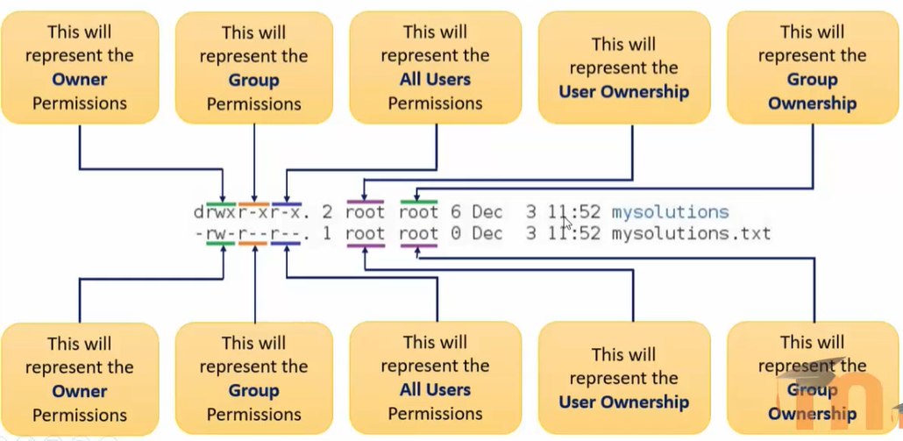
4. chmod Command
chmod means change mode.
It is used to change file or directory permissions.
Syntax
chmod <user_category><operation><permission> file_name
Example
chmod u+x,g+w,o-r demo.txt

Action | Description
u+x | Add execute permission to user
g+w | Add write permission to group
o-r | Remove read permission from others
Note:
Only file owner or root user can change permissions.
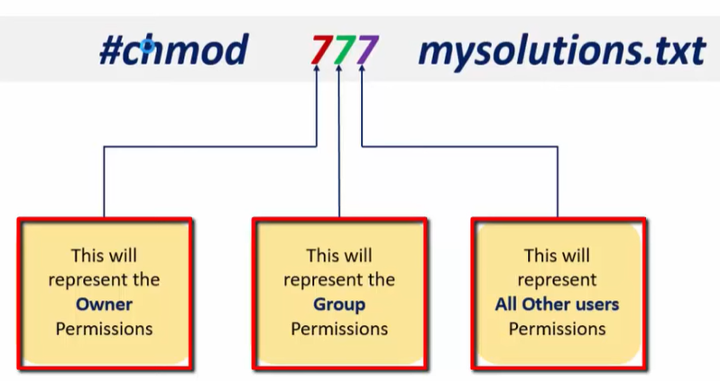

Examples of chmod
Example output:
ls -l demo.txt
Output:
-rw-r--r-- 1 user user 0 Nov 27 demo.txt

Command | Description | Resulting Permission
chmod u+x demo.txt | Add execute permission to user | -rwxr--r--
chmod u+w,g+rw,o+r demo.txt | Add write to user, read & write to group, read to others | -rw-rw-r--
chmod u+x,g-w,o+w demo.txt | Add execute to user, remove write from group, add write to others | -rwxr--rw-
chmod u=rw,g=rw,o=r demo.txt | Assign specific permissions | -rw-rw-r--

5. File Permission
A) Read Permission
If a file does not have read permission, we cannot view its content.
Example:
cat demo.txt
Output:
Permission denied
Commands affected:
Command
cat
head
tail
more
less

B) Write Permission
If a file does not have write permission, we cannot modify the file.
Example:
cat >> demo.txt
Output:
Permission denied

C) Execute Permission
Execute permission allows a file to run as a program.
Example:
./first.sh
If execute permission is missing:
Permission denied
Add execute permission:
chmod u+x first.sh

6. Directory Permissions
Directory permissions behave slightly differently.

A) Read Permission on Directory
Allows user to list files inside the directory.
Example:
ls dir1
Without read permission:
Permission denied

B) Write Permission on Directory
Allows user to add or delete files in a directory.
Example:
touch dir1/file.txt
rm dir1/file.txt
Without write permission:
Permission denied

C) Execute Permission on Directory
Execute permission allows a user to enter the directory.
Example:
cd dir1
Without execute permission:
Permission denied
Important rule:
Condition | Result
No execute permission | Cannot enter directory
No read permission | Cannot list directory files

7. Numeric Permissions (Octal Method)
Permissions can also be set using numbers.
Linux uses octal numbers (0–7).
Number | Binary | Permission
0 | 000 | No permission
1 | 001 | Execute
2 | 010 | Write
3 | 011 | Write + Execute
4 | 100 | Read
5 | 101 | Read + Execute
6 | 110 | Read + Write
7 | 111 | Read + Write + Execute

Shortcut memory trick:
Number | Meaning
4 | Read
2 | Write
1 | Execute

Example:
chmod 632 demo.txt
Meaning:
Category | Permission
User | 6 → rw-
Group | 3 → -wx
Others | 2 → -w-

8. Recursive Permission Change (chmod -R)
The -R option means recursive.
It applies the permission change to a directory and all files/subdirectories inside it.
Syntax
chmod -R permissions directory_name

Example
Command | Description | Result
chmod -R 755 dir1 | Change permissions of directory and all files inside it | All files and subdirectories get rwxr-xr-x
chmod -R u+x dir1 | Add execute permission for user to all files inside directory | User can execute all files
chmod -R g+w dir1 | Add write permission to group for all files | Group members can modify files

Example Scenario
Suppose directory structure is:
dir1/
├── file1.txt
├── file2.txt
└── subdir/
└── file3.txt
Command:
chmod -R 755 dir1
Result:
File/Directory | Permission
dir1 | rwxr-xr-x
file1.txt | rwxr-xr-x
file2.txt | rwxr-xr-x
subdir | rwxr-xr-x
file3.txt | rwxr-xr-x

Important Note
Option | Meaning
chmod -R | Changes permissions recursively for all files and folders
chmod without -R | Changes permissions only for the specified file/directory

9. umask Command
umask means user mask.
It controls default permissions for new files and directories.
Default umask value:
022

Default File Permission Formula
666 - umask
Example:
666 - 022 = 644
Result:
rw-r--r--

Default Directory Permission Formula
777 - umask
Example:
777 - 022 = 755
Result:
rwxr-xr-x

Common umask Values
umask | Result
022 | Standard permission
002 | Group write allowed
077 | Only owner access
007 | No access for others

10. chown Command
chown means change owner.
Only root user can change file ownership.
Example:
chown root demo.txt
Now the owner becomes root.

10. chgrp Command
chgrp means change group.
Example:
chgrp root demo.txt
Now the file belongs to root group.

File Management – Ownership in Linux

These commands control who can access files and how

1. Change File Owner (chown)
🔹 Syntax
chown username filename

🔹 Example
touch sample.txt
ls -l sample.txt
sudo chown javauser sample.txt
ls -l sample.txt
✔ Output
Before:
-rw-r--r-- 1 adminuser adminuser 0 Mar 17 sample.txt
After:
-rw-r--r-- 1 javauser adminuser 0 Mar 17 sample.txt

2. Recursive Owner Change (-R )
👉 Change owner for directory and all files inside
sudo chown -R javauser projectdir/
✔ Changes:
- All files
- All subdirectories

3. Change File Group (chgrp)
🔹 Syntax
chgrp groupname filename

🔹 Example
sudo chgrp pythongroup sample.txt
ls -l sample.txt
✔ Output:
-rw-r--r-- 1 javauser pythongroup 0 Mar 17 sample.txt

4. Recursive Group Change (-R )
sudo chgrp -R pythongroup projectdir/
✔ Applies to all files inside directory

5. Change Owner & Group Together
🔹 Syntax
chown user:group filename

🔹 Example
sudo chown javauser:pythongroup sample.txt
✔ Changes:
- Owner → javauser
- Group → pythongroup

6. Recursive Owner + Group (-R)
sudo chown -R javauser:pythongroup projectdir/
✔ Applies to:
- Directory
- All sub-files
- All sub-directories

Key Observations
Command | Purpose
chmod | Change permissions
chown | Change owner
chgrp | Change group
chown user:group | Change both
-R | Apply recursively

7. Real-Time Examples

Example 1: Script Execution Permission
chmod 755 script.sh
✔ Makes script executable

Example 2: Secure File
chmod 600 secrets.txt
✔ Only owner access

Example 3: Shared File
chmod 660 project.txt
✔ Owner + group access

Example 4: Change Owner & Group
chown dev1:dev project.txt

Example 5: Directory Permission
chmod 755 projectdir/
✔ Directory access enabled

⭐ Example 6: Recursive Ownership Change
chown -R dev1:dev /projectdir
✔ Full directory ownership updated

8. Verification Commands
# Check permissions
ls -l filename
# Check recursively
ls -l /projectdir
# Check user
id username
# Check group
getent group groupname

9. Quick Cheat Sheet
# Change owner
chown user file
# Change group
chgrp group file
# Change both
chown user:group file
# Recursive owner
chown -R user dir
# Recursive group
chgrp -R group dir
# Recursive both
chown -R user:group dir

10. Final Notes
- -R is used for directories
- Be careful → affects all files
- Avoid using in wrong path (/)
- Always verify after recursive changes
- Use for project/shared directories

Topic:File Management – Copy Owner & Group Settings Between Files

- Introduction
- What is Copy Ownership?
- Command Used
- Syntax
- Examples
- Key Observations
- Verification
- Quick Cheat Sheet
- Final Notes

1. Introduction
Sometimes you want:
- Same owner
- Same group
- Same permissions
👉 Instead of setting manually, you can copy from another file

2 What is Copy Ownership?
👉 Copy:
- Owner (user)
- Group
From one file → to another file
📌 Useful in:
- Project setup
- Standard file templates

3 Command Used
👉 Use:
chown --reference

4. Syntax
chown --reference=source_file target_file
✔ Copies:
- Owner
- Group

5. Examples

🔹 Example 1: Copy Owner & Group
ls -l file1 file2
chown --reference=file1 file2
ls -l file1 file2
Before:
-rw-r--r-- 1 user1 dev file1
-rw-r--r-- 1 user2 qa file2
After:
-rw-r--r-- 1 user1 dev file1
-rw-r--r-- 1 user1 dev file2
✔ file2 now has same owner & group as file1

🔹 Example 2: Directory (Recursive)
chown -R --reference=dir1 dir2
✔ Copies ownership for:
- Directory
- All files inside

🔹 Example 3: Real-Time Scenario
touch template.txt newfile.txt
chown dev1:dev template.txt
chown --reference=template.txt newfile.txt
✔ newfile gets same ownership

6. Key Observations
Feature | Behavior
--reference | Copies owner & group
Works on | Files & directories
Combine with -R | Recursive copy
Permissions | ❌ Not copied

7. Important Note (Very Important ⭐)
👉 chown --reference:
- Copies owner & group only
- Does NOT copy permissions
👉 To copy permissions:
chmod --reference=source_file target_file

8. Verification Commands
ls -l file1 file2
id username
getent group groupname

9. Quick Cheat Sheet
# Copy owner & group
chown --reference=source target
# Recursive copy
chown -R --reference=source target
# Copy permissions
chmod --reference=source target

10. Final Notes
- Useful for maintaining consistency
- Avoid manual mistakes
- Works well in automation/scripts
- Always verify using ls -l
- Combine with chmod --reference if needed

Topic: Working with Editors in Linux
Editors are used to create files and modify file content in Linux.
There are many editors available in Linux. The most common ones are:
Editor | Type | Description
gedit | Graphical editor | Similar to Windows Notepad
vi | Command line editor | Works in both desktop and server environments

Important Note
Editor | Works In
gedit | Desktop version only
vi | Desktop and Server
If you connect to a remote server using PuTTY, you cannot use gedit.
You must use vi editor.

1. Working with gedit Editor
gedit is a graphical text editor used in Linux desktop systems.
It is similar to Notepad in Windows.
Syntax
gedit file_name
Example
gedit file1.txt
Create a shell script:
gedit first.sh
Example script content:
echo "This is my first shell script"
mkdir dir{1..6}
echo "Six directories got created"
date
cal
Make the script executable and run it:
chmod u+x first.sh
./first.sh

2. Working with vi Editor
vi means Visual Editor.
It is a command-line editor used to create and edit files.
Syntax
vi file_name
Example
vi file1.txt

Situation | Result
File does not exist | New file will be created
File exists | File opens for editing

To save and exit:
:wq!

Modes in vi Editor
vi editor has three modes.
Mode | Description
Command Mode | Default mode used for commands
Insert Mode | Used to type or edit text
Exit Mode | Used to save or quit editor

1. Command Mode
- Default mode when file opens
- Used to run vi commands
To go to Insert Mode press:
i

2. Insert Mode
- Used to write or edit text
To return to Command Mode press:
Esc

3. Exit Mode
Used to save or exit from the editor.
From Command Mode press:
:

Deleting Lines in vi Editor
Command | Description
dd | Delete the current line where the cursor is located
3dd | Delete the current line and the next 2 lines (total 3 lines)
d$ | Delete content from the cursor position to the end of the line
d^ | Delete content from the cursor position to the beginning of the line
dgg | Delete all lines from the beginning of the file up to the cursor position
dG | Delete all lines from the cursor position to the end of the file

Deleting Entire File Content
Command | Description
ggdG | Delete the entire content of the file
Explanation:
- gg → move to the first line
- dG → delete everything from that line to the end

Opening New Lines in vi
Command | Description
o | Open a new empty line below the current line
O | Open a new empty line above the current line

Copy and Paste in vi
Command | Description
yy | Copy (yank) the current line
3yy | Copy the current line and the next 2 lines
p | Paste the copied content after the cursor
P | Paste the copied content before the cursor

Cursor Navigation Commands
Command | Movement
↑ (Up Arrow) | Move cursor up
↓ (Down Arrow) | Move cursor down
← (Left Arrow) | Move cursor left
→ (Right Arrow) | Move cursor right
$ | Move to the end of the current line
^ | Move to the beginning of the current line
G | Go to the last line of the file
gg | Go to the first line of the file

Additional Navigation Commands
Command | Description
:1 | Move cursor to line number 1
:7 | Move cursor to line number 7
Ctrl + f | Move one page forward (Page Down)
Ctrl + b | Move one page backward (Page Up)

Undo Operation
Command | Description
u | Undo the last action

Exit Mode Commands in vi
Command | Description
:w | Save the file
:wq | Save the file and exit the editor
:wq! | Force save and exit
:q | Quit the editor
:q! | Exit without saving changes

Line Number Commands
Command | Description
:set number | Display line numbers in the editor
:set nonumber | Hide line numbers

Linux User Management
Linux user management is an important part of system administration. It helps you:
- create users
- update user details
- delete users
- create and manage groups
- switch between users
- set and change passwords
- manage file permissions
- use admin access safely with sudo
This document is organized section by section with simple explanations, tables, and examples.

1. Creating Users
A user in Linux is an account that can log in and use the system.
Each user usually has a:
- username
- UID (User ID)
- home directory
- default shell
Common Commands for Creating Users
Command | Purpose
useradd | Create a user using a basic command
adduser | Create a user using an interactive command
passwd | Set password for a user

1.1 Create a User with useradd
useradd is a low-level command. It creates the user, but you may need to set other things manually.
Syntax
sudo useradd username
Example
sudo useradd viswa
sudo passwd viswa
This usually:

- creates the user
- creates a group with the same name
- creates the home directory
- asks for password
- asks for extra details
Getting User Information
id username | Show user ID, group ID, and groups

1.2 Create a User with adduser
adduser is easier because it is interactive.
Syntax
sudo adduser username
Example
sudo adduser pyuser2
This usually:
- creates the user
- creates a group with the same name
- creates the home directory
- asks for password
- asks for extra details
- Getting User Information
id username | Show user ID, group ID, and groups

1.3 Create a User in a Specific Group
Syntax
sudo adduser --ingroup groupname username
Example
sudo adduser --ingroup pythongroup pyuser1
This creates pyuser1 and adds the user to the group pythongroup.
Getting User Information
id username | Show user ID, group ID, and groups

1.4 Important Notes
User details are stored in:
/etc/passwd
Password details are stored in:
/etc/shadow
Example check
id pyuser1
This shows:
- UID
- GID
- groups of the user

2. Getting User Information
Linux provides commands to check user details and current user status.
Common Commands
Command | Purpose
id username | Show user ID, group ID, and groups
whoami | Show current logged-in user
groups | Show groups of current or given user
finger username | Show detailed user information

2.1 Check Current User
Command
whoami
Example
whoami
Output Example
durga

2.2 Check Information of a Specific User
Command
id username
Example
id pyuser1
This shows:
- user ID
- primary group
- secondary groups

2.3 Check User Groups
Current user
groups
Specific user
groups username
Example
groups durga

2.4 Get Detailed User Information with finger
Command
finger username
Example
finger durga
If the command is not installed, install it first:
sudo apt install finger
finger can show:
- login name
- full name
- home directory
- shell
- login time
- mail information

3. Managing Groups
Groups are used to manage permissions easily. Instead of giving permissions to many users one by one, you can put them in a group.
Common Group Commands
Command | Purpose
groupadd | Create a group
addgroup | Create a group (common on Ubuntu/Debian)
groupdel | Delete a group
delgroup | Delete a group (common on Ubuntu/Debian)
usermod -g | Change user’s primary group
usermod -aG | Add user to secondary groups

3.1 Create a New Group
Using groupadd
sudo groupadd developers
Using addgroup
sudo addgroup pythongroup
Output Example
Adding group `pythongroup' (GID 1006) ... Done.

3.2 Add a User to a Group
Syntax
sudo usermod -aG groupname username
Example
sudo usermod -aG developers viswa
Important
- -G means secondary groups
- -a means append
- without -a, existing secondary groups may be removed

3.3 Change User’s Primary Group
Syntax
sudo usermod -g groupname username
Example
sudo usermod -g durga pyuser7
Check result
groups pyuser7

3.4 Add User to Multiple Groups
Syntax
sudo usermod -aG group1,group2,group3 username
Example
sudo usermod -aG uiuser2,uiuser3 uiuser1
Check
groups uiuser1
Example Output
uiuser1 : uiuser1 uiuser2 uiuser3

3.5 Check Available Groups
Check your groups
groups
Check another user’s groups
groups username
Group details file
/etc/group

4. Modifying User Details
You can change user information after creating the account.
Common Commands
Command | Purpose
usermod -l | Change login name
usermod -d | Change home directory
usermod -d -m | Change home directory and move files
chsh -s | Change default shell

4.1 Change Username
Syntax
sudo usermod -l newname oldname
Example
sudo usermod -l newviswa viswa

4.2 Change Home Directory
Syntax
sudo usermod -d /new/home username
Example
sudo usermod -d /home/newviswa newviswa

4.3 Change Home Directory and Move Files
If you want to move old files to the new home directory, use -m.
Syntax
sudo usermod -d /new/home -m username
Example
sudo usermod -d /home/newviswa -m newviswa

4.4 Change Login Shell
Syntax
sudo chsh -s /path/to/shell username
Example
sudo chsh -s /bin/bash viswa

5. Switching Users
Linux allows you to switch from one user account to another.
Common Commands
Command | Purpose
su username | Switch to another user
su - username | Switch user and load that user’s environment
sudo -i | Switch to root shell on Ubuntu

5.1 Switch to Another User
Syntax
su username
Example
whoami
su pyuser1
whoami

5.2 Switch to Root User
Commands
su
or
su root
On Ubuntu, root access is usually done using:
sudo -i

5.3 Difference Between su user and su - user
Command | Meaning
su pyuser1 | Switches only the user
su - pyuser1 | Switches user and loads user environment
Example
su pyuser1
- current directory usually stays same
- environment variables may remain
Example
su - pyuser1
- user changes
- home directory changes
- previous environment variables are not kept

6. Deleting Users
You can remove user accounts when they are no longer needed.
Common Commands
Command | Purpose
userdel username | Delete user
userdel -r username | Delete user and home directory
deluser username | Delete user (common on Ubuntu/Debian)

6.1 Delete User with userdel
Syntax
sudo userdel username
Example
sudo userdel pyuser2

6.2 Delete User with Home Directory
Syntax
sudo userdel -r username
Example
sudo userdel -r pyuser2
Warning
This removes:
- user account
- home directory
- user files in the home directory

6.3 Delete User with deluser
Syntax
sudo deluser username
Example
sudo deluser pyuser2
Output Example
Removing user `pyuser2' ...
Warning: group `pyuser2' has no more members.
Done.

6.4 Check Whether User is Deleted
Command
su pyuser2
Possible output:
No passwd entry for user 'pyuser2'
You can also check:
cat /etc/passwd

7. Deleting Groups
Groups can be deleted if they are no longer used.
Commands
Command | Purpose
groupdel groupname | Delete group
delgroup groupname | Delete group (Ubuntu/Debian)

7.1 Delete a Group
Syntax
sudo groupdel groupname
or
sudo delgroup groupname
Example
sudo delgroup demogroup1

7.2 Important Note
A group cannot be deleted if it is still the primary group of any user.
Example
sudo delgroup pythongroup
Output
/usr/sbin/delgroup: `pyuser1' still has `pythongroup' as their primary group!

8. Managing File Permissions
Permissions decide who can read, write, or execute a file.
Permission Symbols
Symbol | Meaning
r | Read
w | Write
x | Execute

8.1 Check File Permissions
Command
ls -l filename
Example
ls -l ddd.txt
Example Output
-rwxr-xr-x
This permission string is divided into:
- owner permissions
- group permissions
- others permissions

8.2 Permission Numbers
Number | Meaning
7 | rwx
6 | rw-
5 | r-x
4 | r--
Example
chmod 755 file.txt
This means:
- owner = rwx
- group = r-x
- others = r-x

8.3 Change File Permissions
Syntax
chmod permissions filename
Example
chmod 755 file.txt

9. Changing Ownership and Group of Files
You can change the owner or group of a file.
Common Commands
Command | Purpose
chown | Change file owner
chgrp | Change file group

9.1 Change File Owner
Syntax
sudo chown ownername filename
Example
touch ddd.txt
ls -l ddd.txt
sudo chown root ddd.txt
ls -l ddd.txt
Before
-rw-r--r-- 1 durga durga 0 Jan 28 17:16 ddd.txt
After
-rw-r--r-- 1 root durga 0 Jan 28 17:16 ddd.txt
Note
Without sudo, you may get:
Operation not permitted

9.2 Change File Group
Syntax
sudo chgrp groupname filename
Example
sudo chgrp root ddd.txt
Before
-rw-r--r-- 1 root durga 0 Jan 28 17:16 ddd.txt
After
-rw-r--r-- 1 root root 0 Jan 28 17:16 ddd.txt

10. Password Management and Policies
Passwords are important for user security.
Common Commands
Command | Purpose
passwd | Change password
sudo passwd username | Change another user’s password
sudo passwd root | Set or change root password

10.1 Change Your Own Password
Command
passwd

10.2 Change Another User’s Password
Command
sudo passwd username
Example
sudo passwd durga

10.3 Change Root Password
Command
sudo passwd root

10.4 Password Policy Commands
In Linux, password aging policies can be managed with chage.
Command | Purpose
sudo chage -M days username | Set maximum password age
sudo chage -l username | Show password policy
Example: Set password expiry to 90 days
sudo chage -M 90 durga
Example: Check policy
sudo chage -l durga
These policies help improve system security.

11. Difference Between adduser and useradd
Both are used to create users, but they are not the same.
Command | Type | Description
useradd | Low-level | Creates user account only or with limited defaults
adduser | High-level | Interactive and easier for beginners

Example with adduser
sudo adduser durga5
This usually:
- creates the user
- creates the group
- creates home directory
- asks for password
- asks for user details
Example with useradd
sudo useradd durga98
This often needs extra steps like:
sudo passwd durga98

12. sudo Command
sudo means Super User Do.
It is used to run commands with administrator privileges.
Common Uses
Command | Purpose
sudo command | Run command as root
sudo -u username command | Run command as another user
sudo -i | Start root shell

Example 1
sudo adduser durga2
This runs adduser as root.
Example 2
sudo -u durga1 ls
This runs ls as user durga1.
Important Note
These are equal:
sudo command
sudo -u root command

13. sudoers File
The sudoers file controls:
- who can use sudo
- which commands they can run
File Location
/etc/sudoers

13.1 Check the File
Command
ls -l /etc/sudoers
Example Output
-r--r----- 1 root root 755 Jan 18 2018 /etc/sudoers

13.2 Read the File
If you run:
cat /etc/sudoers
You may get:
Permission denied
Use:
sudo cat /etc/sudoers

13.3 Edit the File Safely
Do not edit it directly with normal editors.
Use:
sudo visudo
This is the correct and safe way.

14. Check Allowed sudo Commands
You can check what commands a user is allowed to run with sudo.
Commands
Command | Purpose
sudo -l | Show allowed commands for current user
sudo -l -u username | Show allowed commands for another user

Example
sudo -l
Example Output
User durgasoft may run the following commands on durgasoft:
(ALL : ALL) ALL
This means the user can run all commands with sudo.

15. Important Files Summary
File | Purpose
/etc/passwd | Stores user details
/etc/shadow | Stores encrypted passwords
/etc/group | Stores group details
/etc/sudoers | Stores sudo rules

16. Important Commands Summary
Task | Command
Create user | sudo adduser username
Create user with basic command | sudo useradd username
Set password | sudo passwd username
Create group | sudo addgroup groupname or sudo groupadd groupname
Add user to group | sudo usermod -aG groupname username
Change primary group | sudo usermod -g groupname username
Switch user | su username
Switch user with environment | su - username
Switch to root | sudo -i
Get user info | id username
Get detailed user info | finger username
Check groups | groups or groups username
Delete user | sudo deluser username or sudo userdel username
Delete user with home | sudo userdel -r username
Delete group | sudo delgroup groupname or sudo groupdel groupname
Change file owner | sudo chown owner file
Change file group | sudo chgrp group file
Change file permissions | chmod 755 file
Check sudo permissions | sudo -l

17. Final Summary
Linux user management includes:
- creating users
- modifying user details
- deleting users
- creating and managing groups
- switching between users
- setting passwords
- managing permissions
- using sudo safely
These commands are very important for Linux users, administrators, and anyone working on multi-user systems.
If you want, I can also format this into:

Topic: Job Scheduling Using Cron
1. Introduction
A cron job is a task that runs automatically at a fixed time or interval.
The word cron comes from the Greek word meaning time.
It can be:
- A single command
- A script
All cron jobs are configured using crontab.
In Linux systems (like Red Hat), this is handled by a service called cron (or crond).
Cron helps automate tasks such as:
- Taking backups at night
- Running scripts regularly
- Sending reminders
- System maintenance
This removes the need for manual work.

2. Important Cron Files
These files are used to manage cron jobs:
/etc/crontab | Contains system-wide cron jobs
/var/spool/cron/<username> | Stores user-specific cron jobs
/etc/cron.deny | Users listed here cannot use cron
/etc/cron.allow | Only users listed here can use cron
/var/log/cron | Stores logs of cron jobs

3. Crontab Format (Syntax)
A cron job is written in this format:
m h dom mon dow <command>
Where:
min | Minute (0–59)
hr | Hour (0–23)
dom | Day of month (1–31)
mon | Month (1–12)
dow | Day of week (0–7) (Sunday = 0 or 7) (SUN–SAT)

4. Crontab Format Visualize
The cron configuration file can be found in many paths, one of which is the “/etc/crontab”.
cat /etc/crontab
┌───────────── minute (0–59)
│ ┌───────────── hour (0–23)
│ │ ┌───────────── day of month (1–31)
│ │ │ ┌───────────── month (1–12)
│ │ │ │ ┌───────────── day of week (0–7) (Sunday = 0 or 7) (SUN–SAT)
│ │ │ │ │
│ │ │ │ │
* * * * * command_to_execute

Special Symbols
Symbol | Meaning
* | Is treated as a wild card. Meaning any possible value.
*/5 | Is treated as every 5 minutes, hours, days, or months. Replacing the 5 with another numerical value will change this option.
2,4,6 | Treated as an OR, so if placed in the hours, this could mean at 2, 4, or 6 o-clock.
9-17 | Treats for any value between 9 and 17. So if placed in day of month this would be days 9 through 17. Or if put in hours it would be between 9 and 5.

Basic Crontab Commands
Command | Description
crontab -e | Edit your crontab file, or create one if it doesn’t already exist.
crontab -l | List your current cron jobs
crontab -r | Remove all cron jobs
crontab -u username | Manage another user's cron  If combined with –e, edit a particular user’s Crontab file.  if combined with –l, display a particular user’s crontab file.  If combined with –r, deletes a particular user’s Crontab file.
crontab filename | Load cron jobs from a file

Restrict / Allow Users from Using Cron
1. Deny users:
Edit file:
/etc/cron.deny
Add:
myuser
john
sam

2. Allow Only Specific Users
Create file:
/etc/cron.allow
Add:
adam
rahul

If this file exists, only listed users can use cron.
Note:
if /etc/cron.allow exists but is EMPTY (no content)
No users are listed → NO regular users can use crontab,
But root user can still use crontab

Installing and Setting Up Cron
In most Linux systems (like Red Hat, CentOS, Ubuntu), cron is already installed. If not, you can install it using the package manager.
Install Cron
For Red Hat / CentOS: | yum install cronie
For Ubuntu / Debian: | apt update  apt install cron

Start Cron Service
systemctl start crond.service

Enable Cron at Boot (Auto Start)
systemctl enable crond.service
This ensures cron starts automatically when the system boots.

1. Checking Cron Service Status
To check whether cron is running:
systemctl status crond.service
Output Meaning:
- active (running) → Cron is working properly
- inactive (dead) → Cron is not running

2. Restart Cron Service
After making changes to cron jobs, restart the service:
systemctl restart crond.service

3. Stop Cron Service
To stop cron service:
systemctl stop crond.service

4. Disable Cron Service
To prevent cron from starting at boot:
systemctl disable crond.service

5. Enable Cron Again
To enable it again:
systemctl enable crond.service

Verify Cron is Working (Example)
Step 1: Edit crontab
crontab -e
Step 2: Add test job
* * * * * echo "Cron is working" >> ~/cron_test.txt
Step 3: Wait 1 minute and check file
cat ~/cron_test.txt
If text is added, cron is working correctly.

1. Check Cron Logs
To verify execution logs:
cat /var/log/cron
Or (live monitoring):
tail -f /var/log/cron

2. Check Cron Jobs of Current User
To view the cron jobs of the currently logged-in user, use the following command:
crontab -l
Explanation:
- This command lists all cron jobs scheduled for the current user.
- If no jobs are scheduled, it will show:

no crontab for <username>

3. Check Cron Jobs of a Specific User
To view cron jobs of another user, use:
crontab -l -u <username>
Example:
crontab -l -u myuser
Explanation:
- -u option is used to specify the username.
- This command is usually executed by root user or users with proper permissions.

Important Notes
- You must have administrative (root) privileges to check another user's cron jobs.
- Regular users can only view their own cron jobs.

Saving and Exiting Crontab Editor (vi editor)
When you run:
crontab -e
it usually opens the vi/vim editor.

1. Save and Exit (Correct Way)
To save changes and exit, use:
Esc → :wq! → Enter

2. Exit Without Saving
To exit without saving, use:
Esc → :q! → Enter

Cron Job Examples
1. Example: Print Date Every Minute
Task:
Display the current date every minute on the terminal.
Step 1: Check terminal
tty
Output:
/dev/pts/1
Step 2: Edit crontab
crontab -e
Step 3: Add this line
* * * * * date > /dev/pts/1
Step 4: Restart cron service
systemctl restart crond
This will print the date every minute on the terminal.

2. Example: Create Directory at Specific Time
Task:
Create directory /root/mydir on Sunday at 1:30 AM
30 1 * * 0 mkdir /root/mydir

3. Example: Run Backup Script Weekly
Task:
Run script bkpscript.sh every Saturday at 12:30 PM
Step 1: Create script
Add commands inside bkpscript.sh
Step 2: Add cron job
30 12 * * 6 /path/to/bkpscript.sh
Step 3: Give execute permission
chmod +x bkpscript.sh

4. Example: Send Reminder on Specific Dates
Task:
Run command on 24th, 29th, and 31st October at 2:25 PM
25 14 24,29,31 10 * command

5. Example: Run Task in Date Range
Task:
Run job from 15–20 and 25–30 November at 2:25 PM
25 14 15-20,25-30 11 * command

19. Common Cron Scheduling Examples
Task | Cron Expression
Every minute | * * * * *
Every 5 minutes | */5 * * * *
Every hour | 0 * * * *
Every 2 hours | * */2 * * *
Every day at midnight | 0 0 * * *
Every Sunday | 0 0 * * 0
Weekdays only | 0 0 * * 1-5
Monthly | 0 0 1 * *
Yearly | 0 0 1 1 *

Cron Shortcuts
Macro | Equivalent | Meaning
@reboot | — | Run once at startup (every reboot).
@yearly | 0 0 1 1 * | Run once a year (January 1st).
@annually | 0 0 1 1 * | Alias for @yearly.
@monthly | 0 0 1 * * | Run once a month (on the 1st).
@weekly | 0 0 * * 0 | Run once a week (Sunday).
@daily | 0 0 * * * | Run once a day (at midnight).
@midnight | 0 0 * * * | Same as @daily.
@hourly | 0 * * * * | Run every hour.

Example:
@hourly echo "Hello" >> file.txt

Real-Time Example: Backup Script
Script (test.sh)
tar -cjf backup$(date +%d_%m_%Y_%H_%M).tar ~/Desktop/*
mv backup*.tar ~/backup
Cron Job (Every Friday at 11:59 PM)
59 23 * * FRI bash ~/test.sh

1. Various Time Scheduling Possibilities
Minute-Based Scheduling
Task | Expression
Every minute | * * * * *
Every 2 minutes | */2 * * * *
Every 3 minutes | */3 * * * *
Every 4 minutes | */4 * * * *
Every 15 minutes | */15 * * * *

Hour-Based Scheduling
Task | Expression
Every hour | 0 * * * *
Every 2 hours | 0 */2 * * *
Every half hour | */30 * * * *
At 30th minute every hour | 30 * * * *

Odd and Even Time
Task | Expression
Even minutes | */2 * * * *
Odd minutes | 1-59/2 * * * *
Even hours | 0 */2 * * *
Odd hours | 0 1-23/2 * * *

Specific Time Execution
Task | Expression
At 6, 14, 22 hours | 0 6,14,22 * * *
Every day | 0 0 * * *
Every day at 1 AM | 0 1 * * *
Midnight daily | 0 0 * * *

Day-Based Scheduling
Task | Expression
Every Sunday | 0 0 * * 0 or SUN
Weekdays only | 0 0 * * 1-5
Weekends only | 0 0 * * 6,0

Month and Year Scheduling
Task | Expression
1st of every month | 0 0 1 * *
Every 2 months | 0 0 1 */2 *
Every 6 months | 0 0 1 */6 *
Every year (Jan 1) | 0 0 1 1 *
Feb 14 | 0 0 14 2 *
Leap year (Feb 29) | 0 0 29 2 *

MAILTO in Crontab
1. What is MAILTO?
MAILTO is a variable used in crontab to control where the output of cron jobs is sent.
When a cron job runs, it may produce:
- Standard output (success messages)
- Error output (failures, warnings)
By default, cron tries to send this output as an email to the user who scheduled the job.

2. Is MAILTO Enabled by Default?
- You do NOT need to explicitly enable MAILTO.
- By default:
  - Cron sends emails to the current user, if mail service is configured.
- However:
  - If no mail system is installed, you may not receive any email.
So:
- MAILTO is already active by default
- You only use it to change or disable behavior

3. Using MAILTO
3.1 Send Output to a Specific Email
MAILTO="your@email.com"
0 0 * * * /path/to/script.sh
Explanation:
- All output (success + error) will be sent to the specified email
- Runs daily at midnight

3.2 Disable Email Notifications
MAILTO=""
0 0 * * * /path/to/script.sh
Explanation:
- No emails will be sent
- Output will be ignored

4. Important Notes
- MAILTO must be written at the top of crontab
- It applies to all jobs below it
- It works only if a mail service (like postfix/sendmail) is configured

5. Best Practices
- Use:
MAILTO=""
if you do not want unnecessary emails
- Always use full paths:
/usr/bin/bash /home/user/script.sh
- Test commands manually before adding to cron
- Redirect output if needed:
0 0 * * * /script.sh >> /logfile.log 2>&1

Managing Services in Linux

1. What Are Daemons and Services?
A daemon is a program that runs in the background. It either runs continuously or starts when needed.
Key Features:
- Starts automatically when the system boots
- Runs quietly in the background
- Handles system tasks without user interaction
Common Tasks Managed by Daemons:
- Networking
- Logging
- Scheduling jobs
- Remote access
Examples of Daemons:
- sshd → manages SSH (remote login)
- cron → runs scheduled tasks
- httpd → Apache web server
- docker → manages containers
In Linux, these daemons are called services, and they are managed using the systemctl command.

2. What Are Services?
A service is simply a program (daemon) that runs in the background and waits for requests or system events.
What Services Do:
- Continuously monitor system activity
- Respond automatically when needed
Example:
The Apache web server (httpd) works like this:
- It listens on port 80
- When a user requests a webpage, it sends the requested data back

3. Why Do We Manage Services?
Not all services are required all the time, so managing them is important.
Reasons to Disable Unnecessary Services:
1. Security
- Each running service can be a possible entry point for attackers
- Fewer services = better security
2. Performance
- Less memory and CPU usage
- Faster system boot time

Introduction To Systemd (Rhel 7/8)
1. What is systemd?
systemd is the default system and service manager used in modern Linux systems.
Main Functions:
- Boots the system
- Manages services and processes
- Handles logging, mounts, timers, and other system tasks
Replaces Older Systems:
- SysV init
- Upstart
Key Features:
- Starts services in parallel (faster boot)
- Automatically manages dependencies
- Supports on-demand service activation
- Uses cgroups instead of PID tracking
- Supports system snapshots and restore
Important Point:
The main command used to interact with systemd is systemctl.

2. systemd Targets (Runlevels)
systemd uses targets instead of traditional runlevels.
Runlevel | systemd Target | Description
0 | poweroff.target | Shutdown system
1 | rescue.target | Single-user mode
2 | multi-user.target | Multi-user (no GUI)
3 | multi-user.target | Multi-user (CLI mode)
4 | multi-user.target | Custom (rarely used)
5 | graphical.target | GUI mode
6 | reboot.target | Restart system

Introduction to systemctl

1. What is systemctl?
systemctl is a command-line tool used to control and manage services in Linux.
It is used to:
- Start and stop services
- Enable or disable services at boot
- Check service status
- Restart or reload services

2. Service vs systemctl Commands
Old Command (service) | New Command (systemctl) | Description
service <service_name> start | systemctl start <service_name>.service | Start a service
service <service_name> stop | systemctl stop <service_name>.service | Stop a service
service <service_name> restart | systemctl restart <service_name>.service | Restart a service
service <service_name> reload | systemctl reload <service_name>.service | Reload service configuration
service <service_name> status | systemctl status <service_name>.service | Check service status
— | systemctl is-active <service_name>.service | Check if the service is running
— | systemctl enable <service_name>.service --now | Enable and start the service immediately
— | systemctl disable <service_name>.service --now | Disable and stop the service immediately
service --status-all | systemctl list-units --type=service --all | List all services
— | systemctl list-units --type=service --state=running | List all running services
— | systemctl list-unit-files --type=service --state=enabled | List enabled services (at boot)
— | systemctl list-unit-files --type=service --state=disabled | List disabled services (at boot)

Notes
- Replace <service_name> with the actual service name (e.g., nginx, sshd, vsftpd)
- In modern Linux systems, systemctl is preferred over the old service command
- --now option performs the action immediately + at boot

3. Basic systemctl Commands (Syntax + Examples)

Start a Service
Syntax:
sudo systemctl start <service_name>.service
Example:
sudo systemctl start nginx.service

Stop a Service
Syntax:
sudo systemctl stop <service_name>.service
Example:
sudo systemctl stop nginx.service

Restart a Service
Syntax:
sudo systemctl restart <service_name>.service
Example:
sudo systemctl restart nginx.service

Reload Service Configuration
Syntax:
sudo systemctl reload <service_name>.service
Example:
sudo systemctl reload nginx.service

Check Service Status
Syntax:
sudo systemctl status <service_name>.service
Example:
sudo systemctl status nginx.service

Enable Service at Boot
Syntax:
sudo systemctl enable <service_name>.service
Example:
sudo systemctl enable nginx.service

Disable Service at Boot
Syntax:
sudo systemctl disable <service_name>.service
Example:
sudo systemctl disable nginx.service

Enable and Start Service Together
Syntax:
sudo systemctl enable <service_name>.service --now
Example:
sudo systemctl enable nginx.service --now

Disable and Stop Service Together
Syntax:
sudo systemctl disable <service_name>.service --now
Example:
sudo systemctl disable nginx.service --now

Check if Service is Enabled
Syntax:
systemctl is-enabled <service_name>
Example:
systemctl is-enabled nginx

Check if Service is Running
Syntax:
systemctl is-active <service_name>
Example:
systemctl is-active nginx.service

4. Service Listing Commands)

List All Services
Syntax:
systemctl list-units --type=service --all

List Running Services
Syntax:
systemctl list-units --type=service --state=running

List Active Services (Running + Exited)
Syntax:
systemctl list-units --type=service --state=active

List Enabled Services (Start at Boot)
Syntax:
systemctl list-unit-files --type=service --state=enabled

List Disabled Services
Syntax:
systemctl list-unit-files --type=service --state=disabled

Check Specific Service
Syntax:
systemctl status <service_name>
Example:
systemctl status sshd

Notes
- Replace <service_name> with actual service name (e.g., nginx, sshd, vsftpd)
- Use sudo where administrative permission is required
- These commands are used in RHEL 7/8 and modern Linux systems

Difference Between enable vs active
Feature | enable | active
Meaning | Service starts automatically at boot | Service is currently running
When it works | At system startup | Right now (current state)
Command | systemctl enable nginx | systemctl is-active nginx
Effect | Saves setting for future boots | Shows current status only

Simple Explanation
🔹 enable
- Makes the service start automatically when the system boots
- Does not start the service immediately
Example:
sudo systemctl enable nginx
After reboot → nginx will start automatically

🔹 active
- Shows whether the service is running right now
Example:
systemctl is-active nginx
Output:
- active → running
- inactive → stopped

Important Note
To start + enable together:
sudo systemctl enable nginx --now

2. Difference Between reload vs restart
Feature | reload | restart
Meaning | Reloads configuration without stopping service | Stops and starts the service again
Downtime | No downtime | Small downtime
Use case | After config file changes | When reload fails or major change
Command | systemctl reload nginx | systemctl restart nginx

Simple Explanation
🔹 reload
- Applies new configuration without stopping the service
- Faster and safer
Example:
sudo systemctl reload nginx

🔹 restart
- Completely stops and starts the service again
- Used when reload is not supported or not working
Example:
sudo systemctl restart nginx

Important Note
- Not all services support reload
- If reload fails → use restart

Final Summary
Comparison | Key Idea
enable vs active | Boot-time setting vs current running state
reload vs restart | Soft config update vs full service restart

Introduction To chkconfig (RHEL 7/8)

What is chkconfig?
chkconfig is a command used in older Linux systems (SysV init) to manage services at boot time.

Definition
chkconfig is a tool that:
- Controls whether a service starts automatically at system boot
- Works with runlevels (0–6)

Purpose
It is used to:
- Enable a service to start at boot
- Disable a service from starting at boot
- Check the status of services

Basic Syntax
chkconfig [service-name] [on/off]

Common Commands with Examples
1. Enable a Service at Boot
chkconfig httpd on
This makes the Apache service start automatically when the system boots.

2. Disable a Service at Boot
chkconfig httpd off
This prevents the service from starting at boot.

3. Check Service Status
chkconfig --list httpd
This shows whether the service is enabled or disabled in different runlevels.

Important Points
- Works only in SysV init systems (older Linux versions like RHEL 6)
- Uses runlevels instead of systemd targets
- Now replaced by systemctl in modern systems (RHEL 7/8 and later)

4. chkconfig vs systemctl Commands
Old Command (chkconfig) | New Command (systemctl) | Description
chkconfig --list name | systemctl status name | Check if enabled
chkconfig service on | systemctl enable service | Enable at boot
chkconfig service off | systemctl disable service | Disable at boot
— | systemctl is-enabled service | Check enable status

Practical Example: Managing FTP Service (vsftpd)
1. Check Service Status
systemctl status vsftpd

2. Start Service
systemctl start vsftpd

3. Stop Service
systemctl stop vsftpd

4. Restart Service
(Used when reload does not work)
systemctl restart vsftpd

5. Reload Service
(Used after configuration changes)
systemctl reload vsftpd

6. Enable Service at Boot
systemctl enable vsftpd.service

7. Disable Service at Boot
systemctl disable vsftpd.service

8. Start and Enable at Same Time
systemctl enable vsftpd --now

9. Stop and Disable at Same Time
systemctl disable vsftpd --now

10. Check if Service is Running
systemctl is-active vsftpd

11. Check if Service is Enabled
systemctl is-enabled vsftpd

Key Differences Summary
Feature | service / chkconfig (Old) | systemctl (New)
System Used | SysV init | systemd
Speed | Slower | Faster (parallel startup)
Dependency Mgmt | Manual | Automatic
Command Style | Separate tools | Single unified tool
Status Check | Limited | Detailed
Boot Control | chkconfig | systemctl enable/disable
Monitoring | Basic | Advanced

Note:
- Services are essential background programs in Linux
- Managing them improves security and performance
- systemctl is the modern and powerful tool used in RHEL 7/8
- Always disable unnecessary services to keep your system safe and efficient

Writing a Service File in systemd

1. Objective
Create a custom service that runs a script called my_script.sh located in:
/usr/local/bin/
The script prints:
Hello World

2. Step 1: Create the Script File
Syntax:
sudo vi /usr/local/bin/my_script.sh
Content of my_script.sh:
#!/bin/bash
echo "Hello World"
Make the script executable:
sudo chmod +x /usr/local/bin/my_script.sh

3. Step 2: Create the Service File
Create a service file inside the systemd directory:
sudo vi /etc/systemd/system/my_service.service

4. Step 3: Add Service Configuration
Content of my_service.service:
[Unit]
Description=My Service
After=network.target
[Service]
User=tom
ExecStart=/bin/bash /usr/local/bin/my_script.sh
Restart=always
[Install]
WantedBy=multi-user.target

5. Explanation of Service File
Section | Description
[Unit] | Basic information about the service
Description | Name of the service
After=network.target | Start after network is ready
[Service] | Service execution details
User=tom | Run service as user "tom"
ExecStart | Command to run the script
Restart=always | Restart automatically if stopped
[Install] | Boot-time configuration
WantedBy=multi-user.target | Start in normal system mode

6. Step 4: Reload systemd Daemon
After creating the service file, reload systemd:
sudo systemctl daemon-reload

7. Step 5: Start the Service
sudo systemctl start my_service

8. Step 6: Check Service Status
sudo systemctl status my_service

9. Step 7: View Service Logs (Real-Time)
sudo journalctl -u my_service -f

10. Optional: Enable Service at Boot
sudo systemctl enable my_service

Summary
- Create script → /usr/local/bin/my_script.sh
- Create service file → /etc/systemd/system/my_service.service
- Reload systemd → daemon-reload
- Start service → systemctl start
- Check logs → journalctl

Locations for systemd Service Files

1. /etc/systemd/system/ – Recommended for Custom Services
When to Use:
- When you create your own service
- When you want to modify or override an existing service
Why This Location is Used:
- It is safe for administrator-created files
- Changes are permanent and not removed during system updates
Example:
sudo vi /etc/systemd/system/my_service.service

2. /usr/lib/systemd/system/ or /lib/systemd/system/ – Default System Services
Used By:
- System packages installed using package managers like yum or apt
Important Points:
- Do not edit files directly in this directory
Why:
- Files in this location can be overwritten during system updates

3. /run/systemd/system/ – Temporary Services
When to Use:
- When services are created temporarily at runtime
Important Points:
- Files in this directory are deleted after reboot

Comparison Table
Directory | Purpose | Recommended Usage
/etc/systemd/system/ | Custom and overridden services | Yes (recommended)
/usr/lib/systemd/system/ or /lib/systemd/system/ | Default system services | No (do not edit directly)
/run/systemd/system/ | Temporary runtime services | Rarely used

Best Practices
- Always create custom services in:
/etc/systemd/system/
- If you need to modify an existing system service:
  - Copy the service file to /etc/systemd/system/
  - Then edit it safely
Example:
sudo cp /usr/lib/systemd/system/nginx.service /etc/systemd/system/
sudo vi /etc/systemd/system/nginx.service

Key Differences Summary
Feature | /etc/systemd/system/ | /usr/lib/systemd/system/ | /run/systemd/system/
Purpose | Custom services | Default services | Temporary services
Persistence | Permanent | Permanent (but updated by system) | Temporary
Editable | Yes | No (not recommended) | Yes (temporary only)
Safe from Updates | Yes | No | Not applicable

Conclusion
- Use /etc/systemd/system/ for creating and modifying services
- Avoid editing /usr/lib/systemd/system/ directly
- /run/systemd/system/ is only for temporary services

Options in systemd Service File Sections
A systemd service file has three main sections:
- [Unit]
- [Service]
- [Install]

1. [Unit] Section – Service Information & Dependencies
This section defines basic details and dependencies of the service.
Common Options
Option | Description | Example
Description | Name/description of the service | Description=My Service
Documentation | Link to documentation | Documentation=man:sshd
After | Start this service after another | After=network.target
Before | Start this service before another | Before=apache.service
Requires | Strong dependency (must run) | Requires=network.target
Wants | Weak dependency | Wants=network.target
Conflicts | Cannot run with another service | Conflicts=shutdown.target

Example:
[Unit]
Description=My Service
After=network.target
Requires=network.target

2. [Service] Section – Service Execution Settings
This section defines how the service runs.
Common Options
Option | Description | Example
Type | How service starts | Type=simple
ExecStart | Command to start service | ExecStart=/bin/bash script.sh
ExecStop | Command to stop service | ExecStop=/bin/kill
ExecReload | Reload command | ExecReload=/bin/kill -HUP
User | Run as specific user | User=tom
Group | Run as group | Group=tom
Restart | Restart policy | Restart=always
RestartSec | Delay before restart | RestartSec=5
WorkingDirectory | Working directory | WorkingDirectory=/home/tom
Environment | Set environment variables | Environment=ENV=prod
TimeoutStartSec | Start timeout | TimeoutStartSec=30

Restart Options
Value | Meaning
no | Do not restart
always | Always restart
on-failure | Restart only on failure
on-abnormal | Restart on crash

Example:
[Service]
Type=simple
User=tom
ExecStart=/bin/bash /usr/local/bin/my_script.sh
Restart=always
RestartSec=5

3. [Install] Section – Boot Configuration
This section defines when the service should start during boot.
Common Options
Option | Description | Example
WantedBy | Target that wants this service | WantedBy=multi-user.target
RequiredBy | Strong dependency at boot | RequiredBy=graphical.target
Alias | Alternative name | Alias=myservice.service
Also | Enable/disable additional units | Also=other.service

Example:
[Install]
WantedBy=multi-user.target

Complete Example

[Unit]
Description=My Service
After=network.target
[Service]
Type=simple
User=tom
ExecStart=/bin/bash /usr/local/bin/my_script.sh
Restart=always
[Install]
WantedBy=multi-user.target

Key Differences Summary
Section | Purpose | Focus
[Unit] | Service info & dependencies | When and how it starts relative to others
[Service] | Execution details | How the service runs
[Install] | Boot behavior | When service starts at boot

Conclusion
- [Unit] → defines dependencies and order
- [Service] → defines execution behavior
- [Install] → defines boot-time behavior

Package Management in Red Hat-Based Linux
1. Introduction
Package management in Red Hat-based Linux (like CentOS, RHEL, Rocky Linux, AlmaLinux) is used to install, update, and remove software.
These systems use RPM packages and tools like:
- RPM (low-level)
- YUM (older high-level)
- DNF (modern high-level)

2. What is an RPM Package?
An RPM file is a software package used in Red Hat-based systems.
It contains:
- Program files (binaries)
- Configuration files
- Scripts
- Documentation
- Metadata (name, version, dependencies, etc.)
- Signature (for security)
Example:
If you install an nginx RPM:
- Binary → /usr/sbin/nginx
- Config → /etc/nginx
- Service → /etc/systemd/system
- Docs → /usr/share/doc

3. What is a Repository?
A repository is a storage server that contains:
- RPM packages
- Metadata about packages
Main Parts:
- Packages/ → actual RPM files
- repodata/ → metadata (XML files)
Example:
Think of repository like:
- Play Store → repository
- Apps → packages

4. Types of Repositories
Repository | Purpose
BaseOS | Core system packages
AppStream | Applications (Python, Git, etc.)
Extras | Additional tools
EPEL | Extra community packages
Third-party | External vendors (Docker, etc.)

5. Package Management Tools
5.1 RPM (Low-Level Tool)
- Works only with local RPM files
- Does NOT resolve dependencies
Example:
rpm -ivh nginx.rpm

5.2 YUM and DNF (High-Level Tools)
Feature | YUM | DNF
Usage | Older systems (RHEL 7) | New systems (RHEL 8+)
Speed | Slower | Faster
Dependency handling | Yes | Yes
Status | Deprecated | Default
DNF is the modern replacement of YUM.

6. How DNF Works (Step-by-Step)
- Download metadata from repository
- Store metadata locally
- Resolve dependencies
- Download required RPMs
- Install using RPM tool
- Save details in package database

7. Important Commands with Examples
7.1 Check Repositories
dnf repolist

7.2 Update Metadata and System
sudo dnf update

7.3 Install a Package
sudo dnf install nginx
Example: installs nginx + dependencies

7.4 Remove a Package
sudo dnf remove nginx

7.5 Upgrade Packages
sudo dnf upgrade

7.6 Get Package Info
dnf info nginx

7.7 List Installed Packages
dnf list installed

8. Modules (AppStream Feature)
Some packages come as modules with multiple versions.
Example:
dnf module list nginx
dnf module enable nginx:1.22
sudo dnf install nginx
This installs a specific version (1.22).

9. Installing Packages from Different Sources
9.1 From Default Repositories
Example:
sudo dnf install wget

9.2 From EPEL Repository
Enable EPEL:
sudo dnf install epel-release
Install package:
sudo dnf install ansible

9.3 From Third-Party Repository (Docker)
Add repo and install:
sudo dnf config-manager --add-repo <docker-repo>
sudo dnf install docker-ce

10. Download Packages Without Installing
Used for moving packages to another system.
dnf install ansible --downloadonly --downloaddir=/tmp

11. Removing Unused Packages
sudo dnf autoremove

12. Important Difference: DNF vs APT
Feature | DNF (RedHat) | APT (Debian/Ubuntu)
Update command | dnf update | apt update
Upgrade packages | Included in update | Requires apt upgrade
Package format | RPM | DEB
Default tool | DNF | APT

13. Real-Life Workflow Example
Install nginx:
dnf repolist
sudo dnf update
dnf info nginx
sudo dnf install nginx

14. Summary
- RPM = package file
- Repository = storage for packages
- DNF = main tool for managing packages
- Automatically handles dependencies
- Supports modules and multiple repositories

Package Management in Linux

Package management is the process of managing software in a Linux system.
It includes installing, updating, and removing software packages.
Linux distributions use package management systems to make software handling easier and to maintain system stability.

Packages, Repositories and Dependencies
1. What is a Package
A package in Linux is a single compressed file that contains everything required to install and run a software application or library. It simplifies software installation and distribution.
Contents of a Package:
A typical package includes:
- Program files: Pre-compiled binary files (actual software programs)
- Configuration files: Default settings
- Metadata: Package name, version, description, and dependencies
- Dependencies: Required supporting software
- Scripts: Pre-installation and post-installation scripts to manage setup

Types of Linux Packages:
Linux packages are available in different formats based on the distribution. Each format is designed to work with specific package management systems.
Package Types Table
Format | Used By Distributions | File Extension
DEB | Debian, Ubuntu, Linux Mint | .deb
RPM | RHEL, CentOS, Fedora | .rpm
Source | Gentoo, Arch (AUR), LFS | .tar.gz, .tar.xz

Explanation of Package Types
- DEB (Debian Package)
Used in Debian-based distributions such as Ubuntu and Linux Mint. Managed using tools like APT and dpkg.
- RPM (Red Hat Package Manager)
Used in Red Hat-based distributions such as RHEL, CentOS, and Fedora. Managed using tools like YUM and DNF.
- Source Packages
These contain source code instead of pre-compiled binaries. Users must compile the code before installation. Commonly used in Gentoo, Arch (AUR), and Linux From Scratch (LFS).

2. What is a Repository
A repository is a server or storage location that contains a collection of software packages.
Packages are stored in repositories, which host collections of packages.
Users can download and install packages from repositories using package managers.
Repository Types:
A repository is a central location where software packages are stored and managed.
Types of Repositories
Repository Type | Description | Examples
Official Repository | Maintained by operating system developers | Ubuntu Main Repo, Debian Repo, Red Hat Repo
Third-party Repository | Provided by software vendors or community | Google Chrome Repo, Docker Repo, NodeSource
Local Repository | Maintained within an organization or local network | Internal company repo, offline repo setup

3.Package Dependencies
Programs rely on shared libraries and other components to function correctly.
When a package requires a shared resource, it is said to have a dependency.
Package management systems automatically:
- Identify required dependencies
- Download missing components
- Install all required software

Importance of Packages
Packages are important because they:
- Simplify software installation
- Ensure correct file placement
- Automatically handle dependencies
- Make updates and removal easier

Package Management Tools

Common Tools and Full Forms
Package Manager | Full Form | Used By | Common Commands
apt | Advanced Package Tool | Debian/Ubuntu | apt install, apt remove
apt-get | Advanced Package Tool (CLI) | Debian/Ubuntu | apt-get install, apt-get remove
dnf | Dandified Yum | Fedora/RHEL | dnf install, dnf remove
yum | Yellowdog Updater Modified | Older RHEL/CentOS | yum install, yum remove
pacman | Package Manager (Arch Tool) | Arch Linux | pacman -S, pacman -R
zypper | ZYpp Package Manager | openSUSE/SUSE | zypper install

Note on apt vs apt-get:
- apt is the modern and user-friendly command used in Debian/Ubuntu systems.
- apt-get is an older, low-level command-line tool that provides more detailed control and is often used in scripts and automation.

5. Low-Level and High-Level Tools
7.1 Red Hat-based Distributions
Tool Type | Tool Name
Low-level tool | rpm
Older high-level tool | yum
Modern high-level tool | dnf

7.2 Debian-based Distributions
Tool Type | Tool Name
Low-level tool | dpkg
Older high-level tool | apt
Modern high-level tools | apt, apt-get

Package Manager in Linux

A package manager is a tool used in Linux to automate the process of:
- Installing software
- Updating software
- Removing software
- Managing dependencies
- Keeping track of installed software versions

It ensures that software and its dependencies are managed efficiently.
Package managers handle packages, making it easier to install, update, and remove software on a system.

Working of Package Manager
1. Repositories (Repos):
The package manager retrieves software from repositories, which are online storage locations for packages.

2. Installing Software
- Downloads the package from the repository
- Resolves dependencies (installs required additional software)
- Installs and configures the software automatically

3.Updating Software
- Updates all installed packages using a single command

Removing Software
- Removes software cleanly without leaving unwanted files

Popular Package Managers by Distribution
Distribution | Low-Level Tool | Medium-Level Tool | High-Level Tool | Common Commands | Package Format
Ubuntu/Debian | dpkg | apt-get | apt | dpkg, apt-get, apt | .deb
RedHat/CentOS/Fedora | rpm | yum | dnf | rpm, yum, dnf | .rpm
Arch Linux | — | — | pacman | pacman | .pkg.tar.xz
openSUSE | rpm | — | zypper | zypper | .rpm

Package Manager Architecture
A package manager interacts with the user system, repositories, packages, metadata, and dependencies to install and manage software efficiently.
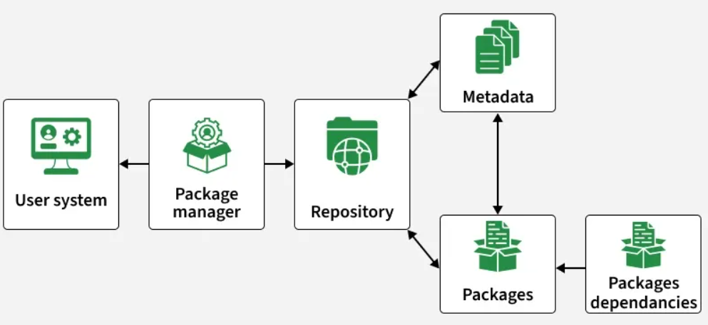

11.1 Package Manager Working
Architecture Overview Table
Component | Description | Examples
User System | Executes user commands and sends requests to the package manager | apt install, yum install
Package Manager | Central controller that processes commands and manages operations | apt, yum, dnf, pacman
Repository | Storage location containing software packages and metadata | Ubuntu repo, Red Hat repo
Metadata | Information about packages (name, version, dependencies, etc.) | package lists, repo metadata
Packages | Actual software files to be installed | nginx, apache2, vim
Dependencies | Required supporting software for proper functioning | libraries, supporting tools

11.2 Component-wise Explanation
1. User System
The user system is where commands are executed by the user.
- The user runs commands like apt install, yum install, or dnf install
- Requests are sent to the package manager for installation or updates

2. Package Manager
The package manager acts as the central controller.
- Processes user commands
- Communicates with repositories
- Manages installation, updates, removal, and dependency handling
Examples: apt, yum, dnf, pacman

3. Repository
A repository is a remote or local storage location that contains software packages.
- Stores packages and related metadata
- Provides required data to the package manager
Examples: Ubuntu repositories, Red Hat repositories

4. Metadata
Metadata contains information about packages.
- Includes package name, version, size, dependencies, and description
- Helps the package manager decide what to install

5. Packages
Packages are the actual software files.
- Contain binaries, configuration files, and documentation
- Downloaded and installed on the user system
Examples: nginx, apache2, vim

6. Package Dependencies
Dependencies are additional packages required for software to work properly.
- Software may depend on libraries or other tools
- The package manager automatically installs these dependencies

Flow Summary
- User runs a command
- Package manager processes the request
- Repository provides packages and metadata
- Metadata helps resolve dependencies
- Packages are downloaded and installed
- Dependencies are installed automatically

How Package Managers Fetch Software from Repositories
A repository is a server that stores software packages and related data. When a package manager installs software, it follows a structured process.

Step-by-Step Process
Step | Process | Description
1 | Check Repository List | The package manager reads configured repository files to know where to download packages
2 | Download Packages | It downloads the required package along with its dependencies
3 | Install and Configure | It installs and configures the software automatically

Repository Configuration Files
Distribution | Repository Location
Ubuntu/Debian | /etc/apt/sources.list.d
RHEL/CentOS/Fedora | /etc/yum.repos.d/*.repo

Internal Working for Red Hat (yum/dnf)

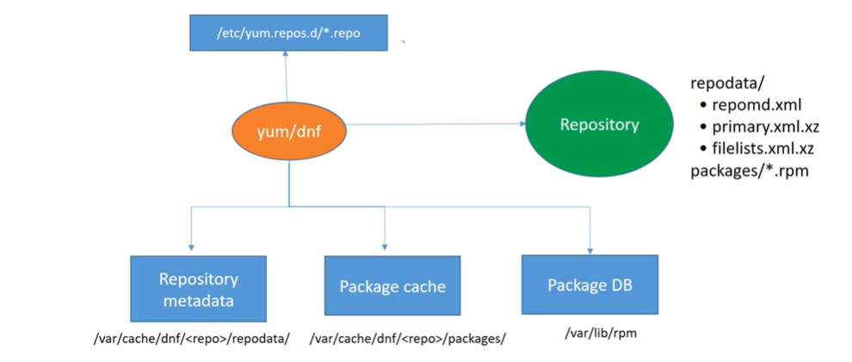
This diagram shows how the yum/dnf package manager works in a Red Hat-based system and how it interacts with repositories, metadata, cache, and the package database.

Marked Components
1. Repository Configuration
Path: /etc/yum.repos.d/*.repo
This is where repository configuration files are stored.
These files tell yum/dnf:
- Which repositories to use
- Repository URLs (where packages are located)

2. Repository (Remote Server)
This is the external server that stores:
- .rpm packages
- Repository metadata (repomd.xml, primary.xml, filelists.xml)
The package manager connects to this repository to fetch data.

3. Internal System Components
These components are used inside the system during installation:

a. Repository Metadata
Path: /var/cache/dnf/<repo>/repodata/
- Contains information about packages such as:
  - Name, version
  - Dependencies
- Used by the package manager to decide what to install
Note:
<repo> represents the repository name or repository ID.
- It is defined in files under /etc/yum.repos.d/*.repo
- It helps organize metadata separately for each repository

b. Package Cache
Path: /var/cache/dnf/<repo>/packages/
- Stores downloaded .rpm packages temporarily before installation
Note:
- <repo> is the repository ID, used to separate cached packages by repository
- Example paths:
  - /var/cache/dnf/baseos/packages/
  - /var/cache/dnf/appstream/packages/
  - /var/cache/dnf/epel/packages/

c. Package Database (Package DB)
Path: /var/lib/rpm
- Keeps records of:
  - Installed packages
  - Versions
  - Installed files

Working Flow (Step-by-Step)
- yum/dnf reads repository configuration from /etc/yum.repos.d/
- Connects to the repository (remote server)
- Downloads repository metadata
- Stores metadata in /var/cache/dnf/<repo>/
- Downloads packages into package cache
- Installs packages and updates the Package DB

Simple Summary Table
Mark | Component | Purpose
1 | Repo Config File | Defines repository sources
2 | Repository | Stores packages and metadata
3 | Metadata + Cache + DB | Handles installation process inside system

Internal Working for Debian (apt / apt-get)
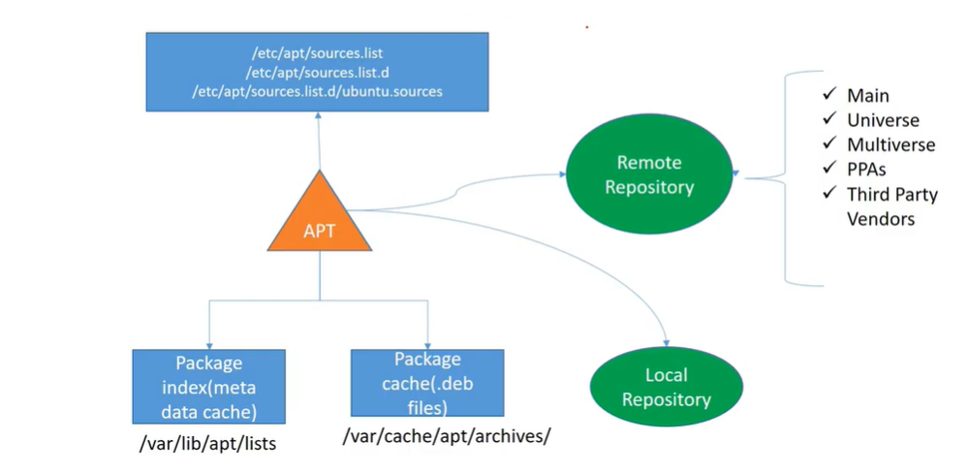
This diagram shows how the APT package manager works in a Debian-based system and how it interacts with repositories, metadata, cache, and the package database (dpkg).

Marked Components
1. Repository Configuration
Paths:
- /etc/apt/sources.list
- /etc/apt/sources.list.d/
- /etc/apt/sources.list.d/ubuntu.sources
These files store repository configuration details.
They tell APT:
- Which repositories to use
- Repository URLs
- Types of repositories (Main, Universe, Multiverse, PPAs, Third-party)

2. Remote Repository
This is the external server that stores:
- .deb packages
- Repository metadata (package index files)
Examples include:
- Main
- Universe
- Multiverse
- PPAs (Personal Package Archives)
- Third-party vendor repositories
APT connects to these repositories to fetch data.

3. Internal System Components
These components are used inside the system during installation:

a. Package Index (Metadata Cache)
Path: /var/lib/apt/lists/
- Stores repository metadata (package lists)
- Contains information such as:
  - Package name
  - Version
  - Dependencies
- Helps APT decide what to install

b. Package Cache (.deb files)
Path: /var/cache/apt/archives/
- Stores downloaded .deb packages temporarily before installation

c. Package Database (dpkg DB)
Path: /var/lib/dpkg/
- Maintained by dpkg (low-level tool)
- Keeps records of:
  - Installed packages
  - Versions
  - Installed files

d. Local Repository
- A local source of packages available on the system or internal network
- Can be used instead of or along with remote repositories

Working Flow (Step-by-Step)
- APT reads repository configuration from /etc/apt/sources.list
- Connects to the remote repository
- Downloads package index (metadata) into /var/lib/apt/lists/
- Downloads required .deb packages into /var/cache/apt/archives/
- Uses dpkg to install packages
- Updates the dpkg database in /var/lib/dpkg/

Simple Summary Table
Mark | Component | Purpose
1 | Repo Config File | Defines repository sources
2 | Remote Repository | Stores packages and metadata
3 | Metadata + Cache + DB | Handles installation inside the system

Summary Comparison Table
Feature | Red Hat (yum/dnf) | Debian (apt/apt-get)
Repo Config Path | /etc/yum.repos.d/ | /etc/apt/sources.list.d/
Metadata Location | /var/cache/dnf/ | /var/lib/apt/lists/
Package Cache | /var/cache/dnf/ | /var/cache/apt/archives/
Package Database | /var/lib/rpm | /var/lib/dpkg
Low-level Tool | rpm | dpkg

Package Groups and Environment Groups in DNF (RHEL)
1. What Are Package Groups?
A package group is a collection of related RPM packages designed for a specific purpose. Instead of installing packages one by one, you can install a complete group at once.
- Example: Development Tools group installs gcc, make, gdb, etc.
- Helps in quickly setting up systems for specific tasks

2. Types of Groups
Type | Description | Example
Package Groups | Collection of packages for a specific task | Development Tools, System Tools
Environment Groups | Larger collections defining a full system role (contains multiple groups) | Server with GUI, Minimal Install

3. Listing Package Groups
Command | Purpose
dnf group list | Show available and installed groups
dnf group list --hidden | Show all groups including hidden
dnf group list --ids | Show group IDs (machine-friendly)

4. Getting Group Information
dnf group info "Development Tools"
This shows:
- Mandatory packages (always installed)
- Default packages (installed by default)
- Optional packages (not installed unless specified)

5. Installing Package Groups
Command | Description
dnf group install "Development Tools" | Install mandatory + default packages
dnf group install --with-optional "Development Tools" | Install all packages including optional
dnf group install --setopt=group_package_types=mandatory "Development Tools" | Install only mandatory packages
dnf install @development | Install using group ID shorthand

6. Environment Groups
Environment groups define a complete system setup.
Example | Purpose
Server | Basic server setup
Server with GUI | Server with graphical UI
Minimal Install | Lightweight system
Workstation | Desktop system

Install example:
dnf group install "Server with GUI"

7. Removing Package Groups
dnf group remove "Development Tools"
- Removes packages installed by the group
- Keeps packages required by other groups or installed manually

8. Updating Groups
dnf group upgrade "Development Tools"
- Installs newly added packages in the group
- Keeps existing packages unchanged

9. Tracking Group Status
Command | Purpose
dnf group list --installed | Show installed groups
dnf group info --installed "Development Tools" | Show group details

10. Key Points
- Groups simplify installation of related packages
- Environment groups define complete system roles
- Use group IDs in scripts for stability
- Prefer groups over manual installation for efficiency

Custom Package Groups in DNF (RHEL)
Introduction
It is possible to create custom package groups in DNF; however, this cannot be done using a simple dnf command. Instead, it requires creating a custom repository that includes group metadata.

1. Working of Custom Package Groups
Package groups in DNF are defined using a metadata file called comps.xml.
This file contains:
- Group name
- Group ID
- List of packages, categorized as:
  - Mandatory
  - Default
  - Optional

2. Steps to Create a Custom Package Group
Step 1: Create the comps.xml File
Create a file named comps.xml to define the package group.
Example:
<comps>
<group>
<id>my-tools</id>
<name>My Custom Tools</name>
<packagelist>
<packagereq type="mandatory">vim</packagereq>
<packagereq type="mandatory">git</packagereq>
<packagereq type="default">htop</packagereq>
<packagereq type="optional">tree</packagereq>
</packagelist>
</group>
</comps>

Step 2: Create a Local Repository and add rpms
Create a directory and download required RPM packages:
mkdir -p /myrepo
cd /myrepo
dnf download --resolve vim git htop tree
Explanation:
- Downloads vim, git, htop, tree and all their dependencies
- Ensures the repository works even in offline environments

Step 3: Add Repository Metadata
Generate repository metadata using the createrepo command:
createrepo /myrepo
Then include the group metadata:
createrepo -g comps.xml /myrepo

Step 4: Configure the Repository
Create a repository configuration file:
Path:
/etc/yum.repos.d/myrepo.repo
Example configuration:
[myrepo]
name=My Custom Repo
baseurl=file:///myrepo
enabled=1
gpgcheck=0

Step 5: Refresh Repository Cache
Reload repository data so the new group becomes available:
dnf clean all
dnf makecache
dnf group list
The custom group will now appear in the group list.

Step 6: Install the Custom Package Group
Install the group using:
dnf group install "My Custom Tools"
Or using the group ID:
dnf install @my-tools

3. Summary Table
Step | Action | Purpose
1 | Create comps.xml | Define group structure and packages
2 | Download RPMs with dnf download | Get packages and dependencies
3 | Generate metadata | Enable repository and group support
4 | Configure repo file | Make repository accessible
5 | Refresh cache | Load updated repository data
6 | Install group | Use the custom package group

4. Important Notes
- Custom groups require a repository (local or remote)
- There is no direct command like dnf group create
- Always use dnf download --resolve to avoid missing dependencies
- Common use cases include:
  - Enterprise environments
  - Automation and provisioning
  - Offline or internal repositories

Conclusion
Custom package groups can be created in DNF by:
- Defining a comps.xml file
- Downloading required RPM packages and dependencies
- Setting up a repository
- Adding group metadata
This approach is widely used in system administration and large-scale deployments to simplify software installation and management.
Common Package Management Tasks in Linux

Introduction
Package management tools such as YUM, DNF, APT, and DPKG are used to manage software in Linux systems. These tools help in:
- Installing software
- Updating software
- Removing software
- Managing dependencies
High-level tools (dnf, yum, apt) handle dependencies automatically, while low-level tools (rpm, dpkg) require manual handling.

2. Working with YUM / DNF Commands (RHEL-based Systems)
2.1 List Available Packages
Command | Description
dnf list | List all available packages
dnf list all | Show complete package list

Repository Check (Before Update)
Command | Description
dnf repolist | Shows enabled repositories
dnf repolist all | Shows all repositories (enabled/disabled)

2.2 List Installed Packages
Command | Description
dnf list installed | Show all installed packages

2.3 Check if a Package is Installed
Command | Description
dnf list installed <package> | Check specific package
Example:
dnf list installed git

2.4 Search for a Package
Command | Description
dnf search git | Search package in repository

2.5 Download Package Only (Without Installing)
Command | Description
dnf download git | Download package only
dnf download --resolve git | Download package with dependencies

2.6 Install a Package (Example: Git)
Command | Description
dnf install git | Install with confirmation
dnf install git -y | Install without confirmation

2.7 Remove a Package
Command | Description
dnf remove git | Remove with confirmation
dnf remove git -y | Remove without prompt

2.8 Update and Upgrade Packages
Command | Description
dnf check-update | Check available updates
dnf update git | Update specific package
dnf update | Update all packages
dnf upgrade | Upgrade system packages

2.9 Install Package from Local File
Command | Description
dnf install /path/pkg.rpm | Install local package
dnf install /path/pkg.rpm -y | Install without prompt
Example:
dnf install /opt/packages/git.rpm -y

2.10 View Package Information
Command | Description
dnf info git | Show package details

2.11 Package Groups
Command | Description
dnf group list | List groups
dnf group install "Development Tools" | Install group
dnf group install "Development Tools" -y | Install without prompt
dnf group remove "Development Tools" | Remove group
dnf group info "Development Tools" | Group details

Section Summary
Task | Command Example
Search | dnf search git
Download | dnf download git
Install | dnf install git
Remove | dnf remove git
Update | dnf update git
Info | dnf info git

3. Working with APT (Debian/Ubuntu Systems)
3.1 List and Search Packages
Command | Description
apt list | List available packages
apt list --installed | List installed packages
apt search git | Search package

Repository Check (Before Update)
Command | Description
cat /etc/apt/sources.list | Check repositories

3.2 Download Package Only
Command | Description
apt download git | Download .deb package only

3.3 Install Package (Example: Git)
Command | Description
sudo apt install git | Install with confirmation
sudo apt install git -y | Install without prompt

3.4 Remove Package
Command | Description
sudo apt remove git | Remove package
sudo apt purge git | Remove completely (with config)

3.5 Update and Upgrade
Command | Description
sudo apt update | Refresh package list
sudo apt upgrade | Upgrade installed packages

Section Summary
Task | Command Example
Search | apt search git
Download | apt download git
Install | apt install git
Remove | apt remove git
Update | apt update
Upgrade | apt upgrade

4. Difference Between Update and Upgrade
Definition
Term | Meaning
Update | Refreshes the package list from repositories (does not install packages)
Upgrade | Installs the latest versions of already installed packages

Detailed Explanation
Update
- Updates the package index (repository data)
- Shows what packages have newer versions available
- Does not install or change software
Examples:
apt update
dnf check-update

Upgrade
- Installs the latest versions of installed packages
- May update dependencies as required
- Replaces older versions with newer ones
Examples:
apt upgrade
dnf upgrade

Additional Clarification (DNF/YUM Behavior)
- dnf upgrade and dnf update are almost the same in modern systems
- Both commands:
  - Update installed packages
  - Resolve dependencies
- In some cases, obsolete packages may be removed if required

Example Scenario
- Check for updates:
dnf check-update
- Apply updates:
dnf upgrade -y

Summary Table
Action | APT Command | DNF Command | Result
Refresh package list | apt update | dnf check-update | Updates repository information
Upgrade packages | apt upgrade | dnf upgrade | Installs latest package versions

Conclusion
- Update → Refreshes repository data only
- Upgrade → Installs newer versions of packages

5. Low-Level Tools (RPM / DPKG)
5.1 RPM (RHEL-based)
Command | Description
rpm -i package.rpm | Install package
rpm -e package | Remove package
rpm -U package.rpm | Upgrade package
rpm -qa | List installed packages

5.2 DPKG (Debian-based)
Command | Description
dpkg -i package.deb | Install package
dpkg -r package | Remove package
dpkg -l | List installed packages

6. High-Level vs Low-Level Tools
Type | Tools | Features
High-Level | apt, yum, dnf | Easy, handles dependencies
Low-Level | rpm, dpkg | Manual control, no dependency handling

7. Overall Summary Table
Task | DNF/YUM | APT
Search | dnf search pkg | apt search pkg
Download | dnf download pkg | apt download pkg
Install | dnf install pkg | apt install pkg
Remove | dnf remove pkg | apt remove pkg
Update list | dnf check-update | apt update
Upgrade | dnf upgrade | apt upgrade
Info | dnf info pkg | apt show pkg

Conclusion
Package management in Linux is simplified using tools like DNF, YUM, APT, and DPKG.
- High-level tools automate dependency handling and simplify usage
- Low-level tools provide direct control over packages
- Understanding update vs upgrade ensures proper system maintenance

Topic: Stream Editor sed in Linux
sed stands for Stream Editor.
It is used to search, replace, delete, and modify text in a file or command output.
sed is commonly used in Linux for:
- Replacing words
- Updating configuration files
- Replacing paths
- Removing unwanted text
- Editing files from shell scripts

Temporary Change vs Permanent Change
Type | Meaning
Temporary change | Shows modified output on the screen only. Original file is not changed.
Permanent change | Modifies the original file using the -i option.

Basic sed Substitute Syntax
sed 's/old_text/new_text/' filename
Meaning
Part | Meaning
sed | Stream editor command
s | Substitute / replace
old_text | Text to search
new_text | Text to replace
filename | File name

1. Create a Sample File
Create a file called demo.txt.
cat > demo.txt
Add this content:
durga soft provides linux training
durga soft provides devops training
durga tech offers cloud training
DURGA jobs provides placement support
Press: to save the file
CTRL + D

2. View File Content
cat demo.txt
Output
durga soft provides linux training durga
durga soft provides devops training
durga tech offers cloud training
DURGA jobs provides placement support

3. Replace First Occurrence in Each Line
Command
sed 's/durga/linux/' demo.txt
Explanation
This command replaces only the first occurrence of durga in each line.
It only displays the modified output.
It does not change the original file.
Output
linux soft provides linux training durga
linux soft provides devops training
linux tech offers cloud training durga
DURGA jobs provides placement support
Important Note
DURGA was not replaced because Linux is case-sensitive by default.

4. Replace All Occurrences in Each Line
Command
sed 's/durga/linux/g' demo.txt
Explanation
Here, g means global.
It replaces all occurrences of durga in each line.
Output
linux soft provides linux training linux
linux soft provides devops training
linux tech offers cloud training linux
DURGA jobs provides placement support

Difference Between With g and Without g
Command | Meaning
sed 's/durga/linux/' demo.txt | Replaces only the first occurrence in each line
sed 's/durga/linux/g' demo.txt | Replaces all occurrences in each line
Must Remember
- Without g → first match only in each line
- With g → all matches in each line

5. Case-Insensitive Replacement
Command
sed 's/durga/linux/gi' demo.txt
Explanation
Option | Meaning
g | Replace all occurrences
i | Ignore uppercase/lowercase
This command replaces:
durga
DURGA
Durga
duRGA
with:
linux
Output
linux soft provides linux training linux
linux soft provides devops training
linux tech offers cloud training linux
linux jobs provides placement support

6. Check Original File After Temporary Replacement
cat demo.txt
Output
durga soft provides linux training
durga soft provides devops training
durga tech offers cloud training
DURGA jobs provides placement support
Why?
Because we did not use -i. earlier commands
Without -i, sed only displays changed output.
It does not modify the file permanently.

7. Save Changes Permanently
To modify the file permanently, use -i.
Command
sed -i 's/durga/linux/g' demo.txt
Explanation
Option | Meaning
-i | Edit file permanently
s | Substitute
g | Replace all occurrences
This command modifies the actual file.
Check File Content
cat demo.txt
Output
linux soft provides linux training
linux soft provides devops training
linux tech offers cloud training
DURGA jobs provides placement support
Important Note
DURGA is still not changed because this command is case-sensitive.

8. Save Changes Permanently with Ignore Case
Command
sed -i 's/durga/linux/gi' demo.txt
Explanation
This command permanently replaces all durga, DURGA, Durga, etc. with linux.
Check File Content
cat demo.txt
Output
linux soft provides linux training
linux soft provides devops training
linux tech offers cloud training
linux jobs provides placement support

9. Recommended Safe Method Before Permanent Change

Method 1: Before using -i, first test the command.
Step 1: Test Without -i
sed 's/durga/linux/gi' demo.txt
Step 2: If Output Is Correct, Save Permanently
sed -i 's/durga/linux/gi' demo.txt

Method 2: Create Backup Before Permanent Change
This is the safest method.
Command
sed -i.bak 's/durga/linux/gi' demo.txt
Explanation
This command does two things:
- Modifies the original file demo.txt
- Creates a backup file called demo.txt.bak
Check Files
ls
Output
demo.txt
demo.txt.bak

What is Inside the .bak File?
The .bak file contains the original content before modification.
For example, if we run:
sed -i.bak 's/durga/linux/gi' demo.txt
Then:
File | Meaning
demo.txt | Modified/new file
demo.txt.bak | Original/old file before modification
Check Backup File
cat demo.txt.bak
Sample Output
durga soft provides linux training
durga soft provides devops training
durga tech offers cloud training
DURGA jobs provides placement support
Check Modified File
cat demo.txt
Sample Output
linux soft provides linux training
linux soft provides devops training
linux tech offers cloud training
linux jobs provides placement support

Restore Original File from Backup
If the modification is wrong, restore the original file:
cp demo.txt.bak demo.txt
Must Remember
Command | Meaning
sed -i | Modify file permanently without backup
sed -i.bak | Modify file permanently and create backup
.bak file | Contains old/original content
cp file.bak file | Restore original file

10. Real-World Example: Replace Path in a File
Requirement
A file contains this old path in many places:
/home/bluechip/scripts
You want to replace it with:
/apps/crons/scripts

Step 1: Create Sample File
Create a file called config.txt.
cat > config.txt
Add this content:
SCRIPT_HOME=/home/bluechip/scripts
Backup script path is /home/bluechip/scripts/backup.sh
Daily cron runs from /home/bluechip/scripts/daily.sh
Log path is /var/log/app.log
Press:
CTRL + D
to save the file.

Step 2: View File Content
cat config.txt
Output
SCRIPT_HOME=/home/bluechip/scripts
Backup script path is /home/bluechip/scripts/backup.sh
Daily cron runs from /home/bluechip/scripts/daily.sh
Log path is /var/log/app.log

Step 3: Test Replacement First
sed 's#/home/bluechip/scripts#/apps/crons/scripts#g' config.txt
Output
SCRIPT_HOME=/apps/crons/scripts
Backup script path is /apps/crons/scripts/backup.sh
Daily cron runs from /apps/crons/scripts/daily.sh
Log path is /var/log/app.log
Explanation
This command only shows the modified output on the screen.
It does not change config.txt.

Step 4: Save Permanently with Backup
sed -i.bak 's#/home/bluechip/scripts#/apps/crons/scripts#g' config.txt
Explanation
This command:
- Replaces /home/bluechip/scripts with /apps/crons/scripts
- Modifies config.txt
- Creates a backup file named config.txt.bak

Step 5: Verify Modified File
cat config.txt
Output
SCRIPT_HOME=/apps/crons/scripts
Backup script path is /apps/crons/scripts/backup.sh
Daily cron runs from /apps/crons/scripts/daily.sh
Log path is /var/log/app.log

Step 6: Check Backup File
cat config.txt.bak
Output
SCRIPT_HOME=/home/bluechip/scripts
Backup script path is /home/bluechip/scripts/backup.sh
Daily cron runs from /home/bluechip/scripts/daily.sh
Log path is /var/log/app.log
Meaning
File | Content
config.txt | Updated file with new path
config.txt.bak | Original file with old path

Step 7: Restore Backup if Needed
If the replacement is wrong, restore the old file:
cp config.txt.bak config.txt
Now check again:
cat config.txt
Output
SCRIPT_HOME=/home/bluechip/scripts
Backup script path is /home/bluechip/scripts/backup.sh
Daily cron runs from /home/bluechip/scripts/daily.sh
Log path is /var/log/app.log

11. Why Use # Instead of / for Paths?
Normally, sed uses / as a delimiter:
sed 's/old/new/g'
But Linux paths contain many / symbols.
So this becomes difficult to read:
sed 's/\/home\/bluechip\/scripts/\/apps\/crons\/scripts/g' config.txt
Better and cleaner:
sed 's#/home/bluechip/scripts#/apps/crons/scripts#g' config.txt
Must Remember
When replacing Linux paths, use # or | as the delimiter.

12. Replace Blank Lines with Text
Create Sample File
cat > notes.txt
Add this content:
Linux is powerful
Shell scripting is useful
DevOps needs automation
Press:
CTRL + D

View File
cat notes.txt
Output
Linux is powerful
Shell scripting is useful
DevOps needs automation

Replace Blank Lines Temporarily
sed 's/^$/I Like Linux/g' notes.txt
Output
Linux is powerful
I Like Linux
Shell scripting is useful
I Like Linux
DevOps needs automation

Save Permanently with Backup
sed -i.bak 's/^$/I Like Linux/g' notes.txt
Explanation
Pattern | Meaning
^ | Start of line
$ | End of line
^$ | Blank line
I Like Linux | Replacement text

13. Delete a Specific Word
Create Sample File
cat > students.txt
Add this content:
Sunny is learning Linux
sunny is learning DevOps
SUNNY is learning shell scripting
sunnyside is a different word
Press:
CTRL + D

Delete the Word sunny Temporarily
sed 's/\<sunny\>//gi' students.txt
Output
is learning Linux
is learning DevOps
is learning shell scripting
sunnyside is a different word

Explanation
Part | Meaning
\<sunny\> | Match only the full word sunny
g | Delete all occurrences
i | Ignore case
Empty replacement | Delete the word

Save Permanently with Backup
sed -i.bak 's/\<sunny\>//gi' students.txt

Important Note
This command deletes:
sunny
Sunny
SUNNY
But it does not delete:
sunnyside
because \<sunny\> matches the complete word only.

Useful sed Commands Summary
Requirement | Command
Replace first occurrence in each line | sed 's/old/new/' file
Replace all occurrences | sed 's/old/new/g' file
Ignore case while replacing | sed 's/old/new/gi' file
Modify file permanently | sed -i 's/old/new/g' file
Modify permanently with backup | sed -i.bak 's/old/new/g' file
Replace path safely | sed 's#old_path#new_path#g' file
Replace blank lines | sed 's/^$/text/g' file
Delete a word | sed 's/\<word\>//g' file

Practice Examples
Practice 1: Replace First Match
sed 's/durga/linux/' demo.txt
Practice 2: Replace All Matches
sed 's/durga/linux/g' demo.txt
Practice 3: Replace All Matches and Ignore Case
sed 's/durga/linux/gi' demo.txt
Practice 4: Save Permanently
sed -i 's/durga/linux/gi' demo.txt
Practice 5: Save Permanently with Backup
sed -i.bak 's/durga/linux/gi' demo.txt
Practice 6: Replace Path
sed -i.bak 's#/home/bluechip/scripts#/apps/crons/scripts#g' config.txt
Practice 7: Replace Blank Lines
sed -i.bak 's/^$/I Like Linux/g' notes.txt
Practice 8: Delete Word
sed -i.bak 's/\<sunny\>//gi' students.txt

Administrating Remote Systems Using SSH

1. Introduction to Remote Access
Remote access allows a user to connect and control another computer over a network. In Linux/Unix systems, this is usually done through a command-line interface (shell).
Earlier, tools like Telnet were used, but they were not secure. Modern systems use SSH (Secure Shell) for safe communication.

2. What is SSH?
SSH stands for Secure Shell. It is a network protocol used to connect to another computer securely over a network.
Key Features of SSH
- Provides encrypted communication
- Ensures secure login
- Protects data from hackers
- Supports remote command execution

3. Telnet vs SSH (Comparison)
Feature | Telnet | SSH
Security | No encryption | Encrypted communication
Data Visibility | Plain text (visible) | Encrypted (hidden)
Port Number | 23 | 22 (default)
Usage | Old method | Modern secure method
Risk Level | High | Low

4. Why SSH is More Secure
In Telnet:
- Data like username and password is sent as plain text
- Hackers can easily capture data using tools like Wireshark
- User -----> Network -----> Server
(Data visible)

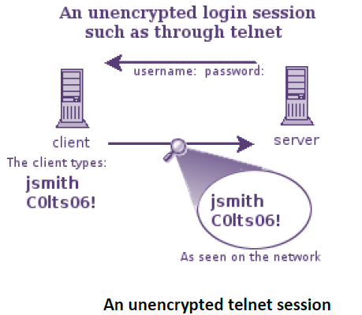
In SSH:
- Data is encrypted (scrambled)
- Only sender and receiver can understand it
- User -----> Network -----> Server
(Encrypted data)

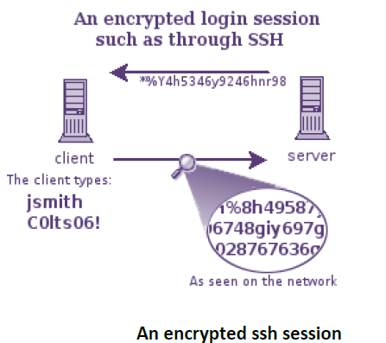

5. SSH Configuration
- Configuration file: /etc/ssh/sshd_config
- SSH service (daemon): sshd

Accessing Remote Machine Using SSH
Syntax
ssh <IP address or hostname of remote machine>
Example
ssh 192.168.10.95
Steps
- Run SSH command: ssh 192.168.10.95
- Accept connection (first time only)
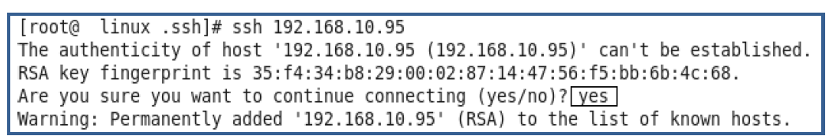
- Enter password the remote system correctly
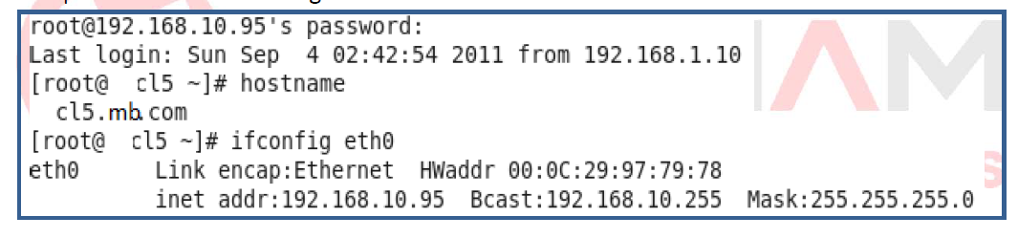
- Verify login using remote hostname/IP
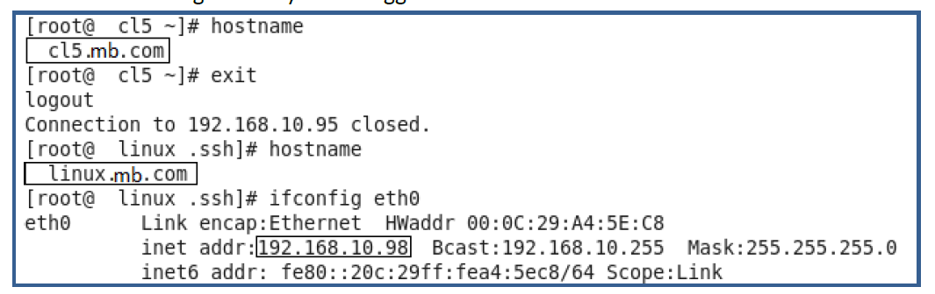
- Use exit to logout

SSH Key-Based Authentication (Password-less Login)

Problem:
System administrators manage many systems and must enter remote system passwords repeatedly.
For example, one person may manage more than 10 systems at a time. In this situation, the administrator needs to transfer files from one system to multiple systems (or vice versa). For every login to a remote system, it will prompt for a password.
Even during file transfer, for each transfer, the password must be entered again.

Solution:
Use SSH keys to login without password.
How It Works
- Two keys are created:
  - Public Key → shared with server
  - Private Key → kept secure on client
- If keys match → login allowed without password

8. SSH Key Cryptography
Key Type | Function
Public Key | Encrypt data
Private Key | Decrypt data

Generating SSH Keys

Command
ssh-keygen
Steps
- Run command: ssh-keygen
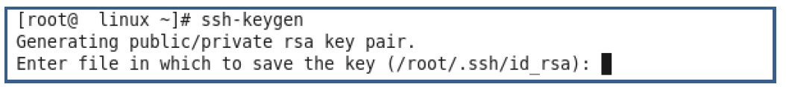
- Press Enter for default location (~/.ssh) or (/root/.ssh/)
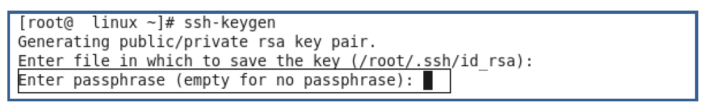
- Enter passphrase (optional)
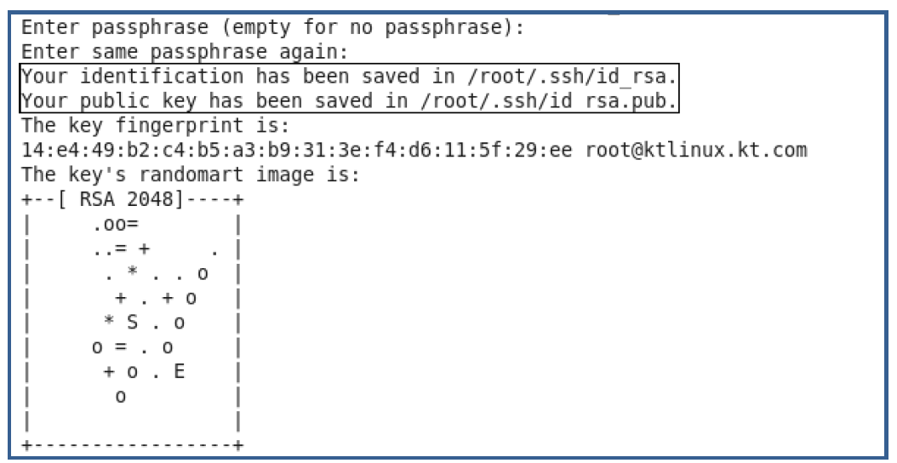
- Keys generated:
Go to /root/.ssh/:
cd /root/.ssh
ls
  - id_rsa (private key)
  - id_rsa.pub (public key)

Copying the SSH Public Key to Remote System (Client System)
Command
ssh-copy-id -i ~/.ssh/id_rsa.pub <remote IP>
Example
ssh-copy-id -i /root/.ssh/id_rsa.pub 192.168.10.95
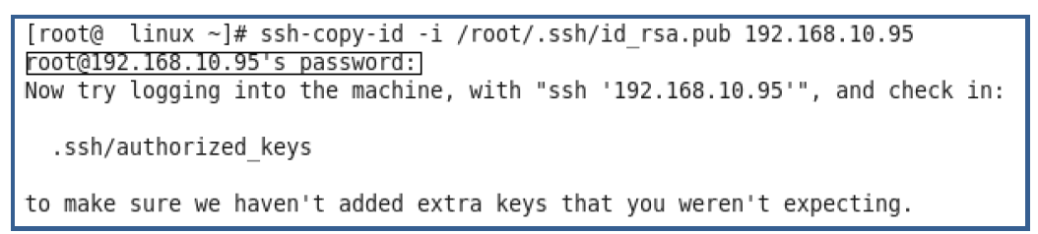

Authorized Keys
The public key will be copied to an (authorized_keys) file on the remote server.
- Stored in: ~/.ssh/authorized_keys
- Contains allowed public keys
- Enables password-less login

Steps to Verify SSH Key and Login
1. Check if the Key is Copied Correctly
- Go to the remote/client machine.
- Navigate to the SSH directory:
cd /root/.ssh/
- Check the authorized_keys file:
cat authorized_keys
Explanation
- The authorized_keys file contains all the public keys of trusted systems
- If the key is present here, the system will allow password-less login

2. Test SSH Login
Method 1: Direct SSH (Without ssh-agent)
Try to login to the remote/client machine from admin server machine using SSH:
ssh 192.168.10.95
SSH will automatically try default keys, such as:~/.ssh/id_rsa
or
ssh -i /root/.ssh/id_rsa 192.168.10.95
- You are explicitly telling SSH which private key to use.
- It will use /root/.ssh/id_rsa for authentication.
- Useful when:
  - You have multiple keys
  - The key is not in the default location

- Observe the result:
- If no password is asked → setup is successful
- If password is asked → key setup is not complete

Method 2: (Using ssh-agent)
Step 1: Start ssh-agent
ssh-agent $SHELL
or
eval $(ssh-agent)

Agent pid 108089

ps aux |grep 108089

Step 2: Add Private Key to Agent
ssh-add /root/.ssh/id_rsa
- Enter passphrase (if set)
- Key is now stored in memory

Step 3: Connect to Remote Server
ssh 192.168.10.95

Explanation
- ssh-agent manages your private key in memory
- SSH automatically uses the loaded key
- No need to specify -i or re-enter passphrase each time

Step 4: Verify Result
- ✅ No password prompt → Setup is successful
- ❌ Password prompt appears → Key not added or setup issue

Securing OpenSSH in Linux
Introduction
- SSH (Secure Shell) is used to connect to Linux servers remotely. By default, SSH is open and can be targeted by attackers. Many hackers try to guess passwords using automated tools.
- In real environments, servers can receive thousands of failed login attempts. Because of this, it is very important to secure SSH, especially if the server is connected to the internet.

1. Use Strong Passwords
Description
Always use a strong password to prevent attackers from guessing it.
Guidelines
- Avoid simple passwords like:
  - password123
  - admin
  - linux
- Use a mix of:
  - Uppercase letters
  - Lowercase letters
  - Numbers
  - Special characters
What happens?
- Harder for attackers to guess password
- Reduces brute-force success rate
- Improves overall system security

2. Disable Root Login
Description
The root user has full control over the system. Allowing direct SSH login as root is risky.
Steps
Edit SSH Configuration
vi /etc/ssh/sshd_config
Update Parameter

PermitRootLogin no
Restart SSH Service
systemctl restart sshd

What happens after change?
- Direct SSH login as root is blocked
- Users must:
  - Login as normal user
  - Then use sudo or su
- Prevents attackers from targeting root account directly

3. Limit Password Login Attempts
Description
Limit the number of failed login attempts to prevent brute-force attacks.
Steps
Edit Configuration
vi /etc/ssh/sshd_config
Set Limit
MaxAuthTries 3
Restart Service
systemctl restart sshd

What happens after change?
- User gets only 3 login attempts
- After 3 failures:
  - SSH connection is closed
- Slows down brute-force attacks

4. Disable Password Authentication
Description
Instead of passwords, use SSH key-based authentication. Keys are more secure and harder to break.
Steps
Edit Configuration
vi /etc/ssh/sshd_config
Disable Password Login
PasswordAuthentication no
Restart Service
systemctl restart sshd

What happens after change?
- Password login is completely disabled
- Only SSH key login works
- If key is not configured:
  - Login will fail completely
- Strong protection against password attacks

5. Change Default SSH Port
Description
SSH runs on port 22 by default. Attackers commonly target this port.
Steps
Edit Configuration
vi /etc/ssh/sshd_config
Change Port
Port 2019
Restart Service
systemctl restart sshd

What happens after change?
- SSH no longer listens on port 22
- Users must connect using:
ssh -p 2019 192.168.10.95
- Reduces automated attack attempts (bots target port 22)

Additional Configuration (if required)
semanage port -a -t ssh_port_t -p tcp 2019
firewall-cmd --add-port=2019/tcp --permanent
systemctl restart firewalld
systemctl restart sshd

6. Limit User Access
Description
Allow only specific users or groups to access SSH.
Steps
Edit Configuration
vi /etc/ssh/sshd_config
Allow Specific Users
AllowUsers user1 user2
OR Allow Group
AllowGroups finance
Restart Service
systemctl restart sshd

What happens after change?
- Only specified users/groups can login
- All other users are denied access
- Unauthorized users cannot even attempt login

7. Set Idle Timeout
Description
Automatically disconnect inactive SSH sessions.
Steps
Edit Configuration
vi /etc/ssh/sshd_config
Set Timeout (Example: 5 minutes)
ClientAliveInterval 300
Restart Service
systemctl restart sshd

What happens after change?
- If no activity for 300 seconds (5 min):
  - SSH session is automatically disconnected
- Prevents unused open sessions

8. Lock User After Failed Attempts
Description
Temporarily lock user accounts after multiple failed login attempts.
Steps
Enable PAM
vi /etc/ssh/sshd_config

UsePAM yes
Configure PAM
Use tools like:
- pam_tally2
- pam_faillock
What happens after change?
- Enables PAM security modules
- With pam_tally2 or pam_faillock:
  - User account gets temporarily locked
  - After multiple failed attempts
- Stops repeated login attacks

🔹 Important Common Step
After every change:
systemctl restart sshd
What happens?
- New configuration is applied
- Old settings are removed
- SSH service reloads with updated rules

Summary Table
Step | Feature | Purpose
1 | Strong Password | Prevent easy password guessing
2 | Disable Root Login | Protect critical system access
3 | Limit Attempts | Stop brute-force attacks
4 | Disable Password Login | Use secure key-based authentication
5 | Change Port | Reduce automated attacks
6 | Limit Users | Allow only authorized access
7 | Idle Timeout | Auto logout inactive sessions
8 | Lock Accounts | Prevent repeated login attempts

Final Notes
- Always use SSH key-based authentication instead of passwords
- Enable firewall and SELinux for better security
- Regularly monitor login attempts

File Transfer Using SCP

What is SCP?
Secure Copy (SCP) is used to transfer files using SSH.
Features
- Secure
- Encrypted transfer
- Simple to use

1. Copy File (Source to Destination)

Syntax
scp <file> <remote IP>:/<destination>
Example
- Source (Admin/Server) IP: 192.168.10.98
- Destination (Client) IP: 192.168.10.95
👉 File myfile.txt is present on source system and needs to be copied to destination system after logging into the server machine.
scp /myfile.txt 192.168.10.95:/root/

Steps
1. Login to Source System
ssh 192.168.10.98
2. Execute SCP Command
- Copy file from source to destination system
scp /myfile.txt 192.168.10.95:/root/

Verification
1. Login to Destination System
ssh 192.168.10.95
2. Check File in Destination Directory
ls -lrt /root

Result
- If the file is visible in /root directory → File transfer successful

2. Copy File (Reverse SCP –From Admin to Client after Login on Client)

Syntax
scp <source IP>:/<file location> <destination location>

Example
- Source (Admin/Server) IP: 192.168.10.98
- Destination (Client) IP: 192.168.10.95
👉 File myfile.txt is present on source system and needs to be copied to destination system after logging into the client machine.
scp 192.168.10.98:/myfile.txt /root/

Steps
1. Login to Destination System
ssh 192.168.10.95
2. Remove Old File (Optional)
- Delete previously copied file if required
rm -f /root/myfile.txt
3. Execute SCP Command
- Copy file from source system to destination system
scp 192.168.10.98:/myfile.txt /root/

Verification
1. Check File in Destination System
ls -lrt /root

Important Note
- If SSH keys are not configured → Password will be asked every time
- If SSH keys are configured → No password will be required

3. Copy Directory (Source to Destination)

Syntax
scp -r <directory> <remote IP>:/<destination>

Example
- Source (Admin/Server) IP: 192.168.10.98
- Destination (Client) IP: 192.168.10.95
👉 Directory mydir is present on source system and needs to be copied to destination system after logging into the server machine.
scp -r /mydir 192.168.10.95:/root/

Steps
1. Login to Source System
ssh 192.168.10.98
2. Execute SCP Command
scp -r /mydir 192.168.10.95:/root/

Verification
1. Login to Destination System
ssh 192.168.10.95
2. Check Directory
ls -lrt /root

4. Copy Directory (Reverse SCP – –From Admin to Client after Login on Client)

Syntax
scp -r <source IP>:/<directory location> <destination location>

Example
- Source (Admin/Server) IP: 192.168.10.98
- Destination (Client) IP: 192.168.10.95
👉 Directory mydir is present on source system and needs to be copied to destination system after logging into the client machine.
scp -r 192.168.10.98:/mydir /root/

Steps
1. Login to Destination System
ssh 192.168.10.95
2. Remove Old Directory (Optional)
rm -rf /root/mydir
3. Execute SCP Command
scp -r 192.168.10.98:/mydir /root/

Verification
1. Check Directory
ls -lrt /root

Result
- If file/directory is visible → Transfer successful
- If not → Check IP, path, or connection

Summary Table
Operation | Command Type
Copy file (forward) | scp file remote:/path
Copy file (reverse) | scp remote:/file local
Copy directory | scp -r dir remote:/path
Reverse directory copy | scp -r remote:/dir local

RSYNC (Remote Synchronization)
What is RSYNC?
A tool used to sync files between systems efficiently.
Advantages
- Transfers only changed data
- Saves time and bandwidth
- Ideal for backups

RSYNC Working Concept
Operation | Behavior
First transfer | Copies all files
Next transfers | Copies only changed files
Delete option | Removes files from destination

System Details
- Source (Admin/Server) IP: 192.168.10.98
- Destination (Client) IP: 192.168.10.95

Syntax
rsync <options> <source> <destination>

RSYNC Transfer
System Details
- Source (Admin/Server) IP: 192.168.10.98
- Destination (Client) IP: 192.168.10.95

Purpose
- Copy entire data for the first time
Behavior
- Transfers all files and directories
Steps
1. Login to Source System
ssh 192.168.10.98
2. Prepare Data on Source System
- Create a directory and add files (e.g., /mydir)

3. Execute RSYNC Command (Run on Source System)
rsync -avz /mydir 192.168.10.95:/root/

4. Login to Destination System and Verify
ssh 192.168.10.95
ls -lrt /root

Result
- Full directory /mydir is copied to destination
- Files/directories are copied to destination
- Initial transfer copies all data

Example Setup
Source System (192.168.10.98) – /mydir
file1.txt
file2.txt
file3.txt
Destination System (192.168.10.95) – /root/mydir
(empty initially)

Testing Incremental Transfer
Purpose
- Copy only new or changed files
Behavior
- Skips already existing files
- Transfers only differences
1. Login to Source System
ssh 192.168.10.98
2. Add New Files
- Add new files in /mydir

3. Run RSYNC Again
rsync -avz /mydir 192.168.10.95:/root/

4. Login to Destination System and Verify
ssh 192.168.10.95
ls -lrt /root

Result
- Only new or modified files are copied
- Existing files are not copied again

Example Setup
Source System (192.168.10.98) – /mydir
file1.txt
file2.txt
file3.txt
Destination System (192.168.10.95) – /root/mydir
file1.txt
file2.txt
file3.txt

Dry Run (Preview Mode)
Purpose
- Preview what will happen without actual transfer
Behavior
- No files are copied
- Only shows list of files
Login to Source System
ssh 192.168.10.98
Execute Dry Run
rsync -avz --dry-run /mydir 192.168.10.95:/root/

Result
- Shows list of files that will be transferred
- No actual data transfer happens

Example Setup

Source System (192.168.10.98) – /mydir

Modify:
file2.txt (updated content)

Shows:
file2.txt will be updated

Destination System (192.168.10.95) – /root/mydir

(no change happens)

Actual Transfer After Dry Run
Purpose
- Perform real transfer after checking preview
Behavior
- Copies only required files (like incremental)
Login to Source System
ssh 192.168.10.98
Execute Command
rsync -avz /mydir 192.168.10.95:/root/

Result
- Files are actually transferred
- Only required files are transferred
- Transfer is fast and efficient

Example Setup

Source System (192.168.10.98) – /mydir

Modify:
file2.txt (updated content)

Destination System (192.168.10.95) – /root/mydir
file2.txt updated on destination

Updating Files
Purpose
- Sync changes in existing files
Behavior
- Updates only modified files
1. Login to Source System
ssh 192.168.10.98
2. Modify Files
- Edit or update files in /mydir

3. Run RSYNC
rsync -avz /mydir 192.168.10.95:/root/

4. Verify on Destination
ssh 192.168.10.95
ls -lrt /root

Result
- Only modified files are updated on destination
- No full copy is done

Example Setup

Source System (192.168.10.98) – /mydir
Modify:
file3.txt
Destination System (192.168.10.95) – /root/mydir
Only file3.txt is updated

Deleting Files with RSYNC
Default Behavior
- Deleted files in source are NOT removed from destination

To Delete Files in Destination
Purpose
- Remove deleted files from destination also
Behavior
- Without option → no deletion
- With --delete → deletes extra files
1. Login to Source System
ssh 192.168.10.98
2. Execute Command
rsync -avz --delete /mydir 192.168.10.95:/root/

3. Verify on Destination
ssh 192.168.10.95
ls -lrt /root

Result
- Destination becomes exact copy of source
- Deleted files in source are also removed from destination
- Both systems remain fully synchronized

Source System (192.168.10.98) – /mydir
Delete:
file1.txt

Without --delete
rsync -avz /mydir 192.168.10.95:/root/
Destination System (192.168.10.95) – /root/mydir
file1.txt still exists on destination ❌

With --delete
rsync -avz --delete /mydir 192.168.10.95:/root/
Destination System (192.168.10.95) – /root/mydir
file1.txt removed from destination ✔

Reverse RSYNC (Restore Data)
Purpose
- Copy data from destination back to source
Behavior
- Used for backup restore
Steps
1. Login to Source System (Original – 192.168.10.98)
ssh 192.168.10.98

2. Execute Reverse RSYNC (Run on Source System)
rsync -avz 192.168.10.95:/root/mydir /root/

3. Verify on Source System
ls -lrt /root

Result
- Missing files are restored to source successfully
- Data is recovered from backup system
- Both systems are synchronized again

Destination System (192.168.10.95) – /root/mydir
file2.txt
file3.txt
file4.txt
Source System (192.168.10.98) – /mydir
file4.txt (Missing)

Command
rsync -avz 192.168.10.95:/root/mydir /root/
Result
file4.txt restored back to source ✔

Final Summary
- RSYNC is fast, efficient, and smart
- Transfers only changed data
- Supports:
  - Incremental updates
  - Preview (dry run)
  - Deletion sync
  - Backup and restore

15. SSH Port Number
- Default port: 22
- Can be changed for security
Example
ssh -p 2019 user@192.168.1.10

16. Changing SSH Port (Basic Steps)
- Edit config file:
/etc/ssh/sshd_config
- Add new port:
Port 2019
- Allow port in firewall
- Restart SSH service

17. Disabling Root Login
Why?
- Root user has full control
- Disabling improves security
Steps
- Edit config file
PermitRootLogin no
- Restart SSH service

18. SSH Connection Process (Simplified)
- Client sends request
- Server sends public key
- Client verifies key
- Password or key authentication happens
- Secure session starts

19. Connecting from Windows
Tools:
- PuTTY
- Bitvise
Steps
- Open tool
- Enter IP address
- Click connect
- Enter credentials

20. Security Best Practices
- Use strong passwords
- Use SSH keys instead of passwords
- Change default port
- Disable root login
- Limit login attempts
- Enable firewall and SELinux

21. Summary
SSH is a secure method to:
- Access remote systems
- Transfer files
- Manage servers
It replaces insecure tools like Telnet and provides strong security through encryption and key-based authentication.

What is a Firewall in Linux

A firewall is a network security system that filters (permits or blocks) incoming & outgoing network traffic based on a predefined set of security rules.
It works by allowing or blocking traffic based on a set of predefined rules called firewall rules.
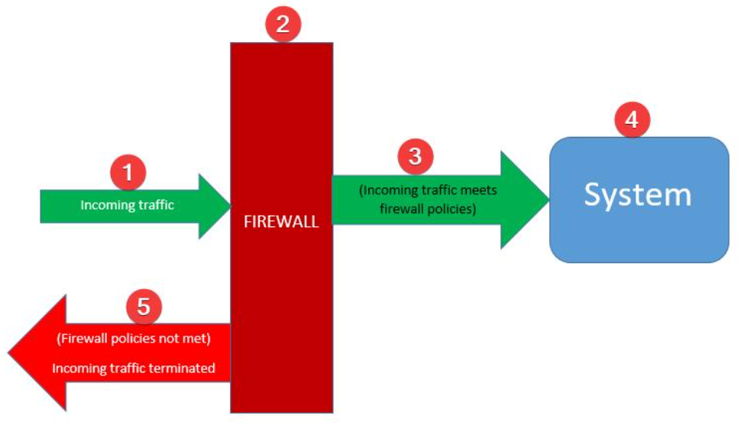
- It acts as a barrier between a trusted internal network and an untrusted external network (Internet), thus monitors all traffic passing through it. And, it blocks all unwanted network traffic or connection.
- A firewall can be dedicated hardware or hosted software.
- firewalld is one of the popular firewall management tools.
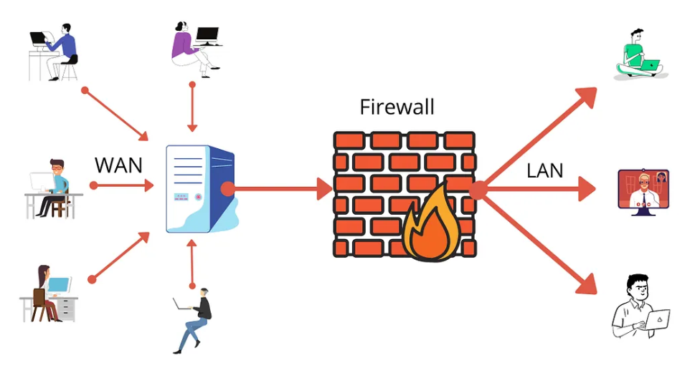

Key Concepts
- A firewall helps prevent unauthorized access to a system
- Rules can be defined to allow or deny specific traffic
- These rules are known as firewall rules

Firewall Tools in Linux
In Linux, firewalls are managed using different tools:
Tool | Description
iptables | Traditional firewall tool (older but widely used)
firewalld | Modern firewall tool (dynamic and easier to manage)
nftables | Advanced and newer firewall framework

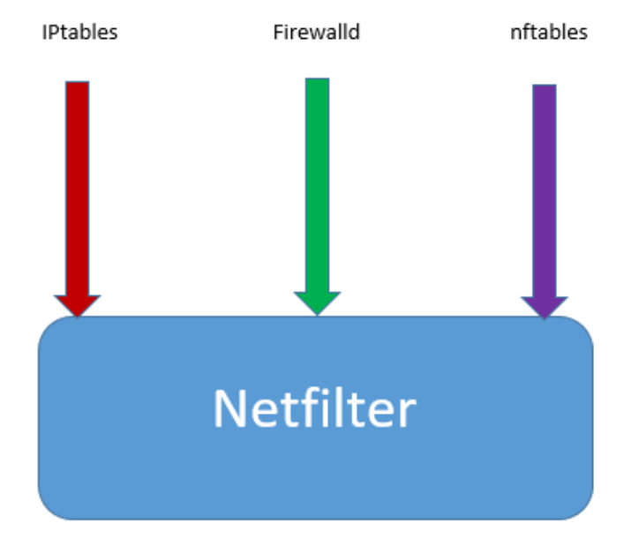

How Firewall Works in Linux
A firewall in Linux is based on a core component called netfilter.
What is Netfilter?
- Netfilter is a framework inside the Linux kernel
- It handles network-related operations such as:
  - Packet filtering
  - Network Address Translation (NAT)
  - Port translation

Working Process
- Network traffic enters the system
- Netfilter checks the traffic
- Firewall rules are applied
- Traffic is either:
  - Allowed
  - Blocked

Relationship Between Netfilter and Firewall Tools
Component | Role
Netfilter | Core engine inside Linux kernel
iptables | Tool to manage netfilter (older)
firewalld | User-friendly tool to manage firewall rules
nftables | Modern replacement for iptables

Important Notes
- iptables has been used for a long time
- Many modern Linux distributions now use firewalld by default
- In newer systems (like RHEL 8+), iptables is deprecated
- nftables is used for advanced firewall configurations

Summary Table
Term | Meaning
Firewall | Protects system by controlling network traffic
Netfilter | Kernel-level framework for packet filtering
iptables | Old firewall management tool
firewalld | Modern, easy-to-use firewall tool
nftables | Advanced and newer firewall system

What is Firewalld?
Firewalld is a dynamic firewall management tool that is included in many Linux distributions such as RHEL, CentOS, Fedora, and more. It provides a higher-level, user-friendly interface for managing firewall rules and network zones.
Firewalld is managed using the firewall-cmd command.
Firewalld comes by default on the following Linux distributions:
- CentOS 7 and newer
- Fedora 18 and newer
- OpenSUSE Leap 15 and newer
- Red Hat Enterprise Linux 7 (RHEL) and newer
- SUSE Linux Enterprise 15 and newer
- Also, it can be installed on other distributions (like Ubuntu) as a package.

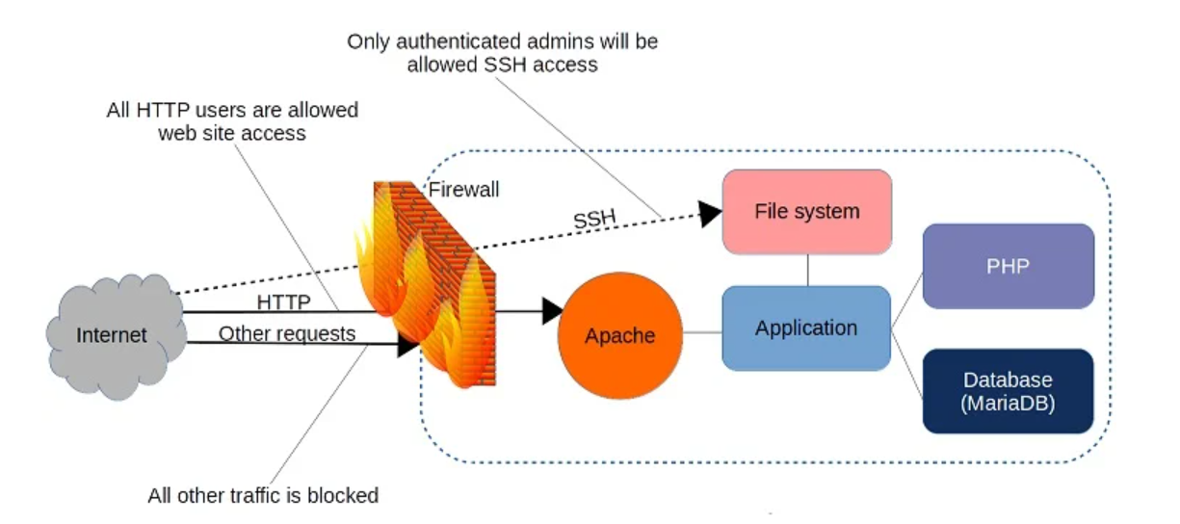

How to Configure Firewall in Linux Using Firewalld

1. Introduction
Firewalld is the default firewall management tool in RHEL 7, 8, and later versions.
It must be installed and running before configuring firewall rules.

2. Install Firewalld
Command
yum install firewalld
Purpose
- Installs the firewalld package if not already available

Summary Table (Installation)
Task | Command | Purpose
Install | yum install firewalld | Install firewall service

3. Check Firewall Status
Command
systemctl status firewalld.service
Purpose
- Verifies whether firewalld is:
  - Running
  - Stopped
  - Enabled

Example Output
Active: active (running)

Summary Table (Status Check)
Task | Command | Purpose
Check status | systemctl status firewalld.service | Verify firewall state

4. Start Firewall Service
Command
systemctl start firewalld
Purpose
- Starts the firewall service immediately

5. Enable Firewall (Auto Start on Boot)
Command
systemctl enable firewalld
Purpose
- Enables firewalld to start automatically after reboot

6. Stop Firewall Service
Command
systemctl stop firewalld
Purpose
- Stops the firewall service temporarily

7. Disable Firewall (Disable Auto Start)
Command
systemctl disable firewalld.service
Purpose
- Prevents firewalld from starting after reboot

8. Service Management Summary Table
Task | Command | Effect
Install | yum install firewalld | Install firewall
Start | systemctl start firewalld | Start service
Enable | systemctl enable firewalld | Enable at boot
Stop | systemctl stop firewalld | Stop service
Disable | systemctl disable firewalld | Disable at boot
Status | systemctl status firewalld | Check current status

9. Additional Useful Commands (Recommended)
Command | Purpose
systemctl restart firewalld | Restart firewall service
systemctl reload firewalld | Reload configuration
firewall-cmd --state | Check firewall running state

Firewalld Configuration Types and Storage
1. Types of Configurations in Firewalld
Firewalld supports two types of configurations:
1.1 Runtime Configuration
- Temporary configuration
- Applied immediately
- Lost after system reboot or service restart
Example:
firewall-cmd --add-service=http

1.2 Permanent Configuration
- Saved configuration
- Persists after reboot
- Must reload the configuration to use in the current session
Example:
firewall-cmd --add-service=http --permanent
firewall-cmd --reload

Configuration Comparison Table
Type | Persistence | Effect | Command Example
Runtime | Temporary | Immediate | firewall-cmd --add-service=http
Permanent | Persistent (after reboot) | Requires reload | --permanent + --reload

Firewalld Configuration Directories

Firewalld stores its configuration in two main directories:
1 Default Configuration
Path | Description
/usr/lib/firewalld/ | Default configurations provided by the system

- May be overwritten during system updates
- Should not be modified directly

2 Custom/System Configuration
Path | Description
/etc/firewalld/ | User-defined configurations

- Persistent across reboots and updates
- Recommended location for customization

How Firewalld Works

In Linux (RHEL-based systems), firewalld is used as a dynamic firewall management tool.
Firewalld works using a zone and service-based approach to manage firewall rules in a simple and structured way.
- Zones (security levels)
- Services and ports (rules)
Firewalld is managed using the firewall-cmd command.

Check Firewall Status
firewall-cmd --state
Shows whether firewalld is running

1. Basic Working Concept
- A zone is created and activated
- Firewall rules are applied to that zone
- Rules control traffic such as:
  - IP addresses
  - Ports
  - Protocols
  - Network interfaces (NICs)
Rules can be configured in two ways:
- Directly on the zone
- By creating a service and attaching it to a zone

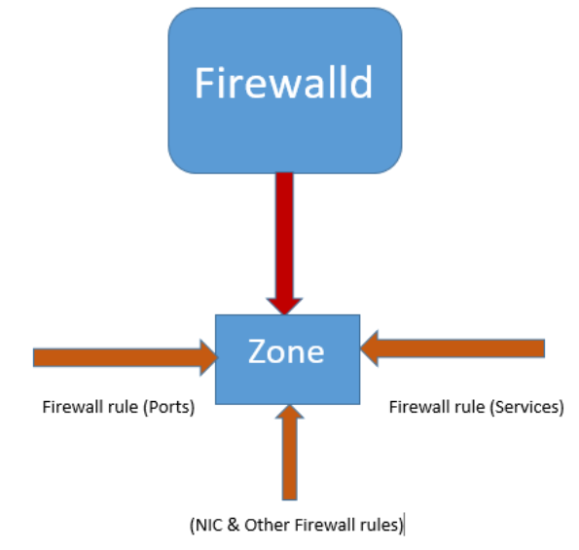

2. Firewalld Architecture
Component | Description
Zone | Group of firewall rules
Service | Predefined set of ports and protocols
Rule | Allow or block traffic
Interface | Network device assigned to a zone

Firewalld Zones

Firewalld organizes network traffic into zones, where each zone has its own set of firewall rules.
- Different zones represent different trust levels
- Examples:
  - public (default, less trusted)
  - internal (trusted network)
  - trusted (fully trusted network)

Predefined Zones
Zone | Suitable For | Behavior
block | Untrusted networks | Blocks all incoming traffic with an ICMP prohibited message
drop | Completely untrusted networks | Drops all incoming traffic without any response
dmz | Public-facing systems with limited access | Allows only selected services (used for servers exposed to the internet)
public | Public or internet networks (default) | Allows only selected incoming traffic
external | External networks / routers | Supports masquerading (NAT) and allows selected traffic
home | Home networks | Trusted network but still allows only selected services
internal | Internal/private networks | Similar to home, used for trusted internal environments
trusted | Fully trusted networks | Allows all incoming traffic without restriction
work | Office/work environments | Trusted network with controlled access
libvirt | Virtualization (KVM/libvirt networks) | Used for virtual machines managed by libvirt

Zone Configuration Location:
Path | Purpose
/usr/lib/firewalld/zones/ | Default zone configuration

4. How Zones Work
- Only the active zone handles incoming traffic
- Network interface is assigned to a zone
- All rules must be defined in that zone

Firewalld Zone Commands and Their Purpose:
1. List Available Zones
firewall-cmd --get-zones
Purpose:
- Displays all predefined zones available in the system
- Helps you understand what zones you can use (public, internal, dmz, etc.)

2. Show Default Zone
firewall-cmd --get-default-zone
Purpose:
- Displays the default active zone
- This is the zone applied to network interfaces unless changed
- Usually public by default

3. Show Active Zone Details
firewall-cmd --list-all
Purpose:
- Shows complete details of the active zone, including:
  - Allowed services
  - Open ports
  - Interfaces
  - Rules applied

Summary Table
Command | Purpose
firewall-cmd --get-zones | List all available zones
firewall-cmd --get-default-zone | Show default (active) zone
firewall-cmd --list-all | Show full configuration of active zone

Firewalld Services

1. Introduction
In firewalld, a service is a method used to define firewall rules in a simple and reusable way.
A service is a combination of:
- Ports
- Protocols (TCP/UDP)
- Sometimes IPv4/IPv6 settings
These services are then attached to zones to allow or control network traffic.
Example
- HTTP service → Port 80
- SSH service → Port 22

Service Usage
Command | Description
firewall-cmd --get-services | List available services
firewall-cmd --add-service=http | Allow HTTP traffic
firewall-cmd --remove-service=http | Remove service

2. Predefined Firewalld Services
Firewalld provides many predefined services by default.
List Available Services
firewall-cmd --get-services
Purpose
- Displays all available predefined services (http, ssh, ftp, samba, etc.)

Service Location
Path | Purpose
/usr/lib/firewalld/services/ | Default service definitions
/etc/firewalld/services/ | Custom user-defined services

3. Structure of a Service File
Each service is defined using an XML file.
Example: samba.xml
<service>
<short>Samba</short>
<description>File sharing service</description>
<port protocol="udp" port="137"/>
<port protocol="udp" port="138"/>
<port protocol="tcp" port="139"/>
<port protocol="tcp" port="445"/>
</service>
Explanation
Element | Description
<short> | Service name
<description> | Service details
<port> | Port and protocol configuration

4. Creating a Custom Firewalld Service
Step 1: Copy Existing Template
cp /usr/lib/firewalld/services/samba.xml /etc/firewalld/services/tekneed.xml

Step 2: Edit the Service File
vi /etc/firewalld/services/tekneed.xml
Example:
<service>
<short>Tekneed</short>
<description>Custom service</description>
<port protocol="udp" port="2020"/>
<port protocol="tcp" port="2020"/>
</service>

Step 3: Reload Firewalld
firewall-cmd --reload

Step 4: Verify Service
firewall-cmd --get-services

5. Attach Service to a Zone
Temporary
firewall-cmd --add-service=tekneed
Permanent
firewall-cmd --add-service=tekneed --permanent
firewall-cmd --reload

6. How Firewalld Services Work
Working Flow
- Network traffic enters the system
- Firewalld checks the active zone
- It evaluates rules defined in that zone
- If a service is allowed, traffic is accepted
- Otherwise, traffic is blocked

7. Important Notes
- Services simplify firewall rule management
- Instead of opening ports manually, use services
- Custom services should be created in:/etc/firewalld/services/
- Multiple zones can be active based on interfaces
- Default zone is usually public

8. Summary Table
Task | Command | Purpose
List services | firewall-cmd --get-services | Show all services
View service files | ls /usr/lib/firewalld/services/ | List service definitions
Create service | Copy + edit XML | Define custom service
Reload firewall | firewall-cmd --reload | Apply changes
Add service | --add-service=name | Allow service
Permanent add | --permanent | Save configuration

Conclusion
Firewalld services provide a simple and structured way to manage firewall rules.
- They group ports and protocols into reusable units
- They are attached to zones to control traffic
- Custom services allow flexibility for specific requirements
This makes firewall configuration easier, organized, and scalable.

Real World Scenarios: Firewalld Service for Tomcat

Default Tomcat Ports
- 8080 (HTTP)
- 8443 (HTTPS - optional)

1. Create a Custom Tomcat Service
Step 1: Copy Template
cp /usr/lib/firewalld/services/http.xml /etc/firewalld/services/tomcat.xml

Step 2: Edit the File
vi /etc/firewalld/services/tomcat.xml
Modify Content
<service>
<short>Tomcat</short>
<description>Apache Tomcat Web Application Server</description>
<port protocol="tcp" port="8080"/>
<port protocol="tcp" port="8443"/>
</service>

Step 3: Reload Firewalld
firewall-cmd --reload

Step 4: Verify Service
firewall-cmd --get-services | grep tomcat

2. Add Tomcat Service to Zone
Temporary
firewall-cmd --add-service=tomcat
Permanent
firewall-cmd --add-service=tomcat --permanent
firewall-cmd --reload

3. Verify Configuration
firewall-cmd --list-all

Summary Table
Step | Command | Purpose
Copy template | cp http.xml tomcat.xml | Create service file
Edit file | vi tomcat.xml | Define ports (8080, 8443)
Reload | firewall-cmd --reload | Apply changes
Add service | --add-service=tomcat | Allow traffic
Verify | --list-all | Confirm rule

Firewalld Rule

1. Firewall Rule
A firewall rule defines whether network traffic is allowed or blocked based on specific conditions.
Purpose
- Control incoming and outgoing traffic
- Allow or deny access based on:
  - Ports
  - Protocols
  - IP addresses
  - Services

Types of Rules
Rule Type | Description
Allow | Permits specific traffic
Block | Rejects traffic with response
Drop | Silently discards traffic

Examples
Allow HTTP Service
firewall-cmd --add-service=http
Allow Specific Port (8080)
firewall-cmd --add-port=8080/tcp
Block Service (Remove Rule)
firewall-cmd --remove-service=http
Permanent Rule
firewall-cmd --add-service=http --permanent
firewall-cmd --reload

Summary Table (Rule)
Task | Command Example | Purpose
Allow service | --add-service=http | Allow HTTP traffic
Allow port | --add-port=8080/tcp | Open custom port
Remove rule | --remove-service=http | Block service
Permanent rule | --permanent + --reload | Save rule permanently

Firewalld Interface

An interface is a network device (NIC) that connects the system to a network.
Each interface is assigned to a zone, and firewall rules are applied based on that zone.

Purpose
- Assign network traffic to a specific zone
- Apply different rules for different networks

Common Interface Names
Interface | Description
ens33 | Ethernet interface
eth0 | Traditional Ethernet name
wlan0 | Wireless interface
virbr0 | Virtual interface (KVM)

Interface Commands
Check Active Interfaces and Zones
firewall-cmd --get-active-zones
Check Zone of Interface
firewall-cmd --get-zone-of-interface=ens33
Assign Interface to Zone
firewall-cmd --zone=public --add-interface=ens33
Permanent Assignment
firewall-cmd --zone=public --add-interface=ens33 --permanent
firewall-cmd --reload

Summary Table (Interface)
Task | Command Example | Purpose
View active zones | --get-active-zones | Show interfaces per zone
Check interface zone | --get-zone-of-interface=ens33 | Identify assigned zone
Assign interface | --add-interface=ens33 | Attach interface to zone
Permanent assign | --permanent + --reload | Save configuration

How Firewalld Processes Traffic

Step-by-Step Flow
- Network traffic enters the system
- Traffic is mapped to an active zone
- Firewalld checks rules in that zone
- Based on rules:
  - Traffic is allowed
  - Traffic is blocked or dropped

7. Zones vs Services
Feature | Zone | Service
Purpose | Defines trust level | Defines allowed ports/protocols
Usage | Contains rules | Attached to zones
Example | public, home | http, ssh

8. Key Points
- Firewalld simplifies firewall management using zones
- Zones define trust levels
- Services define allowed traffic
- Rules can be applied directly or via services
- Default active zone is usually public

Conclusion
Firewalld works by combining zones and services to control network traffic.
- Zones define where rules apply
- Services define what traffic is allowed
This approach makes firewall configuration simpler, flexible, and easier to manage compared to older tools like iptables.

Firewalld Commands

1. Zone Commands
Purpose
Manage firewall zones and their configurations.

Commands
Command | Purpose
firewall-cmd --get-zones | List all available zones
firewall-cmd --get-active-zones | Show active zones and interfaces
firewall-cmd --get-default-zone | Show default zone
firewall-cmd --set-default-zone=<zone> | Change default zone
firewall-cmd --list-all | Show active zone configuration
firewall-cmd --list-all-zones | Show all zones with rules
firewall-cmd --zone=<zone> --list-all | Show specific zone details

Examples
firewall-cmd --get-zones
firewall-cmd --get-active-zones
firewall-cmd --set-default-zone=home

Zone Summary
Task | Command
List zones | --get-zones
Active zones | --get-active-zones
Default zone | --get-default-zone
Change zone | --set-default-zone

2. Service Commands
Purpose
Manage predefined or custom services (group of ports/protocols).

Commands
Command | Purpose
firewall-cmd --get-services | List all services
firewall-cmd --add-service=<service> | Allow service
firewall-cmd --add-service=<service> --permanent | Add permanently
firewall-cmd --remove-service=<service> | Remove service
firewall-cmd --list-services | Show active services
firewall-cmd --zone=<zone> --list-services | Services in specific zone

Examples
firewall-cmd --get-services
firewall-cmd --add-service=http
firewall-cmd --remove-service=http

Service Summary
Task | Command
List services | --get-services
Add service | --add-service=http
Remove service | --remove-service=http
View services | --list-services

3. Rule Commands (Ports / Rich Rules)
Purpose
Control traffic using ports, protocols, and advanced rules.

Commands
Command | Purpose
firewall-cmd --add-port=8080/tcp | Open port
firewall-cmd --add-port=8080/tcp --permanent | Permanent rule
firewall-cmd --remove-port=8080/tcp | Close port
firewall-cmd --list-ports | Show open ports
firewall-cmd --add-rich-rule='rule ...' | Advanced rule
firewall-cmd --remove-rich-rule='rule ...' | Remove rich rule

Examples
firewall-cmd --add-port=8080/tcp
firewall-cmd --add-port=8080/tcp --permanent
firewall-cmd --add-rich-rule='rule family="ipv4" service name="http" accept'

Rule Summary
Task | Command
Open port | --add-port=8080/tcp
Close port | --remove-port=8080/tcp
List ports | --list-ports
Rich rule | --add-rich-rule

4. Interface Commands
Purpose
Manage network interfaces and assign them to zones.

Commands
Command | Purpose
firewall-cmd --get-zone-of-interface=<iface> | Check interface zone
firewall-cmd --zone=<zone> --add-interface=<iface> | Assign interface
firewall-cmd --zone=<zone> --remove-interface=<iface> | Remove interface
firewall-cmd --get-active-zones | Show interfaces in zones

Examples
firewall-cmd --get-zone-of-interface=ens33
firewall-cmd --zone=public --add-interface=ens33

Interface Summary
Task | Command
Check interface zone | --get-zone-of-interface
Assign interface | --add-interface
Remove interface | --remove-interface

5. General / Common Commands
Purpose
Basic firewall operations.

Commands
Command | Purpose
firewall-cmd --state | Check firewall status
firewall-cmd --reload | Reload firewall
firewall-cmd --runtime-to-permanent | Save runtime rules
firewall-cmd --permanent | Apply permanent changes

Examples
firewall-cmd --state
firewall-cmd --reload
firewall-cmd --runtime-to-permanent

General Summary
Task | Command
Check status | --state
Reload firewall | --reload
Save config | --runtime-to-permanent

Zone and Service Configuration & Management in Firewalld

1. Introduction
Firewall configuration in firewalld means defining rules on zones.
These rules control access using:
- Ports
- Services
- Interfaces (NICs)
If no zone is specified, rules are applied to the default zone.

2. Port (Rule) Configuration

2.1 Open a Port (Default Zone)
Commands
firewall-cmd --add-port=2022/tcp
firewall-cmd --add-port=2022/tcp --permanent
firewall-cmd --reload
Purpose
- Opens port 2022 (TCP)
- Applies to default zone

2.2 Verify Open Port
firewall-cmd --list-all

2.3 Open Port on Specific Zone
firewall-cmd --zone=home --add-port=2023/udp --permanent
firewall-cmd --reload

2.4 Verify Zone Configuration
firewall-cmd --zone=home --list-all

2.5 Close / Remove Port
firewall-cmd --zone=public --remove-port=2023/tcp --permanent
firewall-cmd --reload

Port Configuration Summary
Task | Command Example
Open port | --add-port=2022/tcp
Open permanent | --add-port=2022/tcp --permanent
Open on zone | --zone=home --add-port=2023/udp
Remove port | --remove-port=2023/tcp
Verify | --list-all

3. Interface (NIC) Management

3.1 Check Interface Zone
firewall-cmd --get-zone-of-interface=ens33

3.2 Reassign Interface to Zone
firewall-cmd --change-interface=ens33 --zone=home --permanent
firewall-cmd --reload

3.3 Verify Change
firewall-cmd --get-zone-of-interface=ens33

Interface Summary
Task | Command Example
Check interface zone | --get-zone-of-interface=ens33
Assign interface | --change-interface=ens33 --zone=home
Reload | --reload

4. Service Configuration

4.1 Add Service (Default Zone)
firewall-cmd --add-service=samba
firewall-cmd --add-service=samba --permanent
firewall-cmd --reload

4.2 Add Service to Specific Zone
firewall-cmd --zone=home --add-service=samba --permanent
firewall-cmd --reload

4.3 Remove Service
firewall-cmd --remove-service=samba --permanent
firewall-cmd --reload

Service Summary
Task | Command Example
Add service | --add-service=samba
Add permanent | --add-service=samba --permanent
Add to zone | --zone=home --add-service=samba
Remove service | --remove-service=samba

5. Important Notes
- If zone is not specified, rules apply to default zone
- Always use --reload after permanent changes
- Ports = manual rules
- Services = predefined rule sets (recommended)
- Interfaces determine which zone traffic belongs to

Real-World SetUp: Complete Firewalld + HTTPD Setup

1. Installation
Install HTTPD
dnf install httpd -y

Start and Enable Service
systemctl enable --now httpd

Verify Service
systemctl status httpd

2. Configuration
Create Web Page
echo "Hello from Server" > /var/www/html/index.html

Find Server IP
ip a
or
ip address
Example:
192.168.1.10

Check Firewall Status
firewall-cmd --state

3. Test Webpage Using IP (Before Firewall Rule)
From Same Server
curl localhost
curl 192.168.1.10
✅ Works

From Another System (Client)
curl http://192.168.1.10
❌ Blocked (firewall)

4. Allow Incoming Traffic (Fix Firewall)
firewall-cmd --add-service=http --permanent
firewall-cmd --reload

Test Again (Client)
curl http://192.168.1.10
✅ Works

5. Outgoing Traffic (Default Behavior)
- Outgoing traffic is allowed by default
Test:
ping google.com
✅ Works

6. Block Outgoing Traffic (Advanced)
Block outgoing HTTP (example)
firewall-cmd --add-rich-rule='rule family="ipv4" destination port port="80" protocol="tcp" drop'

7. Incoming & Outgoing Scenarios (1 = Allow, 0 = Block)

Case 1: 1 / 1 (Incoming = Allow, Outgoing = Allow)
Setup:
firewall-cmd --add-service=http --permanent
firewall-cmd --reload
Result:
Traffic Type | Status
Incoming | ✅ Allowed
Outgoing | ✅ Allowed
👉 Webpage accessible + server can access internet

Case 2: 1 / 0 (Incoming = Allow, Outgoing = Block)
Setup:
firewall-cmd --add-service=http --permanent
firewall-cmd --add-rich-rule='rule family="ipv4" destination address="0.0.0.0/0" drop'
firewall-cmd --reload
Result:
Traffic Type | Status
Incoming | ✅ Allowed
Outgoing | ❌ Blocked
👉 Users can access server
👉 Server cannot access internet

Case 3: 0 / 1 (Incoming = Block, Outgoing = Allow)
Setup (default state):
firewall-cmd --remove-service=http --permanent
firewall-cmd --reload
Result:
Traffic Type | Status
Incoming | ❌ Blocked
Outgoing | ✅ Allowed
👉 Server cannot be accessed
👉 Server can access internet

Case 4: 0 / 0 (Incoming = Block, Outgoing = Block)
Setup:
firewall-cmd --remove-service=http --permanent
firewall-cmd --add-rich-rule='rule family="ipv4" destination address="0.0.0.0/0" drop'
firewall-cmd --reload
Result:
Traffic Type | Status
Incoming | ❌ Blocked
Outgoing | ❌ Blocked
👉 Fully isolated system

8. Testing Matrix
Scenario | Test Command | Expected Result
Incoming test | curl http://192.168.1.10 | Webpage or fail
Outgoing test | ping google.com | Success or fail

9. Visual Flow
Incoming
Client → Server IP → Firewall → HTTPD → Response
Outgoing
Server → Internet → Firewall → Allowed/Blocked

10. Final Summary Table
Case | Incoming | Outgoing | Use Case
1 / 1 | Allowed | Allowed | Normal server
1 / 0 | Allowed | Blocked | Secure server (no internet access)
0 / 1 | Blocked | Allowed | Client-only machine
0 / 0 | Blocked | Blocked | Isolated system

Conclusion
This setup demonstrates:
- How to install and configure HTTPD
- How to test using IP instead of localhost
- How firewall controls incoming and outgoing traffic
- Real-world security scenarios using firewalld

wget Command in Linux

Introduction
wget is a Linux command-line utility used to download files from the internet.
It supports HTTP, HTTPS, and FTP protocols.

Key Uses
- Download files directly from a terminal
- Resume interrupted downloads
- Download files in the background
- Download multiple files
- Work in scripts and automation

1. Check Whether wget Is Installed
Before using wget, first check whether it is available on the system.
Command
wget –version
or
wget -V
Sample Output
GNU Wget 1.21.4 built on linux-gnu.

+digest +https +ipv6 +iri +large-file +nls +ntlm +opie +psl +ssl/openssl
If wget is installed, this command displays the installed version.

If wget Is Not Installed
If the system shows an error like this:
wget: command not found
then wget is not installed.

2. Install wget on Ubuntu / Debian
Ubuntu and Debian-based systems use the apt package manager.
Command
sudo apt update
sudo apt install wget -y
Verify Installation
wget --version

3. Install wget on RHEL / CentOS / Rocky Linux / AlmaLinux
RHEL-based systems commonly use dnf or yum.
For RHEL 8, RHEL 9, Rocky Linux, AlmaLinux, Fedora
sudo dnf install wget -y
For Older RHEL / CentOS Systems
sudo yum install wget -y
Verify Installation
wget --version

Basic Syntax of wget
wget [options] [URL]
Example
wget http://www.example.com/filename.txt
Explanation
This command downloads filename.txt from the given URL and saves it in the current working directory.

1. Download a File
Command
wget http://www.example.com/filename.txt
Sample Output
--2026-05-02-- http://www.example.com/filename.txt
Resolving www.example.com... 93.184.216.34
Connecting to www.example.com|93.184.216.34|:80... connected.
HTTP request sent, awaiting response... 200 OK
Length: 2048 (2.0K) [text/plain]
Saving to: 'filename.txt'

filename.txt 100%[==================>] 2.00K --.-KB/s in 0s

2026-05-02 - 'filename.txt' saved [2048/2048]

2. Save Downloaded File with a Specific Name or Path
Correct Command
wget -O /path/filename.txt http://www.example.com/filename.txt
Explanation
This downloads the file from the URL and saves it as:/path/filename.txt
Sample Output
--2026-05-02-- http://www.example.com/filename.txt
Resolving www.example.com... connected.
HTTP request sent, awaiting response... 200 OK
Length: 2048 (2.0K) [text/plain]
Saving to: '/path/filename.txt'

/path/filename.txt 100%[==================>] 2.00K --.-KB/s in 0s

3. Save wget Logs to a File
Command
wget -o /path/wget.log http://www.example.com/filename.txt
Explanation
This downloads the file and stores wget output messages in /path/wget.log.
Check the Log File
cat /path/wget.log
Sample Log Output
--2026-05-02-- http://www.example.com/filename.txt
Resolving www.example.com... connected.
HTTP request sent, awaiting response... 200 OK
Saving to: 'filename.txt'

Important Difference Between -O and -o
Many of them get confused between uppercase -O and lowercase -o.
Option | Purpose | Example
-O uppercase O | Saves the downloaded file with a different name or path | wget -O /path/filename.txt http://www.example.com/file.txt
-o lowercase o | Saves wget command logs into a log file | wget -o /path/wget.log http://www.example.com/file.txt
Important Note
This command does not save the downloaded content as /path/filename.txt:
wget http://www.example.com/filename.txt -o /path/filename.txt
It saves the wget log messages into /path/filename.txt.
To save the downloaded file to a specific path, use uppercase -O:
wget -O /path/filename.txt http://www.example.com/filename.txt

4. Resume an Interrupted Download
If a download stops due to network issues, use -c to continue it.
Command
wget -c http://www.example.com/bigfile.iso
Sample Output
HTTP request sent, awaiting response... 206 Partial Content
Length: 734003200 (700M), 524288000 (500M) remaining
Saving to: 'bigfile.iso'

5. Download a File in the Background
Use -b to run the download in the background.
Command
wget -b http://www.example.com/bigfile.iso
Sample Output
Continuing in background, pid 2456.
Output will be written to 'wget-log'.
To check the log:
tail -f wget-log

6. Limit Download Speed
Use --limit-rate to control the download speed.
Command
wget --limit-rate=100k http://www.example.com/bigfile.iso
Explanation
This limits the download speed to 100 KB per second.

7. Download Multiple URLs from a File
Create a file named urls.txt:
http://www.example.com/file1.txt
http://www.example.com/file2.txt
http://www.example.com/file3.txt
Run:
wget -i urls.txt
Explanation
wget reads all URLs from urls.txt and downloads them one by one.

8. Common wget Options Summary
Option | Meaning | Example
--version or -V | Check wget version | wget --version
--help | Show help | wget --help
-O | Save downloaded file with specific name/path | wget -O file.txt URL
-o | Save wget log output to file | wget -o wget.log URL
-c | Resume interrupted download | wget -c URL
-b | Download in background | wget -b URL
-i | Download URLs listed in a file | wget -i urls.txt
--limit-rate | Limit download speed | wget --limit-rate=100k URL
-r | Recursive download | wget -r URL
-np | Do not go to parent directory | wget -r -np URL

Practice Commands
Practice 1: Check wget Version
wget --version
Practice 2: Download a File
wget http://www.example.com/filename.txt
Practice 3: Download and Save with a Custom Name
wget -O student-file.txt http://www.example.com/filename.txt
Practice 4: Save Logs Separately
wget -o wget-output.log http://www.example.com/filename.txt
Practice 5: Resume Download
wget -c http://www.example.com/bigfile.iso

Real-World Example: Installing wget, Maven, and Tomcat
Step 1: Check wget Availability
wget --version
If not installed, install it first.

Step 2: Install wget
Ubuntu / Debian
sudo apt update
sudo apt install wget -y
RHEL / CentOS / Rocky / AlmaLinux
sudo dnf install wget -y

Step 3: Install Java (Required for Maven & Tomcat)
Ubuntu
sudo apt install openjdk-11-jdk -y
RHEL
sudo dnf install java-11-openjdk -y
Check Java:
java -version

Step 4: Install Apache Maven using wget
wget https://downloads.apache.org/maven/maven-3/3.9.9/binaries/apache-maven-3.9.9-bin.tar.gz
Extract:
tar -xvf apache-maven-3.9.9-bin.tar.gz
sudo mv apache-maven-3.9.9 /opt/maven
Set environment variables:
echo 'export M2_HOME=/opt/maven' >> ~/.bashrc
echo 'export PATH=$M2_HOME/bin:$PATH' >> ~/.bashrc
source ~/.bashrc
Verify:
mvn -version

Step 5: Install Apache Tomcat using wget
wget https://downloads.apache.org/tomcat/tomcat-9/v9.0.89/bin/apache-tomcat-9.0.89.tar.gz
Extract:
tar -xvf apache-tomcat-9.0.89.tar.gz
sudo mv apache-tomcat-9.0.89 /opt/tomcat
Start Tomcat:
cd /opt/tomcat/bin
./startup.sh
Check in browser:
http://localhost:8080

Managing Partitions & File Systems

1. What is Disk Partitioning?
Disk partitioning is the process of dividing a physical disk into multiple logical sections, called partitions, so each can be used independently.
👉 Think of a disk like a cupboard, and partitions as separate shelves — each shelf stores different data.
Definition:
A partition is a contiguous set of blocks on a disk treated as an independent disk

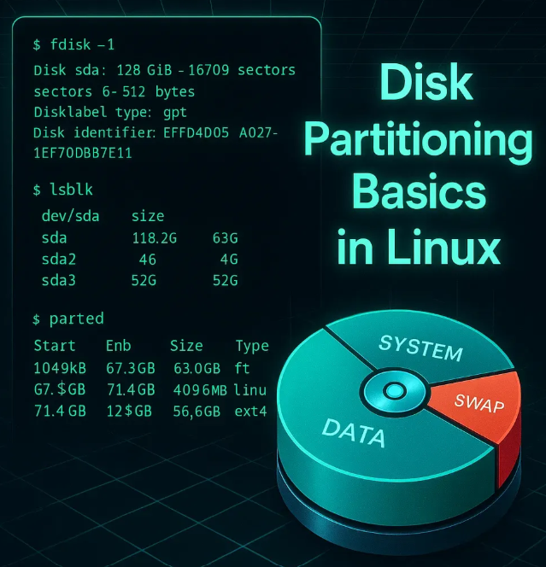

2. Why Do We Need Partitioning?
Partitioning is not just for organization — it plays a critical role in performance, safety, and management.
✅ Key Reasons
Purpose | Explanation | Example
Data Isolation | Failure in one partition won’t affect others | OS crash won’t delete user data
Better Disk Usage | Optimize block sizes based on file types | Small files → smaller blocks
System Protection | Prevent full disk from crashing OS | Separate / and /home
Multi-OS Support | Install multiple OS on same disk | Linux + Windows
Easy Backup | Backup only required partitions | Backup /home only

3. Disk Partitioning Schemes
There are two major partition table types:
- MBR (Master Boot Record)
- GPT (GUID Partition Table)
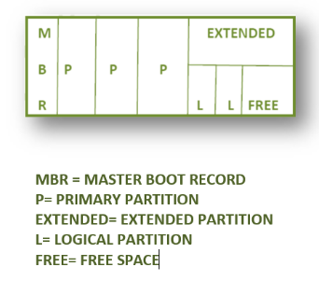
- MBR (Master Boot Record)
- Older standard
- Supports up to 2 TB disk size
- Maximum 4 primary partitions
Structure:
- Boot Loader (IPL – Initial Program Loader)
- Partition Table Information (PTI)
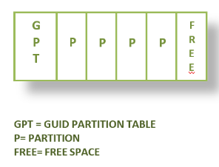
- GPT (GUID Partition Table)
- Modern standard
- Supports very large disks (up to Zettabytes)
- Up to 128 partitions

📊 MBR vs GPT Comparison
Feature | MBR | GPT
Max Disk Size | 2 TB | Very large (ZB scale)
Partitions | 4 Primary | 128
Reliability | Low | High (backup tables)
Boot Mode | BIOS | UEFI

4. Types of Partitions (MBR Concept)
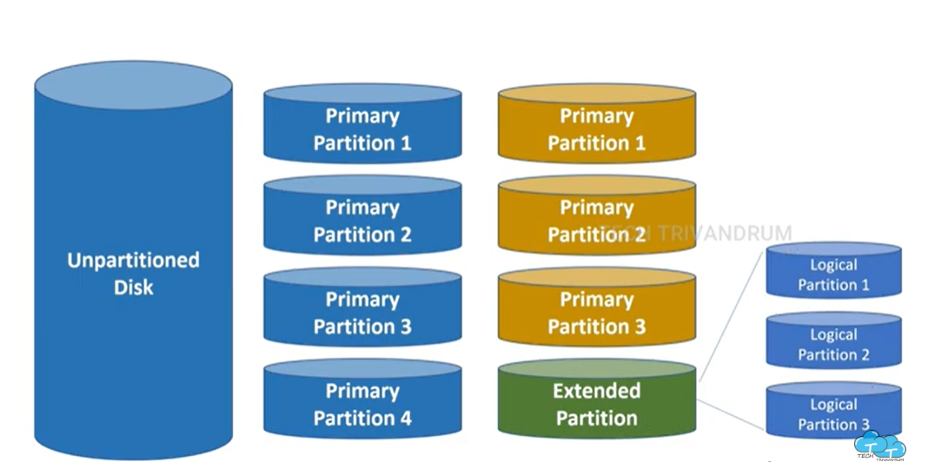

📌 1. Primary Partition
- Used to install OS
- Maximum 4 (or 3 + extended)

📌 2. Extended Partition
- Special partition to create more partitions
- Only one extended partition per disk

📌 3. Logical Partitions
- Created inside extended partition
- Can create multiple logical partitions
Logical Partition Limit
Technically, we can create many logical partitions
In practice: Around 15–25 recommended

📊 Partition Structure Summary
Type | Limit | Purpose
Primary | 4 | OS / Boot
Extended | 1 | Container
Logical | Many | Data storage

Important Rule in MBR
👉 MBR allows maximum 4 partitions
But what if you need more?
✅ Solution:
- Use first 3 as Primary partitions
- Use 4th partition as Extended partition
- Inside Extended → create multiple Logical partitions

5. Types of Partitions (GPT Concept)
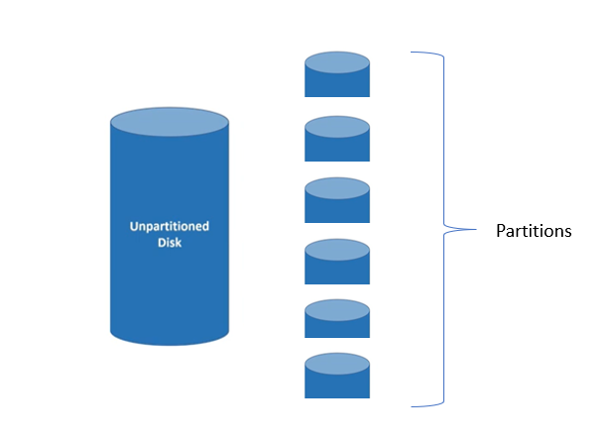
Unlike MBR, GPT uses a simpler and more flexible approach.
👉 In GPT:
- There is no concept of Primary, Extended, or Logical partitions
- All partitions are treated equally

📌 1. GPT Partition (Only One Type)
- Every partition is just called a Partition
- All partitions can:
  - Store data
  - Install OS
  - Be used for any purpose
👉 No hierarchy, no container concept

🔹 Key Features of GPT Partitioning
- Supports up to 128 partitions per disk
- Each partition is independent
- No need for extended or logical partitions
- Designed for modern systems (UEFI)

📊 Partition Structure Summary (GPT)
Type | Limit | Purpose
Partition | Up to 128 | OS / Data / Boot (all same)

🔹 Important Rule in GPT
👉 GPT allows many partitions directly
So:
❌ No need for:
- Extended partition
- Logical partitions
✅ You can directly create partitions as needed

📊 Example Structure (GPT Disk)
Partition | Purpose
/dev/sda1 | EFI Boot
/dev/sda2 | OS
/dev/sda3 | Home
/dev/sda4 | Data
/dev/sda5 | Backup

🔹 Simple Comparison: MBR vs GPT
Feature | MBR | GPT
Partition Types | Primary, Extended, Logical | Single type
Max Partitions | 4 (with workaround) | 128
Complexity | More | Simple
Flexibility | Limited | High

6. Disk Identification in Linux
Linux identifies disks using special naming:
Disk Type | Naming
IDE | /dev/hd*
SATA / SCSI | /dev/sd*
Partitions | /dev/sda1, /dev/sda2
👉 Example:
- /dev/sda → Disk
- /dev/sda1 → First partition
- /dev/sda2 → Second partition

7. Structure of Disk Partitioning
When a disk is prepared:
- Partition Table (MBR/GPT) is created
- Partitions are defined
- Each partition can be used independently
Key Components:
Component | Description
IPL | Boot loader (starts OS)
PTI | Partition details (size, type)

8. Partitioning Methods in Linux
Linux provides two main approaches:
1. Standard Partitioning
2. Logical Volume Manager (LVM)

🟢 1. Standard Partitioning
A standard partition is a method in Linux where a disk is divided into fixed sections (partitions).
👉 Each partition acts as an independent storage unit
- Traditional method
- Fixed partitions
- Difficult to resize later

Tools and Their Usage
Tool | Used For | Partition Type
fdisk | Traditional partitioning | MBR
gdisk | GPT partitioning | GPT
parted | Advanced partitioning | Both MBR & GPT

🔹 Comparison Table: fdisk vs gdisk vs parted
Feature | fdisk | gdisk | parted
Partition Type | MBR | GPT | MBR & GPT
Max Partitions | 4 primary (or 3 + extended) | Up to 128 | Up to 128 (GPT)
Disk Size Support | Up to 2 TB | More than 2 TB | More than 2 TB
Partitioning Style | Legacy | Modern | Modern
Ease of Use | Simple (interactive) | Moderate | Advanced (interactive + scripting)
Supports Both MBR & GPT | ❌ No | ❌ No | ✅ Yes
Best Use Case | Older systems | Modern GPT disks | Advanced & flexible partitioning
Tool Command | fdisk /dev/sdX | gdisk /dev/sdX | parted /dev/sdX

🔹 Disk Naming Convention in Linux
Type | Example
Disk | /dev/sda, /dev/sdb, /dev/sdc
Partition | /dev/sda1, /dev/sda2, /dev/sdb1
👉 Disk topology follows:
sda → sda1, sda2
sdb → sdb1

🔵 2. Logical Volume Manager (LVM)
Logical Volume Manager (LVM) is a device mapper target that provides logical volume management for the Linux kernel. LVM allows a pool of space to manage storage.
- Flexible and dynamic
- Can resize storage easily
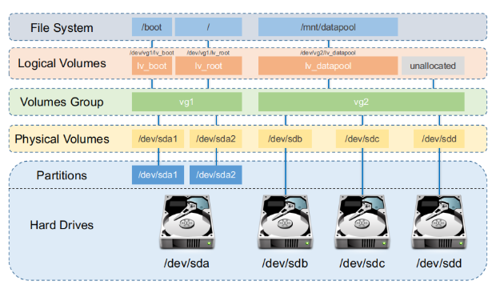
LVM works in layers:
Disk/Partition → Physical Volume (PV) → Volume Group (VG) → Logical Volume (LV) → File System

🔹 What Is a Physical Volume (PV)?
A Physical Volume (PV) is the base storage unit in LVM.
- It can be a disk, partition, or storage device
- It is initialized using the pvcreate command
- LVM metadata is written to it to identify it as part of LVM
- “No physical volume, no volume group”.
👉 Important Rule:
No PV → No VG → No LV

🔹 What Is a Volume Group (VG)?
A Volume Group (VG) is a storage pool in LVM created by combining one or more Physical Volumes (PVs).
- It combines multiple disks or partitions into a single logical storage unit
- It acts like a big virtual disk
- Logical Volumes (LVs) are created from this pool
- It can be created using one or multiple physical volumes
- It is created using the vgcreate command
👉 Important Rule:
“No Volume Group, no Logical Volume”
No VG → No LV

🔹 What Is a Physical Extent (PE)?
A Physical Extent (PE) is the smallest unit of storage used by LVM inside a Physical Volume.
- It represents how a Physical Volume is divided into blocks/chunks
- Data is stored in these fixed-size extents
- All extents in a Volume Group are of equal size
- Default extent size is 4 MB
- Logical Volumes (LVs) are created using these extents
👉 Important Rule:
Data in LVM is stored in blocks (extents), not as continuous space
👉 Flow:
PV → PE → VG → LV

🔹 What Is a Logical Volume (LV)?
A Logical Volume (LV) is the usable storage unit in LVM created from a Volume Group.
- It acts like a virtual partition
- It is created from free space in a Volume Group (VG)
- Filesystem is created on top of LV
- It can be easily extended or reduced
- It is created using the lvcreate command
👉 Important Rule:
“No Volume Group (VG), no Logical Volume (LV)”
👉 Final Flow:
PV → VG → LV → Filesystem → Mount → Use

Components of LVM:
Physical Volume (PV) | Physical Volumes are directly related to hard drives or partitions
Volume Group (VG) | A Volume Group can have multiple physical Volumes
Logical Volume (LV) | A Logical Volume sits inside a Volume Group and it’s what is assigned to a file system.
File System | The filesystem sits on top of the logical volume and it will be formatted to a specifc fs type (vfat, xfs, ext4) and mounted (/root, /home, /mnt/*, etc).

When a physical disk is setup for LVM, metadata is written at the beginning of the disk for normal usage, and at the end of the disk for backup usage.

🔹 Why LVM Is Important
LVM has significantly improved how storage is managed in Linux systems. It allows administrators to:
- Easily resize volumes
- Combine multiple disks into one storage pool
- Manage storage dynamically
This has made storage deployment simpler and more efficient.

🔹 Key Concept
- Multiple Physical Volumes (PVs) can be combined into a single Volume Group (VG)
- From that VG, you can create multiple Logical Volumes (LVs)
👉 Logical Volumes act like virtual partitions, but with much more flexibility than standard partitions.

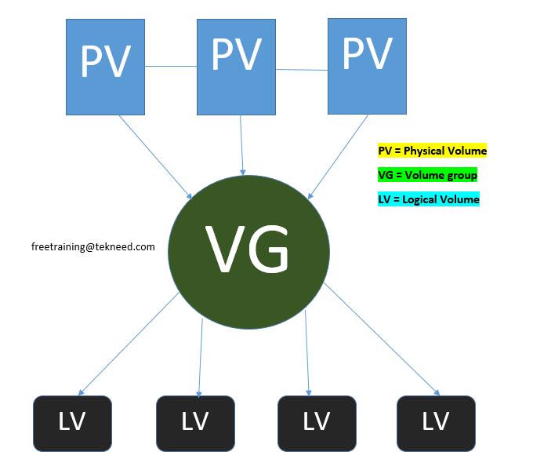

🔹 Advantages of LVM
✅ 1. Easy Volume Resizing
- Volumes can be extended or reduced easily
- No need for complex operations
✅ 2. Flexible Storage Management
- You can add more disks to an existing Volume Group
- No need to worry about disk space limitations
✅ 3. Advanced Features
- Snapshots (backup)
- Mirroring
- Import/export of volume groups

🔹 Disadvantages of LVM
- Requires proper planning before implementation
- If all LVs are on one disk and it fails, data loss can occur (without backup or redundancy)

🔹 LVM vs Standard Partition
Feature | LVM | Standard Partition
Resize | Easy (online) | Difficult
Flexibility | High | Low
Number of volumes | 250+ | Limited (~50)
Management | Dynamic | Static
👉 LVM allows resizing without unmounting, while standard partitions usually require downtime.

9. File System Overview
A file system is a method of storing and organizing data on a partition.
👉 Without a file system, a partition cannot store usable data

10. Types of File Systems in Linux
📊 Comparison Table
Feature | EXT2 | EXT3 | EXT4 | XFS
Full Form | Second Extended | Third Extended | Fourth Extended | X File System
Introduced | 1993 | 2001 | 2008 | 1993
Journaling | ❌ No | ✅ Yes | ✅ Yes | ✅ Yes
Max File Size | Up to 2TB | Up to 2TB | Up to 16TB | Up to 8EB
Max FS Size | 32TB | 32TB | 1EB | 16EB
Conversion | ❌ | ext2 → ext3 | ext2/3 → ext4 | N/A

🔹 Popular File Systems
File System | Use Case
ext4 | General Linux usage
xfs | High-performance systems
vfat | Shared with Windows

🔹 How to Check Filesystem Type in Linux
To identify the filesystem of a specific partition, you can use the following commands:
• blkid → Displays filesystem details (recommended)
• blkid | grep → Filters specific partition from full list
• fsck -N → Shows filesystem type without performing any check

🔹 Method 1: Using blkid (Recommended)
blkid /dev/sdb1
📊 Example Output:
/dev/sdb1: LABEL="tekneed_fs" UUID="fe48facc-c481-4429-93d2-77e4ac0afc89" TYPE="ext4"
👉 Shows:
- Filesystem type → ext4
- Label → tekneed_fs
- UUID → Unique identifier

🔹 Method 2: Using blkid with grep
blkid | grep /dev/sdb1
📊 Example Output:
/dev/sdb1: LABEL="tekneed_fs" UUID="fe48facc-c481-4429-93d2-77e4ac0afc89" TYPE="ext4"
👉 Useful when:
- You want to filter output from multiple devices

🔹 Method 3: Using fsck
fsck -N /dev/sdb1
📊 Example Output:
fsck from util-linux
fsck.ext4 /dev/sdb1
👉 Indicates:
- Filesystem type is ext4

🔹 How To Create a Filesystem
To create a filesystem on a partition:
mkfs.<filesystem-type> /dev/<partition>
🔹 Example
mkfs.ext3 /dev/sdb1
👉 This will:
- Format the partition
- Create an ext3 filesystem

🔹 Important Notes
• Formatting will erase all existing data
• Always verify the correct device before running mkfs
• A filesystem must be created before mounting

🎯 Final Summary
Check Filesystem → blkid / blkid | grep / fsck
Create Filesystem → mkfs

11. Disk Partitioning Tools
Tool | Description
fdisk | CLI tool for MBR partitioning
parted | Advanced tool (MBR + GPT)
gparted | GUI tool

12. Important Commands (Overview Only)

Command | Purpose | What It Shows | Output Type | When to Use
lsblk | Show block devices | Disk → partition hierarchy, mount points, file system type | Tree structure (easy to read) | Quick overview of disks and mounted partitions
fdisk -l | View disk and partition details | Disk size, partitions, sector info, partition type (MBR/GPT) | Detailed, text-heavy | When you need low-level disk information and partition details
fdisk /dev/sda | Manage partitions | Opens interactive disk utility to create/delete partitions | Interactive CLI menu | When creating, deleting, or modifying partitions
parted -l | View partition details (MBR & GPT) | Disk info, partition table type, partitions (supports large disks) | Structured output | When working with modern disks (GPT) or large storage

13. Best Practices for Partitioning
✔ Keep OS and data separate
✔ Use GPT for modern systems
✔ Use LVM for flexibility
✔ Plan partition sizes carefully
✔ Avoid too many partitions

Mounting in Linux

What is Mounting?
Mounting is the process of attaching a partition (file system) to a directory so that it becomes accessible to the system.
👉 In simple terms:
- A partition exists separately
- To use it, it must be connected to a directory


📊 Basic Representation
Partition | Mount Point (Directory)
/dev/sda1 | /data
/dev/sdb1 | /backup
👉 Once mounted, accessing /data means accessing /dev/sda1

Key Concepts
📌 Partition
- A storage unit (disk section)
- Example: /dev/sda1

📌 Mount Point
- A directory where the partition is attached
- Usually an empty directory
👉 Example:
/mnt (default)
/data
/backup

🔹 Default Mount Directory
- Linux provides /mnt directory by default
- Commonly used for temporary mounts
Examples:
/mnt/usb
/mnt/cdrom

Important Files Related to Mounting
📊 Mounting Files Overview
File | Purpose | Type
/etc/mtab | Stores currently mounted file systems | Dynamic (changes automatically)
/etc/fstab | Stores permanent mount configurations | Static (manual entry)

📌 /etc/mtab
- Shows all currently mounted file systems
- Automatically updated by system
- Changes whenever mount/unmount happens

📌 /etc/fstab
- Used for permanent mounting
- Defines which partitions should mount automatically at boot
👉 If you want a partition to be available after reboot → add entry here

🔹 Mounting Flow
Partition → File System → Mount Point → Accessible Data

🎯 Final Summary
👉 Mounting connects a partition to a directory so it can be used
- Partition = storage
- Mount point = access location
- /etc/mtab = current mounts
- /etc/fstab = permanent mounts

Types of Mounting in Linux

In Linux (and UNIX systems), there are two types of mounting:
- Temporary Mounting
- Permanent Mounting

1. Temporary Mounting
Temporary mounting attaches a filesystem to a directory only for the current session.
👉 After reboot, the mount is lost.

🔹 Syntax
mount <device-name> <mount-point>
📌 Example:
mount /dev/sda5 /mnpt

🔹 Verify Mount (All Partitions)
mount
📊 Example Output:
/dev/sda1 on /boot type xfs (rw,relatime)
/dev/sda2 on / type xfs (rw,relatime)
/dev/sda5 on /mnpt type ext4 (rw,relatime)

🔹 Check Specific Partition
📌 Method 1:
mount | grep sda5
📊 Output:
/dev/sda5 on /mnpt type ext4 (rw,relatime)

📌 Method 2:
df -h | grep sda5
📊 Output:
/dev/sda5 976M 2.6M 907M 1% /mnpt

📌 Method 3:
lsblk
📊 Output:
NAME MAJ:MIN RM SIZE RO TYPE MOUNTPOINT
sda 8:0 0 10G 0 disk
└─sda5 8:5 0 1G 0 part /mnpt

🔹 Access Mounted Partition
cd /mnpt
👉 You can:
- Create files
- Store data
- Modify content

🔹 Unmount Partition
umount /mnpt

🔹 Verify Unmount
mount | grep sda5
👉 No output → successfully unmounted

2. Permanent Mounting
Permanent mounting ensures the filesystem is mounted automatically after reboot.
👉 This is configured using /etc/fstab

🔹 Step 1: Create Mount Point
mkdir /kernel

🔹 Step 2: Edit /etc/fstab
vi /etc/fstab

🔹 /etc/fstab File
The /etc/fstab file is used for automatic mounting at boot time.

🔹 View fstab
cat /etc/fstab

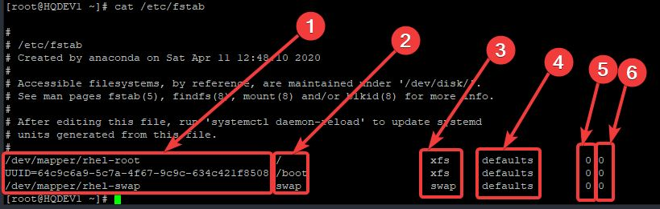

🔹 fstab Columns Explained
Column | Description
1 | Device name / UUID / Label
2 | Mount point
3 | Filesystem type
4 | Mount options
5 | Dump option
6 | FS check order

🔹 Common Mount Options
Option | Meaning
auto / noauto | Mount at boot / not
rw / ro | Read-write / read-only
exec / noexec | Allow execution / not
sync / async | Immediate / delayed write
defaults | Default options

🔹 Best Practice
👉 Always use UUID instead of device name:
UUID=xxxx /test1 ext4 defaults 0 0

🔹 Step 3: Add Entry
📌 Using Device Name:
/dev/sda5 /kernel ext4 defaults 0 0

📌 Using UUID (Recommended)
Get UUID:
blkid /dev/sda5
📊 Output:
/dev/sda5: UUID="abcd-1234" TYPE="ext4"

Add to fstab:
UUID=abcd-1234 /kernel ext4 defaults 0 0

📌 Using Label
Get Label:
blkid /dev/sda5
📊 Output:
/dev/sda5: LABEL="data_disk" UUID="abcd-1234" TYPE="ext4"

Add:
LABEL=data_disk /kernel ext4 defaults 0 0

🔹 Step 4: Apply Configuration
mount -a
👉 If no output → success

🔹 Verify Permanent Mount
df -h | grep kernel
📊 Output:
/dev/sda5 976M 2.6M 907M 1% /kernel

🔹 Troubleshooting Mount Issues

❌ Issue: Device Not Mounted
mount -a
👉 Fix fstab errors

❌ Issue: Unmount Fails (Busy)
Check processes:
lsof /mnpt
OR
fuser -cu /mnpt

Kill processes:
fuser -ck /mnpt

Lazy unmount:
umount -l /mnpt

🔹 Disk Usage Commands

🔹 View Disk Usage
df -h
📊 Output:
Filesystem Size Used Avail Use% Mounted on
/dev/sda5 1G 20M 980M 2% /mnpt

🔹 View Directory/File Size
du -h /mnpt

🔹 Important Notes
- Temporary mount → lost after reboot
- Permanent mount → stored in /etc/fstab
- Always verify with mount -a
- Always check correct device before mounting

🎯 Final Summary
Temporary Mount:
mount → verify → use → umount
Permanent Mount:
fstab → mount -a → verify → persists after reboot

Step-by-Step Guide: Logical Volume Management (LVM)

LVM provides a flexible way to manage storage by allowing dynamic resizing and efficient disk usage.

🔹 Step 1: Install LVM (if not already installed)
sudo apt install lvm2 # Debian/Ubuntu
sudo yum install lvm2 # RHEL/CentOS
📊 Output (Example):
Reading package lists... Done
Building dependency tree
Reading state information... Done
The following NEW packages will be installed:
lvm2
Setting up lvm2... Done

🔹 Step 2: Identify Available Disks
lsblk
📊 Output:
NAME MAJ:MIN RM SIZE RO TYPE MOUNTPOINT
sda 8:0 0 40G 0 disk
├─sda1 8:1 0 1G 0 part /boot
└─sda2 8:2 0 39G 0 part /
sdb 8:16 0 5G 0 disk
sdc 8:32 0 5G 0 disk
👉 We will use /dev/sdc

🔹 Step 3: Create Physical Volume (PV)
pvcreate /dev/sdc
📊 Output:
Physical volume "/dev/sdc" successfully created.

📌 Verify PV
pvs
📊 Output:
PV VG Fmt Attr PSize PFree
/dev/sdc lvm2 --- 5.00g 5.00g

🔹 Step 4: Create Volume Group (VG)
vgcreate tekneed_vg /dev/sdc
📊 Output:
Volume group "tekneed_vg" successfully created

📌 Verify VG
vgs
📊 Output:
VG #PV #LV #SN Attr VSize VFree
tekneed_vg 1 0 0 wz--n- 5.00g 5.00g

🔹 Step 5: Create Logical Volume (LV)
lvcreate -L 1G -n tekneed_lv tekneed_vg
📊 Output:
Logical volume "tekneed_lv" created.

📌 Verify LV
lvdisplay
📊 Output:
--- Logical volume ---
LV Path /dev/tekneed_vg/tekneed_lv
LV Name tekneed_lv
VG Name tekneed_vg
LV Size 1.00 GiB

🔹 Step 6: Format the Logical Volume
mkfs.ext4 /dev/tekneed_vg/tekneed_lv
📊 Output:
mke2fs 1.44.x
Creating filesystem with 262144 4k blocks
Writing inode tables: done
Writing superblocks: done

🔹 Step 7: Create a Mount Point
mkdir /mnt/tekneed3

🔹 Step 8: Mount the Logical Volume
mount /dev/tekneed_vg/tekneed_lv /mnt/tekneed3

🔹 Step 9: Make Mount Persistent
vi /etc/fstab
📌 Add:
/dev/tekneed_vg/tekneed_lv /mnt/tekneed3 ext4 defaults 0 0

📌 Apply Changes
mount -a
👉 No output = success

🔹 Step 10: Verify Setup
df -h
📊 Output:
Filesystem Size Used Avail Use% Mounted on
/dev/mapper/tekneed_vg-tekneed_lv 1G 24M 976M 3% /mnt/tekneed3

📌 Alternative Verification
lsblk
📊 Output:
NAME MAJ:MIN RM SIZE RO TYPE MOUNTPOINT
sdc 8:32 0 5G 0 disk
└─tekneed_vg-tekneed_lv 253:0 0 1G 0 lvm /mnt/tekneed3

🔹 Managing LVM

📌 Unmount Logical Volume
umount /mnt/tekneed3
👉 No output = success

📌 Remove Logical Volume (LV)
lvremove /dev/tekneed_vg/tekneed_lv
📊 Output:
Do you really want to remove active logical volume tekneed_lv? [y/n]: y
Logical volume "tekneed_lv" successfully removed

📌 Remove Volume Group (VG)
vgremove tekneed_vg
📊 Output:
Volume group "tekneed_vg" successfully removed

📌 Remove Physical Volume (PV)
pvremove /dev/sdc
📊 Output:
Labels on physical volume "/dev/sdc" successfully wiped.

🔹 Important Notes
• Always unmount before removing LVM components
• Follow removal order:
LV → VG → PV

📌 Verify Cleanup
pvs
vgs
lvs

🎯 Final Summary
Disk → PV → VG → LV → File System → Mount → Use

🔹 Command Flow
pvcreate → Initialize disk
vgcreate → Create storage pool
lvcreate → Create logical partition
mkfs → Format
mount → Access

Advanced LVM Features (Resize Logical Volumes)
One of the key advantages of LVM is the ability to resize logical volumes dynamically.

🔹 Size Units in LVM
Unit | Meaning
K | Kilobytes
M | Megabytes
G | Gigabytes
T | Terabytes
P | Petabytes

Extending a Logical Volume (LVM)

👉 Used when you need to increase storage size dynamically

🔹 Step 1: Check Available Free Space in VG
vgs
📊 Output:
VG #PV #LV #SN Attr VSize VFree
tekneed_vg 1 1 0 wz--n- 5.00g 3.00g
👉 Confirms:
- Free space is available for extension

🔹 Step 2: Extend Logical Volume
lvextend -L +1G /dev/tekneed_vg/tekneed_lv
📊 Output:
Size of logical volume tekneed_vg/tekneed_lv changed from 1.00 GiB to 2.00 GiB.
Logical volume tekneed_lv successfully resized.
👉 +1G → Adds 1GB to existing size

🔹 Step 3: Resize Filesystem

Method 1: For EXT4 Filesystem
resize2fs /dev/tekneed_vg/tekneed_lv
📊 Output:
resize2fs 1.44.x
Resizing the filesystem on /dev/tekneed_vg/tekneed_lv to 524288 (4k) blocks.
The filesystem on /dev/tekneed_vg/tekneed_lv is now 2.0 GiB.

Method 2: For XFS Filesystem
👉 XFS uses mount point, not device
xfs_growfs /mnt/tekneed3
📊 Output:
meta-data=/dev/mapper/tekneed_vg-tekneed_lv
data blocks changed from 262144 to 524288

🔹 Step 4: Verify Extension

📌 Using df -h
df -h
📊 Output:
Filesystem Size Used Avail Use% Mounted on
/dev/mapper/tekneed_vg-tekneed_lv 2G 24M 1.9G 2% /mnt/tekneed3

📌 Using lsblk
lsblk
📊 Output:
NAME MAJ:MIN RM SIZE RO TYPE MOUNTPOINT
sdc 8:32 0 5G 0 disk
└─tekneed_vg-tekneed_lv 253:0 0 2G 0 lvm /mnt/tekneed3

🔹 Important Notes (Extend)
• Ensure Volume Group has free space → vgs
• EXT4 → use resize2fs
• XFS → use xfs_growfs (must be mounted)
• Always verify after extension

🎯 Final Summary
lvextend → resize filesystem → verify

🔹 Quick Command Flow
lvextend -L +1G <LV>
resize2fs <LV> # ext4
xfs_growfs <mount> # xfs
df -h # verify

Reducing a Logical Volume (LVM)

⚠️ Warning: Reducing is risky and can cause data loss if done incorrectly
👉 Always take a backup before proceeding

🔹 Step 1: Unmount the File System
umount /mnt/tekneed3
👉 No output = success

🔹 Step 2: Check File System (EXT4 Only)
e2fsck -f /dev/tekneed_vg/tekneed_lv
📊 Output:
e2fsck 1.44.x
Pass 1: Checking inodes, blocks, and sizes
Pass 2: Checking directory structure
Pass 3: Checking directory connectivity
Pass 4: Checking reference counts
Pass 5: Checking group summary information
/dev/tekneed_vg/tekneed_lv: clean

🔹 Step 3: Shrink File System (EXT4 Only)
resize2fs /dev/tekneed_vg/tekneed_lv 500M
📊 Output:
resize2fs 1.44.x
Resizing the filesystem on /dev/tekneed_vg/tekneed_lv to 128000 (4k) blocks.
The filesystem is now 500M.

🔹 Step 4: Reduce Logical Volume
lvreduce -L 500M /dev/tekneed_vg/tekneed_lv
📊 Output:
WARNING: Reducing active logical volume to 500.00 MiB.
Do you really want to reduce tekneed_lv? [y/n]: y
Size of logical volume tekneed_vg/tekneed_lv changed from 1.00 GiB to 500.00 MiB.
Logical volume tekneed_lv successfully resized.

🔹 Step 5: Mount Back
mount /dev/tekneed_vg/tekneed_lv /mnt/tekneed3

🔹 Step 6: Verify

📌 Using df -h
df -h
📊 Output:
Filesystem Size Used Avail Use% Mounted on
/dev/mapper/tekneed_vg-tekneed_lv 500M 20M 480M 4% /mnt/tekneed3

📌 Using lsblk
lsblk
📊 Output:
NAME MAJ:MIN RM SIZE RO TYPE MOUNTPOINT
sdc 8:32 0 5G 0 disk
└─tekneed_vg-tekneed_lv 253:0 0 500M 0 lvm /mnt/tekneed3

🔹 ⚠️ XFS Filesystem Limitation
👉 XFS does NOT support shrinking
• You cannot reduce XFS filesystem
• Only option:
- Backup data
- Recreate filesystem with smaller size
- Restore data

🔹 Important Notes (Reduce)
• Always follow order:
👉 Filesystem → Logical Volume
• Never reduce LV before shrinking filesystem
• Always unmount before reducing
• Always run e2fsck before resize (EXT4 only)
• XFS → shrinking not supported

🔹 Extend vs Reduce Summary
Operation | Safe | Order
Extend | Safe | LV → File System
Reduce | Risky | File System → LV

🎯 Final Summary
Extend → lvextend → resize filesystem
Reduce → resize filesystem → lvreduce

🔹 Quick Command Flow
umount → e2fsck → resize2fs → lvreduce → mount → verify

Managing Swap Space in Linux

Swap space acts as virtual memory (RAM) when the system runs out of physical memory.
👉 It helps prevent system crashes when RAM is fully utilized

🔹 Checking Current Swap Usage
free -h
📊 Example Output:
total used free shared buff/cache available
Mem: 2.0G 1.2G 300M 50M 500M 600M
Swap: 1.0G 100M 900M
👉 Shows:
- Total swap
- Used swap
- Free swap

🔹 Creating Swap Space (Using LVM)

📌 Step 1: Create Logical Volume for Swap
lvcreate -L 1G -n swap_lv tekneed_vg
📊 Output:
Logical volume "swap_lv" created.

📌 Step 2: Format as Swap
mkswap /dev/tekneed_vg/swap_lv
📊 Output:
Setting up swapspace version 1, size = 1 GiB
no label, UUID=ab12cd34-5678-90ef-gh12-ijklmnopqrst

📌 Step 3: Activate Swap
swapon /dev/tekneed_vg/swap_lv
👉 No output = success

📊 Verify Swap
free -h
📊 Output:
total used free shared buff/cache available
Mem: 2.0G 1.1G 400M 50M 500M 700M
Swap: 2.0G 100M 1.9G

🔹
Making Swap Permanent
vi /etc/fstab

📌 Add Entry
/dev/tekneed_vg/swap_lv swap swap defaults 0 0

📌 Apply Changes
swapon -a
👉 No output = success

🔹 Managing Swap

📌 Disable Swap
swapoff /dev/tekneed_vg/swap_lv
👉 No output = success

📌 Remove Swap Logical Volume
lvremove /dev/tekneed_vg/swap_lv
📊 Output:
Do you really want to remove active logical volume swap_lv? [y/n]: y
Logical volume "swap_lv" successfully removed

🔹 Checking Available Disks
lsblk
📊 Example Output:
NAME MAJ:MIN RM SIZE RO TYPE MOUNTPOINT
sda 8:0 0 40G 0 disk
├─sda1 8:1 0 1G 0 part /boot
├─sda2 8:2 0 38G 0 part /
sdb 8:16 0 2G 0 disk
sdc 8:32 0 3G 0 disk

🔹 Additional Verification
swapon --show
📊 Output:
NAME TYPE SIZE USED PRIO
/dev/mapper/tekneed_vg-swap_lv partition 1G 0B -2

🔹 Important Notes
• Swap is used only when RAM is full
• LVM-based swap can be resized easily
• Always disable swap before removing it
• Verify swap using swapon --show

🔹 Swap Workflow
Disk → LVM (LV) → mkswap → swapon → Use

🎯 Final Summary
free -h → Check swap usage
lvcreate → Create swap volume
mkswap → Format as swap
swapon → Enable swap
fstab → Make permanent

Standard Partitioning, Filesystem & Mounting – Complete Flow

🔹 What Is Standard Partition in Linux?
A standard partition is a method in Linux where a disk is divided into fixed sections (partitions).
👉 Each partition acts as an independent storage unit

🔹 Disk Naming Convention in Linux
Type | Example
Disk | /dev/sda, /dev/sdb, /dev/sdc
Partition | /dev/sda1, /dev/sda2, /dev/sdb1
👉 Disk topology follows:
sda → sda1, sda2
sdb → sdb1

🔹 View Disks and Partitions
lsblk
📊 Example Output:
NAME MAJ:MIN RM SIZE RO TYPE MOUNTPOINT
sda 8:0 0 15G 0 disk
├─sda1 8:1 0 1G 0 part /boot
└─sda2 8:2 0 14G 0 part
├─rhel-root 253:0 0 12.5G 0 lvm /
└─rhel-swap 253:1 0 1.5G 0 lvm [SWAP]
sdb 8:16 0 5G 0 disk
└─sdb1 8:17 0 1G 0 part /test1
👉 Shows:
- Disk structure
- Partitions
- Mount points
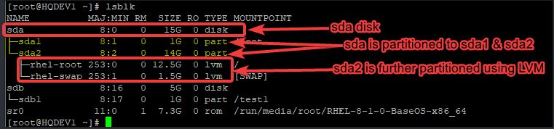

🔹 Partition the Disk
Open the fdisk utility:
sudo fdisk /dev/sdb

Common fdisk Options
Key | Action
m | Show help menu
n | Create new partition
p | Print partition table
d | Delete partition
w | Write changes & exit
q | Quit without saving

Create a New Partition
Inside fdisk:
Command (m for help): n
Follow prompts:
- Select partition type → p (Primary)
- Partition number → 1
- First sector → Press Enter (default)
- Last sector → +1G (example size)

Verify Partition
Command (m for help): p

Save Changes
Command (m for help): w

Confirm Partition
lsblk
Output Example:
sdb 8:16 0 5G 0 disk
└─sdb1 8:17 0 1G 0 part

🔹 Filesystem in Linux
A filesystem is a method of organizing data on a disk.
👉 Without filesystem:
- Partition cannot store usable data

🔹 Common Filesystems
Filesystem | Description
ext4 | Most widely used
xfs | Default in RHEL 7+
ext3/ext2 | Older versions
btrfs | Copy-on-write filesystem
gfs2 | Cluster filesystem

🔹 Create Filesystem
mkfs.<filesystem-type> /dev/<partition>
Example:
mkfs.ext4 /dev/sdb1

🔹 Verify Filesystem
blkid /dev/sdb1
OR
blkid | grep <partition>
OR
fsck -N /dev/sdb1

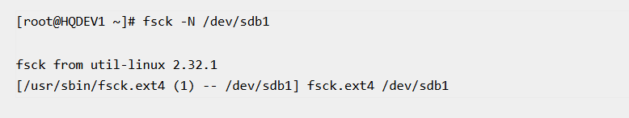

🔹 Mount Points in Linux
A mount point is a directory where a partition is attached.
👉 Default mount directory:
/mnt

🔹 Create Mount Point
mkdir -p /test1

🔹 Manual Mount
mount /dev/sdb1 /test1

🔹 Verify Mount
df -h | grep test1

🔹 Unmount Partition
umount /dev/sdb1

🔹 /etc/fstab File
The /etc/fstab file is used for automatic mounting at boot time.

🔹 View fstab
cat /etc/fstab

🔹 fstab Columns Explained
Column | Description
1 | Device name / UUID / Label
2 | Mount point
3 | Filesystem type
4 | Mount options
5 | Dump option
6 | FS check order

🔹 Common Mount Options
Option | Meaning
auto / noauto | Mount at boot / not
rw / ro | Read-write / read-only
exec / noexec | Allow execution / not
sync / async | Immediate / delayed write
defaults | Default options

🔹 Best Practice
👉 Always use UUID instead of device name:
UUID=xxxx /test1 ext4 defaults 0 0

How To Create a Partition Using fdisk (Standard Partitioning Method in Linux)

👉 Objective: Create a 1GB partition on /dev/sdb

🔹 Step 1: Verify the Disk
Check the disk before partitioning:
lsblk /dev/sdb
📊 Output:
NAME MAJ:MIN RM SIZE RO TYPE MOUNTPOINT
sdb 8:16 0 5G 0 disk
👉 Observation:
- /dev/sdb is a 5GB disk
- No partitions yet

🔹 Step 2: Open fdisk Utility
fdisk /dev/sdb
📊 Output:
Welcome to fdisk (util-linux 2.32.1).
Changes will remain in memory only, until you decide to write them.
Be careful before using the write command.
Device does not contain a recognized partition table.
Created a new DOS disklabel with disk identifier 0x57c3975a.
Command (m for help):
👉 Note:
- Press m anytime to see help menu

Common Commands Inside fdisk
Command | Description
m | Display help menu
n | Create a new partition
d | Delete a partition
p | Print partition table
t | Change partition type
l | List partition types
w | Write changes and exit
q | Quit without saving

🔹 Step 3: Create New Partition
Command (m for help): n
📊 Output:
Partition type
p primary (0 primary, 0 extended, 4 free)
e extended (container for logical partitions)
Select (default p):

🔹 Step 4: Select Partition Type
Select (default p): p
👉 Choosing:
- p → Primary partition

🔹 Step 5: Select Partition Number
Partition number (1-4, default 1):
👉 Press Enter
(Default = 1)

🔹 Step 6: Select First Sector
First sector (2048-10485759, default 2048):
👉 Press Enter
(Default is recommended)

🔹 Step 7: Specify Partition Size
Last sector, +sectors or +size{K,M,G,T,P}:+1G
👉 Press Enter
📊 Output:
Created a new partition 1 of type 'Linux' and of size 1 GiB.
👉 Note:
- If size is not specified → full disk will be used

🔹 Step 8: Verify Partition Before Saving
Command (m for help): p
📊 Output:
Disk /dev/sdb: 5 GiB
Device Boot Start End Sectors Size Id Type
/dev/sdb1 2048 2099199 2097152 1G 83 Linux

🔹 Step 9: Save Partition
Command (m for help): w
📊 Output:
The partition table has been altered.
Calling ioctl() to re-read partition table.
Syncing disks.

🔹 Step 10: Verify New Partition
lsblk /dev/sdb
📊 Output:
NAME MAJ:MIN RM SIZE RO TYPE MOUNTPOINT
sdb 8:16 0 5G 0 disk
└─sdb1 8:17 0 1G 0 part

🔹 Important Notes
- Partition type created = Linux (ID 83) by default
- This is only a partition type, not a filesystem
- You must format it (mkfs) before use

How To Format a Device with a Filesystem in Linux

👉 Objective: Format /dev/sdb1 with ext4 filesystem

🔹 Step 1: Understand the Command
To format a device with ext4 filesystem:
mkfs.ext4 /dev/<device-name>

🔹 Format with Label (Recommended)
To assign a label while formatting:
mkfs.ext4 -L <label-name> <device>
👉 Example:
- -L → assigns a label to filesystem

🔹 Step 2: Format the Partition
mkfs.ext4 -L tekneed_fs /dev/sdb1

📊 Output:
mke2fs 1.44.6 (5-Mar-2019)
Creating filesystem with 262144 4k blocks and 65536 inodes
Filesystem UUID: fe48facc-c481-4429-93d2-77e4ac0afc89
Superblock backups stored on blocks:
32768, 98304, 163840, 229376
Allocating group tables: done
Writing inode tables: done
Creating journal (8192 blocks): done
Writing superblocks and filesystem accounting information: done

🔹 What Happens Internally?
- Filesystem structure is created
- UUID is generated
- Label (tekneed_fs) is assigned
- Disk is now ready for storing data

🔹 Step 3: Verify Filesystem

📌 Method 1: Using blkid
blkid /dev/sdb1
📊 Output:
/dev/sdb1: LABEL="tekneed_fs" UUID="fe48facc-c481-4429-93d2-77e4ac0afc89" TYPE="ext4"

📌 Method 2: Using fsck
fsck -N /dev/sdb1
📊 Output:
fsck from util-linux 2.32.1
[/usr/sbin/fsck.ext4 (1) -- /dev/sdb1] fsck.ext4 /dev/sdb1

🔹 Important Notes
- Formatting erases all existing data on the partition
- Partition must exist before formatting
- Label is optional but recommended
- UUID is automatically generated

🔹 Supported Size Units
Unit | Meaning
K | Kilobytes
M | Megabytes
G | Gigabytes
T | Terabytes
P | Petabytes

🔹 Common Variations
Command | Purpose
mkfs.ext4 /dev/sdb1 | Format without label
mkfs.ext4 -L data /dev/sdb1 | Format with label
mkfs.xfs /dev/sdb1 | Format with xfs filesystem

🎯 Final Summary
Partition → mkfs → Filesystem Created → Ready for Use

How To Create a Mount Point & Manually Mount a Drive or Partition in Linux

👉 Objective: Mount /dev/sdb1 to /test1

🔹 Step 1: Create a Mount Point
To create a mount point directory:
mkdir -p /test1
👉 Notes:
- /test1 → Mount point directory
- -p → Creates parent directories if needed

🔹 Step 2: Manually Mount the Partition
To mount the partition /dev/sdb1:
mount /dev/sdb1 /test1
👉 Meaning:
- /dev/sdb1 → Partition (device)
- /test1 → Mount point

🔹 Step 3: Mount Using Label or UUID (Recommended)
Sometimes, device names may change (e.g., /dev/sdb1 → /dev/sdc1).
To avoid this, use LABEL or UUID.
📌 Using Label:
mount LABEL=tekneed_fs /test1

🔹 Step 4: Verify the Mount
df -h | grep test1
📊 Output:
/dev/sdb1 976M 2.6M 907M 1% /test1
👉 Confirms that:
- Partition is successfully mounted
- Available space is visible

How To Automatically Mount A Device/Partition Using The “/etc/fstab’ File

👉 Problem:
- Manual mount is lost after reboot
👉 Solution:
- Add entry in /etc/fstab for permanent mounting

🔹 Step 5: Open fstab File
vi /etc/fstab

🔹 Step 6: Add Entry
Method 1: Using Device Name (Partition Name)
/dev/sdb1 /test1 ext4 defaults 0 0
📌 Explanation:
Field | Value
Device | /dev/sdb1 (Partition name)
Mount Point | /test1
Filesystem | ext4
Options | defaults
Dump | 0
FS Check | 0
👉 ⚠️ Note:
- Device name may change after reboot (/dev/sdb1 → /dev/sdc1)
- Not recommended for production

Method 2: Using UUID (Recommended)
📌 Step 1: Find UUID
blkid /dev/sdb1
📊 Output Example:
/dev/sdb1: UUID="fe48facc-c481-4429-93d2-77e4ac0afc89" TYPE="ext4"

📌 Step 2: Add in /etc/fstab
UUID=fe48facc-c481-4429-93d2-77e4ac0afc89 /test1 ext4 defaults 0 0

✅ Why UUID?
- Unique identifier
- Does NOT change after reboot
- Best practice in production systems

Method 3: Using Label
📌 Step 1: Find Label
blkid /dev/sdb1
📊 Output Example:
/dev/sdb1: LABEL="tekneed_fs" UUID="fe48facc..." TYPE="ext4"

📌 Step 2: Add in /etc/fstab
LABEL=tekneed_fs /test1 ext4 defaults 0 0

✅ Why Label?
- Easy to remember
- Human-readable
- Useful in small setups

🔹 Method Comparison
Method | Example | Recommended
Device Name | /dev/sdb1 | ❌ No
UUID | UUID=xxxx | ✅ Yes (Best)
Label | LABEL=name | ⚠️ Optional

🔹 Step 7: Apply Configuration
mount -a
👉 If no error:
- Configuration is correct
- Partition will auto-mount on reboot

🔹 Final Result
👉 Now the device /dev/sdb1 is:
- Mounted to /test1
- Automatically available after reboot
- Ready for storing files and directories

🎯 Final Summary
Create Mount Point → Mount → Verify → Add to fstab → mount -a → Persistent Mount

How To Create a Partition Using gdisk (GPT Partitioning Method in Linux)

👉 Objective: Create a 100MB partition on /dev/sdb using GPT

🔹 Step 1: Install gdisk Utility
If gdisk is not installed:
yum install gdisk -y
📊 Output:
Updating Subscription Management repositories.
Red Hat Enterprise Linux 8 for x86_64 - AppStream (RPMs) 529 kB/s | 18 MB 00:35
Complete!

🔹 Step 2: Open gdisk Utility
gdisk /dev/sdb
📊 Output:
GPT fdisk (gdisk) version 1.0.3
Partition table scan:
MBR: MBR only
BSD: not present
APM: not present
GPT: not present
Command (? for help):

🔹 Step 3: Create New Partition
Command (? for help): n

🔹 Step 4: Select Partition Number
Partition number (2-128, default 2):
👉 Press Enter (default = 2)

🔹 Step 5: Select First Sector
First sector (34-10485726, default = 2099200) or {+-}size{KMGTP}:
👉 Press Enter (default)

🔹 Step 6: Specify Partition Size
Last sector (2099200-10485726, default = 10485726) or {+-}size{KMGTP}:+100M
👉 Press Enter

📌 Notes on Size Units
Unit | Meaning
K | Kilobyte
M | Megabyte
G | Gigabyte
T | Terabyte
P | Petabyte

📊 Output:
Current type is 'Linux filesystem'
Hex code or GUID (L to show codes, Enter = 8300):
👉 Press Enter (default type)

📊 Result:
Changed type of partition to 'Linux filesystem'

🔹 Step 7: Verify Partition Before Saving
Command (? for help): p
📊 Output:
Disk /dev/sdb: 10485760 sectors, 5.0 GiB
Model: VMware Virtual S
Sector size (logical/physical): 512/512 bytes
Disk identifier (GUID): CE6C985B-584E-4406-8F0A-366B15471446
Partition table holds up to 128 entries
Number Start (sector) End (sector) Size Code Name
1 2048 2099199 1024.0 MiB 8300 Linux filesystem
2 2099200 2303999 100.0 MiB 8300 Linux filesystem

🔹 Step 8: Save Partition
Command (? for help): w
📊 Output:
Final checks complete. About to write GPT data. THIS WILL OVERWRITE EXISTING PARTITIONS!!
Do you want to proceed? (Y/N): y
OK; writing new GUID partition table (GPT) to /dev/sdb.
The operation has completed successfully.

🔹 Step 9: Verify Created Partition
lsblk /dev/sdb
📊 Output:
NAME MAJ:MIN RM SIZE RO TYPE MOUNTPOINT
sdb 8:16 0 5G 0 disk
├─sdb1 8:17 0 1G 0 part
└─sdb2 8:18 0 100M 0 part

🔹 Important Notes
- gdisk is used for GPT partitioning
- GPT supports up to 128 partitions
- Always verify using p before saving
- Press w to save changes
- Press q to quit without saving

🎯 Final Summary
Disk → gdisk → Create Partition → Verify → Save → Confirm

How To Delete a Standard Partition Using fdisk

👉 Objective: Delete partition /dev/sdb2 from /dev/sdb

🔹 Step 1: Verify the Disk and Partitions
lsblk /dev/sdb
📊 Output:
NAME MAJ:MIN RM SIZE RO TYPE MOUNTPOINT
sdb 8:16 0 5G 0 disk
├─sdb1 8:17 0 1G 0 part
└─sdb2 8:18 0 100M 0 part
👉 Target:
- Delete /dev/sdb2

🔹 Step 2: Check if Partition is Mounted
df -h | grep sdb2
OR
lsblk

🔹 Step 3: Unmount the Partition (If Mounted)
umount /dev/sdb2
👉 If device is busy:
fuser -cu /mountpoint
fuser -cu /test1
OR
lsof /mountpoint
lsof /test1

🔹 Step 4: Remove Entry from /etc/fstab (If Exists)
Open file:
vi /etc/fstab
👉 Remove or comment the entry:
/dev/sdb2 /mountpoint ext4 defaults 0 0
OR
UUID=xxxx /mountpoint ext4 defaults 0 0

📌 Validate fstab
mount -a
👉 If no error → safe to proceed

🔹 Step 5: Open fdisk Utility
fdisk /dev/sdb
📊 Output:
Welcome to fdisk (util-linux 2.32.1).
Changes will remain in memory only, until you decide to write them.
Be careful before using the write command.
Command (m for help):

🔹 Step 6: Delete the Partition
Command (m for help): d
📊 Output:
Partition number (1,2, default 2):
👉 Press Enter (default = 2)

📊 Result:
Partition 2 has been deleted.

🔹 Step 7: Verify Before Saving
Command (m for help): p
📊 Output:
Disk /dev/sdb: 5 GiB
Device Start End Sectors Size Type
/dev/sdb1 2048 2099199 2097152 1G Linux filesystem
👉 Confirms:
- /dev/sdb2 is removed (not yet saved)

🔹 Step 8: Save Changes
Command (m for help): w
📊 Output:
The partition table has been altered.
Calling ioctl() to re-read partition table.
Syncing disks.

🔹 Step 9: Verify Deletion
lsblk /dev/sdb
📊 Output:
NAME MAJ:MIN RM SIZE RO TYPE MOUNTPOINT
sdb 8:16 0 5G 0 disk
└─sdb1 8:17 0 1G 0 part
👉 Confirmed:
- /dev/sdb2 successfully deleted

🔹 Important Notes
- Changes are not permanent until w is used
- Use p to verify before saving
- Use q to exit without saving
- Always unmount partition before deleting
- Always remove /etc/fstab entry before deletion

🔹 Troubleshooting
Issue | Solution
device busy | Unmount or reboot
wrong partition selected | Exit with q
changes not applied | Run partprobe or reboot
fstab error | Fix entry and run mount -a

🎯 Final Summary (Safe Workflow)
Check mount → umount → clean fstab → mount -a → fdisk → d → p → w → lsblk

How To Unmount a Device/Partition in Linux (Safe Method)

👉 Objective: Unmount /dev/sdb1 safely

🔹 Step 1: Verify the Partition is Mounted
Before unmounting, confirm the partition is in use:
df -h | grep sdb1
OR
lsblk
📊 Example Output:
/dev/sdb1 976M 2.6M 907M 1% /test1
👉 Confirms:
- /dev/sdb1 is mounted on /test1

🔹 Step 2: Unmount the Partition (Temporary)
umount /dev/sdb1
👉 OR using mount point:
umount /test1

🔹 Step 3: Verify Unmount
df -h | grep sdb1
👉 If no output:
- Partition successfully unmounted

🔹 Step 4: Permanent Unmount (Remove from /etc/fstab)
👉 Problem:
- Partition will mount again after reboot if entry exists in /etc/fstab

📌 Open fstab File
vi /etc/fstab

📌 Remove or Comment Entry
Find the line:
/dev/sdb1 /test1 ext4 defaults 0 0
👉 Remove it OR comment it:
#/dev/sdb1 /test1 ext4 defaults 0 0

📌 Apply Changes
mount -a
👉 If no error:
- Permanent unmount successful

🔹 Step 5: Check for Active Usage (If Unmount Fails)
If you see error:
umount: target is busy
Check processes:
lsof /test1
OR
fuser -cu /test1

🔹 Step 6: Force or Lazy Unmount (If Required)
👉 Lazy unmount:
umount -l /test1
👉 Force unmount:
umount -f /test1

🔹 Important Notes
- Temporary unmount → umount
- Permanent unmount → remove from /etc/fstab
- Always unmount before:
  - Deleting partition
  - Formatting
  - Resizing

🔹 Troubleshooting
Issue | Solution
target is busy | Use lsof or fuser
mounts again after reboot | Remove from /etc/fstab
permission denied | Run as root

🎯 Final Summary
Check mount → umount → remove fstab entry → mount -a → verify

Extending a Standard Partition

👉 Used when you want to increase partition size

🔹 Step 1: Check Disk Layout
lsblk
📊 Output:
NAME MAJ:MIN RM SIZE RO TYPE MOUNTPOINT
sdb 8:16 0 5G 0 disk
└─sdb1 8:17 0 1G 0 part /test1
👉 Ensure:
- Free space is available on disk

🔹 Step 2: Unmount Partition
umount /dev/sdb1
👉 No output = success

🔹 Step 3: Open fdisk
fdisk /dev/sdb

🔹 Step 4: Delete Partition (⚠️ Required)
Command (m for help): d
👉 Delete /dev/sdb1
⚠️ Important:
- Data will NOT be lost if recreated with same start sector

🔹 Step 5: Recreate Partition with Larger Size
Command (m for help): n
👉 Use:
- Same start sector
- Larger size (e.g., +2G)

🔹 Step 6: Save Changes
Command (m for help): w

🔹 Step 7: Resize Filesystem

🔹 For EXT4
resize2fs /dev/sdb1
📊 Output:
Resizing the filesystem on /dev/sdb1 to xxxx blocks.
The filesystem is now larger.

🔹 For XFS
👉 Must be mounted:
mount /dev/sdb1 /test1
xfs_growfs /test1
📊 Output:
data blocks changed from xxxx to xxxx

🔹 Step 8: Verify
df -h
📊 Output:
/dev/sdb1 2G 20M 1.9G /test1

Reducing a Standard Partition

⚠️ Warning: Risky — may cause data loss
👉 Always take backup

🔹 Step 1: Unmount Partition
umount /dev/sdb1

🔹 Step 2: Check Filesystem (EXT4 Only)
e2fsck -f /dev/sdb1
📊 Output:
/dev/sdb1: clean

🔹 Step 3: Shrink Filesystem
resize2fs /dev/sdb1 500M
📊 Output:
The filesystem is now 500M.

🔹 Step 4: Open fdisk
fdisk /dev/sdb

🔹 Step 5: Delete Partition
d

🔹 Step 6: Recreate Smaller Partition
n
👉 Use:
- Same start sector
- Smaller size (e.g., 500M)

🔹 Step 7: Save Changes
w

🔹 Step 8: Mount Back
mount /dev/sdb1 /test1

🔹 Step 9: Verify
df -h
📊 Output:
/dev/sdb1 500M 20M 480M /test1

🔹 ⚠️ XFS Limitation
👉 XFS cannot be reduced
• Only extension is supported
• To reduce:
- Backup data
- Recreate partition
- Restore data

🔹 Important Notes
• Always unmount before resizing
• EXT4 → supports extend & reduce
• XFS → supports only extend
• Always use same start sector when recreating
• Backup is mandatory for reduce

🔹 Extend vs Reduce Summary
Operation | Safe | Filesystem Support | Method
Extend | Medium | EXT4, XFS | Recreate + grow FS
Reduce | Risky | EXT4 only | Shrink FS + recreate

🎯 Final Summary
Extend → delete → recreate → resize filesystem
Reduce → resize filesystem → delete → recreate

Managing Swap Using Standard Partition

Swap space can also be created using a standard partition (non-LVM) instead of a logical volume.
👉 This is commonly used in:
- Simple setups
- Systems without LVM

🔹 Step 1: Identify Available Disk
lsblk
📊 Output:
NAME MAJ:MIN RM SIZE RO TYPE MOUNTPOINT
sda 8:0 0 40G 0 disk
├─sda1 8:1 0 1G 0 part /boot
├─sda2 8:2 0 38G 0 part /
sdb 8:16 0 2G 0 disk
👉 We will use /dev/sdb

🔹 Step 2: Create Partition for Swap
fdisk /dev/sdb

📌 Inside fdisk:
n → create new partition
p → primary
+1G → size
t → change type
82 → Linux swap
w → save

📊 Output (Key Part):
Created a new partition 1 of type 'Linux' and of size 1 GiB.
Changed type of partition to 'Linux swap'

🔹 Step 3: Verify Partition
lsblk /dev/sdb
📊 Output:
NAME MAJ:MIN RM SIZE RO TYPE
sdb 8:16 0 2G 0 disk
└─sdb1 8:17 0 1G 0 part

🔹 Step 4: Format as Swap
mkswap /dev/sdb1
📊 Output:
Setting up swapspace version 1, size = 1 GiB
no label, UUID=abcd-1234-xxxx

🔹 Step 5: Activate Swap
swapon /dev/sdb1
👉 No output = success

🔹 Step 6: Verify Swap
free -h
📊 Output:
total used free shared buff/cache available
Mem: 2.0G 1.1G 400M 50M 500M 700M
Swap: 1.0G 0B 1.0G

📌 Additional Verification
swapon --show
📊 Output:
NAME TYPE SIZE USED PRIO
/dev/sdb1 partition 1G 0B -2

🔹 Step 7: Make Swap Permanent
vi /etc/fstab

📌 Add Entry
/dev/sdb1 swap swap defaults 0 0

📌 Apply Changes
swapon -a
👉 No output = success

🔹 Managing Swap (Standard Partition)

📌 Disable Swap
swapoff /dev/sdb1
👉 No output = success

📌 Remove Swap Partition
fdisk /dev/sdb
👉 Then:
d → delete partition
w → save

🔹 Important Notes
• Swap partition type = 82
• Always disable swap before removing
• Swap is used only when RAM is full
• Use free -h or swapon --show to verify

🔹 Swap Workflow (Standard Partition)
Disk → Partition → mkswap → swapon → Use

🎯 Final Summary
fdisk → create partition
mkswap → format
swapon → enable
fstab → make permanent

Managing Processes in Linux (Part 1)

In Linux, everything runs as a process. This includes:
- Applications
- System services
- Commands you run in the terminal
- Even the terminal itself
A process is simply a program that is currently running.
When the Linux system starts, many background programs and services begin running automatically.
Each of these processes is assigned a unique Process ID (PID).
Managing processes is an important task in Linux, and most operations are done using these PIDs.

What is a Process in Linux?
A process is:
- A running program
- Can run in:
  - Foreground (Shell) – visible to the user
  - Background – runs silently
  - Job – a task started from the shell

View Or List All Processes in Linux

To see running processes, Linux provides the ps command.
Common Commands:
- ps means print snapshot of processes.
1) (Standard format)
ps -ef

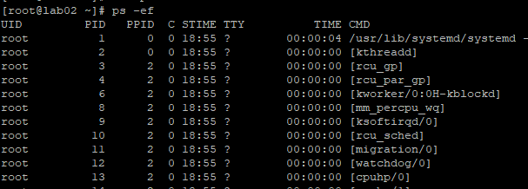

2) (BSD format)
ps aux
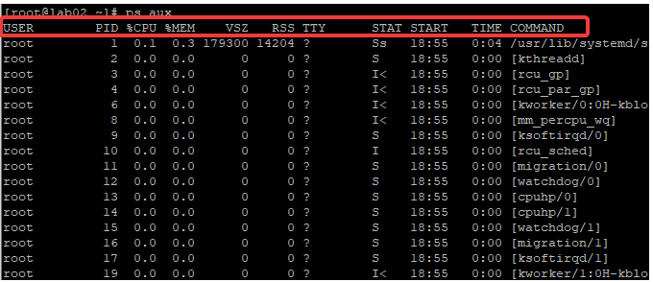

Important Notes:
- Root user can see all processes.
- Normal users can usually see only their own processes.

Counting Total Number of Processes Running on the System in Linux

To find how many processes are running:
ps aux | wc
Example output:
143 1655 13871
- The first number represents total processes.

Process Attributes (Fields Explanation)
When you run ps aux, you see different columns. Here is what they mean:
Field | Meaning
USER | User running the process
PID | Unique Process ID
%CPU | CPU usage percentage
%MEM | Memory usage percentage
VSZ | Virtual memory size
RSS / RES | Actual RAM used
TTY | Terminal associated with process
STAT | Process state
START | Start time
TIME | Total running time
COMMAND | Command used to start process

Process States
Code | Meaning
R | Running
S | Sleeping (waiting)
I | Idle kernel thread
T | Stopped
Z | Zombie (finished but still listed)
< | High priority
s | Session leader

To learn more:
man ps

Parent and Child Processes in Linux

In Linux, a process can create other processes.
This relationship is similar to a parent and child.
- A process that creates another process is called a Parent Process
- The created process is called a Child Process
  - Parent process → creates other processes
  - Child process → created by parent
Every process has:
- PID (Process ID) → Unique ID of the process
- PPID (Parent Process ID) → ID of the parent process

How Parent and Child Processes Work
- A parent process can start (spawn) multiple child processes
- Child processes depend on the parent process
- This creates a process hierarchy (tree structure)

Viewing Process Tree
To see parent-child relationships between processes:
ps fax
OR
pstree
Example Diagram (Process Tree)
systemd
├── sshd
│ └── bash
│ └── pstree
├── httpd
│ ├── httpd
│ └── httpd
└── cron

Killing Processes:
- If you kill a parent process
→ All child processes will also stop
- If you kill a child process
→ Parent process will continue running

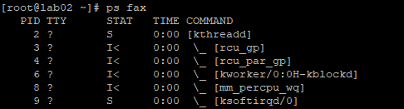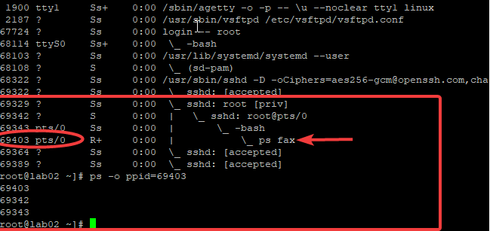

Finding Parent Process ID (PPID)

Method 1
ps -o ppid=<PID>
Example
ps -o ppid=69403
Note
- This command may show shell-related PPID
- It may not show the actual parent in some cases

Recommended Method to Get Real PPID
ps -l <PID> | grep -v grep
Example
ps -l 73272 | grep -v grep

This shows:
- PID
- PPID (actual parent)
- Other process details

Important Difference Between Commands
Command | Usage
ps -o ppid=<PID> | Shows shell-related PPID
ps -l <PID> | Shows actual PPID (recommended)

Special Case: Jobs vs Background Processes
- Some commands (like ps fax) are jobs, not background services
- For such jobs:
  - PPID may not display correctly
- For daemon/background processes (like httpd):
  - PPID is correctly shown

What Happens When You Kill Parent Process?
If you kill a parent process:
- SSH session may disconnect
- Terminal session may close
- System services may stop
Example:
- Killing bash parent process → user gets logged out

How to Find a Specific Running Process in Linux

Sometimes, we do not need to see all running processes.
Instead, we may want to find a specific process.
In Linux:
- Every running process has a Process ID (PID)
- You can search for a process using its name or PID

Using ps with grep
The most common way to find a process is by using:
ps -ef | grep <process-name>
Example 1: Find vsftpd Process
ps -ef | grep vsftpd
Output Example
root 81592 1 0 ? 00:00:00 /usr/sbin/vsftpd /etc/vsftpd/vsftpd.conf
root 87579 ... grep vsftpd
Explanation
- First line → Actual process
- Second line → grep command itself (not needed)

Example 2: Find httpd Process
ps -ef | grep httpd
Output
root 73272 1 ... /usr/sbin/httpd
apache 89292 73272 ... httpd
apache 89293 73272 ... httpd
Explanation
- 73272 → Parent process
- Other PIDs → Child processes

Finding Parent Process of a Child Process

To check PPID of a process:
ps -l <PID> | grep -v grep
Example
ps -l 89293 | grep -v grep
Output
PID PPID
89293 73272
- 73272 → Parent process of 89293

Using pidof Command
pidof directly shows the PID of a process.
Example 1
pidof vsftpd
Output:
2187

Example 2
pidof httpd
Output:
89295 89294 89293 89292 73272
- Shows all related processes

Removing "grep" from Output
When using grep, it shows itself in the result.
To remove it:
Method 1
ps -ef | grep -i <process> | grep -v grep
Method 2 (Using awk)
ps -ef | grep -i <process> | awk '$8!="grep" {print $0}'

Example
ps -ef | grep -i vsftpd | grep -v grep
OR
ps -ef | grep -i vsftpd | awk '$8!="grep" {print $0}'
Output
root 36460 1 ... /usr/sbin/vsftpd /etc/vsftpd/vsftpd.conf

Summary
- Use ps -ef | grep <name> to find a process
- Use pidof <name> for quick PID lookup
- Use ps -l <PID> to find parent process
- Use grep -v grep or awk to clean output
- Parent and child processes can be identified from output

How to Find a Process Name Using Process ID (PID) in Linux

Every process in Linux has a unique Process ID (PID).
If you already know the PID, you can find:
- The process name
- Its details
- Its child processes

Command to Find Process Name Using PID
Use the following command:
ps -ef | grep <PID>

Example
To find the process name of PID 36805:
ps -ef | grep 36805

Example Output
root 36805 1 ... /usr/sbin/httpd -DFOREGROUND
apache 36806 36805 ... httpd
apache 36807 36805 ... httpd
apache 36808 36805 ... httpd
apache 36809 36805 ... httpd

Explanation
- 36805 → Main (parent) process
- Other PIDs → Child processes of 36805
- All are running the httpd (web server) service
You may also see:
grep 36805
This is not part of the actual process; it is just the search command.

Key Points
- You can identify:
  - Process name
  - Parent process
  - Child processes
- Useful for troubleshooting and monitoring

How to Find the Tree of a Specific Process
Using pstree Command
pstree
Example Output
systemd
├── NetworkManager
├── sshd
│ └── bash
├── httpd
├── cron
└── vsftpd

To view the process hierarchy of a sepecic process (tree structure), use:
pstree | grep <process-name>

Example
To see the tree of httpd process:
pstree | grep httpd

Example Output
|-httpd-+-httpd
| |-httpd
| `-httpd

Explanation
- Shows parent-child relationship in tree form
- Helps understand:
  - How processes are connected
  - Which process started others

Simple Process Tree Diagram
httpd (Parent)
├── httpd (Child)
├── httpd (Child)
└── httpd (Child)

Summary
- Use ps -ef | grep <PID> → Find process name using PID
- Output shows parent and child processes
- Use pstree → View process hierarchy
- Helps in understanding process relationships and debugging

How to Kill a Process in Linux

Killing a process means sending a signal to stop it.
Sometimes:
- An application may freeze or stop responding
- Restarting may not work because the process is still running
In such cases, you must manually kill the process.

Signals in Linux
Signals are instructions sent to processes.
To view all signals:
man 7 signal

Common Signals
Signal | Meaning
SIGTERM | Gracefully stop a process
SIGKILL | Forcefully kill a process
SIGSTOP | Pause a process
SIGCONT | Resume a paused process
SIGHUP | Restart a process

SIGTERM vs SIGKILL
Feature | SIGTERM | SIGKILL
Type | Graceful stop | Forceful stop
Safety | Safe | Risky
Can process handle it? | Yes | No
Shortcut | Ctrl + C | No shortcut

Explanation
- SIGTERM:
  - Stops process safely
  - Allows cleanup (saving data, closing files)
- SIGKILL:
  - Immediately stops process
  - No cleanup → may cause data loss
  - Use only if SIGTERM fails

Commands to Kill a Process

Killing Process by PID (Process ID)
1. Default (SIGTERM)
kill <PID>
2. Using SIGTERM explicitly
kill -SIGTERM <PID>
3. Using SIGKILL
kill -9 <PID>
OR
kill -SIGKILL <PID>

Killing Process by Name
Instead of PID, you can kill processes using name.
Commands
pkill -9 <process-name>
killall -9 <process-name>
Advantage
- Useful when multiple processes have the same name
- Kills all at once

What is a Job in Linux?
A job is:
- A command started in the terminal (shell)
- Runs interactively
- Does not run as a system service (daemon)
Examples of Jobs
- ls
- cp
- mv
- dd
Important Points
- A job is also a process
- It runs in the shell
- It does not continue after system reboot

Foreground vs Background Jobs
Type | Description
Foreground | Runs in terminal, blocks it
Background | Runs in background, frees terminal

Running a Job in Background
Method 1: Using &
Run command directly in background:
dd if=/dev/zero of=/dev/null &

Method 2: Using Ctrl + Z and bg
- Start a command:
dd if=/dev/zero of=/dev/null
- Press:
Ctrl + Z
→ Stops the job
- Run:
bg
→ Moves job to background

Viewing Background Jobs
jobs
Example Output
[1] Running dd if=/dev/zero of=/dev/null &
[2] Running dd if=/dev/zero of=/dev/null &
[3]- Running dd if=/dev/zero of=/dev/null &
[4]+ Running dd if=/dev/zero of=/dev/null &
- Numbers represent job IDs

Job Queue Behavior
- Multiple background jobs can run together
- They stay in queue until completed

Bringing Job to Foreground

Basic Command
fg
Specific Job
fg <job-number>
Example:
fg 4

Moving Stopped Job to Background
bg <job-number>
Example:
bg 4

How to Kill a Job
Method 1: Keyboard Shortcut
Ctrl + C
- Stops foreground job

Method 2: Using kill command
kill -SIGTERM %<job-number>
Example:
kill -SIGTERM %4

Job Control Flow (Simple Diagram)
Start Job → Foreground
↓ (Ctrl + Z)
Stopped
↓ (bg)
Background
↓ (fg)
Foreground
↓ (Ctrl + C / kill)
Terminated

Summary
- Processes can be stopped using signals
- SIGTERM is safe, SIGKILL is forceful
- Jobs are commands run in terminal
- You can:
  - Run jobs in background (&, bg)
  - View jobs (jobs)
  - Bring to foreground (fg)
  - Kill jobs (Ctrl + C, kill)

Examples for how to Kill Processes in Linux

1. Kill a Process Using PID (vsftpd Example)
Step 1: Find the Process ID
pidof vsftpd
Example output:
36460

Step 2: Kill the Process
Using default signal (SIGTERM):
kill 36460
OR using force kill (SIGKILL):
kill -9 36460

2. Kill a Process Using Process Name
You can directly kill the process without using PID:
pkill vsftpd

3. Kill a Process with Child Processes (httpd Example)
Step 1: Find All Process IDs
pidof httpd
Example output:
70239 36809 36808 36807 36806 36805

Step 2: Kill All Related Processes
killall httpd
- This command stops the parent and all child processes together

4. Kill Multiple Processes at the Same Time
You can kill multiple processes by specifying multiple PIDs:
kill 24353 62562 67278

Summary
- Use kill <PID> → Stop a process using PID
- Use kill -9 <PID> → Forcefully stop a process
- Use pkill <name> → Kill process by name
- Use killall <name> → Kill all related processes
- Use multiple PIDs → Kill many processes at once

What is Process Priority in Linux?

Every process in Linux has:
- A Process ID (PID)
- A Priority level
Definition
Process priority determines:
- How much CPU time and system resources a process gets
Key Idea
- Higher priority → More CPU time
- Lower priority → Less CPU time

What is Niceness?
Niceness is a value that controls process priority.
- It defines how "nice" a process is to other processes
- It affects how resources are shared

Nice Value Range
Nice Value | Priority Level
-20 | Highest priority
0 | Default
+19 | Lowest priority
Explanation
- Negative values → Higher priority (more CPU)
- Positive values → Lower priority (less CPU)

Important Concepts
- By default, all processes start with nice value = 0
- You can:
  - Increase priority → Use negative nice values
  - Decrease priority → Use positive nice values
Best Practice
- Change priority gradually
- Avoid large sudden changes

Checking Process Priority and Nice Value

Use the following command:
ps -eo pid,ppid,pri,ni,comm
Fields Explanation
Field | Meaning
PID | Process ID
PPID | Parent Process ID
PRI | Priority
NI | Nice value
COMMAND | Process name
Example
ps -eo pid,ppid,pri,ni,comm | grep 15338

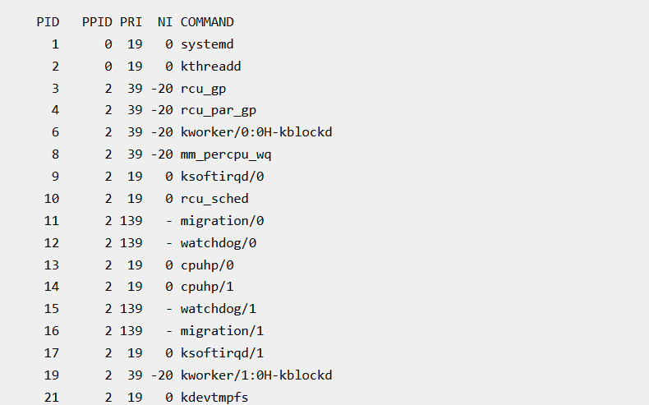

Using top Command to View Priority

Command:
top
- Shows running processes
- Displays CPU usage and priority
- Shows only active/high-resource processes
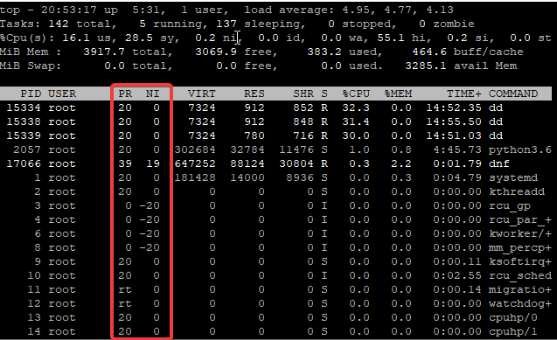

Changing Priority of Running Process (Renice)

Method 1: Using Command Line
renice -n <nice-value> <PID>
Example
renice -n -7 77184
Steps
- Check current priority:
ps -eo pid,ppid,pri,ni,comm | grep 77184

77184 76680 19 0 dd
- Change priority:
renice -n -7 77184
- Verify again:
ps -eo pid,ppid,pri,ni,comm | grep 77184

77184 76680 26 -7 dd

Checking CPU Usage After Changing Priority
ps -p <PID> -o %cpu,%mem
Example
ps -p 77184 -o %cpu,%mem

Changing Priority Using top Command

Steps
- To renice and change the priority of the PID, 5237, do the following steps
enter the top command,
[root@lab02 ~]# top
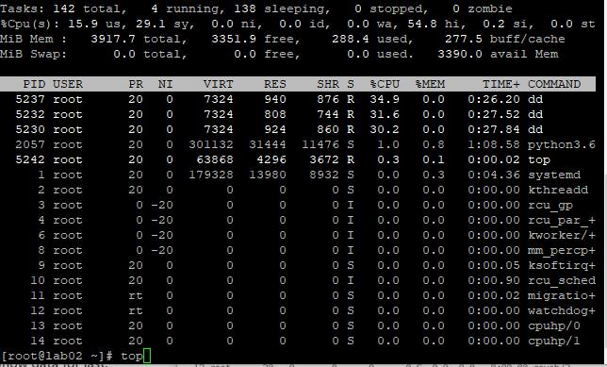

Enter the key, r which means renice, you will see the “PID to renice” information
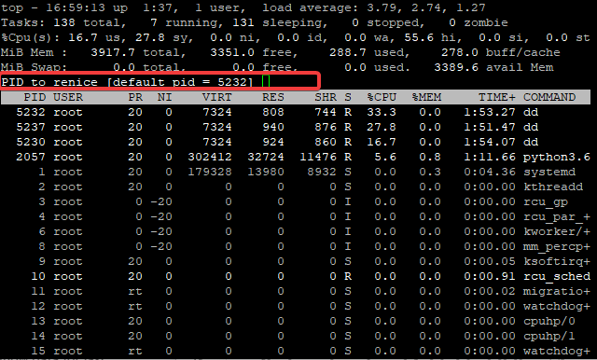
Enter the PID, 5237 in my case
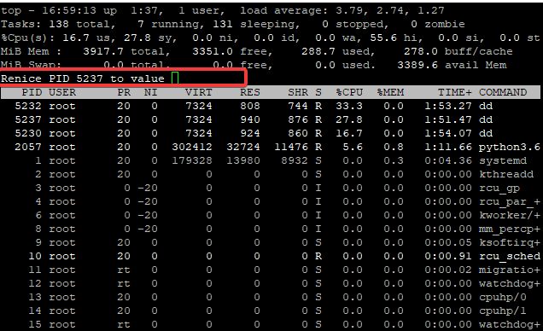

Enter the nice value
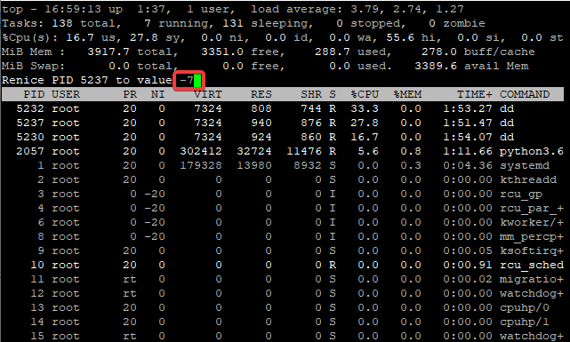
Tap the enter key
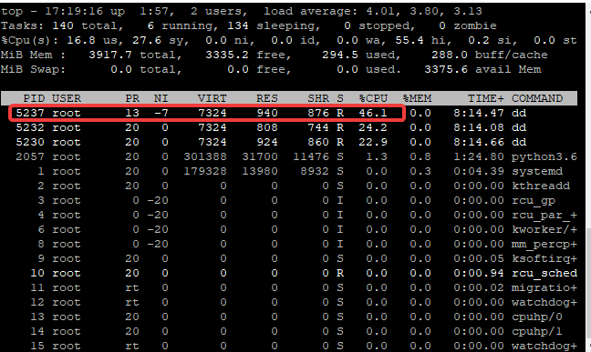
you will see that the priority value, “PR” has changed to 13 and the CPU power for the process has increased to 46.1%.

Changing Priority by Username

You can change priority for all processes of a user:
renice -n <nice-value> -u <username>
Example
renice -n -7 -u nginx

Difference Between CLI and top Output
Method | Behavior
CLI (renice) | Priority value increases numerically
top | Priority appears reduced
Important Note
- This difference can confuse beginners
- Focus on nice value, not display format

Setting Priority for New Process (Nice)
To set priority while starting a process:
nice -n <nice-value> <command>
Example
nice -n 11 dd if=/dev/zero of=/dev/null
Run in Background
nice -n 11 dd if=/dev/zero of=/dev/null &

Process Priority Flow Diagram
Start Process (NI = 0)
↓
Change Priority (nice / renice)
↓
Higher Priority (negative NI) → More CPU
Lower Priority (positive NI) → Less CPU

Summary
- Every process has a priority and nice value
- Nice value controls CPU allocation
- Range: -20 to +19
- Use:
  - nice → For new process
  - renice → For running process
- Use top or ps to monitor

