1.INTRODUCTION

This document is a software requirement specification for weather app
named as Clima.
In this document, firstly we are going to define
the problem solve by weather App and introduce purpose and the scope of this document. Secondly, we are going
to give an overall description. Then, we are going to state specific requirements. Lastly, we
are going to give data model and description.

1.1 Problem solved

weather Apps are very use full in day to day life. With help of this we app people can have very good and accurate knowledge weathers like
temperature ,pressure,humidity and many more.
Hence these App can we used by different sectors of people for different purposes
This project will deal with all the problems related to weather and predict steps to take by using all weather conditions report given by this App.

1.2 Purpose

This software requirement specification document is defining the detailed description
of the architecture, specifications and functionalities the project clima. This document is
prepared for both the development team and the users. The purpose of the project is

developing an post emergency Weather app. Target audience of the clima is
farmers,students,teacher to working persons in metropolitian city and every people who may face with problem with unknown weather situation and need to take precaution.

1.3 Scope

The final product is a mobile application that serves a new communication system.
especially for predicting unkown weather situations. The application will be able to set a connection between
users with weather forcasting site through Internet using weather API. Users of the application will be able to know:
●
temperature of any place in the world by entering its name
●
pressure,humidity,windspeed and may more.
●
According to situation of weather the will decide their work plane also.

1.4 System Overview

A weather Communication System App- “clima” is a weather forcatsing APP for
Android devices which allows users to communicate with weather API providing site(https://openweathermap.org/)using the Internet,selftower,gps. In order to explain in more detail, main scenarios are shown below.
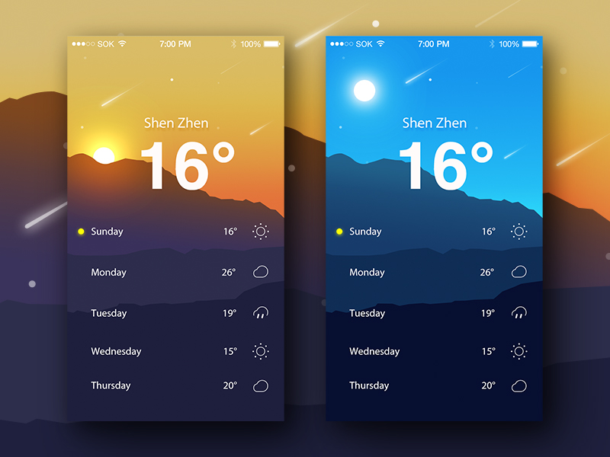

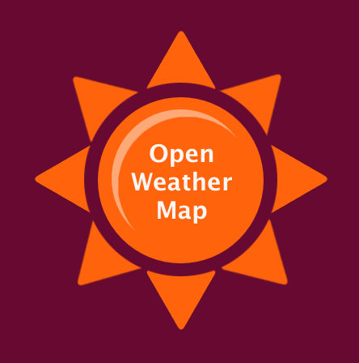
Through Api

Scenario: user will enter the name of city which will be converted to city’s co-ordinate in json formate and send to openweather map and its will provide the information requested for in json and again it will be converted to text or number formate by app and display to the user of the app.

1.5
Definitions, acronyms, and abbreviations

API: Application programming interface

Android: android is the name of the mobile operating system made by American company;Google.

GPS:Global Positioning System

JSON:JSON stands for JavaScript Object Notation

1.6 Assumptions and dependencies
●
Operating
System
:

The application will be developed for Android platforms.
❖
API leve 16 and above
❖
Android with internet and (Wi-Fi Direct should be supported.)
➢
According
IDC [2], Android
dominated the smart phone market with a
share of 82.8% and IOS is in 13.9%. Therefore covering IOS and
Android devices will be result in covering 95% of the smart phone
market.
6.
range of weather forcaste will be

about 1km-2km
or depending on tower location of your network provider.

●
Battery
:
In todays world energy is also becoming a very important issue.
Most probably our application will drain battery very fast. Therefore, user of this app close the app whwn not in use.

●
the app will provide the weather information of all over the world which ever is in range of open weather map .SRS document will be updated according to these changes(changing the range of open weather map.)

2. Overall description
2.1 Product functions

The clima App can be used to get temperatur of any valid city in the world by entering the name in the app.
It can also used to check pressure ,humidity also of particular city .

On checking the pressure and humidity the app provide option of checking the pressure and humidity of current day,current week(all 7 days),or current month(all days of month).

There might be a case in which weekly or monthly data is not present in the database.

Note: there are also some places whos data might not be available to show(error case)

2.1.1 Use-case model
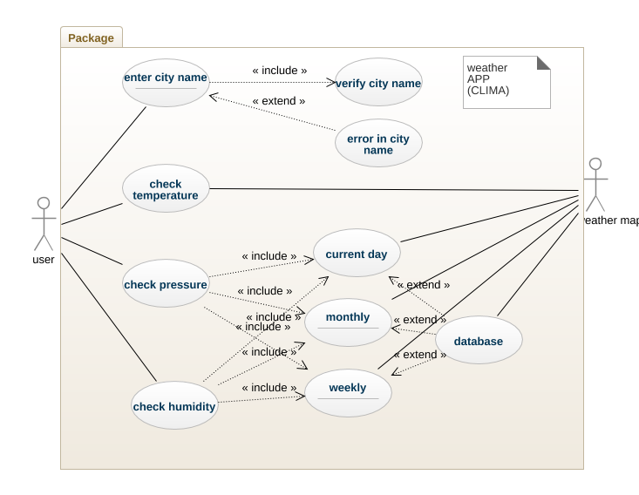

Here user can be any one like->

farmers,students,teacher to working persons in metropolitian city and every people who may face with problem with unknown weather

2.2 Interfaces

The application will be implemented in Java and it will use Android SDK. Moreover,.
There is use of json xml different images files for developing the App.

2.2.1 User Interfaces

User interface of our application will be easy to use and understandable. It uses
English language since our application is designed for people at any age.
Moreover,the user is expected to know how to use Android mobile devices and to be
able to write and read city name and use buttons.
User interfaces are explained in details below:

2.2.1.1 “Enter city “Interface

In this interface user can enter the name of city in text box and press the go on the key pad the new interface with temperature of city will appear

2.2.1.2 pressure search Interface

on pressing this button user will be able to navigate to choice buttons of monthly ,weekly,or current day and accordingly user will able to see pressure data;

2.2.1.3 humidity search Interface

on pressing this button user will be able to navigate to choice buttons of monthly ,weekly,or current day and accordingly user will able to see humidity data;
user can choose any one of them.

2.2.1.3 Back key interface

In this interface,user can press the back button at top corner right corner to back to again enter new city name.
This button can be used in case of invalid city name or if user whant to search for new city name.

2.2.2 Hardware Interfaces

This application works on Android mobile devices and tablets. No other
hardware is required.

2.2.3 Software Interfaces

Since this application is a mobile application, it will only need an Android having api
level 16 or higher in order to perform.

2.2.4 Communications Interfaces

This application uses Wi-Fi Direct to communicate Android devices or Internet with gps.

2.3 Constraints

● Users have to download the application on their phone in order to use it .

● clima will operate on Android api level 16 and above only operating system.

● There should be at least 5 MB of free space on the device.

● Java should be the programming language used in implementation with Android SDK

3. Specific Requirements

3.1 Interface Requirements
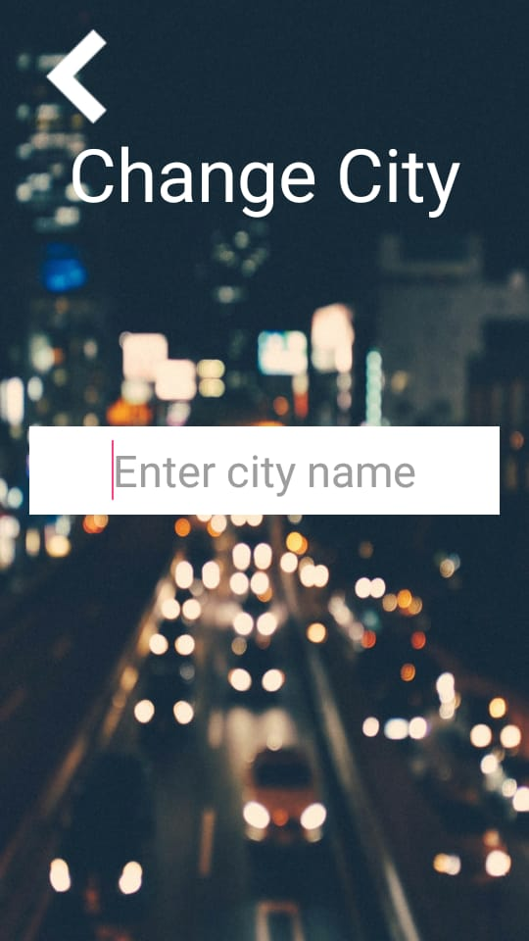
3.1.1. “Enter city” Page

3.1.1. “Temperature display” Page
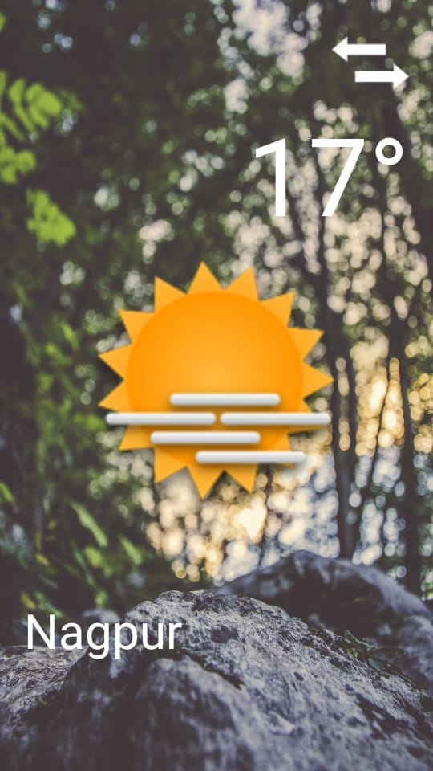

3.2 Functional Requirements

User “Enter city”

Use Case Number 1
Use Case “Enter city name”
Summary Ordinary person needs to enter the name of city to the system
Actor= (Ordinary person(as above).
Trigger go (<-) Button
Precondition Downloaded the clima application.
Scenario
● After user download the clima, s/he must
enter the valid city name to system in order to use application.

● after entering the city name go (<-)button in the page redirects user to
the temperature ,pressure,humidity showing page.

● After filling required fields with information, s/he
can we the data related to it.

● After user get the data from the system, s/he can go back to
to enter the city name again.

3.2.2. Discover weekly,monthly or daily data.

● after opening the temperature ,pressure,humidity showing page,user can see the pressure,humidity data of whole month,whole week,or current day.

3.3 Nonfunctional Requirements

In this section, last group of the requirements which is nonfunctional requirements
will be explained in detail. Nonfunctional requirements are separated into usability, reliability,
performance, supportability requirements subsections.

3.3.1 Usability

● This application is mobile application designed for Android users. Moreover,
it is using English language so that everyone literate with English can use it.
Furthermore, users have to know how to use mobile device and how to read and
write messages. Thus, our application is easy to use and understandable so that no
time is required for users to become productive at the usage of Clima.

3.3.2 Reliability

● Application will be installed on mobile devices, it need Internet connection
to run.

● Our application will send city name with its co-ordinate format in json to openweather map site and then it will send data related to it.

3.3.3 Performance

● The data will be delivered to the users in a very short time less than 1 second
and there will be delay which is mentioned in detail below:

● Delay:
● there will delay in getting data from server due to slow internet condition.

● Users should have 5MB free space on their mobile devices. CPU speed or RAM of
the device is not a big concern.

3.3.4 Supportability

● Programming language used in this project is object-oriented so that the tasks are
independent of each other and therefore easy to maintain.

● The codes must be easy to understand and readable.

● All design architecture should be well documented.

3.3.5 Security
● In order to receive the data from server(open waether map need an account to sign there hence we will use the user gmail account.

● Sent and received message should be transferred via Reliable Data Transfer
connection
4. Data Model and Description
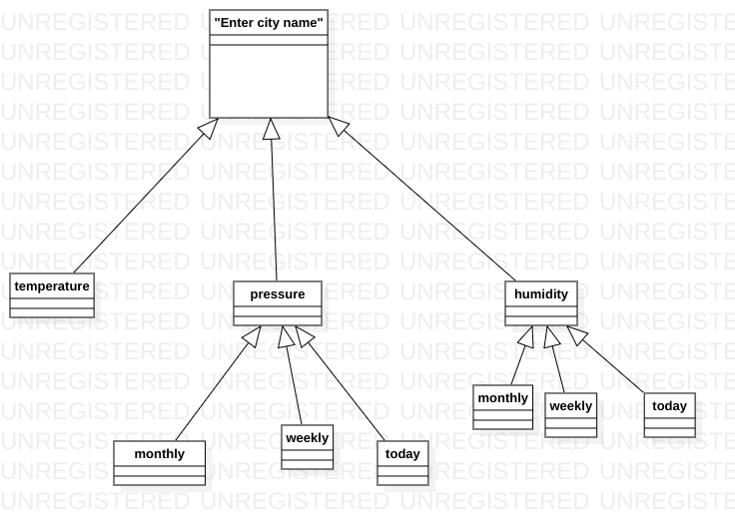
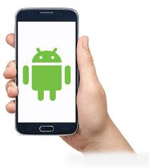



Component Diagram communication of clima APP(above)

5. Behavioral Model and Description

5.1 State Transition Diagram
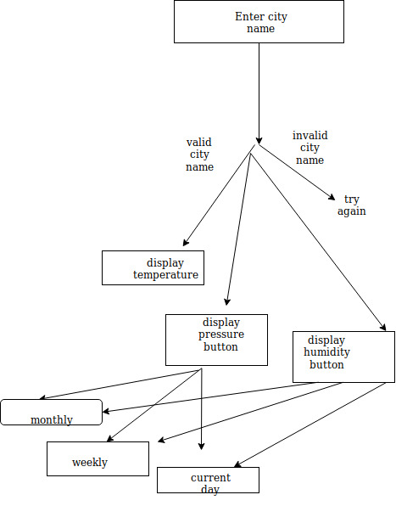

6.Planning

6.1 Team Structure
We periodically meet with our professors for consultancy. In our group,everyone
contributes to each part of the work. Our members are below:
● sudhir pal
● sudhir pal

6.2 Process Model
We use Agile Scrum software development modeling this project. Agile method is
based on an iterative approach. Each iteration takes 1-4 days.

7.Conclusion
In this project, we aim to help people to get instant and accurate weather within range of 1km.
The Software Requirement Specification states system interfaces, user interfaces, software
and hardware interfaces,communication interfaces and functional and nonfunctional
requirements in detail. Developer of the project will make use of this document throughout
the implementation process.
8. References
[1] IEEE Guide for Software Requirements Specifications," in IEEE Std 830-1984 , vol., no.,
pp.1-26, Feb. 10 1984, doi: 10.1109/IEEESTD.1984.119205,

