* **What Data is?**
  + Information or facts that can be collected, measured and analysed. Such as images, audio, or video.
  + **Structured**- Names, addresses, and purchase history in a spreadsheet, etc.
  + **Semi-structured**- Email messages, social media posts, and XML files.
  + **Unstructured**- Text, Images, Audio, or Video in a collection form.
* **Database Management System- DBMS:**
  + In computing, a database is an organized collection of data stored and accessed on a file system, while large databases are hosted on computer clusters or cloud storage/mainframe.
* **Relational Database Management System (RDBMS):**
  + **RDBMS** stands for Relational Database Management System.
  + A relational database management system (**RDBMS**) is a program used to create, update, store and provide access to data points that are related to one another.
  + Some of the most well-known RDBMSs include MySQL, PostgreSQL, MariaDB, Microsoft SQL Server, and Oracle Database.
  + A Relational database management system (RDBMS) is a database management system (DBMS) that is based on the relational model as introduced by E.F. Codd in 1970.
* **Why SQL?**
  + SQL is a popular query language to work with databases.
  + It is portable.
  + It processes queries quickly.
  + It doesn’t require coding skills.
  + It uses standardized language.
  + It provides multiple data views.
  + It has open-source code.
  + It’s used by major database management system vendors.
  + It’s highly interactive.
  + It is frequently used in all types of applications that interacts with databases in some way.
  + SQL integrates well with different programming languages, and it makes life easier for Data analysts and developers learn and use it.
    - For example, they can embed SQL queries with the C#/Java/Python programming language to build high-performing data processing applications with major SQL database systems such as Oracle or MS SQL Server.

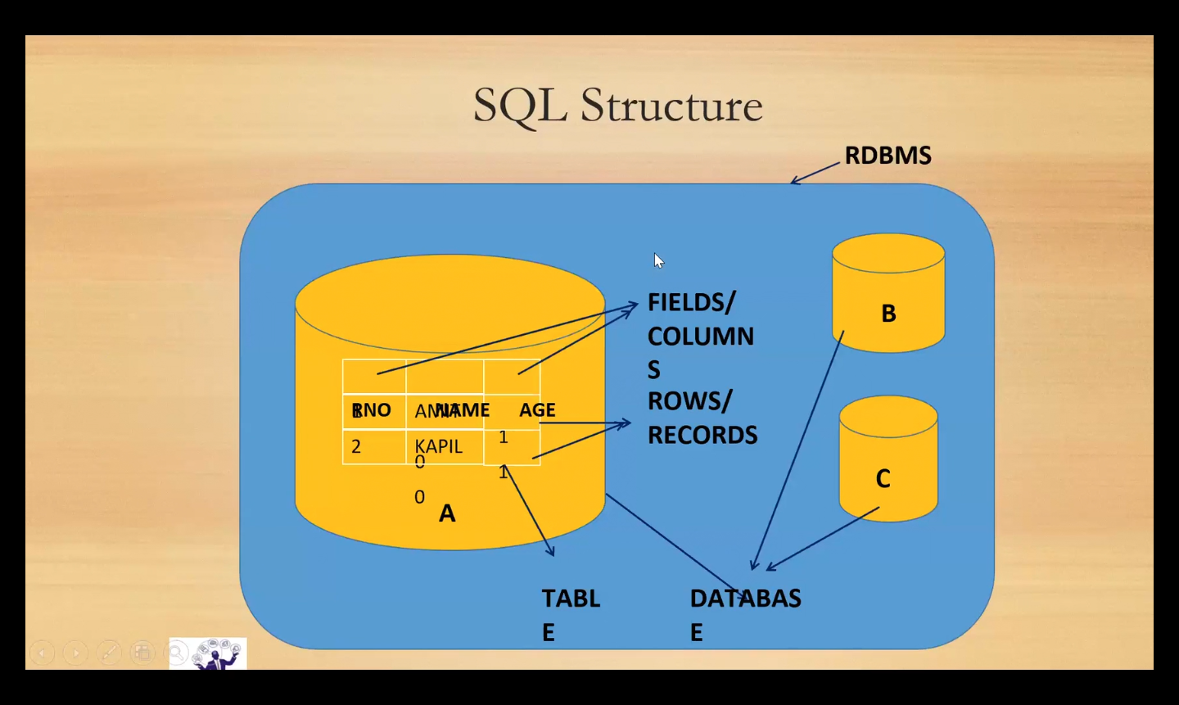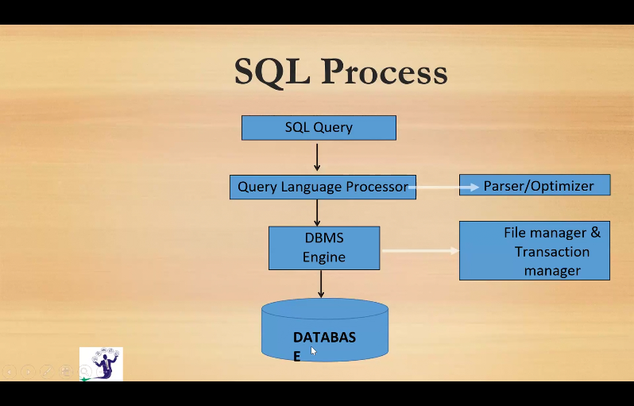

* **Process in SQL**
  + SQL implementations involve a server machine that processes the database queries and returns the results.
  + **Parser:**
    - **Correctness**: The parser verifies the semantics, or rules, which ensure the correctness of the query statement, like semicolon, commas, etc.
    - **Authorization**: Validates that the user running the query has the necessary authorization.
  + **Relational Engine**: Creates a plan for retrieving, writing, or updating the corresponding data in the most effective manner.
  + **Database Engine**: It is the software component that processes the byte code and runs the intended SQL statement. It reads and stores the data in the database files on physical disk storage. Upon completion, the storage engine returns the result to the requesting application.
* **Introduction:**
  + Data- collection of information
  + Database- Where the data has been stored
  + RDBMS- A software package is used to store relation databases.
  + SQL- A Query language to communicate between databases.
* **SQL Environment:**
  + Editor Pane
  + Result Tab
  + Message Tab
  + Object Explorer

