Predicting Sales

Forecasting the monthly sales with LSTM

Barış Karaman

Jun 9, 2019·8 min read

This series of articles was designed to explain how to use Python in a simplistic way to fuel your company’s growth by applying the predictive approach to all your actions. It will be a combination of programming, data analysis, and machine learning.
I will cover all the topics in the following nine articles:
1- Know Your Metrics
2- Customer Segmentation
3- Customer Lifetime Value Prediction
4- Churn Prediction
5- Predicting Next Purchase Day
6- Predicting Sales
7- Market Response Models
8- Uplift Modeling
9- A/B Testing Design and Execution
Articles will have their own code snippets to make you easily apply them. If you are super new to programming, you can have a good introduction for Python and Pandas (a famous library that we will use on everything) here. But still without a coding introduction, you can learn the concepts, how to use your data and start generating value out of it:
Sometimes you gotta run before you can walk — Tony Stark
As a pre-requisite, be sure Jupyter Notebook and Python are installed on your computer. The code snippets will run on Jupyter Notebook only.
Alright, let’s start.

Part 6: Predicting Sales
Before this section, almost all our prediction models were on customer level (e.g. churn prediction, next purchase day, etc.). It is useful to zoom out and look at the broader picture as well. By considering all our efforts on the customer side, how do we affect the sales?
Time series forecasting is one of the major building blocks of Machine Learning. There are many methods in the literature to achieve this like Autoregressive Integrated Moving Average (ARIMA), Seasonal Autoregressive Integrated Moving-Average (SARIMA), Vector Autoregression (VAR), and so on.
In this article, we will focus on Long Short-term Memory (LSTM) method, which is a quite popular one if you want to use Deep Learning. We will use Keras in our project to implement LSTM.
Lastly, how does knowing the future sales helps our business?
First of all, it is a benchmark. We can use it as the business as usual level we are going to achieve if nothing changes in our strategy. Moreover, we can calculate the incremental value of our new actions on top of this benchmark.
Second, it can be utilized for planning. We can plan our demand and supply actions by looking at the forecasts. It helps to see where to invest more.
Last but not least, it is an excellent guide for planning budgets and targets.
Now it is time to jump into coding and build our first deep learning model. The implementation of our model will have 3 steps:
- Data Wrangling
- Data Transformation to make it stationary and supervised
- Building the LSTM model & evaluation

Data Wrangling
In this example, we use the dataset from a Kaggle competition. It represents the daily sales for each store and item.
Like always we start with importing the required libraries and importing our data from CSV:
Our data looks like below:

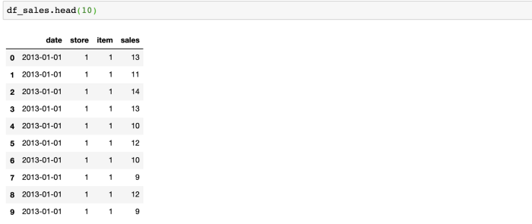
Our task is to forecast monthly total sales. We need to aggregate our data at the monthly level and sum up the sales column.
#represent month in date field as its first day
df_sales['date'] = df_sales['date'].dt.year.astype('str') + '-' + df_sales['date'].dt.month.astype('str') + '-01'
df_sales['date'] = pd.to_datetime(df_sales['date'])#groupby date and sum the sales
df_sales = df_sales.groupby('date').sales.sum().reset_index()
After applying the code above, df_sales is now showing the aggregated sales we need:

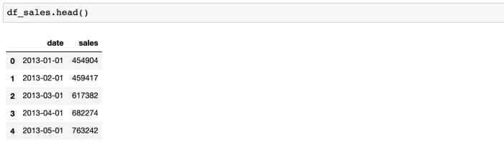

Data Transformation
To model our forecast easier and more accurate, we will do the transformations below:
- We will convert the data to stationary if it is not
- Converting from time series to supervised for having the feature set of our LSTM model
- Scale the data
First off, how do we check if the data is not stationary? Let’s plot it and see:
#plot monthly sales
plot_data = [
go.Scatter(
x=df_sales['date'],
y=df_sales['sales'],
)
]plot_layout = go.Layout(
title='Montly Sales'
)
fig = go.Figure(data=plot_data, layout=plot_layout)
pyoff.iplot(fig)
Monthly sales chart:

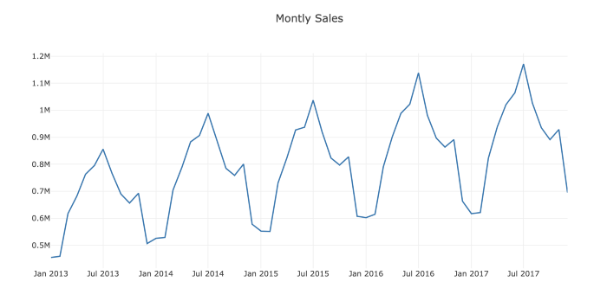
Monthly Sales — not stationary
Obviously, it is not stationary and has an increasing trend over the months. One method is to get the difference in sales compared to the previous month and build the model on it:
#create a new dataframe to model the difference
df_diff = df_sales.copy()#add previous sales to the next row
df_diff['prev_sales'] = df_diff['sales'].shift(1)#drop the null values and calculate the difference
df_diff = df_diff.dropna()
df_diff['diff'] = (df_diff['sales'] - df_diff['prev_sales'])df_diff.head(10)
Now we have the required dataframe for modeling the difference:

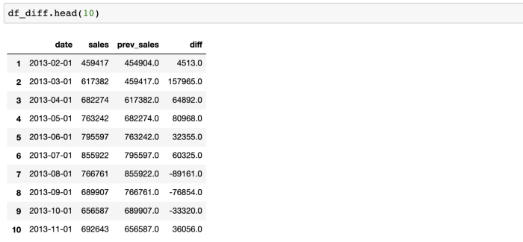
Let’s plot it and check if it is stationary now:
#plot sales diff
plot_data = [
go.Scatter(
x=df_diff['date'],
y=df_diff['diff'],
)
]plot_layout = go.Layout(
title='Montly Sales Diff'
)
fig = go.Figure(data=plot_data, layout=plot_layout)
pyoff.iplot(fig)

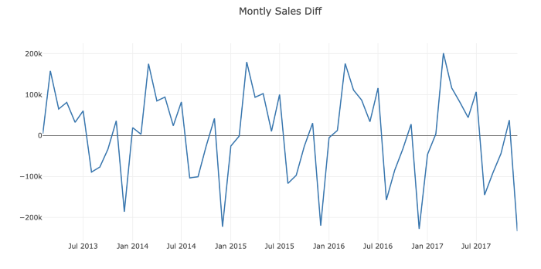
Monthly Sales Difference — stationary
Perfect! Now we can start building our feature set. We need to use previous monthly sales data to forecast the next ones. The look-back period may vary for every model. Ours will be 12 for this example.
So what we need to do is to create columns from lag_1 to lag_12 and assign values by using shift() method:
#create dataframe for transformation from time series to supervised
df_supervised = df_diff.drop(['prev_sales'],axis=1)#adding lags
for inc in range(1,13):
field_name = 'lag_' + str(inc)
df_supervised[field_name] = df_supervised['diff'].shift(inc)#drop null values
df_supervised = df_supervised.dropna().reset_index(drop=True)
Check out our new dataframe called df_supervised:

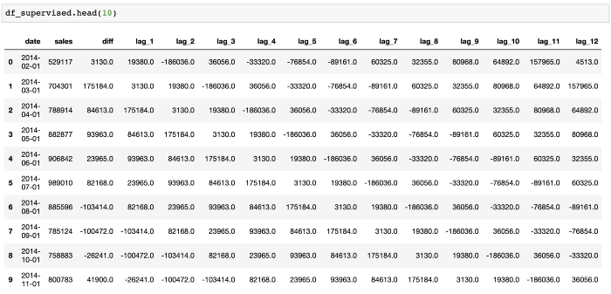
We have our feature set now. Let’s be a bit more curious and ask this question:
How useful are our features for prediction?
Adjusted R-squared is the answer. It tells us how good our features explain the variation in our label (lag_1 to lag_12 for diff, in our example).
Let’s see it in an example:
# Import statsmodels.formula.api
import statsmodels.formula.api as smf# Define the regression formula
model = smf.ols(formula='diff ~ lag_1', data=df_supervised)# Fit the regression
model_fit = model.fit()# Extract the adjusted r-squared
regression_adj_rsq = model_fit.rsquared_adj
print(regression_adj_rsq)
So what happened above?
Basically, we fit a linear regression model (OLS — Ordinary Least Squares) and calculate the Adjusted R-squared. For the example above, we just used lag_1 to see how much it explains the variation in column diff. The output of this code block is:

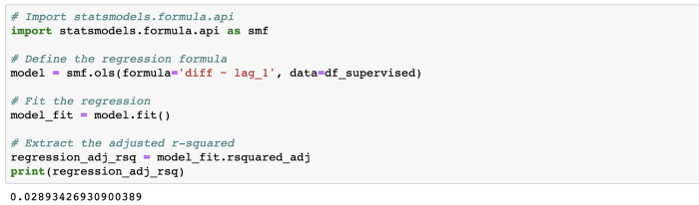
lag_1 explains 3% of the variation. Let’s check out others:

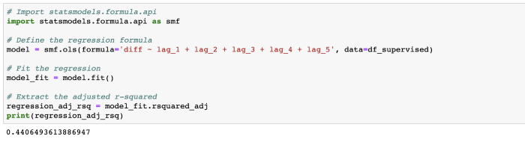
Adding four more features increased the score from 3% to 44%.
How is the score if we use the entire feature set:

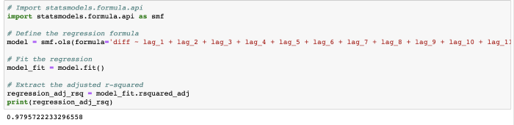
The result is impressive as the score is 98%. Now we can confidently build our model after scaling our data. But there is one more step before scaling. We should split our data into train and test sets. As the test set, we have selected the last 6 months’ sales.
#import MinMaxScaler and create a new dataframe for LSTM model
from sklearn.preprocessing import MinMaxScaler
df_model = df_supervised.drop(['sales','date'],axis=1)#split train and test set
train_set, test_set = df_model[0:-6].values, df_model[-6:].values
As the scaler, we are going to use MinMaxScaler, which will scale each future between -1 and 1:
#apply Min Max Scaler
scaler = MinMaxScaler(feature_range=(-1, 1))
scaler = scaler.fit(train_set)
# reshape training set
train_set = train_set.reshape(train_set.shape[0], train_set.shape[1])
train_set_scaled = scaler.transform(train_set)# reshape test set
test_set = test_set.reshape(test_set.shape[0], test_set.shape[1])
test_set_scaled = scaler.transform(test_set)

Building the LSTM model
Everything is ready to build our first deep learning model. Let’s create feature and label sets from scaled datasets:
X_train, y_train = train_set_scaled[:, 1:], train_set_scaled[:, 0:1]
X_train = X_train.reshape(X_train.shape[0], 1, X_train.shape[1])X_test, y_test = test_set_scaled[:, 1:], test_set_scaled[:, 0:1]
X_test = X_test.reshape(X_test.shape[0], 1, X_test.shape[1])
Let’s fit our LSTM model:
model = Sequential()
model.add(LSTM(4, batch_input_shape=(1, X_train.shape[1], X_train.shape[2]), stateful=True))
model.add(Dense(1))
model.compile(loss='mean_squared_error', optimizer='adam')
model.fit(X_train, y_train, nb_epoch=100, batch_size=1, verbose=1, shuffle=False)
The code block above prints how the model improves itself and reduce the error in each epoch:

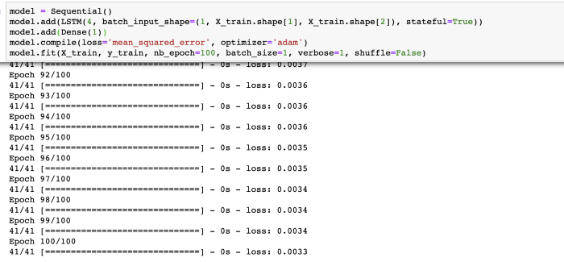
Let’s do the prediction and see how the results look like:
y_pred = model.predict(X_test,batch_size=1)#for multistep prediction, you need to replace X_test values with the predictions coming from t-1
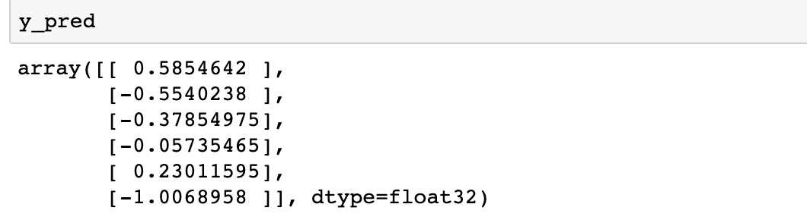
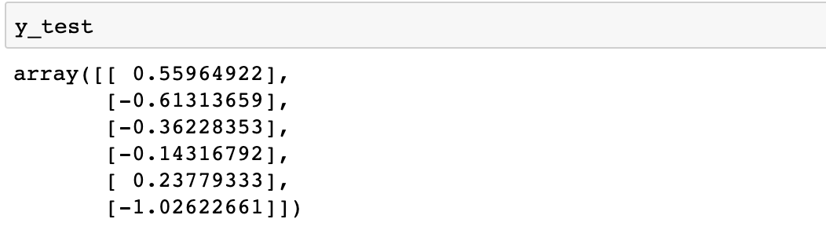
y_pred vs y_test
Results look similar but it doesn’t tell us much because these are scaled data that shows the difference. How we can see the actual sales prediction?
First, we need to do the inverse transformation for scaling:
#reshape y_pred
y_pred = y_pred.reshape(y_pred.shape[0], 1, y_pred.shape[1])#rebuild test set for inverse transform
pred_test_set = []
for index in range(0,len(y_pred)):
print np.concatenate([y_pred[index],X_test[index]],axis=1)
pred_test_set.append(np.concatenate([y_pred[index],X_test[index]],axis=1))#reshape pred_test_set
pred_test_set = np.array(pred_test_set)
pred_test_set = pred_test_set.reshape(pred_test_set.shape[0], pred_test_set.shape[2])#inverse transform
pred_test_set_inverted = scaler.inverse_transform(pred_test_set)
Second, we need to build the dataframe has the dates and the predictions. Transformed predictions are showing the difference. We should calculate the predicted sales numbers:
#create dataframe that shows the predicted sales
result_list = []
sales_dates = list(df_sales[-7:].date)
act_sales = list(df_sales[-7:].sales)
for index in range(0,len(pred_test_set_inverted)):
result_dict = {}
result_dict['pred_value'] = int(pred_test_set_inverted[index][0] + act_sales[index])
result_dict['date'] = sales_dates[index+1]
result_list.append(result_dict)
df_result = pd.DataFrame(result_list)#for multistep prediction, replace act_sales with the predicted sales
Output:

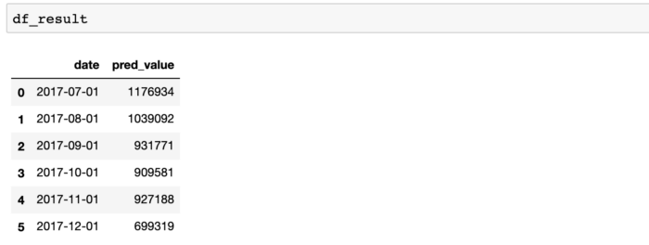
Great! We’ve predicted the next six months’ sales numbers. Let’s check them in the plot to see how good is our model:
#merge with actual sales dataframe
df_sales_pred = pd.merge(df_sales,df_result,on='date',how='left')#plot actual and predicted
plot_data = [
go.Scatter(
x=df_sales_pred['date'],
y=df_sales_pred['sales'],
name='actual'
),
go.Scatter(
x=df_sales_pred['date'],
y=df_sales_pred['pred_value'],
name='predicted'
)
]plot_layout = go.Layout(
title='Sales Prediction'
)
fig = go.Figure(data=plot_data, layout=plot_layout)
pyoff.iplot(fig)
Actual vs predicted:

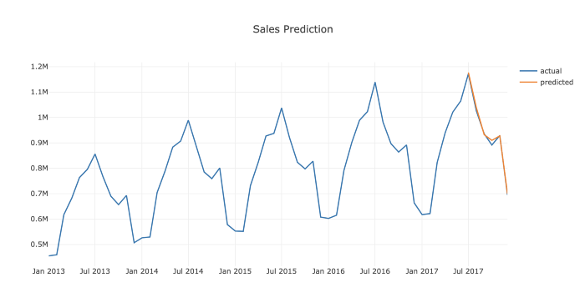
Looks pretty good for a simple model.
One improvement we can do for this model is to add holidays, breaks, and other seasonal effects. They can be simply added as a new feature.
By using this model, we have our baseline sales predictions. But how we can predict the effect of a promotion on sales? We will look into it in Part 7.
You can find the Jupyter Notebook for this article here.
To discuss growth marketing & data science, go ahead and book a free session with me here.

DATA DRIVEN GROWTH WITH PYTHON

Market Response Models

Predicting incremental gains of promotional campaigns

Barış Karaman

Jul 28, 2019·9 min read

This series of articles was designed to explain how to use Python in a simplistic way to fuel your company’s growth by applying the predictive approach to all your actions. It will be a combination of programming, data analysis, and machine learning.
I will cover all the topics in the following nine articles:
1- Know Your Metrics
2- Customer Segmentation
3- Customer Lifetime Value Prediction
4- Churn Prediction
5- Predicting Next Purchase Day
6- Predicting Sales
7- Market Response Models
8- Uplift Modeling
9- A/B Testing Design and Execution
Articles will have their own code snippets to make you easily apply them. If you are super new to programming, you can have a good introduction for Python and Pandas (a famous library that we will use on everything) here. But still without a coding introduction, you can learn the concepts, how to use your data and start generating value out of it:
Sometimes you gotta run before you can walk — Tony Stark
As a pre-requisite, be sure Jupyter Notebook and Python are installed on your computer. The code snippets will run on Jupyter Notebook only.
Alright, let’s start.

Part 7: Market Response Models
By using the models we have built in the previous articles, we can easily segment the customers and predict their lifetime value (LTV) for targeting purposes. As a side note, we also know what will be our sales numbers. But how we can increase our sales? If we do a discount today, how many incremental transactions should we expect?
Segmenting customers and doing A/B tests enable us to try lots of different ideas for generating incremental sales. This is one of the building blocks of Growth Hacking. You need to ideate and experiment continuously to find growth opportunities.
Splitting the customers who we are going to send the offer into test and control groups helps us to calculate incremental gains.
Let’s see the example below:

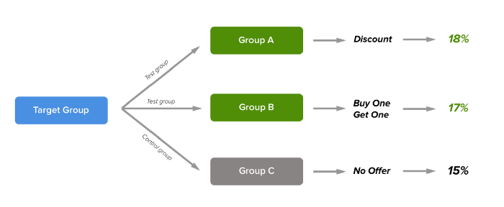
In this setup, the target group was divided into three groups to find an answer to the questions below:
1- Does giving an offer increase conversion?
2- If yes, what kind of offer performs best? Discount or Buy One Get One?
Assuming the results are statistically significant, Discount (Group A) looks the best as it’s increased the conversion by 3% compared to the Control group and brought 1% more conversion against Buy One Get One.
Of course in the real world, it is much more complicated. Some offers perform better on specific segments. So you need to create a portfolio of offers for selected segments. Moreover, you can’t count on conversion as the only criterion of success. There is always a cost trade-off. Generally, while conversion rates go up, cost increases too. That’s why sometimes you need to select an offer that is cost-friendly but brings less conversion.
Now we know which offer performed well compared to others thanks to the experiment. But what about predicting it? If we predict the effect of giving an offer, we can easily maximize our transactions and have a forecast of the cost. Market Response Models help us building this framework. But there is more than one way of doing it. We can group them into two:
1- If you don’t have a control group (imagine you did an open promotion to everyone and announced it on social media), then you cannot calculate the incrementality. For this kind of situation, better to build a regression model that predicts overall sales. The prior assumption will be that the model will provide higher sales numbers for the promo days.
To build this kind of model, your dataset should include promo & non-promo days sales numbers so that the machine learning model can calculate the incrementality.
2- If you have a control group, you can build the response model based on segment or individual level. For both of them, the assumption is the same. Giving an offer should increase the probability of conversion. The uptick in the individuals’ conversion probability will bring us the incremental conversion.
Let’s jump into coding and see how we can build an individual level response model. In this example, we will be using the marketing dataset here. But I’ve done some alterations to make it more relevant to our case (which you can find here.)
Let’s import the libraries we need and import our data:
First 10 rows of our data:

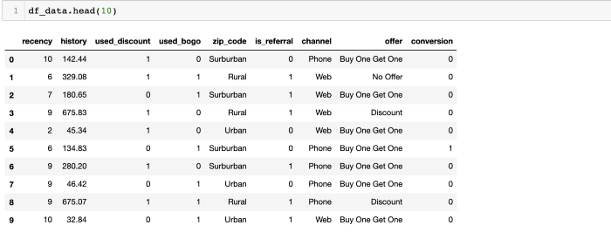
Our first 8 columns are providing individual-level data and conversion column is our label to predict:
- recency: months since last purchase
- history: $value of the historical purchases
- used_discount/used_bogo: indicates if the customer used a discount or buy one get one before
- zip_code: class of the zip code as Suburban/Urban/Rural
- is_referral: indicates if the customer was acquired from referral channel
- channel: channels that the customer using, Phone/Web/Multichannel
- offer: the offers sent to the customers, Discount/But One Get One/No Offer
We will be building a binary classification model for scoring the conversion probability of all customers. For doing that, we are going to follow the steps below:
- Building the uplift formula
- Exploratory Data Analysis (EDA) & Feature Engineering
- Scoring the conversion probabilities
- Observing the results on the test set

Uplift Formula
First off, we need to build a function that calculates our uplift. To keep it simple, we will assume every conversion means 1 order and the average order value is 25$.
We are going to calculate three types of uplift:
Conversion Uplift: Conversion rate of test group - conversion rate of control group
Order Uplift: Conversion uplift * # converted customer in test group
Revenue Uplift: Order Uplift * Average order $ value
Let’s build our calc_uplift function:
def calc_uplift(df):
#assigning 25$ to the average order value
avg_order_value = 25
#calculate conversions for each offer type
base_conv = df[df.offer == 'No Offer']['conversion'].mean()
disc_conv = df[df.offer == 'Discount']['conversion'].mean()
bogo_conv = df[df.offer == 'Buy One Get One']['conversion'].mean()
#calculate conversion uplift for discount and bogo
disc_conv_uplift = disc_conv - base_conv
bogo_conv_uplift = bogo_conv - base_conv
#calculate order uplift
disc_order_uplift = disc_conv_uplift * len(df[df.offer == 'Discount']['conversion'])
bogo_order_uplift = bogo_conv_uplift * len(df[df.offer == 'Buy One Get One']['conversion'])
#calculate revenue uplift
disc_rev_uplift = disc_order_uplift * avg_order_value
bogo_rev_uplift = bogo_order_uplift * avg_order_value
print('Discount Conversion Uplift: {0}%'.format(np.round(disc_conv_uplift*100,2)))
print('Discount Order Uplift: {0}'.format(np.round(disc_order_uplift,2)))
print('Discount Revenue Uplift: ${0}\n'.format(np.round(disc_rev_uplift,2)))
print('-------------- \n')print('BOGO Conversion Uplift: {0}%'.format(np.round(bogo_conv_uplift*100,2)))
print('BOGO Order Uplift: {0}'.format(np.round(bogo_order_uplift,2)))
print('BOGO Revenue Uplift: ${0}'.format(np.round(bogo_rev_uplift,2)))
If we apply this function to our dataframe, we will see the results below:

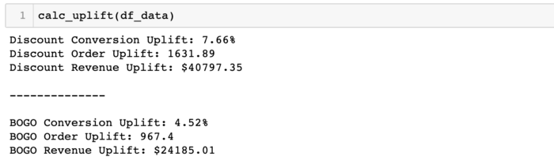
Discount looks like a better option if we want to get more conversion. It brings 7.6% uptick compared to the customers who didn’t receive any offer. BOGO (Buy One Get One) has 4.5% uptick as well.
Let’s start exploring which factors are the drivers of this incremental change.

EDA & Feature Engineering
We check every feature one by one to find out their impact on conversion
1- Recency
Ideally, the conversion should go down while recency goes up since inactive customers are less likely to buy again:
df_plot = df_data.groupby('recency').conversion.mean().reset_index()
plot_data = [
go.Bar(
x=df_plot['recency'],
y=df_plot['conversion'],
)
]plot_layout = go.Layout(
xaxis={"type": "category"},
title='Recency vs Conversion',
plot_bgcolor = 'rgb(243,243,243)',
paper_bgcolor = 'rgb(243,243,243)',
)
fig = go.Figure(data=plot_data, layout=plot_layout)
pyoff.iplot(fig)

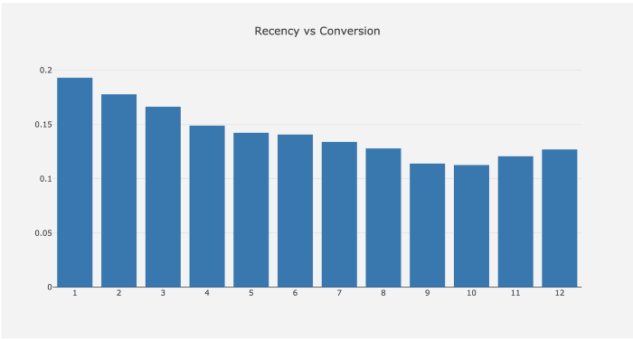
It goes as expected until 11 months of recency. Then it increases. It can be due to many reasons like having less number of customers in those buckets or the effect of the given offers.
2- History
We will create a history cluster and observe its impact. Let’s apply k-means clustering to define the significant groups in history:
kmeans = KMeans(n_clusters=5)
kmeans.fit(df_data[['history']])
df_data['history_cluster'] = kmeans.predict(df_data[['history']])#order the cluster numbers
df_data = order_cluster('history_cluster', 'history',df_data,True)#print how the clusters look like
df_data.groupby('history_cluster').agg({'history':['mean','min','max'], 'conversion':['count', 'mean']})#plot the conversion by each cluster
df_plot = df_data.groupby('history_cluster').conversion.mean().reset_index()
plot_data = [
go.Bar(
x=df_plot['history_cluster'],
y=df_plot['conversion'],
)
]plot_layout = go.Layout(
xaxis={"type": "category"},
title='History vs Conversion',
plot_bgcolor = 'rgb(243,243,243)',
paper_bgcolor = 'rgb(243,243,243)',
)
fig = go.Figure(data=plot_data, layout=plot_layout)
pyoff.iplot(fig)
Overview of the clusters and the plot vs. conversion:

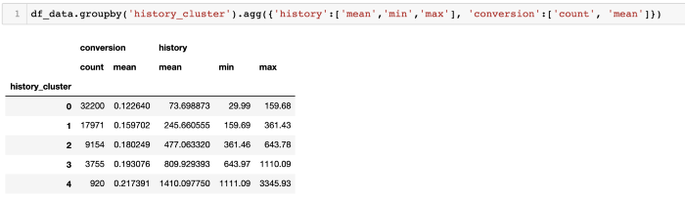

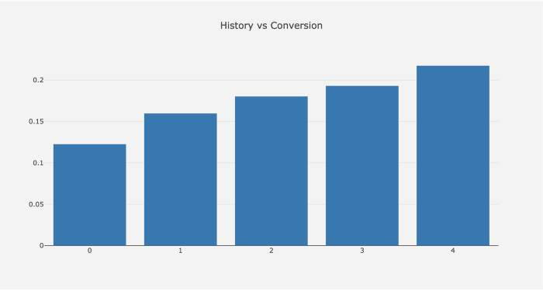
Customers with higher $ value of history are more likely to convert.
3- Used Discount & BOGO
We will check these two features together with the following code line:
df_data.groupby(['used_discount','used_bogo','offer']).agg({'conversion':'mean'})
Output:

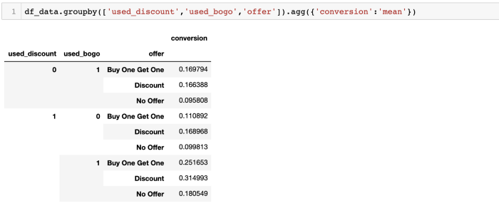
Customers, who used both of the offers before, have the highest conversion rate.
4- Zip Code
Rural shows better conversion compared to others:
df_plot = df_data.groupby('zip_code').conversion.mean().reset_index()
plot_data = [
go.Bar(
x=df_plot['zip_code'],
y=df_plot['conversion'],
marker=dict(
color=['green', 'blue', 'orange'])
)
]plot_layout = go.Layout(
xaxis={"type": "category"},
title='Zip Code vs Conversion',
plot_bgcolor = 'rgb(243,243,243)',
paper_bgcolor = 'rgb(243,243,243)',
)
fig = go.Figure(data=plot_data, layout=plot_layout)
pyoff.iplot(fig)

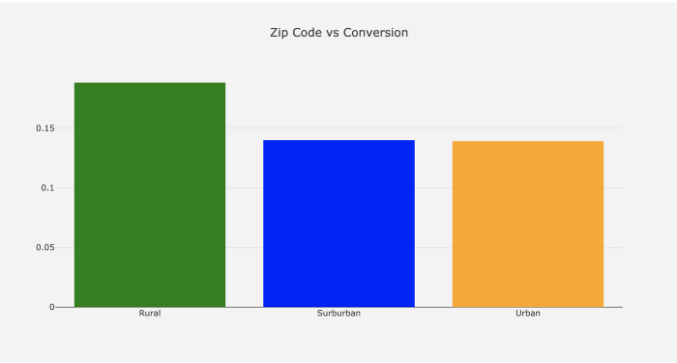
5- Referral
As we see below, customers from referral channel have less conversion rate:

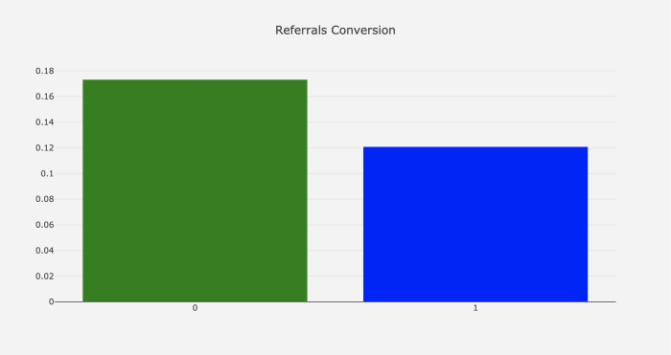
They show almost 5% less conversion.
6- Channel

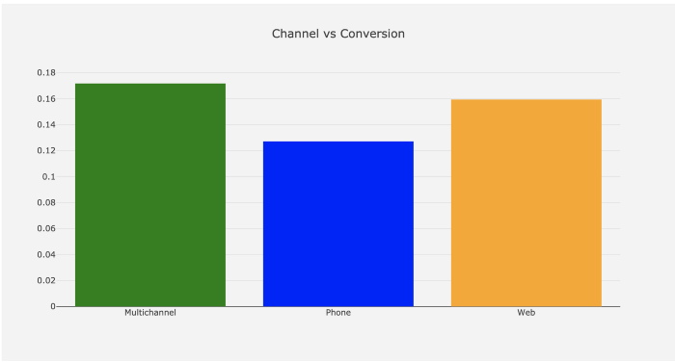
Multichannel shows higher conversion rate as we expected. Using more than one channel is an indicator of high engagement.
7- Offer Type

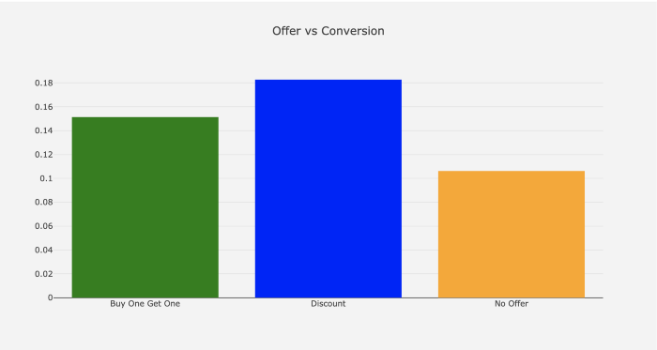
Customers who get discount offers show ~18% conversion whereas it is ~15% for BOGO. If customers don’t get an offer, their conversion rate drops by ~4%.
Feature Engineering of this data will be pretty simple. We will apply .get_dummies() to convert categorical columns to numerical ones:
df_model = df_data.copy()
df_model = pd.get_dummies(df_model)
It is time to build our machine learning model to score conversion probabilities.

Scoring conversion probabilities
To build our model, we need to follow the steps we mentioned earlier in the articles.
Let’s start with splitting features and the label:
#create feature set and labels
X = df_model.drop(['conversion'],axis=1)
y = df_model.conversion
Creating training and test sets:
X_train, X_test, y_train, y_test = train_test_split(X, y, test_size=0.2, random_state=56)
We will fit the model and get the conversion probabilities. predit_proba() function of our model assigns probability for each row:
xgb_model = xgb.XGBClassifier().fit(X_train, y_train)
X_test['proba'] = xgb_model.predict_proba(X_test)[:,1]
Let’s see how our probability column looks like:

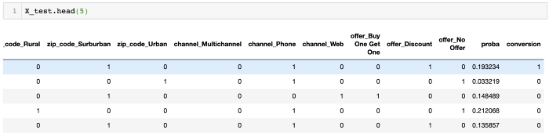
From the above, we can see that our model assigned the probability of conversion (from 0 to 1) for each customer.
Finally, we need to understand if our model works well or not.

Results on test set
Now we assume, the difference in the probability of discount, bogo and control group should be similar to conversion differences between them.
We need to use our test set to find it out.
Let’s calculate predicted and real order upticks for discount:
real_disc_uptick = len(X_test)*(X_test[X_test['offer_Discount'] == 1].conversion.mean() - X_test[X_test['offer_No Offer'] == 1].conversion.mean())pred_disc_uptick = len(X_test)*(X_test[X_test['offer_Discount'] == 1].proba.mean() - X_test[X_test['offer_No Offer'] == 1].proba.mean())
For real uptick calculation, we used the conversion column. For the predicted one, we replaced it with proba.

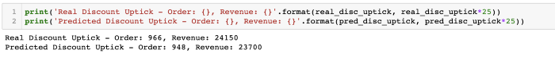
The results are pretty good. The real order uptick was 966 and the model predicted it as 948 (1.8% error).
Revenue uptick prediction comparison: 24150 vs 23700.
We need to check if the results are good for BOGO as well:
real_bogo_uptick = len(X_test)*(X_test[X_test['offer_Buy One Get One'] == 1].conversion.mean() - X_test[X_test['offer_No Offer'] == 1].conversion.mean())pred_bogo_uptick = len(X_test)*(X_test[X_test['offer_Buy One Get One'] == 1].proba.mean() - X_test[X_test['offer_No Offer'] == 1].proba.mean())

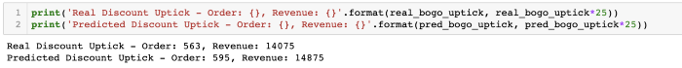
Promising results for BOGO:
Order uptick - real vs predicted: 563 vs 595
Revenue uptick — real vs predicted: 14075 vs 14875
The error rate is around 5.6%. The model can benefit from improving the prediction scores on BOGO offer type.
Calculating conversion probabilities help us a lot in different areas as well. We have predicted the return of the different types of offers but it can help us to find out who to target for maximizing the uplift as well. In the next article, we will build our own uplift model.
You can find the Jupyter Notebook for this article here.

