

RECOMMENDATION SYSTEM FOR OVER THE TOP CONTENT MANAGEMENT SYSTEM

by

Ranjitha B R
(1847131)

Under the guidance of
Dr. Deepa V Jose
&
Mr. Sudhir Murthy

A Project report submitted in partial fulfillment of the requirements for the award of degree of MSc Computer Science of CHRIST (Deemed to be University)
April - 2020


CERTIFICATE

This is to certify that the report titled RECOMMENDATION SYSTEM FOR OVER THE TOP CONTENT MANAGEMENT SYSTEM is a bonafide record of work done by Ranjitha BR (1847131) of CHRIST(Deemed to be University), Bengaluru, in partial fulfillment of the requirements of IV Semester MSc Computer Science during the year 2020.

Head of the Department Project Guide

Valued-by:
 |  | Name | :
1. |  | Register Number | :
 |  | Examination Centre | : CHRIST(Deemed to  be University)
2. |  | Date of Exam | :

ACKNOWLEDGEMENTS

This project would not have been possible without the kind support and help of many individuals and organizations. I would like to extend my sincere thanks to all of them. During our project duration I have been accompanied by many people. It is a pleasant aspect to have the opportunity to express our gratitude for all of them whose constant guidance and encouragement made all our efforts meet with success.
First and foremost is Almighty God without whom nothing would have been possible. No words can be articulated for our deepest gratitude to you Lord for the inspiration and guidance which I have received.
I am highly indebted to CHRIST (Deemed to be University) and Claysol company for their guidance and constant supervision as well as for providing necessary information regarding the project and also for their support in completing the project. I express my deep sense of gratitude to Rev. Fr. Dr. Abraham. V.M, Vice Chancellor of CHRIST (Deemed to be University) for providing us with necessary facilities that helped us accomplishing the work.
I am deeply indebted to Prof. Joy Paulose, Head, Department of Computer Science, CHRIST (Deemed to be university), for rendering us invaluable support during the course of this project work.
I acknowledge our sincere thanks to Prof. Tulasi, Coordinator, Department of Computer Science, for her motivation and valuable guidance throughout the course of the project.
I am highly indebted to our project guide Dr. Deepa V Jose, professor at Christ university and Mr. Sudhir Murthy, Director of Claysol Media labs private ltd., for guiding us with true spirit throughout the project with profound sincerity and gratitude.
I would like to thank the faculty members of the Department of Computer Science, CHRIST (Deemed to be University), for providing us advises and motivation that helped us in staying on track. I consider it as a pleasant duty to acknowledge the abundant help received from all my colleagues. I am also extremely thankful to all our family members for having been there when I needed them the most. I would also like to thank each and every one who has contributed directly or indirectly towards the completion of our project work.

ABSTRACT

Recommendation system for Over the top content management system is a system that gives recommendations of video content to the users based on the preferences of the users. The users can find the products they are interested to buy which helps the users to get best experience and also increases the business of the company. The system takes the information regarding the user’s ratings and gives the recommendations. To solve the information overload problem recommendation system is built. In this project I am using particle swarm optimization. Recommendations are given based on the users likes and dislikes which is analyzed through the implicit and explicit ratings given by the users. Implicit ratings refer to the ratings which is given indirectly by the user that is the data collected through the behavior of the users like the clicks, views, purchase details and explicit ratings refer to the ratings gives directly like 5- star ratings, like or dislike etc. The technologies used for the development of this project are python, node js and mongo db.

TABLE OF CONTENTS

Acknowledgements |  |  |  |  | iv
Abstract |  |  |  |  | v
1. | Introduction |  |  |  | 1
 | 1.1 | OTT |  |  | 1
 | 1.2 | CMS |  |  | 1
 | 1.3 | AI/ML in recommendation system |  |  | 2
 | 1.4 | Brief introduction to AI/ML |  |  | 2
2. | System Analysis |  |  |  | 5
 | 2.1 | Existing System |  |  | 5
 | 2.2 | Proposed System |  |  | 28
 | 2.3 | CPU based computing |  |  | 31
 | 2.4 | Need for GPU based computing and TensorFlow |  |  | 31
3. | System Design |  |  |  | 34
 | 3.1 | System Architecture |  |  | 34
 | 3.2 | Swimlane diagram |  |  | 35
4. | Implementation |  |  |  | 36
 | 4.1 | Programming Language |  |  | 36
 |  | 4.1.1 | Numpy |  | 36
 |  | 4.1.2 | Pandas |  | 36
 |  | 4.1.3 | Scipy |  | 37
 | 4.2 | Framework for machine learning |  |  | 40
 |  | 4.2.1 |  | Scikit learn | 42
 |  | 4.2.2 |  | Keras | 44
 |  | 4.2.3 |  | Tensor flow | 45
 |  | 4.2.4 |  | Pytorch | 46
 | 4.3 | Advent of jupyter notebook |  |  | 48
 | 4.4 | Source code |  |  | 53
5. | Testing |  |  |  | 55
6. | Conclusion |  |  |  | 57
References 58

LIST OF FIGURES

Fig No | Name | Page No
1.1 | Unsupervised Learning | 3
2.1 | Matrix | 7
2.2 | Matrices | 8
2.3 | Product of matrices | 9
2.4 | Matrix Factorization | 9
2.5 | Error calculation in matrix factorization | 10
2.6 | Splitting of matrix | 10
2.7 | RMSE for probabilistic matrix factorization | 13
2.8 | Cuckoo search algorithm | 16
2.9 | cuckoo search recommendation system architecture | 17
2.10 | AIS recommendation system algorithm | 21
2.11 | CPU architecture | 31
2.12 | GPU architecture | 32
4.1 | System Architecture | 34
4.2 | Swim lane diagram | 35
5.1 | Model Accuracy | 56

LIST OF TABLES

Table no. | Name | Page No
2.1 | Comparison of CS with GA | 17
2.2 | Comparison of CS with PSO | 17
2.3 | Datatypes in numpy | 39
2.4 | Scipy packages | 39

- INTRODUCTION
Since there is lot of content that is available on internet there is a problem of information overload. That is the users are not able to find the items in which they are interested in. Recommendation system gives product suggestions to the users for which there is a greater probability of buying. recommendation system is used to show the content to the users based on their likes and dislikes. The users can find the products they are interested to buy which helps the users to get best experience and also increases the business of the company. Recommendations are given based on the users likes and dislikes which is analyzed through the implicit and explicit ratings given by the users. Implicit ratings refer to the ratings which is given indirectly by the user that is the data collected through the behavior of the users like the clicks, views, purchase details and explicit ratings refer to the ratings gives directly like 5- star ratings, like or dislike etc.
1.1 OTT
OTT stands for “Over the top” video services to deliver the video contents to the users through internet. It is used for distributing the media contents like audio, video through internet. It is not only used for distributing video contents but also for billing management, customer support, subscription, editorial, marketing, social media and operations. OTT is the primary platforms for content delivery in applications like Netflix, iTunes, HBO, amazon etc. OTT has become a replacement for the traditional TV services. Video content management system (CMS) is for managing the video content and organizing it. CMS makes it easier to handle and organize the video content. The recommendation system is built for the video content so that it is easier for the users to get the content in which they are interested in and to increase the revenue of the company.
1.2 CMS
CMS is the software behind the websites and manages the content on the website. CMS reduces time and complexity required to manage the video library. It is used to make the changes in metadata, make quickly import or upload multiple videos and organize content. Top online CMS are WordPress, Drupal, Joomla and Moodle. CMS provides cloud storage to upload video repository. It helps to store multiple videos and also share the videos. It is used to organize and manage the videos. Uploading and sharing videos is simple by using CMS.
1.3 AI/ML IN RECOMMENDER SYSTEMS
Recommender systems are of two types they are content based recommendation system and recommender system based on collaborative filtering. Collaborative filtering finds similar users or similar items to give recommendation to the users. Content based systems use the comments of the users and users’ profiles to find the users likes and dislikes to give recommendations. Hybrid recommender system uses both content-based and collaborative filtering methods to give the recommendation to the users. Basic K-means clustering algorithm can be used to give recommendations. By using the artificial intelligence in recommender systems gives appropriate recommendations based on the specific users. Lot of research is going on in the field of recommender systems using artificial intelligence and machine learning. Different methods like collaborative filtering with cuckoo search, collaborative recommendation system with computational intelligence, artificial immune system, recommender systems based on graph database etc. are used to build recommender systems.
1.4 BRIEF INTRODUCTION TO ARTIFICIAL INTELLIGENCE AND MACHINE LEARNING
Artificial intelligence deals with creating systems that performs tasks which require human intelligence like reasoning, learning and problem solving. Artificial intelligence is applied in gaming, natural language processing, expert systems, vision systems, speech recognition, hand writing recognition etc. machine learning and deep learning are the subsets of artificial intelligence. machine learning deals with creating systems that have ability to learn without being explicitly programmed. It is the application of artificial intelligence.
Machine learning algorithms is categorized into three types. They are: supervised machine learning algorithms, unsupervised machine learning and reinforcement learning.
Supervised Leaning - In supervised learning algorithms the machine is trained using the labelled data. That is the data which is already tagged with correct answers. When the new examples are given the algorithm analyses the training data and gives correct output. Suppose you want to train the machine to identify the letters. Then you train the machine learning model with the dataset of all letters to identify the particular letter.
Unsupervised learning is the training of machine using information that is neither classified nor labelled and allowing the algorithm to act on that information without guidance. Here the task of machine is to group unsorted information according to similarities, patterns and differences without any prior training of data. Example, There is a dataset with names of players, wickets taken and score of the player. Machine can identify the batsmen and bowlers based on the scores and the wickets taken.
Fig 1.1 represents how unsupervised learning classifies the data.
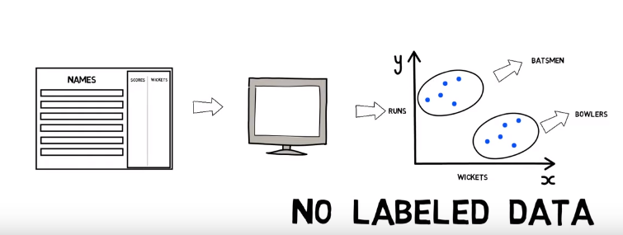
Fig 1.1: Unsupervised learning
Semi-supervised learning -The machine is trained with the dataset with both labelled and unlabeled data. Common situations for this kind of learning are medical images like CT scans or MRIs. A trained radiologist can go through and label a small subset of scans for tumors or diseases. It would be too time-intensive and costly to manually label all the scans — but the deep learning network can still benefit from the small proportion of labelled data and improve its accuracy compared to a fully unsupervised model.
Reinforcement learning –Reinforcement learning is an area of machine learning which deals with taking suitable steps to maximize the reward in the particular situation. It deals with training the machine to take the best path in specific situations. There are two types of reinforcement they are, Positive and negative. Positive Reinforcement is defined as when an event, occurs due to a particular behavior, increases the strength and the frequency of the behavior. In other words, it has a positive effect on the behavior. Negative reinforcement is defined as strengthening of behavior because a negative condition is stopped or avoided.
For example, if you want the machine to identify a picture. The picture is given as an input. If the machine identifies it wrongly then a negative feedback is given and if the machine identifies it right then positive feedback is given based on which the machine is trained to learn and identify the picture.

2. SYSTEM ANALYSIS
2.1 EXISTING SYSTEM
There are several approaches of building a recommendation system. Some of the approaches are discussed in this section.
Collaborative filtering is based on the user’s previous behavior. Predicting the preferences of the users based on the user’s previous data. The approach to collaborative is that the users who have agreed in the past tend to agree in the future hence only the user’s data history is needed for collaborative filtering. User preferences can be found by explicit ratings given to the items on 1-5 scale. Implicit rating is the user’s preferences found by their clicks, page views, purchases records and so on.
The standard method of collaborative filtering is nearest neighbor algorithm. There are two types of collaborative filtering they are:
- user-based CF
- item-based CF

In User based CF There is nxm matrix of rating, with user u_{i}, i=1,2,.n and item pj , j=1,2..m. now we want to predict the rating rij if the target user i did not watch/rate an item j. calculate the similarities between target user i and all other users, select the top X similar users, and take the weighted average of ratings from these X users with similarities as weights.

$r_{ij}=\frac{\sum_{k}{Similaries(u_{i},u_{k})r_{kj}}}{number of ratings}$ (1)

Different people have different baselines for giving ratings, some people give high score generally, some are pretty strict even though they are satisfied with items. To avoid this bias, subtract each user’s average rating from all items when computing the weighted average.

$r_{ij}=\overline{r_{i}}+\frac{\sum_{k}{Similaries(u_{i},u_{k})(r_{kj}- {\overline{r}}_{k}) }}{number of ratings}$ (2)

Calculate Pearson correlation and cosine similarity –

$Pearson Correlation:Sim\left(u_{i},u_{k}\right)= \frac{\sum_{j}{(r_{ij}- r_{i})(r_{kj}- r_{k}) }}{\sqrt{\sum_{j}{{(r_{ij}- r_{i})}^{2}} \sum_{j}{{(r_{kj}- r_{k})}^{2}}}}$ (3)

$Cosine Similarity:Sim\left(u_{i},u_{k}\right)= \frac{\sum_{j}{r_{ij}r_{kj} }}{\sqrt{\sum_{j}{{r_{ij}}^{2}} \sum_{j}{{r_{kj}}^{2}}}}$ (4)

Find the users who are similar to your target users. Weight their ratings to predict the target users rating of the particular item.

In this method if two users give similar rating to the same item then we consider that the users are similar without knowing anything about the users and items.
Item-based CF, we say two items are similar when they received similar ratings from a same user. Then, we will make prediction for a target user on an item by calculating weighted average of ratings on most X similar items from this user. One key advantage of Item-based CF is the stability which is that the ratings on a given item will not change significantly overtime, unlike the tastes of human beings. There are quite a few limitations of this method. It doesn’t handle sparsity well when no one in the neighborhood rated an item that is what you are trying to predict for target user. Also, it’s not computational efficient as the growth of the number of users and products.

Advantages of collaborative filtering –
- No domain knowledge necessary
We don't need domain knowledge because the embeddings are automatically learned.

- Serendipity
The model can help users discover new interests. In isolation, the ML system may not know the user is interested in a given item, but the model might still recommend it because similar users are interested in that item.

- Great starting point
To some extent, the system needs only the feedback matrix to train a matrix factorization model. In particular, the system doesn't need contextual features. In practice, this can be used as one of multiple candidate generators.
Disadvantages of collaborative filtering
- Complexity and expense. Collaborative filtering algorithms can run into scalability problems when the number of users and items gets too high (think in tens of millions of users and hundreds of thousands of items), especially when recommendations need to be generated in real-time online. Potential solution: This is where distributed clusters of machines running Hadoop or Spark come in handy. Depending on your project, it may also be possible to calculate relationships offline overnight by way of batch processing, which makes serving recommendations much quicker even if they’re no longer being updated in real-time.
- Data sparsity. Many user signals are ambiguous. Just watching a video doesn’t tell YouTube whether you liked that particular video or not, and just eating at a restaurant doesn’t tell Yelp whether you liked it or not. That’s why ratings are so important in collaborative-filtering systems. But users don’t rate every item they interact with, and many users don’t rate anything at all. Potential solution: Depending on the nature of the data, there may be proxy measures that can be used. Another common technique is to assume that missing reviews are equivalent to average reviews, though this is a very strong assumption in most cases.
- The “cold start” problem. As we’ve seen, collaborative-filtering can be a powerful way of recommending items based on user history, but what if there is no user history? This is called the “cold start” problem, and it can apply both to new items and to new users. Items with lots of history get recommended a lot, while those without never make it into the recommendation engine, resulting in a positive feedback loop. At the same time, new users have no history and thus the system doesn’t have any good recommendations. Potential solution: Onboarding processes can learn basic info to jump-start user preferences, importing social network contacts.
Matrix factorization uses matrix of ratings for giving recommendations. Let us consider there are 5 users A, B, C, D, E given ratings to 5 different movies M1, M2, M3, M4, M5. Put it in a matrix for example:

 | M1 | M2 | M3 | M4 | M5
A | 3 | 1 | 1 | 3 | 1
B | 1 | 2 | 4 | 1 | 3
C | 3 | 1 | 1 | 3 | 1
D | 4 | 3 | 5 | 4 | 4
Fig 2.1: matrix

In this matrix we can find that the ratings of A and C are same. Columns 1 and 4 are same. This means that movie 1 and 4 are similar movies and people gave similar ratings. We can see that adding the values of the second and third row we get the ratings of the fourth row. Maybe B loves comedy movie and C loves action movies and D loves both action and comedy movies. We can see that the column 5 is average of column 2 and 3. There are relation between columns and rows which can be explained through the attributes but some relations cannot be explained but exists within the ratings of different users. These dependencies can be used to guess the ratings of the user who has not watched or rated the particular movie.
For example, in the above matrix if C hasn’t rated M5 then we can say that the user C will most likely to give 1 as the rating to the M5 since A and C users have given similar ratings to all the movies. Using matrix factorization these kinds of dependencies can be found out. Matrix factorization is dividing the ratings matrix into simpler matrices such that the product of these matrices gives the original rating matrix. Different genres like action, comedy, drama, horror, etc. can be considered for matrix factorization. For example, consider two genres comedy and action. We figured out A likes comedy and does not like action. Let’s manage to rate how much comedy and action the movie has. A movie has rating of 3 in comedy and one in action. Since A likes action, we consider 3 of action and say that A gives rating 3 to the movie. B does not like comedy and likes action therefore B can give rating 1 to the movie. Consider D likes action and comedy then D is likely to rate the movie 3+1 that is 4.

 | C | A
A | 1 | 0
B | 0 | 1
C | 1 | 0
D | 1 | 1
Consider two matrices:
 | C | A
M1 | 3 | 1
M2 | 1 | 2
M3 | 1 | 4
M4 | 3 | 1
M5 | 1 | 3

Fig 2.2: Matrices
In the ratings matrix A has given the rating for M1 as 3 since she likes comedy and does not like action. User B likes action not comedy hence gives the movie rating as 1. For every user and movie, we can get a relation like this for the ratings given. Movie feature matrix and the user feature matrix can be used to get the ratings matrix for the users and movies. This is expressed as the product of these two matrices.
 | M1 | M2 | M3 | M4 | M5
C | 3 | 1 | 1 | 3 | 1
A | 1 | 2 | 4 | 1 | 3

 | M1 | M2 | M3 | M4 | M5
A | 3 | 1 | 1 | 3 | 1
B | 1 | 2 | 4 | 1 | 3
C | 3 | 1 | 1 | 3 | 1
D | 4 | 3 | 5 | 4 | 4
 | C | A
A | 1 | 0
B | 0 | 1
C | 1 | 0
D | 1 | 1

Fig 2.3: Product of matrix
In this we can see that B has given 4 as rating to M3. B likes action and not comedy that’s why M3 is given rating 4. This is how the matrix factorization works. Here we can see that A and C has the same preferences hence the dependencies can be found within these two matrices easily. We can see that the combination of preferences of B and C is the preference of D since B likes action and C likes comedy. D likes both action and comedy. Hence 2nd row plus 3rd row is 4th row. Dividing the matrix into smaller ones so that the feature extraction becomes easy is matrix factorization. Storage is the advantage of matrix factorization. If there is matrix of 2000 users and 1000 movies. So, there are 2 million ratings in this. This can be factorized into a matrix with 100 features and 2000 users and another matrix of 1000 movie and 100 features. The number of entries reduces to 300k entries. Dot product of these two matrices can be used to find the rating of the movie by particular user.
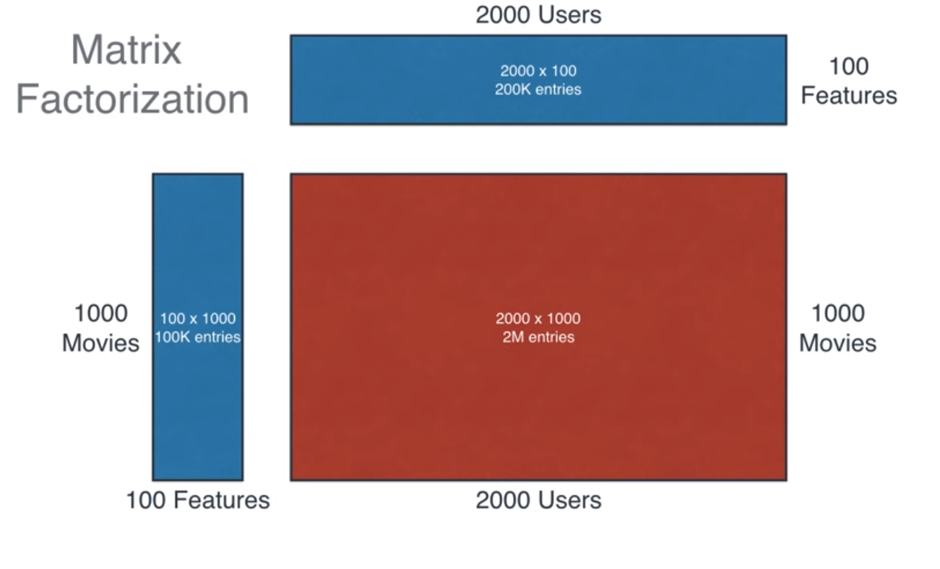
Fig 2.4: Matrix Factorization
Finding the right factorization can be done using machine learning. Gradient decent is used for matrix factorization. 2 matrices with random values is generated for user feature matrix and movie feature matrix. The dot product of these 2 matrices with random value is found. Then this matrix is compared with the original ratings matrix to find the difference. Changes are made to the two matrices to get the ratings matrix. Error function is used to find the difference between the original rating matrix and the matrix formed by the product of two matrix produced by the computer. The error found is the sum of square of the differences of each pair of entries in the matrix of the corresponding pair of entries.
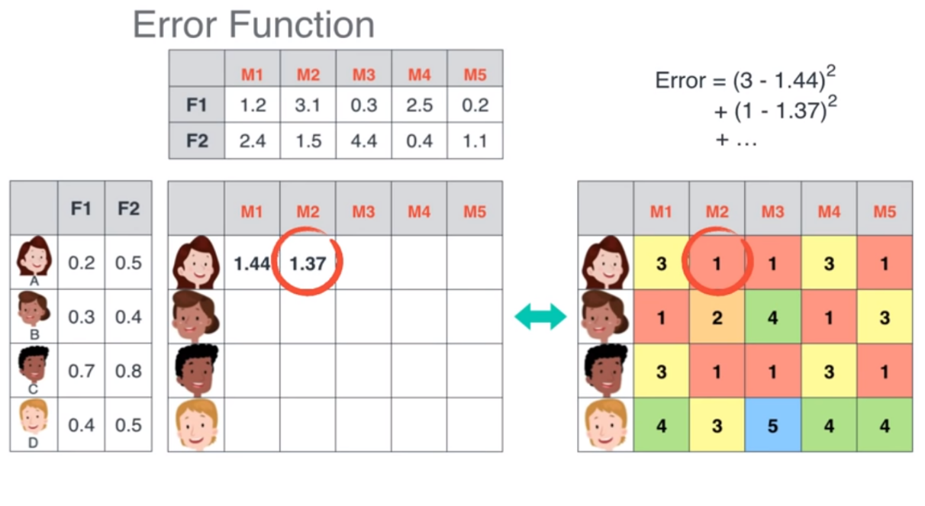
Fig 2.5: Error calculation in matrix factorization

This error is reduced by taking the derivative of the error. By this we can find the value to be added or decreased from the matrices so that the product of the two matrices is the ratings matrix. This method is called as gradient decent. This method is repeatedly applied on all the entries to split the ratings matrix into two matrix such that the product is equal to the ratings matrix. In the data set all users won’t rate all the movies hence there will be missing values in the dataset.
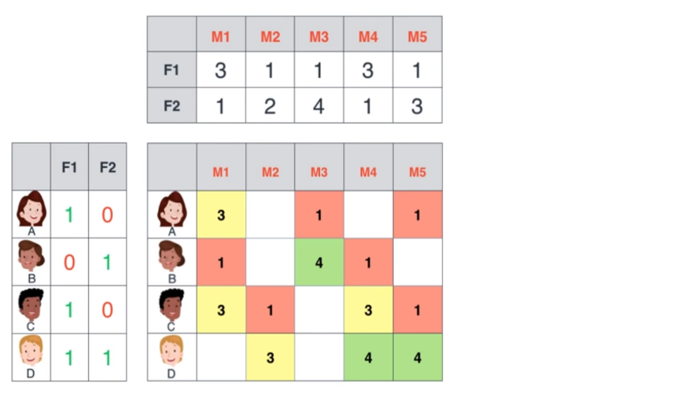
Fig 2.6: Splitting of matrix

When there are missing values that is the particular user has not rated a movie then this can be predicted using the machine learning algorithm by forming the two matrices using matrix factorization method. After predicting the possible ratings, the movie which has the highest predicted rating for the particular user is recommended to the user.
There are various matrix factorization models, some commonly used are:

The Singular Value Decomposition (SVD) is the powerful technique of dimensionality reduction. The key issue in an SVD decomposition is to find a lower dimensional feature space. SVD of an m × n matrix A is of the form: Where, U and V are m × m and n × n orthogonal matrices respectively. Σ is the m × n singular orthogonal matrix with non-negative elements. A m × m matrix U is called orthogonal if equals to an m × m identity matrix. The diagonal elements in Σ (σ1, σ2, σ3, …… σn) are called the singular values of matrix A. Usually, the singular values are placed in the descending order in Σ. The column vectors of U and V are called the left singular vectors and the right singular vectors respectively.

Advantages of matrix factorization is given below
- It’s very efficient (via Lanczos algorithm or similar it can be applied to really big matrices)
- The basis is hierarchical, ordered by relevance
- It tends to perform quite well for most data sets

Disadvantages of matrix factorization is given below
- If the data is strongly non-linear it may not work so well
- Results are not always the best for visualization
- It is difficult to interpret
- Strongly focused in variance, sometimes there’s not a direct relationship between variance and predictive power so it can discard useful information
The Principal Component Analysis (PCA) is also the powerful technique of dimensionality reduction and is a particular realization of the Matrix Factorization (MF) approach. PCA is a statistical procedure that uses an orthogonal transformation to convert a set of observations of possibly correlated variables into a set of values of linearly uncorrelated variables called principal components. The number of original variables is greater than or equal to principal components. This transformation is defined in such a way that a linear projection of high dimensional data into a lower dimensional subspace such as the variance retained is maximized and the least square reconstruction error is minimized. The principal components are orthogonal because they are the eigenvectors of the covariance matrix. PCA is sensitive to the relative scaling of the original variables. PCA allows to obtain an ordered list of components that account for the largest amount of the variance from the data in terms of least square errors. The amount of variance captured by the first component is larger than the amount of variance on the second component and so on. We can reduce the dimensionality of the data by neglecting those components.
Advantages of PCA are given below.
- It’s very efficient (via Lanczos algorithm or similar it can be applied to really big matrices)
- The basis is hierarchical, ordered by relevance
- It tends to perform quite well for most data sets

Disadvantages of PCA are given below.
- If the data is strongly non-linear it may not work so well
- Results are not always the best for visualization
- It is difficult to interpret
- Strongly focused in variance, sometimes there’s not a direct relationship between variance and predictive power so it can discard useful information
The Probabilistic Matrix Factorization (PMF) is a probabilistic linear model with Gaussian observation noise. The user preference matrix is represented as the product of tow lower-rank user and item matrices in Probabilistic Matrix Factorization (PMF). Suppose we have N users and M movies. Let Rij be the rating value of user i for movie j, Ui and Vj represent D-dimensional user-specific and movie specific latent feature vectors respectively. Then the conditional distribution over the observed ratings R∈ and the prior distributions over U∈ R^{DxM} and V∈ R^{DxM} are given by:

$p\left(R | U,V,σ^{2}\right)= \prod_{i=1}^{N}{\prod_{j=1}^{M}{{[N\left(R_{ij} | U_{i}^{T}V_{i}σ^{2}\right)]}^{I_{ij}}}}$ (5)

$p\left(U | σ_{u}^{2}\right)= \prod_{j=1}^{M}{N(U_{i}|0,σ_{u}^{2}I)}$ (6)

$p\left(V | σ_{v}^{2}\right)= \prod_{j=1}^{M}{N(V_{j}|0,σ_{v}^{2}I)}$ (7)

Where $N(x|μ,σ^{2})$, denotes the Gaussian distribution with mean μ and variance Iij is the indicator variable that is equal to 1 if user i rated movie j and equal to 0 otherwise.
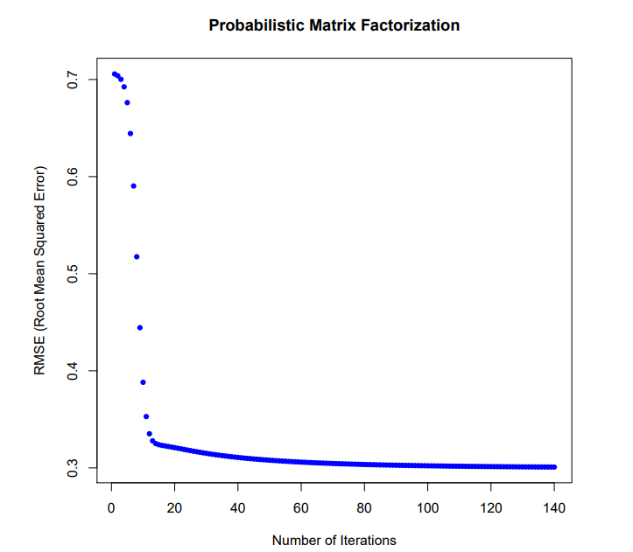
Fig 2.4: RMSE for probabilistic matrix factorization
RMSE on test data on the optimized U and V matrices for the normalized ratings is 0.588912961491.

hybrid system based on content and collaborative filtering uses the opinions of the users, similar users and the content of the movies which are watched by the users to give the recommendations to the users. Neural networks are used. The data is split into training, validation and test set. training the network is based on the movies that are watched and evaluated by the users [1].
Java parser and URLs provided in MovieLens is used to extract the synopsis of each movie. Content of the movie and preferences of similar users is taken into consideration for giving recommendation. Directors, script writers and actors are taken into account.
the data set consists of three main matrices with the characteristic features of each film: Kinds (19 kinds x 1682 films), Stars (4416 persons x 1682 films) and Synopsis (8595 terms x 1682 films).
For each user three neural network is constructed based on three movie features.

Disadvantages are mentioned below.
- The cold-start problem is encountered when a new item is added and it has no evaluations.
- If the number of users is actually small, the quality is low.
- All films cannot be taken into consideration since there will be infinite choices.
Advantage of the system is that the success rate per user is 80%. 4 out of 5 films are successfully recommended using this system.

Cuckoo search algorithm for recommender systems was developed by Rahul Katarya and Om Prakash Verma. in this recommendation Cuckoo search algorithm has been applied to the output of clustering k-means algorithm to give recommendations to the users. [2]
K-means –
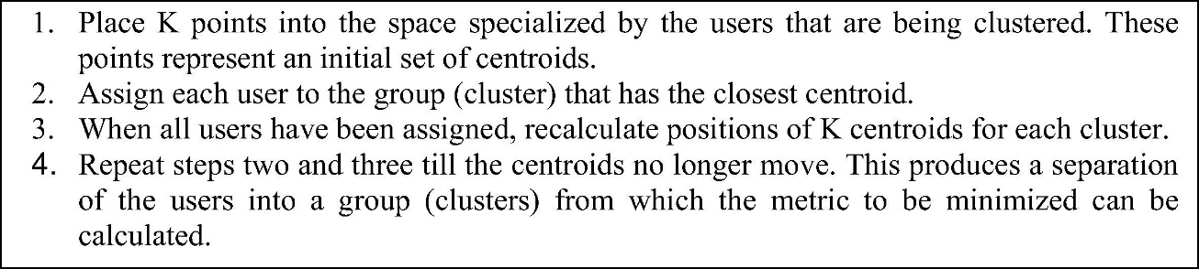

Cuckoo search optimization is applied to the results of k-means for the optimization of results.
Cuckoo search algorithm was inspired by the obligate brood parasitism of some cuckoo species by laying their eggs in the nests of other host birds (of other species). Some host birds can engage direct conflict with the intruding cuckoos. For example, if a host bird discovers the eggs are not their own, it will either throw these alien eggs away or simply abandon its nest and build a new nest elsewhere. Some cuckoo species such as the New World brood-parasitic Tapera have evolved in such a way that female parasitic cuckoos are often very specialized in the mimicry in colours and pattern of the eggs of a few chosen host species. Cuckoo search idealized such breeding behaviour, and thus can be applied for various optimization problems.
Each egg in a nest represents a solution, and a cuckoo egg represents a new solution. The aim is to use the new and potentially better solutions (cuckoos) to replace a not-so-good solution in the nests. In the simplest form, each nest has one egg. The algorithm can be extended to more complicated cases in which each nest has multiple eggs representing a set of solutions.
CS is based on three idealized rules:
1. Each cuckoo lay one egg at a time, and dumps its egg in a randomly chosen nest;
2. The best nests with high quality of eggs will carry over to the next generation;
3. The number of available hosts nests is fixed, and the egg laid by a cuckoo is discovered the host bird with a probability . Discovering operate on some set of worst nests, and discovered solutions dumped from farther calculations.
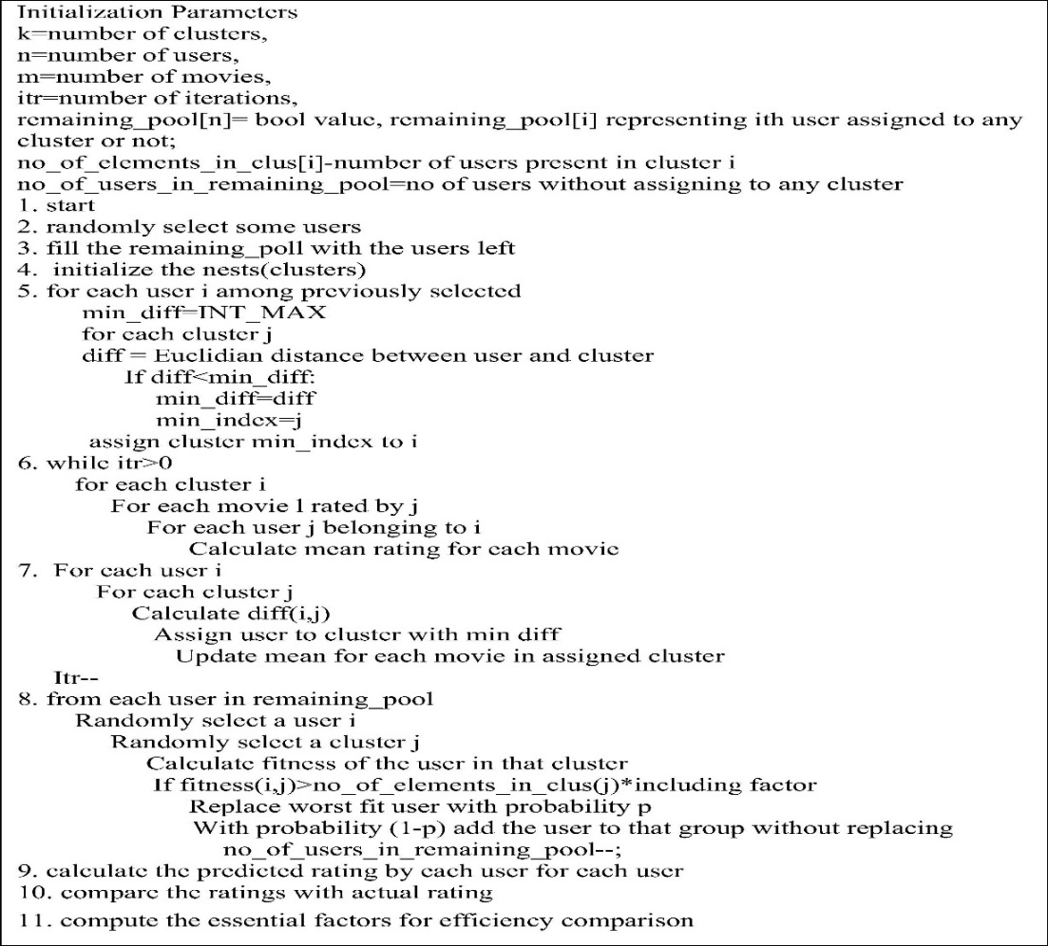
Fig 2.5: Cuckoo search algorithm
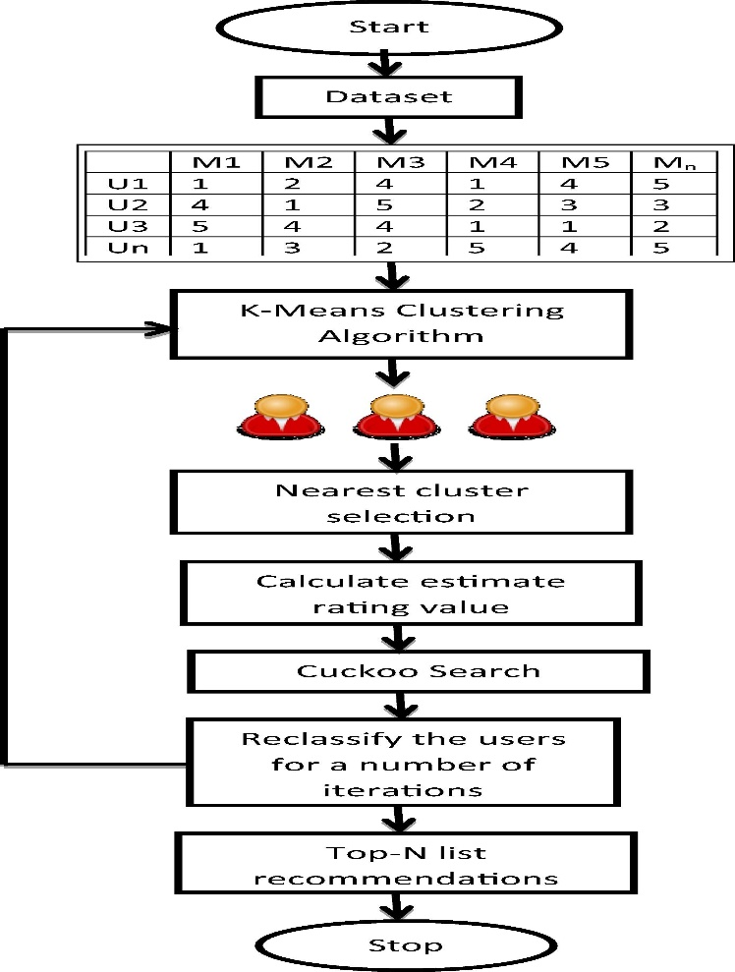
Fig 2.6: Cuckoo search recommendation system architecture
Comparison of cuckoo search algorithm with genetic algorithm and particle swarm optimization for various standard test functions. After implementing these algorithms using MATLAB, we have carried out extensive simulations and each algorithm has been run at least 100 times so as to carry out meaningful statistical analysis. The algorithms stop when the variations of function values are less than a given tolerance ϵ ≤ 10−5. The results are summarized in the following tables (see Tables 1 and 2) where the global optima are reached. The numbers are in the format: average number of evaluations (success rate), so 927±105(100%) means that the average number (mean) of function evaluations is 927 with a standard deviation of 105. The success rate of ﬁnding the global optima for this algorithm is 100%.

Table 2.1: Comparison of CS with GA
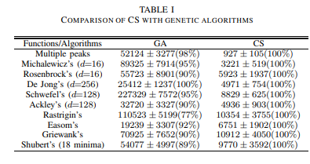
Table 2.2: Comparison of CS with PSO
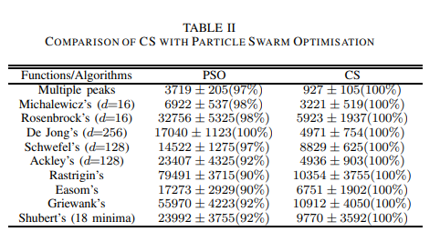
The Cuckoo Search is much more efficient in finding the global optima with higher success rates. From the above two tables we can conclude that cuckoo search algorithm has outperformed both genetic algorithm and particle swarm optimization algorithm.
Genetic algorithm for recommender systems is another type of recommendation system. Genetic algorithm considers the users as chromosomes. Each chromosome consists of number of genes which is used to determine the likelihood of reproduction for the next generation. Chromosomes with fittest value are more likely to reproduce. Genetic algorithm iteratively creates new population replace of old ones by selecting solutions on the basis of prespecified fitness function. Three operations are executed to construct the new generation known as selection, crossover and mutation. Selection process selects the proportion of current population to breed new generation according to fitness values. Crossover operator allows swapping the portion of two parent chromosomes for each other to be recombined into new offspring. Mutation operator randomly alters the value of gene to produce offspring. All operators provide the means to extend the diversity of population over time and bring new information to it. Iterations tend to terminate when the fitness threshold is met or a predefined number of generations is reached.
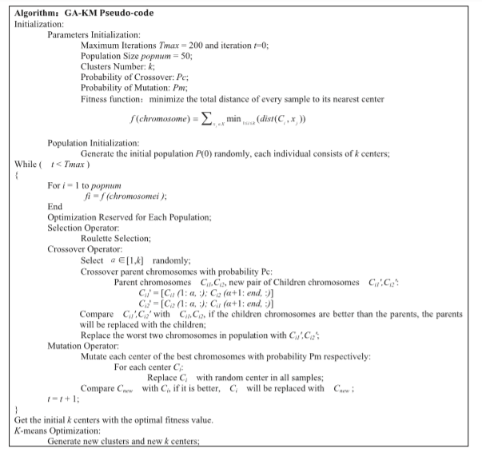
Fig 2.7: GA algorithm

Advantages of the system is mentioned below.
Movie recommendations are made based on like-minded people with similar interest. Filtering is done based on the sentiment of users which increases the accuracy in recommendation.

Artificial immune system for recommendation system. artificial immune system algorithm gives solution to the optimization problem. AIS clustering and collaborative filtering methods is used for recommender system. Artificial immune system algorithm is derived from the mechanism where biological immune system fights against foreign pathogens. By using the adaptive immune response, this algorithm can be used to search for the best solution of an optimization problem. It can also be used to cluster or classify data for a problem. Immune network theory is first proposed by Jerne in 1974. He suggested that in a real immune system, when a biological organism encountered an invasion from outside pathogens, the biological organism would develop its own protective agents known as antigen. Immune system would produce antibodies to combine with antigens to fight off pathogens as an immune response. This process from the immune system suggests a good approach in finding the best solution for an optimization problem. The antigen would be our objective function and the antibody is the solution to our problem. We would focus on our antigen and search for an antibody that can combine with it to be our solution for the problem.
Flowchart for AIS algorithm
- Step1: Generate initial antibodies. These antibodies can be seen as the initial solution for the evolutionary algorithm.
- Step2: Identify antigens. This step is used to simulate the situation when a body is invaded by foreign pathogens. In AIS algorithm, we just read in unidentified data to complete this step.
- Step3: Calculate affinity. When the antibodies are trying to identify the antigens, the binding between the antibody and antigen has to be determined.
- Step4: Adjust antibodies. Select good antibodies for adjustment.
- Step5: Generate new antibodies. Copy the adjusted antibodies to create new antibodies and add them into the antibodies’ pool.
- Step6: Check termination condition. If the stop condition is met, go to Step7. Otherwise, go back to Step2.
- Step7: Finish the algorithm. [4]
This research focuses on applying AIS algorithm to cluster MovieLens data. In the training phase, MovieLens data is defined as antigens and Pearson correlation coefficient is used to assess the affinity between antigens and antibodies to find the relation between the data for clustering. In the testing phase, the collaborative filtering method is applied on the data cluster to predict a rating for the movie. In the following, we explain our AIS clustering and collaborative filtering algorithm for movie rating evaluation. In this research, every single data is treated as antigen and antibody. The affinity between the data is calculated for clustering.
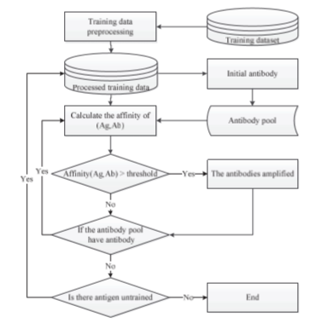
Fig 2.8: AIS recommendation system

user based collaborative filtering with Graph database. py2neo library in python working with neo4j is used for building the recommendation system. Collaborative filtering with Graph database is used. Movies are recommended based on node and edge. Neo4j is an open source NoSQL graph database implemented by Java, which realizes the storage of graph data model at the professional database level. Compared with common graphics processing and memory level databases, neo4j provides complete database features, including ACID transaction support, cluster support, backup and failover, and so on. In addition, the use of Neo4j only needs to understand the Cypher similar to the SQL language, and does not need to delve into the profound theoretical knowledge of graph theory. What’s more, using neo4j can be developed with many existing class libraries. This movie recommender system is developed with Python language.
The system default shows to movies with an average score of the top 50. The larger the radius of the node, the higher the recommendation. For movies with different averages, different colours are used to distinguish them. [5]

Jointly Modeling Aspects, Ratings and Sentiments for Movie Recommendation (JMARS) model provides a principled extension of the factorization models commonly used for recommendation. That is, we retain the notion that reviews are generated by incorporating user and movie speciﬁc features. However, unlike simple vectorial rating models, we use a structured representation to capture the interaction between movie and user. In this sense our model borrows from the tensorial factorization approach of and it extends it from scalars to documents. More speciﬁcally, we assume that each user (and each movie) has an aspect distribution of interest. Reviews are generated by drawing from the product of movie and user aspects. For instance, a review text will likely contain details about special eﬀects, but only if the user is actually interested in them and if the movie has special eﬀects worth discussing. Hence, reviews inform both about the content of a movie and also about the interests of a user. This diﬀerentiation allows us to attribute partial scores to interests, i.e. we assume that the review scores arise from the process of combining partial scores associated with diﬀerent aspects of the movie. Not only does this improve rating accuracy, it also allows us to attach sentiments to aspects. In other words, we can model which terms associate with positive, negative, and neutral aspect speciﬁc words within an aspect. We model the following ﬁve groups of words:

Background That is, words uniformly distributed in every review are considered background words. For example, in the case of movie reviews, these words include “characters”, “movies”, etc.

Movie-speciﬁc Words such as the name of the characters in a movie, or any term that appears only in the movie are considered movie-speciﬁc. These two types of words provide less information about movie quality.

Aspect These are words associated with speciﬁc aspects. For example, “music”, “sound”, and “singing” are all aspect words related to the “music” aspect.

Aspect-Sentiment These words usually come with a speciﬁc aspect to express positive or negative sentiments. For example, words such as “bored”, “predictable” usually appear with a discussion of the “plot”.

General sentiment for example, words such as “great”, “bad”, or “worse” do not really convey any aspect speciﬁc content. We call them general sentiment words

Disadvantages of the system is mentioned below.
Method fails if the user gives low rating and gives positive feedback regarding the movie in the reviews. [6]

Movie swarm mining method generate swarms based on the genre is used by the research article written by Sajal Halder, A. M. Jehad Sarkar and Young-koo lee to create a recommendation system.
Let Udb = {u1, u2, ..., un} be the set of all users
Tdb = {t1, t2, ..., tm} be the set of all timestamps in the database
Gdb = {g1,g2,...,gp} be the set of all movie genres
Idb = {i1,i2,...,iq} be the set of all movie items.
A subset of Udb is called a user set U. A subset of Tdb is called time set T, a subset of Gdb is called movie genres set G and a subset of Idb is called movie Items set I.
The number of user set, time set, movie genres set and movie item set indicate |U|, |T|, |G| and |I| respectively. Before describing more details, we have deﬁned a set of terms. Deﬁnition 1. Short Time Movie Swarm (STMS): A swarm set (U,t,g) is said to be a short time movie swarm if all users in U ⊆ Udb enjoy movie genres g ∈ Gdb at timestamps t ∈ Tdb.
Deﬁnition2. Long Time Movie Swarm (LTMS): A swarm set (U,T,G) is said to be a long time movie swarm if all users in U ⊆ Udb enjoy movie genres G ∈ Gdb at timestamps T ∈ Tdb, where |T|≥mint(minimum threshold). To avoid mining redundant long time movie swarms, we further give the deﬁnition of long time movie close swarm as follows:
Deﬁnition 3. Long Time Movie Closed Swarm (LTMCS): A long time movie swarm (U,T,G) is called long time movie closed swarm if there are no T` , U` where T ⊂ T` and U ⊂ U` for particular genres Gp ⊆ Gdb and (U`,T`,Gp) is long time movie swarm.
Deﬁnition 4. Interesting Movie (IM) : A movie item i ∈ Idb is said to be interesting movie if a short time swarm (U,t,i) enjoy the item i at time stamps t where |U|≥minim u and the average rating of this movie avgr(i) >rim
Deﬁnition 5. Popular Movie (PM) : A movie item i ∈ Idb is said to be popular movie if a short time swarm (U,t,i) enjoy the item i at time stamps t where |U|≥minpm u and the average rating of this movie avgr(i) >rpm .
Deﬁnition 6. Interesting Popular Movie (IPM) : A movie item i ∈ Idb is said to be interesting popular movie if a short time swarm (U,t,i) enjoy the item i at time stamps t where |U|≥minpm u and the average rating of this movie avgr(i) >rim.

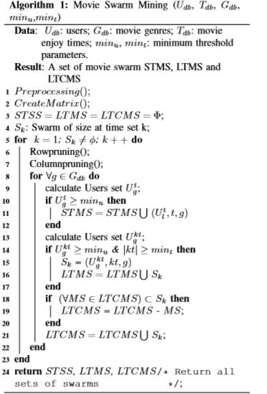
Fig:2.9 Movie Swarm mining 1

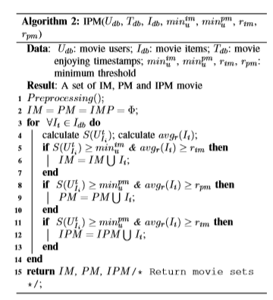
Fig 2.10: Movie Swarm mining 2
[7]

Collaborative filtering with particle swarm optimization is used to build recommendation system. Particle swarm optimization (PSO) was inspired by the social behavior as it is an evolutionary computation technique. In PSO, the possible resolutions called particles, fly around in a multidimensional search space, to determine an optimal, or sub optimal, answer by competition as well as support for themselves. The system primarily has a population of random responses. The individual particle is given a random velocity and is drifted through the d-dimensional problem space. The position or location(xid) and velocity(vid) of every particle in dimension d is revised based on its previous velocity, the previous best particle location (pid or pbest), and the previous global best location or position of a particle in the population (pgd orgbest).The key approach of PSO lies in accelerating each particle towards its pbest and gbest locations at each time step. The authorized velocity and position of ith particle are given

$v_{id}=w* v_{id}+ c_{1}*rand1* {(p}_{id}- x_{id})+ c_{2}* rand2 (p_{gd}- x_{id})$ (8)

$x_{id}= x_{id}+v_{id}$ (9)

w denotes the inertia weight factor and is usually set to a value in the range of 0.5–1. pid is the location of the particle that understands the best fitness value. pgd is the position of the particles that involve a global best fitness value. c1 and c2 are constants recognized as social acceleration coefficients. d signifies the aspect of the problem space. rand1, rand 2 are random values in the scope of (0, 1), which ensures wide search through problem space. The inertia weight factor w delivers the essential diversity to the swarm by altering the momentum of particles to escape the stagnation of particles at the local optima. Equation5 needs each particle to record its existing coordinate xid. The velocity vid specifies the speed of its movement sideways the dimensions in a problem space, and the coordinates pid and pgd. Where the best fitness values were computed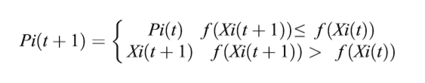 (10)
symbol f represents the fitness function; Pi (t) stands for the finest fitness values and the coordination where the significance was calculated. t denotes the generation step. Finally, PSO algorithm can be outlined as a) Initialize every particle in the population pool within the search space of initial velocities; b) Calculate the fitness value of each of these particles. c) If this value is better than its best fitness value recorded until this time, which is also called as population best (pid), then set the current value as the new pid. d) The global best (pgd) is selected from the candidates, which is the best fitness value of all of them in the pool. This is updated in every iteration after this comparison as the new pgd. e) Calculate the particle velocity. Refresh the particle position according to Eq. 3. g) Carry out stages b to e until minimum error criteria are attained. The fuzzy c-means algorithm is a clustering algorithm where each item may belong to two or more clusters, not just one. Here, the degree of membership is considered for each item which is given by a probability distribution over the clusters. Fuzzy c-means (FCM) is a clustering algorithm that is useful when an item’s similarity matches with more than one cluster, and we do not want just to consider but various other clusters too. FCM is different in the sense that it does not decide the entire membership of a data point to a given group; instead, it calculates the likelihood (the degree of membership). Since there is no absolute membership in one cluster but the various percentage of membership in different clusters, FCM can be extremely fast. This is because high accurateness can be achieved with a large number of iterations with this clustering method. FCM is grounded on minimization of the following objective function:
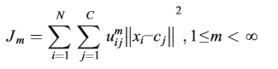(11)
Where m is some real number larger than 1, uij is the degree of association of xi in the cluster j. xi is the ith of d-dimensional dignified data, cj is the d-dimension center of the cluster. ||*|| is somewhat norm expressing the similarity between any measured data and the centre. Fuzzy partitioning is supported out by an iterative optimization of the objective function mentioned above, with the apprise of membership uij and the cluster centres cj by:
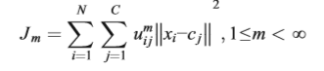(12)
Where m is some real number larger than 1, uij is the degree of association of xi in the cluster j. xi is the ith of d-dimensional dignified data, cj is the d-dimension center of the cluster. ||*|| is somewhat norm expressing the similarity between any measured data and the center. Fuzzy partitioning is supported out by an iterative optimization of the objective function mentioned above, with the apprise of membership uij and the cluster centers cj by:
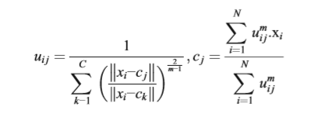(13)

Particle swarm optimization application for the movie:
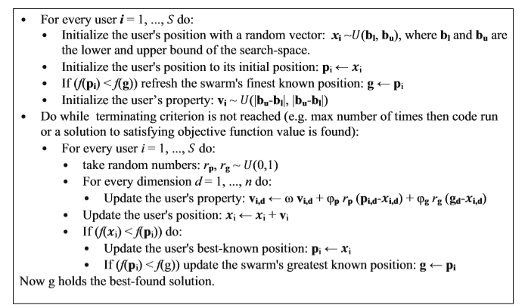[8]
Fig 2.11: PSO recommendation system
2.2 PROPOSED SYSTEM
User profile consists of rating information. The items can be represented using some features (genres). User profiles are formed by extracting the ratings and the genre of the movie for which the user has rated. The genre is converted into 0 and 1.
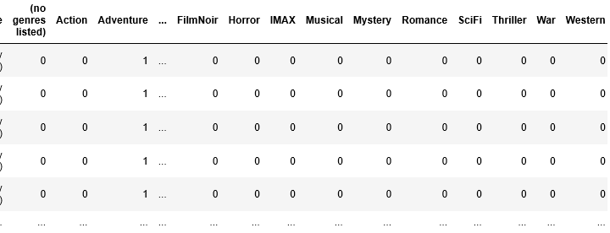
The genre interestingness measure is calculated by the following formula:
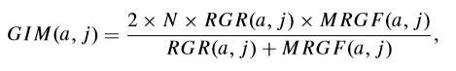
Code:
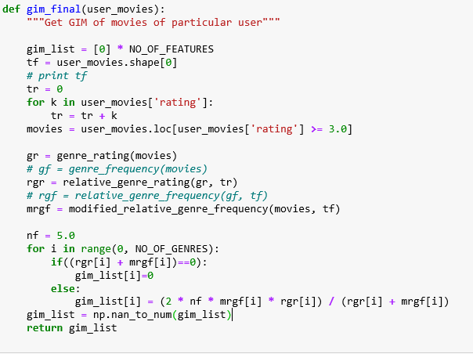

MRGF is modiﬁed relative genre frequencyof genre Gjfor user ua which is expressed as:

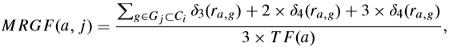
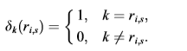
Code:
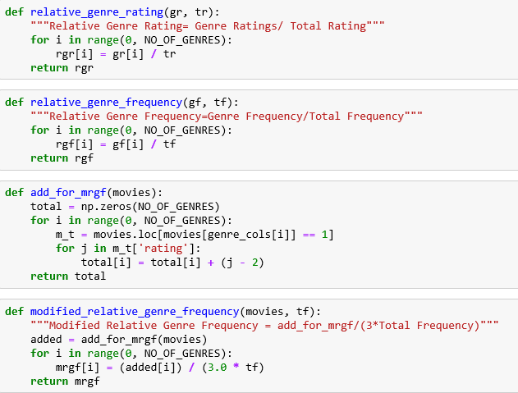

RGR (relative genre rating) is the ratio of ui’s ratings for high rated items of Gj to her total ratings, which is computed by formula:
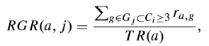

GIM can be represented more naturally by linguistic variables using six fuzzy sets namely very bad (VB), bad (B), average (AV), good (G), very good (VG), and excellent (E).
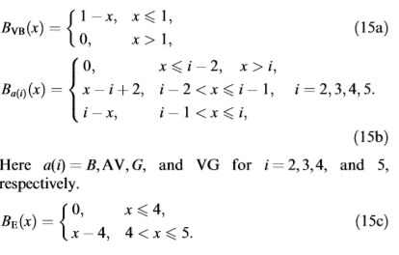
Code:
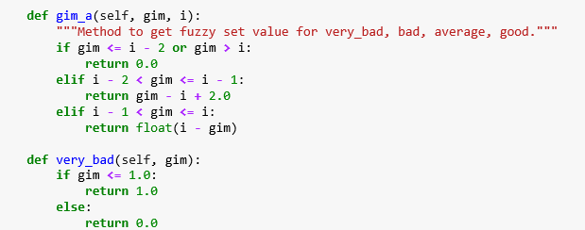
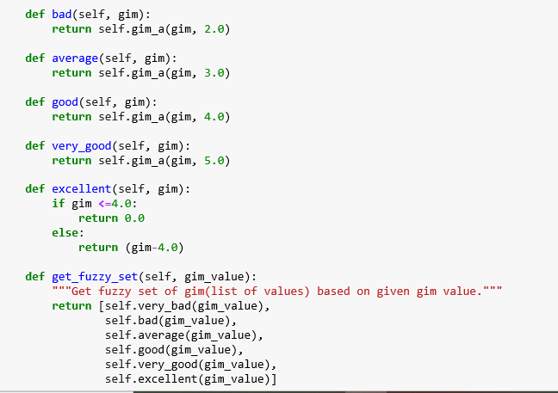
For performing CF it is required to compute similarity between users, as our proﬁle is based on the fuzzy sets so we have used the following formula, the local fuzzy distance between u and v is deﬁned as:
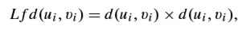
where d(ui,v i) is simply the difference operator, u and v are vectors of size m, andd(ui,vi) is any vector distance metric. In all of our experiments,the Euclidean distance functions used for d(ui,vi)
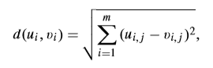
where m is the total number of fuzzy sets for the ith feature, and ui,j is the membership value of the ith feature in the jth fuzzy set. The global fuzzy distance is computed by the Euclidean distance formula:
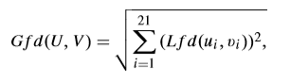
In this formula features are equally weighted but it does not reﬂect the real life scenario where every user places different priorities on different features. The modiﬁed formula to compute the similarity between two users is as follows:
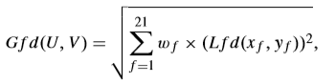

Code:
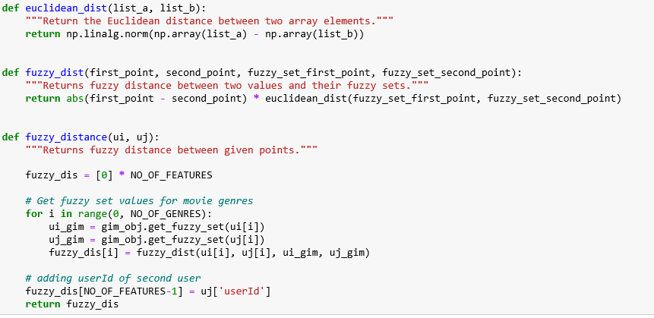
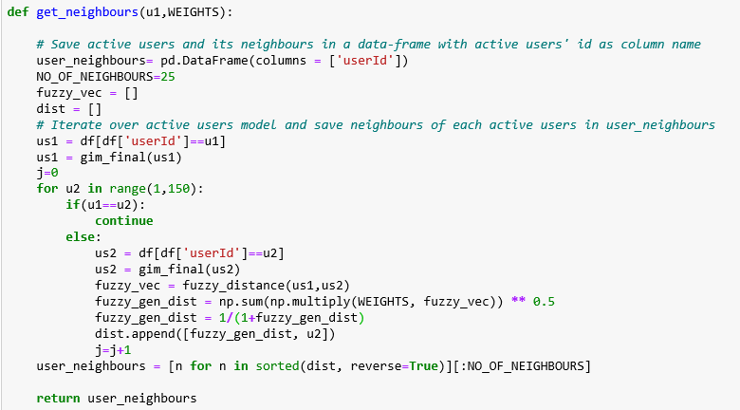

Once k neighbours are found, several approaches can be used to combine the ratings of neighbours to compute a prediction value on unseen items for the active user. After predicting how an active user will like speciﬁc items which have not been rated yet by the active user, the top-N item set, a set of ordered items with a higher predicted value, is identiﬁed and recommended. The predicted rating, p of item i of a user u is computed by the following formula:
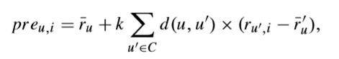
Code:
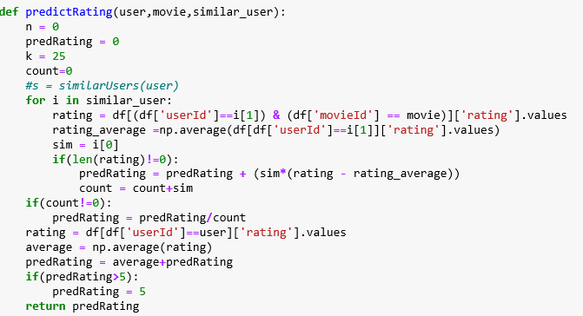
We PSO to learn these weights in our proposed approach FPSO-CF. The necessary components of a PSO algorithm incorporated in our approach are as follows:
A conventional PSO algorithm is used to learn the 21 feature weights, each feature weight is represented by 8-bit binary digits and the value of weight is ranging from 0 to 255. In PSO every particle is associated with its position and velocity. We have kept 10 as a population size containing 10 particles.
Fitness function:
The root mean square error of the ratings predicted for a particular user is used as the fitness function for finding the weights.
Particles move all over the search space by a simple set of equations. The algorithm updates the entire swarm at each time stamp by updating the velocity and position of each particle in every dimension by the following rules:
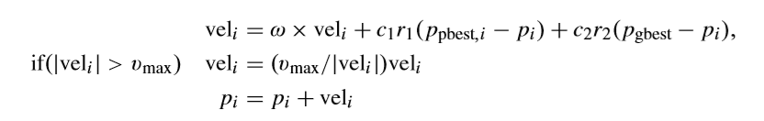

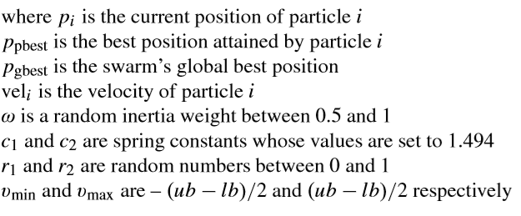
2.3. CPU BASED COMPUTING
CPU executes the instructions of the program. It performs operations given by the instruction. CPU has control unit, processing unit, main memory and I/O circuitry.
Arithmetic and logic unit performs arithmetic and logic operations is the principle component of CPU. Processor registers supply operands to the ALU and store the results of ALU operations. Control unit that orchestrates the fetching (from memory) and execution of instructions by directing the coordinated operations of the ALU, registers and other components. CPU can handle multiple tasks.

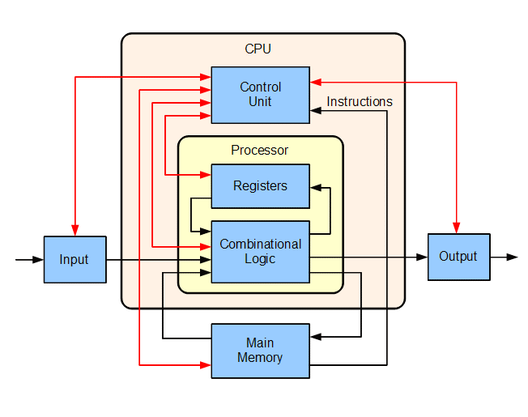
Fig 2.12: CPU architecture
2.4. NEED FOR GPU BASED COMPUTING AND TENSOR FLOW
Central Processing Units (CPUs) have evolved from their initial origins as single core to more intricate multi-core processors. CPUs have been used to run a wide variety of applications because of their design. As the demand for more applications grew, Graphic Processing Units (GPUs) were introduced to offload the processing of displaying graphical data. GPUs evolved and were used for general purpose computing because of their massively parallel computational features. New workloads have been defined in computing using both CPUs and GPUs together for complex and computational work. High performance computing and scalability of applications demanded full advantage of multi-core CPUs and many-core GPUs functionalities. New approaches to solving high performance computing included parallel computing for application scalability and performance. CPUs and GPUs impacted application scalability and processing by working in tandem.

CPU has few processing units with some cache and control units, but in GPU there are many more processing units with their own cache and control units with dedicated and specific works defined for them. GPUs are mostly with hundreds of cores which work in parallel to process the data, but in general CPUs processing is done on few cores with very little parallelism. The architectural comparison of CPU with GPU is more suitable for stream computations. They can process data elements in parallel with SIMD & MIMD capability. So a new technique called GPGPU(General Purpose computation on GPU) emerged and in recent years has become a hot research topic in not only graphics domain but also in general computations.
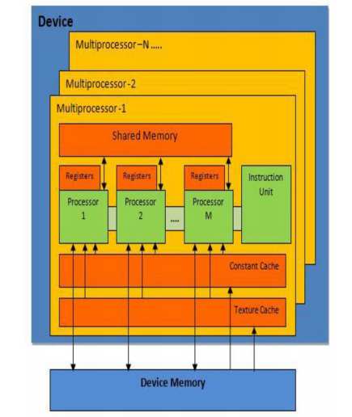

Fig 2.12: GPU based computing
Tensor flow is the deep learning library. It is an open source library for fast numerical computing.
It was created and is maintained by Google and released under the Apache 2.0 open source license. The API is nominally for the Python programming language, although there is access to the underlying C++ API.
Unlike other numerical libraries intended for use in Deep Learning like Theano, TensorFlow was designed for use both in research and development and in production systems, not least RankBrain in Google search and the fun DeepDream project.
It can run on single CPU systems, GPUs as well as mobile devices and large scale distributed systems of hundreds of machines.
Tensor flow architecture works in three parts:
- Pre-processing the data
- Build the model
- Train and estimate the model
Computations are specified and these computations are accomplished by computational graph. Computational graph takes multidimensional matrix called tensors and does computations on them. Each node in graph denotes an operation. When creating the graph, you have the possibility to explicitly specify where the computations should be done, on the GPU or CPU. By default, it will check if a GPU is available, and use that. Graph is run in session. Operations to be performed is specified in the run function.

3. SYSTEM DESIGN
3.1 SYSTEM ARCHITECTURE
Fig 3.1 represents the system architecture of the recommendation system which is built using particle swarm optimization.
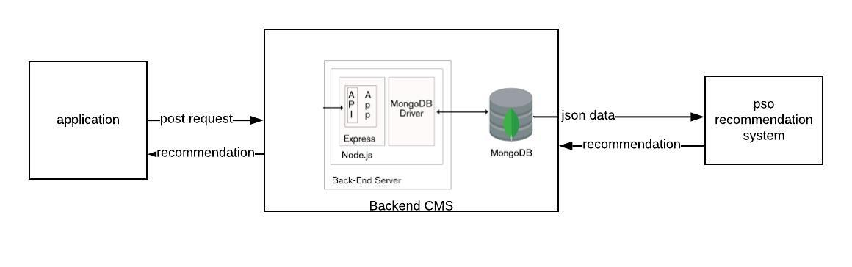
Fig 3.1: System architecture
The Fig:3.1 represents the system architecture of the built recommendation system. The website asks the users to register. The information of the registered users is stored in the mongodb in the document called users. When the user registers to the system a post request is made using the express framework in node js and mongoose is used to store the data in the mongodb. The information of the movies that are rated by the particular user is sent to the recommendation system through mongodb. The recommendation system gives recommendations to the particular user based on the data. The recommendations in json format is stored in mongodb and shown to the user.

3.2 SWIMLANE DIAGRAM
Fig 3.2 is the swim lane diagram for the recommendation system.
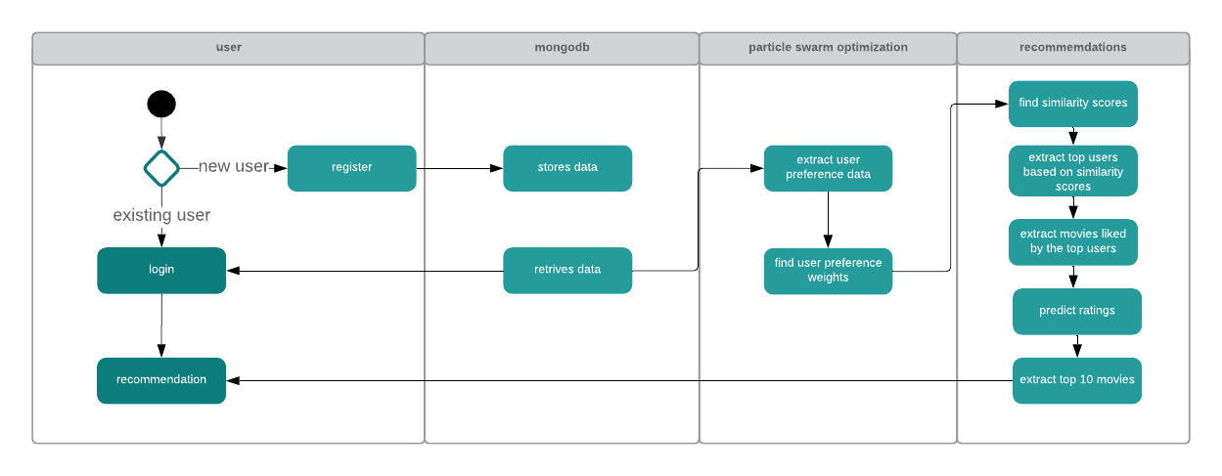
Fig 3.2: Swim lane diagram
The Fig:3.2 shows the working of the recommendation system. The website asks the users to register. If the user is already registered then the user is asked to login to the system. The user data is stored during the registration and the movies that are rated by the user is stored in the database. The user preference data is extracted then the similarity scores for the users is found to get the top neighbors for the user who is active. Then top users are extracted based on the similarity scores and the movies that are given higher rating by the similar users is extracted then the prediction is made. Top 10 predicted movies are recommended to the user.

4. IMPLEMENTATION
4.1 PROGRAMMING LANGUAGE
Python is a high-level language released in 1991 created by Guido van Rossum. It is simple and easy to understand. Python is interpreted and object oriented. Syntax is readable and reduce the cost of maintenance. Modules and packages make the python language reusable. It is dynamically typed and there is no need to declare anything.
map() function returns a list of the results after applying the given function to each item of a given iterable (list, tuple etc.)
def keyword is used to define the normal functions and the lambda keyword is used to create anonymous functions.
The filter() function in Python takes in a function and a list as arguments. This offers an elegant way to filter out all the elements of a sequence “sequence”, for which the function returns True.
The reduce() function in Python takes in a function and a list as argument. The function is called with a lambda function and a list and a new reduced result is returned. This performs a repetitive operation over the pairs of the list.
4.1.1 PANDAS –
Pandas is python library used for data analysis. It takes data and creates a python object with rows and columns. This object is called as data frame. Python 3.5.3 and above is required for the installation of pandas library. The library’s name derives from panel data, a common term for multidimensional data sets encountered in statistics and econometrics.
Pandas deals with the following three data structures.
- Series
- DataFrame
- Panel
Series can be created using ndarray, dict and scalar. Index label can be used to get or set values of the series.
Pandas dataframe is a 2D structure aligned in rows and columns. Columns can be added or deleted from the dataframe. It can be created using
- Lists
- dict
- Series
- Numpy ndarrays
- Another DataFrame
A panel is a 3D container of data. The term Panel data is derived from econometrics and is partially responsible for the name pandas − pan(el)-da(ta)-s.
The names for the 3 axes are intended to give some semantic meaning to describing operations involving panel data. They are −
- items − axis 0, each item corresponds to a DataFrame contained inside.
- major_axis − axis 1, it is the index (rows) of each of the DataFrames.
- minor_axis − axis 2, it is the columns of each of the DataFrames.
4.1.2 NUMPY
Numpy is the library in python programming language for scientific computation. It supports multi-dimensional array and matrices with the help of high-level mathematical functions which are written in this library. It is a scientific computation package written in python and contains many things like:
1. Powerful N-dimensional array object.
2. Broadcasting functions.
3. Tools for integrating C/C++ and Fortran code.
4. Useful for computing linear algebra, Fourier transform, and random number capabilities.
Arrays in NumPy: NumPy’s main object is the homogeneous multidimensional array.
- It is a table of elements (usually numbers), all of the same type, indexed by a tuple of positive integers.
- In NumPy dimensions are called axes. The number of axes is rank.
- NumPy’s array class is called ndarray. It is also known by the alias array.

Array creation: There are various ways to create arrays in NumPy.
- For example, you can create an array from a regular Python list or tuple using the array function. The type of the resulting array is deduced from the type of the elements in the sequences.
- Often, the elements of an array are originally unknown, but its size is known. Hence, NumPy offers several functions to create arrays with initial placeholder content. These minimize the necessity of growing arrays, an expensive operation.
For example: np.zeros, np.ones, np.full, np.empty, etc.
- To create sequences of numbers, NumPy provides a function analogous to range that returns arrays instead of lists.
- arange: returns evenly spaced values within a given interval. step size is specified.
- linspace: returns evenly spaced values within a given interval. num no. of elements are returned.
- Reshaping array: We can use reshape method to reshape an array. Consider an array with shape (a1, a2, a3, …, aN). We can reshape and convert it into another array with shape (b1, b2, b3, …, bM). The only required condition is:
a1 x a2 x a3 … x aN = b1 x b2 x b3 … x bM . (i.e original size of array remains unchanged.)
- Flatten array: We can use flatten method to get a copy of array collapsed into one dimension. It accepts order argument. Default value is ‘C’ (for row-major order). Use ‘F’ for column major order.

Array Indexing: Knowing the basics of array indexing is important for analysing and manipulating the array object. NumPy offers many ways to do array indexing.
Slicing: Just like lists in python, NumPy arrays can be sliced. As arrays can be multidimensional, you need to specify a slice for each dimension of the array.

Integer array indexing: In this method, lists are passed for indexing for each dimension. One to one mapping of corresponding elements is done to construct a new arbitrary array.

Boolean array indexing: This method is used when we want to pick elements from array which satisfy some condition.

Basic operations: Plethora of built-in arithmetic functions are provided in NumPy.

Operations on single array: We can use overloaded arithmetic operators to do element-wise operation on array to create a new array. In case of +=, -=, *= operators, the existing array is modified.
Unary operators: Many unary operations are provided as a method of ndarray class. This includes sum, min, max, etc. These functions can also be applied row-wise or column-wise by setting an axis parameter.

Binary operators: These operations apply on array elementwise and a new array is created. You can use all basic arithmetic operators like +, -, /, , etc. In case of +=, -=, = operators, the exsisting array is modified.

Universal functions (ufunc): NumPy provides familiar mathematical functions such as sin, cos, exp, etc. These functions also operate elementwise on an array, producing an array as output.

Sorting array: There is a simple np.sort method for sorting NumPy arrays.
Datatypes in numpy are given below.

Table 2.3: Datatypes in numpy
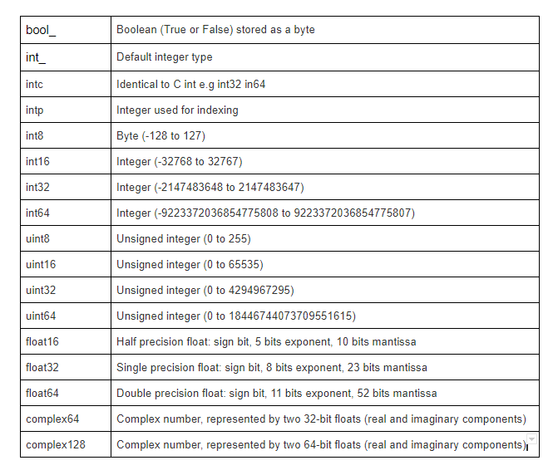
4.1.3 SCIPY
SciPy, a scientific library for Python is an open source, BSD-licensed library for mathematics, science and engineering. The SciPy library depends on NumPy, which provides convenient and fast N-dimensional array manipulation. The main reason for building the SciPy library is that, it should work with NumPy arrays. It provides many user-friendly and efficient numerical practices such as routines for numerical integration and optimization.
SciPy is organized into sub-packages covering different scientific computing domains. These are summarized in the following table
Table 2.4: Scipy packages
scipy.cluster | Vector quantization / Kmeans
scipy.constants | Physical and mathematical constants
scipy.fftpack | Fourier transform
scipy.integrate | Integration routines
scipy.interpolate | Interpolation
scipy.io | Data input and output
scipy.linalg | Linear algebra routines
scipy.ndimage | n-dimensional image package
scipy.odr | Orthogonal distance regression
scipy.optimize | Optimization
scipy.signal | Signal processing
scipy.sparse | Sparse matrices
scipy.spatial | Spatial data structures and algorithms
scipy.special | Any special mathematical functions
scipy.stats | Statistics

4.2 FRAMEWORK FOR MACHINE LEARNING
4.2.1 SCIKIT LEARN
Scikit is a machine learning library for python which can be used for various machine learning algorithms like support vector machine, random forests, and k-neighbours, and it also supports libraries like numpy and scipy.
train_test_split() is used to split the data set into test and train samples.
accuracy_score() is used to compare the accuracy of the algorithms.
LabelEncoder() is used to convert categorical values into numerical labels.
fit_transform() function takes user defined labels as input and then returns encoded labels.
GaussianNB method can be used to apply naïve-Bayes algorithm.
LinearSVC is subclass of SVM class. It tries to divide the 2D space into classes.
random_state is an instruction to the built-in random number generator to shuffle the data in a specific order.
KNeighborsClassifier class can be used to implement k-nearest neighbours classifier algorithm.
ClassificationReport class provided by the Yellowbrick library can be used to visual report of how models perform.

4.2.2 TENSORFLOW
TensorFlow is a Python library for fast numerical computing created and released by Google. It is a foundation library that can be used to create Deep Learning models directly or by using wrapper libraries that simplify the process built on top of TensorFlow.
- Nodes: Nodes perform computation and have zero or more inputs and outputs. Data that moves between nodes are known as tensors, which are multi-dimensional arrays of real values.

- Edges: The graph defines the flow of data, branching, looping and updates to state. Special edges can be used to synchronize behaviour within the graph, for example waiting for computation on a number of inputs to complete.

- Operation: An operation is a named abstract computation which can take input attributes and produce output attributes. For example, you could define an add or multiply operation.

Its flexible architecture allows for the easy deployment of computation across a variety of platforms (CPUs, GPUs, TPUs), and from desktops to clusters of servers to mobile and edge devices. It is mainly used for: classification, perception, understanding, discovering, prediction and creation.
Main use cases of tensor flow are
1. Voice/Sound recognition
Neural networks are able to understand audio signal and
- Voice recognition – mostly used in IoT, Automotive, Security and UX/UI
- Voice search – mostly used in Telecoms, Handset Manufacturers
- Sentiment Analysis – mostly used in CRM
- Flaw Detection (engine noise) – mostly used in Automotive and Aviation
2. text-based applications
popular uses of TensorFlow are, text based applications such as sentimental analysis (CRM, Social Media), Threat Detection (Social Media, Government) and Fraud Detection (Insurance, Finance)
3. Image processing
Mostly used by Social Media, Telecom and Handset Manufacturers; Face Recognition, Image Search, Motion Detection, Machine Vision and Photo Clustering can be used also in Automotive, Aviation and Healthcare Industries. Image Recognition aims to recognize and identify people and objects in images as well as understanding the content and context.

4. Time series
TensorFlow Time Series algorithms are used for analysing time series data in order to extract meaningful statistics. They allow forecasting non-specific time periods in addition to generate alternative versions of the time series.
5. Video Detection
TensorFlow neural networks also work on video data. This is mainly used in Motion Detection, Real-Time Thread Detection in Gaming, Security, Airports and UX/UI fields. Recently, Universities are working on Large scale Video Classification datasets like YouTube-8M aiming to accelerate research on large-scale video understanding, representation learning, noisy data modelling, transfer learning, and domain adaptation approaches for video.
4.2.3 KERAS –
Keras is a high-lebel neural networks API, written in python and capable or running on top of TensorFlow, CNTK, or Theano. It was developed with a focus on enabling fast experimentation.
Keras contains numerous implementations of commonly used neural-network building blocks such as layers, objectives, activation functions, optimizers, and a host of tools to make working with image and text data easier to simplify the coding necessary for writing Deep Neural Network code.
Keras was developed and maintained by François Chollet, a Google engineer using four guiding principles:
- Modularity: A model can be understood as a sequence or a graph alone. All the concerns of a deep learning model are discrete components that can be combined in arbitrary ways.
- Minimalism: The library provides just enough to achieve an outcome, no frills and maximizing readability.
- Extensibility: New components are intentionally easy to add and use within the framework, intended for researchers to trial and explore new ideas.
- Python: No separate model files with custom file formats. Everything is native Python.

We can summarize the construction of deep learning models in Keras as follows:
- Define your model. Create a sequence and add layers.
- Compile your model. Specify loss functions and optimizers.
- Fit your model. Execute the model using data.
- Make predictions. Use the model to generate predictions on new data.

4.2.4 PYTORCH
PyTorch is a python-based library built to provide flexibility as a deep learning development platform. The workflow of PyTorch is as close as you can get to python’s scientific computing library – numpy. Pytorch gives more than 200+ mathematical operations that can be used.
- Easy to use API – It is as simple as python can be.
- Python support – As mentioned above, PyTorch smoothly integrates with the python data science stack. It is so similar to numpy that you might not even notice the difference.
- Dynamic computation graphs – Instead of predefined graphs with specific functionalities, PyTorch provides a framework for us to build computational graphs as we go, and even change them during runtime. This is valuable for situations where we don’t know how much memory is going to be required for creating a neural network.
Tensors are nothing but multidimensional arrays. Tensors in PyTorch are similar to numpy’s ndarrays, with the addition being that Tensors can also be used on a GPU.
Torch.optim is used to implement various optimization algorithms.
4.3. THE ADVENT OF IPYTHON AND NOTEBOOKS
The notebook extends the console-based approach to interactive computing in a qualitatively new direction, providing a web-based application suitable for capturing the whole computation process: developing, documenting, and executing code, as well as communicating the results. The IPython notebook combines two components:
A web application: a browser-based tool for interactive authoring of documents which combine explanatory text, mathematics, computations and their rich media output.
Notebook documents: a representation of all content visible in the web application, including inputs and outputs of the computations, explanatory text, mathematics, images, and rich media representations of objects.
Notebook documents contains the inputs and outputs of an interactive session as well as additional text that accompanies the code but is not meant for execution. In this way, notebook files can serve as a complete computational record of a session, interleaving executable code with explanatory text, mathematics, and rich representations of resulting objects. These documents are internally JSON files and are saved with the .ipynb extension. Since JSON is a plain text format, they can be version-controlled and shared with colleagues.
Notebooks may be exported to a range of static formats, including HTML (for example, for blog posts), reStructuredText, LaTeX, PDF, and slide shows, via the new nbconvert command.
Furthermore, any .ipynb notebook document available from a public URL can be shared via the IPython Notebook Viewer (nbviewer). This service loads the notebook document from the URL and renders it as a static web page. The results may thus be shared with a colleague, or as a public blog post, without other users needing to install IPython themselves. In effect, nbviewer is simply nbconvert as a web service, so you can do your own static conversions with nbconvert, without relying on nbviewer.
Jupyter Notebook (formerly IPython Notebooks) is a web-based interactive computational environment for creating Jupyter notebook documents. The "notebook" term can colloquially make reference to many different entities, mainly the Jupyter web application, Jupyter Python web server, or Jupyter document format depending on context. A Jupyter Notebook document is a JSON document, following a versioned schema, and containing an ordered list of input/output cells which can contain code, text (using Markdown), mathematics, plots and rich media, usually ending with the ".ipynb" extension.
A Jupyter Notebook can be converted to a number of open standard output formats (HTML, presentation slides, LaTeX, PDF, ReStructuredText, Markdown, Python) through "Download As" in the web interface, via the nbconvert library or "jupyter nbconvert" command line interface in a shell.
To simplify visualisation of Jupyter notebook documents on the web, the nbconvert library is provided as a service through NbViewer which can take a URL to any publicly available notebook document, convert it to HTML on the fly and display it to the user.
Jupyter Notebook interface
Jupyter Notebook provides a browser-based REPL built upon a number of popular open-source libraries:
- IPython
- ØMQ
- Tornado (web server)
- jQuery
- Bootstrap (front-end framework)
- MathJax
Jupyter Notebook can connect to many kernels to allow programming in many languages. By default, Jupyter Notebook ships with the IPython kernel. As of the 2.3 release (October 2014), there are currently 49 Jupyter-compatible kernels for many programming languages, including Python, R, Julia and Haskell.
The Notebook interface was added to IPython in the 0.12 release (December 2011), renamed to Jupyter notebook in 2015 (IPython 4.0 – Jupyter 1.0). Jupyter Notebook is similar to the notebook interface of other programs such as Maple, Mathematica, and SageMath, a computational interface style that originated with Mathematica in the 1980s. According to The Atlantic, Jupyter interest overtook the popularity of the Mathematica notebook interface in early 2018.

Jupyter kernels
A Jupyter kernel is a program responsible for handling various types of request (code execution, code completions, inspection), and providing a reply. Kernels talk to the other components of Jupyter using ZeroMQ over the network, and thus can be on the same or remote machines. Unlike many other Notebook-like interfaces, in Jupyter, kernels are not aware that they are attached to a specific document, and can be connected to many clients at once. Usually kernels allow execution of only a single language, but there are a couple of exceptions.
By default, Jupyter ships with IPython as a default kernel and a reference implementation via the ipykernel wrapper. Kernels for many languages having varying quality and features are available.

JupyterHub
JupyterHub is a multi-user server for Jupyter Notebooks. It is designed to support many users by spawning, managing, and proxying many singular Jupyter Notebook servers. While JupyterHub requires managing servers, third-party services like Jupyo provide an alternative to JupyterHub by hosting and managing multi-user Jupyter notebooks in the cloud.

JupyterLab
JupyterLab is the next-generation user interface for Project Jupyter. It offers all the familiar building blocks of the classic Jupyter Notebook (notebook, terminal, text editor, file browser, rich outputs, etc.) in a flexible and powerful user interface. The first stable release was announced on February 20, 2018.

Industry adoption
The Jupyter Notebook has become a popular user interface for cloud computing, and major cloud providers have adopted the Jupyter Notebook or derivative tools as a frontend interface for cloud users. Examples include Amazon's SageMaker Notebooks, Google's Colaboratory and Microsoft's Azure Notebook.
4.4 SOURCE CODE
def euclidean(u1,u2,weights):
s = pd.merge(df[df['userId']==u1], df[df['userId']==u2], how="inner", on="movieId")
sum1 = 0
similarity=0
w1 = weights[0]
w2 = weights[1]
w3 = weights[2]
w4 = weights[3]
w5 = weights[4]
w6 = weights[5]
w7 = weights[6]
w8 = weights[7]
w9 = weights[8]
w10 = weights[9]
w11 = weights[10]
w12 = weights[11]
w13 = weights[12]
w14 = weights[13]
w15 = weights[14]
w16 = weights[15]
w17 = weights[16]
w18 = weights[17]
w19 = weights[18]
w20 = weights[19]

for index, row in s.iterrows():

tempvar = (w1*((row.rating_x - row.rating_y)**2) + \
w2*((row.Action_x - row.Action_y)**2) + \
w3*((row.Adventure_x - row.Adventure_y)**2) + \
w4*((row.Animation_x - row.Animation_y)**2) + \
w5*((row.Children_x - row.Children_y)**2) + \
w6*((row.Comedy_x - row.Comedy_y)**2) + \
w7*((row.Crime_x - row.Crime_y)**2) + \
w8*((row.Documentary_x - row.Documentary_y)**2) + \
w9*((row.Drama_x - row.Drama_y)**2) + \
w10*((row.Fantasy_x - row.Fantasy_y)**2) + \
w11*((row.SciFi_x-row.SciFi_y)**2) + \
w12*((row.Horror_x - row.Horror_y)**2) + \
w13*((row.IMAX_x - row.IMAX_y)**2) + \
w14*((row.Musical_x - row.Musical_y)**2) + \
w15*((row.Mystery_x - row.Mystery_y)**2) + \
w16*((row.Romance_x - row.Romance_y)**2) + \
w17*((row.FilmNoir_x-row.FilmNoir_y)**2) + \
w18*((row.Thriller_x - row.Thriller_y)**2) + \
w19*((row.War_x - row.War_y)**2) + \
w20*((row.Western_x - row.Western_y)**2)
)
tempvar = max(0, tempvar)
tempvar = math.sqrt(tempvar)
sum1 += tempvar
distance = sum1/s.shape[0]
similarity = 1/(1+distance)
return similarity
def similarUsers(user,user_weight_dict):
k = 25
sim_scores = []
for i in df.userId.unique():
s = euclidean(user, i, user_weight_dict)
#s = correlation(user,i)
#s = euclidean_similarity(user,i)
sim_scores.append(s)
simusers = {'users':df.userId.unique(), 'similarity_score':sim_scores}
simusers = pd.DataFrame(simusers)
simusers = simusers.nlargest(k, 'similarity_score')
return simusers
def predictRating(user,movie,similar_user):
n = 0
predRating = 0
k = 25
#s = similarUsers(user)
for i in similar_user['users']:
rating = df[(df['userId']==i) & (df['movieId'] == movie)]['rating'].values
sim = similar_user[similar_user['users']==i]['similarity_score'].values
if(len(rating)!=0):
predRating = predRating + (rating * sim)
predRating = predRating/k
rating = df[df['userId']==user]['rating'].values
average = np.average(rating)
predRating = average+predRating
if(predRating>5):
predRating = 5
return predRating
def getTopMovies1(user,similar_user):
top_movies = []
#s = similarUsers(testUser)
for i in similar_user['users']:
if i == user:
continue
movies = df[(df['userId']==i) & (df['rating']>4)]['movieId'].values
for j in movies:
if j not in top_movies:
top_movies.append(j)
return top_movies
def recommendation1(testUser,similar_user):
mo = []
p = []
u = []
m = getTopMovies1(testUser,similar_user)
pr = 50
if(len(m)<50):
pr = len(m)
for j in range(0,pr):
predRating = predictRating(testUser,m[j],similar_user)
mo.append(m[j])
u.append(testUser)
if np.isscalar(predRating):
p.append(predRating)
else:
p.append(predRating[0])
d = {'userId':u,'movieId':mo, 'predicted rating': p}
df_u = pd.DataFrame(d)
df_u = df_u.nlargest(50, 'predicted rating')
return df_u

5. APPROACHES OF TESTING THE ACCURACY OF MODEL
Different approaches like F1 score testing, A/B testing, mean absolute error (MAE) are used to test the accuracy of the machine learning model built for recommendation system. There are 4 parameters that are used to find the precision of the model they are:
True positive - these are correctly predicted positive values. Actual class tells that the customer watched the movie which is recommended and the model also tells the same thing.
True negative – these are correctly predicted negative values. Actual class tells that the movie recommended by the system is not watched by the customer and the model also tells the same thing.
False positive – actual class has negative value but the model wrongly predicts a positive value. The movies recommended by the system is not watched by the user but the model predicts that the movie recommended by the system is watched by the user.
False negative – actual class has positive value but the model wrongly predicts a negative value. The movies recommended by the system is watched by the user but the model predicts that the movie is not watched.
Accuracy – accuracy is the ratio of correctly predicted values by the total observations. accuracy is a great measure but only when you have symmetric datasets where values of false positive and false negatives are almost same.
Precision – it is the ratio of correctly predicted positive values that is the true positive to the total predicted positive values. That is
$precision=\frac{true positive}{true positive+false positive}$ (13)
Recall – it is the ratio of the correctly predicted positive values to the total of all the positive observations in the data.
$Recall=\frac{true positive}{true positive+false negative}$ (14)
F1 score – it is the weighted average of precision and recall. F1 score takes both false positives and false negatives into account.
$f1 score=2*\frac{Recall*Precision}{Recall+Precision}$ (15)

A/B testing is used to compare two or more versions. It gives an overview of whether the difference between the two versions is statistically significant. The two different webpages or newsletters can be compared using this test. Which color button is better? hypothesis should be defined to conduct the test that is what is the possible outcome of changing the version from A to B. maybe you are hoping to increase the open rate, newsletter sign-ups. Criteria for success should be defined before conducting the test. For example, the movies recommended by the model is watched by the customers. The traffic is split into two. You need to figure out what is the minimum number of people to run A/B test to achieve statistically significant results. This can be used to update the recommendations given to the users. Before conducting A/B test A/A test should be conducted to make sure A/B test is conducted properly.
In A/B test the traffic is divided into two parts, group A and group B. Group A is routed into the old model and group B is routed into the new model. Performance is compared and decision is made on whether the new model performs better than the old model or not. Statistical hypothesis testing makes the testing more precise.
A/B tests are formulated to answer the question, “Does this new model lead to a statistically significant change in the key metric?” The null hypothesis is often “the new model doesn’t change the average value of the key metric,” and the alternative hypothesis “the new model changes the average value of the key metric.” The test for the average value (the population mean, in statistical speak) is the most common, but there are tests for other population parameters as well.
Briefly, A/B testing involves the following steps:
1. Split into randomized control/experimentation groups. 2. Observe behaviour of both groups on the proposed methods. 3. Compute test statistics. 4. Compute p-value. 5. Output decision.
A/A test is used to find out if the data is messy or randomization of data is not conducted correctly or if something is broken. It is used for validation of set up. It is conducted to compare the identical experience on different set of users. The same experiment is conducted on two random set of users. If there is different data for different users for the same experience then there is something wrong. For example, if two groups of people get the same medication. If it is same experiment and metric is different then there is something wrong.

5.1 TESTS AND RESULTS
F1-score and root mean square error has been calculated for the recommendation system. Sci-kit learn provides f1 score for conducting f1 score testing for the accuracy of recommendation system. This gives the accuracy rate of 0.9924 which tells that the recommendations given to the user using particle swarm optimization technique is 99% accurate.
Root mean square error –
It’s the square root of the average of squared differences between prediction and actual observation.
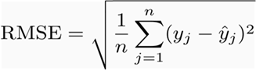 (16)

Root mean square for the recommendation is 0.5580212333393456
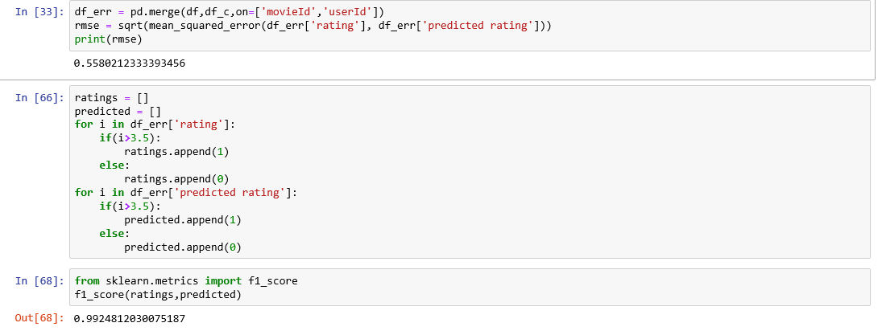
Fig: 5.1: Model accuracy
6. CONCLUSION
This work has shown how particle swarm optimization can be employed to fine-tune a profile-matching algorithm within a recommender system, tailoring it to the preferences of individual users. particle swarm optimization is run for each user for finding the set of weights which describes the user’s preferences. These weights are multiplied to Euclidean distance to find the similar users to the active user. Since the weights for genres for each user is considered the error in predicting the ratings is reduces significantly.
Since the built system runs on CPU, large amount of time is required for giving the recommendations.
In future the recommendation system will be enhanced to run on GPU. Keras and tensorflow are the machine learning libraries which can be used to run on GPU. These libraries will be used to build the recommendation system so that it runs faster for huge dataset.

References
- C. Christakou and A. Stafylopatis, "A hybrid movie recommender system based on neural networks," 5th International Conference on Intelligent Systems Design and Applications (ISDA'05), Warsaw, 2005,

- Katarya, Rahul & Verma, Om. “An effective collaborative movie recommender system with cuckoo search.”, Egyptian Informatics Journal, Volume 18, 2018

- A. D. Chang, J. Liao, P. Chang, C. Teng and M. Chen, "Application of artificial immune systems combines collaborative filtering in movie recommendation system," 18th International Conference on Computer Supported Cooperative Work in Design (CSCWD), Hsinchu, 2014

- N. Yi, C. Li, X. Feng and M. Shi, "Design and Implementation of Movie Recommender System Based on Graph Database," 14th Web Information Systems and Applications Conference (WISA), Liuzhou, 2017

- Diao, Qiming & Qiu, Minghui & Wu, Chao-Yuan & Smola, Alexander & Jiang, Jing & Wang, Chong., “Jointly modeling aspects, ratings and sentiments for movie recommendation (JMARS)”. Proceedings of the ACM SIGKDD International Conference on Knowledge Discovery and Data Mining, 2014

- S. Halder, A. M. J. Sarkar and Y. Lee, "Movie Recommendation System Based on Movie Swarm,", Second International Conference on Cloud and Green Computing, 2012

- X. Yang and Suash Deb, "Cuckoo Search via Lévy flights,", World Congress on Nature & Biologically Inspired Computing (NaBIC), Coimbatore, 2009,

