version | author | topics
0.1 | Ranjitha Rajashekara | - Introduction  - Artificial intelligence and machine leaning  - approaches/techniques for recommendation systems  - approaches of testing the algorithms/models for accuracy

TABLE OF CONTENTS
- Let's articulate the problem - "One line problem"
  - Introduction
    - What is OTT and what are the famous player out there - Netflix, Zee5, AltBalaji etc
    - What is a Recommendation System and how does it work for OTT and VOD Content and where it is used - business use cases - Recommending products in Amazon FireTV, Netflix, Zee5, Alt Balaji etc.
    - Refine the problem statement and talk about it briefly here
      - What is a CMS for OTT and How do you want to build a recommendation system to power the CMS to recommend VOD Content
    - AI / ML in Recommendation Systems
- A brief introduction into AI, ML and Types of Learning - Supervised, Semi-Supervised, Unsupervised, Reinforcement learning
- Let's look at various approaches/techniques for recommendation systems
  - Supervised, Deep Learning, NN etc
- Let's look at the approaches of testing the algorithms/models for accuracy
  - What is the final level of accuracy desired?
- Let's finalize the approach that we are going to perform for the recommendation system
  - Data Sources and Publicly Available Data Sources: Kaggle, Fast.ai etc. (SM to provide and RR also to Investigate)
  - Define Datasets
  - Data Analysis / EDA or Exploratory Data Analysis
  - Data Preparation
  - Building an AI Model
  - Testing the Model for Accuracy
  - Deploying and Productionizing the Model
- Let's talk about the technology used to develop these algorithms
  - CPU based computing
  - The need for GPU based computing and Tensor Flow
  - Programming Language
    - What is Python most sought after PL for Data and ML
      - Python
      - Pandas
      - NumPy
      - SciPy
    - The advent of IPython and Notebooks
      - IPython
      - Jupyter Notebooks
  - Framework for Machine Learning
    - Scikit Learn
    - TensorFlow
    - Keras
    - PyTorch
- Design of the Recommendation System
  - Recommendation System Architecture
  - High Level Flows - Data Flow / Control Flow
  - Interactions with different components of the system
- Code
- Tests and Results
- Conclusion

Recommendation system for OTT CMS for VOD content
- Introduction –

1.1 What is OTT?
OTT stands for “Over the top” video services to deliver the video contents to the users through internet. It is used for distributing the media contents like audio, video through internet. It is not only used for distributing video contents but also for billing management, customer support, subscription, editorial, marketing, social media and operations. OTT is the primary platforms for content delivery in applications like Netflix, itunes, HBO, amazon etc. OTT has become a replacement for the traditional TV services. Video content management system (CMS) is for managing the video content and organising it. CMS makes it easier to handle and organize the video content. The recommendation system is built for the video content so that it is easier for the users to get the content in which they are interested in and to increase the revenue of the company.

1.2 what is recommender system?
Since there is lot of content that is available on internet there is a problem of information overload. That is the users are not able to find the items in which they are interested in. Recommendation system gives product suggestions to the users for which there is a greater probability of buying. recommendation system is used to show the content to the users based on their likes and dislikes. The users can find the products they are interested to buy which helps the users to get best experience and also increases the business of the company. Recommendations are given based on the users likes and dislikes which is analysed through the implicit and explicit ratings given by the users. Implicit ratings refer to the ratings which is given indirectly by the user that is the data collected through the behaviour of the users like the clicks, views, purchase details and explicit ratings refer to the ratings gives directly like 5- star ratings, like or dislike etc.

1.3 Business use cases for recommender system
Recommendation system helps the companies to increase ROI. Companies like amazon, Netflix use recommendation systems to increase the revenue of the company. The website changes based on the interest of the customers. 35% of the revenue in amazon website is generated by the recommendation system. 2/3rd of the revenue generated by the Netflix website is through recommendation system. Google news has increased click-throughs by 38% by using recommendation systems. [1] If the Netflix user does not find the item in which they are interested within 60 to 90 seconds then the user loses interest. Several recommendation algorithms are combined in Netflix to give the recommendations to the users. Some of the algorithms used in Netflix recommender systems are personalized video ranker algorithm, top-N video ranker algorithm, continue ranker algorithm is a video ranker algorithm used by Netflix. [2] hence if the recommendation is not given to user based on their interest then there are chances that the user might stop using the particular website. YouTube uses RS to give recommendations to the users. Item to item collaborative filtering and search-based recommendation algorithms are used to give recommendations in amazon. [3] Zee5 has taken OTT services to more than 190 countries. It is the first Indian company to do it. [4]

1.4 what is CMS?
CMS is the software behind the websites and manages the content on the website. CMS reduces time and complexity required to manage the video library. It is used to make the changes in metadata, make quickly import or upload multiple videos and organize content. Top online CMS are WordPress, Drupal, Joomla and Moodle. CMS provides cloud storage to upload video repository. It helps to store multiple videos and also share the videos. It is used to organise and manage the videos. Uploading and sharing videos is simple by using CMS.

1.5 AI/ML in recommender systems
Recommender systems are of two types they are content based recommendation system and recommender system based on collaborative filtering. Collaborative filtering finds similar users or similar items to give recommendation to the users. Content based systems use the comments of the users and users’ profiles to find the users likes and dislikes to give recommendations. Hybrid recommender system uses both content-based and collaborative filtering methods to give the recommendation to the users. Basic K-means clustering algorithm can be used to give recommendations. By using the artificial intelligence in recommender systems gives appropriate recommendations based on the specific users. Lot of research is going on in the field of recommender systems using artificial intelligence and machine learning. Different methods like collaborative filtering with cuckoo search, collaborative recommendation system with computational intelligence, artificial immune system, recommender systems based on graph database etc are used to build recommender systems.

- BRIEF INTRODUCTION TO ARTIFICIAL INTELLIGENCE AND MACHINE LEARNING
Artificial intelligence deals with creating systems that performs tasks which require human intelligence like reasoning, learning and problem solving. Artificial intelligence is applied in gaming, natural language processing, expert systems, vision systems, speech recognition, hand writing recognition etc. machine learning and deep learning are the subsets of artificial intelligence. machine learning deals with creating systems that have ability to learn without being explicitly programmed. It is the application of artificial intelligence.
Machine learning algorithms is categorised into three types. They are: supervised machine learning algorithms, unsupervised machine learning and reinforcement learning.

Supervised learning –
In supervised learning algorithms the machine is trained using the labelled data. That is the data which is already tagged with correct answers. When the new examples are given the algorithm analyses the training data and gives correct output.
For example –
Suppose you want to train the machine to identify the letters. Then you train the machine learning model with the dataset of all letters to identify the particular letter.

Unsupervised learning –
Unsupervised learning is the training of machine using information that is neither classified nor labelled and allowing the algorithm to act on that information without guidance. Here the task of machine is to group unsorted information according to similarities, patterns and differences without any prior training of data.
There is a dataset with names of players, wickets taken and score of the player. Machine can identify the batsmen and bowlers based on the scores and the wickets taken.

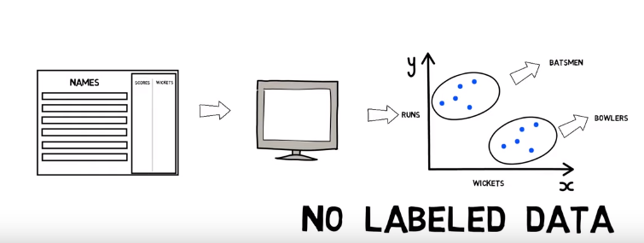

Semi-supervised learning –
The machine is trained with the dataset with both labelled and unlabelled data. Common situations for this kind of learning are medical images like CT scans or MRIs. A trained radiologist can go through and label a small subset of scans for tumours or diseases. It would be too time-intensive and costly to manually label all the scans — but the deep learning network can still benefit from the small proportion of labelled data and improve its accuracy compared to a fully unsupervised model.

Reinforcement learning –
Reinforcement learning is an area of machine learning which deals with taking suitable steps to maximize the reward in the particular situation. It deals with training the machine to take the best path in specific situations. There are two types of reinforcement they are, Positive and negative.
Positive Reinforcement is defined as when an event, occurs due to a particular behaviour, increases the strength and the frequency of the behaviour. In other words, it has a positive effect on the behaviour.
Negative reinforcement is defined as strengthening of behaviour because a negative condition is stopped or avoided.
For example, if you want the machine to identify a picture. The picture is given as a input. If the machine identifies it wrongly then a negative feedback is given and if the machine identifies it right then positive feedback is given based on which the machine is trained to learn and identify the picture.

- Various approaches/techniques for recommendation systems
There are several approaches of building a recommendation system. Some of the approaches are discussed in this section.

COLLABORATIVE FILTERING
Collaborative filtering is based on the user’s previous behaviour. Predicting the preferences of the users based on the user’s previous data. The approach to collaborative is that the users who have agreed in the past tend to agree in the future hence only the user’s data history is needed for collaborative filtering. User preferences can be found by explicit ratings given to the items on 1-5 scale. Implicit rating is the user’s preferences found by their clicks, page views, purchases records and so on.

Nearest neighbour algorithm –
The standard method of collaborative filtering is nearest neighbour algorithm. There are two types of collaborative filtering they are:
- user-based CF
- item-based CF

User based CF –
There is nxm matrix of rating, with user u_{i}, i=1,2,.n and item pj , j=1,2..m. now we want to predict the rating rij if the target user i did not watch/rate an item j. calculate the similarities between target user i and all other users, select the top X similar users, and take the weighted average of ratings from these X users with similarities as weights.

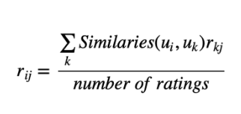

Different people have different baselines for giving ratings, some people give high score generally, some are pretty strict even though they are satisfied with items. To avoid this bias, subtract each user’s average rating from all items when computing the weighted average.

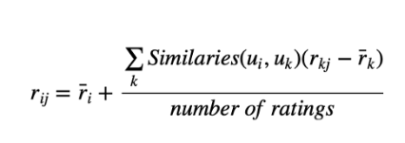

Calculate Pearson correlation and cosine similarity –

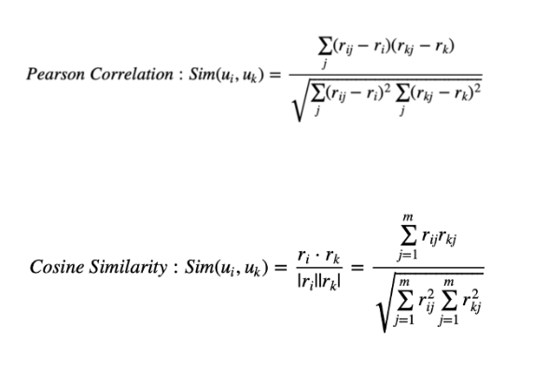

Find the users who are similar to your target users. Weight their ratings to predict the target users rating of the particular item.

In this method if two users give similar rating to the same item then we consider that the users are similar without knowing anything about the users and items.

Item-based CF, we say two items are similar when they received similar ratings from a same user. Then, we will make prediction for a target user on an item by calculating weighted average of ratings on most X similar items from this user. One key advantage of Item-based CF is the stability which is that the ratings on a given item will not change significantly overtime, unlike the tastes of human beings. There are quite a few limitations of this method. It doesn’t handle sparsity well when no one in the neighbourhood rated an item that is what you are trying to predict for target user. Also, it’s not computational efficient as the growth of the number of users and products.

MATRIX FACTORIZATION
Let us consider there are 5 users A, B, C, D, E given ratings to 5 different movies M1, M2, M3, M4, M5. Put it in a matrix for example:

 | M1 | M2 | M3 | M4 | M5
A | 3 | 1 | 1 | 3 | 1
B | 1 | 2 | 4 | 1 | 3
C | 3 | 1 | 1 | 3 | 1
D | 4 | 3 | 5 | 4 | 4

In this matrix we can find that the ratings of A and C are same. Columns 1 and 4 are same. This means that movie 1 and 4 are similar movies and people gave similar ratings. We can see that adding the values of the second and third row we get the ratings of the fourth row. Maybe B loves comedy movie and C loves action movies and D loves both action and comedy movies. We can see that the column 5 is average of column 2 and 3. There are relation between columns and rows which can be explained through the attributes but some relations cannot be explained but exists within the ratings of different users. These dependencies can be used to guess the ratings of the user who has not watched or rated the particular movie.
For example, in the above matrix if C hasn’t rated M5 then we can say that the user C will most likely to give 1 as the rating to the M5 since A and C users have given similar ratings to all the movies. Using matrix factorization these kinds of dependencies can be found out. Matrix factorization is dividing the ratings matrix into simpler matrices such that the product of these matrices gives the original rating matrix. Different genres like action, comedy, drama, horror, etc. can be considered for matrix factorization. For example, consider two genres comedy and action. We figured out A likes comedy and does not like action. Let’s manage to rate how much comedy and action the movie has. A movie has rating of 3 in comedy and one in action. Since A likes action we consider 3 of action and say that A gives rating 3 to the movie. B does not like comedy and likes action therefore B can give rating 1 to the movie. Consider D likes action and comedy then D is likely to rate the movie 3+1 that is 4.
Consider two matrices:
 | C | A
M1 | 3 | 1
M2 | 1 | 2
M3 | 1 | 4
M4 | 3 | 1
M5 | 1 | 3

 | C | A
A | 1 | 0
B | 0 | 1
C | 1 | 0
D | 1 | 1

In the ratings matrix A has given the rating for M1 as 3 since she likes comedy and does not like action. User B likes action not comedy hence gives the movie rating as 1. For every user and movie we can get a relation like this for the ratings given. Movie feature matrix and the user feature matrix can be used to get the ratings matrix for the users and movies. This is expressed as the product of these two matrices.

 | M1 | M2 | M3 | M4 | M5
C | 3 | 1 | 1 | 3 | 1
A | 1 | 2 | 4 | 1 | 3

 | C | A
A | 1 | 0
B | 0 | 1
C | 1 | 0
D | 1 | 1

 | M1 | M2 | M3 | M4 | M5
A | 3 | 1 | 1 | 3 | 1
B | 1 | 2 | 4 | 1 | 3
C | 3 | 1 | 1 | 3 | 1
D | 4 | 3 | 5 | 4 | 4

In this we can see that B has given 4 as rating to M3. B likes action and not comedy that’s why M3 is given rating 4. This is how the matrix factorization works. Here we can see that A and C has the same preferences hence the dependencies can be found within these two matrices easily. We can see that the combination of preferences of B and C is the preference of D since B likes action and C likes comedy. D likes both action and comedy. Hence 2nd row plus 3rd row is 4th row. Dividing the matrix into smaller ones so that the feature extraction becomes easy is matrix factorization. Storage is the advantage of matrix factorization. If there is matrix of 2000 users and 1000 movies. So there are 2 million ratings in this. This can be factorized into a matrix with 100 features and 2000 users and another matrix of 1000 movies and 100 features. The number of entries reduces to 300k entries. Dot product of these two matrices can be used to find the rating of the movie by particular user.
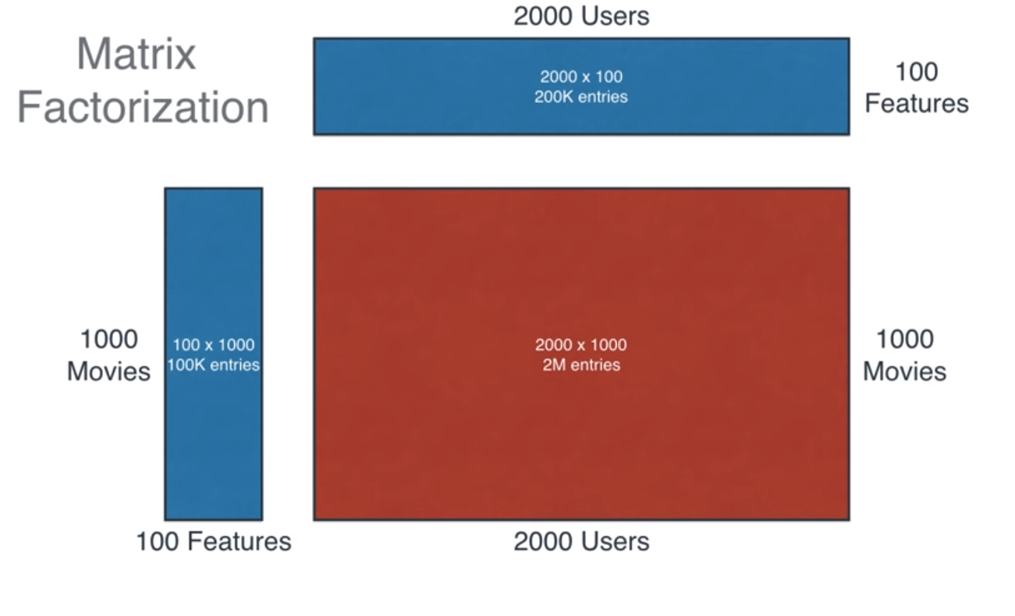
Finding the right factorization can be done using machine learning. Gradient decent is used for matrix factorization. 2 matrices with random values is generated for user feature matrix and movie feature matrix. The dot product of these 2 matrices with random value is found. Then this matrix is compared with the original ratings matrix to find the difference. Changes are made to the two matrices to get the ratings matrix. Error function is used to find the difference between the original rating matrix and the matrix formed by the product of two matrix produced by the computer. The error found is the sum of square of the differences of each pair of entries in the matrix of the corresponding pair of entries.
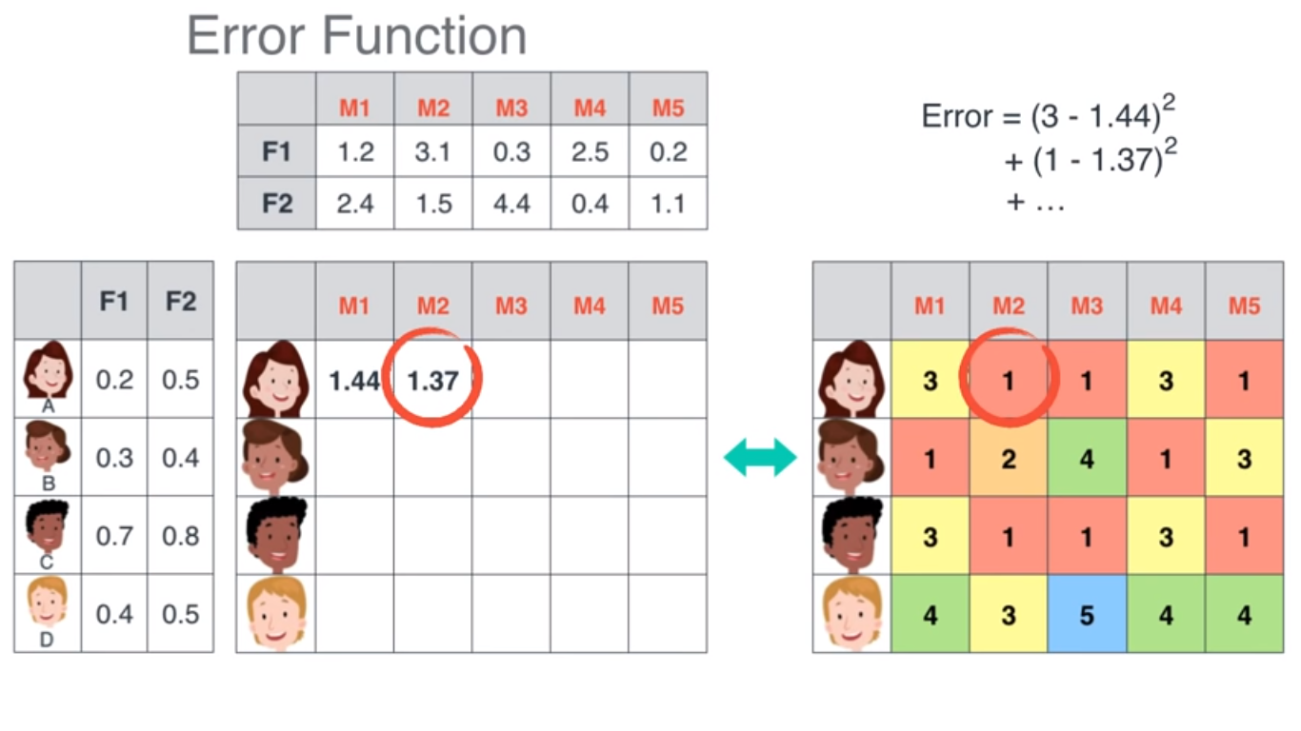
This error is reduced by taking the derivative of the error. By this we can find the value to be added or decreased from the matrices so that the product of the two matrices is the ratings matrix. This method is called as gradient decent. This method is repeatedly applied on all the entries to split the ratings matrix into two matrix such that the product is equal to the ratings matrix. In the data set all users won’t rate all the movies hence there will be missing values in the dataset.
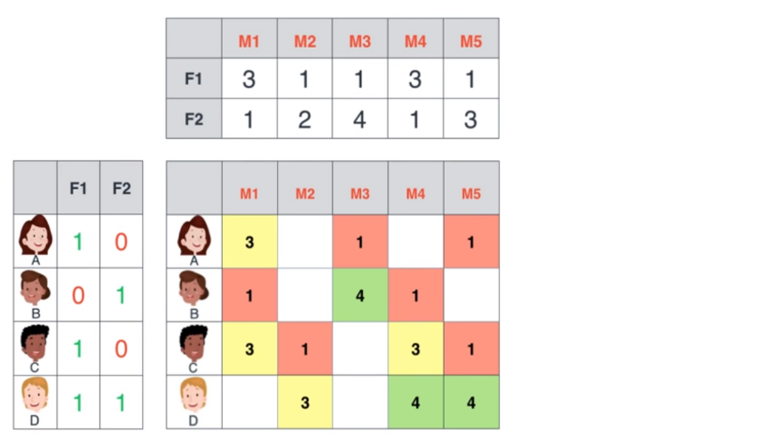

When there are missing values that is the particular user has not rated a movie then this can be predicted using the machine learning algorithm by forming the two matrices using matrix factorization method. After predicting the possible ratings, the movie which has the highest predicted rating for the particular user is recommended to the user.
Base line algorithm for recommender system –
Base line algorithm gives the most popular items. It returns the items which has greater occurrences in during the testing period. [5]
For instance, you come up with an idea to predict movie ratings for people who have not watched those movies. For this problem, baseline algorithm might be this:
We need to find the prospective rating of Inception movie for a specific user u. Baseline algorithm finds the k-many closest people (who have watched Inception and rated already) for user u. After that, you can find the average rating and say, this is the rating for movie Inception by user u. This is the only one movie but you can calculate the performance of this baseline algorithm in this fashion on test set. Your suggested algorithm provides -at least- better performance than this baseline algorithm.

hybrid system based on content and collaborative filtering uses the opinions of the users, similar users and the content of the movies which are watched by the users to give the recommendations to the users. Neural networks are used. The data is split into training, validation and test set. training the network is based on the movies that are watched and evaluated by the users [6].

Java parser and URLs provided in MovieLens is used to extract the synopsis of each movie. Content of the movie and preferences of similar users is taken into consideration for giving recommendation. Directors, script writers and actors are taken into account.

the data set consists of three main matrices with the characteristic features of each film: Kinds (19 kinds x 1682 films), Stars (4416 persons x 1682 films) and Synopsis (8595 terms x 1682 films).

For each user three neural network is constructed based on three movie features.

DISADVANTAGES –
- The cold-start problem is encountered when a new item is added and it has no evaluations.
- If the number of users is actually small, the quality is low.
- All films cannot be taken into consideration since there will be infinite choices.
ADVANTAGES –
success rate per user is 80%. 4 out of 5 films are successfully recommended using this system.
Cuckoo search algorithm for recommender systems –
Rahul Katarya and Om Prakash verma in the recommendation system has applied Cuckoo search algorithm to the output of clustering k-means algorithm to give recommendations to the users. [7]

K-means –
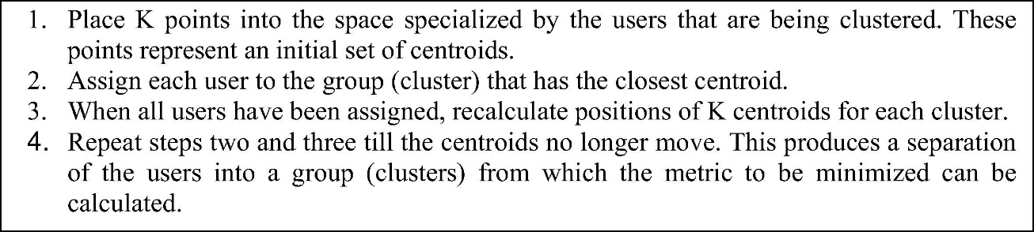

Cuckoo search optimization is applied to the results of k-means for the optimization of results.
Cuckoo search algorithm –
It was inspired by the obligate brood parasitism of some cuckoo species by laying their eggs in the nests of other host birds (of other species). Some host birds can engage direct conflict with the intruding cuckoos. For example, if a host bird discovers the eggs are not their own, it will either throw these alien eggs away or simply abandon its nest and build a new nest elsewhere. Some cuckoo species such as the New World brood-parasitic Tapera have evolved in such a way that female parasitic cuckoos are often very specialized in the mimicry in colours and pattern of the eggs of a few chosen host species. Cuckoo search idealized such breeding behaviour, and thus can be applied for various optimization problems.
Each egg in a nest represents a solution, and a cuckoo egg represents a new solution. The aim is to use the new and potentially better solutions (cuckoos) to replace a not-so-good solution in the nests. In the simplest form, each nest has one egg. The algorithm can be extended to more complicated cases in which each nest has multiple eggs representing a set of solutions.
CS is based on three idealized rules:
- Each cuckoo lays one egg at a time, and dumps its egg in a randomly chosen nest;
- The best nests with high quality of eggs will carry over to the next generation;
- The number of available hosts nests is fixed, and the egg laid by a cuckoo is discovered by the host bird with a probability . Discovering operate on some set of worst nests, and discovered solutions dumped from farther calculations.
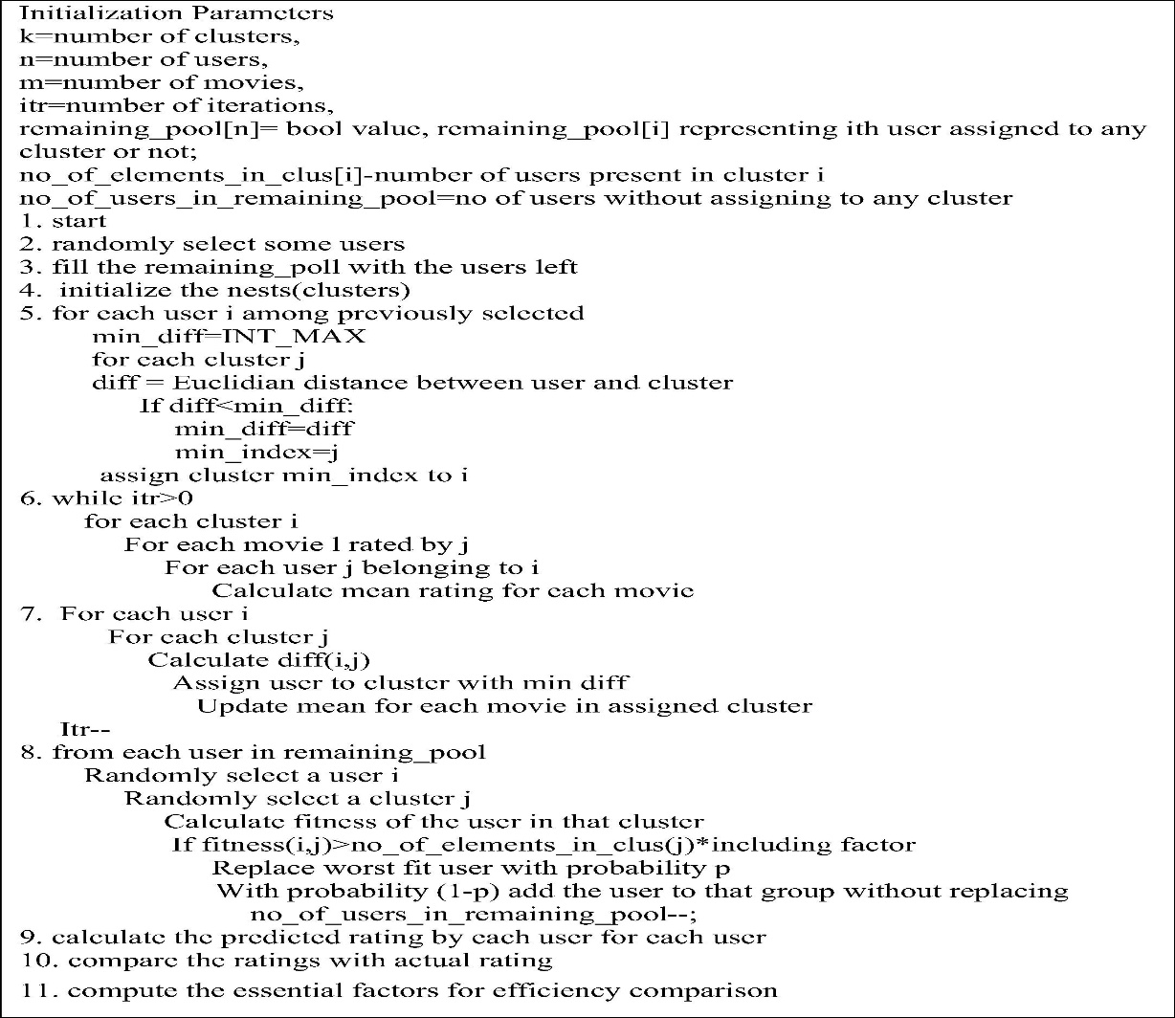
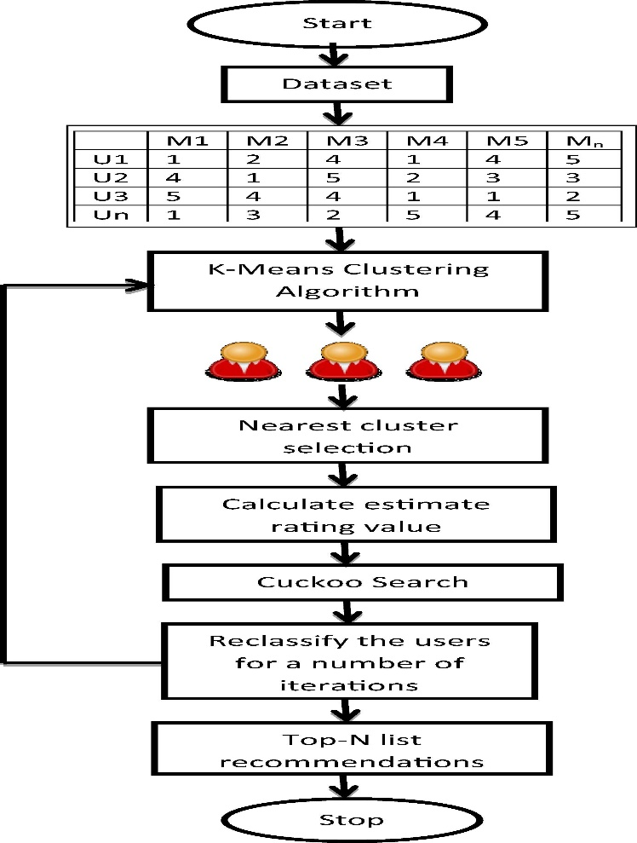
Genetic algorithm for recommender systems –
Genetic algorithm considers the users as chromosomes. Each chromosomes consists of number of genes which is used to determine the likelihood of reproduction for the next generation. Chromosomes with fittest value are more likely to reproduce. Genetic algorithm iteratively creates new population replace of old ones by selecting solutions on the basis of prespecified fitness function. Three operations are executed to construct the new generation known as selection, crossover and mutation. Selection process selects the proportion of current population to breed new generation according to fitness values. Crossover operator allows swapping the portion of two parent chromosomes for each other to be recombined into new offspring. Mutation operator randomly alters the value of gene to produce offspring. All operators provide the means to extend the diversity of population over time and bring new information to it. Iterations tend to terminate when the fitness threshold is met or a predefined number of generations is reached.
[8]
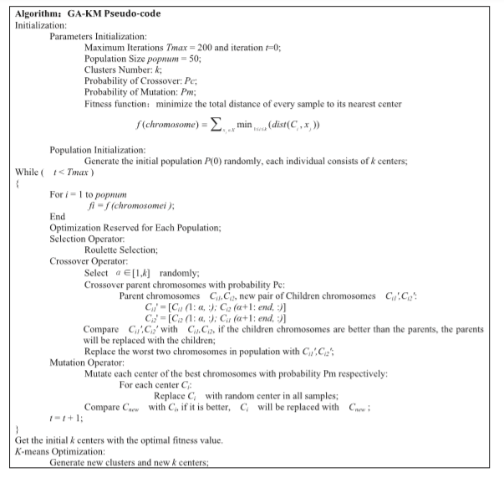 ADVANTAGES –
Movie recommendations are made based on like-minded people with similar interest. Filtering is done based on the sentiment of users which increases the accuracy in recommendation.
Artificial immune system for recommendation system –
artificial immune system algorithm gives solution to the optimization problem. AIS clustering and collaborative filtering methods is used for recommender system. Artificial immune system algorithm is derived from the mechanism where biological immune system fights against foreign pathogens. By using the adaptive immune response, this algorithm can be used to search for the best solution of an optimization problem. It can also be used to cluster or classify data for a problem. Immune network theory is first proposed by Jerne in 1974. He suggested that in a real immune system, when a biological organism encountered an invasion from outside pathogens, the biological organism would develop its own protective agents known as antigen. Immune system would produce antibodies to combine with antigens to fight off pathogens as an immune response. This process from the immune system suggests a good approach in finding the best solution for an optimization problem. The antigen would be our objective function and the antibody is the solution to our problem. We would focus on our antigen and search for an antibody that can combine with it to be our solution for the problem.
Flowchart for AIS algorithm –
- Step1: Generate initial antibodies. These antibodies can be seen as the initial solution for the evolutionary algorithm.
- Step2: Identify antigens. This step is used to simulate the situation when a body is invaded by foreign pathogens. In AIS algorithm, we just read in unidentified data to complete this step.
- Step3: Calculate affinity. When the antibodies are trying to identify the antigens, the binding between the antibody and antigen has to be determined.
- Step4: Adjust antibodies. Select good antibodies for adjustment.
- Step5: Generate new antibodies. Copy the adjusted antibodies to create new antibodies and add them into the antibodies’ pool.
- Step6: Check termination condition. If the stop condition is met, go to Step7. Otherwise, go back to Step2.
- Step7: Finish the algorithm. [9]

This research focuses on applying AIS algorithm to cluster MovieLens data. In the training phase, MovieLens data is defined as antigens and Pearson correlation coefficient is used to assess the affinity between antigens and antibodies to find the relation between the data for clustering. In the testing phase, the collaborative filtering method is applied on the data cluster to predict a rating for the movie. In the following, we explain our AIS clustering and collaborative filtering algorithm for movie rating evaluation. In this research, every single data is treated as antigen and antibody. The affinity between the data is calculated for clustering.
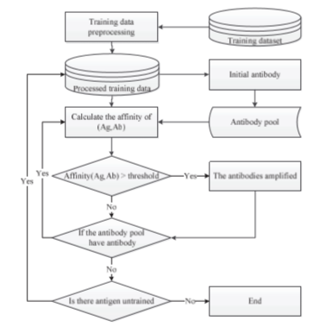

user based collaborative filtering with Graph database
py2neo library in python working with neo4j is used for building the recommendation system. Collaborative filtering with Graph database is used. Movies are recommended based on node and edge. Neo4j is an open source NoSQL graph database implemented by Java, which realizes the storage of graph data model at the professional database level. Compared with common graphics processing and memory level databases, neo4j provides complete database features, including ACID transaction support, cluster support, backup and failover, and so on. In addition, the use of Neo4j only needs to understand the Cypher similar to the SQL language, and does not need to delve into the profound theoretical knowledge of graph theory. What’s more, using neo4j can be developed with many existing class libraries. This movie recommender system is developed with Python language.
The system default shows to movies with an average score of the top 50. The larger the radius of the node, the higher the recommendation. For movies with different averages, different colours are used to distinguish them. [10]
Jointly Modeling Aspects, Ratings and Sentiments for Movie Recommendation (JMARS) –
model provides a principled extension of the factorization models commonly used for recommendation. That is, we retain the notion that reviews are generated by incorporating user and movie speciﬁc features. However, unlike simple vectorial rating models, we use a structured representation to capture the interaction between movie and user. In this sense our model borrows from the tensorial factorization approach of and it extends it from scalars to documents. More speciﬁcally, we assume that each user (and each movie) has an aspect distribution of interest. Reviews are generated by drawing from the product of movie and user aspects. For instance, a review text will likely contain details about special eﬀects, but only if the user is actually interested in them and if the movie has special eﬀects worth discussing. Hence, reviews inform both about the content of a movie and also about the interests of a user. This diﬀerentiation allows us to attribute partial scores to interests, i.e. we assume that the review scores arise from the process of combining partial scores associated with diﬀerent aspects of the movie. Not only does this improve rating accuracy, it also allows us to attach sentiments to aspects. In other words, we can model which terms associate with positive, negative, and neutral aspect speciﬁc words within an aspect. We model the following ﬁve groups of words:
Background That is, words uniformly distributed in every review are considered background words. For example, in the case of movie reviews, these words include “characters”, “movies”, etc.
Movie-speciﬁc Words such as the name of the characters in a movie, or any term that appears only in the movie are considered movie-speciﬁc. These two types of words provide less information about movie quality.
Aspect These are words associated with speciﬁc aspects. For example, “music”, “sound”, and “singing” are all aspect words related to the “music” aspect.
Aspect-Sentiment These words usually come with a speciﬁc aspect to express positive or negative sentiments. For example, words such as “bored”, “predictable” usually appear with a discussion of the “plot”.
General sentiment For example, words such as “great”, “bad”, or “worse” do not really convey any aspect speciﬁc content. We call them general sentiment words.
DISADVANTAGES:
Method fails if the user gives low rating and gives positive feedback regarding the movie in the reviews. [11]
Movie swarm mining –
This method generate swarms based on the genre is used by the research article written by Sajal Halder, A. M. Jehad Sarkar and Young-koo lee to create a recommendation system.
Let Udb = {u1,u2,...,un} be the set of all users
Tdb = {t1,t2,...,tm} be the set of all timestamps in the database
Gdb = {g1,g2,...,gp} be the set of all movie genres
Idb = {i1,i2,...,iq} be the set of all movie items.

A subset of Udb is called a user set U. A subset of Tdb is called time set T, a subset of Gdb is called movie genres set G and a subset of Idb is called movie Items set I.

The number of user set, time set, movie genres set and movie item set indicate |U|, |T|, |G| and |I| respectively. Before describing more details, we have deﬁned a set of terms. Deﬁnition 1. Short Time Movie Swarm (STMS): A swarm set (U,t,g) is said to be a short time movie swarm if all users in U ⊆ Udb enjoy movie genres g ∈ Gdb at timestamps t ∈ Tdb.

Deﬁnition2. Long Time Movie Swarm (LTMS): A swarm set (U,T,G) is said to be a long time movie swarm if all users in U ⊆ Udb enjoy movie genres G ∈ Gdb at timestamps T ∈ Tdb, where |T|≥mint(minimum threshold). To avoid mining redundant long time movie swarms, we further give the deﬁnition of long time movie close swarm as follows:

Deﬁnition 3. Long Time Movie Closed Swarm (LTMCS): A long time movie swarm (U,T,G) is called long time movie closed swarm if there are no T` , U` where T ⊂ T` and U ⊂ U` for particular genres Gp ⊆ Gdb and (U`,T`,Gp) is long time movie swarm.

Deﬁnition 4. Interesting Movie (IM) : A movie item i ∈ Idb is said to be interesting movie if a short time swarm (U,t,i) enjoy the item i at time stamps t where |U|≥minim u and the average rating of this movie avgr(i) >rim

Deﬁnition 5. Popular Movie (PM) : A movie item i ∈ Idb is said to be popular movie if a short time swarm (U,t,i) enjoy the item i at time stamps t where |U|≥minpm u and the average rating of this movie avgr(i) >rpm .

Deﬁnition 6. Interesting Popular Movie (IPM) : A movie item i ∈ Idb is said to be interesting popular movie if a short time swarm (U,t,i) enjoy the item i at time stamps t where |U|≥minpm u and the average rating of this movie avgr(i) >rim.

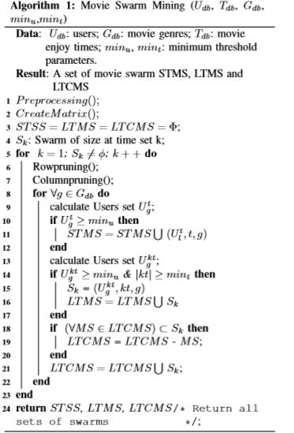

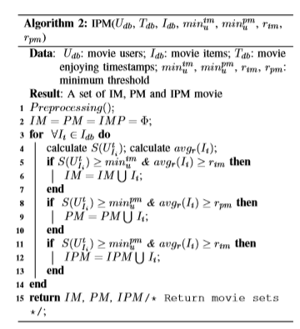
[12]

Collaborative filtering with particle swarm optimization to build recommendation system –

Particle swarm optimization (PSO) was inspired by the social behaviour as it is an evolutionary computation technique. In PSO, the possible resolutions called particles, fly around in a multidimensional search space, to determine an optimal, or sub optimal, answer by competition as well as support for themselves. The system primarily has a population of random responses. The individual particle is given a random velocity and is drifted through the d-dimensional problem space. The position or location(xid) and velocity(vid) of every particle in dimension d is revised based on its previous velocity, the previous best particle location (pid or pbest), and the previous global best location or position of a particle in the population (pgd orgbest).The key approach of PSO lies in accelerating each particle towards its pbest and gbest locations at each time step. The authorized velocity and position of ith particle are given

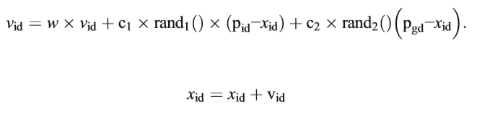

w denotes the inertia weight factor and is usually set to a value in the range of 0.5–1. pid is the location of the particle that understands the best fitness value. pgd is the position of theparticlesthatinvolveaglobalbestfitnessvalue.c1 andc2 are constants recognized as social acceleration coefficients. d signifies the aspect of the problem space. rand1, rand 2 are random values in the scope of (0, 1), which ensures wide search through problem space. The inertia weight factor w delivers the essential diversity to the swarm by altering the momentum of particles to escape the stagnation of particles at the local optima. Equation5 needs each particle to record its existing coordinate xid. The velocity vid specifies the speed of its movement sideways the dimensions in a problem space, and the coordinates pid and pgd. Where the best fitness values were computed:
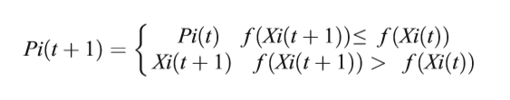
symbol f represents the fitness function; Pi (t) stands for the finest fitness values and the coordination where the significance was calculated. t denotes the generation step. Finally, PSO algorithm can be outlined as a) Initialize every particle in the population pool within the search space of initial velocities; b) Calculate the fitness value of each of these particles. c) If this value is better than its best fitness value recorded until this time, which is also called as population best (pid), then set the current value as the new pid. d) The global best (pgd) is selected from the candidates, which is the best fitness value of all of them in the pool. This is updated in every iteration after this comparison as the new pgd. e) Calculate the particle velocity. Refresh the particle position according to Eq. 3. g) Carry out stages b to e until minimum error criteria are attained. The fuzzy c-means algorithm is a clustering algorithm where each item may belong to two or more clusters, not just one. Here, the degree of membership is considered for each item which is given by a probability distribution over the clusters. Fuzzy c-means (FCM) is a clustering algorithm that is useful when an item’s similarity matches with more than one cluster, and we do not want just to consider but various other clusters too. FCM is different in the sense that it does not decide the entire membership of a data point to a given group; instead, it calculates the likelihood (the degree of membership). Since there is no absolute membership in one cluster but the various percentage of membership in different clusters, FCM can be extremely fast. This is because high accurateness can be achieved with a large number of iterations with this clustering method. FCM is grounded on minimization of the following objective function:
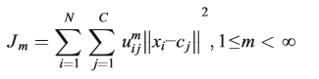
Where m is some real number larger than 1, uij is the degree of association of xi in the cluster j. xi is the ith of d-dimensional dignified data, cj is the d-dimension center of the cluster. ||*|| is somewhat norm expressing the similarity between any measured data and the centre. Fuzzy partitioning is supported out by an iterative optimization of the objective function mentioned above, with the apprise of membership uij and the cluster centres cj by:
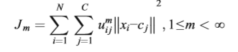
Where m is some real number larger than 1, uij is the degree of association of xi in the cluster j. xi is the ith of d-dimensional dignified data, cj is the d-dimension center of the cluster. ||*|| is somewhat norm expressing the similarity between any measured data and the center. Fuzzy partitioning is supported out by an iterative optimization of the objective function mentioned above, with the apprise of membership uij and the cluster centers cj by:
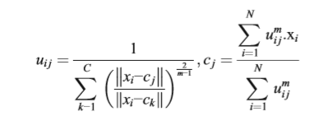

Particle swarm optimization application for the movie:
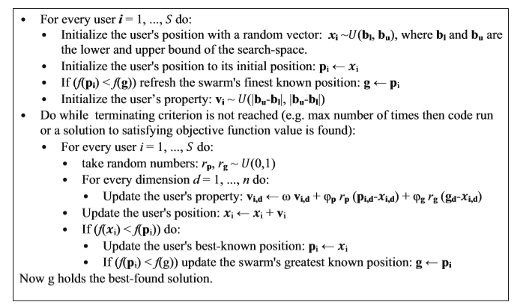

- Approaches of testing the accuracy of model

Different approaches like F1 score testing, A/B testing, mean absolute error (MAE) are used to test the accuracy of the machine learning model built for recommendation system. There are 4 parameters that are used to find the precision of the model they are:
True positive - these are correctly predicted positive values. Actual class tells that the customer watched the movie which is recommended and the model also tells the same thing.
True negative – these are correctly predicted negative values. Actual class tells that the movie recommended by the system is not watched by the customer and the model also tells the same thing.
False positive – actual class has negative value but the model wrongly predicts a positive value. The movies recommended by the system is not watched by the user but the model predicts that the movie recommended by the system is watched by the user.
False negative – actual class has positive value but the model wrongly predicts a negative value. The movies recommended by the system is watched by the user but the model predicts that the movie is not watched.
Accuracy – accuracy is the ratio of correctly predicted values by the total observations. accuracy is a great measure but only when you have symmetric datasets where values of false positive and false negatives are almost same.
Precision – it is the ratio of correctly predicted positive values that is the true positive to the total predicted positive values. That is
$$precision=\frac{true positive}{true positive+false positive}$$
Recall – it is the ratio of the correctly predicted positive values to the total of all the positive observations in the data.
$$Recall=\frac{true positive}{true positive+false negative}$$
F1 score – it is the weighted average of precision and recall. F1 score takes both false positives and false negatives into account.
$$f1 score=2*\frac{Recall*Precision}{Recall+Precision}$$
A/B testing is used to compare two or more versions. It gives an overview of whether the difference between the two versions is statistically significant. The two different webpages or newsletters can be compared using this test. Which colour button is better? hypothesis should be defined to conduct the test that is what is the possible outcome of changing the version from A to B. maybe you are hoping to increase the open rate, newsletter sign-ups. Criteria for success should be defined before conducting the test. For example, the movies recommended by the model is watched by the customers. The traffic is split into two. You need to figure out what is the minimum number of people to run A/B test to achieve statistically significant results. This can be used to update the recommendations given to the users. Before conducting A/B test A/A test should be conducted to make sure A/B test is conducted properly.
In A/B test the traffic is divided into two parts, group A and group B. Group A is routed into the old model and group B is routed into the new model. Performance is compared and decision is made on whether the new model performs better than the old model or not. Statistical hypothesis testing makes the testing more precise.
A/B tests are formulated to answer the question, “Does this new model lead to a statistically significant change in the key metric?” The null hypothesis is often “the new model doesn’t change the average value of the key metric,” and the alternative hypothesis “the new model changes the average value of the key metric.” The test for the average value (the population mean, in statistical speak) is the most common, but there are tests for other population parameters as well.
Briefly, A/B testing involves the following steps:
- Split into randomized control/experimentation groups.
- Observe behaviour of both groups on the proposed methods.
- Compute test statistics.
- Compute p-value.
- Output decision.
A/A test is used to find out if the data is messy or randomization of data is not conducted correctly or if something is broken. It is used for validation of set up. It is conducted to compare the identical experience on different set of users. The same experiment is conducted on two random set of users. If there is different data for different users for the same experience then there is something wrong. For example, if two groups of people get the same medication. If it is same experiment and metric is different then there is something wrong.

- CPU based computing
CPU executes the instructions of the program. It performs operations given by the instruction. CPU has control unit, processing unit, main memory and I/O circuitry.
Arithmetic and logic unit performs arithmetic and logic operations is the principle component of CPU. Processor registers supply operands to the ALU and store the results of ALU operations. Control unit that orchestrates the fetching (from memory) and execution of instructions by directing the coordinated operations of the ALU, registers and other components. CPU can handle multiple tasks.

- Need for GPU based computing and tensor flow
Deep learning requires considerable hardware to perform tasks. GPU can compute faster than a CPU. It is used for analysis and computing large datasets. Whenever intensive computations are required GPU is used. GPU can handle few tasks at a faster rate. Large amounts of data can be analysed at a faster rate using GPU. Since it is faster and more powerful than CPU based computing it is used for building recommendation system since a large dataset of user’s ratings is used. GPU is suited for parallel computing.

Tensor flow is the deep learning library. Tensor flow architecture works in three parts:
- Pre-processing the data
- Build the model
- Train and estimate the model
Computations are specified and these computations are accomplished by computational graph. Computational graph takes multidimensional matrix called tensors and does computations on them. Each node in graph denotes an operation. When creating the graph, you have the possibility to explicitly specify where the computations should be done, on the GPU or CPU. By default, it will check if a GPU is available, and use that. Graph is run in session. Operations to be performed is specified in the run function.
- PROGRAMMING LANGUAGE
Python is a high-level language released in 1991 created by Guido van Rossum. It is simple and easy to understand. Python is interpreted and object oriented. Syntax is readable and reduce the cost of maintenance. Modules and packages make the python language reusable. It is dynamically typed and there is no need to declare anything.

Pandas is python library used for data analysis. It takes data and creates a python object with rows and columns. This object is called as data frame. Python 3.5.3 and above is required for the installation of pandas library. Statistics of data frame can be collected through commands df.mean(), df.std(), df.corr(), df.count(), df.min(), df.max(), df.median(). Pandas can be used to select the data and compare. Position can be selected using iloc. Columns can be filtered using different conditions. & (and) or | (or) can be used for different conditions to filtering. The values can be sorted in ascending or descending order. df.sort_values(col) is used to sort values in ascending order and df.sort_values(col,ascending= FALSE) is used to sort values in descending order. groupby command is used to split the data based on some criteria. command pd.isnull() checks null values and returns Boolean array. pd.notnull() command is the opposite of pd.isnull() command.

References –
[1] Yadav, D.K. & Singh, Ankur & Kr, Vijay. (2015). A Movie Recommender System: MOVREC. International Journal of Computer Applications. 124. 7-11. 10.5120/ijca2015904111.
[2] Carlos A. Gomez-Uribe and Neil Hunt. 2015. The Netflix Recommender System: Algorithms, Business Value, and Innovation. ACM Trans. Manage. Inf. Syst. 6, 4, Article 13 (December 2015), 19 pages. DOI: https://doi.org/10.1145/2843948
[3] Linden, Greg & Smith, B. & York, J.. (2003). Linden G, Smith B and York J: ‘Amazon.com recommendations: item-to-item collaborative filtering’, Internet Comput. IEEE, , 7. Internet Computing, IEEE. 7. 76 - 80. 10.1109/MIC.2003.1167344.
[4] https://www.ibef.org/research/india-study/ott-video-small-screen-big-play
[5] J. Yuan, F. Sivrikaya, F. Hopfgartner, A. Lommatzsch, and M. Mu. Context-aware LDA: Balancing Relevance and Diversity in TV Content Recommenders. 2015
[6] C. Christakou and A. Stafylopatis, "A hybrid movie recommender system based on neural networks," 5th International Conference on Intelligent Systems Design and Applications (ISDA'05), Warsaw, 2005, pp. 500-505.
[7] Katarya, Rahul & Verma, Om. (2016). An effective collaborative movie recommender system with cuckoo search. Egyptian Informatics Journal. 18. 10.1016/j.eij.2016.10.002.
[8] Zan Wang, Xue Yu, Nan Feng, and Zhenhua Wang. 2014. An improved collaborative movie recommendation system using computational intelligence. J. Vis. Lang. Comput. 25, 6 (December 2014), 667-675. DOI: https://doi.org/10.1016/j.jvlc.2014.09.011
[9] A. D. Chang, J. Liao, P. Chang, C. Teng and M. Chen, "Application of artificial immune systems combines collaborative filtering in movie recommendation system," Proceedings of the 2014 IEEE 18th International Conference on Computer Supported Cooperative Work in Design (CSCWD), Hsinchu, 2014, pp. 277-282.
[10] N. Yi, C. Li, X. Feng and M. Shi, "Design and Implementation of Movie Recommender System Based on Graph Database," 2017 14th Web Information Systems and Applications Conference (WISA), Liuzhou, 2017, pp. 132-135.
[11] Diao, Qiming & Qiu, Minghui & Wu, Chao-Yuan & Smola, Alexander & Jiang, Jing & Wang, Chong. (2014). Jointly modeling aspects, ratings and sentiments for movie recommendation (JMARS). Proceedings of the ACM SIGKDD International Conference on Knowledge Discovery and Data Mining. 10.1145/2623330.2623758.
[12] S. Halder, A. M. J. Sarkar and Y. Lee, "Movie Recommendation System Based on Movie Swarm," 2012 Second International Conference on Cloud and Green Computing, Xiangtan, 2012, pp. 804-809.
doi: 10.1109/CGC.2012.121

