**Task 1:**

**Check whether /user/acadgild directory exists or not in the HDFS.**

**If it doesn't exist, then create this.**

**Create a directory /user/acadgild/hadoop.**

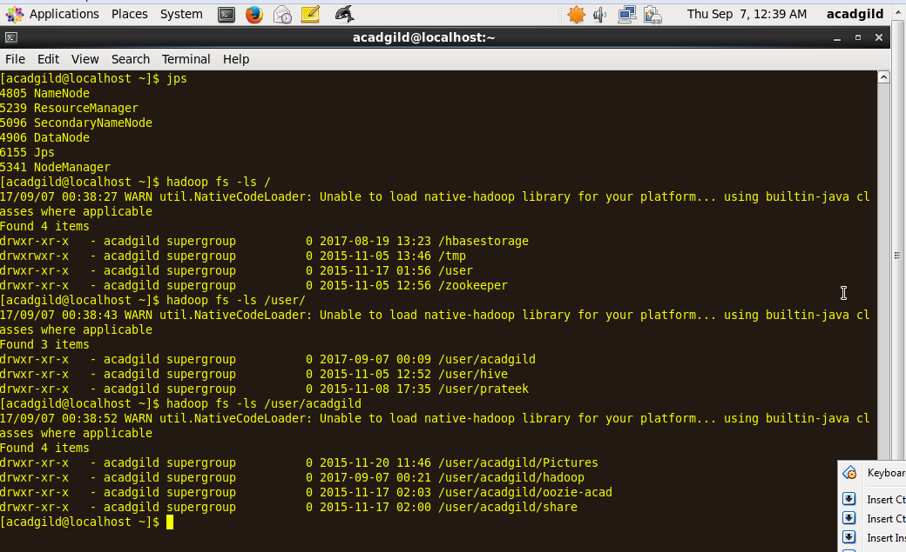

**Task 2:**

**Create a file in HDFS under directory /user/acadgild/hadoop, with name word-count.txt.**

**Whatever we type on screen should get appended to the file.**

**Try to type (on screen) few lines from any online article or textbook.**

Using **appendToFile** command to perform the above task.

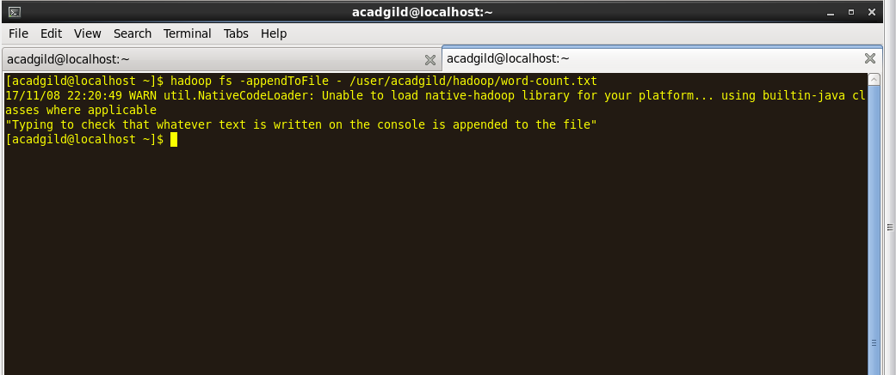

Ctrl +D to save and Exit

Use CAT command to view if the text written above is appended to the file.

