Technical Expertise Document (TED)


This document of Cybage Software Pvt. Ltd. is for restricted circulation. No part of this publication may be reproduced, stored in a retrieval system or transmitted in any form or by any means – recording, photocopying, electronic and mechanical, without prior written permission of Cybage Software Pvt. Ltd.
Document name | Technical Expertise Document  Web Security
Version no. | 1.0
Release date | TBD
Document ID | S/DEP/TED
Classification | Departmental

Document history

Ver. No | Release Date | Created By / Modified By and Date | Reviewed By and Date | Approved By and Date | Remarks and Changes Made
1 | 08/07/13 | Sudhir Sharma 09-Jul-13 | NA | Name of the approver / <dd-Mon-yy> | Initial draft.

Distribution List

Sr. No. | Name | Role | Organization Name
1.
2.
3.
4.
5.

Table of Contents
Document history 2
Distribution List 2
1. Introduction 4
1.1 Objectives of the Document 4
1.2 Acronyms and Definitions 4
2. Features Used 4
3. Problem Statement 4
4. Technology Evaluation 4
5. Solution Approach 5
5.1 XSS solution using blacklisting. 5
5.2 Cross-Site Request Forgery (CSRF) 5
5.3 Security Best practive 6
2. Challenges/Limitations 8
3. Benchmarking Metrics 8

Introduction
This document will be used to demonstrate technical expertise to stakeholders like potential/existing client that Cybage possesses for the Web security Remediation implementation concept.

Objectives of the Document
The purpose of this document is to
- Provide list of web security vulnerability fixed in project
- Provide the concept to fix the vulnerability
- Identify challenges/limitations while addressing the vulnerability

Acronyms and Definitions
Sr. No. | Acronyms | Definitions
1. | OWASP | Open Web Application Security Project
2 | XSS | Cross-site scripting
3 | CSRF | Cross-Site Request Forgery

Features Used
This section covers the list of security vulnerability fixed using concept mention in OWASP.:

- XSS using blacklisting.
- Cross-Site Request Forgery (CSRF)
- Security Best Practice.

Problem Statement
The project is having a homemade mvc framework written using legacy code which is having various security vulnerability.

Technology Evaluation
- NA

Solution Approach
This section demonstrates aforementioned vulnerability were fixed.

XSS solution using blacklisting.
What is black listing approach – Define untrusted scripting character and encode(or remove) then from actual request
Solution using above approach
  - Define servlet filter (XSSFilter) – Filter will return sanitized Http Request Wrapper
  - Define Sanitized HTTP request Wrapper – Override every method and return the clean value by applying the sanitization
  - Define Sanitized rule – rules are nothing but configurable untrusted character per page per parameter
  - Define Sanitization (This will clean unsafe character)

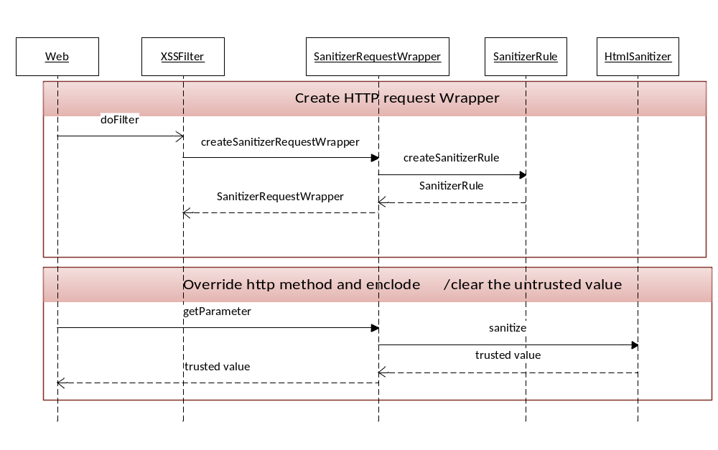

Cross-Site Request Forgery (CSRF)
Solution for CSRF:
For Appilcation flows requiring CSRF checks, the System code will now require a random secret key to be passed along as value of CSRFAuthKey http request parameter for validation. This random secret key is generated for a brand new session and stored as a http session attribute with name CSRF_KEY
Shown below is the code snippet inside CSRFUtil.java which creates a random secret key for brand new http sessions
CSRFUtil.java

Set CSRF key to session
if (newSession) {
....
if (isCSRFSEbabled()) {
String encryptedCSRFKey = Generate random encrypted key;
session().setAttribute(CSRF_KEY, encryptedCSRFKey);
}
}
....
}

Set CSRF key in hidden property of each form

<input type="hidden" name="CSRFAuthKey" property="<bean:write name="CSRF_KEY" scope="session" filter="true"/>"/>

Compare the CSRF key

String csrfKeyInHttpSession = session.getAttribute(ControllerConstants.CSRF_KEY);

String csrfKeyFromFormPost = request.getParameter(ControllerConstants.FORM_CSRF_AUTH_KEY);

if (!csrfKeyInHttpSession.equals(csrfKeyFromFormPost)) {
CSRF attack found
} }

Security Best practive
Authentication
- All pages and resources must require authentication except those specifically intended to be public.
- If a maximum number of authentication attempts is exceeded, the account must be locked for a period of time long enough to deter brute force attacks as directed
- All authentication controls must be enforced on the server side.
- All authentication controls should have a centralized implementation.
Like LDAP based authentication
Or single sign on based authentication
- All authentication controls must fail securely.
- All authentication events must be logged.
- All passwords must be stored securely using approved encryption algorithm or an approved one-way hash algorithm. One-way hash is preferred.

Session Management
- Sessions must be invalidated when the user logs out.
// Kill the current session
session.invalidate();
- Sessions must timeout after a specified period of inactivity.
Session().setMaxInactiveInterval(15*60); //in seconds
- All pages that require authentication must have logout links.
- The session id must never be disclosed other than in cookie headers; particularly in URLs, error messages, or logs. This includes verifying that the application does not support URL rewriting of session cookies.
- The session id must be changed on login.
HttpSession session = request.getSession();
Map<String,Object> values = session.getAll(); //This line is psydo code

// Kill the current session
session.invalidate();

HttpSession newSession = request.getSession(true);
newSession.putAllValues(values); //This line is psydo code

- The session id must be changed on re-authentication.

- The session id must be changed or cleared or invalidated on logout or timeout.

- Cookies which contain authenticated session tokens/ids must have their domain and path set to an appropriately restrictive value for that site.

- Set HTTPOnly to guard against cross-site scripting (XSS). When HTTPOnly is set for a cookie, the browser should not allow scripts to access the cookie
Input Validation
- A validation pattern must be defined and applied to all input.
- All input validation failures must result in input rejection or input sanitization.
- A character set, such as UTF-8, is specified for all sources of input.
- All input validation must be performed on the server side.
- Input validation failures should be captured.
Output Encoding/Escaping
- Output encoding /escaping controls must encode all characters not known to be safe for the intended interpreter.
- All output encoding/escaping controls must be implemented on the server side.
- All un-trusted data that is output to SQL interpreters must use parameterized interfaces, prepared statements, or be escaped properly.
- All un-trusted data that are output to XML must use parameterized interfaces or be escaped properly.
- All un-trusted data that are used in LDAP queries must be escaped properly.
- All un-trusted data that are included in operating system command parameters must be escaped properly.
- All un-trusted data that are output to any interpreters not specifically listed above must be escaped properly.
- There should be a single security control implementation for output encoding/escaping for each intended destination type.

Challenges/Limitations
NA

Benchmarking Metrics
NA

