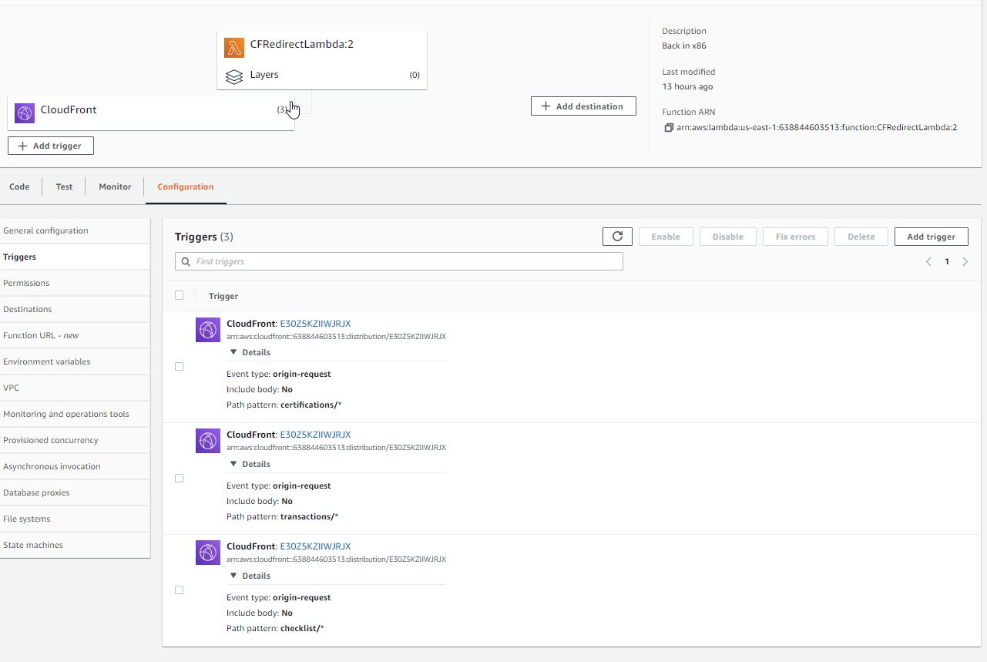

https://docs.aws.amazon.com/AmazonCloudFront/latest/DeveloperGuide/edge-functions.html